**MOVIMENTO**

**PROBLEM STATEMENT:**

Build a manual robot with hand mechanism and an autonomous robot which can follow black line in white surface.

**ARENA:**

* A sample arena is given below.
* There will be two zones, red zone for manual robot and rest is for autonomous robot.
* There will be 4 checkpoints as marked by red flags.
* The width of black line will be 2cm.

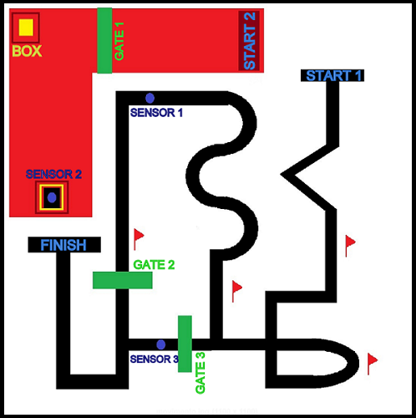

**GAMEPLAY:**

* There will be two rounds.
* In first round only autonomous robot has to traverse from START 1 to 4th checkpoint.
* No sensors or gates will be activated during first round of play.
* In second round all the sensors and gates will be activated.
* The GATE 1 for the manual robot will be opened only after the autonomous robot crosses the SENSOR 1.
* Then the manual robot has to start from START 2 and pick the box(5cm*5cm*5cm) and place it on the SENSOR 2.
* GATE 2 will be opened for the autonomous robot only after placing the box on the SENSOR 2.
* Similarly GATE 3 for autonomous robot will be opened only after the autonomous robot crosses SENSOR 3.
* GATE 3 is a feedback path, so it is to be avoided.

**RULES:**

* A maximum no of 4 participants are allowed in a team.
* The team will be provided 220V, 50Hz standard AC supply.
* Participants should bring any other power supply required for their robots.
* Teams qualifying 1st round will go into the final round.
* Lego kits or any pre-made spare parts are not allowed.
* Teams cannot touch their robots during run.
* In 1st round 3 runs will be given to each team and best score among those will be considered.
* Maximum 3 restarts will be available for each run. No penalty will be given for the restarts but the time will **not** be set to zero.
* The decision of the coordinator will be the final decision.

**BOT SPECIFICATION:**

* The manual BOT should fix in a box of 25cm*25cm(l*b) or less, no constraint on height.
* The manual BOT can be wired or wireless, can have on-board or off-board power supply.
* The autonomous BOT should fix in a box of 20cm*20cm(l*b) or less, no constraint on height.
* The autonomous BOT must have on board power supply.

**SCORING:**

* Each checkpoint = 100 points.
* In 2nd round putting the box on SENSOR 2 will be of 50 points and crossing the finish line will be of 150 points.
* In both round total score = Total points-time(in seconds) taken for completing the task.

**CONTACTS:**

Vineet Nayak

Mob.no.+919439547701

Dharmasish Dwibedy

Mob.no.+919438456451