

Kadi Sarva Vishwavidyalaya
•B. P. College of Computer Studies – BCA
•S.V. Institute of Computer Studies - BCA
BCA SEMESTER – V BCA – 507
“PROJECT PHASE - I”

“Exam Helper”
STUDENT NAME EXAM NUMBER ENROLLMENT NUMBER
Patel Divy Dineshbhai 014134 20BCA04149
Patel Dhruv Girishbhai 014131 20BCA04147 Tapodhan Dhruv Jayeshbhai 014239 20BCA04262 Upadhyay Rajan Chiragkumar 014244 20BCA04268
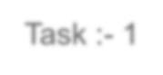
Task :
-
1
- Project Title :- Exam Helper
- Project Definition :- To increase exam performance and Help to achieve target.
- Technology Used :-
- Front End :- HTML , CSS , J.S
- Back End :- ASP.NET , MYSQL


Task :- 2
- Project Scope / Objective :-
- Exam Helper that will provide you latest five year exam paper according to your stream.
- It will Provide all the study material and arrange mock test.
- Study of Existing System :-
- We analyzed the manual system of Exam Helper , It is helpful for student and teacher also
- Paper and materials from each subject are difficult to find.
- Student has to go to get the material offline.
- It is Time consuming for student.
Task :- 2
- Advantages :-
- Student Does not required internet.
- Student can get hardcopy so it is useful for student.
- Disadvantages :-
- It is Difficult to get material and notes of each subject according to each stream.
- Taking offline test Wastes Paper.
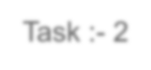
Task :
-
2
- Operational Level Problem :-
- It is Difficult to find paper and material offline.
- Time Consuming to find papers and materials according to stream.
- Technical Level Problem :-
- Student have to come and collect the material offline.
- Informational Level Problem :-
- Finding materials/information offline is difficult.
- Proposed System :-
- System Provide latest 5 year paper and material Digitally.
- In System all services is free of cost for all the student.
- System provide mock test also.
- System provide material according to the university , and material is different for each university.
- Student can put their own material on System so that if someone doesn’t want to use material , they can get another material also.
- Proposed System Advantages :• Quick Access
- Student can get all Paper and material digitally.
- Student can give mock test.
- Save the Student time.
- Free of Cost.
- Proposed System Disadvantages :-
- Material Mismatched.
- Some time University answer is different and system answer is different.
- SRS including functional requirement and non-functional requirement :

- Hardware and Software
❖ Client Side: -
- Hardware Specification(minimum)
▪ CPU: - Ryzen / Intel - 2.20 GHz
▪ Ram: - 1 GB ▪ HDD: - 500MB
▪ Laptop / Mobile / PC
▪ Scanner And Printer (Optional)
- Software Specification (minimum)
▪ Windows 7/8/10/11S
▪ Mozilla Firefox
▪ Internet Explorer or Chrome
❖ Developer Side: -
- Hardware Specification(minimum)
▪ CPU: - Ryzen / Intel 4.2GHz
▪ RAM: - 2GB
▪ HDD: - 1Gb
- Software Specification(minimum)
▪ Windows 10
▪ Front End Tool o Designing Tool: - Microsoft visual Studio 2019 o Scripting Tool: - ASP. Net
▪ Back End Tool: o MySQL Server
 Server Side: ➢ Hardware Specification(minimum)
- CPU: - Ryzen / Intel 4.2GHz
- RAM: - 8GB
- HDD: - 1GB
- SSD:- 1GB
➢ Software Specification(minimum)
▪ Apache

- Functional Requirement :-
- This section provides requirement overview of the system. Various function modules that can be implemented by the system.
  - Login / Registration
  - Select University.
  - Select Stream.
  - Download Paper.
  - Apply for mock.
  - Get Instant Result.
- Non-Functional Requirement :-
  - The system shall be user friendly and consistent.
  - Performance and Scalability .
  - Availability :- Website will be available and working properly for all the time (24 hours).
  - Security.
- Feasibility Study :-
  - Operational Feasibility.
  - Technical Feasibility.
  - Economically Feasibility.
  - Scheduled Feasibility.
- Operational Feasibility :-
  - This project is being made for the platform owner and student only , This system will greatly reduce a huge student time and money.
- Technical Feasibility :-
  - Easy to search Material and Paper at one platform.
3.Economic Feasibility :-
  - Proposed system gives more facilities.
  - Development cost is less. 4.Schedule Feasibility :-
  - It is management in have given some schedule time to complete your project.

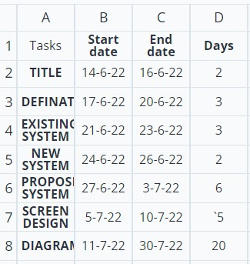
0
5
10
15
20
25
TITLE
DEFINATION
EXISTING SYSTEM
NEW SYSTEM
PROPOSE SYSTEM
SCREEN DESIGN
DATA DIAGRAM
Days
  - Proposed System Module : -
- Admin.
- User.
- Admin :• Login
  - Add Papers and Material
  - Add Mock test question
  - Manage Users
  - Manage Papers and Material
  - View Feedback
- User :• Registration/Login
  - Search University
  - Select Stream
  - Download Exam Paper and material
  - Give Mock Test
  - Give Feedback

Registration
Enter OTP
Send OTP
Username
Mobile Number
E-mail Address
Create Password
Confirm Password
  - Screen Designing 

Sign Up


Username
Password
Login
Login
Forgot Password
Don’t
have
an
account
?
Sign
up
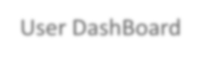
User
DashBoard
Exam Helper
Home
University
Stream
Log
Out
About
us
Home
Paper
Material
Mock
Test
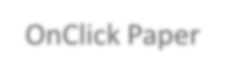
Exam Helper
Home
University
Stream
Log
Out
About
us
Paper
University
List
Search
OnClick
Paper
Gujarat University
College
List
H.L College Of Commerce
Stream
List
B.Com
Download
Paper’s
Download
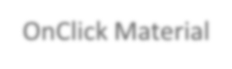
Exam Helper
Home
University
Stream
Log
Out
About
us
Material
University
List
Search
OnClick
Material
Gujarat University
College
List
H.L College Of Commerce
Stream
List
B.Com
Download
Material
Download
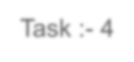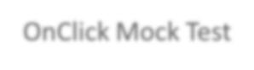
Task :
-
4
Exam Helper
Home
University
Stream
Log
Out
About
us
Mock Test
Search
OnClick
Mock Test
Stream
List
B.Com
Question
List
Give Test
Result
Get Result

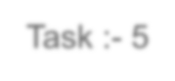
Zero Level DFD
Task :
-
5
Admin
User
Exam Helper
Login
Add paper/material
Reg/login
Paper/Material Request
Approve Reg/login
0
Get Paper/Material
Approve
Paper/material
Login Successfully
User Reg/login
User Paper req
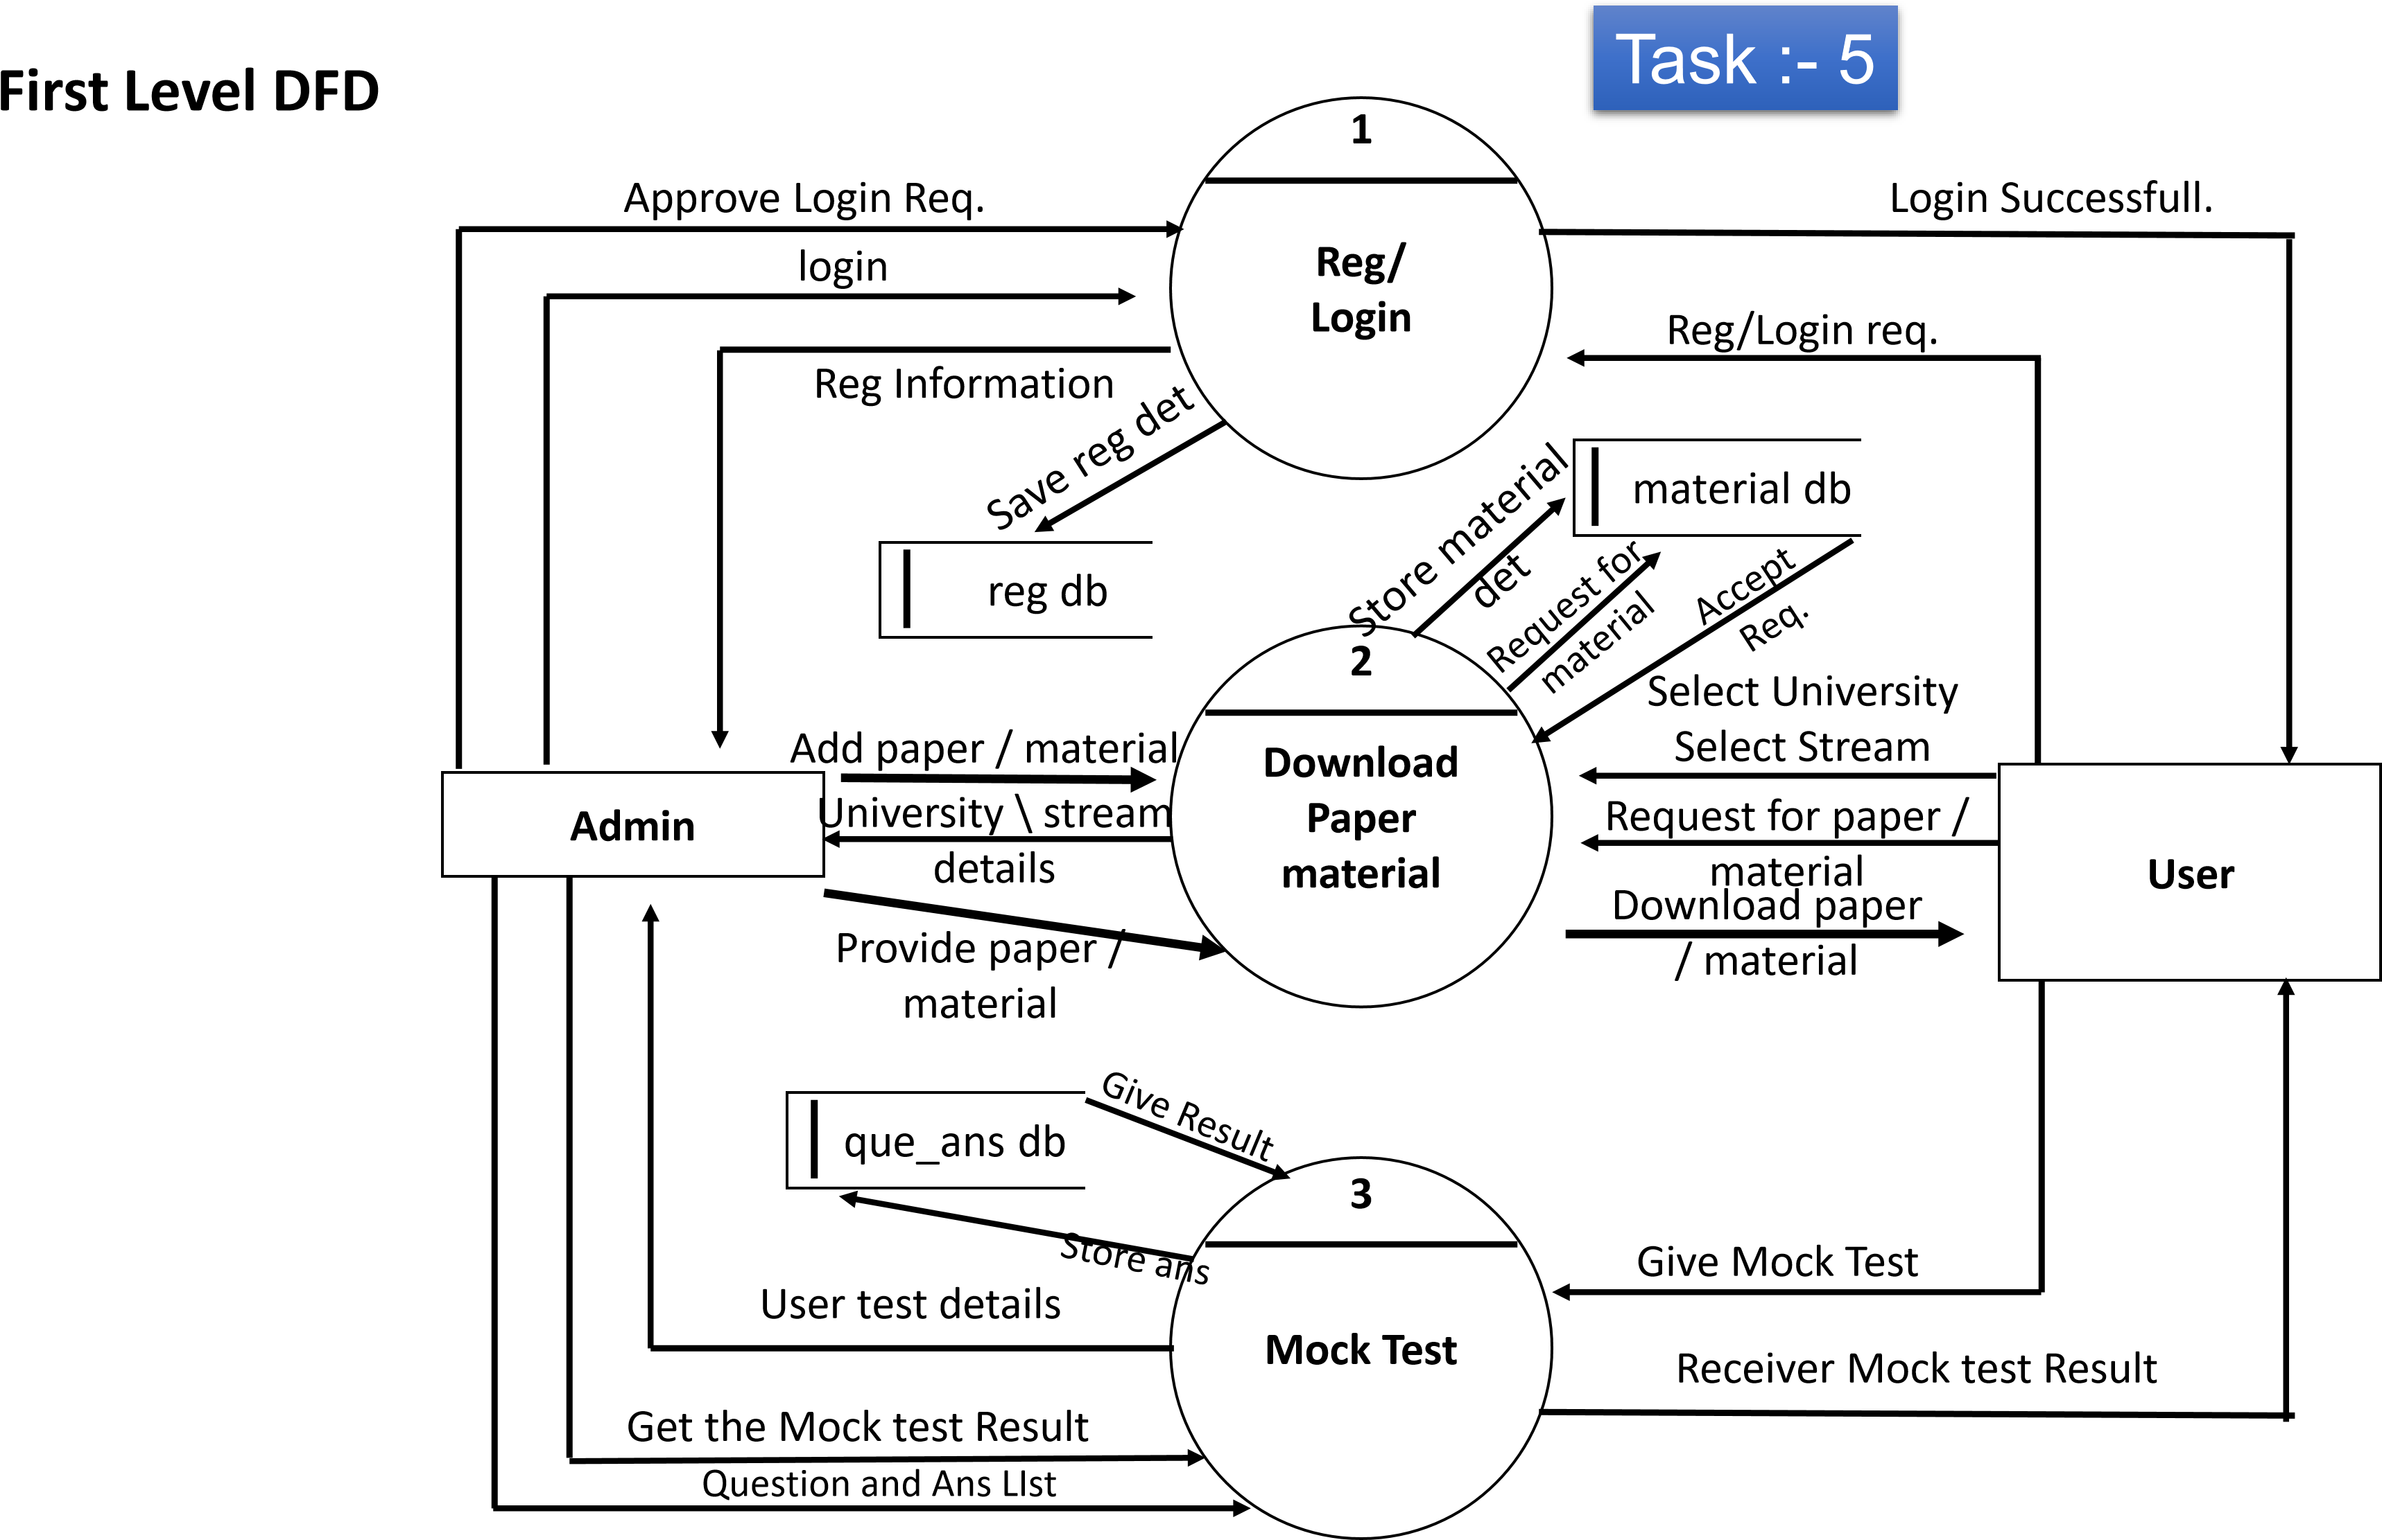



Registrati
on
Login
Forgot/
Password
Second Level DFD
Registration
1.1
1.2
1.3
User
Username /
Password
Reg details
Forgot Password
Enter new Password
reg db
Save reg det
Admin
Forgot Password
Enter new Password
Updated Password
Task :
-
5
Username /
Password
Updated
Password
Reg approve
Password Changed
successfully
Login Done



Download
paper
Download
Material
Cancel
2.1
2.2
2.3
User
Select university & college
Select stream
Select
university,college
Select stream
Download
material
Admin
Add Material
Cancel download
Task :
-
5
Second Level DFD
Download material
Download Paper
Add Paper
Cancel info
Download info
Download info
material db

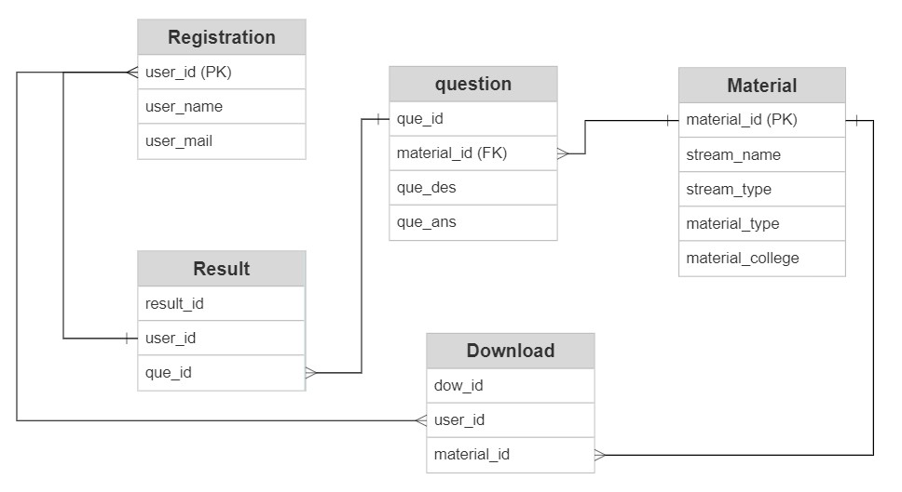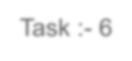
ER Diagram
Task :
-
6
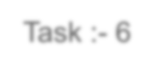
Data Dictionary
Task :
-
6
 |  |  | Registration Table
No | Field Name | Data type | Field Length | Constraint | Description | Example
1 | user_id | Integer | 10 | Primary Key | User’s Special id | 1001
2 | User_name | Varchar | Max | Not null | User’s name | Divy
3 | User_mail | Varchar | Max | Not null | Customer’s mail | rajan760li@gmail.com
4 | User_mobile | Varchar | Max | Not null | Customer’s Password | Rajan123#@
5 | User_password | Integer | 10 | Not null | Customer’s Phone no. | 9879924100
6 | Datetime | Date | Max | Not null | Registration Date | 10/09/2022

 |  |  |  | Material Table
No | Field Name | Data type | Field Length | Constraint | Description | Example
1 | Material_id | Integer | 10 | Primary Key | Material’s Special id | 001
2 | Stream_name | Varchar | Max | Not null | Stream name | BCA
3 | Stream_year | Varchar | Max | Not null | Stream Year | BCA 1 year
4 | Material_type | Varchar | Max | Not null | Material Type | PDF/Doc
5 | Material_college | Integer | 10 | Not null | Material Provided By college | B.P College of  Computer Studies.

Question Table
No | Field Name | Data type | Field Length | Constraint | Description | Example
1 | qus_id | Integer | 10 | Primary Key | Qus’s Special id | 1
2 | Material_id | Integer | 10 | Foreign Key | Material Special id | 001
4 | que_desc. | Varchar | Max | Not null | Question Desc. | Full Form of MVC
5 | Choice1 | Varchar | Max | Not null | Option 1 | Model Controller
6 | Choice2 | Varchar | Max | Not null | Option 2 | Model View Control
7 | Choice3 | Varchar | Max | Not null | Option 3 | Model Controller
8 | Choice4 | Varchar | Max | Not null | Option 4 | Model View
5 | que_ans | Integer | 10 | Not null | Question Answer | Model View Controller

 |  |  |  | Result Table
No | Field Name | Data type | Field Length | Constraint | Description | Example
1 | result_id | Integer | 10 | Primary Key | Result Special id | 100
2 | user_id | Integer | 10 | Foreign Key | User’s Special id | 1001
3 | que_id | Integer | 10 | Foreign Key | Material id | 001
4 | Datetime | Date | Max | Not null | Registration Date | 10/09/2022

 |  |  | Download Table
No | Field Name | Data type | Field Length | Constraint | Description | Example
1 | dow_id | Integer | 10 | Primary Key | Download’s Special id | 1
2 | user_id | Integer | 10 | Foreign Key | User’s Special id | 1001
3 | Material_id | Integer | 10 | Foreign Key | Material id | 001
4 | Datetime | Date | Max | Not null | Registration Date | 10/09/2022

 |  |  |  | Admin Table
No | Field Name | Data type | Field Length | Constraint | Description |  | Example
1 | Admin_id | Integer | 10 | Primary Key | Admin’s Special id | 1
2 | user_id | Integer | 10 | Foreign Key | User’s Special id | 1001
3 | Material_id | Integer | 10 | Foreign Key | Material id | 001
4 | que_id | Integer | 10 | Foreign Key | Material id | 001
5 | result_id | Integer | 10 | Primary Key | Result Special id | 100
6 | dow_id | Integer | 10 | Primary Key | Download’s Special id | 1

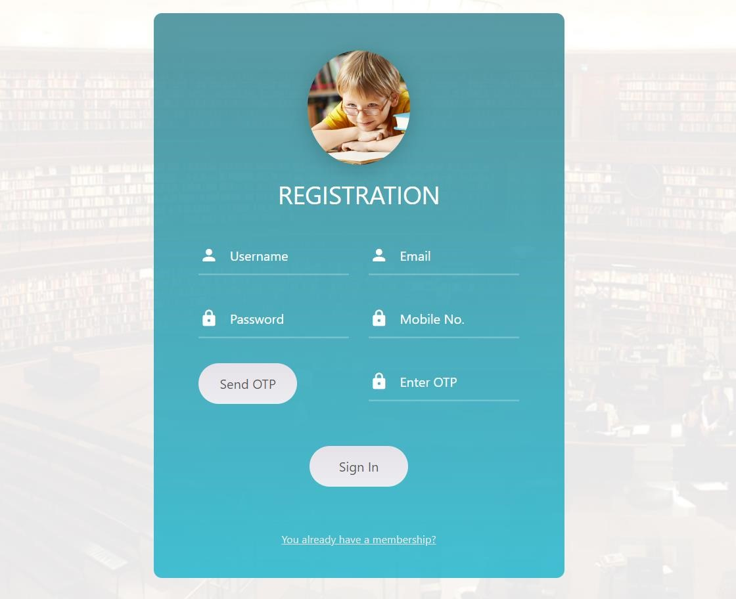
Task :
-
7
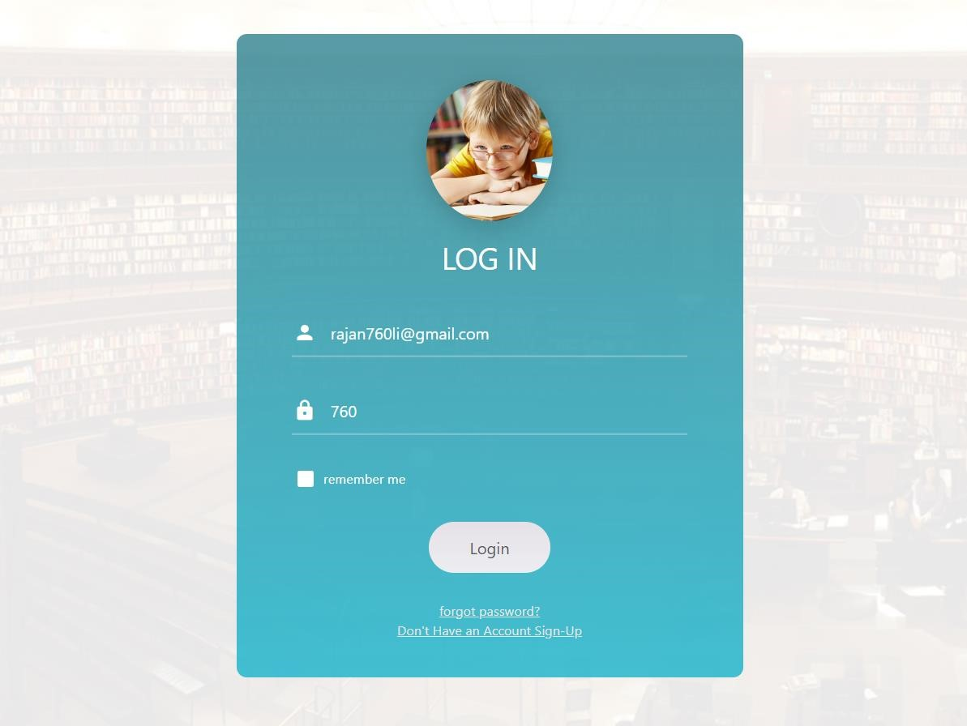
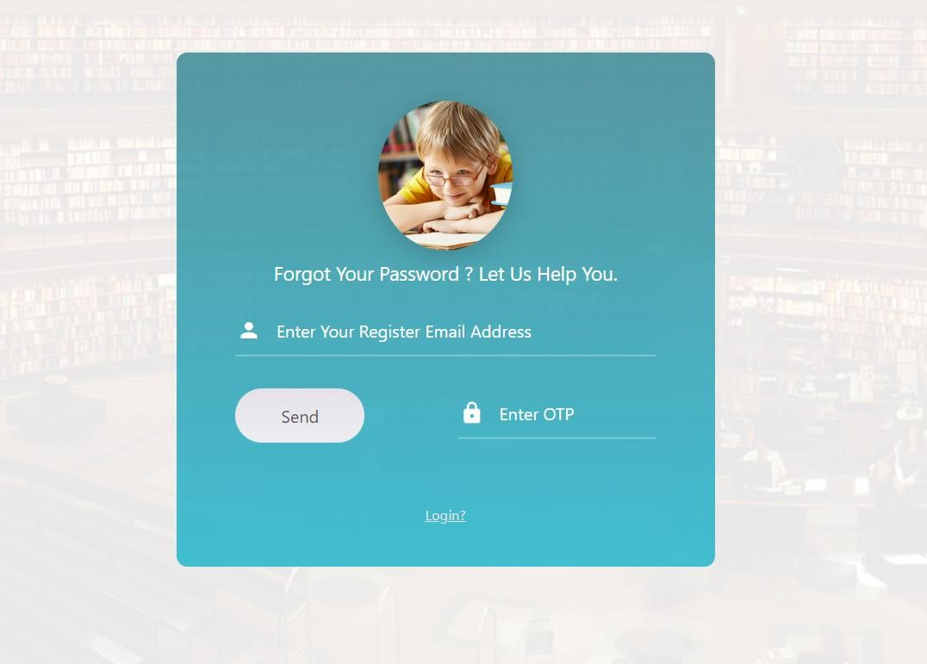



<%@ Page Language="C#" AutoEventWireup="true" CodeFile="registration_page.aspx.cs" Inherits="registration_page" %> Registration Aspx
<!DOCTYPE html>
<html xmlns="http://www.w3.org/1999/xhtml">
<head runat="server">
<meta charset="utf-8" />
<meta http-equiv="X-UA-Compatible" content="IE=edge" />
<meta content="width=device-width, initial-scale=1" name="viewport" />
<meta name="description" content="Responsive Admin Template" />
<meta name="author" content="SmartUniversity" />
<!-- google font -->
<link href="https://fonts.googleapis.com/css?family=Poppins:300,400,500,600,700" rel="stylesheet" type="text/css" /> <!-- icons -->
<link href="fonts/font-awesome/css/font-awesome.min.css" rel="stylesheet" type="text/css" />
<link rel="stylesheet" href="assets/plugins/iconic/css/material-design-iconic-font.min.css" /> <!-- bootstrap -->
<link href="assets/plugins/bootstrap/css/bootstrap.min.css" rel="stylesheet" type="text/css" /> <!-- style -->
<link rel="stylesheet" href="assets/css/pages/extra_pages.css" /> <!-- favicon -->
<%--<link rel="shortcut icon" href="assets/img/favicon.ico" />--%>
<title>Exam Helper</title>
</head>
<body>
<form id="form1" runat="server">
<div>
<div class="limiter">
<div class="container-login100 page-background">
<div class="wrap-login100">
<form class="login100-form validate-form">
<span class="login100-form-logo">
<img alt="" src="../assets/images/examhelper.jpg"/> </span>
<span class="login100-form-title p-b-34 p-t-27">Registration
</span>
<div class="row">
<div class="col-lg-6 p-t-20">
<div class="wrap-input100 validate-input" data-validate="Enter username">
<asp:TextBox runat="server" ID="usernametxt" class="input100" placeholder="Username" /> </div>
</div>
<div class="col-lg-6 p-t-20">
<div class="wrap-input100 validate-input" data-validate="Enter email">
<asp:TextBox runat="server" ID="emailtxt" class="input100" placeholder="Email" />
<%--<input class="input100" type="email" name="email" placeholder="Email">--%>
<span class="focus-input100" data-placeholder="&#xf207;"></span>
</div>
</div>
<div class="col-lg-6 p-t-20">
<div class="wrap-input100 validate-input" data-validate="Enter password">
<asp:TextBox runat="server" ID="passwordtxt" class="input100" placeholder="Password" />
<%--<input class="input100" type="password" name="pass" placeholder="Password">--%>
<span class="focus-input100" data-placeholder="&#xf191;"></span>
</div>
</div>
<div class="col-lg-6 p-t-20">
<div class="wrap-input100 validate-input" data-validate="Enter password again">
<asp:TextBox runat="server" ID="mobiletxt" class="input100" placeholder="Mobile No." />
<div class="col-lg-6 p-t-20">
<div class="wrap-input100 validate-input" data-validate="Enter password again">
<asp:TextBox runat="server" ID="otptxt" class="input100" placeholder="Enter OTP" />
<%--<input class="input100" type="password" name="pass2" placeholder="Confirm password">--%> <span class="focus-input100" data-placeholder="&#xf191;"></span>
</div>
</div>
<div class="container-login100-form-btn mt-4">
<asp:Button Text="Sign In" ID="registrationbtn" OnClick="registrationbtn_Click" class="login100-form-btn" runat="server" />
<%--<button class="login100-form-btn">
</button>--%>
</div>
<div class="text-center p-t-50">
<a class="txt1" href="login_page.aspx">You already have a membership? </a>
</div> </div>
<script src="assets/plugins/jquery/jquery.min.js"></script> <!-- bootstrap -->
<script src="assets/plugins/bootstrap/js/bootstrap.min.js"></script>
<script src="assets/js/pages/extra_pages/login.js"></script>
<!-- end js include path -->
</div>
</form>
</body>
</html>

