FYP Streaming Prototype: Initial Local Evaluation
Measured synthetic-media experiments. This report evaluates the research prototype, not a completed conferencing application.

Environment and method
processor: Intel(R) Core(TM) 7 150U
logicalProcessors: 12
memoryGiB: 15.72
os: Microsoft Windows 11 Home
Linux SFU: Node v22.23.4, mediasoup 3.31.0, x64, kernel 6.18.40.1-microsoft-standard-WSL2. Exact image ID and server-source checksum are in linux-environment.json.
Browser participants and the mediasoup SFU share one physical Windows laptop. The SFU platform is recorded per run. Each participant publishes animated 640 x 360 synthetic video and a quiet 440 Hz tone. Browser sessions are isolated. Telemetry is sampled about once per second. Runs include join setup and functional checks before a timed observation period; the tables use all saved samples, including startup. These short trials provide functional evidence and preliminary telemetry, not statistically validated capacity or codec-quality conclusions.

Results
Source clocks distinguish animation-frame, timer and video-frame-timer implementations. Larger accelerated headless runs stalled under more than one source implementation. A separately labelled software-video configuration passed the six-browser check. Browser arguments in the manifests identify the actual settings. Failure outcomes must be read alongside the metrics; low bitrate from a frozen source is not an efficiency improvement. Use matched software-video runs for preliminary comparisons; the trials do not establish a GPU root cause or separate-device capacity.
Mode | Peers | Outcome | Upload kb/s | Video FPS | SFU CPU % | Node RSS MiB
h264 | 2 | PASS | 169.43 | 29.76 | 0.70 | 33.34
h264 | 4 | PASS | 171.18 | 30.13 | 1.96 | 33.36
h264 | 6 | PASS | 172.29 | 29.14 | 12.49 | 30.08
h264 | 8 | PASS | 163.48 | 27.76 | 18.53 | 32.37
simulcast | 2 | PASS | 263.97 | 29.04 | 1.61 | 33.45
vp9 | 2 | PASS | 412.68 | 29.75 | 0.96 | 32.33
Upload is the average of per-peer means from outbound RTP payload counter differences; headers and network overhead are excluded. FPS averages per-peer inbound video means. SFU CPU is worker utilization as a percentage of one core. CPU/RSS use peer 0 server telemetry so the server is not counted once per endpoint; Node RSS excludes the separate worker process. Full per-peer values and setup timings are in the CSV. Per-peer results from a shared laptop are correlated. ICE RTT is not end-to-end audio delay.

Functional checks and run outcomes
2026-10-23T20-50-58-014Z-h264-6p-windows-software-video: PASS; 30 s observation; msedge 155.0.4283.62; source b399551a634f7ed1102f2563ebf7fea1dfd73fce
2026-10-23T20-52-07-926Z-h264-8p-windows-software-video: PASS; 30 s observation; msedge 155.0.4283.62; source b399551a634f7ed1102f2563ebf7fea1dfd73fce
2026-10-23T20-53-08-456Z-h264-2p-windows-software-video: PASS; 30 s observation; msedge 155.0.4283.62; source b399551a634f7ed1102f2563ebf7fea1dfd73fce
2026-10-23T20-53-42-678Z-h264-4p-windows-software-video: PASS; 30 s observation; msedge 155.0.4283.62; source b399551a634f7ed1102f2563ebf7fea1dfd73fce
2026-10-23T20-54-20-652Z-simulcast-2p-windows-software-video: PASS; 30 s observation; msedge 155.0.4283.62; source b399551a634f7ed1102f2563ebf7fea1dfd73fce
2026-10-23T20-54-55-023Z-vp9-2p-windows-software-video: PASS; 30 s observation; msedge 155.0.4283.62; source b399551a634f7ed1102f2563ebf7fea1dfd73fce
The automated checks cover expected remote track counts, microphone producer pause/resume, video producer pause/resume, delivery of a chat message to a second peer, continued decoded video/audio packet progress on every peer during observation, and remote-track cleanup after leaving. They do not establish perceptual audio quality or continuous frame delivery at a specified FPS.
Earlier failed accelerated runs and all available per-peer measurements remain in the CSV and evidence archive. The report tables focus on the matched software-video configuration rather than pooling incompatible conditions.

Controlled Linux media-network experiments
The SFU runs in a dedicated Docker Linux container on the same physical laptop as two synthetic Edge endpoints. Network shaping applies only to outgoing SFU media, shared across receivers; signaling is excluded. It is not a per-sender uplink experiment. Delay is applied in one direction. Configurations, actual rate-change timestamps and kernel queue/drop counters are saved under artifacts/network. One exploratory run per profile, no fixed random seed and no confidence interval. A functional pass is not a conversational-quality acceptance result.
Profile | Exit code | RTT p95 max ms | Mean video FPS | Kernel drops
egress-1500kbit | 0 | 8.95 | 29.63 | 0
egress-250kbit | 0 | 6936.00 | 13.32 | 232
egress-500kbit | 0 | 695.55 | 29.55 | 0
egress-750kbit | 0 | 19.00 | 30.37 | 0
egress-delay-100ms | 0 | 105.00 | 30.06 | 0
egress-delay-200ms | 0 | 216.00 | 30.36 | 0
egress-delay-400ms | 0 | 405.00 | 30.22 | 0
egress-jitter-10ms | 0 | 122.00 | 30.29 | 0
egress-jitter-30ms | 0 | 171.00 | 30.43 | 0
egress-jitter-60ms | 0 | 218.70 | 30.25 | 0
egress-loss-10pct | 0 | 5.00 | 29.70 | 631
egress-loss-1pct | 0 | 6.00 | 29.82 | 56
egress-loss-3pct | 0 | 5.00 | 29.79 | 178
egress-loss-5pct | 0 | 7.40 | 29.62 | 318
egress-step-2000-500-2000kbit | 0 | 1354.40 | 30.14 | 0
linux-clean | 0 | 7.00 | 29.58 | N/A
RTT values are the maximum of per-peer p95 values, not pooled p95. Kernel drops include emulation/queue drops and do not equal unrepaired RTP loss. Concealment, NACK and freeze counters are retained in the CSV; no subjective quality score or proof of repair before playback deadlines is inferred.
At the shared 250 kb/s cap, mean received video was 13.32 FPS and the maximum peer ICE RTT p95 was 6936.00 ms. The media-progress check passed while queue delay and media diagnostics deteriorated. This is not evidence of acceptable conversational quality or a measured mouth-to-ear result.

Measured figures and screenshots
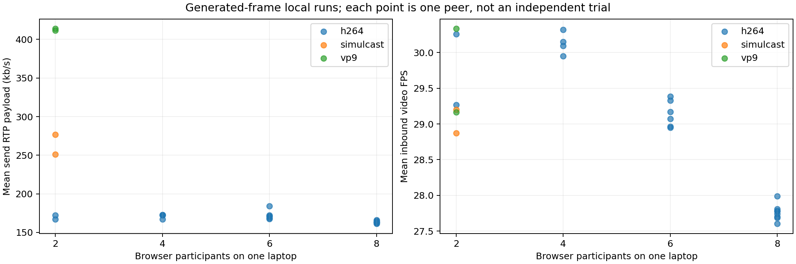
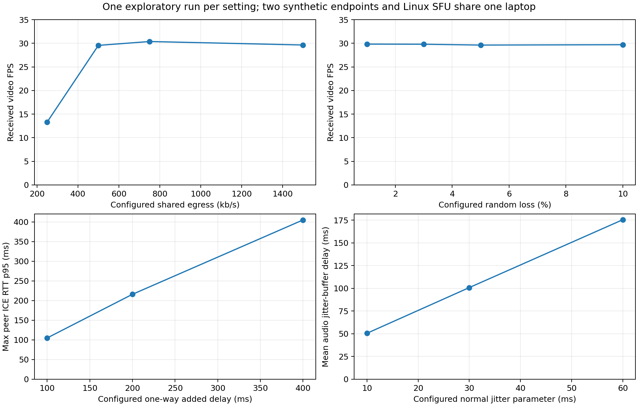
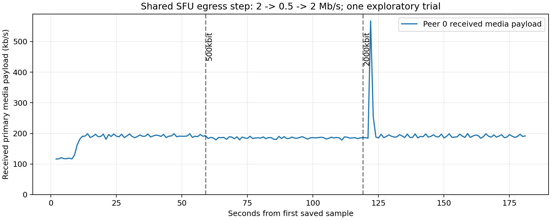
2026-10-23T20-50-58-014Z-h264-6p-windows-software-video
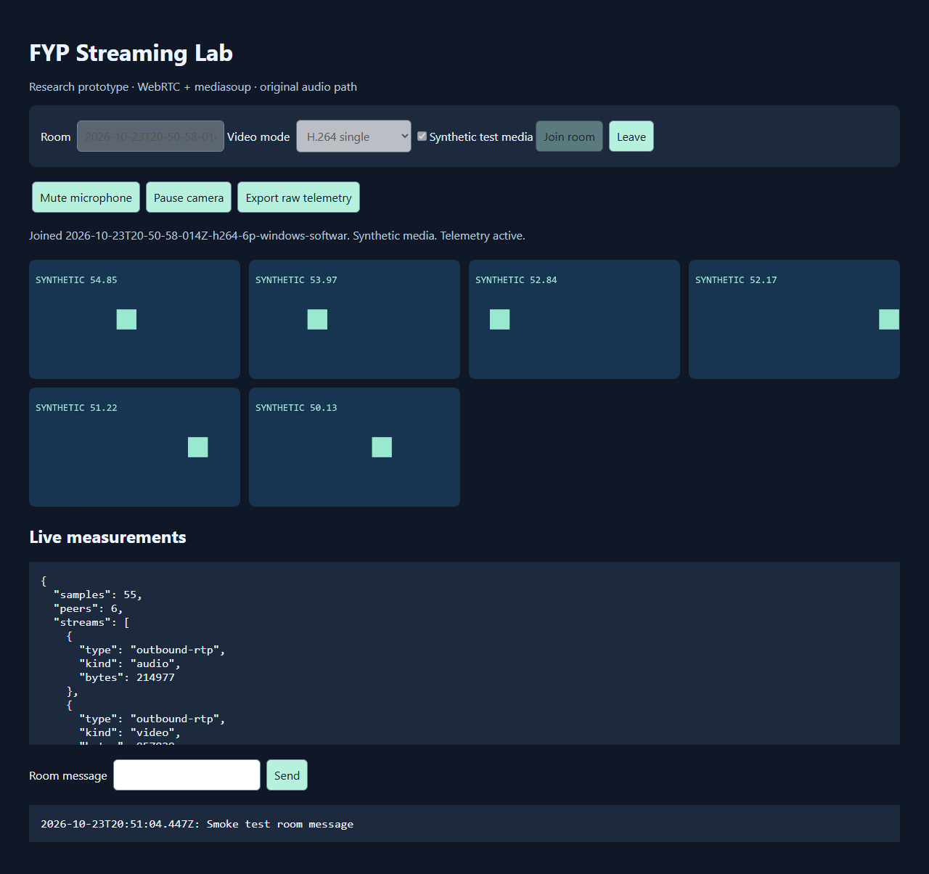
2026-10-23T20-52-07-926Z-h264-8p-windows-software-video
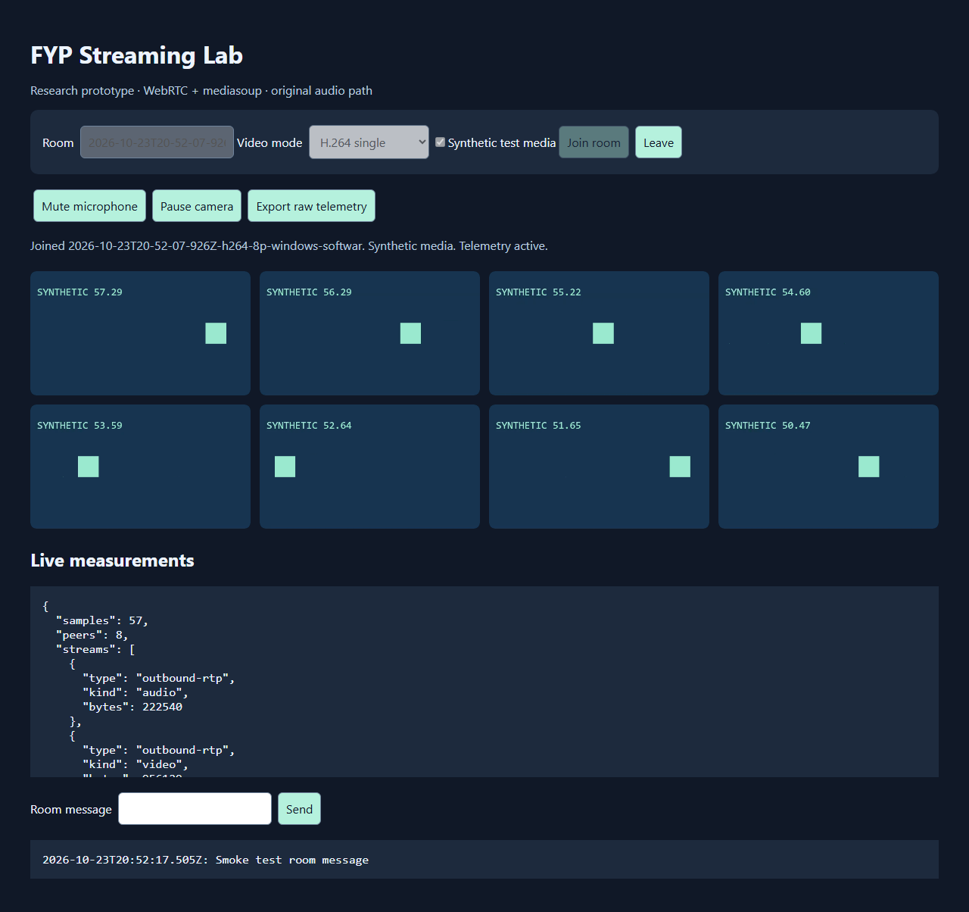
2026-10-23T20-53-08-456Z-h264-2p-windows-software-video
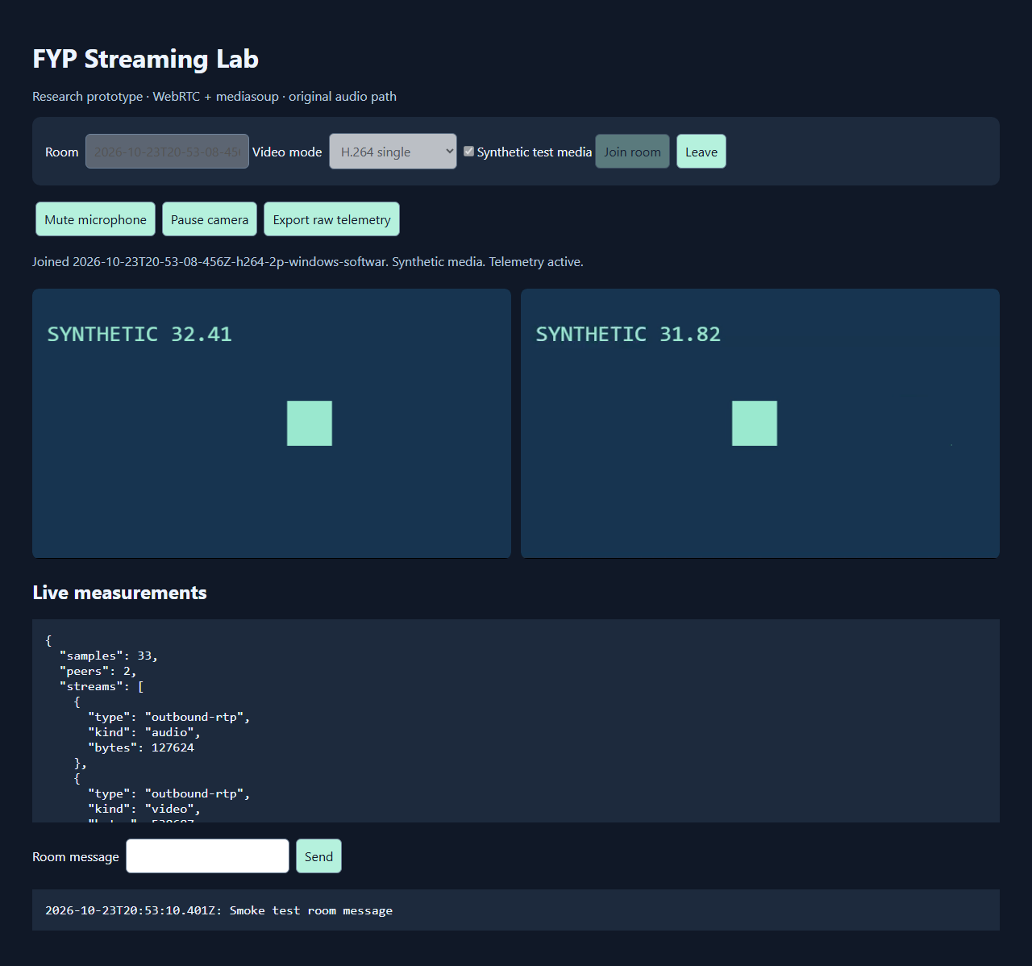
2026-10-23T20-53-42-678Z-h264-4p-windows-software-video
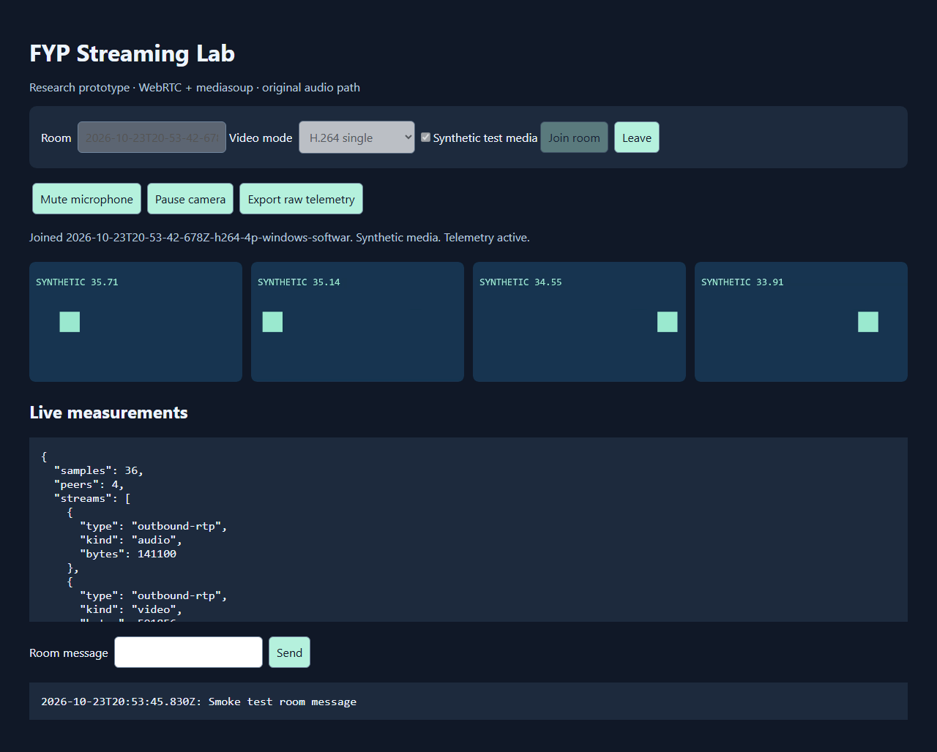
2026-10-23T20-54-20-652Z-simulcast-2p-windows-software-video
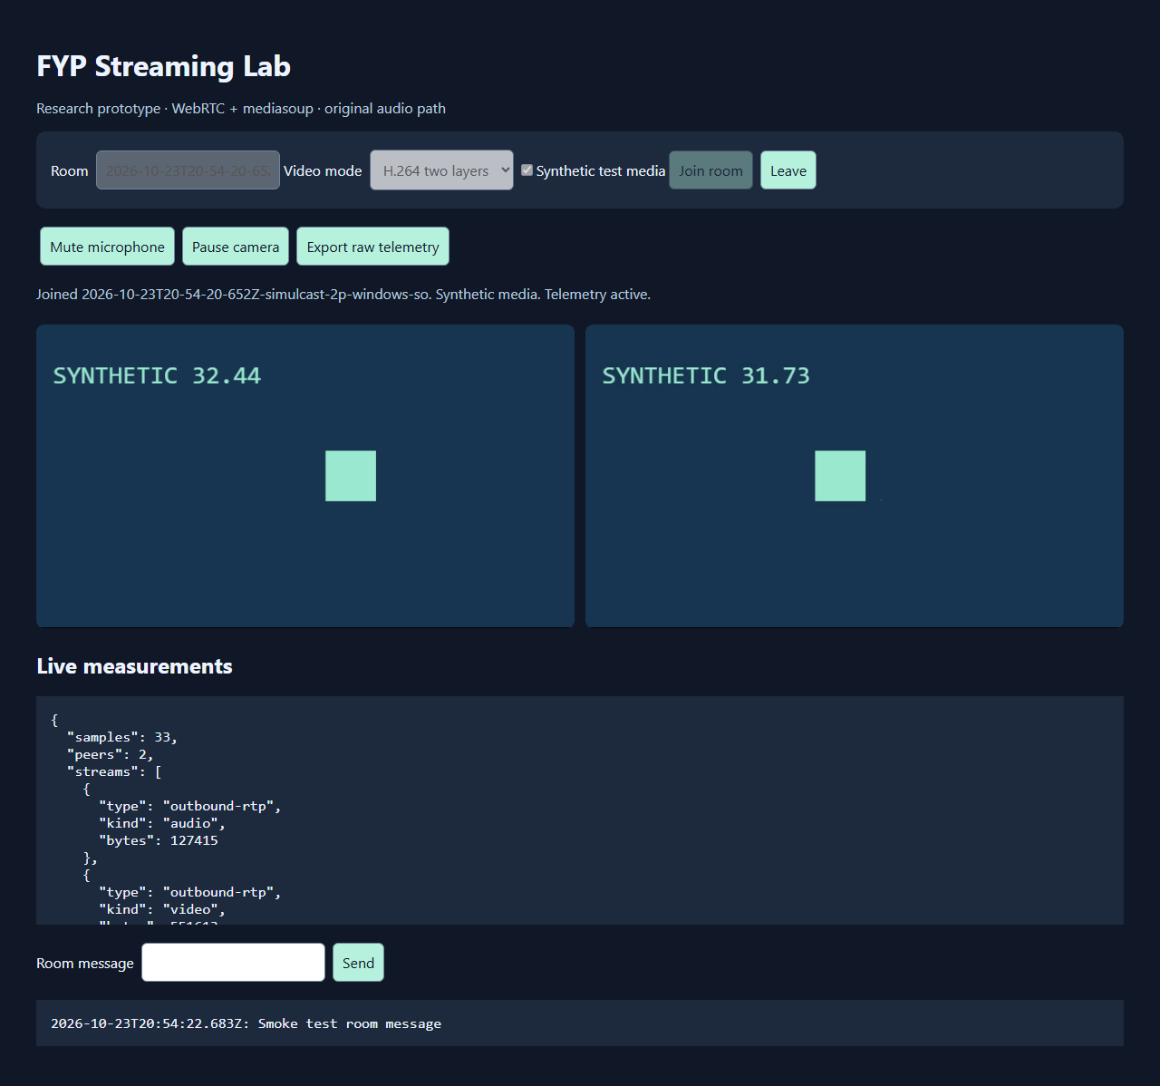
2026-10-23T20-54-55-023Z-vp9-2p-windows-software-video
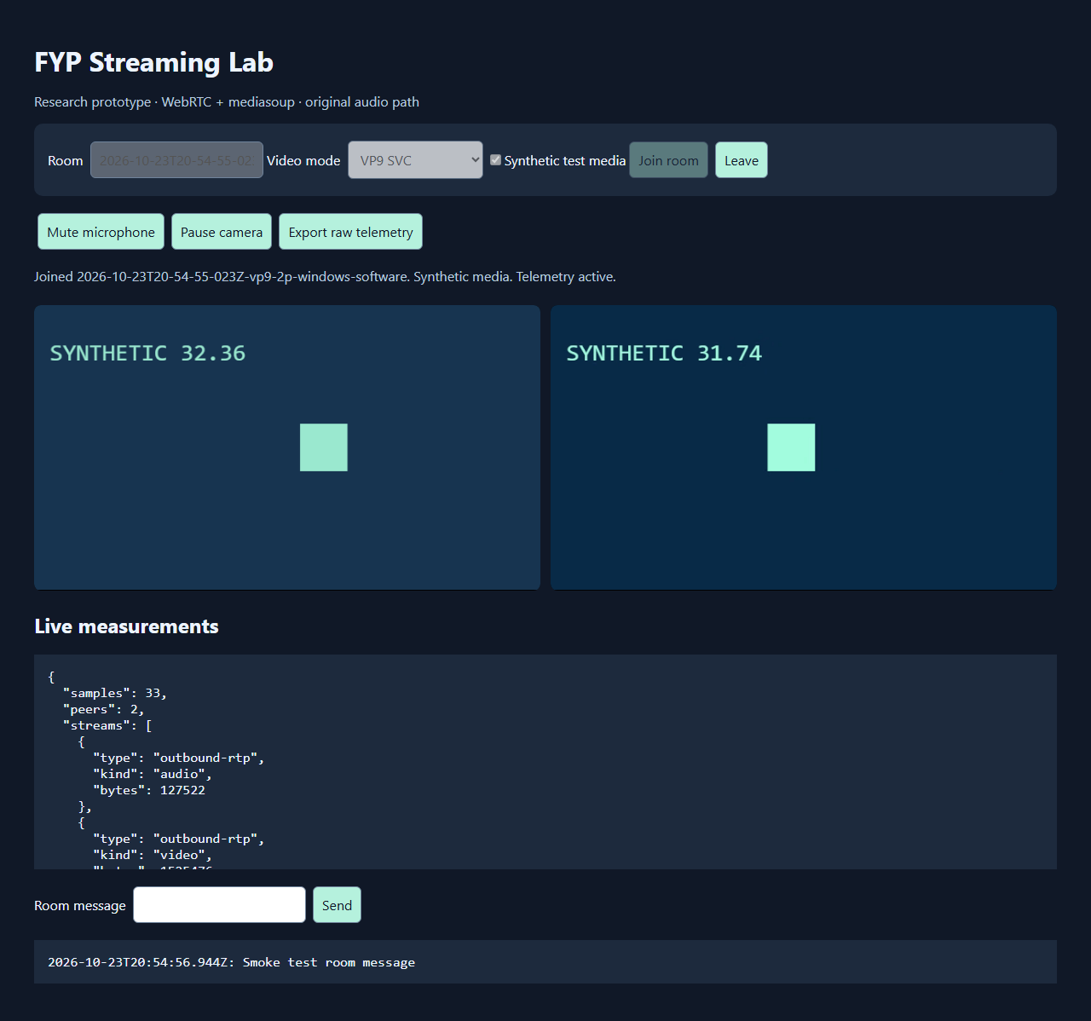
2026-10-23T21-04-26-535Z-h264-2p-egress-250kbit
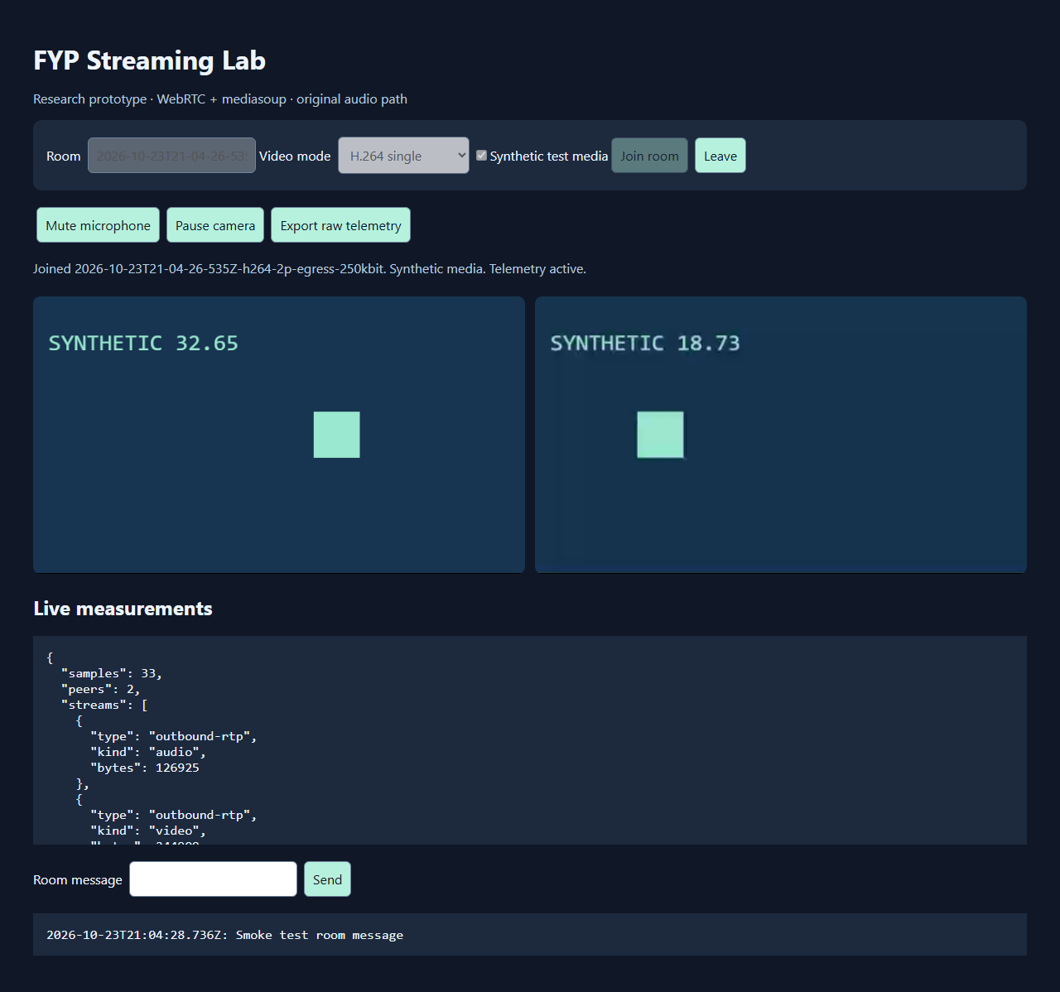
2026-10-23T21-08-46-645Z-h264-2p-egress-loss-10pct
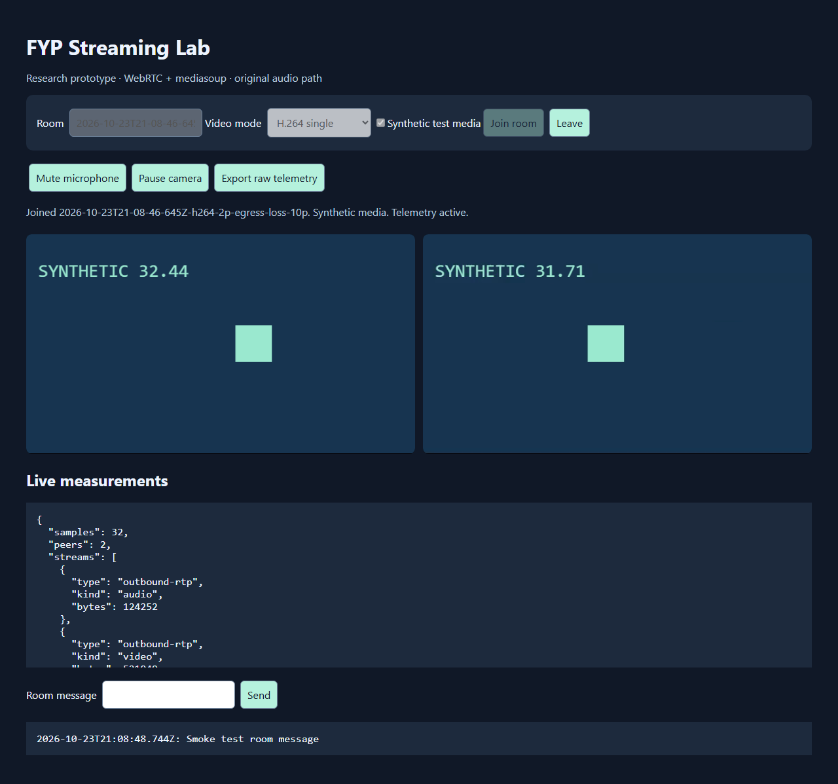
2026-10-23T21-12-29-370Z-h264-2p-egress-delay-400ms
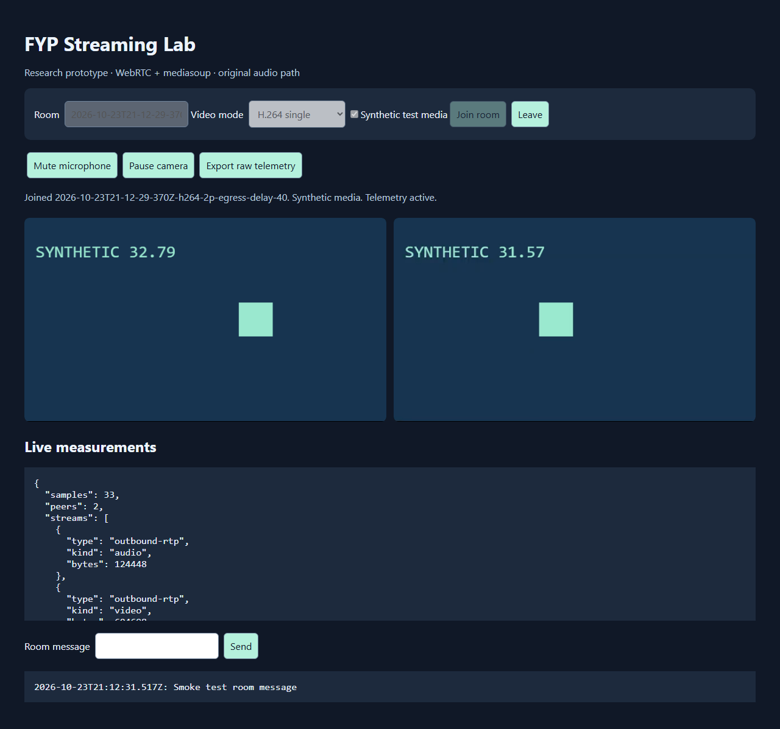
2026-10-23T21-13-06-388Z-h264-2p-egress-step-2000-500-2000kbit
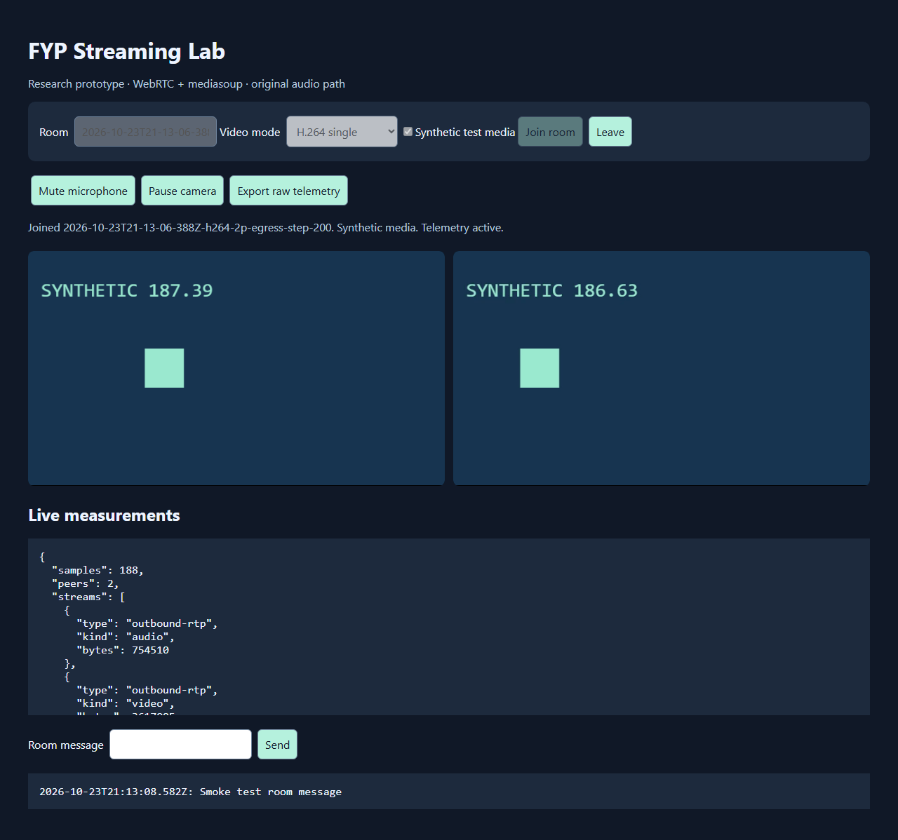

Limitations and pending experiments
- No real microphone, speaker, camera, acoustic echo or mouth-to-ear test has been performed. The original-audio target below 200 ms remains unverified.
- Shared-SFU egress impairment trials are preliminary; per-sender uplink, real WAN, NAT and TURN behavior remain unverified.
- Multiple browser sessions on one laptop do not establish eight-device meeting capacity or cross-browser compatibility.
- No aligned reference/received video recording, VMAF, PSNR, SSIM or human MOS was measured. Synthetic-canvas bitrate cannot establish codec superiority.
- Screen sharing, host permissions, whiteboard, recorder and AI branches are not implemented in this prototype and are not tested.
- The experiment matrix retains pending work. Further measurements require repeated trials, controlled media, actual network shaping and separate endpoint devices.

Evidence and reproduction
See README.md for startup commands, scripts/smoke.mjs for the automated procedure, scripts/report.py for calculations, artifacts/results.csv for numeric data, and artifacts/screenshots for visual evidence. Raw telemetry and detailed manifests are retained locally under artifacts/raw and excluded from the public repository pending review of connection metadata.

