Lab 9: Profiling in Python
Omar Khalil | GitHub: omk166 | Solo submission
Repository: https://github.com/omk166/lab9_Omar_Khalil

Environment and method
3.13.7 (tags/v3.13.7:bcee1c3, Aug 14 2025, 14:15:11) [MSC v.1944 64 bit (AMD64)]
Windows-11-10.0.22631-SP0
The original workload uses 10,000, 100, and 10,000,000 iterations, respectively. All profiling runs use the full workload. Raw command outputs are in reports/. The screenshots below capture actual Windows console windows after rerunning each command, with the required project identifier. Longer output is displayed in pages inside the console so every line remains readable in the screenshots. Package versions are recorded in requirements.txt. Timing comparisons use perf_counter/timeit without instrumentation: medians of five repeats, with repeated calls for very short functions.

Changes and correctness
The handout contains duplicated fragments and damaged indentation, which were repaired. The original implementation is preserved in profiler.py. Optimized code uses n(n-1)(2n-1)/6 for the sum of squares over range(n), replacing each loop. fast_function is replaced by optimized_fast_function in every optimized runner and test. The two-second sleep is removed because it does not change the returned sum. If a real application requires a delay, removing it would not preserve that timing contract. All three exact results are tested, and the formula is independently checked against a loop for six sizes.

Uninstrumented performance comparison
Function | Before (s/call) | After (s/call) | Speedup
slow_function | 2.0019036 | 1.40366e-07 | 14262026.40x
fast_function | 4.521837e-06 | 1.0768e-07 | 41.99x
memory_intensive_function | 0.5814529 | 1.57128e-07 | 3700504.69x
Speedups are specific to this machine. Each original sum takes O(n) arithmetic operations; the formulas use O(1) arithmetic operations for these fixed inputs. Both approaches retain only a few integers. Python integer size grows with n, so constant operation counts do not imply constant bit complexity for arbitrarily large integers.

cProfile analysis
The original report identifies time.sleep as the largest time consumer, followed by memory_intensive_function. The fast function is too brief for the printed millisecond precision to resolve well. The optimized profile removes the sleep and long loops. Very short optimized calls may print as 0.000 seconds; this is rounding, not zero execution time. Use the uninstrumented table above for their comparison.

Line profiler analysis
Before optimization, the sleep line dominates slow_function, while repeated loop control and total += i ** 2 dominate the ten-million-iteration function. After optimization there are no per-element loop lines: each wrapper calls the formula once. Line tracing overhead is substantial, especially for millions of hits, so its total duration should not be interpreted as normal application runtime.

Memory analysis
Before: largest reported line RSS = 24.7 MiB.
After: largest reported line RSS = 23.9 MiB.
Despite its name, memory_intensive_function does not build a large list: range is lazy and the function keeps a running integer total. Both versions therefore have low auxiliary storage, and RSS can remain flat or fluctuate because of allocator and process activity. Removing the loop reduces temporary integer allocations, but a lower RSS is not guaranteed. Before/after process baselines also include profiler and interpreter overhead. The handout assertion requiring final RSS to increase was replaced with exact result checks and positive RSS measurements; otherwise a correct implementation could fail unpredictably.
Large negative values can appear in the Increment column on repeatedly executed loop lines. These are an aggregation artifact: memory_profiler accumulates differences against the previous line's recorded maximum across millions of hits. A small RSS drop can therefore be counted repeatedly. They do not mean the program freed hundreds of gigabytes. Use the Mem usage column for the reported RSS.

Coverage analysis
Before: 19/21 statements covered. Unexecuted lines: [28, 32]. Missing branches: [[31, 32]].
After: 10/12 statements covered. Unexecuted lines: [23, 27]. Missing branches: [[26, 27]].
The unit tests call computational functions directly. The main orchestration and script-entry paths are exercised by the profiler commands but are outside these unit-test coverage runs; their uncovered lines are therefore expected. Branch coverage is enabled. The complete standalone HTML report directories are included, not just index.html, because the index depends on accompanying assets and per-file pages.
The optimized percentage can be lower despite equivalent tested results: the formula removes many covered loop statements while the same two orchestration and entry-point statements remain uncovered. Percentages alone do not establish test quality.

Before optimization: evidence

cProfile
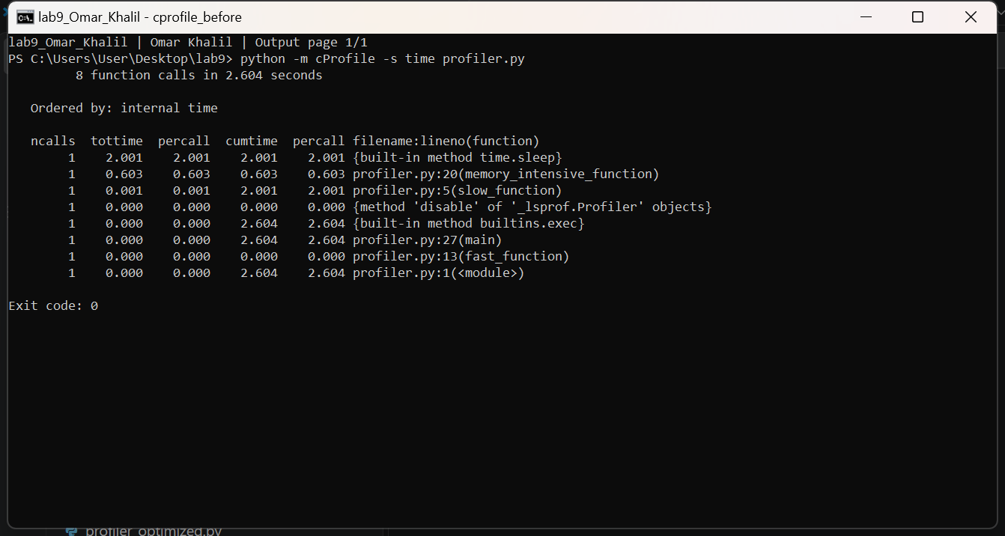

line_profiler
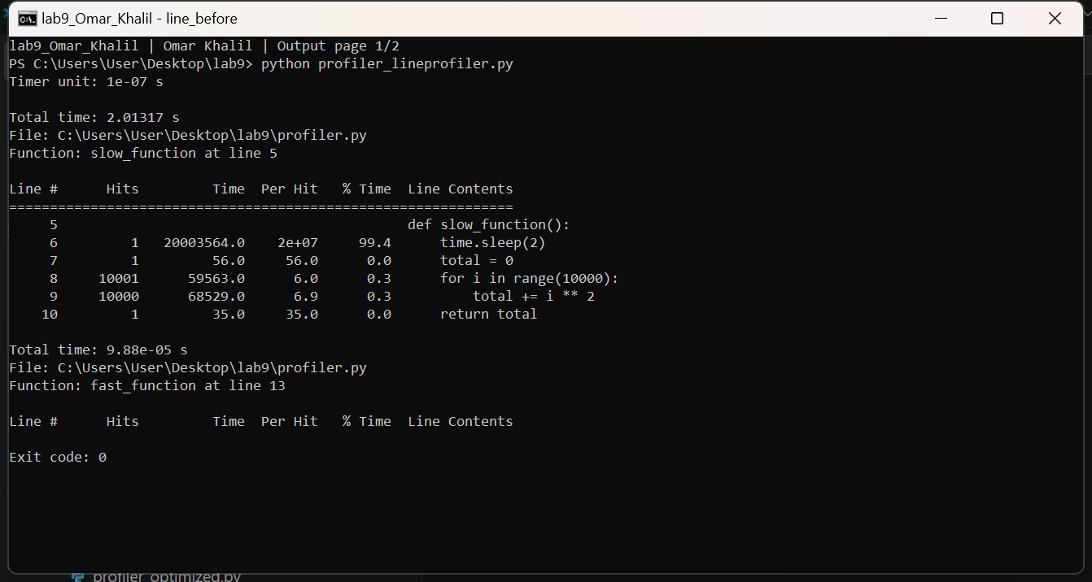
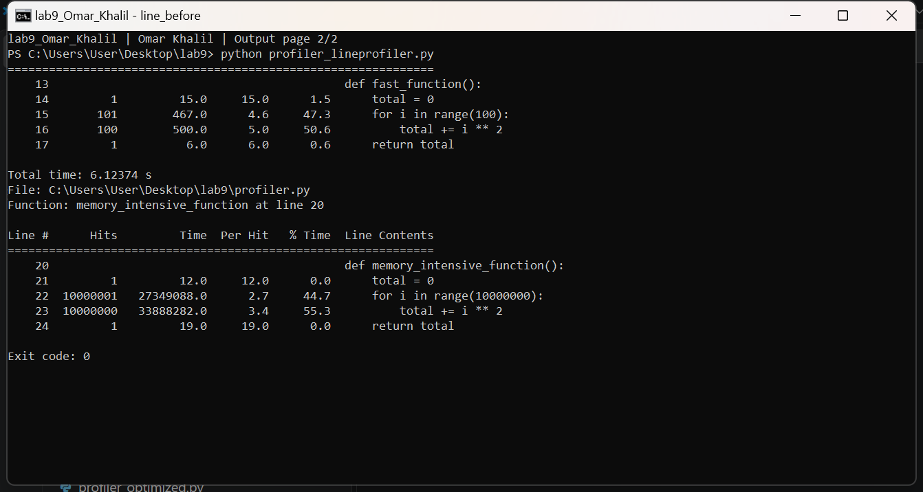

memory_profiler
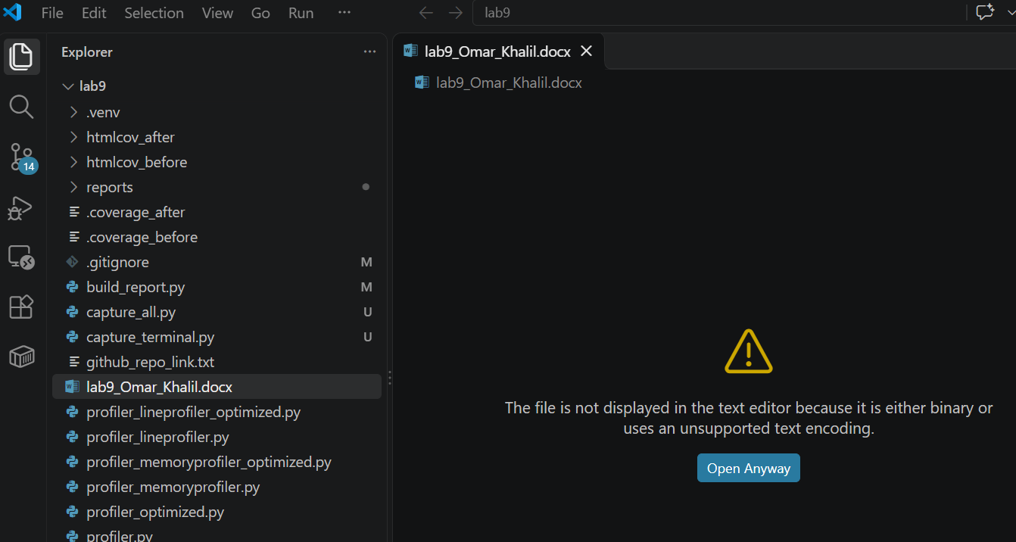
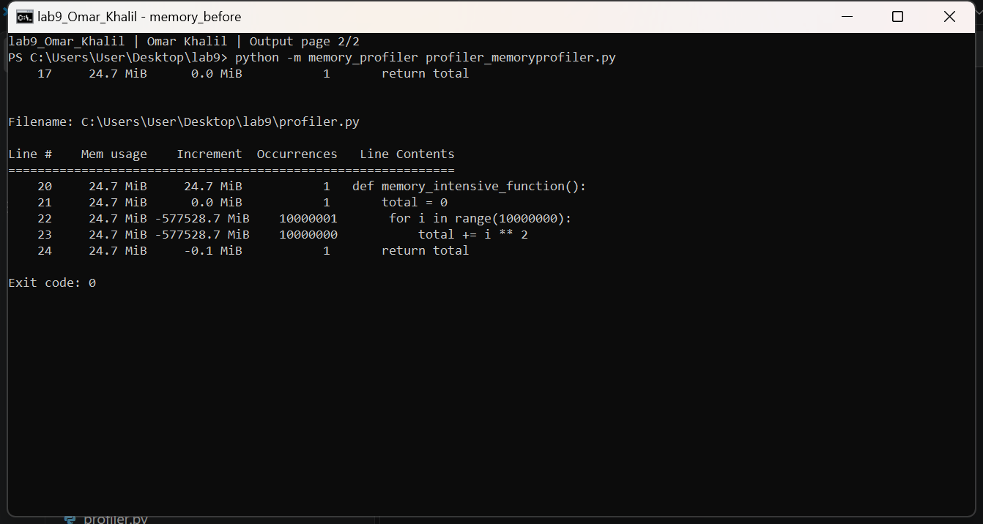

Unit tests
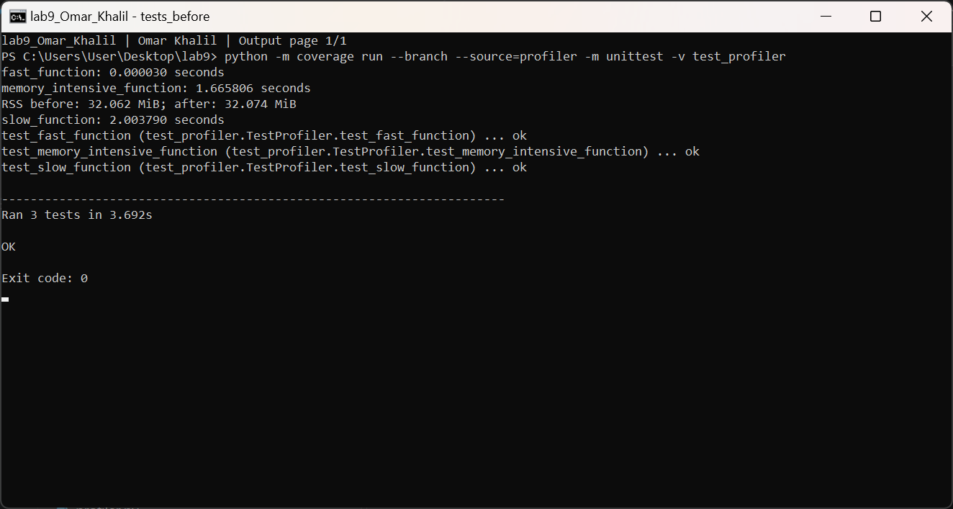

Coverage
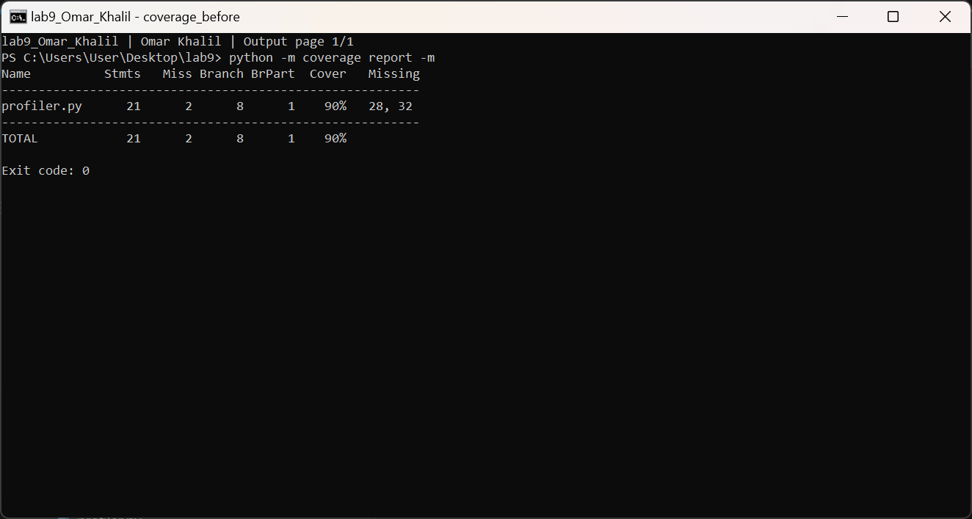

After optimization: evidence

cProfile
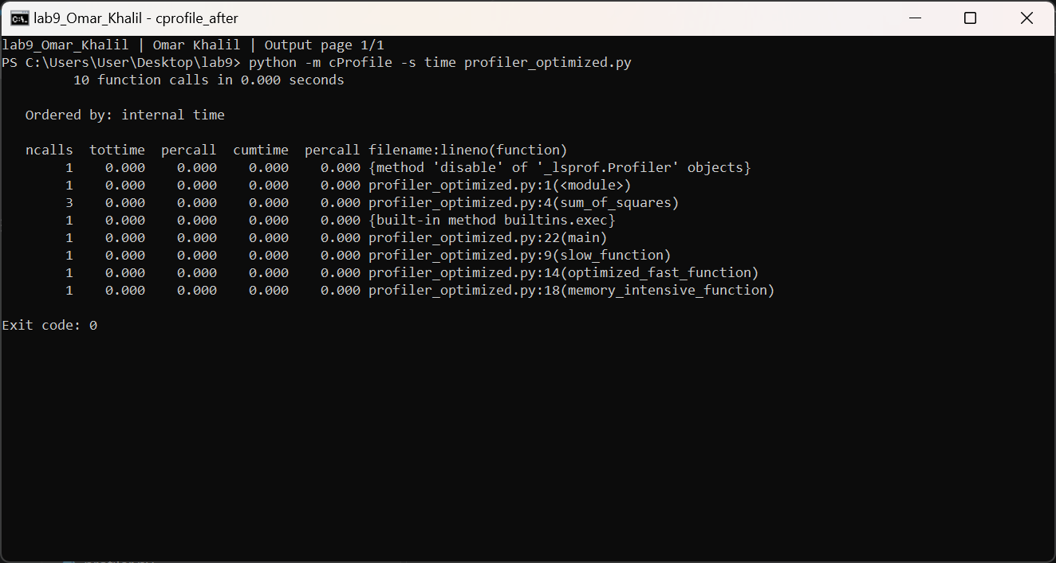

line_profiler
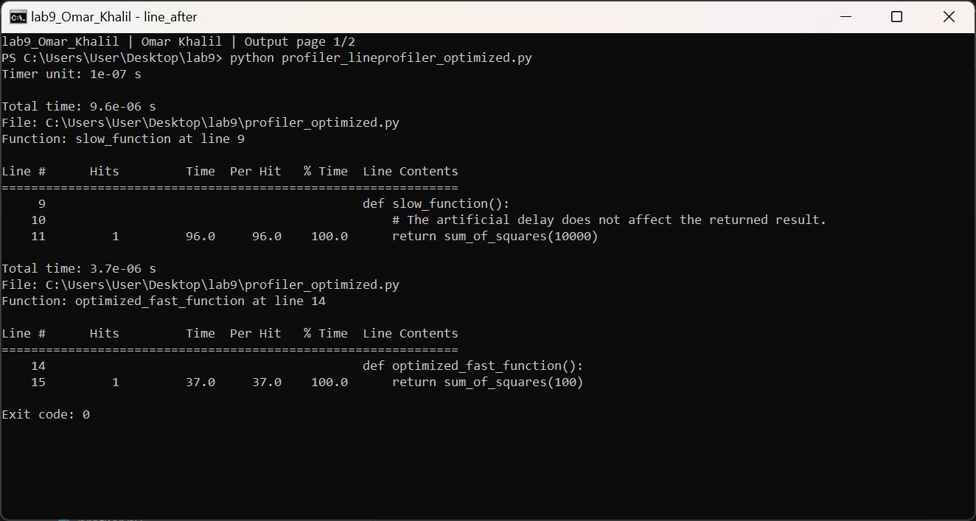
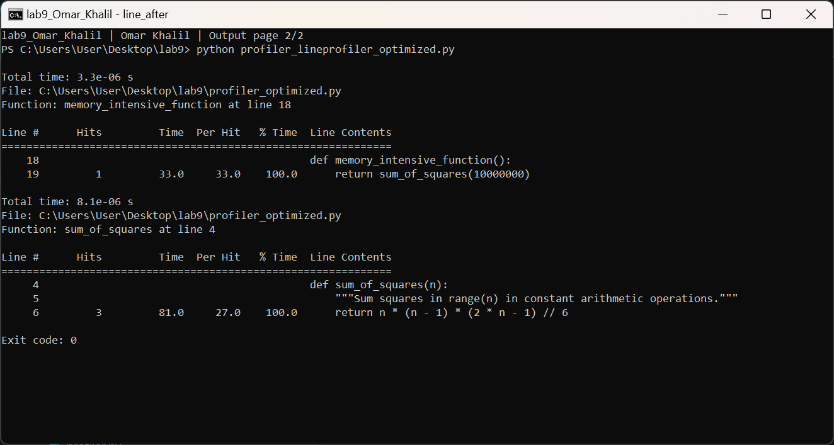

memory_profiler
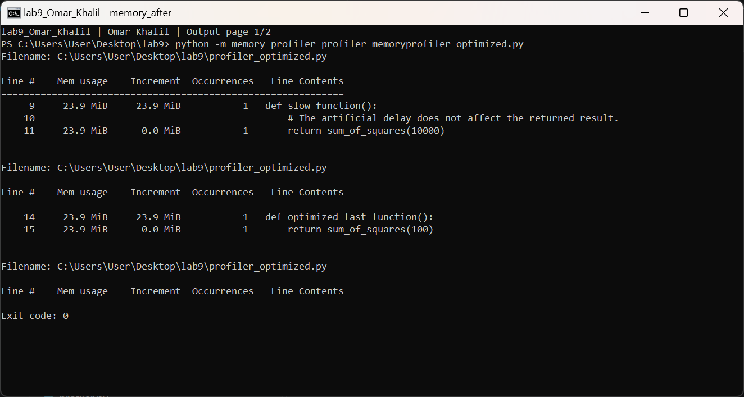
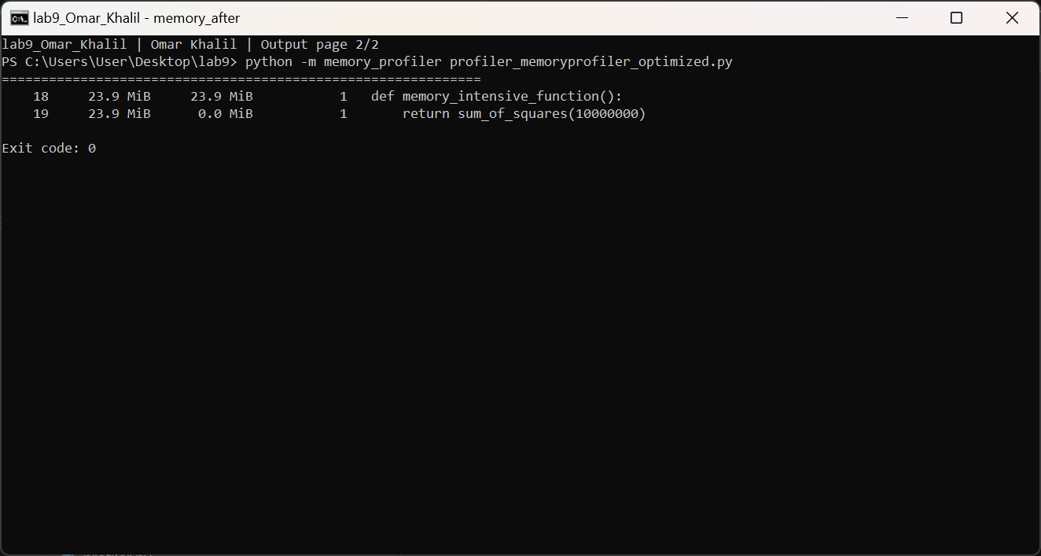

Unit tests
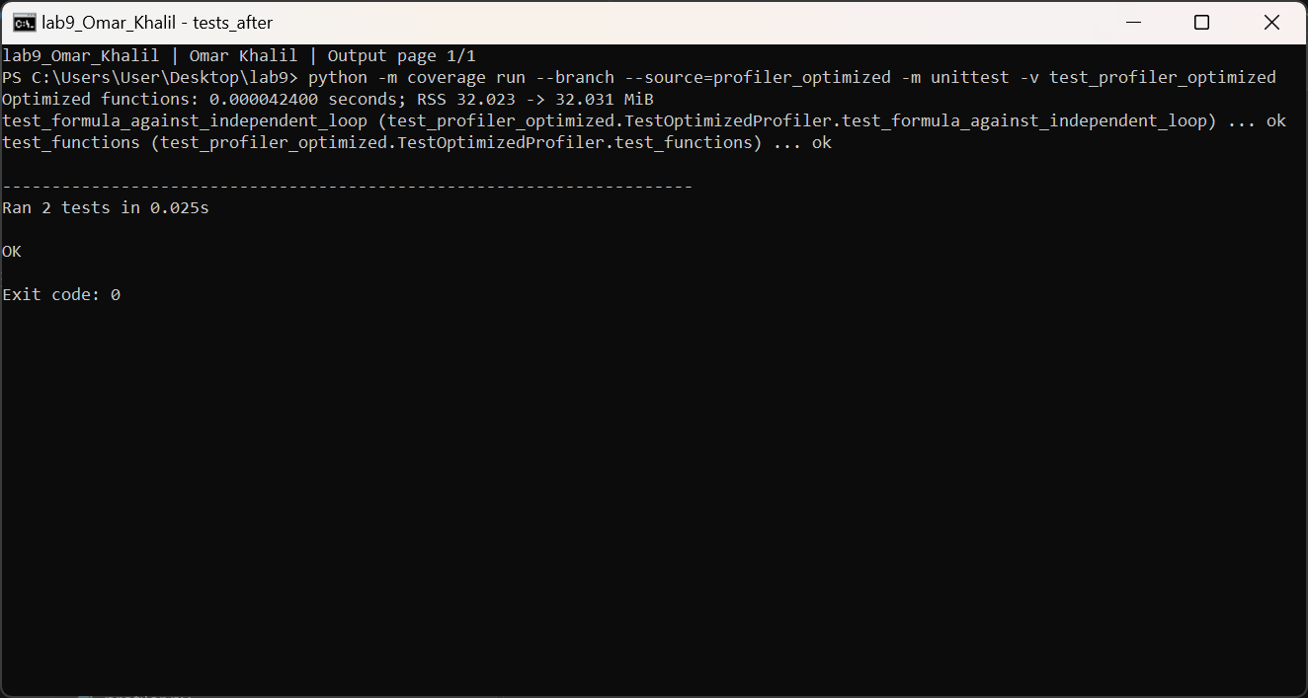

Coverage


