DTL Assignment: Bash Scripting

Name: Omkar Sandip Salunke MIS: 112103120 Branch: Comp Div 2 Batch: S2

1. ALLDONE:

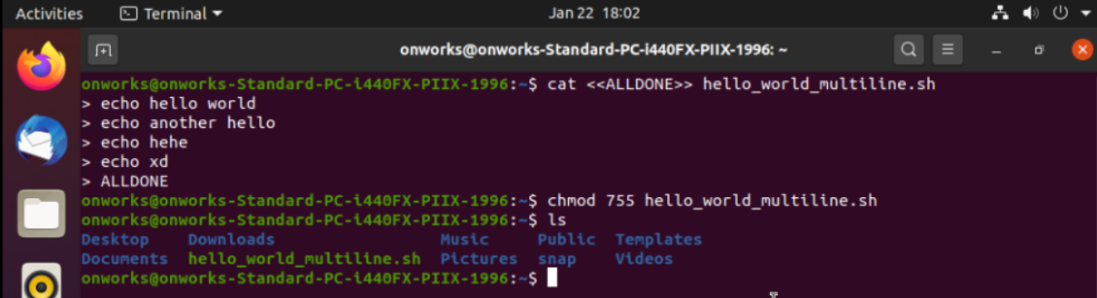

1. 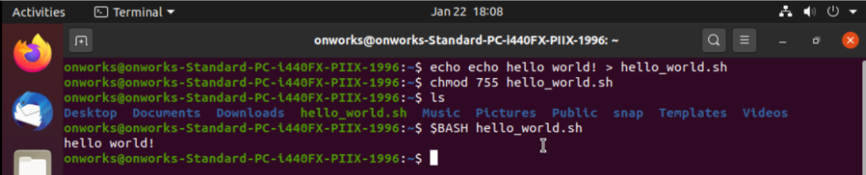
2. 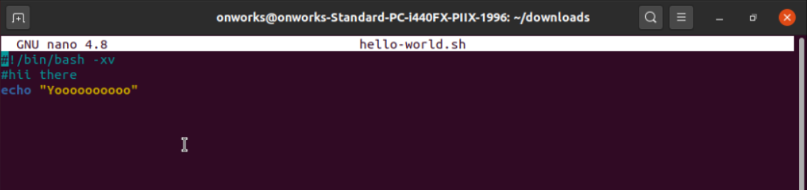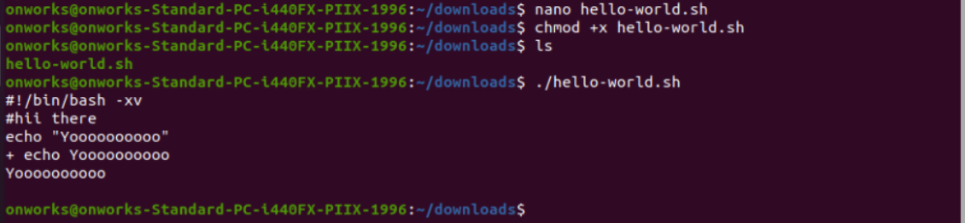
3. 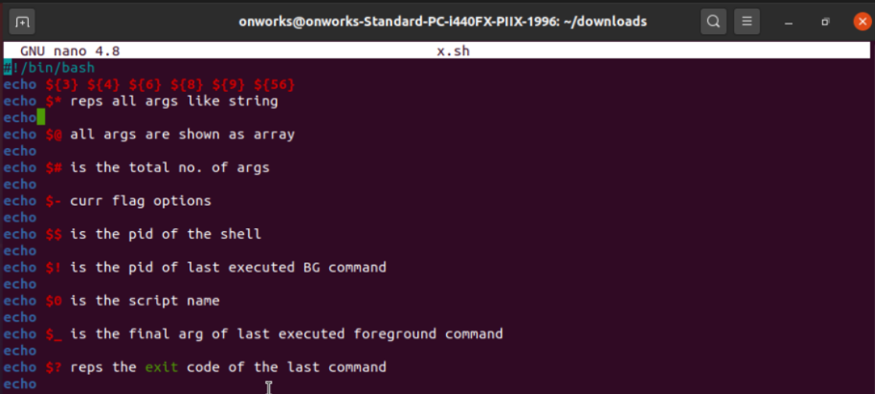

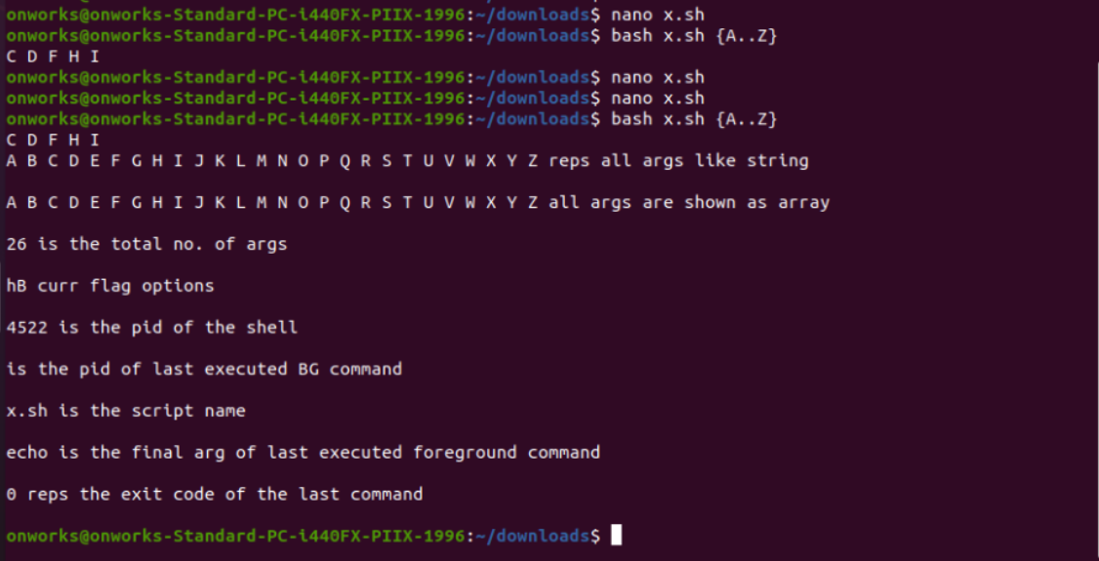

1. 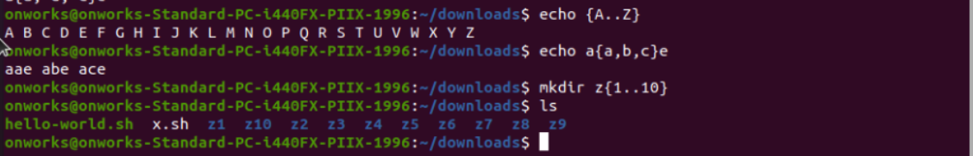
2. 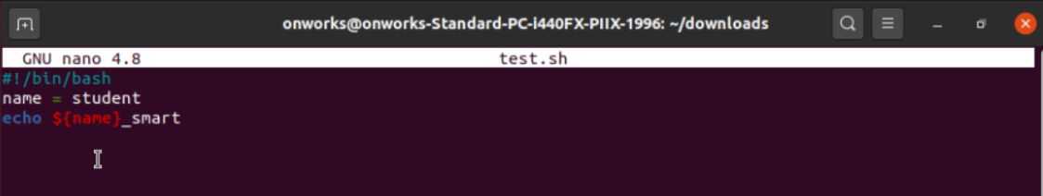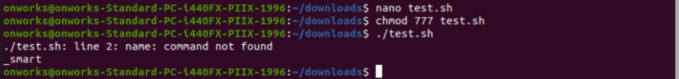
3. 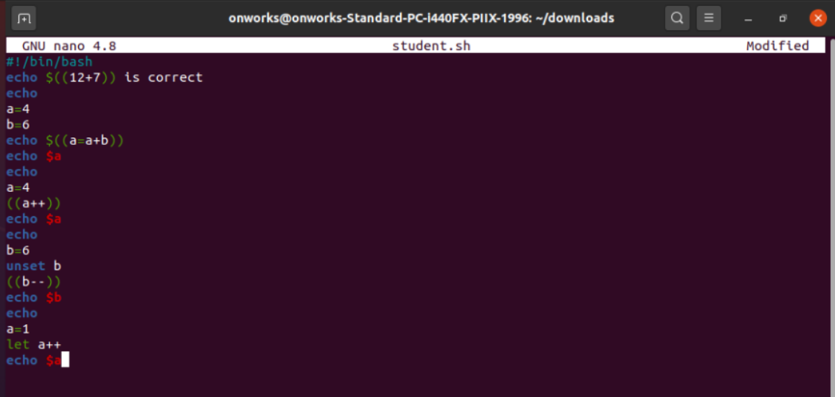

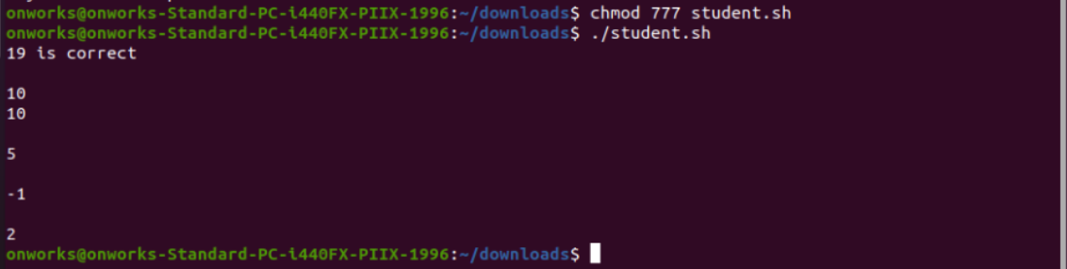

1. 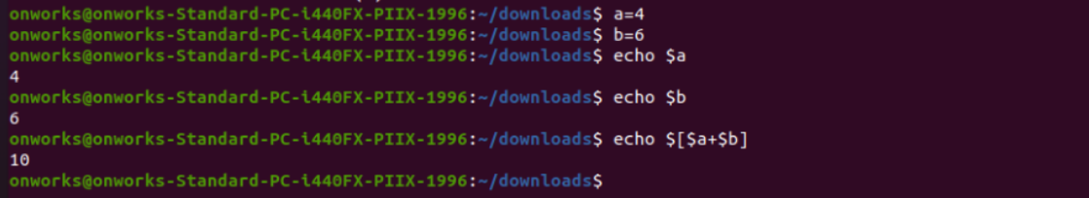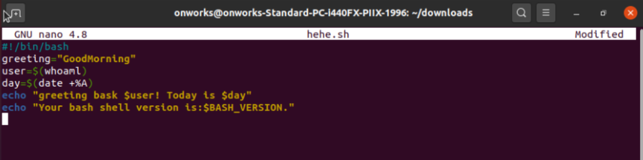

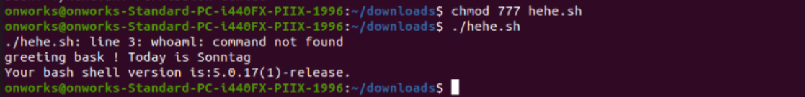

1. 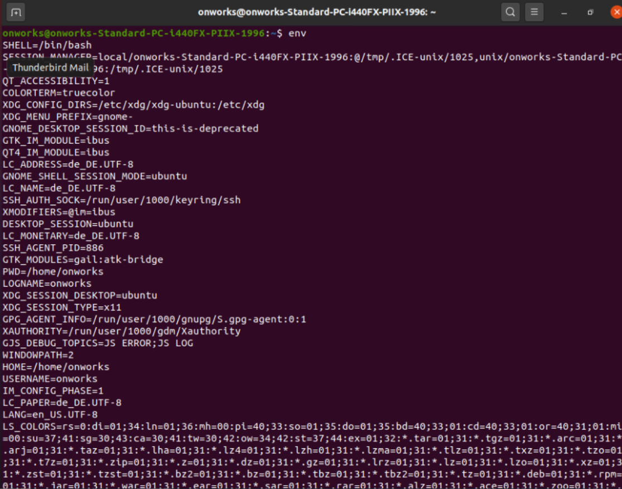
2. 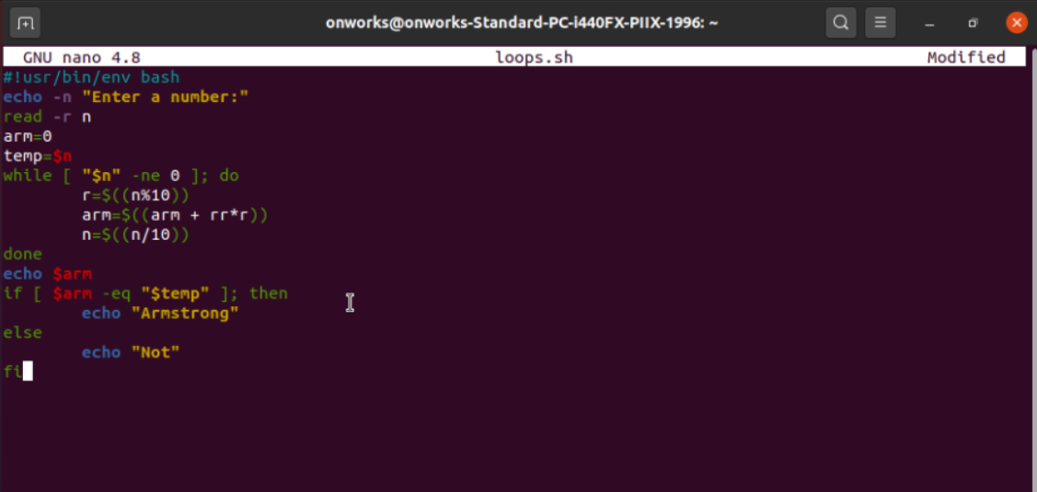

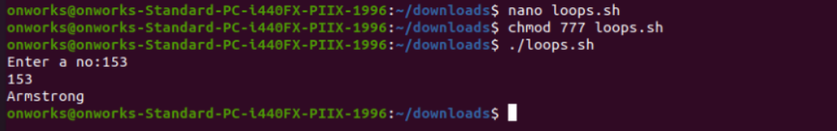

1. 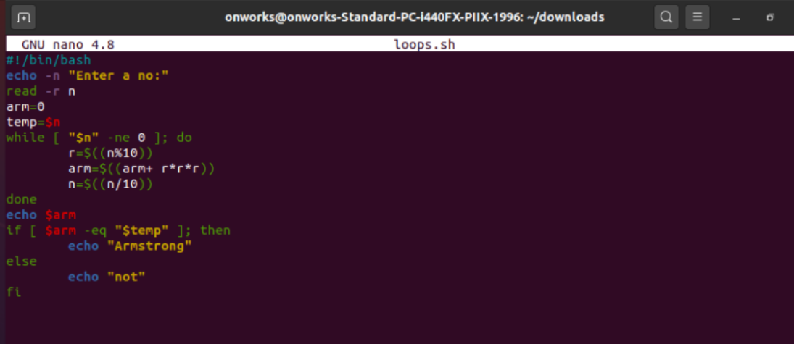
2. 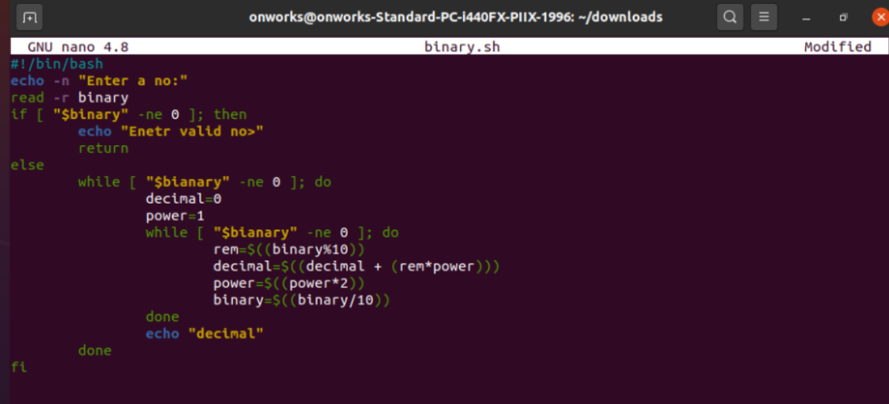
3. 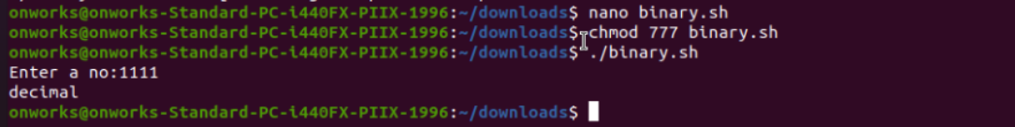
4. 