Employee Attrition Analytics Platform Technical Report
Assignment 5441
This report presents the verified local analysis, its business meaning, and the limits that must guide use and submission.

Executive conclusion
The completed local platform compares six classifiers and selects Logistic Regression by held-out ROC-AUC. It achieved ROC-AUC 0.812, recall 68.1%, and precision 38.1%. The saved preprocessing and model pipeline powers both the FastAPI scoring service and the dashboard. IBM Cloud deployment remains pending because credentials were not supplied.

System scope
- Training: leakage-safe preprocessing, stratified holdout evaluation, and five-fold cross-validation.
- Analytics: Logistic Regression, Gaussian Naive Bayes, LDA, regularized QDA, a neural network, and Random Forest.
- Serving: FastAPI loads the fitted joblib artifact and validates the full feature schema.
- Presentation: Streamlit separates observed workforce KPIs from model-generated risk categories.
- Operations: a retraining entry point and a documented Watson Studio and Watson Machine Learning procedure.

Model comparison
Model | Accuracy | Precision | Recall | F1 | ROC-AUC | CV AUC
Logistic Regression | 0.772 | 0.381 | 0.681 | 0.489 | 0.812 | 0.831
Linear Discriminant Analysis | 0.864 | 0.621 | 0.383 | 0.474 | 0.802 | 0.838
Random Forest | 0.833 | 0.462 | 0.255 | 0.329 | 0.800 | 0.810
Neural Network | 0.874 | 0.708 | 0.362 | 0.479 | 0.782 | 0.487
Quadratic Discriminant Analysis | 0.813 | 0.420 | 0.447 | 0.433 | 0.740 | 0.788
Gaussian Naive Bayes | 0.646 | 0.261 | 0.660 | 0.373 | 0.703 | 0.763

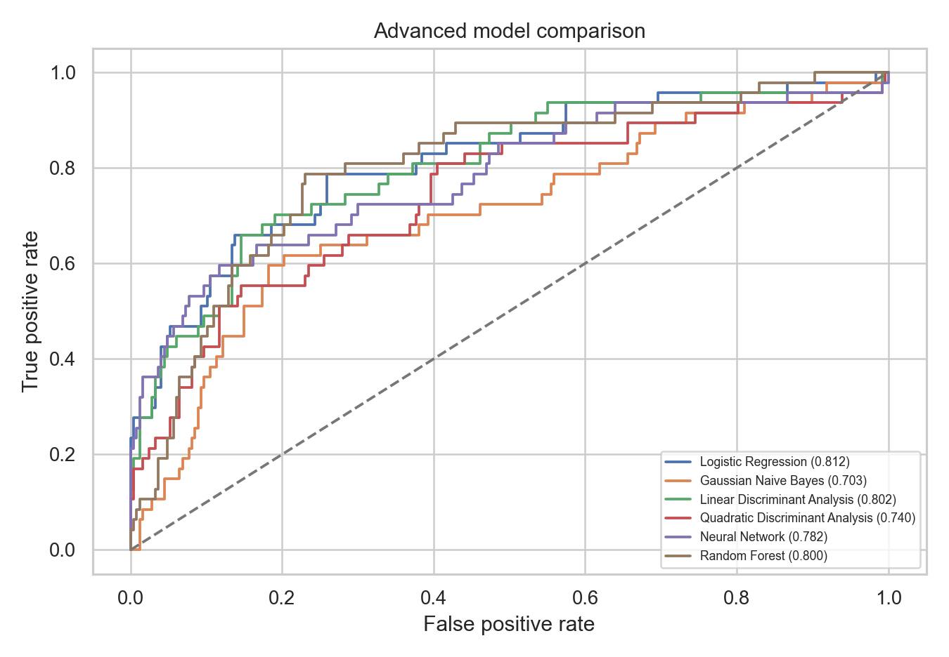
Figure 1 Held-out ROC curves for advanced and classical models

Algorithm suitability
Method | Role | Practical note
Gaussian Naive Bayes | Bayesian baseline | Strong independence assumption; high recall but weak ranking here
LDA | Shared-covariance discriminant model | High cross-validated AUC and compact linear boundary
QDA | Class-specific covariance model | Regularization reduces instability in the small minority class
Neural network | Nonlinear comparison | Higher accuracy but weaker ROC-AUC and unstable CV on this small tabular sample
Random Forest | Nonlinear ensemble | Competitive ranking but low default-threshold recall

Explainability
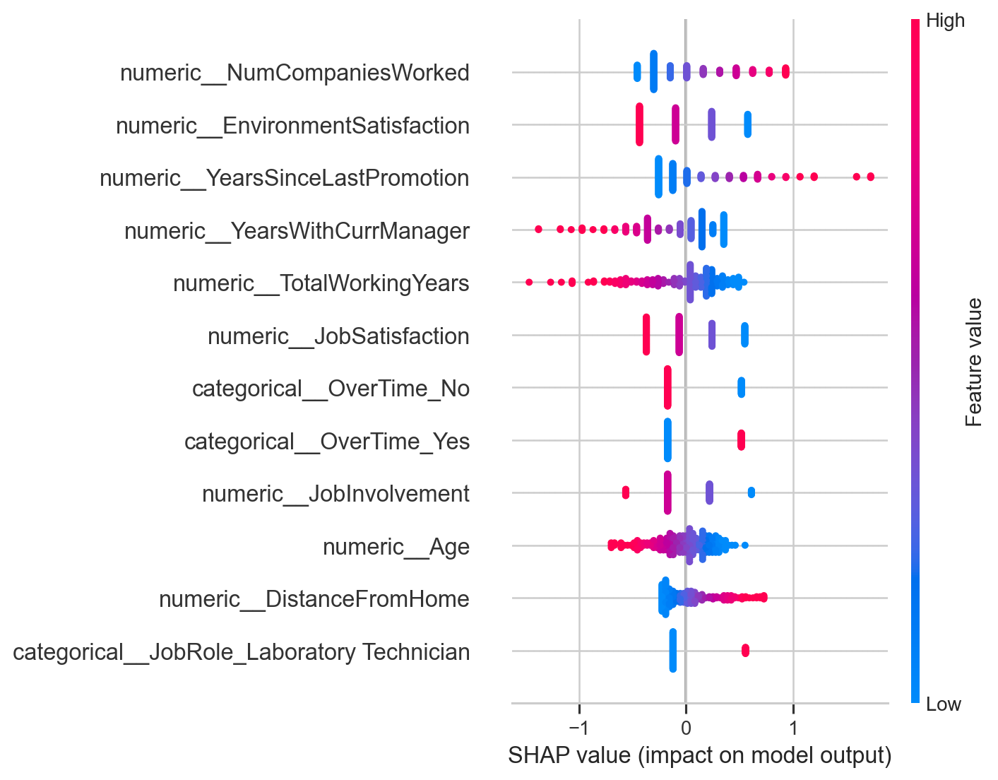
Figure 2 SHAP summary for the selected logistic model
SHAP values summarize how transformed features move model output across the evaluated sample. They explain the fitted model, not causal effects. Explanations should accompany the probability, dataset context, and known limitations.

API and dashboard
The POST /predict endpoint accepts one complete employee feature record, checks missing fields, calls predict_proba on the saved pipeline, and returns probability, a Boolean prediction, and a low, medium, or high risk category. GET /health confirms that the model loaded. The dashboard reports observed attrition and retention separately from predictions and supports department filtering.

Architecture and workflow
Stage | Local component | IBM target
Data | data/employee_attrition.csv | Cloud Object Storage or governed asset
Training | src/train.py | Watson Studio runtime
Artifact | models/attrition_platform_model.joblib | WML model repository
Serving | api/app.py | WML online deployment or protected application API
Scheduling | workflow/retrain.py | Watson Studio Job
Monitoring | saved metrics and review gates | Drift, fairness, and deployment monitoring

Deployment status
The model has not been deployed to IBM Cloud. The repository contains credential placeholders and an ordered deployment procedure. Completion requires an IBM Cloud API key, Watson Machine Learning service, deployment space, compatible software specification, and a verified scoring response.

Limitations and responsible use
- The data is fictional, small, and cross-sectional; performance does not establish production readiness.
- Risk categories are threshold bands, not diagnoses or causal findings.
- Subgroup error, calibration, privacy, drift, and intervention impact require review before use.
- The API is a local demonstration and needs authentication, logging, encryption, rate limits, and access controls for production.
- No financial savings, deployment latency, or organizational impact is claimed without measured evidence.

Conclusion
The repository provides a functioning local analytics platform and a transparent path to IBM deployment. Its strongest evidence is reproducible model evaluation and a real model-backed API. Cloud deployment and production governance remain explicit next steps.

