Employee Attrition Prediction Evaluation Report
Assignment 5439
This report presents the verified local analysis, its business meaning, and the limits that must guide use and submission.

Executive conclusion
Logistic Regression produced the strongest held-out ROC-AUC at 0.812. It identified 68.1% of observed leavers, while 38.1% of employees flagged at the default threshold actually left. This makes the model suitable for ranking supportive retention outreach, not for making employment decisions.

Dataset and evaluation design
The IBM HR Analytics sample contains 1,470 fictional employee records and 35 source fields. Attrition occurs in 16.1% of records, so accuracy alone would reward majority-class predictions. The implementation removes identifier and constant columns, performs a stratified 80/20 split, and fits imputation, scaling, and one-hot encoding only within each training pipeline.
- Models: Logistic Regression, Decision Tree, Random Forest, and XGBoost.
- Selection: five-fold stratified cross-validation followed by ROC-AUC-focused grid search.
- Metrics: accuracy, precision, recall, F1, and ROC-AUC on the held-out test set.

Held-out test results
Model | Accuracy | Precision | Recall | F1 | ROC-AUC
Logistic Regression | 0.772 | 0.381 | 0.681 | 0.489 | 0.812
Random Forest | 0.830 | 0.440 | 0.234 | 0.306 | 0.793
XGBoost | 0.813 | 0.423 | 0.468 | 0.444 | 0.754
Decision Tree | 0.728 | 0.301 | 0.532 | 0.385 | 0.704

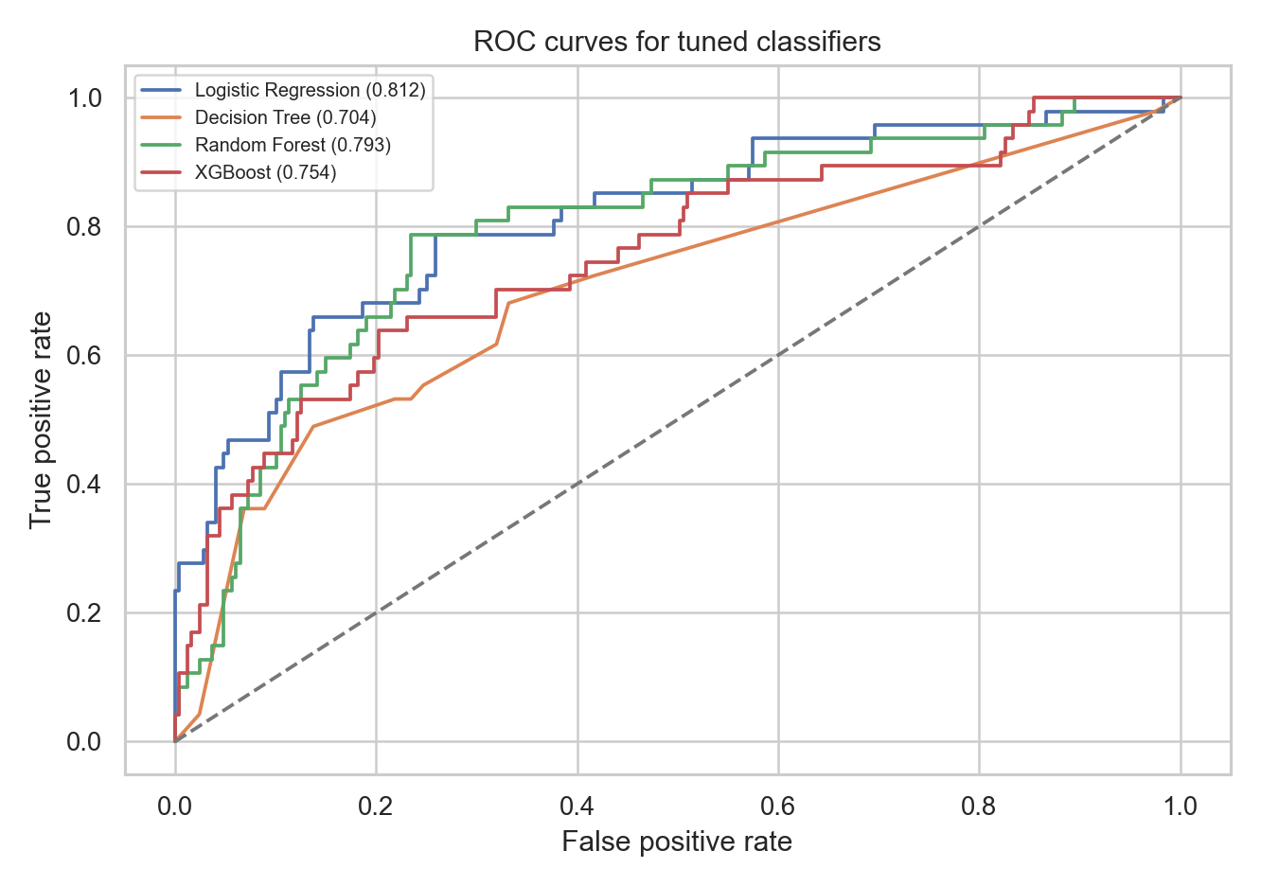
Figure 1 ROC curves for the tuned classifiers

Cross-validation
Model | Accuracy | Precision | Recall | F1 | ROC-AUC
Logistic Regression | 0.753 | 0.372 | 0.737 | 0.492 | 0.827
Random Forest | 0.861 | 0.870 | 0.174 | 0.284 | 0.801
XGBoost | 0.870 | 0.629 | 0.484 | 0.544 | 0.794
Decision Tree | 0.777 | 0.300 | 0.268 | 0.279 | 0.572

The cross-validation table measures average training-fold generalization. The held-out test set remains the final comparison evidence. The small number of leavers means both estimates can vary across samples.

Selected model behavior
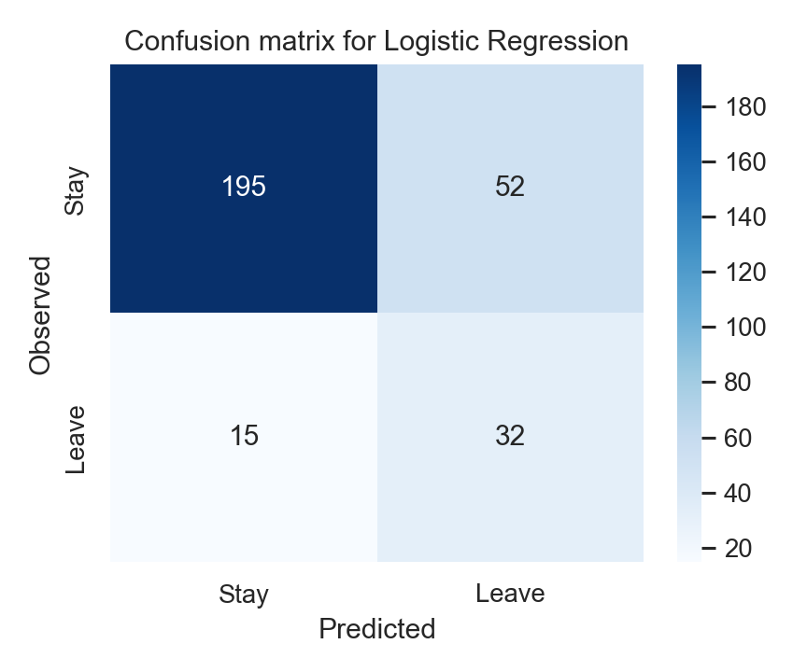
Figure 2 Confusion matrix for Logistic Regression
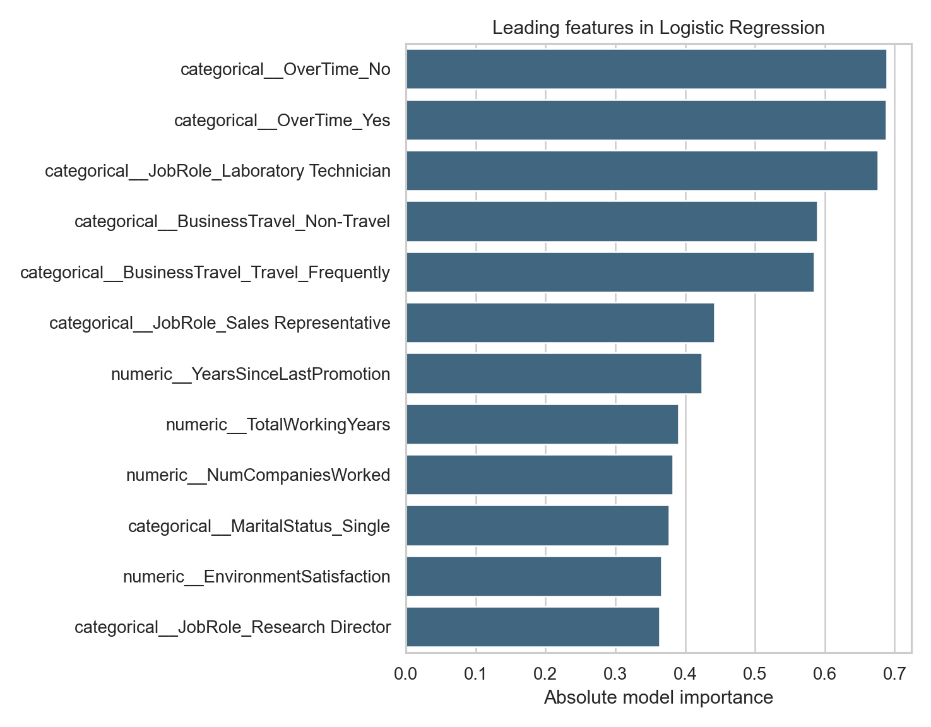
Figure 3 Leading absolute feature effects for Logistic Regression
The importance chart reports model association, not causal effect. A feature may proxy for another condition and must not be interpreted as proof that changing it will prevent attrition.

Reproducibility and limitations
- The fitted preprocessing and model pipeline is stored in models/attrition_model.joblib.
- Random seed 42, the exact dependency file, saved metrics, and executable source support reproduction.
- The dataset is fictional and cross-sectional; it does not establish causes, future stability, or fairness in a real workforce.
- Threshold choice changes recall and precision. A real pilot must set the threshold from intervention capacity and the cost of false positives and false negatives.

