**Skin Cancer Detection and Diagnosis Using Deep Learning**

**Prof. H.R.Khairnar *1, Ankita Chaudhari*2, Laxmikant Borse*3, Omkar Borhade*4, Vaishanavi Kapadi*5**

*\*1 Professor, Department of Information Technology, MET’s BKC Ioe, Nashik, Maharashtra, India.*

*\*2, 3, 4, 5 UG Student, Department of Information Technology, MET’s BKC Ioe, Nashik, Maharashtra, India.*

**Abstract**

Skin cancer is a type of cancer that grows in the skin tissue, which can cause damage to the surrounding tissue, disability, and even death. The accuracy of diagnosis and the early proper treatment can minimize and control the harmful effects of skin cancer. Due to the similar shape of the lesion between skin cancer and benign tumor lesions, physicians consuming much more time in diagnosing these lesions. The system was developed in this study could identify skin cancer and benign tumor lesions automatically using the Convolutional Neural Network (CNN). This project introduces a novel application of advanced neural network techniques to facilitate the identification and diagnosis of skin cancer. The core of this approach lies in its utilization of deep learning, particularly through convolutional neural networks (CNNs), to effectively analyze skin images uploaded for examination. The system extends its impact beyond diagnosis by providing personalized recommendations for skin cancer prevention.

***Keywords:*** *Convolutional Neural Network, Deep learning, detection, transfer learning, Skin cancer.*

1. **Introduction**

Skin cancer is one of the most common health complaints worldwide, encompassing various types of cancer that arise on the skin. The prevalence of both carcinoma and non-melanoma skin cancers has increased in recent years. According to the Skin Cancer Foundation, one in five Americans will be diagnosed with skin cancer at some point in their lifetime.

The World Health Organization (WHO) indicates that three out of every four cancer cases are related to skin cancer, with rising rates observed in countries like the US, Canada, and Australia. Skin disorders significantly impact global health.

While individuals with darker skin tones are about 20 to 30 percent less likely to develop melanoma than those with lighter skin, they may face different mortality risks for certain carcinoma types. The three main types of skin cancer are melanoma, squamous cell carcinoma (SCC), and basal cell carcinoma (BCC).

The primary environmental factor contributing to skin cancer is UV radiation from sun exposure. Other risk factors include age, light skin tone, smoking, HPV infections, genetic disorders, chronic wounds, and artificial UV radiation. Undetected skin cancer can be life-threatening, making early detection essential for preserving lives.

Computer vision systems have become increasingly popular in various research domains in recent years, including medical [1], leather inspection [2], error measurement [3], and so on. The diagnosis and detection of diseases in humans is greatly aided by learning algorithms and computer vision. Convolutional neural networks (CNNs) are learning techniques that have gained a lot of traction in recent computer vision applications. This is because CNNs are better at making predictions and tend to gravitate toward larger networks with more complex computational and memory requirements [4, 5]. Fig. 1 lists the common forms of skin cancer.

(

a

)

Basal Cell Carcinoma (BCC)

(

b) Squamous

-

cell skin cancer (SSC)

(

c) Melanoma

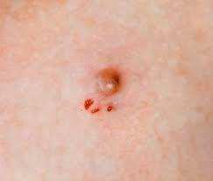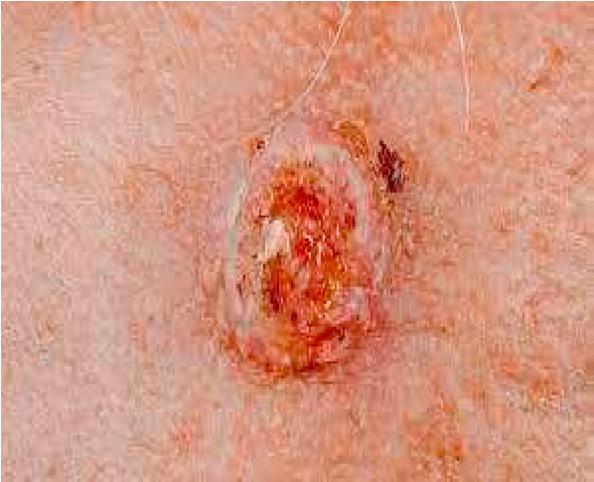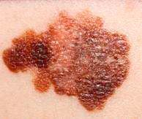

Fig.1. Common types of Skin cance

1. **Literature Survey** :

This section contains a thorough assessment and analysis of academic journals and other information sources pertaining to the identification of skin cancer. The classification of skin cancer was based on the identification of only two types of cancer: malignant and benign. Many techniques were proposed with various Deep CNN (DCNNs) and Support Vector Machine (SVM) approaches, yielding good results. Convolutional Neural Network (CNN) has recently gained prominence as a potent tool for skin cancer diagnosis. This study uses the Human Against Machine (HAM) 10000 dataset to illustrate the skin cancer classification method [6]. The dataset with 2437 training images, 660 test images and 200 validation images were used for the early cancer detection by utilizing deep learning architectures ResNet-101 and Inception-v3 [7]. This model could recognize seven different categories of skin lesions. On the HAM 10000 dataset, an analysis has been done for the classification and the transfer learning with multiple pre-trained models were used together with class-weighted loss and data augmentation techniques [8]. A Generative Adversarial Network (GAN) has been created to create fake images of skin cancer in order to make up for the lack of data needed to train the suggested CNN algorithm. Without the obtained synthetic images, the classification performance of the planned trained CNN was close to 53%, but by including the synthetic images in the primary database, the performance of the model was enhanced to 71% [9]. Deep neural network-based categorization techniques for computer-assisted skin cancer typically produce predictions based only on images of skin lesions. Although the results are encouraging, it is still feasible to improve the performance by taking into account patient demographics, which are significant indicators that human experts take into account when screening for skin lesions. The problem of applying deep learning models for skin cancer classification to combine image and metadata elements were discussed in [10]. The paper suggests an automated system for classifying skin cancer. In this classification, nine different forms of skin cancer were classified. Additionally, the effectiveness of deep convolutional neural networks (DCNN) was also observed. Nine different clinical kinds of skin cancer are included in the dataset, including actinic keratosis, basal cell carcinoma, benign keratosis, dermatofibroma, melanoma, nevus, seborrheic keratosis, squamous cell carcinoma, and vascular lesions [11]. Although melanoma, a type of skin illness, only accounts for a small portion of skin cancers in the USA, it accounts for more than 75% of all skin disorders linked to mortality in that country alone. One of the most effective methods for the early detection and treatment of skin cancer is skin lesion segmentation using machine learning. Recently, researchers segmented and diagnosed skin cancer using several deep network architectures [12]. Later, in 2020, hybrid detection techniques were proposed for detection of skin cancer using different deep learning architectures. The data collection of about 3000 images of people with skin conditions were collected for classification as malignant and benign. In this work, xception network provides highest classification with an accuracy of 85.303% [13]. In this proposed work, skin cancer is identified and classified into two categories as benign and malignant using image processing techniques and deep convolutional neural network (DCCN).

1. **Proposed Methodology**

In this work, we proposed a model capable of increasing performance significantly to classify seven types of skin cancer. The framework used in this method requires few GPU hours than a conventional search algorithm, which needs to train a model. A CNN is a particular type of network for deep learning algorithm which is utilized for tasks like image recognition, image classification and data processing. Although there are different kinds of neural networks in deep learning, CNNs are the preferred network architecture for identifying and recognizing objects. They are therefore ideally suited for computer vision (CV) applications where accurate object recognition is crucial, such as facial and self-driving automobile systems.

The architecture of CNN is made up of three layers namely Convolution layer, Pooling layer, and Fully connected layer. Pooling layer of the CNN is to extract the most salient features of the image while discarding the non-essential information. There are different types of pooling layers like max pooling, average pooling, L2-norm pooling etc. Max pooling is the widely used technique. It divides the input image into small rectangular blocks, and for each block it keeps only the maximum value. This reduces the size of each feature map without losing any important information, and it also helps to reduce overfitting. Overall, the pooling layer plays a critical role in reducing the dimensionality of the feature maps, providing translation invariance to the model and improving computational efficiency by reducing the number of parameters.

A network with three or more layers is a neural network, and deep learning is a subset of machine learning. Although far from being able to match the human brain's capacity for "learning" from vast volumes of data, these neural networks make an attempt to mimic its behaviour. Despite the fact that a neural network with a single layer can still produce approximations, more hidden layers can help to refine and optimize for accuracy.

Deep neural networks are made up of many layers of interconnected nodes, each of which improves upon the prediction or categorization made by the one underneath it. Forward propagation refers to the movement of calculations through the network. A deep neural network's visible layers are its input and output layers. The deep learning model ingests the data for processing in the input layer, and the final prediction or classification is performed in the output layer. Fig.2 shows the block diagram of the proposed method.

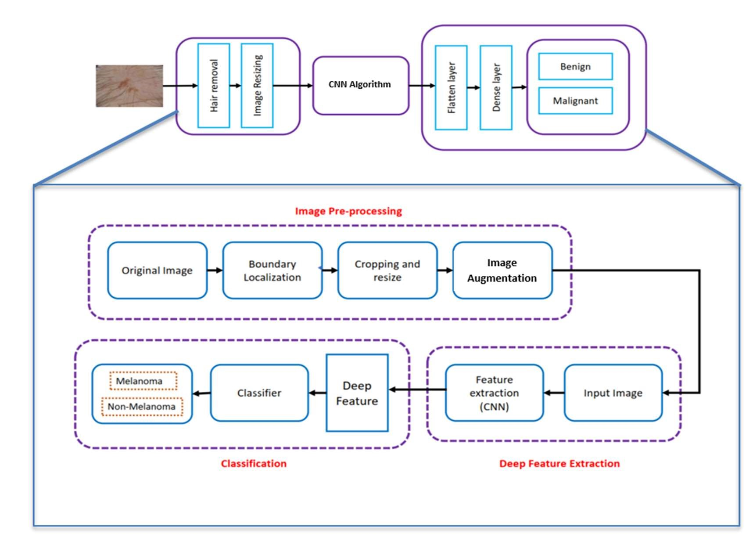

Fig.2 block diagram of the proposed method.

1. **Dataset**

The International Skin Imaging Collaboration (ISIC) produced 2357 images of both malignant and benign oncological diseases for this collection. With the exception of melanomas and moles, whose photos have a minor predominance, all images were sorted according to the categorization determined with ISIC, and all subgroups were divided into the same number of images.

The data set contains the following diseases:

* Actinic keratosis
* Basal cell carcinoma
* Dermatofibroma
* Melanoma
* Nevus
* Pigmented benign keratosis
* Seborrheic keratosis
* Squamous cell carcinoma
* Vascular lesion

1. **Pre-Processing**

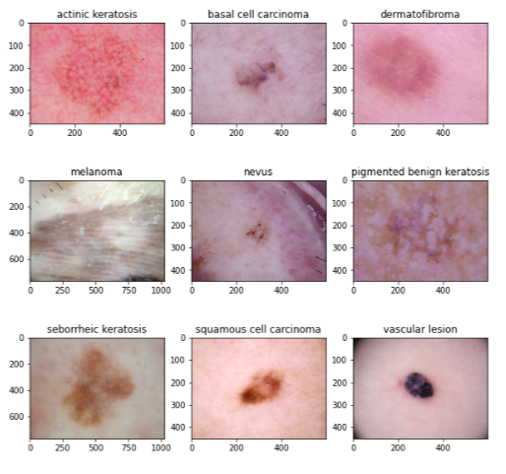 In order to eliminate noise and improve the quality of source image, pre-processing is a crucial stage in the detection process. The accuracy of the system can be significantly increased by carefully choosing the preprocessing approaches. It must be used in order to restrict the background image search for anomalies. The primary goal is to enhance the melanoma images quality by eliminating extraneous and irrelevant background elements and the resulting image will be used for further analysis.

Fig.3. Image Segmentation Skin Lesion

The Segmentation is the process of breaking up the region of interest in an image. To accomplish this separation, treat each pixel in the image as having a similar attribute. The ability to handle images in segments as opposed to as a whole is the main advantage of segmentation. The segmented region of interest is depicted in Fig. 3. Segmentation is typically used to delineate the borders of a certain area. Data augmentation is the following stage of pre-processing. Data augmentation techniques are used in

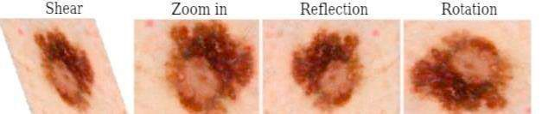data analysis to increase the volume of data by creating new synthetic data from existing data or by appending copies of current data that have undergone significant modification. Fig. 4 provides some augmented images.

Fig.4. Data Augmentation Representation

# **Deep lear ning Algorithms**

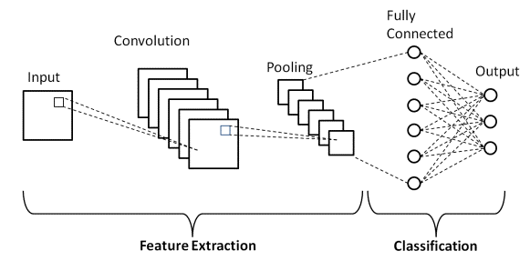Many artificial intelligence (AI) systems, which improve automation by doing mental as well as physical activities without human involvement, are based on deep learning. These models can be trained on a variety of data sources to improve their accuracy and robustness. Skin cancer diagnosis could become much more accurate and efficient with the use of deep learning, leading to earlier detection and improved patient outcomes. There are different deep learning algorithms available. In this work, the Convolution Neural Network (CNN) Figure 5 illustrate the Flow of CNN Mechanism that was utilized for skin cancer detection and categorization. The CNN is the most recommended deep learning network architecture for identification and recognition. A deep learning Convolutional, pooling, and fully connected (FC) layers make up the three layers of CNN. The convolutional layer comes first, and the FC layer comes last. CNN becomes more intricate as it moves from the convolutional layer to the FC layer.

Fig.5. Flowchart of CNN Mechanism

***Convolutional Layer****:* The majority of computations happen in the convolutional layer, which is CNN's primary component. A convolutional layer that comes after the first one could be present. During the convolution process, a kernel or filter inside this layer travels over the receptive fields of the image to detect the presence or absence of features.

***Pooling Layer:***Like the convolutional layer, the pooling layer applies a kernel or filter to the input image. The pooling layer contains fewer input parameters than the convolutional

***Fully Connected Layer****:* The CNN's FC layer categorizes images based on the attributes that were derived from the layers above. In this case, "fully connected" indicates that all of the inputs or nodes from the previous layer are connected to all of the activation units or nodes of the next layer.

**Explanation:**

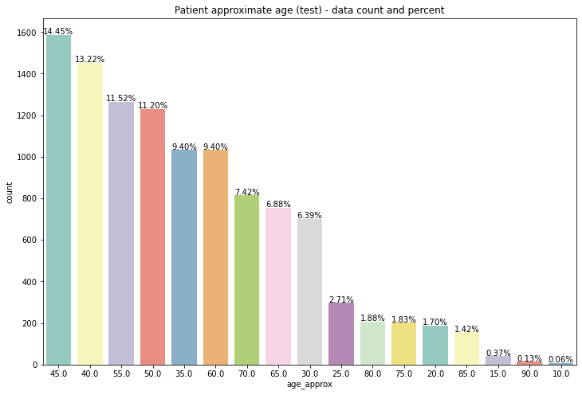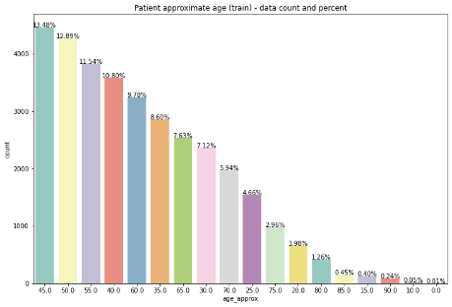Initially the images are preprocessed and converted to a standard size (120X120). In order to have a large number of images in the dataset, the images are rotated in all the directions (each differing by 90 degrees) and also flipped. Then the image is given as an input to the first layer of the network. Then as shown above, Convolutional Neural Network is applied onto it until high-level features such as border, edge and colour are obtained from it. This is done with the help of the different operations of the ConvNet such as Convolution, Max Pooling,etc till the image flattens out into an image vector. These are the vectors with which classification can be done as these vectors contain the information leading to the determination of high level features. The initial batch size is taken to be 20 while epoch size is taken to be 25. After feature extraction model is saved into the dataset. This data gets updated after each epoch. After the model is trained, test images are used in order to check the results

Fig.6. Testing data count Vs age distribution Fig.7.Training data count Vs age distribution

The Fig.6, 7 bar graphs illustrating the age distribution of skin cancer patients reveal that the majority of cases occur in individuals aged 45 and younger. This suggests that younger demographics are significantly impacted by skin cancer, necessitating targeted prevention and screening efforts in this age group.

**5. Conclusion**

In conclusion, the AI-powered skin cancer detection project represents a groundbreaking advancement in the field of dermatology, offering the potential to revolutionize the way we identify and address this critical healthcare challenge. By harnessing deep learning and image analysis technologies, the system enables early and accurate detection, reducing diagnostic delays, and improving patient outcomes. Its contribution to enhanced healthcare standards, alongside the generation of data-driven insights for public health, underscores the transformative impact such innovations can have on healthcare. This project not only signifies a pivotal step towards more effective skin cancer diagnosis but also highlights the broader potential of AI in transforming medical practices and improving healthcare delivery

**References**

1. Priyanka, S., Kavitha, C. and Kumar, M.P.: Deep Learning based Approach for Prediction of Diabetes. In 2023 2nd International Conference for Innovation in Technology (INOCON). IEEE. pp. 1-6.(2023).
2. Moganam, P.K. and Sathia Seelan, D.A.: Deep learning and machine learning neural network approaches for multi class leather texture defect classification and segmentation. Journal of Leather Science and Engineering, 4(1), p.7. (2022).
3. Kavitha, C. and Ashok, S.D.: A new approach to spindle radial error evaluation using a machine vision system. Metrology and Measurement Systems, 24(1), 201-219. (2017).
4. Priyanka, S., Diego Oliva., Kethepalli Mallikarjuna., and M. S. Sudhakar. : l-shaped geometry-based pattern descriptor serving shape retrieval. Expert Systems with Applications, 213. (2023).
5. Priyanka, S. and Sudhakar. M.S.: Lightweight Spatial Geometric Models Assisting Shape Description and Retrieval. In Computational Intelligence Methods for Super-Resolution in Image Processing Applications. Cham: Springer International Publishing. pp. 209-230. 2021.
6. Aburaed, N., Panthakkan, A., Al-Saad, M., Amin, S.A. and Mansoor, W., 2020, November. Deep convolutional neural network (DCNN) for skin cancer classification. In 2020 27th IEEE International Conference on Electronics, Circuits and Systems (ICECS) (pp. 1-4). IEEE.
7. Demir, A., Yilmaz, F. and Kose, O., 2019, October. Early detection of skin cancer using deep learning architectures: resnet-101 and inceptionv3. In 2019 medical technologies congress (TIPTEKNO) (pp. 1-4). IEEE.
8. Kondaveeti, H.K. and Edupuganti, P., 2020, December. Skin cancer classification using transfer learning. In 2020 IEEE International Conference on Advent Trends in Multidisciplinary Research and Innovation (ICATMRI) (pp. 1-4). IEEE.
9. Sedigh, P., Sadeghian, R. and Masouleh, M.T., 2019, November. Generating synthetic medical images by using GAN to improve CNN performance in skin cancer classification. In 2019 7th International Conference on Robotics and Mechatronics (ICRoM) (pp. 497-502). IEEE.
10. Pacheco, A.G. and Krohling, R.A., 2021. An attention-based mechanism to combine images and metadata in deep learning models applied to skin cancer classification. IEEE journal of biomedical and health informatics, 25(9), pp.3554-3563.
11. Rezaoana, N., Hossain, M.S. and Andersson, K., 2020, December. Detection and classification of skin cancer by using a parallel CNN model.

In 2020 IEEE International Women in Engineering (WIE) Conference on Electrical and Computer Engineering (WIECON-ECE) (pp. 380386). IEEE.

1. Diame, Z.E., Al-Berry, M.N., Salem, M.A.M. and Roushdy, M., 2021, May. Deep learning architiectures for aided melanoma skin disease recognition: a review. In 2021 International Mobile, Intelligent, and Ubiquitous Computing Conference (MIUCC) (pp. 324-329). IEEE.
2. Hasan, H.A. and Ibrahim, A.A., 2020, October. Hybrid detection techniques for skin cancer images. In 2020 4th International Symposium on Multidisciplinary Studies and Innovative Technologies (ISMSIT) (pp. 1-8). IEEE.
3. Hekler A, Utikal JS, Enk AH, Hauschild A, Weichenthal M, Maron RC, et al. Superior skin cancer classification by the combination of human and artificial intelligence. Eur J Cancer. 2019;120:114-21.doi: 10.1016/j.ejca.2019.07.019. PubMed PMID:31518967.
4. Ali K, Shaikh ZA, Khan AA, Laghari AA. Multiclass skin cancer classification using EfficientNets – a first step towards preventing skin cancer. Neuroscience Informatics. 2022;2(4):100034. doi: 10.1016/j.neuri.2021.100034.
5. Mehr, R.A. and Ameri, A., 2022. Skin Cancer Detection Based on Deep Learning. *Journal of Biomedical Physics & Engineering*, *12*(6), p.559.
6. Jainesh Rathod, Vishal Waghmode, Aniruddh Sodha, "Diagnosis of skin diseases using Convolutional Neural Networks", Proceedings of the 2nd International conference on Electronics, Communication and Aerospace Technology, 29-31 March 2021