* **CLIMATE ACTION**
* **FOOD SHORTAGE & GREENHOUSE EMISSIONS**

Group: **NOVA**

Arpit Palo (114941242)

Arun Kumar (114708780)

Nisarg Gupta (115067918)

Omkar Kanade (115097399)

### 

### Introduction

The task of analyzing climate data and examining its impact on food production is of paramount importance in today's world. The increasing greenhouse emissions have led to a myriad of challenges, including food shortages, hunger, and malnutrition, which pose a significant threat to the survival of millions of people worldwide. Moreover, the environmental damage caused by these emissions, such as deforestation and desertification, further exacerbates the vicious cycle of ecological and social degradation.

It is crucial to address these issues as they align with the Sustainable Development Goals (SDGs) outlined by the United Nations Climate Action. Specifically, the focus lies on SDG 2, which aims to ensure food security for all, and SDG 13, which targets the reduction of greenhouse emissions. By comprehensively analyzing climate data and exploring the disparities between developed and developing nations, we aim to shed light on different regions' challenges and contribute to finding sustainable solutions. This endeavor underscores the situation's urgency and presents technical challenges that necessitate innovative problem-solving approaches.

### Background

Our analysis builds upon established methods and initiatives focused on climate action and food security. One prominent program is the Climate Change, Agriculture, and Food Security (CCAFS) program, which operates in the United States. This program addresses the challenges climate change poses to agricultural systems and food security. Another influential initiative is the Global Yield Gap Atlas program, based in the Netherlands. This program strives to close the yield gap in global food production by providing information and tools to identify regions with the potential for increased agricultural productivity.

The SDG Report of 2021 provides valuable insights into the progress made towards achieving these goals. It highlights the pressing need to address food security challenges, especially considering increasing energy-related carbon dioxide (CO2) emissions and their detrimental environmental effects. The report also emphasizes the projections of rising sea levels, which will pose significant risks to coastal communities and agricultural systems. These statistics and findings underscore the urgency of our analysis, as it contributes to understanding the current state of food security, the impacts of greenhouse gas emissions, and the need for effective climate action to ensure a sustainable future. Many organizations, like Berkeley Earth, are currently working on collating the temperature data on land and sea[5].

### Data Collections

We obtained climate-related data from the Iowa Environmental Mesonet (IEM) for our analysis. The data collection process involved downloading daily data for 1-hour intervals from all stations from 1960 to 2017 using their official API. To make the data more manageable, we transformed the raw data into monthly aggregates for crucial variables such as temperature, relative humidity, wind speed, precipitation, and more. Initially, the raw data occupied substantial storage space, ranging from 500 MB to 10 GB per year. The accumulated raw data accounted for a total size exceeding 50 GB.

We sourced the data from the University of Melbourne Greenhouse Gas dataset for the historical greenhouse gas levels. Specifically, we focused on capturing the concentrations of Carbon Dioxide, Methane, and Nitrous Oxide from 1960 to 2014. The initial raw data size for each gas concentration was around 500 MB.

To study the aspects related to food security and production, we relied on data obtained from the United States Department of Agriculture (USDA). The raw data provided valuable insights and covered a variety of metrics. In its original form, the data occupied approximately 10 MB of storage.

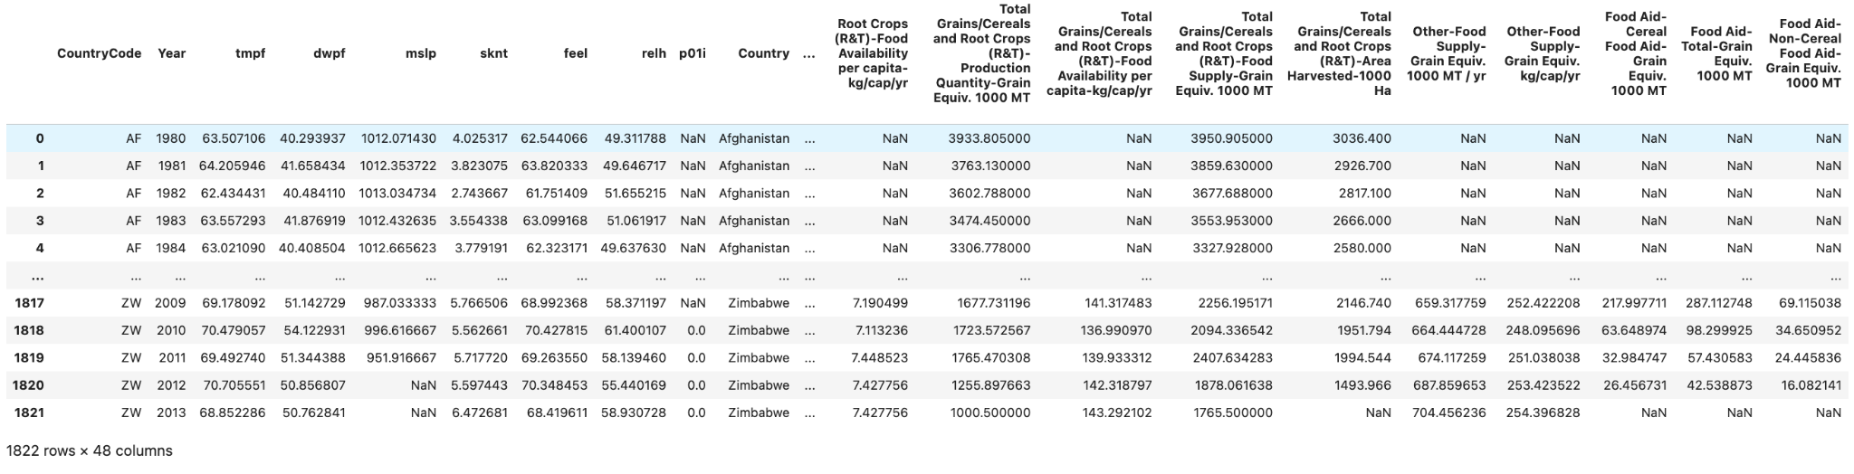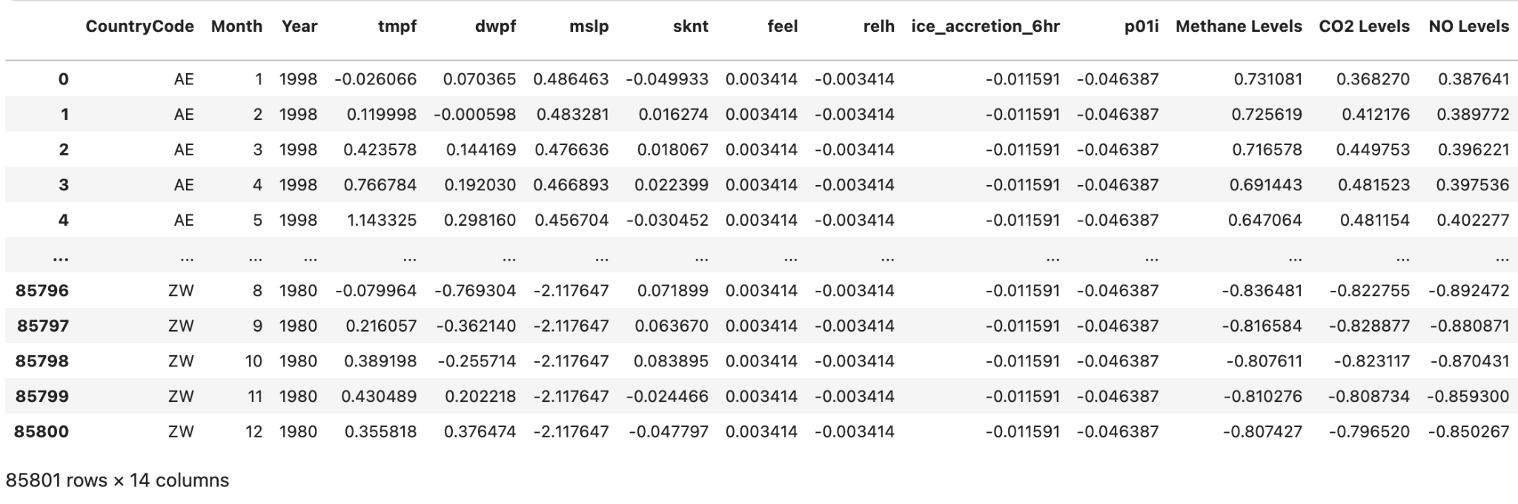

### 

### Methods

We queried the meteorological data provided by the IOWA University state website. Our data includes various features like humidity, air temperature, latitude, longitude, collection center, dew point temperature, mean sea level pressure, wind speeds, ice accelerations, etc., from 1960 to 2015. To account for the local variations in climate, which may bias our results, we collected data from the thousands of collection centers across the countries and continents. We used a reverse geocoder library in Python to map the longitude and latitude of their respective countries to aggregate the data at the country level. We used a Python script to query the data from the IOWA state for each day, with observations coming every hour. We aggregated the observations using PySpark to each country and month level. We joined the greenhouse concentration data extracted from [1] website and similarly left-joined the food production data from the [1] site. We reduced the 60GB of meteorological data to 85K observations and ~18 features.

We used ARIMA models to predict each country's greenhouse gas level increase in the time series analysis for the CO2, NO, and CH4 gasses. We found that most countries expect an increase in the greenhouse gas levels in the future. After much deliberation and manual testing, we found that the ARIMA model value of p = 12, d = 2, and q = 2 fits best for our case.

We also did the time series analysis using ARIMA models for developing and developed countries for temperature, observing the increasing predicted trend in certain countries.

We wrote a multiple linear regression pipeline in PyTorch to identify if a positive correlation exists between our predictor variable, i.e., temperature, and other features. After obtaining the corresponding coefficients to check for their significance, we did hypothesis testing for the corresponding beta’s.

To check whether the temperature negatively affects food security and production over the years. We primarily focused on low and middle-income countries and constructed a correlation heat map.

### Evaluation/Results

### 

### Our data observed a seasonality of -20F to 20F in average monthly temperature data. We observe this seasonality in almost all countries. From the Berkeley Earth Foundation[3], the expected rise in global temperature from the 1960s to 2010s is around 1.5 F. The coefficients could have done better here when the temperature seasonality is higher than our traditional linear regression methods. More research and analysis need to be done to carefully aggregate the temperature data at the monthly level to quantify climate change correctly. Also, collection center sensors sometimes give random noise, and making those adjustments require careful data analysis.

Below is our selected beta with hypothesis testing results. Our null hypothesis was that all beta values were not significant.

| **Variable** | **Corresponding Beta Value** | **T statistic** | **p-value** | **Result** |
| --- | --- | --- | --- | --- |
| Sea Pressure | 0.1287 | -0.08 | 0.464 | Failed to reject |
| Wind speed | -0.1004 | 0 | 0.47 | Failed to reject |
| Feel like | 0.0016 | 0 | 0.5 | Failed to reject |
| Humidity | -0.0015 | 0 | 0.5 | Failed to reject |
| Ice acceleration | -0.0144 | 0 | 0.498 | Failed to reject |
| Precipitation | -0.0064 | 0.04 | 0.498 | Failed to reject |
| CO2 | -0.4435 | 0.02 | 0.483 | Failed to reject |
| Methane levels | -2.1074 | 0.01 | 0.49 | Failed to reject |
| NO levels | 2.6312 | 0.09 | 0.497 | Failed to reject |

### Our time series analysis of greenhouse gasses using ARIMA models indicates that their concentration is expected to increase. Data for selected countries are in the attached figures.

### 

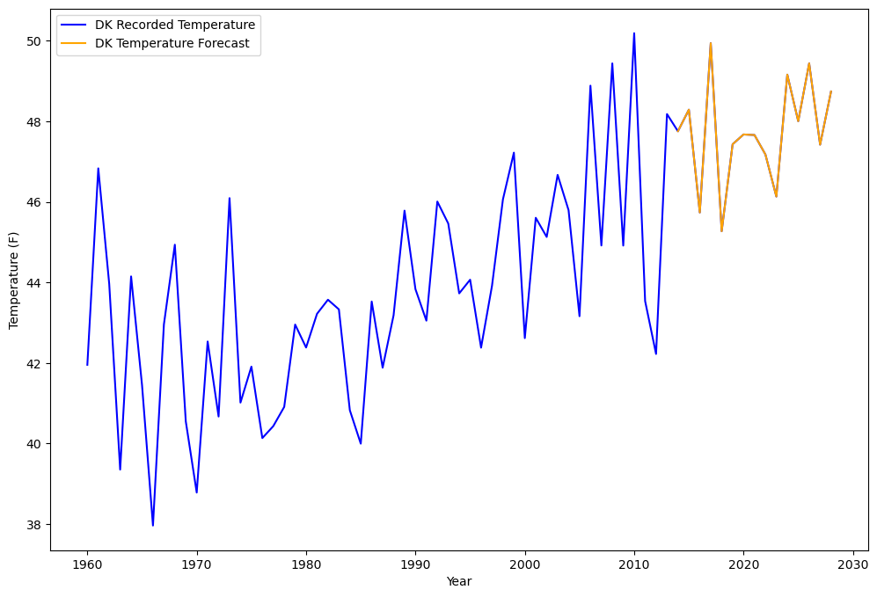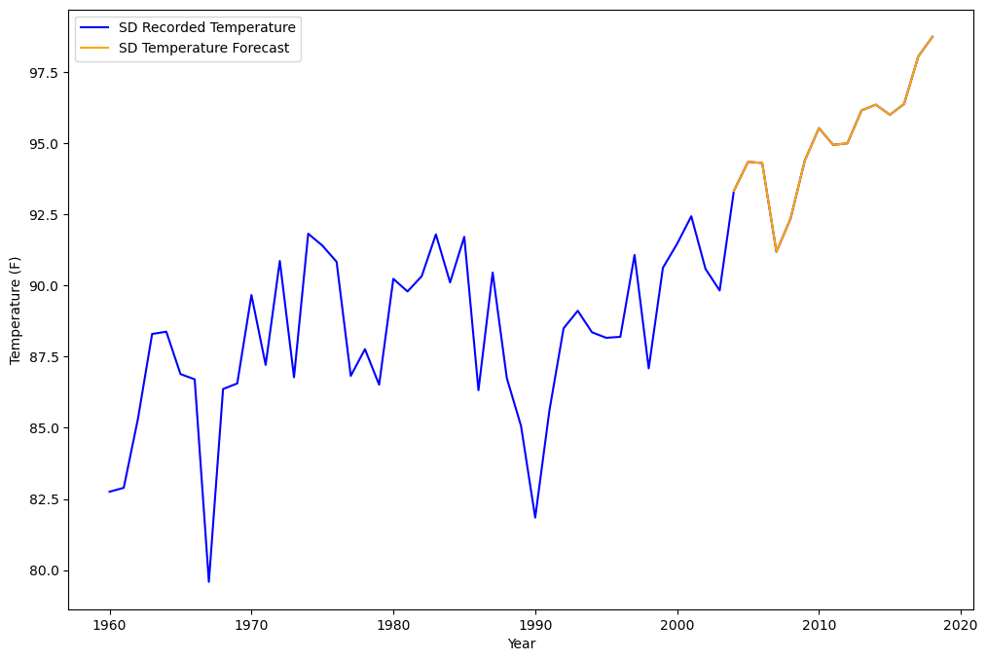

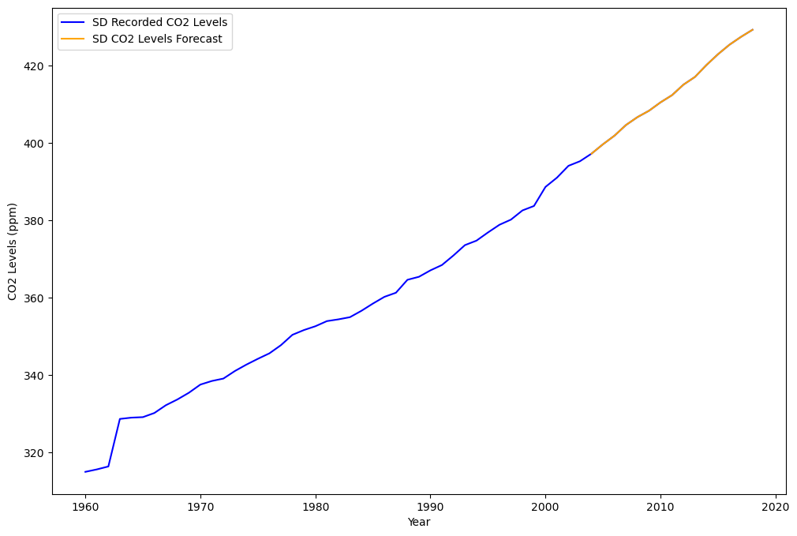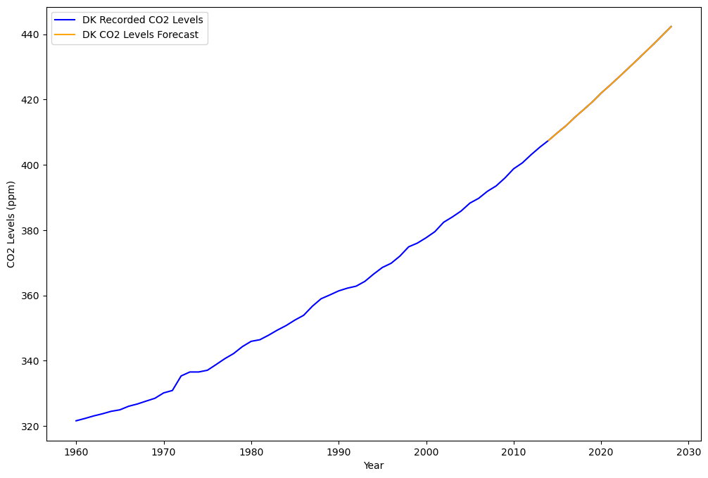

Food Security and temperature: We look at the heat map of food variables and temperature to determine how temperature affects food production. In our correlation heat map for the different countries we observed, we couldn’t find any direct trends between food production and temperature. We did look at the correlations that exist between the temperature and per capita food production. For 12 out of 68 countries, we observed a statistically significant correlation between the above parameter. We think it’s difficult to prove causality between them because of various factors like the current state of agricultural technology, precipitation, government policy, pest & weed infestation, etc., impacting food production. It’s challenging to quantify the impact of temperature on food production. Works such as Hanish Dadool et al.[4] do try to quantify that impact, but it requires a more in-depth understanding of data and more granular data which captures different variables impacting agriculture.

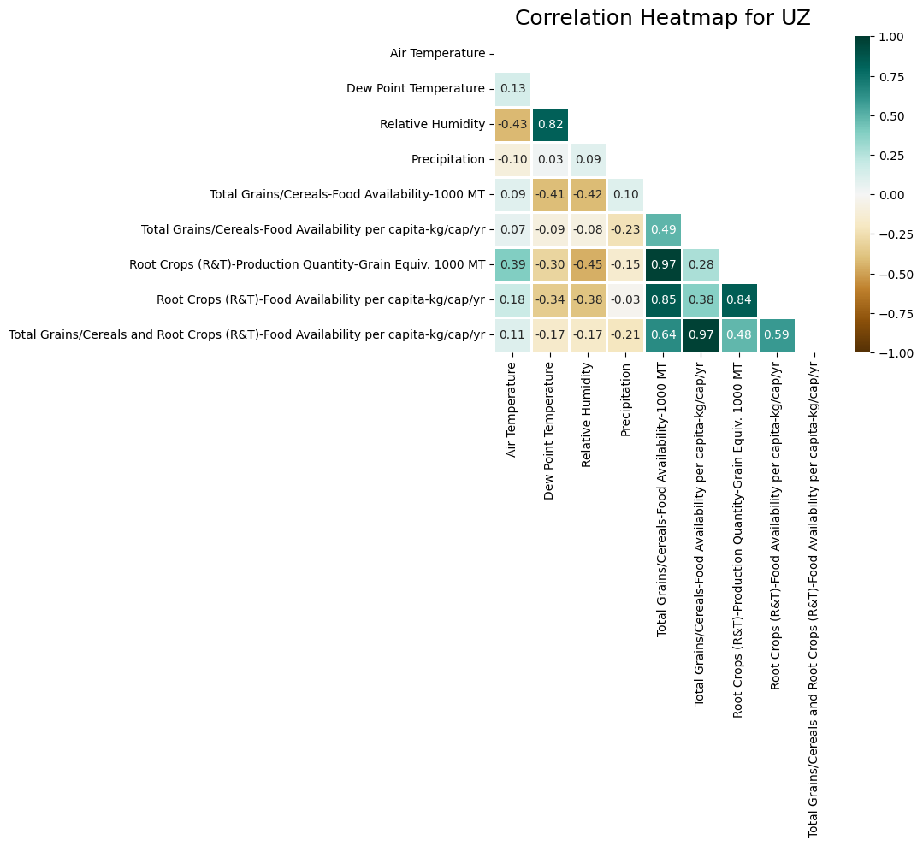

### Conclusion

Climate change is a complex phenomenon affected by greenhouse gas (GHG) emissions, among several other things. Through current technology and sensors, we can collect large amounts of big data; however, it takes considerable expertise and experience to make sense of climate data. Similarly, it’s difficult to measure the impact of climate change on food production because the interaction between the climate, crops, and agriculture is challenging to quantify. Understanding these complex interactions helps policymakers develop mitigation and adaptation strategies.

### 

### References

[1] Links for data collection:

<https://mesonet.agron.iastate.edu/>

<https://greenhousegases.science.unimelb.edu.au/#!/view>

<https://www.usda.gov/>

<https://www.fao.org/faostat/en/#data>

* [2] Nature, Data-driven pathway analysis and forecast of global warming and sea level rise Jiecheng Song Guanchao Tong, Jiayou Chao, Jean Chung, Minghua Zhang, Wuyin Lin, Tao Zhang, Peter M. Bentler & Wei Zhu
* [3] <https://berkeleyearth.org/global-temperature-report-for-2022/>
* [4]Quantifying the impact of climate change on Food-Energy-Water nexus interactions: [10.5194/egusphere-egu21-3853](https://ui.adsabs.harvard.edu/link_gateway/2021EGUGA..23.3853D/doi:10.5194/egusphere-egu21-3853)
* [5]<https://essd.copernicus.org/articles/12/3469/2020/essd-12-3469-2020.html>
* [6][https://www.worldbank.org/en/news/feature/2022/10/17/what-you-need-to-know-about-food-security-and-climate-chang](https://www.worldbank.org/en/news/feature/2022/10/17/what-you-need-to-know-about-food-security-and-climate-change)e