Q1. Basic File Operations :
Commands used: mkdir linuxexam cd linuxexam touch student.txt course.txt result.txt pwd ls
Screenshot:
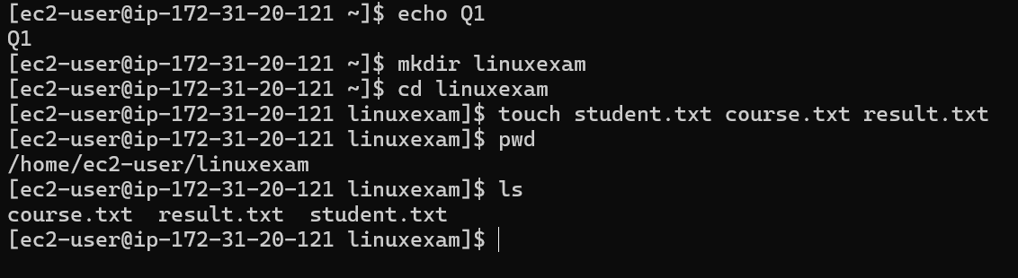

Q2. File Management :
Commands used:
cp student.txt student_backup.txt mv course.txt linux_course.txt rm result.txt
mkdir documents backups scripts mv linuxexam/student_backup.txt backups/ tree Screenshot:
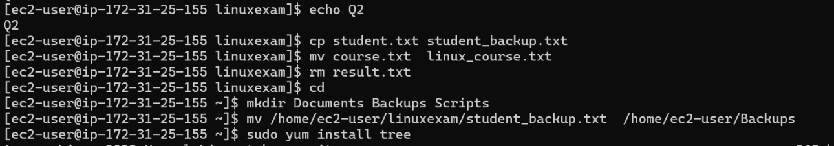
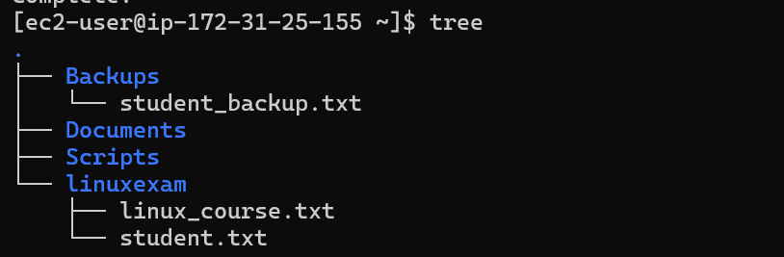

Q3. File Content Operations :
Commands used: cat > student.txt cat > linux_course.txt cat student.txt head -n 3 student.txt tail -n 2 student.txt wc student.txt
Screenshot:

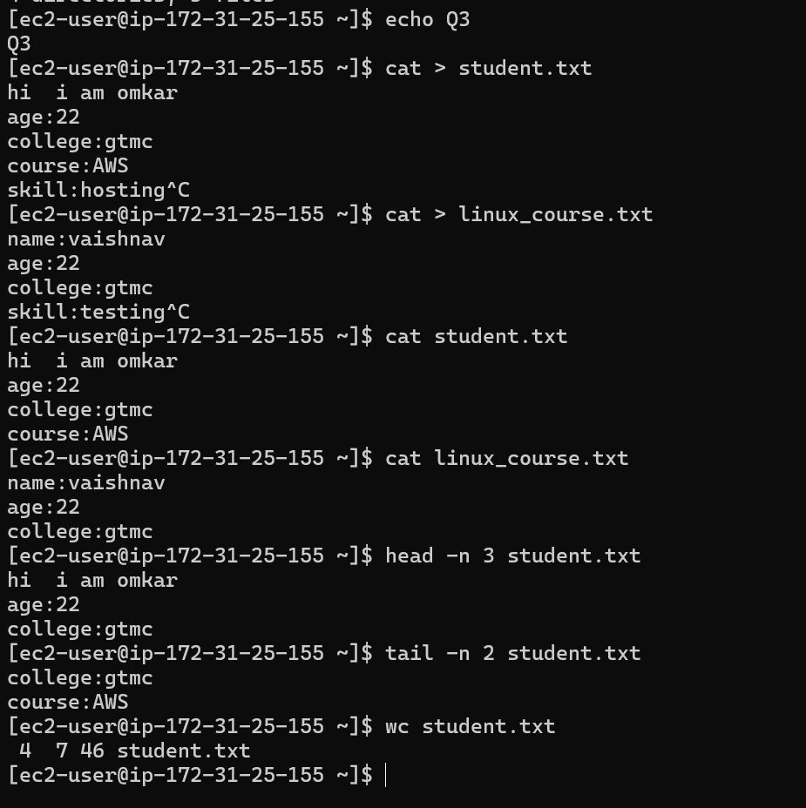

Q4. User Management :
Commands used:
sudo useradd student01 sudo passwd student01 id student01 eval echo ~student01 su - student01
whoami
Screenshot:
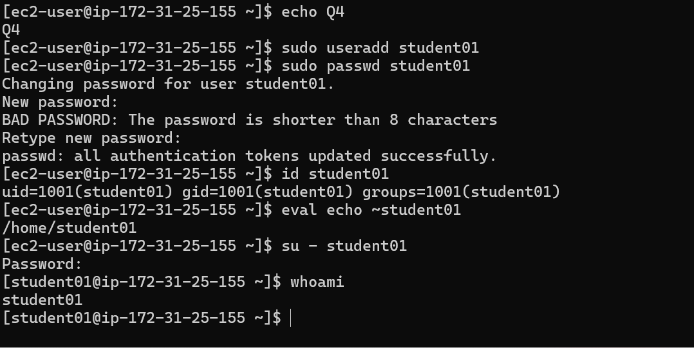

Q5. Group Management :
Commands used:
sudo groupadd linuxbatch sudo usermod -aG linuxbatch student01 sudo useradd student02 sudo usermod -aG linuxbatch student02 getent group linuxbatch groups student01
Screenshot:
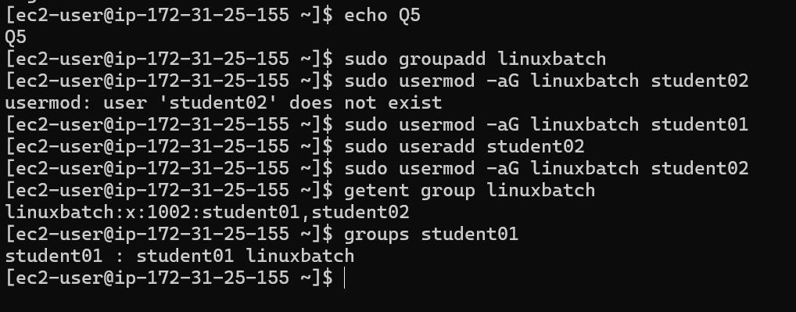

Q6. File Permissions :
Commands used: touch project.txt sudo chmod 754 project.txt ls -l sudo chmod 640 project.txt sudo chown student01 project.txt sudo chgrp linuxbatch project.txt ls -l project.txt
Screenshot:
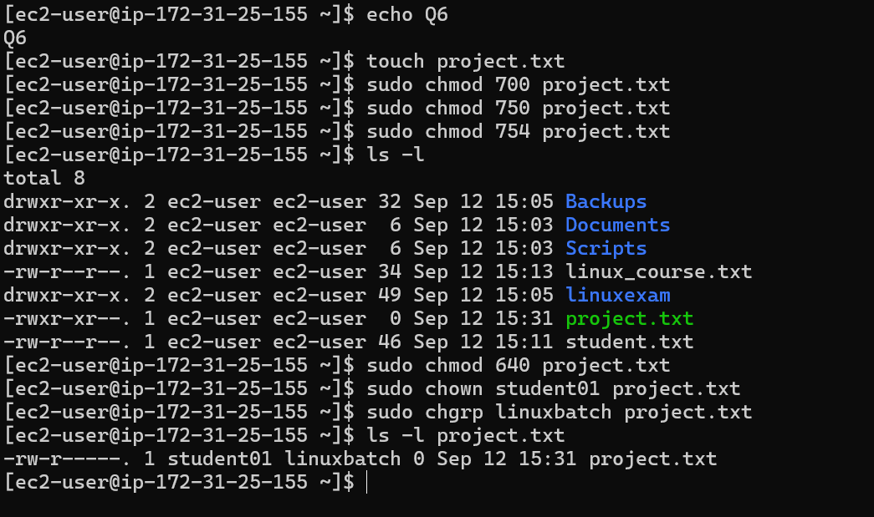

Q7. Permission Challenge :
Commands used:
mkdir -p linuxexam/public linuxexam/private linuxexam/shared sudo chmod 777 public sudo chmod 700 private sudo chmod 770 shared ls -ld public private shared
Screenshot:
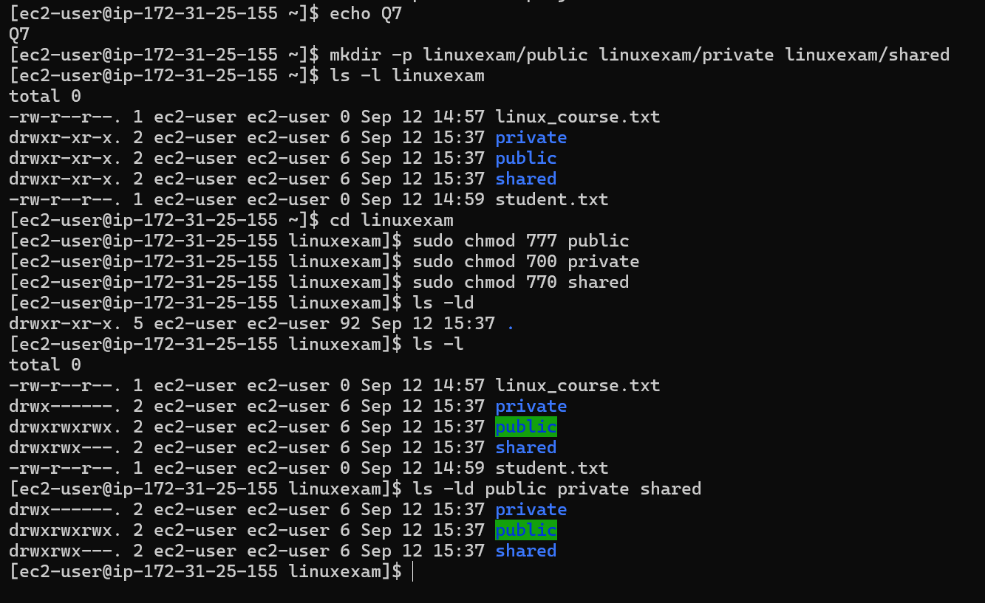

Q8. Package Management :
Commands used: sudo yum update sudo yum install httpd -y httpd -v
sudo systemctl start httpd sudo systemctl status httpd sudo systemctl enable httpd sudo systemctl is-enabled httpd
Screenshot:
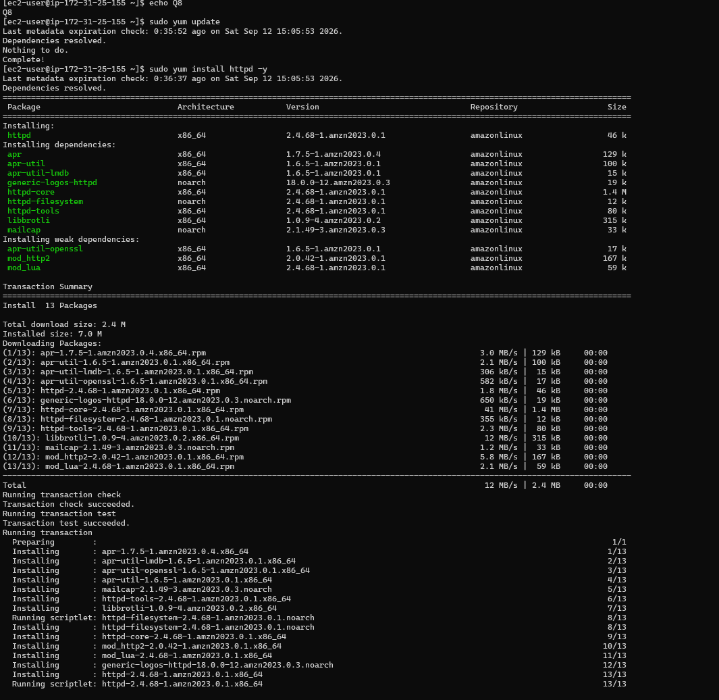
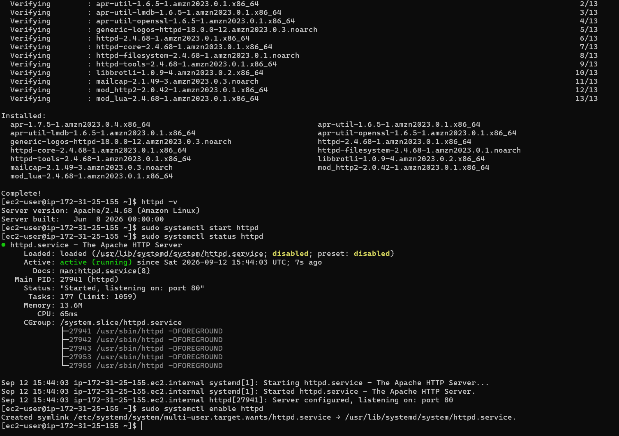

Q9. Apache Web Server Configuration :
Commands used: sudo nano /etc/httpd/conf/httpd.conf cd /var/www/html sudo nano index.html sudo systemctl restart httpd curl http://<server-ip> curl -i http://<server-ip>
Screenshot:
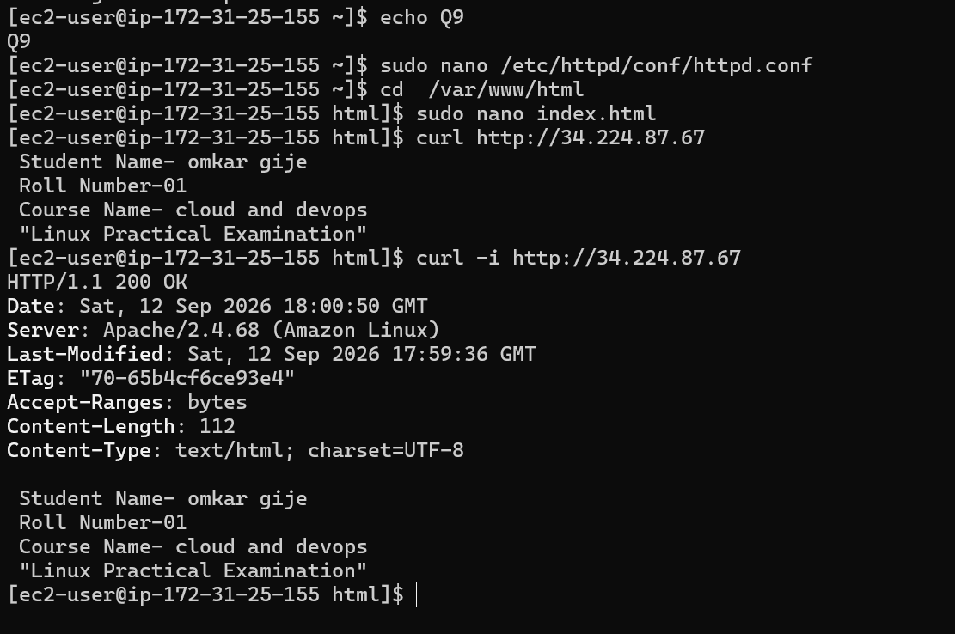

Q10. Process Management :
Commands used:
ps -ef top pgrep httpd ps -p <PID> -f sudo systemctl stop httpd sudo systemctl status httpd sudo systemctl start httpd sudo systemctl status httpd
Screenshot:
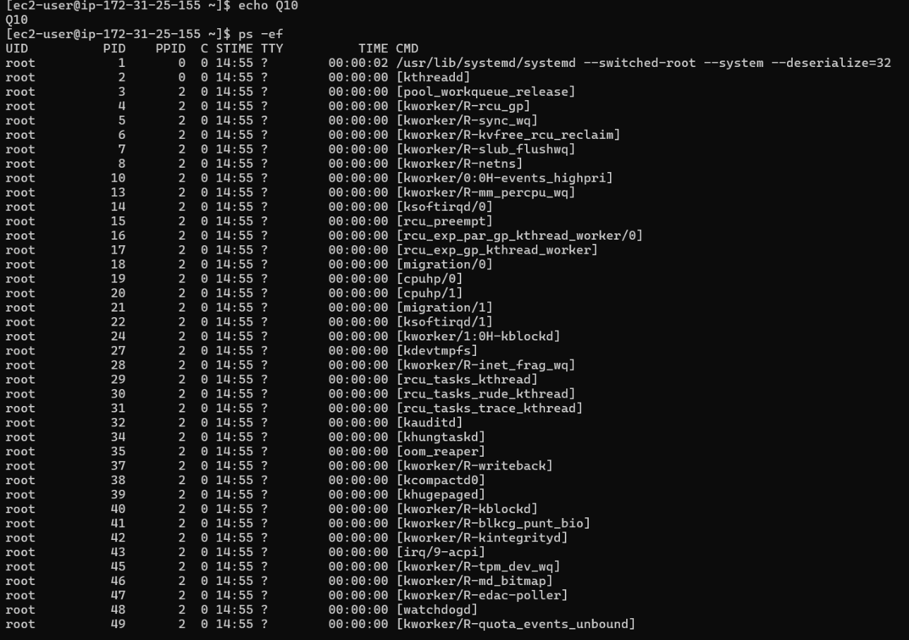
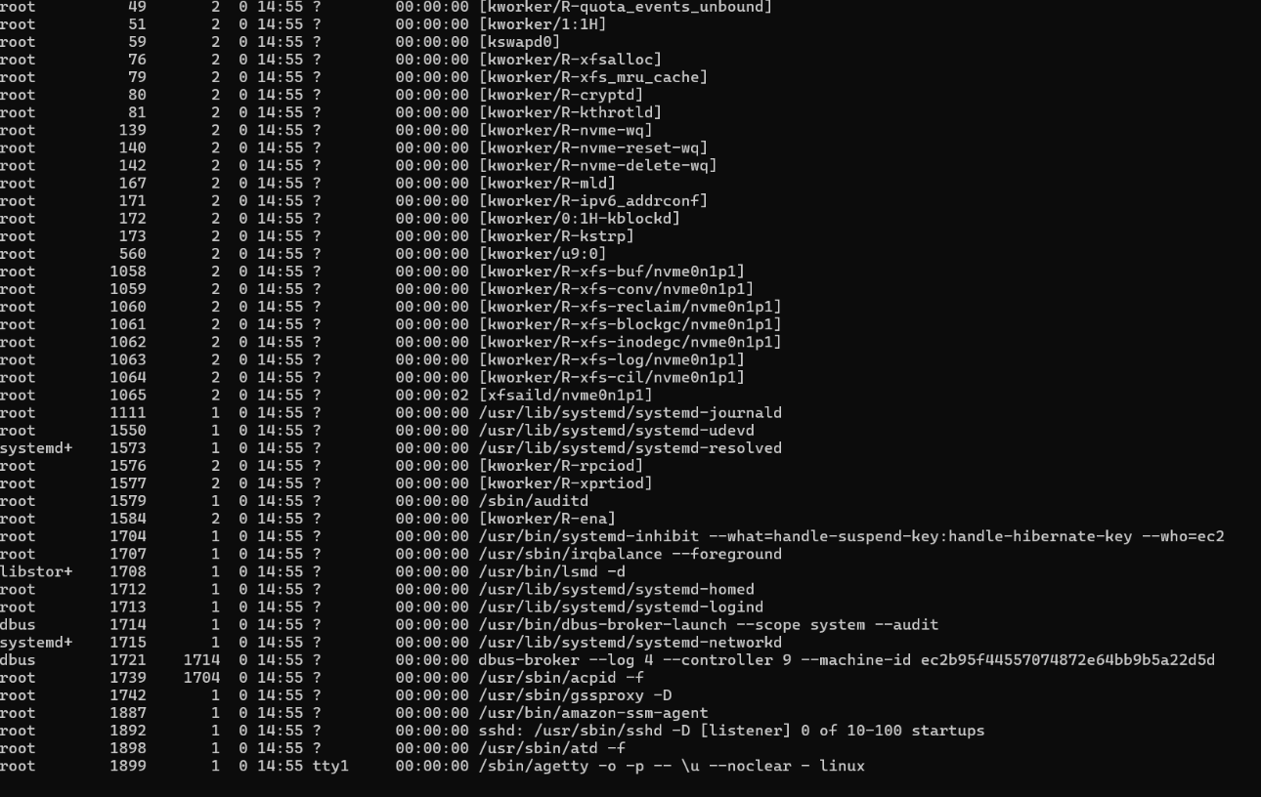
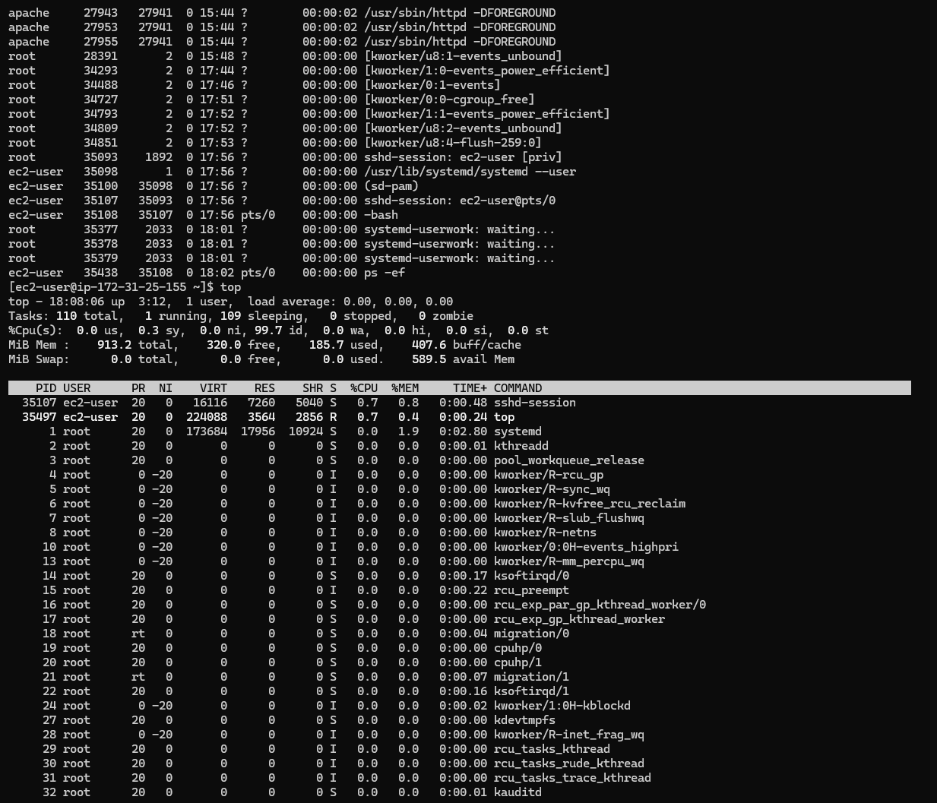
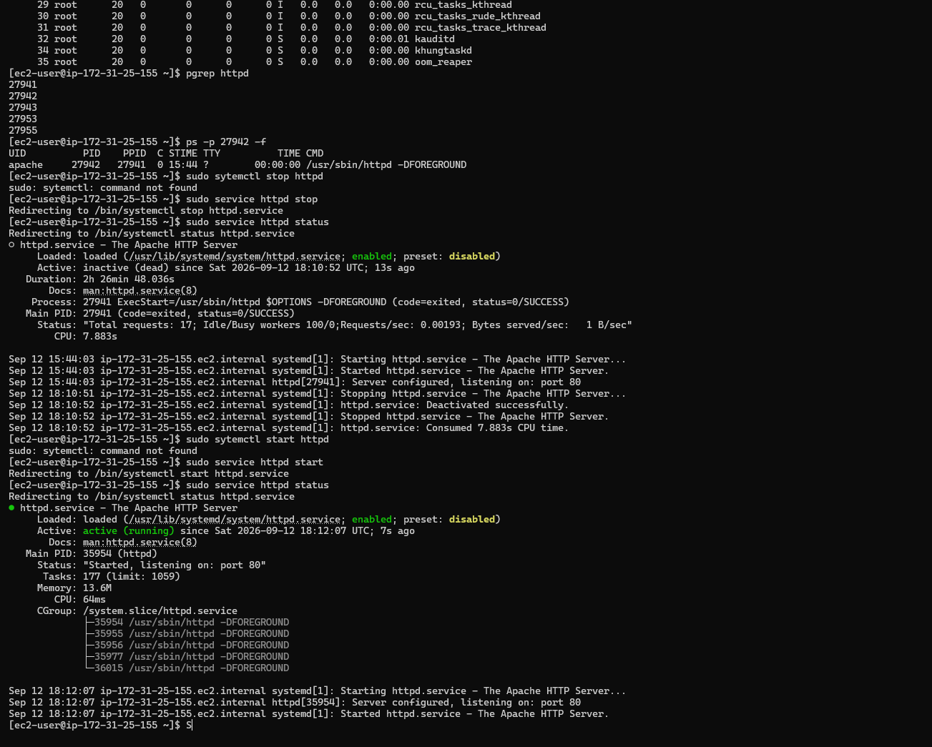

Q11. Search and Text Processing :
Commands used: touch students.txt nano students.txt grep "vishal" students.txt grep -i "a" students.txt grep -i -c "a" students.txt sort students.txt sort -k2 students.txt
Screenshot:
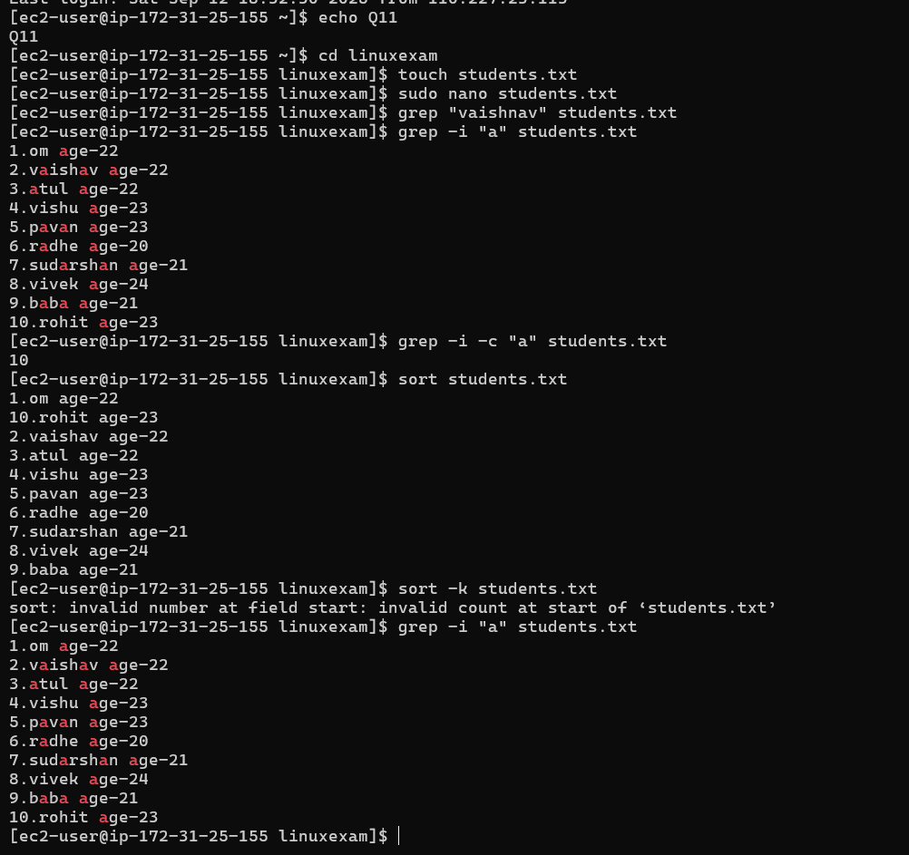

Q12. Linux Networking :
Commands used:
hostname ip addr ip link ip route ping google.com ping -c 4 8.8.8.8 curl http://<server-ip> nslookup <domain> sudo ss -tulnp
Screenshot:
