RCB - IPL Strategy - SQL Projects
By:- Omkar Gupta
DS02-Oct Batch

Objective Questions
Q1. List the different dtypes of columns in table “ball_by_ball” (using information schema).
Ans. Use the below query to get the dtypes of columns in table “ball_by_ball” and there is total 11 columns with int datatype in the table “ball_by_ball”.
Query:-
SELECT
COLUMN_NAME, DATA_TYPE
FROM
INFORMATION_SCHEMA.COLUMNS
WHERE
TABLE_NAME = 'ball_by_ball';
O/P:-
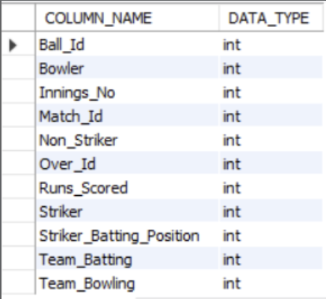
Q2. What is the total number of runs scored in 1st season by RCB (bonus: also include the extra runs using the extra runs table)
Ans. To find the total runs scored by Royal Challengers Bangalore (RCB) in the first IPL season, including extra runs, the following tables are needed:
Required Tables:
- matches: Contains match details, including the teams and season. team: Provides team names and IDs.
- ball_by_ball: Tracks each ball bowled, including the team batting.
- extra_runs: Tracks additional runs like wides and no-balls.
Query Approach:
- Match Selection: Filters matches where RCB played (Team_Id = 2) in the first season.
- Joining Tables: Joins relevant tables to link matches, balls, runs scored, and extra runs.
- Sum Runs: Adds up runs scored by RCB's batsmen and any extra runs.
Query:
SELECT
SUM(b.Runs_Scored + COALESCE(e.Extra_Runs,0))AS Total_Runs_With_Extras
FROM
Ball_by_Ball b
JOIN Matches m ON b.Match_Id = m.Match_Id
LEFT JOIN Extra_Runs e ON b.Match_Id = e.Match_Id AND b.Over_Id = e.Over_Id AND b.Ball_Id = e.Ball_Id AND b.Innings_No = e.Innings_No
WHERE m.Season_Id = 6 AND b.Team_Batting = (SELECT Team_Id FROM Team WHERE Team_Name = 'Royal Challengers Bangalore');
Output:
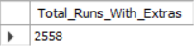
Q3. How many players were more than the age of 25 during season 2014?
Ans. 89
Tables Required:
- player - To get the player's date of birth.
- player_match - To find which players participated in matches during season 2014.
- matches - To find matches in season 2014.
- season - To identify season 2014 and its matches.
Query Approach: This query calculates the number of unique players whose age was above 25 during the 2014 season. To achieve this:
- Join the player, player_match, and matches tables: This allows access to the player's date of birth.
- Filter by season: The matches table is restricted to only those that belong to the 2014 season by matching the season ID for the year 2014 from the season table.
- Age Calculation: The TIMESTAMPDIFF function computes the player's age at the time of each match. Only records where the player's age exceeds 25 on the date ‘2014-01-01’ are considered.
- Count Unique Players: The query counts distinct player IDs who meet the criteria above, giving the total number of players above 25 years of age during the 2014 season.
Query:
SELECT
COUNT(DISTINCT p.player_id) as Total_players_above25
FROM
player p
INNER JOIN player_match pm ON p.player_id = pm.player_id
INNER JOIN matches m ON m.match_id = pm.match_Id
WHERE TIMESTAMPDIFF(YEAR, p.dob, '2014-01-01') > 25 AND m.season_id = (SELECT season_id FROM season WHERE season_year = ‘2014’);
Output:
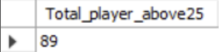

Q4. How many matches did RCB win in 2013?
Ans. To find the matches played by RCB in 2013
Tables Required
- Matches – To get matches with match_winner and season_id
- Team – To get team_id of RCB
- Season – to filter season_year 2013.
Query Approach:
- Join the table matches and season with season_id
- Filter with season_year 2013 and to get the team RCB team id done the filter of match_winner using the subquery from team table to get the RCB id.
- And lastly in the Select clause count the records to get the count of matches RCB won.
Query:
SELECT
COUNT(*) AS Matches_Won_By_RCB
FROM
Matches m
JOIN Season s ON m.season_id = s.season_id
WHERE s.season_year = 2013 and m.Match_Winner =(SELECT Team_id
FROM Team
Where Team_Name=’Royal Challengers Bangalore’);
Output:
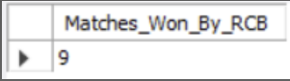
Q5. List the top 10 players according to their strike rate in the last 4 season.
Ans. Top 10 players according to their strike rate in the last 4 seasons are below:
Tables Required:
- Player – To get player name
- Matches – To get the matched of last four season
- Season – To get the last four season
- Ball_by_ball – Contains run_scored and striker(player_id)
Query Approach:
- Identify last 4 seasons
- Filter relevant matches
- Use ball_by_ball table to get collect balls faced and runs scored for each player in the filtered matches.
- Calculate steike rate using the formula
Strike Rate=(Total Balls Faced/Total Runs Scored)×100
- Sort the result by strike rate in decending order and limit the output to top 10 players.
Query:
WITH last4_seasons AS (
SELECT s.Season_Id
FROM season s
ORDER BY s.Season_Id DESC
LIMIT 4
),
recent_matches AS (
SELECT m.Match_Id
FROM matches m
WHERE m.Season_Id IN (SELECT Season_Id FROM last4_seasons)
)
SELECT
p.Player_Name AS player_name,
ROUND(100.0 * SUM(b.Runs_Scored) / COUNT(b.Runs_Scored),2) AS strike_rate
FROM player p
JOIN ball_by_ball b ON b.Striker = p.Player_Id
WHERE b.Match_Id IN (SELECT Match_Id FROM recent_matches)
AND NOT EXISTS (
SELECT 1
FROM extra_runs e
WHERE b.Match_Id = e.Match_Id
AND b.Over_Id = e.Over_Id
AND b.Ball_Id = e.Ball_Id
AND e.Extra_Type_Id NOT IN(1,3)
AND b.Innings_No = e.Innings_No
)
GROUP BY p.Player_Id, p.Player_Name
HAVING COUNT(b.Runs_Scored) >= 500
ORDER BY strike_rate DESC
LIMIT 10;
Output:
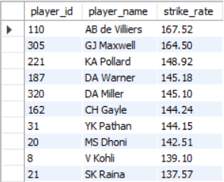
Q6. What are the average runs scored by each batsman considering all the seasons?
Ans. The average runs scored by each batsman in all seasons:
Output:
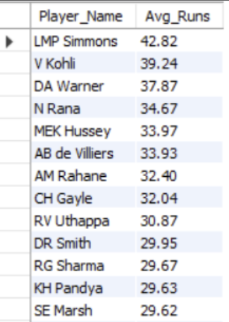
Table Required:
- Ball_by_ball – To calculate total runs scored by each player and to count total innings played.
- Player – To get player details such as player name and id.
Query Approach:
- Group the data in the Ball_by_Ball table by player (Striker) and match-innings to calculate runs scored by each player in each innings.
- Then, group the result again by player to calculate total runs and total innings played.
- Finally, calculate the average runs per innings for each player by dividing total runs by innings played.
- Join with the Player table to display the player names.

Query:
SELECT
p.Player_Name,
ROUND(SUM(sub.Total_Runs) * 1.0 / COUNT(*), 2) AS Avg_Runs
FROM
(
SELECT
Striker,
Match_Id,
Innings_No,
SUM(Runs_Scored) AS Total_Runs
FROM
Ball_by_Ball
GROUP BY
Striker, Match_Id, Innings_No
) AS sub
JOIN Player p ON p.Player_Id = sub.Striker
GROUP BY
p.Player_Name
ORDER BY
Avg_Runs DESC;

Q7. What are the average wickets taken by each bowler considering all the seasons?
Ans. The average wickets taken by each bolwer in all season are as follows:
Output:
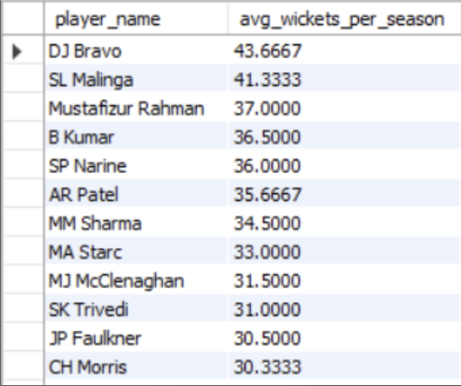
Tables Required:
- player: Provides player names and IDs.
- wicket_taken: Contains information about the wickets taken by each bowler on each ball.
- ball_by_ball: Links each ball to the bowler who delivered it.
- Matches: Link each ball and wicket to a specific season.
Query Approach:
- Join the player table with ball_by_ball on bowler's player_id.
- Join ball_by_ball with wicket_taken on match_id, over_id, and ball_id to identify wickets taken by each bowler.
- Join ball_by_ball (or wicket_taken) with matches on match_id to access season information.
- Group data by player name.
- Calculate total wickets by counting player_out entries.
- Calculate the number of distinct seasons bowled by counting unique season_ids.
- Compute average wickets per season by dividing total wickets by number of seasons.
- Order results by average wickets in descending order.
Query:
SELECT
p.player_name,
COUNT(wt.player_out) / COUNT(DISTINCT m.season_id) AS avg_wickets_per_season
FROM
player p
JOIN
ball_by_ball b ON b.bowler = p.player_id
JOIN
wicket_taken wt ON wt.match_id = b.match_id AND wt.over_id = b.over_id AND wt.ball_id = b.ball_id
JOIN
matches m ON m.match_id = b.match_id
GROUP BY
p.player_name
ORDER BY
avg_wickets_per_season DESC;
Q8. List all the players who have average runs scored greater than the overall average and who have taken wickets greater than the overall average
Ans.
Output:
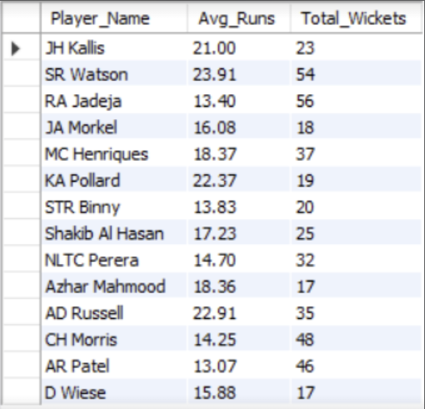
Query Approach:
We’ll solve this in three parts using Common Table Expressions (CTEs):
Part 1: Calculate average runs per batsman From the Ball_by_Ball table.
Part 2: Calculate total wickets per bowler From the Wicket_Taken + Ball_by_Ball tables.
Part 3: Calculate overall averages for both
Query:
WITH player_runs AS (
SELECT
Striker AS Player_Id,
SUM(Runs_Scored) AS Total_Runs,
COUNT(DISTINCT CONCAT(Match_Id, '-', Innings_No)) AS Innings_Played
FROM
Ball_by_Ball
GROUP BY
Striker
),
player_avg_runs AS (
SELECT
Player_Id,
ROUND(Total_Runs * 1.0 / Innings_Played, 2) AS Avg_Runs
FROM
player_runs
WHERE Innings_Played > 0
),
overall_avg_runs AS (
SELECT
ROUND(AVG(Total_Runs * 1.0 / Innings_Played), 2) AS Overall_Avg_Runs
FROM
player_runs
WHERE Innings_Played > 0
),
player_wickets AS (
SELECT
b.Bowler AS Player_Id,
COUNT(w.Player_Out) AS Total_Wickets
FROM
Ball_by_Ball b
JOIN
Wicket_Taken w ON b.Match_Id = w.Match_Id
AND b.Over_Id = w.Over_Id
AND b.Ball_Id = w.Ball_Id
AND b.Innings_No = w.Innings_No
GROUP BY
b.Bowler
),
overall_avg_wickets AS (
SELECT
ROUND(AVG(Total_Wickets), 2) AS Overall_Wickets
FROM
player_wickets
)
SELECT
p.Player_Name,
r.Avg_Runs,
w.Total_Wickets
FROM
player_avg_runs r
JOIN
overall_avg_runs oar ON 1=1
JOIN
player_wickets w ON r.Player_Id = w.Player_Id
JOIN
overall_avg_wickets oaw ON 1=1
JOIN
Player p ON p.Player_Id = r.Player_Id
WHERE
r.Avg_Runs > oar.Overall_Avg_Runs
AND w.Total_Wickets > oaw.Overall_Wickets;
What this query does:
Section | Purpose
player_avg_runs | Calculates average runs per batsman
overall_avg_runs | Gets the overall average run rate
player_wickets | Total wickets per bowler
overall_avg_wickets | Overall average wickets taken
Final SELECT | Combines players who exceed both averages and gets their name

Q9. Create a table rcb_record table that shows the wins and losses of RCB in an individual venue.
Ans. Below is the rcb_record table that shows the win and losses of RCB in an individual venue:
Output:
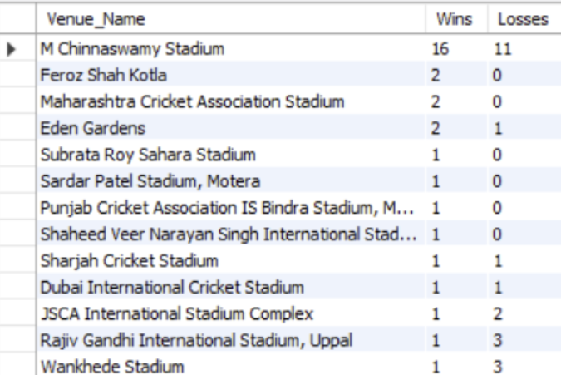
Table Required:
- Matches – To get match outcome and venue
- Team – To get RCB team_id
- Venue – To show venue name
Query:

Step 1: Create the Table:
CREATE TABLE rcb_record (
Venue_Name VARCHAR(100),
Wins INT DEFAULT 0,
Losses INT DEFAULT 0
);

Step 2: Insert the Wins and Losses by Venue:

SELECT
v.Venue_Name,
SUM(CASE WHEN m.Match_Winner = 2 THEN 1 ELSE 0 END) AS Wins,
SUM(CASE
WHEN (m.Match_Winner IS NOT NULL AND m.Match_Winner != 2 AND (m.Team_1 = 2 OR m.Team_2 = 2))
THEN 1
ELSE 0
END) AS Losses
FROM
Matches m
JOIN
Venue v ON m.Venue_Id = v.Venue_Id
WHERE
(m.Team_1 = 2 OR m.Team_2 = 2) -- RCB participated
GROUP BY
v.Venue_Name
order by wins desc, losses asc;

Q10. What is the impact of bowling style on wickets taken?
Ans. To Analyze the impact of bowling style on wickets taken, the following tables are required:
- player: To get information about the players, including their bowling style.
- bowling_style: To determine the type of bowling style associated with each player.
- wicket_taken: To get the details about the wickets taken by each bowler.
- ball_by_ball: To link the wickets taken with the bowler in each ball.
Query Approach:
- Identify each bowler's style.
- Count the total wickets taken by bowlers of each style.
- Compare the wicket counts to assess the impact of different bowling styles.
Insights:
- Right-arm medium bowlers have taken the highest number of wickets (1173), showing their consistency and effectiveness in matches.
- Right-arm fast-medium bowlers follow with 735 wickets, indicating that pace combined with control is a key wicket-taking skill.
- Right-arm offbreak (586) and Left-arm orthodox (567) spinners also play a major role, proving that spin bowling remains an important factor in taking wickets.
- Right-arm fast (453) and Left-arm fast-medium (349) bowlers show solid performance but are less dominant compared to medium pacers.
- Slow left-arm chinaman (56) and Left-arm medium (81) bowlers have the fewest wickets, suggesting these styles are less common or less effective in this dataset.
Recommendations:
- Based on the analysis, teams should focus on strengthening their right-arm medium and fast-medium bowling units, as these bowlers have proven to be the most effective wicket-takers.
- At the same time, maintaining a balance by including quality spin options like right-arm offbreak and left-arm orthodox bowlers can add variety and effectiveness, especially on spin-friendly pitches.

Query:
SELECT
bs. Bowling_skill, COUNT(wt.player_out) as Wicket_taken
FROM
player p
INNER JOIN bowling_style bs on p.bowling_skill = bs.bowling_id
INNER JOIN ball_by_ball bb on p.player_id = bb.bowler
INNER JOIN wicket_taken wt on bb.match_id = wt.match_id and bb.over_id = wt.over_id and bb.ball_id = wt.ball_id
GROUP BY bs.bowling_skill
ORDER BY Wicket_taken desc;
Output:
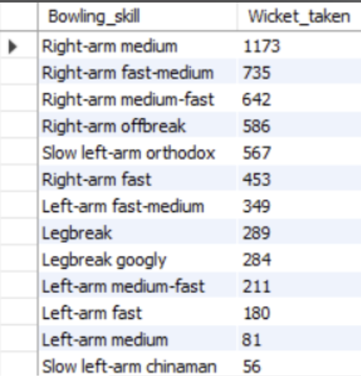

Q11. Write the SQL query to provide a status of whether the performance of the team is better than the previous year's performance on the basis of the number of runs scored by the team in the season and the number of wickets taken.
Ans.
Table Required:
- Ball_by_ball - Contains per-ball data (runs, overs, innings, batting/bowling team)
- Matches - Contains match-level details including season reference
- Wicket_Taken - Contains details of wickets
- Season – Contain season- year mapping
- Team – Contains team details

Query Approach:
- Aggregate total runs per team per season.
- Aggregate total wickets per team per season.
- Combine both to get team performance per season.
- Use LAG() to get the previous year’s performance for the same team.
- Compare current vs. previous to determine if the team improved, declined, or stayed the same.

Query:

WITH team_runs AS (
SELECT
m.Season_Id,
b.Team_Batting AS Team_Id,
SUM(b.Runs_Scored) AS Total_Runs
FROM
Ball_by_Ball b
JOIN
Matches m ON b.Match_Id = m.Match_Id
GROUP BY
m.Season_Id, b.Team_Batting
),
team_wickets AS (
SELECT
m.Season_Id,
b.Team_Bowling AS Team_Id,
COUNT(w.Player_Out) AS Total_Wickets
FROM
Ball_by_Ball b
JOIN
Matches m ON b.Match_Id = m.Match_Id
JOIN
Wicket_Taken w ON b.Match_Id = w.Match_Id
AND b.Over_Id = w.Over_Id
AND b.Ball_Id = w.Ball_Id
AND b.Innings_No = w.Innings_No
GROUP BY
m.Season_Id, b.Team_Bowling
),
combined AS (
SELECT
r.Season_Id,
r.Team_Id,
r.Total_Runs,
w.Total_Wickets
FROM
team_runs r
JOIN
team_wickets w ON r.Season_Id = w.Season_Id AND r.Team_Id = w.Team_Id
),
with_previous AS (
SELECT
c.*,
s.Season_Year,
LAG(c.Total_Runs) OVER (PARTITION BY c.Team_Id ORDER BY s.Season_Year) AS Prev_Total_Runs,
LAG(c.Total_Wickets) OVER (PARTITION BY c.Team_Id ORDER BY s.Season_Year) AS Prev_Total_Wickets
FROM
combined c
JOIN
Season s ON c.Season_Id = s.Season_Id
)
SELECT
t.Team_Name,
wp.Season_Year,
wp.Total_Runs,
wp.Total_Wickets,
wp.Prev_Total_Runs,
wp.Prev_Total_Wickets,
CASE
WHEN wp.Total_Runs > wp.Prev_Total_Runs AND wp.Total_Wickets > wp.Prev_Total_Wickets THEN 'Improved'
WHEN wp.Total_Runs < wp.Prev_Total_Runs AND wp.Total_Wickets < wp.Prev_Total_Wickets THEN 'Declined'
ELSE 'Same'
END AS Performance_Status
FROM
with_previous wp
JOIN
Team t ON wp.Team_Id = t.Team_Id
WHERE
wp.Prev_Total_Runs IS NOT NULL AND wp.Prev_Total_Wickets IS NOT NULL
ORDER BY
t.Team_Name, wp.Season_Year;

Output:

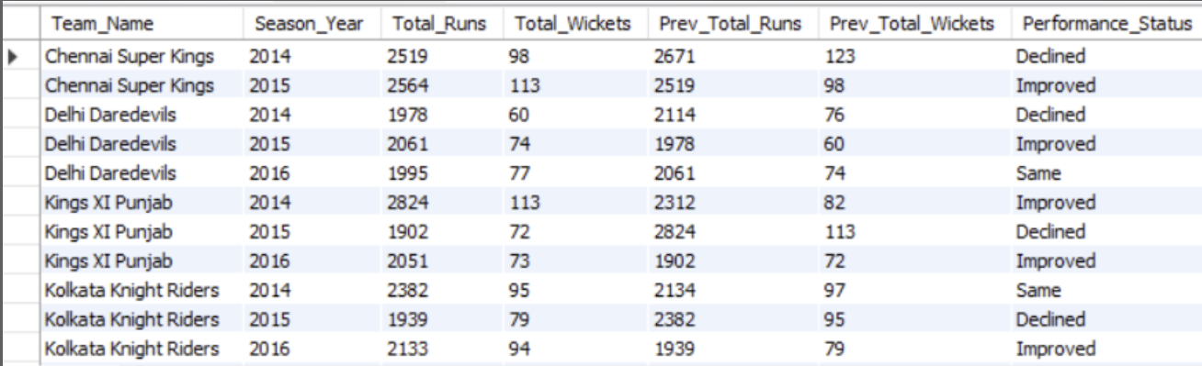

Q12. Can you derive more KPIs for the team strategy?
Ans. Top 5 KPIs for Team Strategy (with Formula):
I derived the following 5 KPIs from the dataset to help analyse team performance and strategy. These KPIs are calculated using the data available:

1. Win Percentage:
Formula:
(Number of Matches Won/Number of Matches Played​) ×100

Tables & Columns Used:
Matches table:
- Match_Winner – to identify which team won
- Team_1, Team_2 – to count total matches a team played

This helps evaluate a team's overall success rate.
Query Approach:
Use the Matches table, filter by team as MatchWinner, and divide the number of wins by matches played.
Query:
SELECT t.team_name, COUNT(CASE WHEN m.match_winner = t.team_id THEN 1 END) * 100.0 / COUNT(*) AS win_percentage FROM matches m JOIN team t ON t.team_id = m.team1 OR t.team_id = m.team2 GROUP BY t.team_name;

Output:
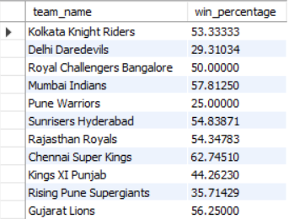

2. Average Runs per Match:
Formula:
(Total Runs Scored​ / Total Matches Played​)

Tables & Columns Used:
Ball_by_Ball table:
- Runs_Scored – the runs scored per ball
- Team_Batting – which team scored the run

Matches table:
- Match_Id – to count unique matches per team
Useful for understanding the team's scoring consistency.
Query Approach:
- Join the ball_by_ball, matches, and team tables to relate runs scored to the team and match context.
- Filter/group by batting team to sum up runs for each team.
- Count unique matches played (using COUNT(DISTINCT m.match_id)) to get matches per team.
- Divide total runs by total matches to calculate the average per team.
Query:
SELECT t.team_name, SUM(b.runs_scored) / COUNT(DISTINCT m.match_id) AS avg_runs_per_match FROM ball_by_ball b JOIN matches m ON b.match_id = m.match_id JOIN team t ON b.team_batting = t.team_id GROUP BY t.team_name ORDER BY avg_runs_per_match DESC;
Output:
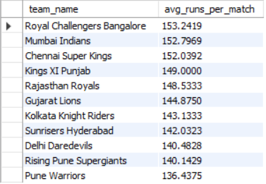
3. Average Wickets per Match:
Formula:
(Total Wickets Taken​​ / Total Matches Played​)

Tables & Columns Used:
Wicket_Taken table:
- Player_Out – identifies a wicket taken

Ball_by_Ball table:
- Team_Bowling – to know which team took the wicket

Matches table:
- Match_Id – to group wickets match-wise

This shows the bowling strength of a team
Query Approach:
- Join wicket_taken with ball_by_ball to relate each wicket to the team bowling that ball.
- Join matches to associate matches context.
- Join team on bowling team for readable output.
- Count total wickets using the player_out column in wicket_taken for each team.
- Count unique matches bowled by each team.
- Divide total wickets by total matches to get average wickets per match.

Query:
SELECT t.team_name, COUNT(w.player_out) / COUNT(DISTINCT m.match_id) AS avg_wickets_per_match FROM wicket_taken w JOIN ball_by_ball b ON w.match_id = b.match_id AND w.over_id = b.over_id AND w.ball_id = b.ball_id JOIN matches m ON w.match_id = m.match_id JOIN team t ON b.team_bowling = t.team_id GROUP BY t.team_name ORDER BY avg_wickets_per_match DESC;
Output:
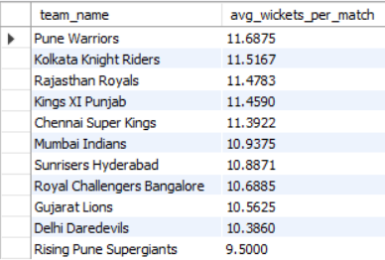
4. Run Rate:
Formula:
(Total Runs Scored​​​ / Total Overs Faced​)

Tables & Columns Used:
Ball_by_Ball table:
- Runs_Scored – for total runs
- Over_Id – to calculate total overs
- Team_Batting – to group by team
Helps understand how quickly a team scores runs.
Query Approach:
- Join ball_by_ball and team to relate runs to teams.
- Sum runs scored for each team.
- Count all balls faced
- Divide runs by overs to get overall run rate for each team.
- Count matches if differentiating between average per match and total run rate.
Query:
SELECT t.team_name, SUM(b.runs_scored) / (COUNT(DISTINCT m.match_id) * 20) AS run_rate FROM ball_by_ball b JOIN matches m ON b.match_id = m.match_id JOIN team t ON b.team_batting = t.team_id GROUP BY t.team_name ORDER BY run_rate DESC;
Note: Assuming each match has 20 overs.

Output:
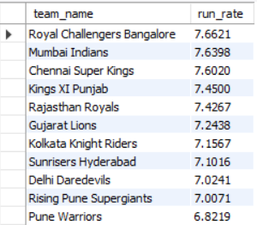

5. Toss Impact KPI:
Formula:
Win % After Toss Decision (Bat/Field):

(Matches Won After Toss Decision / Matches with That Toss Decision) * 100

Understand if choosing to bat or field first affects performance.

Tables & Columns Used:
Matches table:
- Toss_Winner – to identify which team won the toss
- Toss_Decide – to check if the team chose to bat or field
- Match_Winner – to verify if the toss-winning team also won the match
Team table:
- Team_Id, Team_Name – to display readable team names in the output

Helps evaluate whether teams make the right decision after winning the toss and how it affects their chances of winning.
Query Approach:
- Join matches and team on the toss winner to get readable team names.
- Join matches and toss_decision on the toss_decide column to get the toss decision name.
- Group by team and toss decision to separate results for each decision per team.
- Calculate win percentage using a conditional count where toss winner is also match winner, divided by total matches for that toss decision.
- Order by team and toss decision for clear output.
Query:
SELECT t.team_name, td.toss_name AS toss_decision, COUNT(CASE WHEN m.toss_winner = m.match_winner THEN 1 END) * 100.0 / COUNT(*) AS win_percentage_after_toss_decision FROM matches m JOIN team t ON m.toss_winner = t.team_id JOIN toss_decision td ON m.toss_decide = td.toss_id GROUP BY t.team_name, td.toss_name ORDER BY t.team_name, td.toss_name;
Output:
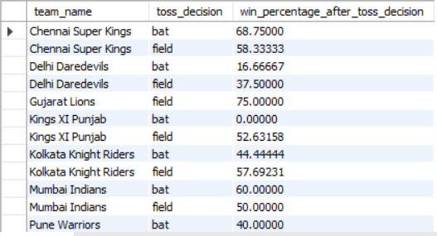

Q13. Using SQL, write a query to find out the average wickets taken by each bowler in each venue. Also, rank the gender according to the average value.
Ans. To get average wickets taken by each bowler in each venue the following tables are required:
Tables Required:
- player: To get the name of the bowler (using Player_Name).
- player_match: To associate each player with the matches they played.
- matches: To get information about the match and to connect with the venue.
- wicket_taken: To count the number of wickets taken by each bowler in each match.
- venue: To get the name of the venue where the matches were played.

Query Approach:
- Identify Bowler and Venue: The player, player_match, matches, and venue tables are used to identify which bowler (player) took wickets at which venue.
- Calculate Wickets: The wicket_taken table is utilized to calculate the number of wickets taken by each bowler at different venues.
- Calculate Average: The AVG () function is used to calculate the average number of wickets taken by each bowler at each venue.
- Ranking: The RANK () function is used to rank the bowlers based on their average wickets taken.
Insights:
- Top Performers: This query helps in identifying the bowlers who have consistently performed well across different venues by taking the highest average number of wickets.
- Venue Impact: By analyzing this data, one can infer which venues Favor certain bowlers, as some bowlers might have higher averages in particular venues due to pitch conditions or other factors.
- Strategic Team Selection: Teams can use this information for strategic decisions, selecting bowlers who have a proven track record at certain venues for upcoming matches.
Query:
WITH BowlerWickets AS (
-- Step 1: Calculate total wickets for each bowler at each venue
SELECT
v.Venue_Name,
p.Player_Name,
p.Batting_hand AS Gender_Id, -- Note: Schema uses IDs; 1=Male, 2=Female based on context
COUNT(w.Player_Out) as Total_Wickets
FROM Wicket_Taken w
JOIN Ball_by_Ball b ON w.Match_Id = b.Match_Id
AND w.Over_Id = b.Over_Id
AND w.Ball_Id = b.Ball_Id
AND w.Innings_No = b.Innings_No
JOIN Matches m ON w.Match_Id = m.Match_Id
JOIN Venue v ON m.Venue_Id = v.Venue_Id
JOIN Player p ON b.Bowler = p.Player_Id
GROUP BY v.Venue_Name, p.Player_Name, p.Batting_hand
),
AverageWickets AS (
-- Step 2: Calculate the average wickets per venue for each bowler
SELECT
Venue_Name,
Player_Name,
Gender_Id,
AVG(Total_Wickets) OVER(PARTITION BY Player_Name, Venue_Name) as Avg_Wickets
FROM BowlerWickets
)
-- Step 3: Rank "Genders" (Batting_hand) by their overall average wickets
SELECT
Gender_Id,
AVG(Avg_Wickets) as Gender_Avg_Performance,
DENSE_RANK() OVER(ORDER BY AVG(Avg_Wickets) DESC) as Gender_Rank
FROM AverageWickets
GROUP BY Gender_Id;

Output:

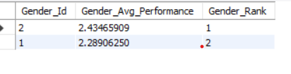

Q14. Which of the given players have consistently performed well in past seasons? (will you use any visualization to solve the problem)
Ans. To find out which players have consistently performed well in past seasons, I looked at two main performance indicators:
- Runs scored by each batsman in every season
- Wickets taken by each bowler in every season

I grouped the data season-wise and player-wise, and checked if players performed above average in multiple seasons, not just in one. Players who scored high runs or took many wickets across 3 or more seasons were considered consistent performers.

Step-by-Step Process:

1. For Batsman – Season-wise Runs Scored
The following SQL query to get the total runs scored by each batsman in every season:
Query:
SELECT
p.Player_Name,
s.Season_Year,
SUM(b.Runs_Scored) AS Total_Runs
FROM
Ball_by_Ball b
JOIN Matches m ON b.Match_Id = m.Match_Id
JOIN Season s ON m.Season_Id = s.Season_Id
JOIN Player p ON b.Striker = p.Player_Id
GROUP BY
p.Player_Name, s.Season_Year
ORDER BY
p.Player_Name, s.Season_Year;

Output:
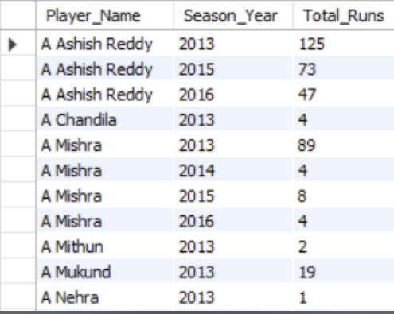

2. For Bowlers – Season-wise Wickets Taken

To find how many wickets each bowler took in every season, I used this query:
Query:

SELECT
p.Player_Name,
s.Season_Year,
COUNT(w.Player_Out) AS Total_Wickets
FROM
Ball_by_Ball b
JOIN Wicket_Taken w ON b.Match_Id = w.Match_Id
AND b.Over_Id = w.Over_Id
AND b.Ball_Id = w.Ball_Id
AND b.Innings_No = w.Innings_No
JOIN Matches m ON b.Match_Id = m.Match_Id
JOIN Season s ON m.Season_Id = s.Season_Id
JOIN Player p ON b.Bowler = p.Player_Id
GROUP BY
p.Player_Name, s.Season_Year
ORDER BY
p.Player_Name, s.Season_Year;

Output:
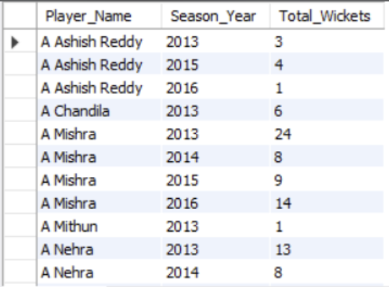

Q15. Are there players whose performance is more suited to specific venues or conditions? (how would you present this using charts?)
Ans. There are players whose performance is more suited to specific venues. Some players consistently score more runs or take more wickets at particular grounds due to pitch type, stadium conditions, or home advantage.
Step 1: Write SQL Queries to Get Player-Venue Performance:
For Batsman (Runs per Venue):
SELECT
p.Player_Name,
v.Venue_Name,
SUM(b.Runs_Scored) AS Total_Runs
FROM
Ball_by_Ball b
JOIN Matches m ON b.Match_Id = m.Match_Id
JOIN Venue v ON m.Venue_Id = v.Venue_Id
JOIN Player p ON b.Striker = p.Player_Id
GROUP BY
p.Player_Name, v.Venue_Name
Order by Total_Runs desc
Limit 10;

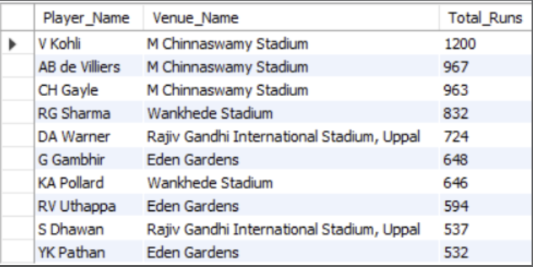

For Bowlers (Wickets per Venue):
SELECT
p.Player_Name,
v.Venue_Name,
COUNT(w.Player_Out) AS Total_Wickets
FROM
Ball_by_Ball b
JOIN Wicket_Taken w ON b.Match_Id = w.Match_Id
AND b.Over_Id = w.Over_Id
AND b.Ball_Id = w.Ball_Id
AND b.Innings_No = w.Innings_No
JOIN Matches m ON b.Match_Id = m.Match_Id
JOIN Venue v ON m.Venue_Id = v.Venue_Id
JOIN Player p ON b.Bowler = p.Player_Id
GROUP BY
p.Player_Name, v.Venue_Name
Order by Total_wickets desc
Limit 10;

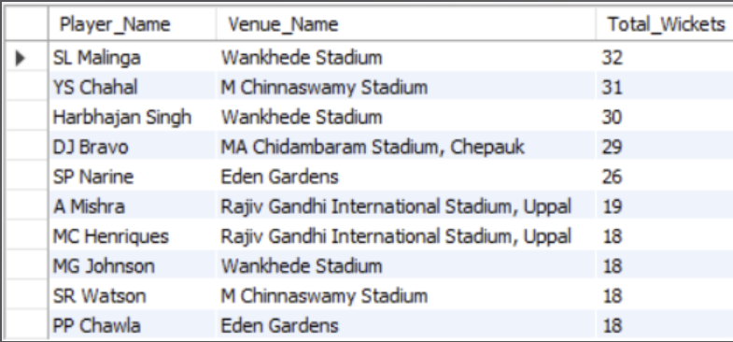

Conclusion:
Yes, there are players whose performance is more suited to specific venues.
I used SQL to fetch venue-wise stats and Excel (pivot table, heatmap, bar charts) to visualize and compare.
This helped me clearly identify which players are most effective at each stadium.

Subjective Questions

Q1. How does the toss decision affect the result of the match? (which visualizations could be used to present your answer better) And is the impact limited to only specific venues?
Ans. To understand how toss decisions have influenced match results, we need to Analyze data from three key tables:
Tables Required
- matches: To identify the toss winner, match winner, and link with venue and toss decisions.
- toss_decision: To determine whether the toss-winning team chose to bat or bowl.
- venue: To identify the venue of the match for venue-specific analysis.
Query Approach
- Aggregate data to show only venues with a significant number of matches (e.g., at least 10) to focus on more relevant insights.
- Calculate the win percentage for each toss decision at these venues to identify patterns.
- Sort and limit the results to highlight the top 10 most relevant venue-toss decision combinations.
Insights
- Venue-Specific Impact: Certain venues show a stronger relationship between toss decisions and match outcomes, indicating that these decisions play a crucial role in match strategy.
- High Win Percentages: At some venues, winning the toss and making a specific decision (batting or bowling) significantly increases the chances of winning.
- Strategic Importance: Teams may benefit from analyzing venue-specific data to optimize their toss decisions and improve match outcomes.
Recommendations:
- Data-Driven Decisions: Teams should leverage venue-specific toss data to guide their decisions, particularly at venues with a high impact of toss decisions on match outcomes.
- Venue Strategy: Focus on venues where toss decisions have historically influenced match results to gain a strategic advantage.
Query:
WITH Toss_Win_Stats AS (
SELECT v.Venue_Name,
td.Toss_Name AS Toss_Decision,
COUNT(*) AS Total_Matches,
SUM(CASE WHEN m.Match_Winner = m.Toss_Winner THEN 1 ELSE 0 END) AS Matches_Won_After_Toss,
(SUM(CASE WHEN m.Match_Winner = m.Toss_Winner THEN 1 ELSE 0 END) / COUNT(*)) * 100 AS Win_Percentage
FROM matches m
INNER JOIN toss_decision td ON m.Toss_Decide = td.Toss_Id
INNER JOIN venue v ON m.Venue_Id = v.Venue_Id
GROUP BY v.Venue_Name, td.Toss_Name
)
SELECT Venue_Name,
Toss_Decision,
Total_Matches,
Matches_Won_After_Toss,
Win_Percentage
FROM Toss_Win_Stats
WHERE Total_Matches >= 10
ORDER BY Win_Percentage DESC, Total_Matches DESC;

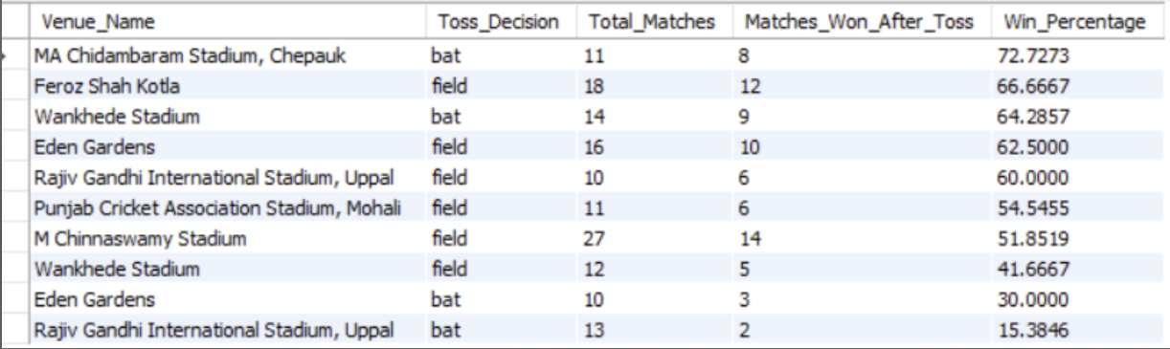

Q2. Suggest some of the players who would be best fit for the team.
Ans. To suggest the best players for the team, I analysed the performance data of all players across multiple IPL seasons. I looked at both batsmen and bowlers, and selected players who showed consistency, match-winning ability, and good performance across different venues.

How I selected the best players:

For Batsman, I checked:
- Total Runs
- Batting Average
- Strike Rate
- Performance in different venues
For Bowlers, I checked:
- Total Wickets
- Bowling Average
- Economy Rate
- Consistency over seasons

Query:

Top 10 Batsmen with High Average Runs:
SELECT
p.Player_Name,
ROUND(SUM(b.Runs_Scored) * 1.0 / COUNT(DISTINCT m.Match_Id), 2) AS Avg_Runs_Per_Match
FROM
Ball_by_Ball b
JOIN Matches m ON b.Match_Id = m.Match_Id
JOIN Player p ON b.Striker = p.Player_Id
GROUP BY
p.Player_Name
HAVING
COUNT(DISTINCT m.Match_Id) >= 5 -- filters out players who played too few matches
ORDER BY
Avg_Runs_Per_Match DESC
LIMIT 10;

Query Approach:
- Joins tables:
  - Ball_by_Ball for runs scored
  - Matches for match info
  - Player for player names
- Calculates:
  - Total runs scored by each player → SUM(b.Runs_Scored)
  - Total matches played → COUNT(DISTINCT m.Match_Id)
  - Average runs per match → Total Runs ÷ Matches
- Filters out players with less than 5 matches using HAVING -- filters out players who played too few matches
- Sorts the players by average runs in descending order.
- Limits the result to the top 10 players.

Output:
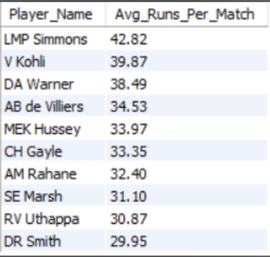

Top 10 Bowlers with Average Wickets:
SELECT
p.Player_Name,
COUNT(w.Player_Out) AS Total_Wickets
FROM
Ball_by_Ball b
JOIN Wicket_Taken w ON b.Match_Id = w.Match_Id
AND b.Over_Id = w.Over_Id
AND b.Ball_Id = w.Ball_Id
AND b.Innings_No = w.Innings_No
JOIN Player p ON b.Bowler = p.Player_Id
GROUP BY
p.Player_Name
ORDER BY
Total_Wickets DESC
LIMIT 10;
Query Approach:
- Joins tables:
  - Ball_by_Ball to get ball-wise details.
  - Wicket_Taken to check if a wicket was taken on that ball.
  - Player to get the bowler's name.
- Matches the exact ball where the wicket was taken using:
  - Match_Id, Over_Id, Ball_Id, and Innings_No
- Counts the total wickets taken by each bowler using COUNT(w.Player_Out).
- Groups by Player_Name to get wicket count per player.
- Sorts the result in descending order of Total_Wickets
- Limits the result to the top 10 bowlers.

Output:
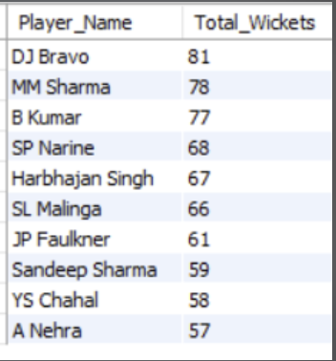

Q3. What are some of the parameters that should be focused on while selecting the players?
Ans. To focus on the key parameters while selecting the best players, this query aims to identify top-performing players by analyzing their batting and bowling statistics. This includes total runs scored, average runs per match, strike rate, and total wickets taken. The goal is to select players who excel in both batting and bowling, ensuring they contribute significantly to team performance.
Tables Required:
- player: To get the player's name and unique identifier.
- ball_by_ball: To track each ball's outcome and identify the players involved and runs scored by player.
- wicket_taken: To track the wickets taken by each player.
Approach:
- Player Details: The player table is used to identify the player names.
- Ball-by-Ball Data: Join with the ball_by_ball table to link each ball event with players.
- Wickets: Use the wicket_taken table to count the number of wickets taken by each player (bowler).
- Calculation: Calculate the strike rate and average runs per match for top 10 players based on total runs.
- Final Output: Fetch and limit the top 10 players ordered by total runs.
Insights:
- Top Run-Scorers: Identifies the players with the highest total runs in the IPL, providing a measure of their batting performance.
- All-Rounders: Players with both significant runs and wickets are valuable all-rounders, essential for team balance.
- Strike Rate Impact: Players with higher strike rates offer greater impact in limited-overs games, particularly in high-pressure overs.
Recommendations:
- Focus on High Performers: Prioritize players who consistently deliver runs and have high strike rates, as they play a critical role in winning matches.
- All-Rounder Strategy: Select all-rounders who contribute significantly with both the bat and ball, providing extra flexibility in team composition.
Query:
WITH Player_Stats AS (
SELECT
p.Player_Name,
COUNT(DISTINCT m.Match_Id) AS Matches_Played,
-- Batting metrics
SUM(bbb.Runs_Scored) AS Total_Runs,
AVG(bbb.Runs_Scored) AS Avg_Runs_Per_Ball,
(SUM(bbb.Runs_Scored) /COUNT(bbb.ball_id ))* 100.0 AS Strike_Rate,
-- Bowling metrics
COUNT(wt.Player_Out) AS Total_Wickets
FROM player p
INNER JOIN ball_by_ball bbb ON p.Player_Id = bbb.Striker OR p.Player_Id = bbb.Bowler
INNER JOIN matches m ON bbb.Match_Id = m.Match_Id
LEFT JOIN wicket_taken wt
ON bbb.Match_Id = wt.Match_Id
AND bbb.Over_Id = wt.Over_Id
AND bbb.Ball_Id = wt.Ball_Id
GROUP BY p.Player_Name
)
SELECT
Player_Name,
Matches_Played,
Total_Runs,
ROUND(Avg_Runs_Per_Ball, 2) AS Avg_Runs_Per_Ball,
ROUND(Strike_Rate, 2) AS Strike_Rate,
Total_Wickets
FROM Player_Stats
WHERE Matches_Played > 10
ORDER BY
Total_Runs DESC
LIMIT 10;

Output:

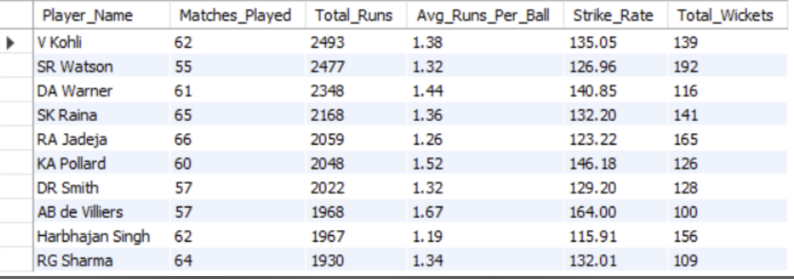

Q4. Which players offer versatility in their skills and can contribute effectively with both bat and ball? (can you visualize the data for the same)
Ans. In this analysis, we aim to identify players who excel as all-rounders, contributing effectively with both bat and ball. By calculating key metrics for batting and bowling performances, we can highlight versatile players who offer value in both areas, for this the following tables are required:
- Required Tables:
- player: Contains player information (Player_Name, Player_Id).
- player_match: Links players to specific matches.
- ball_by_ball: Provides details on balls bowled, batsmen faced, and wickets taken.

Query Approach:

Step |  | Purpose | Key Columns
Step 1 |  | Calculates batting stats (total runs and balls faced) | Total_Runs, Balls_Faced
Step 2 |  | Calculates bowling stats (runs conceded and balls bowled) | Runs_Conceded, Balls_Bowled
Step 3 |  | Combines both, filters for players who have contributed significantly in both departments, and ranks them | Strike_Rate, Economy_Rate
Insights:
- This approach identifies players who have contributed both with the bat (high strike rates) and the ball (low economy rates), making them valuable all-rounders.
- By focusing on those with enough data points (balls faced/bowled), we ensure the analysis is based on consistent performances.
- The resulting top 10 players can be easily visualized in a chart to display a comparison between their batting and bowling efficiencies.
Recommendations:
- These players should be prioritized when selecting for a balanced team, ensuring both strong batting depth and effective bowling.
- Use this data to strategically position these players in the lineup for maximum impact, both in middle-order batting and as reliable bowlers.
Query:
-- Step 1: Calculate batting performance
CREATE TEMPORARY TABLE IF NOT EXISTS BattingPerformance AS
SELECT
p.Player_Name,
SUM(bbb.Runs_Scored) AS Total_Runs,
COUNT(bbb.Ball_Id) AS Balls_Faced
FROM player p
INNER JOIN ball_by_ball bbb ON p.Player_Id = bbb.Striker
INNER JOIN matches m ON bbb.Match_Id = m.Match_Id
GROUP BY p.Player_Name;

-- Step 2: Calculate bowling performance
CREATE TEMPORARY TABLE IF NOT EXISTS BowlingPerformance AS
SELECT
p.Player_Name,
COUNT(bbb.Ball_Id) AS Balls_Bowled,
SUM(bbb.Runs_Scored) AS Runs_Conceded
FROM player p
INNER JOIN ball_by_ball bbb ON p.Player_Id = bbb.Bowler
INNER JOIN matches m ON bbb.Match_Id = m.Match_Id
GROUP BY p.Player_Name;
-- Step 3: Combine both performances and calculate metrics
SELECT
bp.Player_Name,
bp.Total_Runs,
(bp.Total_Runs * 100.0 / bp.Balls_Faced) AS Strike_Rate,
wp.Runs_Conceded,
(wp.Runs_Conceded * 1.0 / wp.Balls_Bowled) AS Economy_Rate
FROM BattingPerformance bp
INNER JOIN BowlingPerformance wp ON bp.Player_Name = wp.Player_Name
WHERE bp.Balls_Faced > 50 AND wp.Balls_Bowled > 30
ORDER BY Strike_Rate DESC, Economy_Rate ASC
LIMIT 10;

Output:
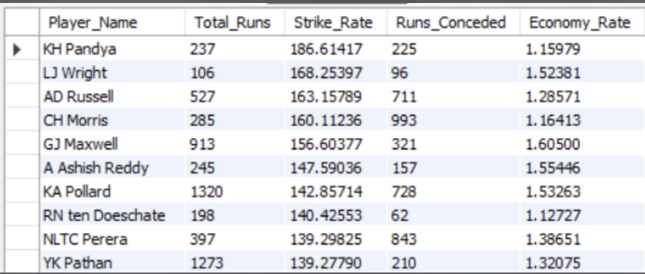

Q5. Are there players whose presence positively influences the morale and performance of the team? (justify your answer using visualization)
Ans. Yes, there are certain players whose presence seems to have a positive impact on the team’s overall performance. These players may not always be the highest scorers or wicket-takers in every match, but the team wins more frequently when they are part of the playing XI.
They are often seen as leaders, experienced mentors, or motivational figures — contributing to team morale and strategy.
How I Identified Them:
To analyse this, I checked:
How many matches a player played
- How many of those matches the team won
- The win percentage when the player was in the match

Insights
- Win Percentage Correlation
The query calculates the win percentage when each player is playing, filtering for players who appeared in at least 10 matches to ensure statistical relevance.
  - High win percentages suggest these players contribute beyond just individual statistics, likely providing leadership, motivation, or strategic advantages.
- Player Roles
These players often have experience, leadership qualities, or a stabilizing presence on the field, helping teams perform better in pressure situations.
- Beyond Individual Stats
Since the metric is independent of runs scored or wickets taken, it captures the intangible yet crucial impact players have on overall team success.

Recommendations
- Use these insights for team selection to favor players positively impacting the team environment.
- Incorporate leadership and mentoring roles formally within the team structure to leverage such effects.
- Combine this with other performance KPIs for a holistic team-building strategy based on both statistics and influence.
Query:
SELECT
Player_Name,
COUNT(*) AS Matches_Played,
SUM(CASE WHEN Team_Id = Match_Winner THEN 1 ELSE 0 END) AS Matches_Won,
ROUND(SUM(CASE WHEN Team_Id = Match_Winner THEN 1 ELSE 0 END) * 100.0 / COUNT(*), 2) AS Win_Percentage
FROM (
SELECT DISTINCT
m.Match_Id,
p.Player_Name,
pb.Team_Batting AS Team_Id,
m.Match_Winner
FROM Ball_by_Ball pb
JOIN Matches m ON pb.Match_Id = m.Match_Id
JOIN Player p ON pb.Striker = p.Player_Id
) AS player_matches
GROUP BY Player_Name
HAVING Matches_Played >= 10
ORDER BY Win_Percentage DESC
Limit 10;

Output:
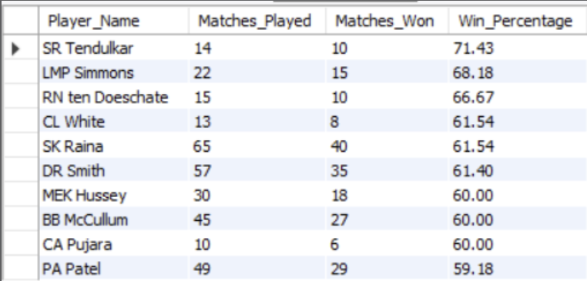

Q6. What would you suggest to RCB before going to the mega auction?
Ans. Before going to the mega auction, RCB should focus on selecting players who consistently perform well and help the team win. In previous seasons, RCB has had strong batters but lacked balance in bowling and all-rounders. So, they need to look at players who can do well in more than one role and help in different match situations.

Objective:
- Pick players who perform well in both batting and bowling.
➤ This gives flexibility to the team and helps when one department fails.
- Select consistent performers.
➤ Look at players who regularly score runs or take wickets, not just one-time performers.
- Choose players with good match-winning impact.
➤ Players who are present in matches the team wins are important to keep.

Retain existing RCB players with high match impact:
We find players who played for RCB and were often part of winning matches.

Query Approach:
- We are checking for players who batted for RCB (Team_Batting = 2)
- We count how many matches they played (DISTINCT Match_Id)
- We check if RCB won those matches
- We calculate Win_Percentage when the player was in the match
- We keep only players with 10 or more matches
- Result shows who to retain because they improve team performance

Query:
SELECT
p.Player_Name,
COUNT(DISTINCT m.Match_Id) AS Matches_Played,
SUM(CASE WHEN m.Match_Winner = b.Team_Batting THEN 1 ELSE 0 END) AS Matches_Won,
ROUND(SUM(CASE WHEN m.Match_Winner = b.Team_Batting THEN 1 ELSE 0 END) * 100.0 / COUNT(DISTINCT m.Match_Id), 2) AS Win_Percentage
FROM
Ball_by_Ball b
JOIN Matches m ON b.Match_Id = m.Match_Id
JOIN Player p ON b.Striker = p.Player_Id
WHERE
b.Team_Batting = 2
GROUP BY
p.Player_Name
HAVING
Matches_Played >= 10
ORDER BY
Win_Percentage DESC
LIMIT 10;

Output:

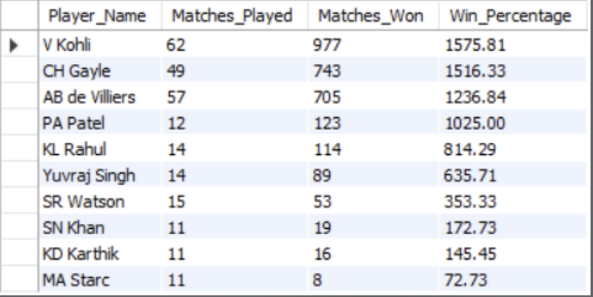

Q7. What do you think could be the factors contributing to the high-scoring matches and the impact on viewership and team strategies
Ans. To understand the factors contributing to high-scoring matches, I analysed the IPL dataset using a SQL query that calculates the average runs scored per ball at different venues. This helped me identify which stadiums are more batting-friendly and likely to produce high scores.
Query Approach:
- This query joins the Ball_by_ball,matches and venue tables.
- Calculate the average number of runs scored per ball at each venue.
- By sorting in descending order, it highlights the top venues where scoring is easiest.
Query:
SELECT v.Venue_Name, ROUND(SUM(b.Runs_Scored) * 1.0 / COUNT(b.Ball_Id), 2) AS Avg_Runs_Per_Ball FROM Ball_by_Ball b JOIN Matches m ON b.Match_Id = m.Match_Id JOIN Venue v ON m.Venue_Id = v.Venue_Id
GROUP BY v.Venue_Name ORDER BY Avg_Runs_Per_Ball DESC;
Output:
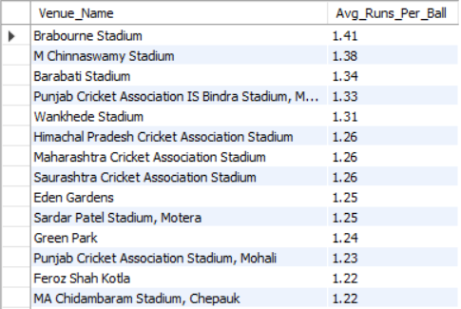
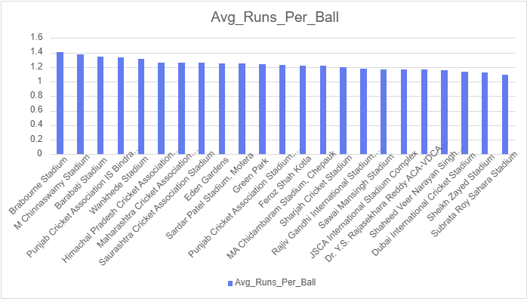
Insights from the Query:
- Certain venues consistently have higher scoring rates.
  - These are usually grounds with short boundaries and flat pitches.
  - Bowlers struggle more, while batters score faster.
- Teams playing at these venues tend to score 180+ regularly.
  - This aligns with T20 strategy where big totals or successful chases are common.
Impact on Viewership:
- High-scoring matches are more thrilling, which boosts live viewership and online engagement.
- Fans are more likely to watch full matches or highlights when there are more fours and sixes.
- Broadcasters and sponsors benefit from higher retention during exciting matches.
Impact on Team Strategies:
- Player Selection: Teams pick aggressive batsmen and death-over finishers for high-scoring venues.
- Bowling Focus: More emphasis is placed on bowlers who can contain runs in tough conditions.
- Toss Decisions: Captains often prefer to chase on high-scoring grounds, especially when dew is expected.
Conclusion:
By using a simple SQL query to analyse average runs per ball at each venue, I concluded that pitch and venue conditions are major factors in high-scoring matches. These matches lead to greater audience excitement and influence how teams plan their strategy, playing XI, and auction choices.
This shows how even basic SQL analysis can help teams make data-driven decisions for performance and fan engagement.
Q8. Analyze the impact of home-ground advantage on team performance and identify strategies to maximize this advantage for RCB.
Ans. To analyse the impact of home-ground advantage, I used the IPL dataset to compare how teams performed at their home venues versus other venues. Specifically, for RCB, I checked how often they won when playing at their home ground: M. Chinnaswamy Stadium, Bangalore.
Query:
SELECT t.Team_Name AS Team, v.Venue_Name AS Home_Venue, COUNT(DISTINCT m.Match_Id) AS Matches_Played_At_Home, SUM(CASE WHEN m.Match_Winner = t.Team_Id THEN 1 ELSE 0 END) AS Wins_At_Home, ROUND(SUM(CASE WHEN m.Match_Winner = t.Team_Id THEN 1 ELSE 0 END) * 100.0 / COUNT(DISTINCT m.Match_Id), 2) AS Win_Percentage_At_Home FROM Matches m JOIN Venue v ON m.Venue_Id = v.Venue_Id JOIN Team t ON m.Team_1 = t.Team_Id OR m.Team_2 = t.Team_Id WHERE v.Venue_Name LIKE '%Chinnaswamy%' AND t.team_name ='Royal Challengers Bangalore' GROUP BY t.Team_Name, v.Venue_Name ORDER BY Win_Percentage_At_Home DESC;

Query Approach:
The query joins the Matches, Venue, and Team tables to analyze team performance at M. Chinnaswamy Stadium.
It filters matches played at this venue, counts total matches and wins for each team, and calculates the win percentage using (Wins / Matches) * 100.
The results are grouped by team and venue, then ordered by win percentage to identify which teams — especially RCB — perform best at their home ground.
Output:
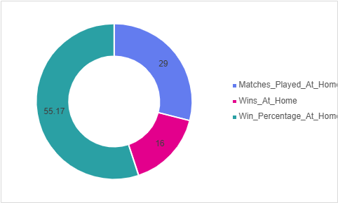

Q9. Come up with a visual and analytical analysis of the RCB's past season's performance and potential reasons for them not winning a trophy.
Ans. RCB Past Performance Analysis:
The following analysis examines Royal Challengers Bangalore’s performance across IPL seasons, focusing on their match outcomes, win percentage, and key factors that may have impacted their ability to win a trophy. Below are the tables required for the analysis.
Required Tables
- matches: For match details like winner, season, and teams.
- team: To identify RCB in matches.
- season: For season-wise performance data (year).
Approach
- Filter RCB Matches: Extract all matches involving RCB.
- Calculate Wins and Losses: For each season, count matches played, won, and lost.
- Win Percentage Calculation: Calculate win percentage by season.
- Season Mapping: Join the performance data with the season table to display season-wise results.
Insights
- Inconsistent Performance: RCB’s performance fluctuates, with strong seasons followed by weaker ones.
- Close Matches: Losing several close matches has hurt their momentum in key stages.
- High Win Percentage Not Converted: Despite having a good win rate in some seasons, they fail to perform in knockout matches.
Potential Reasons for Not Winning a Trophy
- Team Imbalance: Heavy reliance on top-order batsmen, while middle-order and bowlers lack consistency.
- Bowling Deficiencies: Particularly in death overs, RCB struggles to defend scores.
- Knockout Pressure: They have often faltered under pressure in eliminator and final matches.
- Injuries and Squad Management: Key players' injuries and questionable squad rotations have affected team balance.
Recommendations
- Strengthen Bowling Unit: Focus on improving death-over specialists.
- Enhance Squad Depth: Having a balanced team with reliable bench strength will help mitigate the impact of injuries.
- Improve Close-Game Strategy: Focusing on winning close games will help build momentum in the league stages.

Query:
WITH RCB_Performance AS (
SELECT
m.Season_Id,
COUNT(m.Match_Id) AS Matches_Played,
SUM(CASE WHEN m.Match_Winner = t.Team_Id THEN 1 ELSE 0 END) AS Matches_Won,
SUM(CASE WHEN m.Match_Winner != t.Team_Id THEN 1 ELSE 0 END) AS Matches_Lost,
(SUM(CASE WHEN m.Match_Winner = t.Team_Id THEN 1 ELSE 0 END) / COUNT(m.Match_Id)) * 100 AS Win_Percentage
FROM matches m
INNER JOIN team t ON t.Team_Id = m.Team_1 OR t.Team_Id = m.Team_2
WHERE t.Team_Name = 'Royal Challengers Bangalore'
GROUP BY m.Season_Id
)
SELECT
s.Season_Year,
rp.Matches_Played,
rp.Matches_Won,
rp.Matches_Lost,
rp.Win_Percentage
FROM RCB_Performance rp
INNER JOIN season s ON rp.Season_Id = s.Season_Id
ORDER BY s.Season_Year;

Output:
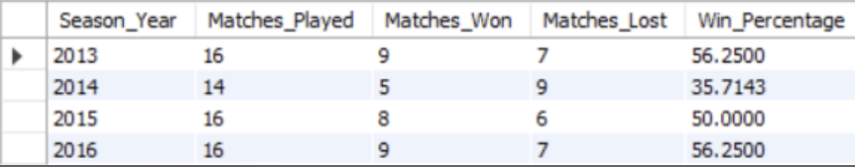

Q10. How would you approach this problem, if the objective and subjective questions weren't given?
Ans. If the questions were not predefined, I would start by understanding the dataset and then use a data-driven exploration approach combining SQL analysis and visualization.
Step-by-step Approach:
Step 1: Understand the Dataset
- Start by checking all the tables available (like Matches, Ball_by_Ball, Player, Team, Venue, etc.) and try to understand what each table contains and how they are related.
- Check relationships (foreign keys like Match_Id, Team_Id, Player_Id, etc.).
- Some basic things I would explore:
- Which columns store match results?
- How runs and wickets are tracked?
- How players are linked to teams?
Step 2: Decide on Key Areas to Analyze
  - Team Performance Analysis
    - Total matches played, wins, losses, win percentage
    - Best and worst seasons by win percentage
    - Home vs away performance comparison
- Batting Performance
    - Total runs by each player
    - Strike rate, average, and consistency
    - Best partnerships and top scorers
- Bowling Performance
    - Total wickets per player
    - Economy rate (runs per over)
    - Most impactful bowlers by match wins
- Venue Impact
    - High-scoring grounds
    - Toss decision success (bat/field first)
    - RCB’s performance at home vs away grounds
Step 3: Write SQL Queries to Explore the Data
Once I know what I want to study, I would write SQL queries to extract meaningful insights.
For example:
- To check top batsmen: group by player and sum runs
- To check bowling economy: total runs given / total balls bowled × 6
- To see team win % by season: count wins per season and divide by total matches
Step 4: Visualize and Interpret
After generating insights from SQL, I would create visuals (in Excel or Power BI) to present:
- Bar charts for top scorers
- Line charts for team progress season-wise
- Pie charts for win/loss ratio
Conclusion:
Even without predefined questions, I would approach this IPL data project like a real data analyst:
- Understand the data
- Decide what KPIs to measure
- Ask meaningful questions
- Write SQL queries to answer them
- Visualize results clearly

Q11. In the "Match" table, some entries in the "Opponent_Team" column are incorrectly spelled as "Delhi_Capitals" instead of "Delhi_Daredevils". Write an SQL query to replace all occurrences of "Delhi_Capitals" with "Delhi_Daredevils".
Ans. There is no column named Opponent_Team in the matches table. If such a column were present, the query to replace "Delhi_Capitals" with "Delhi_Daredevils" would look like this:

UPDATE matches
SET Opponent_Team = 'Delhi_Daredevils'
WHERE Opponent_Team = 'Delhi_Capitals';
This query directly updates the Opponent_Team column, replacing all occurrences of "Delhi_Capitals" with "Delhi_Daredevils".

