Zomato Restaurant Analysis
Objective:
To analyze the data and come up with some useful insights to open a new restaurant.

Q1. What is the total no. of tables present in the data?
Ans. The Excel file “Zomato_Data.xlsx” has 2 tables:
- Raw Data – This table has all the main information about restaurants like name, location, rating, cuisines, cost, etc. It will help us analyze and find the best places for Zomato to open new restaurants.
- Country Description – This table explains the country codes used in the main table. It helps us know which country each restaurant belongs to.
These two tables together give us all the information we need to study Zomato's current data and suggest new places for expansion.
Q2. What is the total no. of attributes present in the data?
Ans. The dataset contains two tables: the Raw Data table with 20 attributes, and the Country Description table with 2 attributes, making a total of 22.
Q3. How many categorical columns are there in the data? [Search about categorical and continuous data, and try to answer this question]
Ans. Categorical data is information that is grouped into different categories or labels. It tells us the type or name of something, but not a number we can calculate with. So, in this dataset we have 14 following categorical columns:
RestaurantName, City, Address, Locality, LocalityVerbose, Cuisines, Currency, Has_Table_booking, Has_Online_delivery, Is_delivering_now, Switch_to_order_menu, Datekey_Opening, CountryCode, Price_Range
Q4. The data consists of some inconsistent and missing values so ensure that the data used for further analysis is cleaned.
Ans. Findings:
- The “Datekey_Opening” consists of inconsistent format.
- At the end of each column use “Countblank()” formula to check whether there is any blank cell or not. So found that in “Cuisines” column there are 9 blank cells. And there 9 blank cells are from same country code i.e. 216.
- Used Remove duplicates in whole data but no duplicate is there.
Approach:
- For Datekey_Opening
Used =TEXT(DATEVALUE( SUBSTITUTE(V2,"_","-")),"dd-mm-yyyy") formula to convert the value in date. And created the new column Updated_Datekey_Opening.

- For Cuisines column
Created pivot table with Cuisines in row and count of cuisines as values then created a filter with country code 216 to get the most frequent cuisine type for the country.

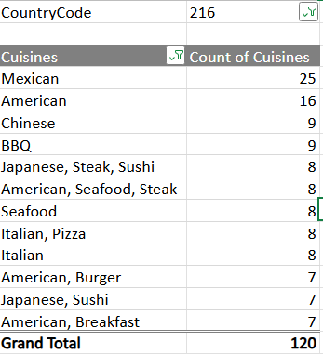
Now, got the most frequent cuisine “Mexican” and used formula =IF(ISBLANK($J2),"Mexican",$J2) in the new column Updated_Cuisine.

Q5. Using the LookUp functions, fill up the countries in the original data using the country code.
Ans. Used VLOOKUP function to fetch the country names in Raw Data sheet.
Approach:
- Inserted a new column next to the CountryCode column in the Raw Data sheet. I named this new column Country.
- Used the following Vlookup formula to fetch country names from Country description sheet.
=VLOOKUP(C2,'country description'!$A$1:$B$16,2)
Where:
- C2 is the country code
- 'country description'!$A$1:$B$16 is the range from country description table.
- 2 means we want value from the second column from the range

- Using fill handle functionality fill all the cells.
Q6. Create a table to represent the number of restaurants opened in each country.
Ans. Using Pivot Table created the table Country Vs. Count of Restaurant. Below are the steps:
- Firstly, select all the range from Raw Data.
- Go to Insert -> Pivot table then select the cell where we want to insert the pivot table.
- Once the table is created select Country in Row section and select Restaurant in Value section. By default, it may display sum of values, but we must change it to count to get the number of restaurants.

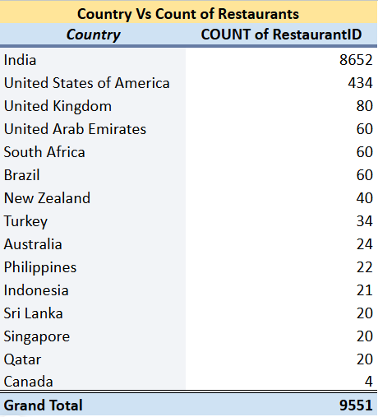
Q7. Also, the management wants to look at the number of restaurants opened each year, so provide them with something here.
Ans. To help management to track restaurant growth each year, I analyzed the Updated_DataKey_Opened column and extract year from that column by using the formula =Year(W2) in the new column Year. And with the help of Pivot table got the below count.
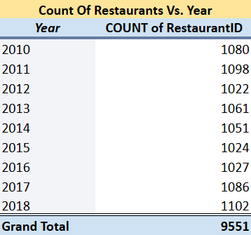
Q8. What is the total number of restaurants in India in the price range of 4?
Ans. Using countifs formula to get the count of restaurants in India having price range of 4.
Formula : =COUNTIFs('Raw Data'!D2:D9552,"India",'Raw Data'!R2:R9552,"4")
{ref. 'country description'!E20}
The result is 388, indicating there are 388 restaurants in India with a price range of 4.
Q9. What is the average number of voters for the restaurants in each country according to the data?
Ans. Using pivot table and column chart got the average number of voters.
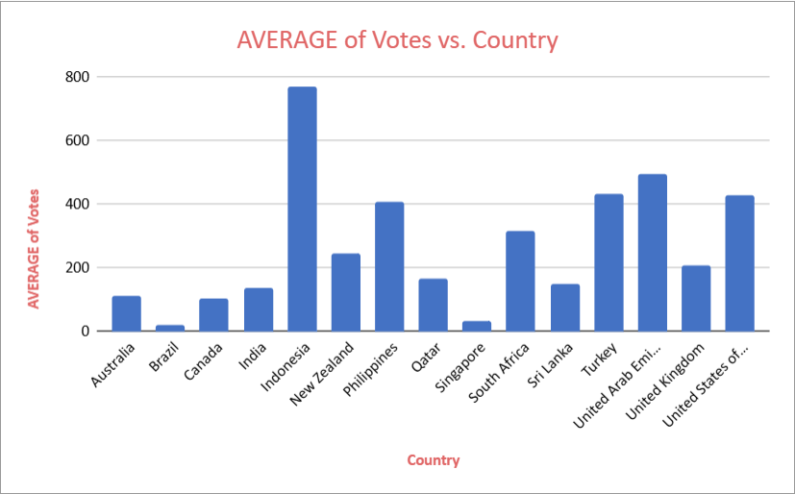
Observation:
- Using the column chart, Indonesia has the highest Avg. no of voters 772.0952381
- Brazil has the lowest Avg. no of voters 19.61666667
Q10. Calculate the average rating for all the restaurants that have price_range < 4 and provide online delivery. Use only the “IF” function, Logical Operators, and Aggregation functions to solve this problem. [Note: Don’t use Conditional aggregation in this question.]
Ans. Used Average, IF function and Array Formula to get the average rating. So, the average rating for all the restaurants that have price range <4 and online delivery is 3.27381151 {ref.‘country description’ E21:E24}.

=ArrayFormula(AVERAGE(IF(('Raw Data'!$R$2:$R$9552<4)*('RawData'!$O$2:$O$9552="Yes"),'Raw Data'!$U$2:$U$9552)))
Where: R -> Price_range, O -> Has_Online_delivery, U-> Rating

Q11. Using Conditional formatting highlight the rows of restaurants that are located in the countries or cities that you’ve suggested to the management for opening new restaurants.
Ans. To find countries or cities that I have suggested to the management for opening new restaurants below are the step:
- Firstly, created a pivot table in which taken rows as Country and Average of rating as Values and took count of restaurants as values.
- And arrange table in ascending order of Count of Restaurants.
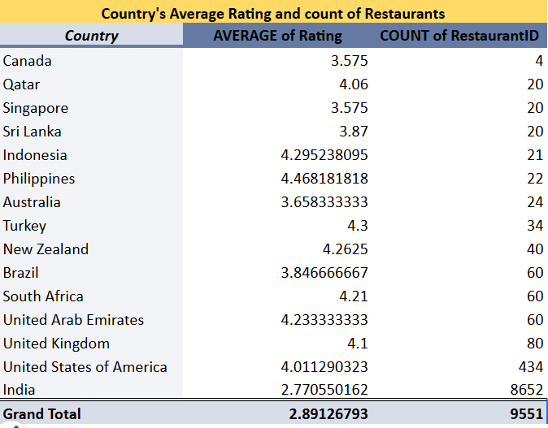
Observation:
- 4 countries (Canada, Qatar, Singapore and Sri Lanka) have count of restaurants less than or equal to 20 but have average rating above 3.5
- So, I would suggest management to open restaurant in these 4 countries as there is low competition and rate of customer satisfaction is also good.
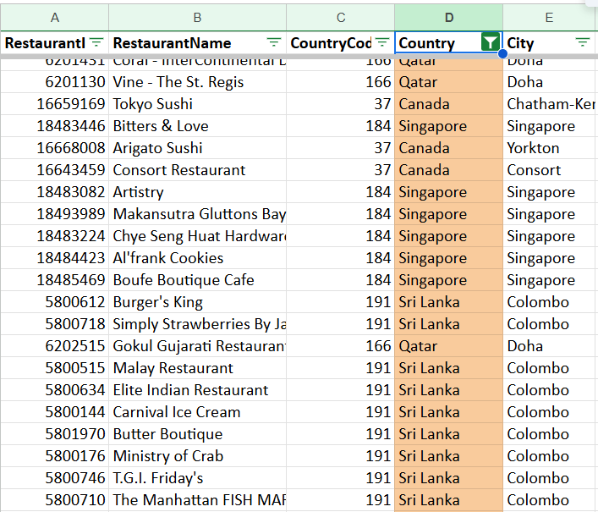
- Used Conditional formatting to highlight the rows of restaurants that are in the countries that I’ve suggested to the management for opening new restaurants.
- Home -> Conditional Formatting -> New Rule
- Give range as D2:D9552
- Under “Format cell if” select “Custom formula is”
- Give custom formula as:
=OR ($D2="Canada", $D2="Sri Lanka",$D2="Singapore",$D2="Qatar")

Q12. Create a new customized price column that consists of the abbreviation/symbol of the currency along with the Average_cost_for_two value. [Use string operations to do this task]
Ans. Created new column Price that combines the currency abbreviation/symbol with the average cost for two people. I used string function to do this task:
=CONCAT(SUBSTITUTE(RIGHT(M2,len(M2)-find("(",M2)),")"," "),T2)
Where: M -> Currency, T -> Average_Cost_for_two
This formula extracts the currency symbol from the "Currency" column (M) and combines it with the "Average_cost_for_two" value from column T, creating a customized price format.

Q13. How can you create an array formula in Excel or Google Sheets to count the number of restaurants listed that do not offer online delivery, are in the lowest price range, and have an average cost for two people less than or equal to 250 Indian Rupees?
Ans. Following are the steps to get the restaurant count:
- Firstly, converted the average cost of two people into Indian rupees as there are different currencies are also there.
- Used the formula:
=ArrayFormula(COUNTIFS('Raw Data'!O2:O9552,"No",'Raw Data'!R2:R9552,1,'Raw Data'!V2:V9552,"<=250"))
- So, the number of restaurants listed that do not offer online delivery, are in the lowest price range, and have an average cost for two people less than or equal to 250 Indian Rupees are 1694. {ref. ‘country description’ E25:E28}

Subjective Questions:
Q1. Suggest a few countries where the team can open newer restaurants with lesser competition. Which visualization/technique will you use here to justify the suggestions?
Ans. I analyzed the number of restaurants currently listed in each country and based on the average price range. Countries with fewer listings indicate lesser competition, making them ideal for market entry and growth. The most suitable countries are those where:
- The average price range is below 3.
- The total number of restaurants are less than 50.
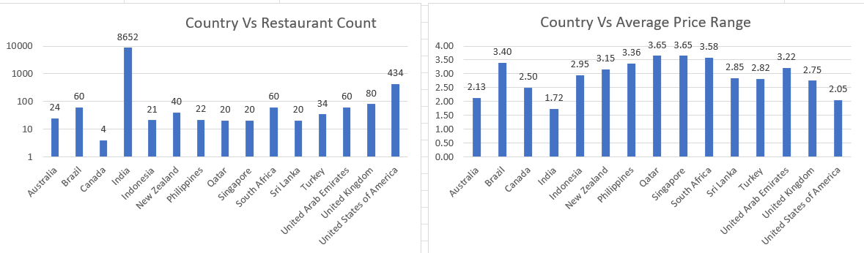

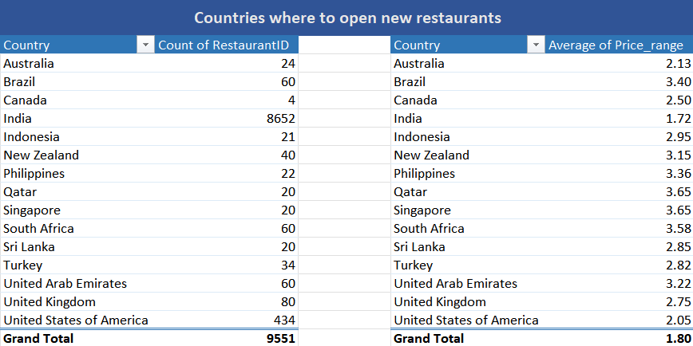

Insight and Recommendations:
- Countries with fewer restaurants: Countries with shorter bars, like Australia, Canada, Turkey, Indonesia and Sri Lanka indicate lower restaurant densities.
- To find lesser competition with the help of pivot table we find these countries might have lesser competition as their average price range is below 3.
- Here we are not considering USA and India even though they have price range below 3 as they have higher number of restaurants opened. As higher the number of restaurants higher competition will be there.
Q2. Come up with the names of States and cities in the suggested countries suitable for opening restaurants.
Ans. Using pivot table to visualize Country/City Vs Avg price range.
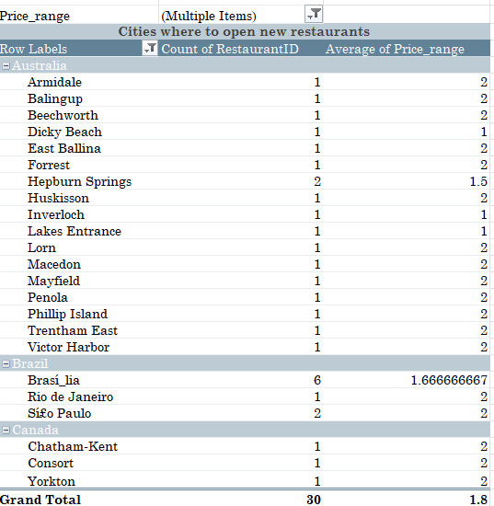
Insight and Recommendation:
- The pivot table represents countries and cities filtered by the average price range < 3 in the selected countries and count of restaurants present.
- The pivot table represents some cities in the selected countries where team can open new restaurants with less competition.

Q3. According to the countries you suggested, what is the current quality regarding ratings for restaurants that are open there?
Ans.
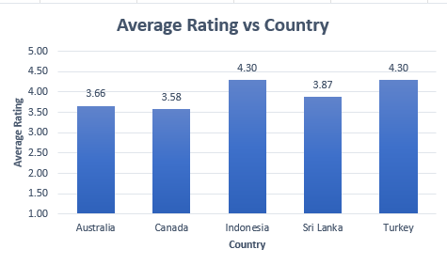
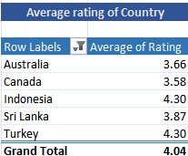

The Countries which I have suggested for opening the new restaurants has current quality of average rating is more than 3.5 also have lesser number of restaurants already present there. So, rating above 3.5 indicates that the current quality is good and can be a very potential demographic to open new line of restaurants for the existing customers.
Q4. Also, what is the current expenditure on food in the suggested countries, so we can keep our financial expenditure in control?
Ans. Used pivot table and Bar chart to visualize the expenditure on food in the suggested countries.

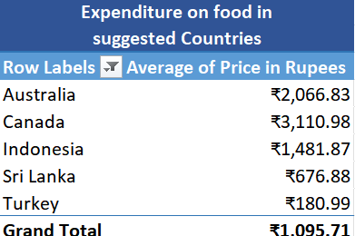
Insights:
- 3D bar chart indicates the Countries and their total expenses on food by taking avg_cost_of_two people in Rupees into account. This helps visualize affordability and prioritize countries with high disposable food budgets vs. lower competition.
- Canada and Australia: Higher spending indicates strong potential for premium services and tech-integrated delivery.
- Sri Lanka and Turkey: Lower costs make them ideal for affordable and scalable restaurant models.
- Indonesia: Stable economy, Zomato can target expat communities and urban professionals.

Q5. Come up with the names of restaurants from the recommended states that are our biggest competitors and also those that are rated in the lower brackets, i.e. 1-2 or 2-3.
Ans. To find the restaurant name that are our biggest competitor, look for restaurants with ratings 4.0 and above and high votes or price range. These are likely your strongest competitors. Below pivot table shows the restaurants have rating 4 and above, average voting is also good so it signifies the customer satisfaction is also good our biggest competitors:
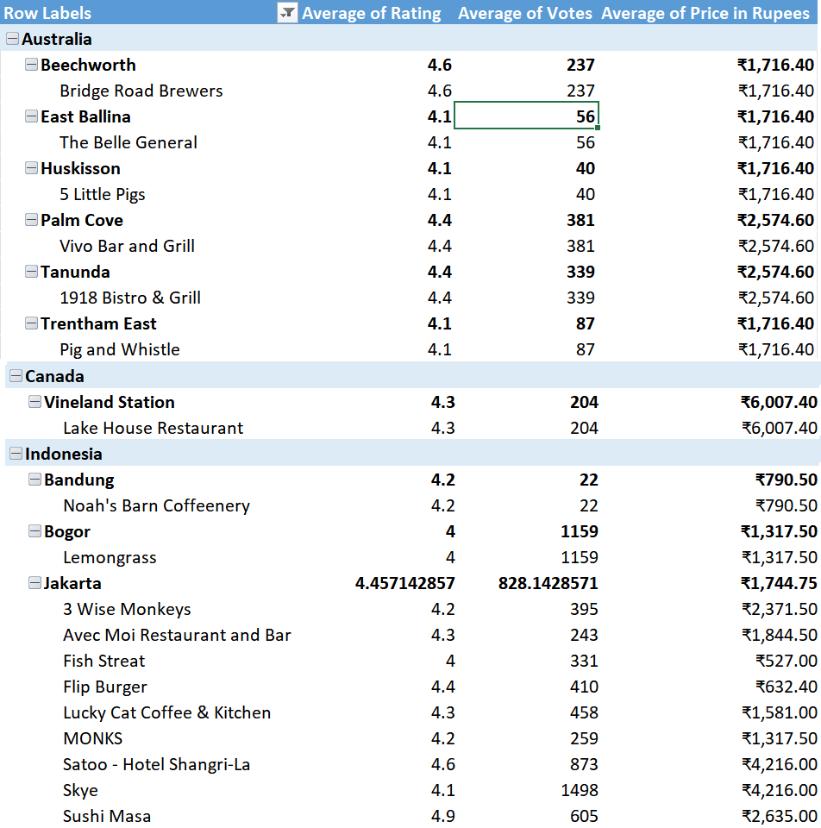

Below pivot table indicates countries having restaurants that are rated in lower brackets:
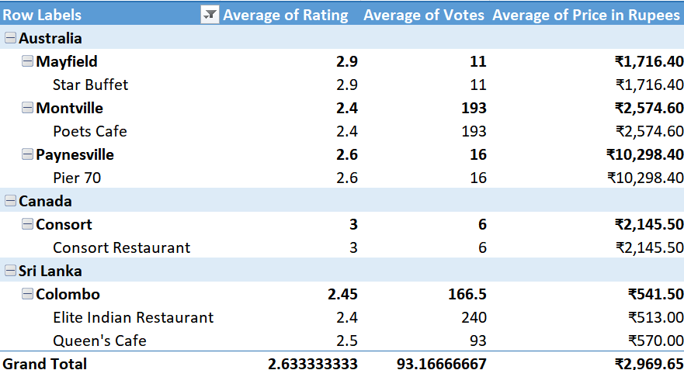
Insights:
- Low rated competitors exist in the key markets, ratings under 3 indicates poor customer satisfaction.
- Low votes suggest limited customer engagement. With low review counts these restaurants may not have strong customer loyalty or visibility.
- Pricing does not always justify quality. As we see the price range is mid-to-high but the rating and votes are poor, suggesting service or quality issues.
Recommendation:
- Capitalize on competitor weaknesses: Enter these markets with a strong focus on quality, service and customer satisfaction.
- Target dissatisfied customers: Invest in marketing, promotions and customer engagement strategies to attract customer.
- Optimize pricing strategy: Ensure pricing aligns with the value offered, offering best quality at the similar price.

Q6. Which cuisines should we focus on in the newer restaurants to get better feedback? Does the choice of cuisines affect the restaurant ratings?
Ans. Focused on high rated cuisines. So, created a pivot table with cuisines and the average rating, filter out the cuisines based on high rating (above 4.5).
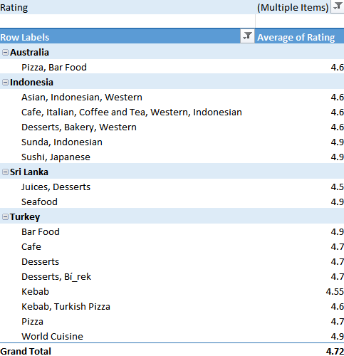
Based on the analysis of cuisine rating, incorporating these types of cuisines into new restaurant enhance customer satisfaction and make restaurant more appealing and strong market demand.
Q7. According to our current data, should we go for online delivery and table booking? Does that affect the customer’s ratings?
Ans. Yes, it affects customer rating. I used donut chart to visualize this.
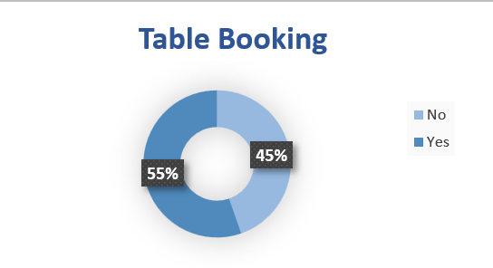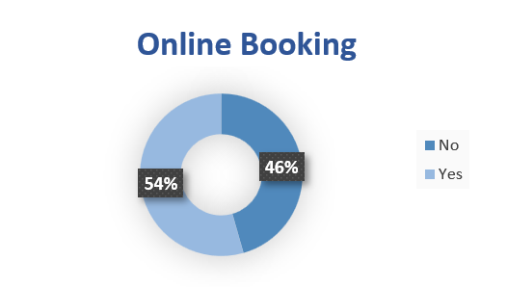
Insights:
- Restaurants that offer online delivery and table booking consistently receive higher ratings and significantly better reviews.
- This implies that structured dine-in experiences, shorter wait times, and better service planning positively impact user experience.
- Customers are more likely to rate a restaurant favorably if they can access it through delivery apps.
Recommendations:
- Online Delivery:
  - Partner with food delivery platforms or build your own ordering system.
  - Ensure your packaging, delivery speed, and order accuracy are optimized.

- Table Booking:
  - Table booking helps restaurants manage crowds and provide better customer service, which likely contributes to higher ratings and return visits.
So, implementing online delivery and table booking is a strategic move that improves customer satisfaction, leads to higher ratings.
Q8. Should the team keep the rate of cuisines higher? Will that affect the feedback? According to our data are the rates of cuisines and ratings, correlated?
Ans. To analyse the relationship between them, we:
- Plotted a scatter chart of "Price" vs "Rating"
- Calculated the correlation coefficient.


Insights:
A correlation of 0.30 is considered a moderate positive correlation. Here’s what it means:
- There is a mild tendency that as cuisine prices increase, ratings also increase.
- However, the relationship is not strong enough to claim that higher prices always result in better feedback.
- Other factors (like service, taste, ambience, location) likely have a stronger influence on ratings than cost alone.
Recommendations:
- Plan to raise prices:
  - Ensure the quality and service match the expectation.
  - High cost may damage ratings instead of helping.
- Restaurants that offer quality food at slightly premium pricing might benefit — as moderate correlation supports this.
Q9. What is the distribution of the number of restaurants of different price ranges in all the countries?
Ans.
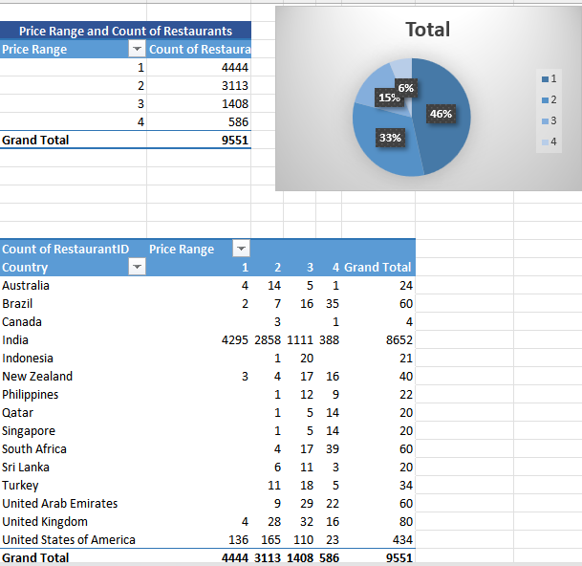
Insights:
- India dominates the dataset with over 90% of the total restaurant count, with a majority in Price Range 1 and 2.
- Countries like the USA, UK, and UAE have a more balanced distribution across all price ranges, especially noticeable in the higher ranges (3 and 4).
- Countries like South Africa and Brazil have higher share in Price Range 4 compared to others, indicating a skew towards premium or fine-dining establishments.
Recommendations:
- Affordable restaurant expansion: Open more budget friendly restaurants in countries like Canada, Indonesia, Qatar.
- Focus on maintaining quality in low to mid-price range offerings.
- Tap into the growing middle-class segment by promoting more mid-range (Price 2-3) restaurants.
Q10. Explain your approach in brief for suggesting countries/cities in order to open new restaurants, if the objective and subjective questions would have not been given to assist you. [you have to give bullet pointers in order to answer this question]
Ans. Bullet-point approach to how I would independently suggest countries and cities for opening new restaurants without any predefined objective or subjective questions:
- Data Cleaning: Ensure that the raw data is accurate and consistent by addressing any issues such as missing values, formatting errors, or inconsistencies.
- Country-wise Restaurant Count: Count the number of restaurants by country to identify countries with low restaurant presence but with a higher income per capita. This way, we can target areas where people have more spending power and less competition.
- Analyze Competition: Use metrics like:
  - Number of restaurants per country/city
  - Average rating and votes
  - Price range comparison
  - Target regions with fewer restaurants but acceptable ratings and price range.
- Economic Feasibility:
  - Compare average cost for two with local currency (Rupees) and spending patterns.
  - Choose countries with a balanced or low cost of dining.
- Delivery & Service Availability: As data suggests, online delivery and table-booking services affect customer ratings; I'll provide more such services, such as special offers and free delivery on order value, to attract more customers and improve the overall customer experience.
- Visualizations: Visualize the data with charts derived from pivot tables to identify trends, patterns, and insights more effectively.
- Compile into a dashboard: Assemble the charts and insights into a comprehensive dashboard. This centralizes information and facilitates a more holistic analysis to support decision-making.

