Department Of Computer Engineering



D. Y. Patil College of Engineering, Akurdi, Pune-44

SYNOPSIS

Group Details:

|  |  |  |
| --- | --- | --- |
| Name Of the Students | Roll No | Sign |
| Ayush Chandrakant Patil | SECO2223A03 |  |
| Aditya Ashok Mhase | SECO2223A04 |  |
| Dipak Balu Vyavahare | SECO2223A06 |  |
| Omkar Shantaram Khalkar | SECO2223A14 |  |

1. Class: S.E. Computer Engineering Sem-l.
2. Batch: A-1.
3. Title Of the Project: Second-Hand Books Selling Website.
4. Overview :

* The Bookshelf is a website which leads you to obtain the books at the affordable prices.
* You can simply login to your account and get the desired books from the college you belong.
* Rather than Buying the Books you can Sell the Books to the Needy Students.
* This App provides you with the ease and flexibility for using Buying and Selling Books.

1. Objective:
   * To bring ease in Buying and Selling the desired books.
   * To provide flexibility for Handling the books.
   * Students will get their desired books at the affordable prices .
   * The ease of selecting the desired books at their affordable price.
   * The app help in communicating with the people/students for buying and selling the books.
   * It will also provide the option for Negotiation with the book prices.
   * The Students pay lot of money on buying the book, Some Students may also have the affordability issues . Our project will solve the general issue of the student for buying Second-hand books rather than than the New books.
2. Software and Hardware Requirements:

Software:

* + Visual Studio Code -Text Editor
  + Supported Operating System: Windows 11
  + Supported Databases: MongoDb,Node JS,PHP
  + Languages: HTML, CSS, Javascript,SQL,etc Hardware:
  + Dual-Core 2 Ghz or higher
  + 4 GB RAM
  + 1 GB free disk space Other Requirements :
  + List of Various Courses for user Flexibility.
  + List of Various Books for user Flexibility.
  + Understanding the Requirement of the User for providing the required elements/service

1. Problem Approach:
2. The algorithm which is expected to have higher accuracy in recommending the best preference list of Books used.
3. This project would prove helpful for students minimizing their time in searching Books.
4. We have collected the Books of Various Courses for creating the Database.
5. Using this app the user can find the price they required and the price needed for the books.
6. Accordingly, the user can buy the Books at the affordable prices.
7. Related Work:

Earlier there are some book stole who use to sell and buy old books but they were very less in numbers and it was also very difficult for the people to find the shop and sell their books or buy old books. But here comes our system which has following advantages:-

1-People can sell their book very easily they have to just upload books photos and details on our website.

2-People can buy books easily they have to just search and buy the book they want.

3-People do not have to search for the second hand book stole they have to just go to our site and can buy and sell their books.

1. Architectural flow of Project:

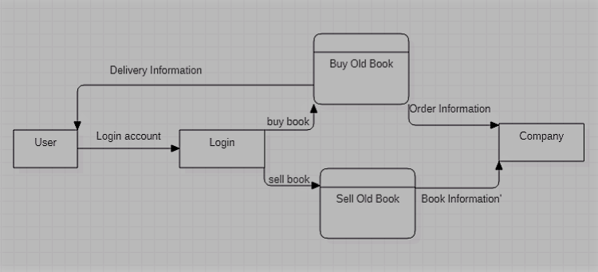

1. Experimental Results :

1. References:

1) http://nevonprojects.com/online-book-resellingportal/

2)https://www.quora.com/What-is-size-of-secondhand-books-market-in-India

3)https://www.slideshare.net/amitpandey1986/pitch-for-our-idea-venture-lab-13579708

4)https://www.edureka.co/blog/android-onlinebook-portal/

5)https://en.wikipedia.org/wiki/XAMPP

6)https://developer.mozilla.org/bm/docs/Web/JavaScript

1. Names Of at least one conference, where papers can be published:

a). IEEE Pune Section International Conference (IEEE PuneCon 2022)

b). International Research Journal of Engineering and Technology (IRJET)

|  |  |
| --- | --- |
| Mrs.Pooja Bhondve |  |
| Project Guide | Project Co-ordinator |