Omkar Singh – B237007

Topic – Create API Endpoint to fetch S3 Data using Lambda Function

* Basic Information about the services used

1. **Amazon API Gateway** -It is a full managed service that makes it easy for developers to create, publish, maintain, monitor and secure APIs at any scale. It acts as a front door for applications to access data, business logic or functionality from your backend services.

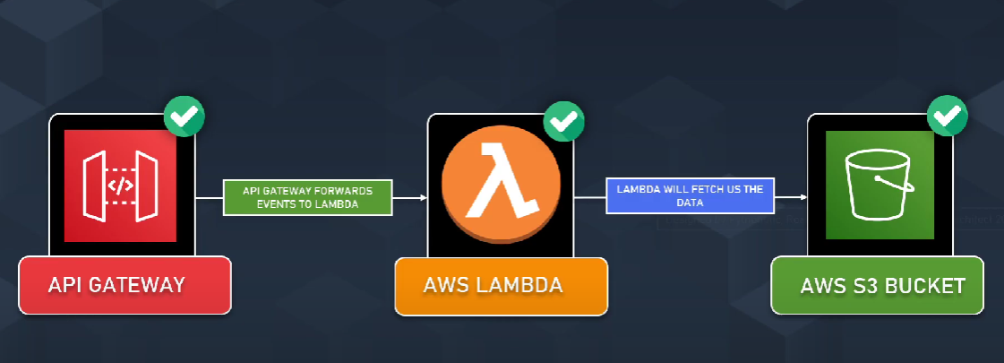

1. **AWS Lambda** – It is a serverless compute service that lets you run code without provisioning or managing servers. You can upload your code, and AWS Lambda takes care of the compute fleet, ensuring automatic scaling and high availability.
2. **Amazon S3 (Simple Storage Service**) – S3 Bucket is an object storage service that offers industry-leading scalability, data availability, security, and performance. It is designed to store and retrieve any amount of data from anywhere on the web.

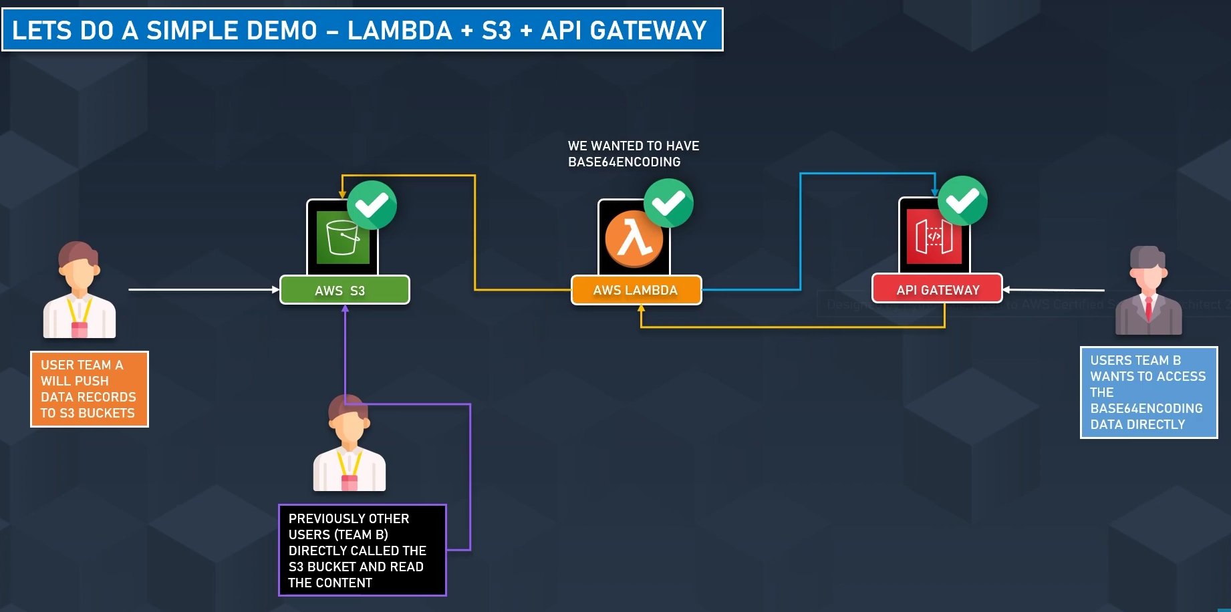

* Creation Of Project

1. **Creation of S3 Bucket**

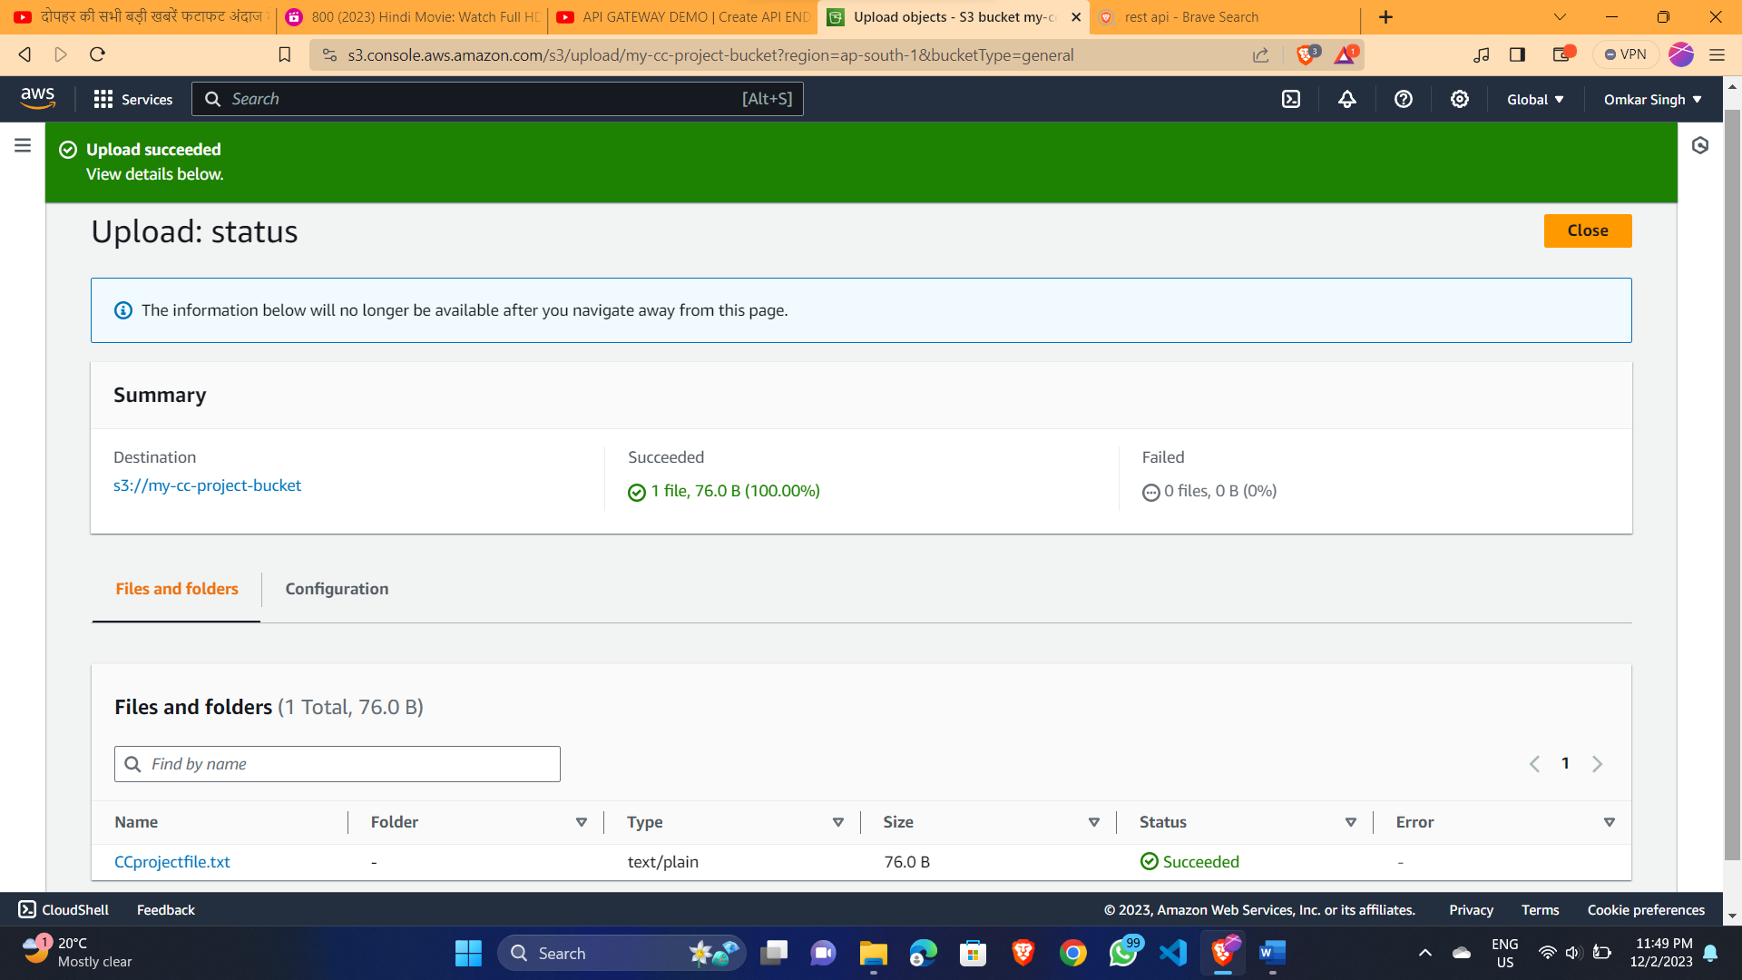

1. **Adding txt file in S3 Bucket**

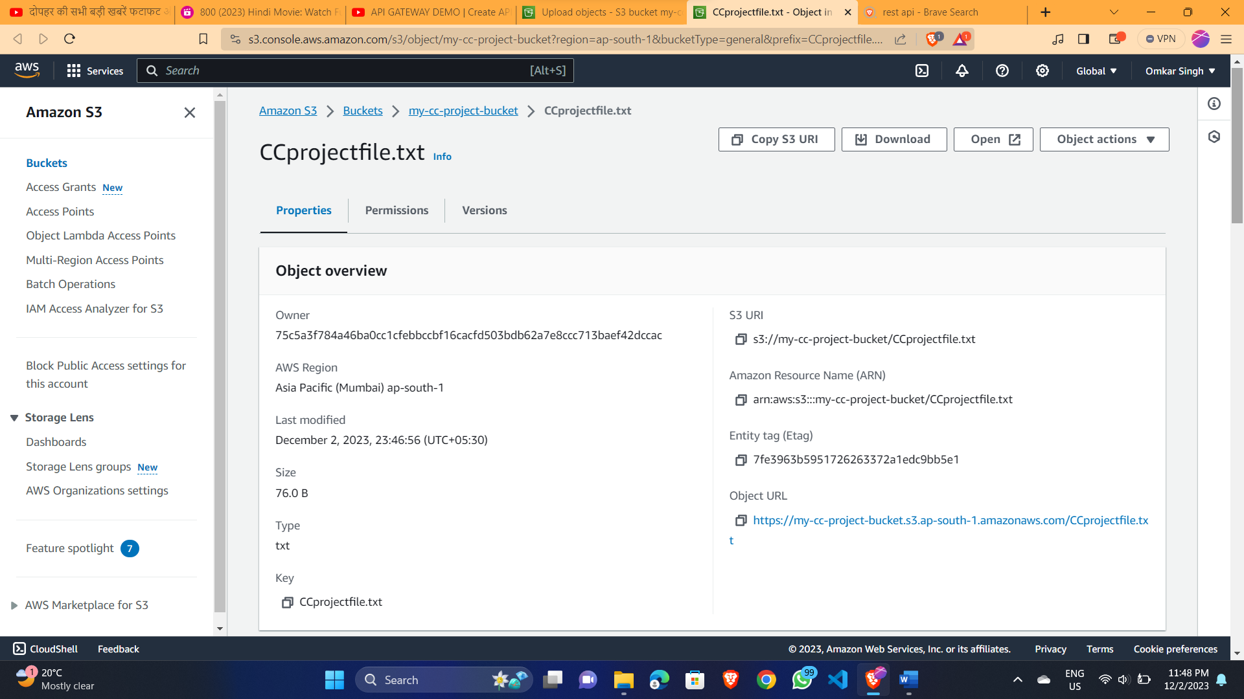

1. **Creating Lambda Function**

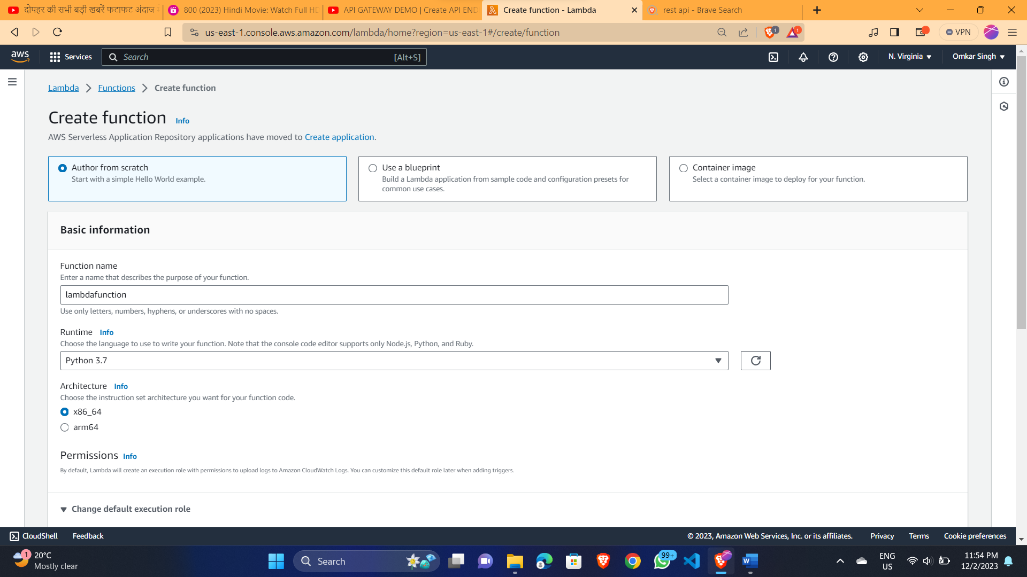

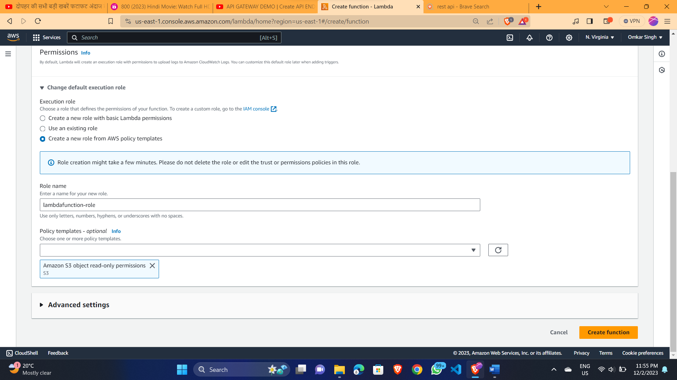

1. **Creating API Gateway**

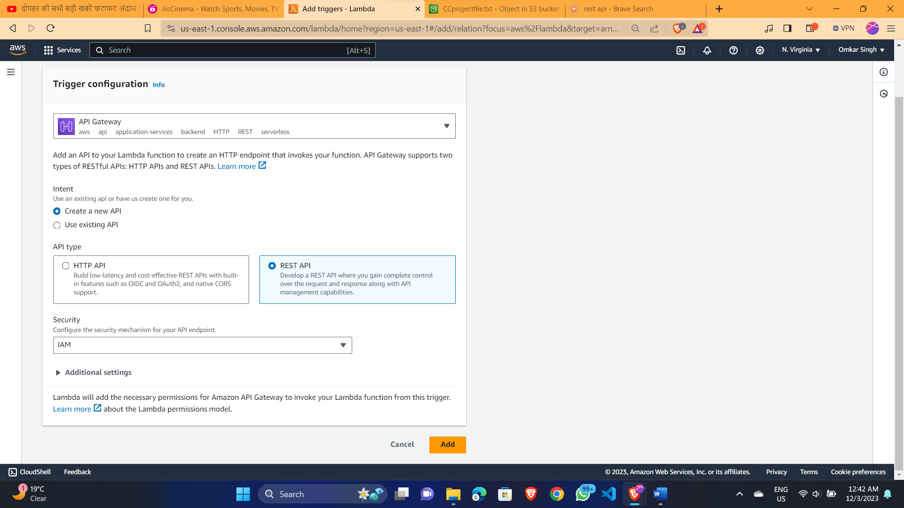

1. **Creating GET method**

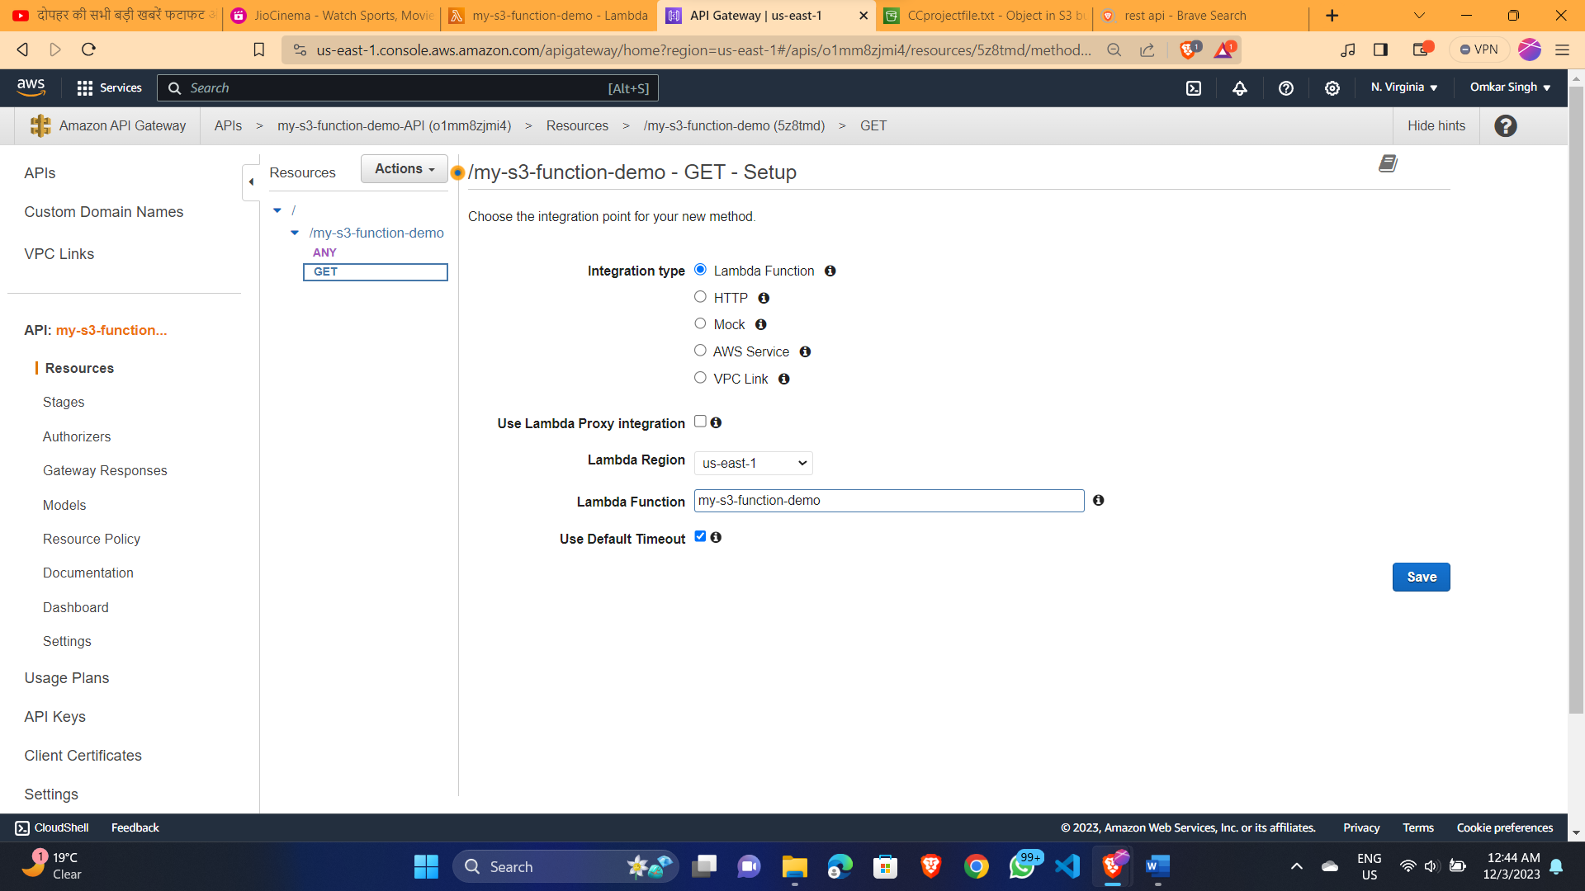

1. **Setting up Method Request**

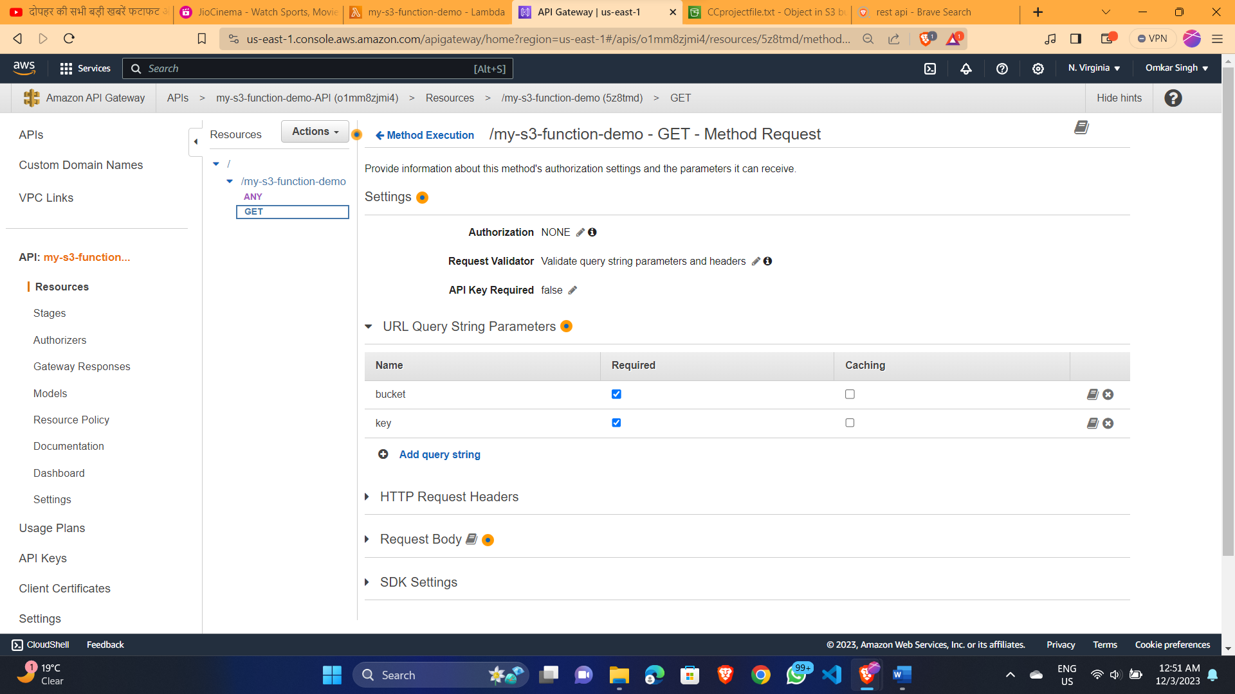

1. **Setting up Integration Request**

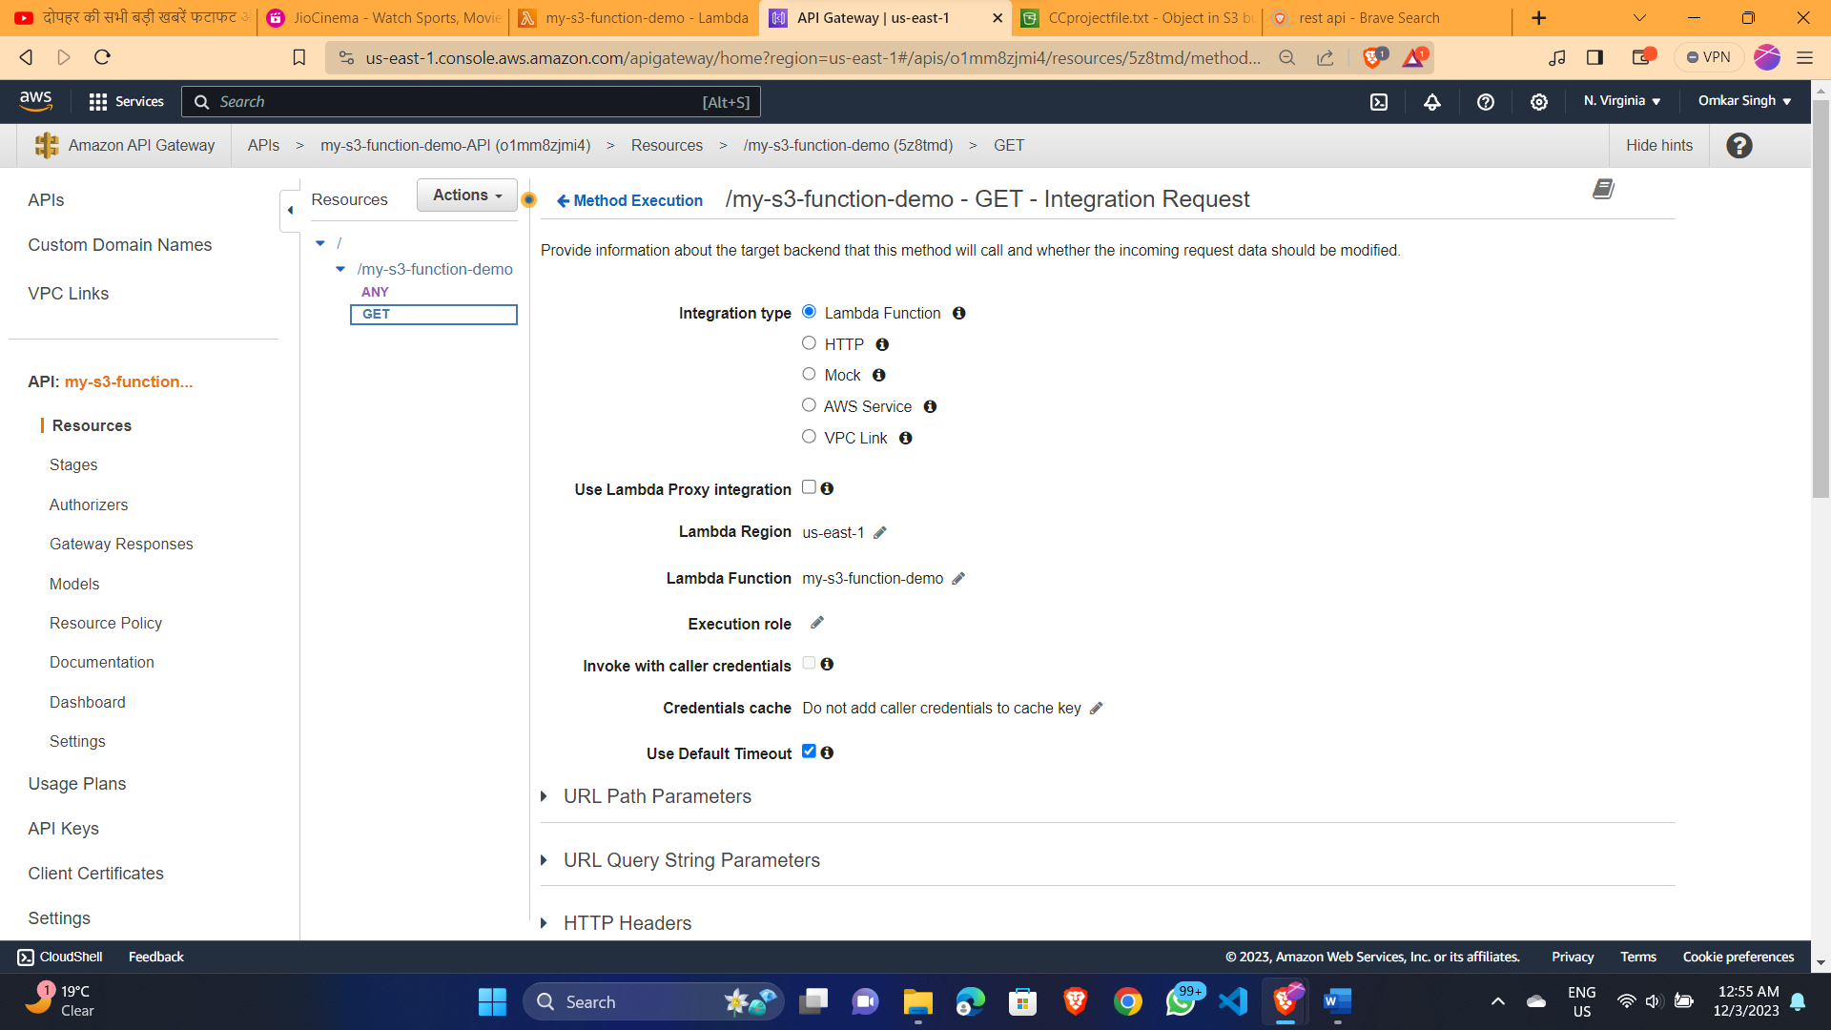

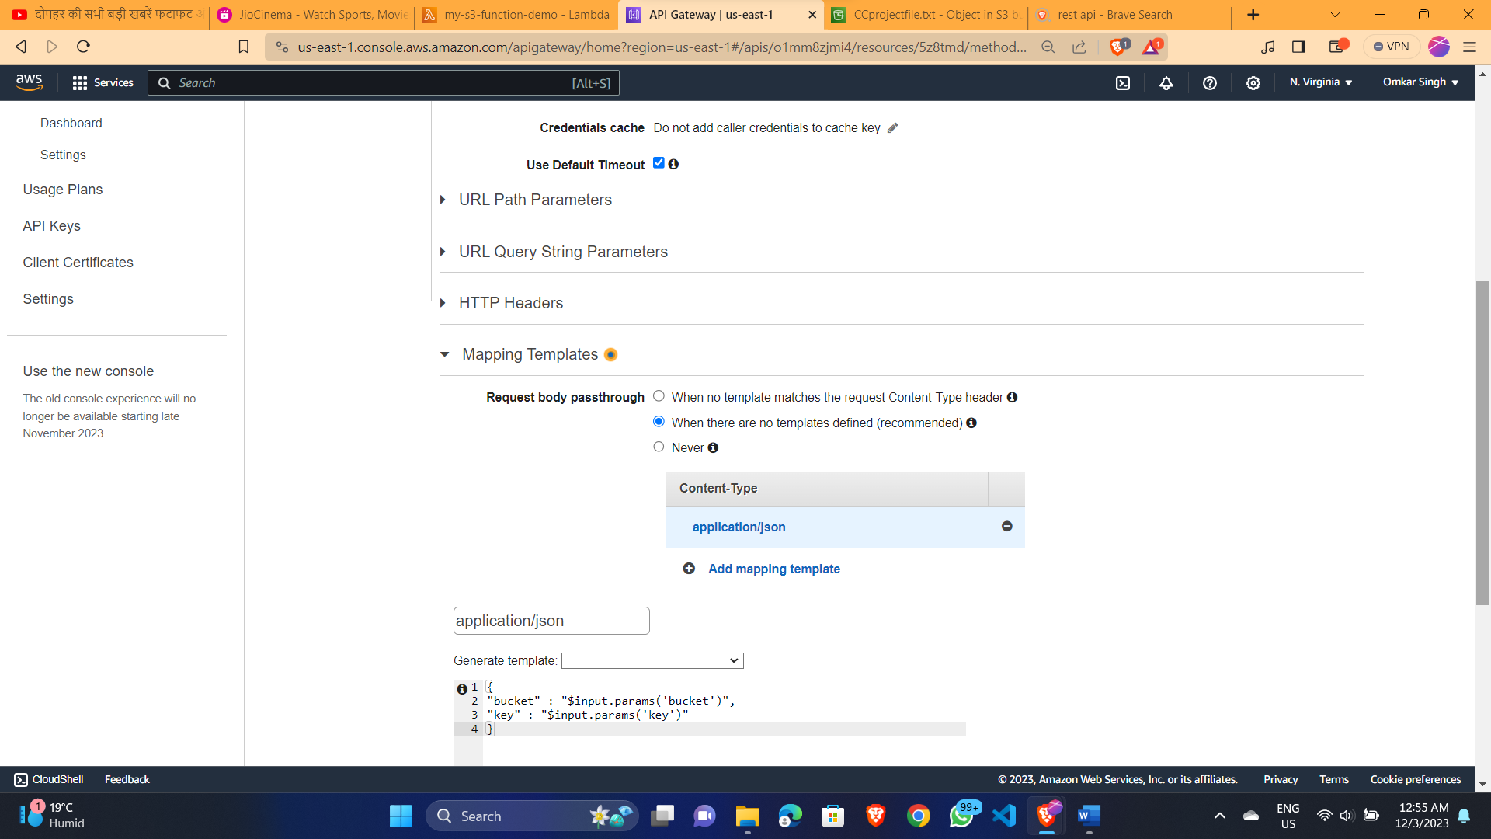

1. **Final Request on S3 bucket using API gateway through lambda Function**

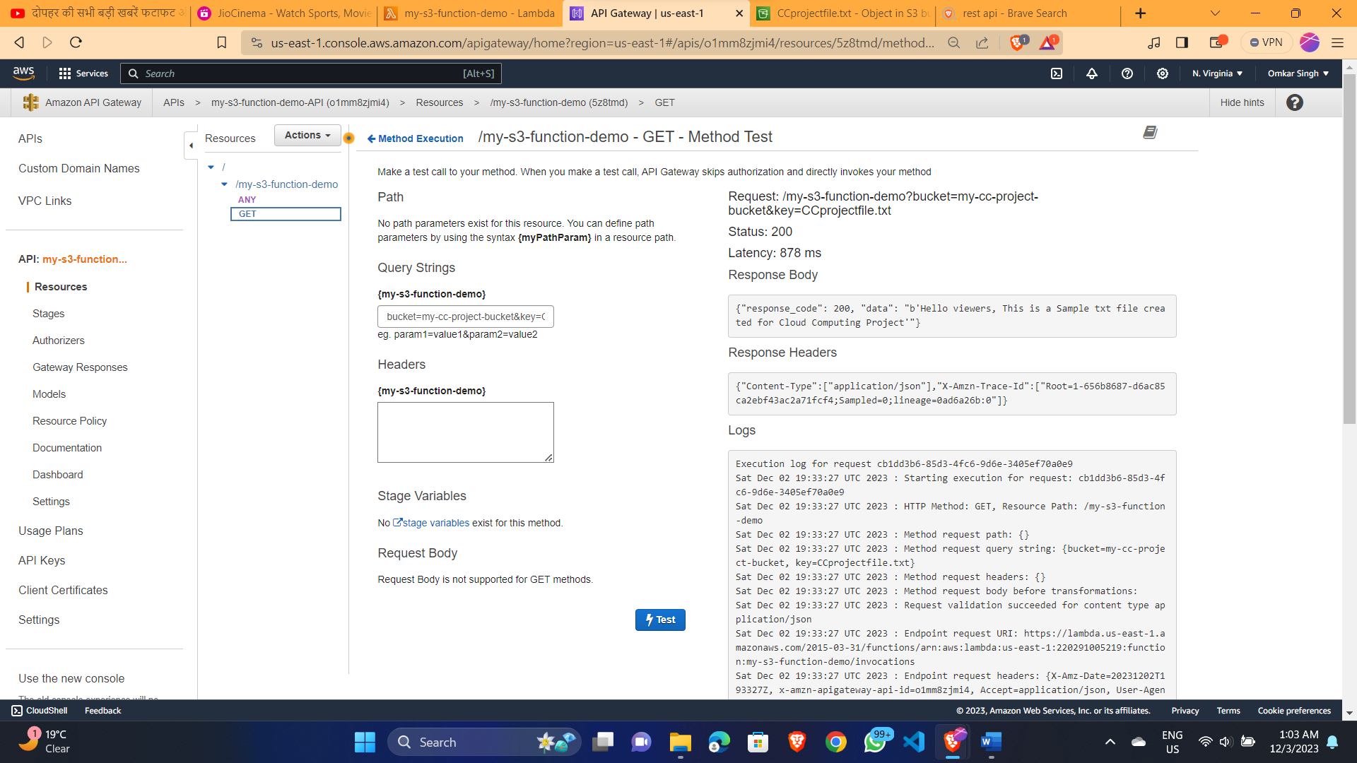

1. **Final Request on S3 bucket using API gateway through lambda Function (with base64 encoding)**

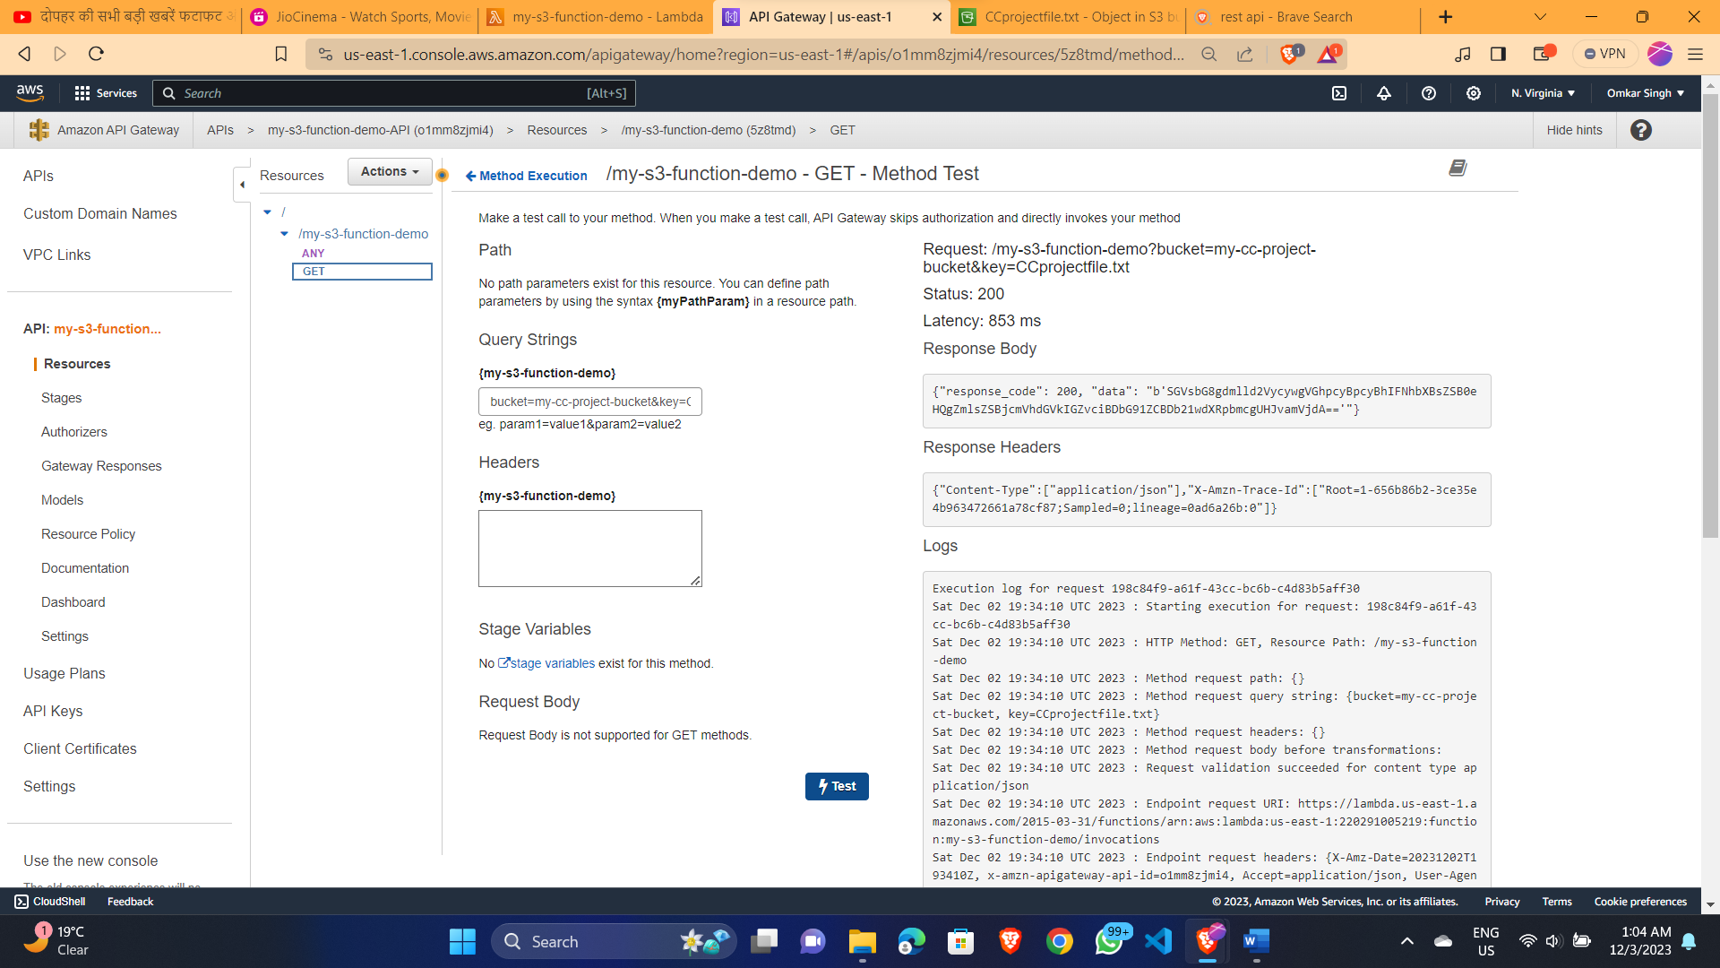

1. **Code written in python for hitting API and saved in lambda function editor**

