**“CODING RELATED MEMES”**

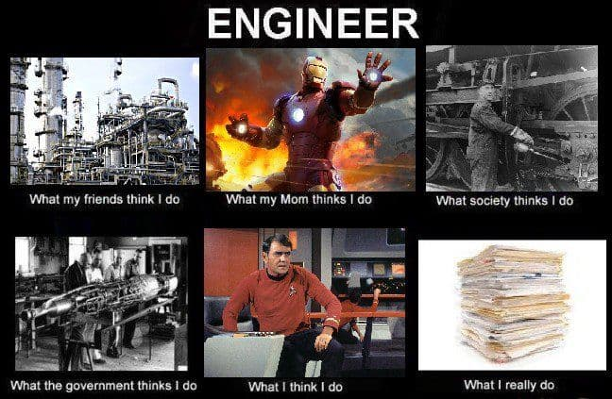

[This Photo](https://kithub.cc/2016/02/5-ways-to-celebrate-engineers-week/) by Unknown Author is licensed under [CC BY-SA-NC](https://creativecommons.org/licenses/by-nc-sa/3.0/)

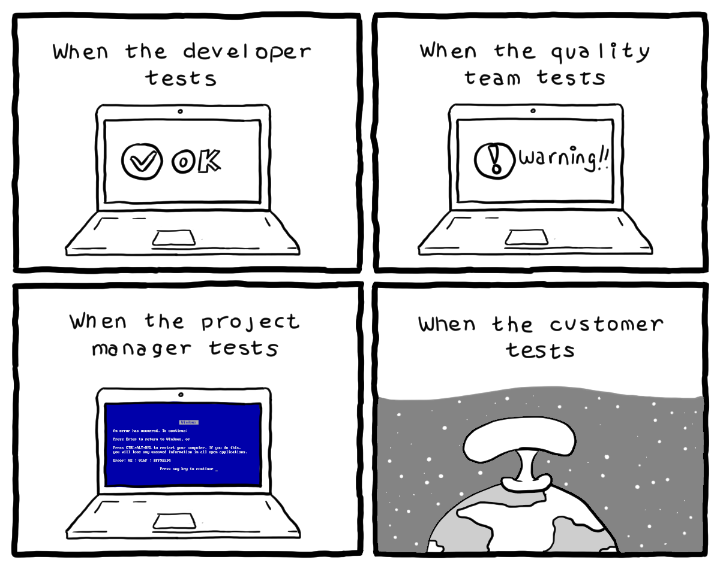

[This Photo](http://turnoff.us/geek/software-test) by Unknown Author is licensed under [CC BY-SA-NC](https://creativecommons.org/licenses/by-nc-sa/3.0/)

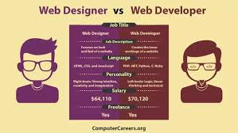

[This Photo](https://internationaljournalofresearch.com/2020/06/13/how-to-become-a-web-developer/) by Unknown Author is licensed under [CC BY-NC-ND](https://creativecommons.org/licenses/by-nc-nd/3.0/)

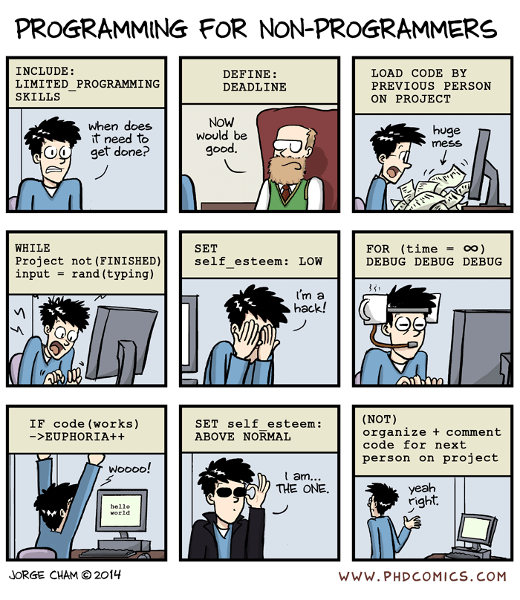

[This Photo](http://www.i3s.unice.fr/~malapert/R/) by Unknown Author is licensed under [CC BY-NC](https://creativecommons.org/licenses/by-nc/3.0/)