**Results:**

1. SVM

True Positives (TP) = 61 → 61 malignant cases were correctly predicted as malignant.

False Negatives (FN) = 2 → 2 malignant cases were wrongly predicted as benign.

False Positives (FP) = 2 → 2 benign cases were wrongly predicted as malignant.

True Negatives (TN) = 106 → 106 benign cases were correctly predicted as benign.

Interpretation of Performance

1. Accuracy: 97.7% The model is highly accurate.
2. Precision: When the model predicts malignant, it's correct 96.8% of the time.
3. Recall (Sensitivity): The model correctly identifies 96.8% of actual malignant cases.
4. F1-score: high, meaning a good balance between precision & recall.

The sharp rise near (0,1) and flat top means the model is highly effective.

AUC = 1.00 means a perfect classifier (no misclassifications).

curve is very close to the top-left corner → This means the model has high sensitivity (recall) and low false positives.

Classification report:

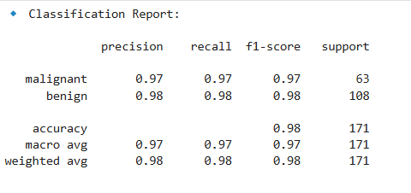

**Malignant Class (Cancerous Tumour)**

1. Precision: 0.97 → When the model predicts malignant, it is correct 97% of the time.
2. Recall: 0.97 → The model correctly identifies 97% of malignant cases.
3. F1-score: 0.97 → The balance of precision and recall is excellent.
4. Support: 63 → The number of actual malignant cases in the test set.

**Benign Class (Non-Cancerous Tumour)**

1. Precision: 0.98 → When the model predicts benign, it is correct 98% of the time.
2. Recall: 0.98 → The model correctly identifies 98% of benign cases.
3. F1-score: 0.98 → Strong balance between precision and recall.
4. Support: 108 → The number of actual benign cases in the test set.

**Overall Model Performance:**

Accuracy: 0.98 (98%) → The model correctly classified 98% of the total test samples.

Macro Avg (0.97) → The average of precision, recall, and F1-score across both classes (equal weight for each class).

Weighted Avg (0.98) → The average considering class distribution (since benign cases are more, their contribution is slightly higher).

**Conclusion:**

The SVM model performs exceptionally well, achieving 98% accuracy.

The high precision and recall for both classes indicate the model is making very few errors.

Very balanced performance across both classes.

This model is well-suited for breast cancer classification, as it minimizes false positives and false negatives effectively.

1. KNN

**Classification Report:**

1. Precision (0.95 for malignant, 0.96 for benign): This means when the model predicts a malignant tumour, it is correct 95% of the time, and when it predicts benign, it is correct 96% of the time.
2. Recall (0.93 for malignant, 0.97 for benign): The model correctly identifies 93% of malignant cases and 97% of benign cases.
3. F1-score (0.94 for malignant, 0.97 for benign): This is a balance between precision and recall, indicating that the model performs well for both classes.
4. Accuracy (95.6%): The overall performance of the model is quite strong.

**Confusion Matrix:**

1. True Positives (39 malignant, 70 benign): These are correctly classified cases.
2. False Positives (3 for malignant): These are benign cases misclassified as malignant.
3. False Negatives (2 for benign): These are malignant cases misclassified as benign.
4. The model is slightly better at identifying benign cases but has very few misclassifications.

**ROC Curve and AUC Score:**

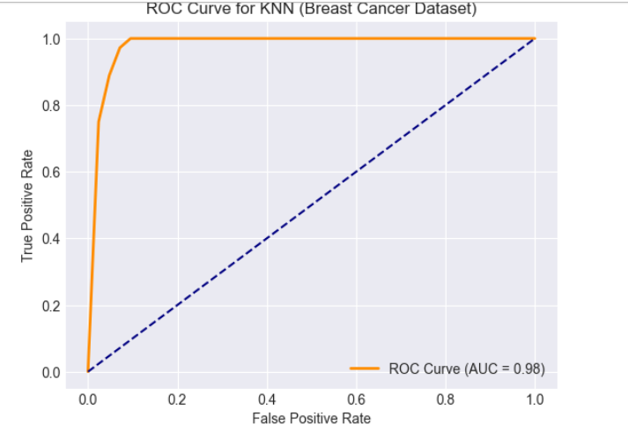

The ROC curve shows a near-perfect classification ability with an **AUC of 0.98**, meaning the model is highly effective at distinguishing between malignant and benign tumours.

A curve close to the top-left corner suggests excellent sensitivity and specificity.

**Conclusion:**

* The KNN model (k=5) performs exceptionally well on this dataset.
* The model shows a **high accuracy (95.6%)** and **strong precision-recall balance**.
* The **ROC AUC score of 0.98** confirms that the model has excellent classification ability.
* Only a few cases are misclassified, which could be improved further by tuning hyperparameters or using a different classifier.