**Step Over:**

It executes the statement line by line even if the statement contains a call to the function, it will execute and will hop into next statement.

**Step Into:**

It executes the statement line by line and if the statement contains a call to the function, it will go to the function to execute the function statements.

**Step Out:**

After stepping into a function if you want to get back to the previous code Step Out is used.

**Locals:**

**Locals**windows automatically displays the list of variables and it’s values within the scope of current methods.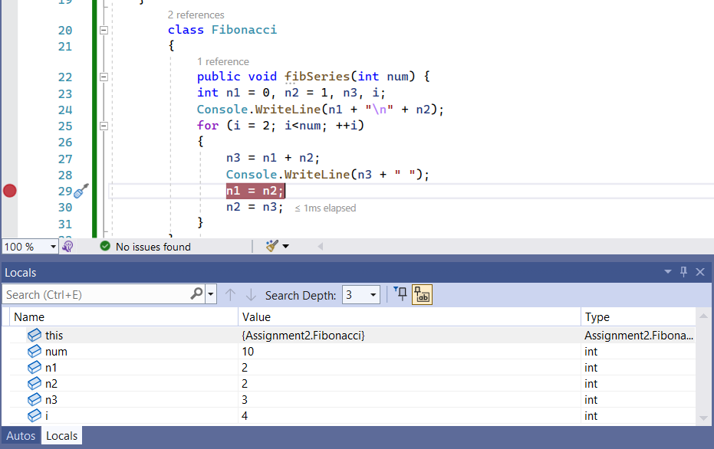

**Auto:**

It is subset of Local. It shows the object in current statement and the previous statement with in that current scope.

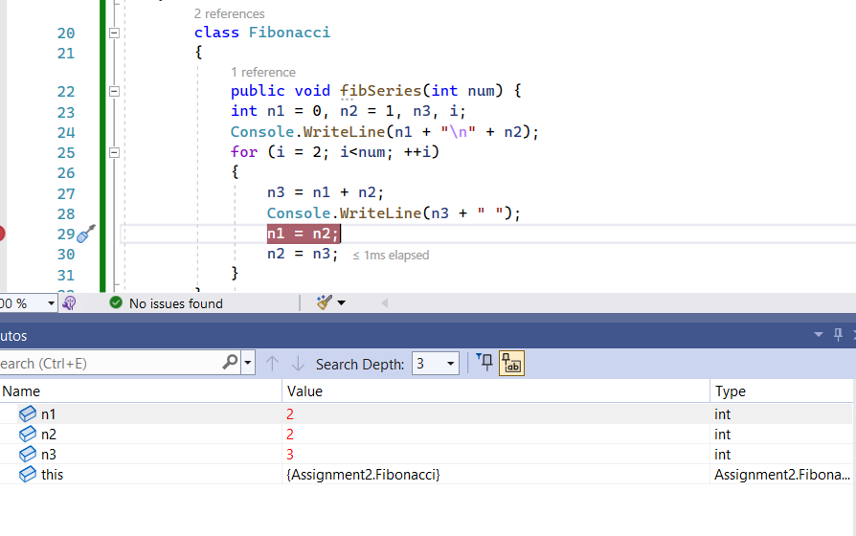

**Immediate:**

We can type in any expression and the immediate window will evaluate.

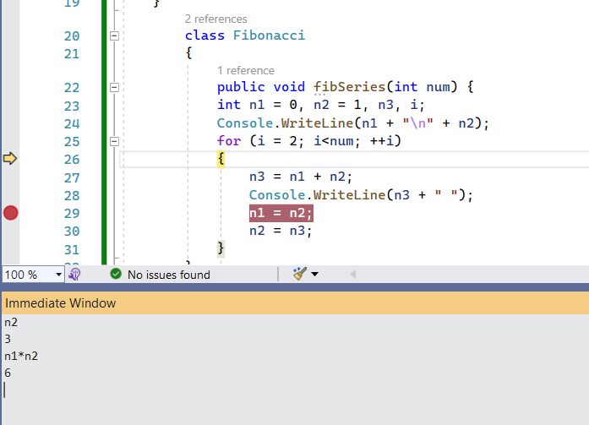

**Watch:**

The **Watch Window** allows you to see value of variables and expressions while debugging.

