1.

#include <iostream>

using namespace std;

/\* run this program using the console pauser or add your own getch, system("pause") or input loop \*/

int main(int argc, char\*\* argv) {

int wage,finalpay;

cout<<"Enter the Gross Payment recived by the worker:"<<endl;

cin>>wage;

cout<<"Income tax deducted is:"<<wage\*0.1<<endl;

cout<<"State tax deducted is"<<wage\*0.03<<endl;

cout<<"Social Security tax deducted is:"<<wage\*0.02<<endl;

cout<<"Medicare tax deducted is:"<<wage\*0.0278<<endl;

cout<<"Pension plan is:"<<wage\*0.06<<endl;

cout<<"\n\nThe finalized pay the worker gets is:"<<wage-0.2378\*wage;

return 0;

}

Output:

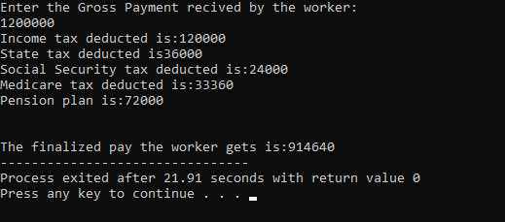

2.

#include <iostream>

using namespace std;

int main(int argc, char\*\* argv) {

cout<<"CCCCCCCCC ++ ++"<<endl;

cout<<"C ++ ++ "<<endl;

cout<<"C ++++++++++++++ ++++++++++++++"<<endl;

cout<<"C ++++++++++++++ ++++++++++++++"<<endl;

cout<<"C ++ ++"<<endl;

cout<<"CCCCCCCCC ++ ++"<<endl;

return 0;

}

Output:

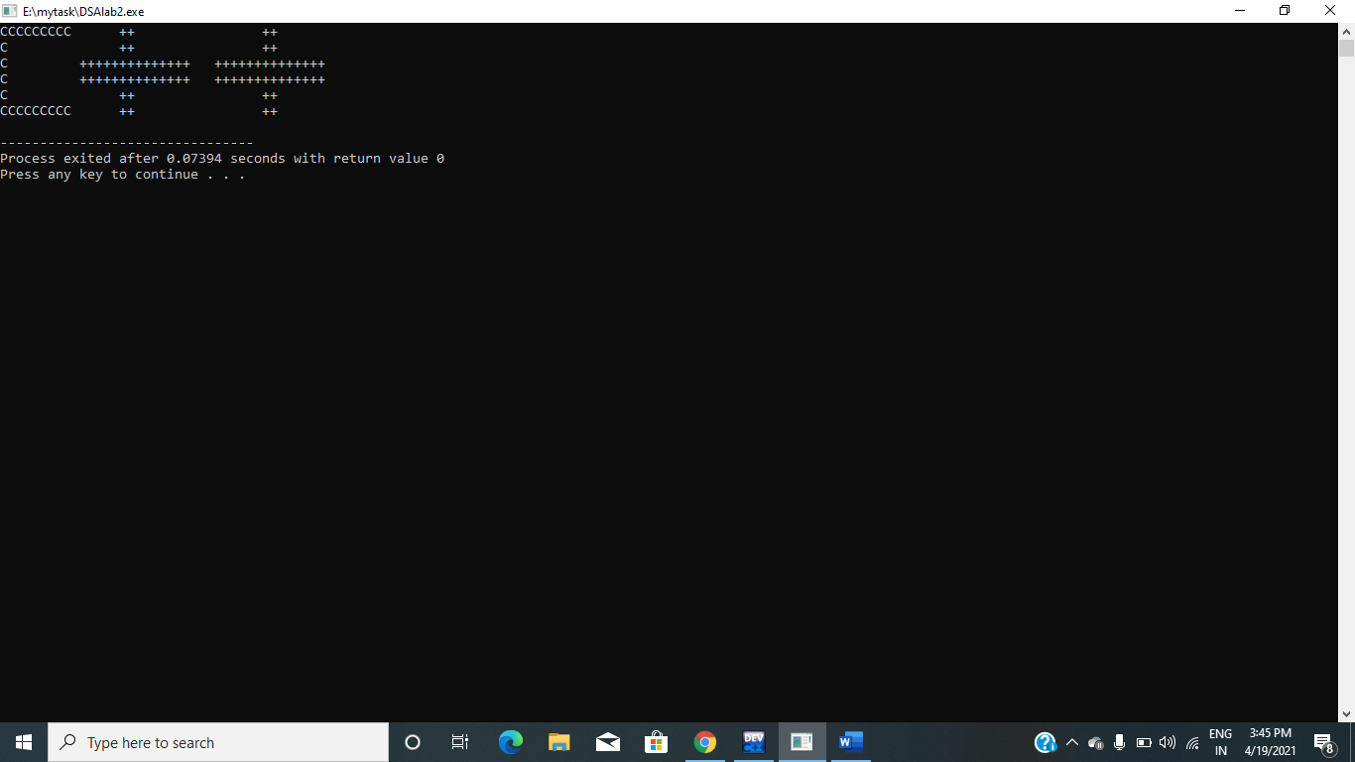

Using for loop:

#include <iostream>

using namespace std;

int main(int argc, char\*\* argv) {

for(int i=0;i<=6;i++)

{

if(i==1 or i==6)

{

cout<<"CCCCCCCCC ++ ++"<<endl;

}

else if(i==2 or i==5)

{

cout<<"C ++ ++"<<endl;

}

else if(i==3 or i==4)

{

cout<<"C ++++++++++++++ ++++++++++++++"<<endl;

}

}

return 0;

}

Output:

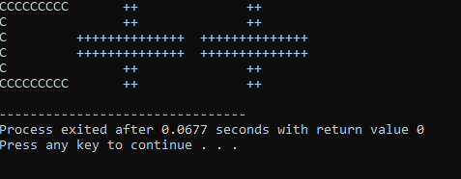

3.

#include <iostream>

using namespace std;

int main(int argc, char\*\* argv) {

float far;

float cel=0;

cout<<"Enter the Temperature Fahrenheit:"<<endl;

cin>>far;

cel=5.0/9.0\*(far-32.0);

cout<<"The Temperature in Celsius:"<<cel<<endl;

return 0;

}

Output:

