code1:

#include <iostream>

using namespace std;

/\* run this program using the console pauser or add your own getch, system("pause") or input loop \*/

class matrix

{

int i,j,k,n,d1,d2,sum1,sum2,a1[10][10],a2[10][10],t1[10][10],t2[10][10],a[10][10],s[10][10],m[10][10];

public:

void data();

void display();

void utm();

void operation();

void transpose();

void digonal();

void sumall();

};

void matrix::data()

{

cout<<"Enter the size of matrix(n\*n)\n";

cin>>n;

cout<<"Enter the element of matrix 1\n";

for(i=0;i<n;i++)

{

for(j=0;j<n;j++)

cin>>a1[i][j];

}

cout<<"Enter the element of matrix 2\n";

for(i=0;i<n;i++)

{

for(j=0;j<n;j++)

cin>>a2[i][j];

}

}

void matrix::utm()

{

for (i = n-1; i < n; i++)

{

for (j = 0; j < i; j++)

if (a1[i][j] != 0)

cout << "\nMatrix 1 is not an Upper Triangular Matrix\n";

else

cout << "\nMatrix 1 is upper Triangular Matrix\n";

}

for (i = n-1; i < n; i++)

{

for (j = 0; j < i; j++)

if (a2[i][j] != 0)

cout << "\nMatrix 2 is not an Upper Triangular Matrix\n";

else

cout << "\nMatrix 2 is upper Triangular Matrix\n";

}

}

void matrix::operation()

{

for(i=0;i<n;i++)

{

for(j=0;j<n;j++)

a[i][j]=a1[i][j]+a2[i][j];

}

for(i=0;i<n;i++)

{

for(j=0;j<n;j++)

s[i][j]=a1[i][j]-a2[i][j];

}

for(i=0;i<n;i++)

{ for(j=0;j<n;j++){

m[i][j]=0;

for(k=0;k<n;k++)

m[i][j]=m[i][j]+a1[i][k]\*a2[k][j];

}

}

}

void matrix::transpose()

{

for(i=0;i<n;i++)

{

for(j=0;j<n;j++)

t1[i][j]=a1[i][j];

}

for(i=0;i<n;i++)

{

for(j=0;j<n;j++)

t2[i][j]=a2[i][j];

}

}

void matrix::digonal()

{

d1=0;

d2=0;

for(i=0;i<n;i++)

{

for(j=0;j<n;j++)

if(i==j)

{

d1=d1+a1[i][j];

}

}

for(i=0;i<n;i++)

{

for(j=0;j<n;j++)

if(i==j)

{

d2=d2+a2[i][j];

}

}

}

void matrix::sumall()

{

sum1=0;

sum2=0;

for(i=0;i<n;i++)

{

for(j=0;j<n;j++)

sum1=sum1+a1[i][j];

}

for(i=0;i<n;i++)

{

for(j=0;j<n;j++)

sum2=sum2+a2[i][j];

}

}

void matrix::display()

{

cout<<"\nAddition of matrix\n";

for(i=0;i<n;i++)

{

for(j=0;j<n;j++)

cout<<a[i][j]<<"\t";

cout<<"\n";

}

cout<<"\nSubstraction of matrix\n";

for(i=0;i<n;i++)

{

for(j=0;j<n;j++)

cout<<s[i][j]<<"\t";

cout<<"\n";

}

cout<<"\nMultiplication of matrix\n";

for(i=0;i<n;i++)

{

for(j=0;j<n;j++)

cout<<m[i][j]<<"\t";

cout<<"\n";

}

cout<<"\ntranspose of matrix 1\n";

for(i=0;i<n;i++)

{ for(j=0;j<n;j++)

cout<<t1[i][j]<<"\t";

cout<<"\n";

}

cout<<"\ntranspose of matrix 2\n";

for(i=0;i<n;i++)

{ for(j=0;j<n;j++)

cout<<t2[i][j]<<"\t";

cout<<"\n";

}

cout<<"\nsum of diagonal elements of matrix 1\n"<<d1;

cout<<"\nsum of diagonal elements of matrix 2\n"<<d2;

cout<<"\nsum of all elements of matrix 1\n"<<sum1;

cout<<"\nsum of all elements of matrix 2\n"<<sum2;

}

int main(int argc, char\*\* argv) {

matrix b;

b.data();

b.utm();

b.operation();

b.transpose();

b.digonal();

b.sumall();

b.display();

return 0;

}

Output:

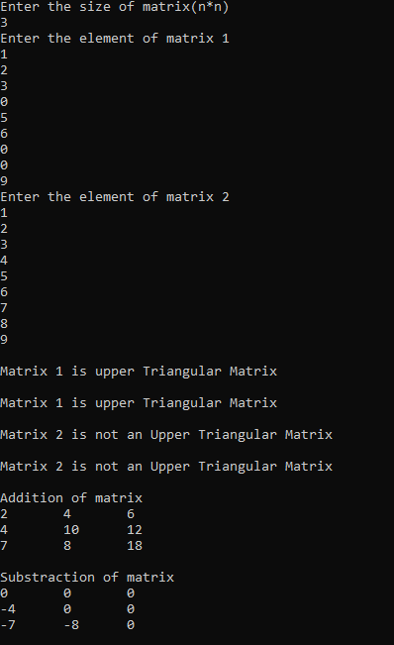

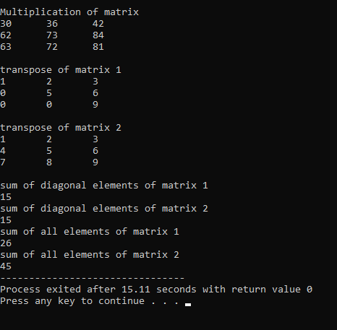

Code2:

#include <iostream>

using namespace std;

/\* run this program using the console pauser or add your own getch, system("pause") or input loop \*/

void Polynomial(int b[],int n)

{

for (int i = 0; i < n; i++)

{

cout<<b[i];

if (i==1) cout<<"x";

if (i!=0 && i!=1) cout<<"x^"<<i;

if (i!=n-1) cout<<" + ";

}

cout<<endl;

}

void Add(int a[],int b[],int c,int d)

{

int size=max(c,d);

int sum[size]={0};

for (int i = 0; i < c; i++){

sum[i]=a[i];

}

for (int i = 0; i < d; i++){

sum[i]+=b[i];

}

cout<<"The sum of the polynomials is: ";

Polynomial(sum,size);

}

void Subtract(int a[],int b[],int c,int d)

{

int size=max(c,d);

int differ[size]={0};

for (int i = 0; i < c; i++){

differ[i]=a[i];

}

for (int i = 0; i < d; i++){

differ[i]-=b[i];

}

cout<<"The difference of the polynomials is: ";

Polynomial(differ,size);

}

void Multiply(int a[],int b[],int c,int d)

{

int product[c+d-1];

for (int i = 0; i < (c+d-1); i++){

product[i]=0;

}

for (int i = 0; i < c; i++)

{

for (int j = 0; j < d; j++)

{

product[i+j]+=a[i]\*b[j];

}

}

cout<<"The product of polynomials is: ";

Polynomial(product,c+d-1);

}

int main()

{

int k;

cout<<"Enter the degree of polynomial: ";cin>>k;

int b[k]={0};

cout<<"Enter the coefficients of polynomial: ";

for (int i = 0; i < k; i++){

cin>>b[i];

}

Polynomial(b,k);

int k1;

cout<<"Enter the degree of second polynomial: ";cin>>k1;

int b1[k1]={0};

cout<<"Enter the coefficients of second polynomial: ";

for (int i = 0; i < k1; i++){

cin>>b1[i];

}

Polynomial(b1,k1);

Add(b,b1,k,k1);

Subtract(b,b1,k,k1);

Multiply(b,b1,k,k1);

return 0;

}

Output:

