**Smart Ignition Interlock Device**

A Project report submitted in partial fulfillment of the requirements for the award of the degree of

**BACHELOR’S OF TECHNOLOGY**

**in**

**ELECTRONICS AND COMMUNICATION ENGINEERING**

**by**

**Himanshu Sushil Agrawal**

**112016001**

**Omkar Rajendra Bharitkar**

**112016020**

**Janvi Palli**

**112016021**

**Under the Supervision of: Dr. Shruti Taksali.**

**Semester VI**



**DEPARTMENT OF ELECTRONICS AND COMMUNICATION ENGINEERING**

#### Indian Institute of Information Technology, Pune

**(An Institute of National Importance by an Act of Parliament)**

**APRIL 2023**

**BONAFIDE CERTIFICATE**

This is to certify that the project report entitled **“Smart Ignition Interlock Device”** submitted by **Students’ Name** bearing the **MIS No: 112016001**, **Student’s Name: Himanshu Sushil Agrawal**, bearing the **MIS No: 112016020**, **Student’s Name: Omkar Rajendra Bharitkar,** bearing the **MIS No: 112016021, Student’s Name: Janvi Palli** in completion of their project work under the guidance of **Dr. Shruti Taksali** is accepted for the project report submission in partial fulfillment of the requirements for the award of the degree of **Bachelor of Technology** in the **Department of Electronics and Communication Engineering**, Indian Institute of Information Technology, Pune (IIIT Pune), during the academic year **2022-23**.

#### Dr. Shruti Taksali Dr. Sandeep Mishra

Project Guide Head of the Department

Assistant Professor Assistant Professor

Department of ECE Department of ECE

IIIT Pune IIIT Pune

**Undertaking for Plagiarism**

We, **Himanshu Sushil Agrawal, Omkar Rajendra Bharitkar , Janvi Palli** solemnly declare that research work presented in the **report/dissertation** titled **“Smart Ignition Interlock System”** is solely **our** research work with no significant contribution from any other person. Small contribution/help wherever taken has been duly acknowledged and that complete report/dissertation has been written by **us**. I understand the zero tolerance policy of **Indian Institute of Information Technology Pune** towards plagiarism. Therefore, **we** declare that no portion of our **report/dissertation** has been plagiarized and any material used as reference is properly referred/cited. I undertake that if I am found guilty of any formal plagiarism in the above titled thesis even after award of the degree, the Institute reserves the right to withdraw/revoke my **B.Tech** degree.

**Himanshu Sushil Agrawal**

**Omkar Rajendra Bharitkar**

**Janvi Palli**

**Conflict of Interest**

**Manuscript title: Smart Ignition Interlock System**

The authors whose names are listed immediately below certify that they have NO affiliations with or involvement in any organization or entity with any financial interest (such as honoraria; educational grants; participation in speakers’ bureaus; membership, employment, consultancies, stock ownership, or other equity interest; and expert testimony or patent-licensing arrangements), or non-financial interest (such as personal or professional relationships, affiliations, knowledge or beliefs) in the subject matter or materials discussed in this manuscript.

**Himanshu Sushil Agrawal**

**Omkar Rajendra Bharitkar**

**Janvi Palli**

Smart Ignition Interlock Device

**1**.**PROBLEM STATEMENT**

Driving under the influence (DUI) of alcohol is a significant public health concern. It leads to a high number of accidents, injuries and fatalities on roads. Existing ignition interlock devices (IIDs) are commonly used as a deterrent for repeat DUI offenders. But there are several limitations that can be addressed through technological advancements.

**2.OBJECTIVES.**

* To prevent alcohol-impaired driving
* To enhance user accountability
* To provide real time monitoring
* To collect data for analysis
* To improve and enhance the user experience
* To increase road safety

## ACKNOWLEDGEMENT

This project would not have been possible without the help and cooperation of many. I would like to thank the people who helped me directly and indirectly in the completion of this project work.

First and foremost, I would like to express my gratitude to our honorableDirector,**Prof. O.G. Kakde**, for providing his kind support in various aspects. I would like to express my gratitude to my project guide **Dr Shruti Taksali**, **Department of ECE**, for providing excellent guidance, encouragement, inspiration, constant and timely support throughout this **B.TechProject**.I would like to express my gratitude to the **Head of Department Dr. Sandeep Mishra**, **Department of ECE**, for providing his kind support in various aspects.I would also like to thank all the faculty members in the **Department of CSE/ECE** and my classmates for their steadfast and strong support and engagement with this project.

## Abstract

Alcohol-impaired driving remains a significant public health concern, leading to numerous accidents, injuries, and fatalities on the roads. Traditional ignition interlock devices (IIDs) have been used to deter repeat DUI offenders, but their effectiveness can be limited due to lack of advanced features and functionalities.

In this abstract, we discuss the development of a smart IID that leverages cutting-edge technologies such as IoT and advanced sensor technologies to provide innovative solutions to prevent alcohol impaired driving.

The proposed IID requires the driver to pass a breathalyzer test before starting the vehicle, ensuring that their breath alcohol concentration (BAC) is below the legal limit. Real time monitoring allows for immediate alerts in case of DUI violations. The data collected by the IID can also be surveyed to recognize patterns and thus further help in eradicating drunk driving.

The smart IID also focuses on the user experience, providing an user-friendly interface, and intuitive control. Furthermore, additional functionalities such as GPS tracking, remote monitoring, and smartphone connectivity help in enhancing the user’s experience.

The endmost objective of any smart IID is to improve road safety efficiently by preventing or altogether terminating alcohol-hindered drunk driving incidents.

Keywords: Smart IID, alcohol impaired driving, IoT, User accountability, Real time monitoring, Road Safety

## TABLE OF CONTENTS

**Abstract i**

**(i)** **List of Figures/Symbols/Nomenclature iv**

**(ii)** **List of Tables v**

1. **Introduction 1**

1.1 Overview of work . . . . . . . . . . . . . . . . . . . . . . . . . . . . . . . . . . 1

1.2 Motivation of work . . . . . . . . . . . . . . . . . . . . . . . . . . . . . . . . . 1

1.3 Literature Review . . . . . . . . . . . . . . . . . . . . . . . . . . . . . . . . . . 1

1.4 Research Gap. . . . . . . . . . . . . . . . . . . . . . . . . . . . . . . . . . . . . 1

1. **Problem Statement**

2.1 Research Objectives . . . . . . . . . . . . . . . . . . . . . . . . . . . . . . . . . 1

2.2 Methodology of work . . . . . . . . . . . . . . . . . . . . . . . . . . . . . . . . . 1

1. **Analysis And Design 5**
2. **Results and Discussion 9**
3. **Conclusion and Future Scope 10**

**6 References**

# List of Figures

# Circuit Diagram.

* **Arduino Uno**
* **MQ-3 Alcohol sensor**
* **Relay module**
* **9 volt battery**
* **DC motor**
* **Propeller (attached to motor)**
* **Push button with general PCB**
* **Battery cap**
* **LCD 16*2**
* **wires**

**Chapter 1**

**Introduction**

## Overview of Work

* A smart IID is an advanced technology-based solution designed to prevent alcohol-impaired driving by requiring the driver to pass a breathalyzer test before starting their vehicle.
* The key features typically include real-time monitoring of breath tests, vehicle usage, and other relevant data.

## Motivation of the Work

* Preventing Alcohol-Impaired Driving
* Reducing Recidivism among DUI offenders
* Leveraging Advanced Technologies
* Enhancing User experience
* Promoting Road safety

**1.3 Literature Review**.

* A study published in the journal Accident Analysis & Prevention in 2019 found that the use of smart ignition interlock devices led to a significant reduction in recidivism rates among offenders and had a positive impact on public safety.
* Another study published in the Journal of Safety Research in 2020 examined the usability and user experience of smart ignition interlock devices. The study reported that users feel more accountable for their driving behavior, indicating that the device had a positive impact on their driving habits.
* A study published in the Journal of Transportation Safety & Security in 2018 reported that sensors could be used to detect signs of alcohol consumption, such as odor and behavior, and could be integrated into the device to enhance its accuracy and effectiveness.
* A review published in the Journal of Forensic Sciences in 2017 examined the legal and ethical considerations of using smart ignition interlock devices. The review highlighted the importance of ensuring the accuracy and reliability of the device, as well as protecting user privacy and preventing false accusations of alcohol-impaired driving.
* A study published in the Journal of Safety Research in 2015 compared the effectiveness of traditional ignition interlock devices with smart ignition interlock devices. The study found that smart ignition interlock devices were more effective in preventing alcohol-impaired driving, as they were better at detecting attempts to circumvent the system and had additional features such as real-time monitoring and data analysis.
  1. **Research Gap.**
* There is a need for long-term studies to evaluate the sustained effectiveness of the smart IIDs over a longer period of time, including factors that may influence their long-term effectiveness, like maintenance, device tampering, and behavioral changes among users.
* Smart IIDs can be costly to install. So there is a need for research on the cost-effectiveness of these devices in comparison to other anti-DUI inventions. This could include evaluating the cost-benefit ratio of using smart ignition interlock devices as part of a comprehensive DUI prevention program, considering factors such as the reduction in DUI-related costs (e.g., healthcare costs, legal costs, property damage), and the potential savings in terms of lives saved and injuries prevented.
* The accessibility of smart IIDs needs to be examined, particularly in terms of their availability and affordability.

#### Chapter 2

#### Problem Statement

Drunken driving is considered as one of the major reasons for accidents worldwide. Drivers under the influence of alcohol show a clear failure of perception recognition and vehicle control. Due to this, accidents occur.

**Methodology of the Work.**

‘Smart Ignition Interlock Device’ is a device that has been made by the help of “Internet Of Things”

**Components used :**

**1.Hardware Components:**

* Arduino Uno.

Arduino UNO is a low-cost, flexible, and easy-to-use programmable open-source microcontroller board that can be integrated into a variety of electronic projects. The board is equipped with sets of digital and analog input/output (I/O) pins that may be

interfaced to various expansion boards (shields) and other circuits.

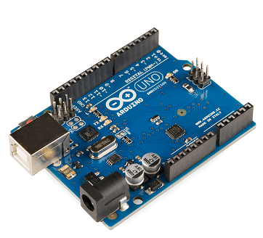

* MQ-3 Alcohol Sensor

The MQ3 alcohol sensor is simple to use and has two different outputs. It not only provides a binary indication of the presence of alcohol, but also an analog representation of its concentration in air. The sensor’s analog output voltage (at the A0 pin) varies in proportion to the alcohol concentration. The higher the concentration of alcohol in the air, the higher the output voltage; the lower the concentration, the lower the output voltage.

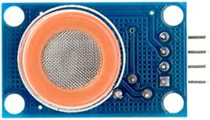

* Relay Module

A power relay module is an electrical switch that is operated by an electromagnet. The electromagnet is activated by a separate low-power signal from a micro controller. When activated, the electromagnet pulls to either open or close an electrical circuit.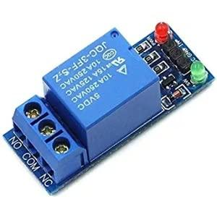

* 9-volt battery

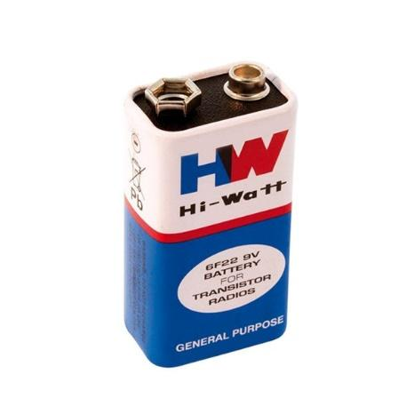

* DC Motor.

A DC motor or direct current motor is an electrical machine that transforms electrical energy into mechanical energy by creating a magnetic field that is powered by direct current. When a DC motor is powered, a magnetic field is created in its stator. The field attracts and repels magnets on the rotor; this causes the rotor to rotate. To keep the rotor continually rotating, the commutator that is attached to brushes connected to the power source supply current to the motors wire windings.

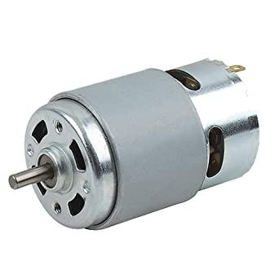

* Propeller (attached to motor)

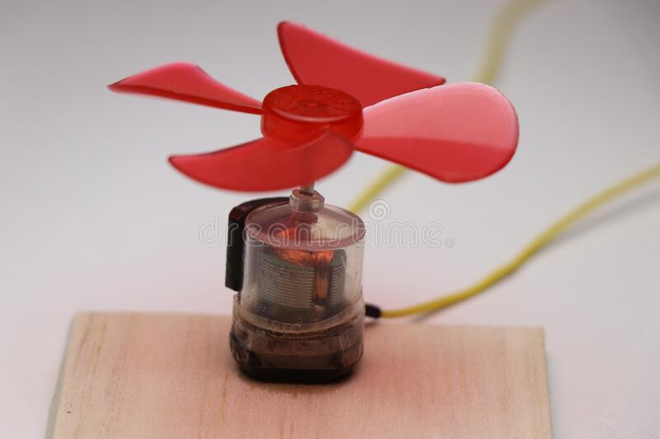

* Push button with general PCB

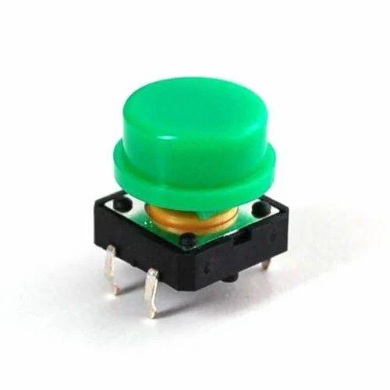

* Battery cap

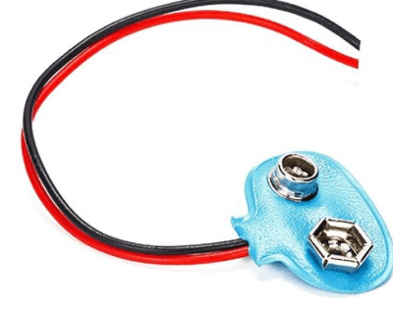

* LCD 16*2

Liquid crystal display screen is the electronic display module and finds a wide range of applications. A 16*2 LCD display is a very basic module and it is very commonly used in various devices and circuits. These modules are preferred to seven segments and other multi segment LEDs. The reason being: LCDs are economical; easily programmable; have no limitation of displaying special and even custom characters (unlike in 7 segments), animations and so on. A 16*2 LCD means it can display 16 characters per line and there are 2 such lines. In this LCD each character is displayed in 5*7 pixel matrix. This LCD has 2 registers , namely command and data

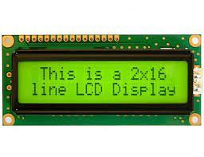

* Wires

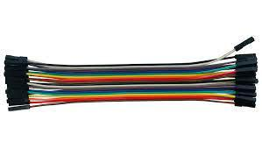

**2. Software Components.**

* Arduino IDE.

The Arduino Integrated Development Environment - or Arduino Software (IDE) - contains a text editor for writing code, a message area, a text console, a toolbar with buttons for common functions and a series of menus. It connects to the Arduino hardware to upload programs and communicate with them.



* TinkerCad

Tinkercad is a free-of-charge, online 3D modeling program that runs in a web browser. Since it became available in 2011 it has become a popular platform for creating models for 3D printing as well as an entry-level introduction to constructive Arduino based circuits.



# Chapter 3

# Analysis and Design

Following is the circuit Diagram of the proposed system.

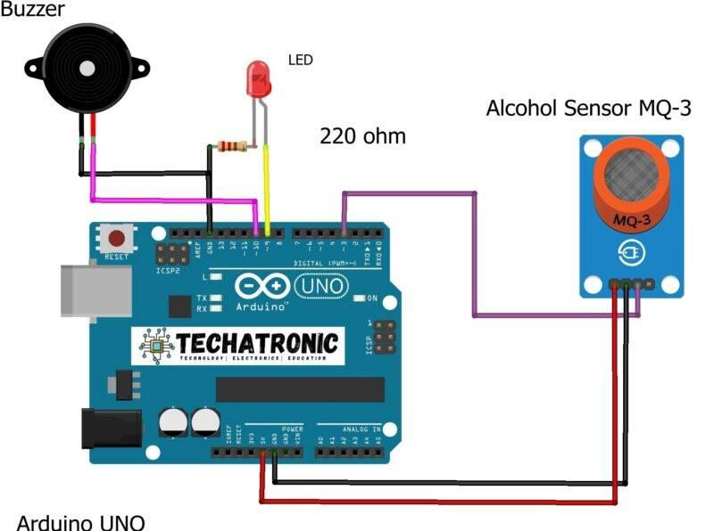

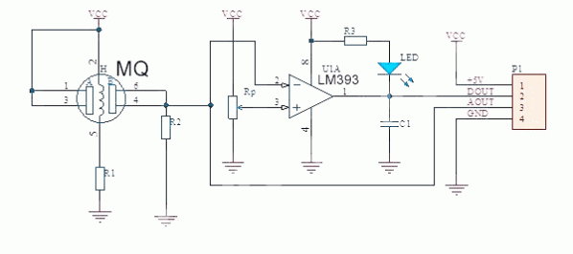

**System Flowchart**

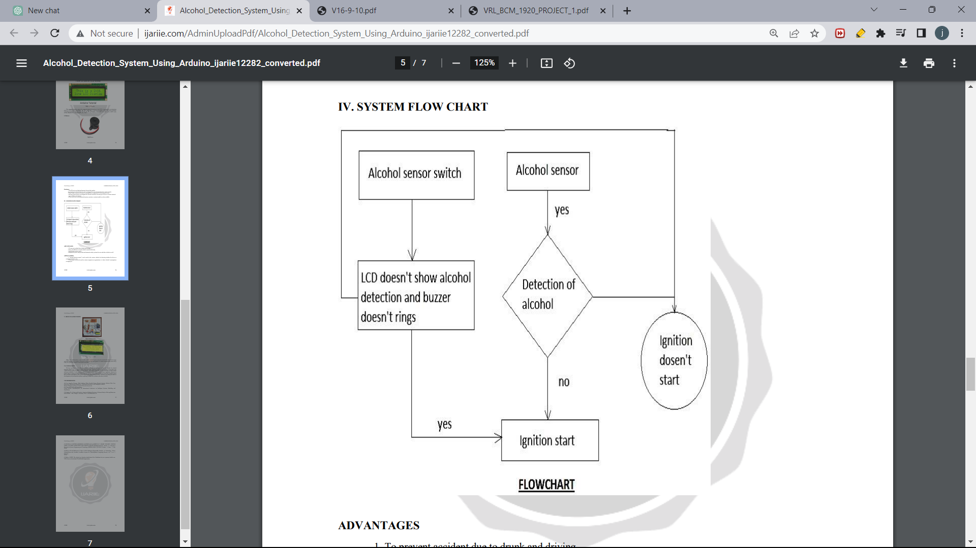

**Code to be run in Arduino IDE for Alcohol Detection:**

#include <LiquidCrystal.h>

LiquidCrystal lcd(8, 9, 10, 11, 12, 13);//RS,EN,D4,D5,D6,D7

#define gas 5

#define engine 6

#define gnd 3

#define relay 7

int alc=0,button=0;

void setup()

{

Serial.begin(9600); // initialize serial communications at 9600 bps:

pinMode(gas,INPUT);

pinMode(engine,INPUT_PULLUP);

pinMode(relay,OUTPUT);

pinMode(gnd,OUTPUT);

digitalWrite(relay,HIGH);

digitalWrite(gnd,LOW);

lcd.begin(16, 2);//initializing LCD

lcd.setCursor(0,0);

lcd.print("Smart Vehicle");

lcd.setCursor(0,1);

lcd.print("Protection");

delay(3000);

lcd.clear();

lcd.setCursor(0,0);

lcd.print("press key....");

delay(1000);

}

void loop()

{

alc=digitalRead(gas);

button=digitalRead(engine);

if(alc==HIGH)

{

if(button==LOW)

{ lcd.clear();

digitalWrite(relay,LOW);

lcd.setCursor(0,1);

lcd.print("safe drive...");

delay(2000);

}

}

else

{

digitalWrite(relay,HIGH);

lcd.setCursor(0,0);

lcd.print("ALCOHOL DETECTED");

delay(1000);

lcd.clear();

}

}

Prototype code:

#define sensorDigital 2

#define LED 3

#define buzzer 4

#define sensorAnalog A1

void setup() {

pinMode(sensorDigital, INPUT);

pinMode(LED, OUTPUT);

pinMode(buzzer, OUTPUT);

Serial.begin(9600);

}

void loop() {

bool digital = digitalRead(sensorDigital);

int analog = analogRead(sensorAnalog);

Serial.print("Analog value : ");

Serial.print(analog);

Serial.print("t");

Serial.print("Digital value :");

Serial.println(digital);

if (digital == 0) {

digitalWrite(LED, LOW);

digitalWrite(buzzer, HIGH);

} else {

digitalWrite(LED, HIGH);

digitalWrite(buzzer, LOW);

}

}

**Code to be run for Drowsiness Detection:**

import cv2

import dlib

import pyttsx3

from scipy.spatial import distance

# INITIALIZING THE pyttsx3 SO THAT

# ALERT AUDIO MESSAGE CAN BE DELIVERED

engine = pyttsx3.init()

# SETTING UP OF CAMERA TO 1 YOU CAN

# EVEN CHOOSE 0 IN PLACE OF 1

cap = cv2.VideoCapture(1)

# FACE DETECTION OR MAPPING THE FACE TO

# GET THE Eye AND EYES DETECTED

face_detector = dlib.get_frontal_face_detector()

# PUT THE LOCATION OF .DAT FILE (FILE FOR

# PREDECTING THE LANDMARKS ON FACE )

dlib_facelandmark = dlib.shape_predictor(

"C:\Users\HP\OneDrive\Desktop\New folder")

# FUNCTION CALCULATING THE ASPECT RATIO FOR

# THE Eye BY USING EUCLIDEAN DISTANCE FUNCTION

def Detect_Eye(eye):

poi_A = distance.euclidean(eye[1], eye[5])

poi_B = distance.euclidean(eye[2], eye[4])

poi_C = distance.euclidean(eye[0], eye[3])

aspect_ratio_Eye = (poi_A+poi_B)/(2*poi_C)

return aspect_ratio_Eye

# MAIN LOOP IT WILL RUN ALL THE UNLESS AND

# UNTIL THE PROGRAM IS BEING KILLED BY THE USER

while True:

null, frame = cap.read()

gray_scale = cv2.cvtColor(frame, cv2.COLOR_BGR2GRAY)

faces = face_detector(gray_scale)

for face in faces:

face_landmarks = dlib_facelandmark(gray_scale, face)

leftEye = []

rightEye = []

# THESE ARE THE POINTS ALLOCATION FOR THE

# LEFT EYES IN .DAT FILE THAT ARE FROM 42 TO 47

for n in range(42, 48):

x = face_landmarks.part(n).x

y = face_landmarks.part(n).y

rightEye.append((x, y))

next_point = n+1

if n == 47:

next_point = 42

x2 = face_landmarks.part(next_point).x

y2 = face_landmarks.part(next_point).y

cv2.line(frame, (x, y), (x2, y2), (0, 255, 0), 1)

# THESE ARE THE POINTS ALLOCATION FOR THE

# RIGHT EYES IN .DAT FILE THAT ARE FROM 36 TO 41

for n in range(36, 42):

x = face_landmarks.part(n).x

y = face_landmarks.part(n).y

leftEye.append((x, y))

next_point = n+1

if n == 41:

next_point = 36

x2 = face_landmarks.part(next_point).x

y2 = face_landmarks.part(next_point).y

cv2.line(frame, (x, y), (x2, y2), (255, 255, 0), 1)

# CALCULATING THE ASPECT RATIO FOR LEFT

# AND RIGHT EYE

right_Eye = Detect_Eye(rightEye)

left_Eye = Detect_Eye(leftEye)

Eye_Rat = (left_Eye+right_Eye)/2

# NOW ROUND OF THE VALUE OF AVERAGE MEAN

# OF RIGHT AND LEFT EYES

Eye_Rat = round(Eye_Rat, 2)

# THIS VALUE OF 0.25 (YOU CAN EVEN CHANGE IT)

# WILL DECIDE WHETHER THE PERSONS'S EYES ARE CLOSE OR NOT

if Eye_Rat < 0.25:

cv2.putText(frame, "DROWSINESS DETECTED", (50, 100),

cv2.FONT_HERSHEY_PLAIN, 2, (21, 56, 210), 3)

cv2.putText(frame, "Alert!!!! WAKE UP DUDE", (50, 450),

cv2.FONT_HERSHEY_PLAIN, 2, (21, 56, 212), 3)

# CALLING THE AUDIO FUNCTION OF TEXT TO

# AUDIO FOR ALERTING THE PERSON

engine.say("Alert!!!! WAKE UP DUDE")

engine.runAndWait()

cv2.imshow("Drowsiness DETECTOR IN OPENCV2", frame)

key = cv2.waitKey(9)

if key == 20:

break

cap.release()

cv2.destroyAllWindows()

# Chapter 4

# Results and Discussion

* We aim to create a Smart Ignition Interlock device that will turn off the ignition of the vehicle when alcohol content is detected in the breath of the driver. This helps avoid road accidents, increasing safety of driver, passenger, and pedestrians.

Proposed Circuit:

Hardware setup

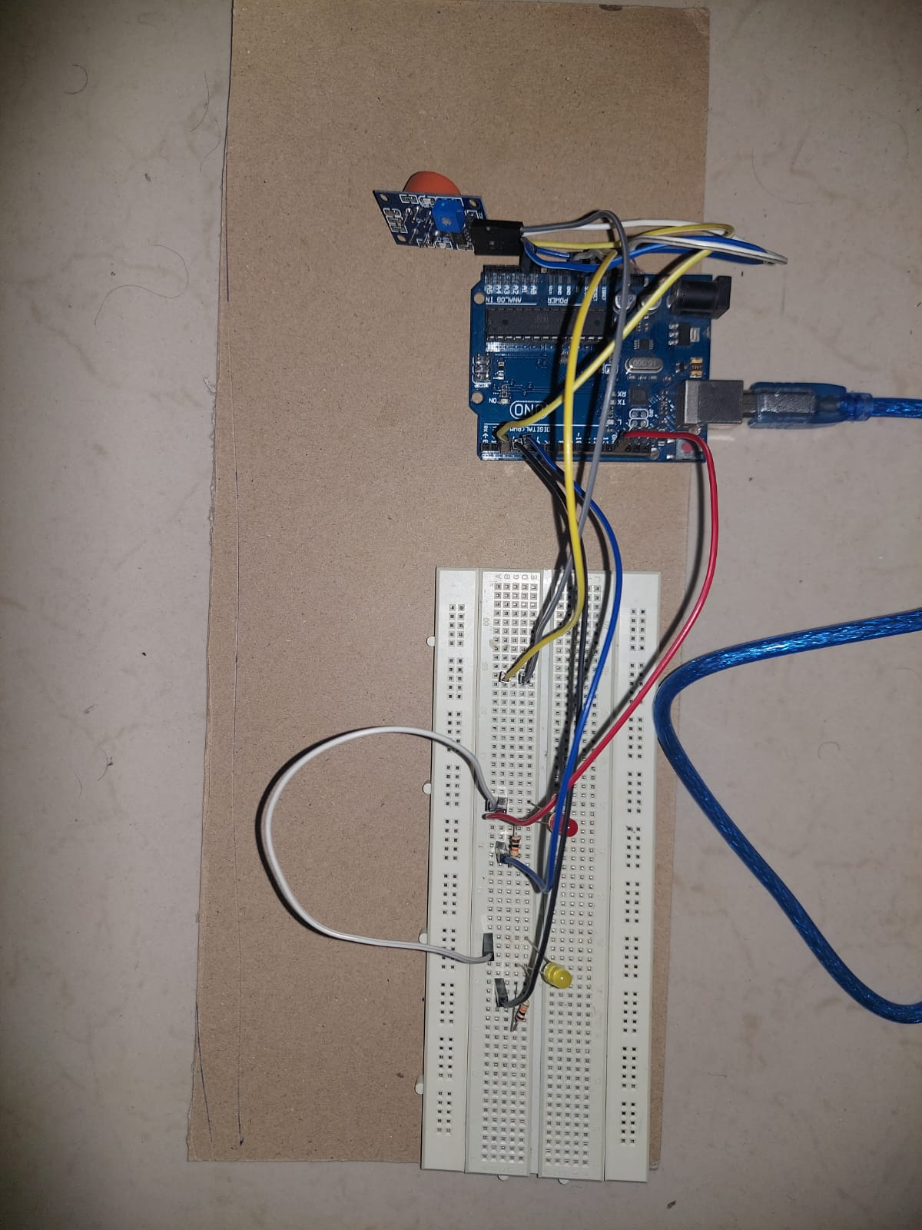

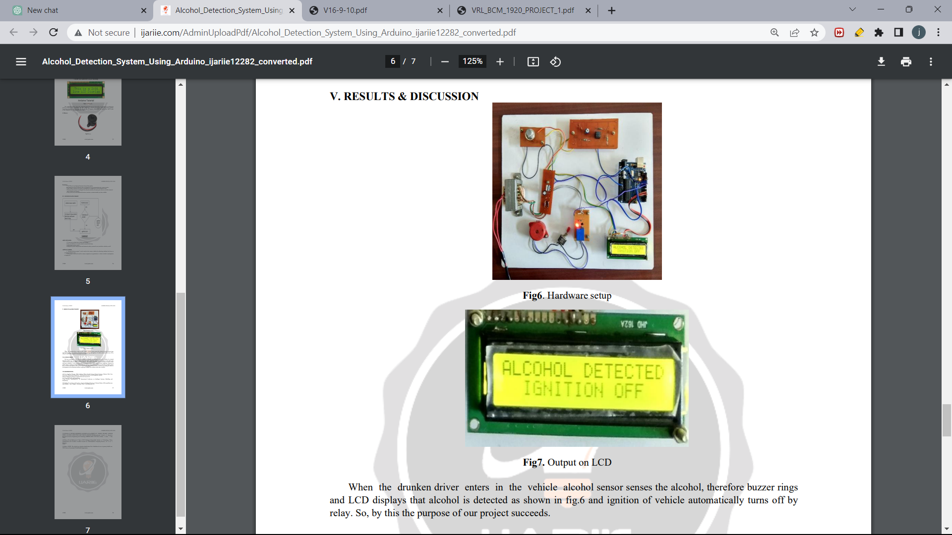

Output on LCD

When the drunken driver enters the vehicle, the alcohol sensor senses the alcohol, and the LCD displays that alcohol is detected as shown in the above figure and ignition of the vehicle automatically turns off by relay. So, by this the purpose of our project succeeds.

# Chapter 5

# Conclusion and Future Scope

**5.1 Conclusion**

In conclusion, smart ignition interlock devices have emerged as a promising technology to prevent alcohol-impaired driving and reduce recidivism rates among DUI offenders. These devices incorporate advanced technologies such as AI, IoT, and sensors, and offer features such as real-time monitoring, data analysis, and user-friendly interfaces. The existing literature suggests that smart ignition interlock devices are generally effective in preventing alcohol-impaired driving and improving road safety.

However, there are several research gaps that need further exploration, including long-term effectiveness, user experience and acceptance, cost-effectiveness, equity and accessibility, technological advancements, and policy and legal considerations. Addressing these research gaps can help improve the understanding and implementation of smart ignition interlock devices, and contribute to evidence-based strategies for reducing alcohol-impaired driving and promoting public safety.

Despite the potential benefits of smart ignition interlock devices, it is important to consider their limitations, such as the potential for device tampering, false positives/negatives, and the need for ongoing maintenance and monitoring. Furthermore, ethical and legal considerations, such as user privacy and due process rights, should be carefully addressed in the implementation and use of these devices.

In conclusion, smart ignition interlock devices have shown promise in preventing alcohol-impaired driving and reducing recidivism rates among DUI offenders, but further research, technological advancements, and policy considerations are needed to fully harness their potential in improving road safety and public health.

**5.2 Future Scope**

* Integrating the key aspect of the smart IID i.e., Alcohol detection, with drowsiness detection, thus making the smart IID an even safer and better tool to prevent road accidents.
* Integration with other technologies: Smart ignition interlock devices could potentially be integrated with other technologies, such as smartphones, wearables, or connected car platforms, to provide additional functionalities and improve user experience. For example, integrating with smartphones could allow for remote monitoring, notifications, and data analysis, while integration with connected car platforms could enable real-time feedback and interventions based on vehicle data.
* Enhanced sensor technologies: Advances in sensor technologies, such as breathalyzers or touch-based sensors, could further improve the accuracy and reliability of smart ignition interlock devices. For instance, using more sensitive and specific sensors could reduce the potential for false positives or negatives, and enable better detection of alcohol impairment.
* Data analytics and machine learning: The use of data analytics and machine learning algorithms could enable more sophisticated analysis of device usage data, user behavior, and contextual factors. This could provide insights into patterns of alcohol consumption, risk factors for relapse, and personalized interventions to improve compliance and prevent alcohol-impaired driving.
* User-centered design: User-centered design approaches could be incorporated in the development and refinement of smart ignition interlock devices to ensure that they are user-friendly, accessible, and acceptable to a wide range of users. This could involve involving end-users in the design process, conducting usability testing, and incorporating feedback from users to continuously improve the user experience and increase user acceptance.
* Expansion of implementation and accessibility: The implementation of smart ignition interlock devices could be expanded to reach a wider population of DUI offenders and at-risk individuals. This could involve addressing barriers to accessibility, such as cost, geographic location, or socio-economic status, and promoting equity in the availability and affordability of these devices.
* Policy and regulatory advancements: Future advancements in policies and regulations could impact the use of smart ignition interlock devices. This could include standardizing installation and maintenance procedures, establishing clear guidelines on device tampering, improving enforcement practices, and developing consistent policies on device usage and data privacy.

# References

[1] Tsxperts (2018, Mar), Arduino™ Compatible Compiler for LabVIEW [Online], available at: https://www.tsxperts.com/arduino -compatible compiler - for -labview/ .

[2] Dhivya M and Kathiravan S, Dept. of ECE, Kalaignar Karunanidhi Institute of Technology- Driver Authentication and Accident Avoidance System for Vehicles[Smart Computing Review, vol. 5, no. 1, February 2015]

[3] A. ISuge, H.Takigawa, H.Osuga, H.Soma, K.Morisaki, AccidentVehicle Automatic Detection System By Image Processing Technology , ©IEEE 1994 Vehiclee Navigation & information Systems Conference

[4] Babor, AUDIT: The alcohol use disorders identification Test: Guidelines for use in primary health care. 1992, Geneva, Switzerland: World Health Organization.

[5] Texas Instruments (2015), Understanding the I 2C Bus Online], available at: http://www.ti.com /lit /an / slva 704 / slva704.pdf.

[6] Vehicle Accident Detection and reporting system using GPS and GSM Module.", International Journal of Emerging Technologies and Innovative Research (www.jetir.org | UGC and issn Approved ), ISSN:2349-5162, Vol.2, Issue 5, page no. pp1433-1436, May-2015, Available at http://www.jetir.org/papers/JETIR1505018.pdf

[7] Lea Angelica Navarro, Mark Anthony Diño, Exechiel Joson, Rommel Anacan, Roberto Dela Cruz Electronics Engineering Department, Technological Institute of the Philippines- Manila Manila, Philippines-Design of Alcohol Detection System for Car Users thru Iris Recognition Pattern Using Wavelet Transform[2016 7th International Conference on Intelligent Systems, Modelling and Simulation]