SMART INDIA HACKATHON 2026
LANDSYNC AI
AI-Powered Multi-Source Geospatial Data Harmonization for Urban Land Records
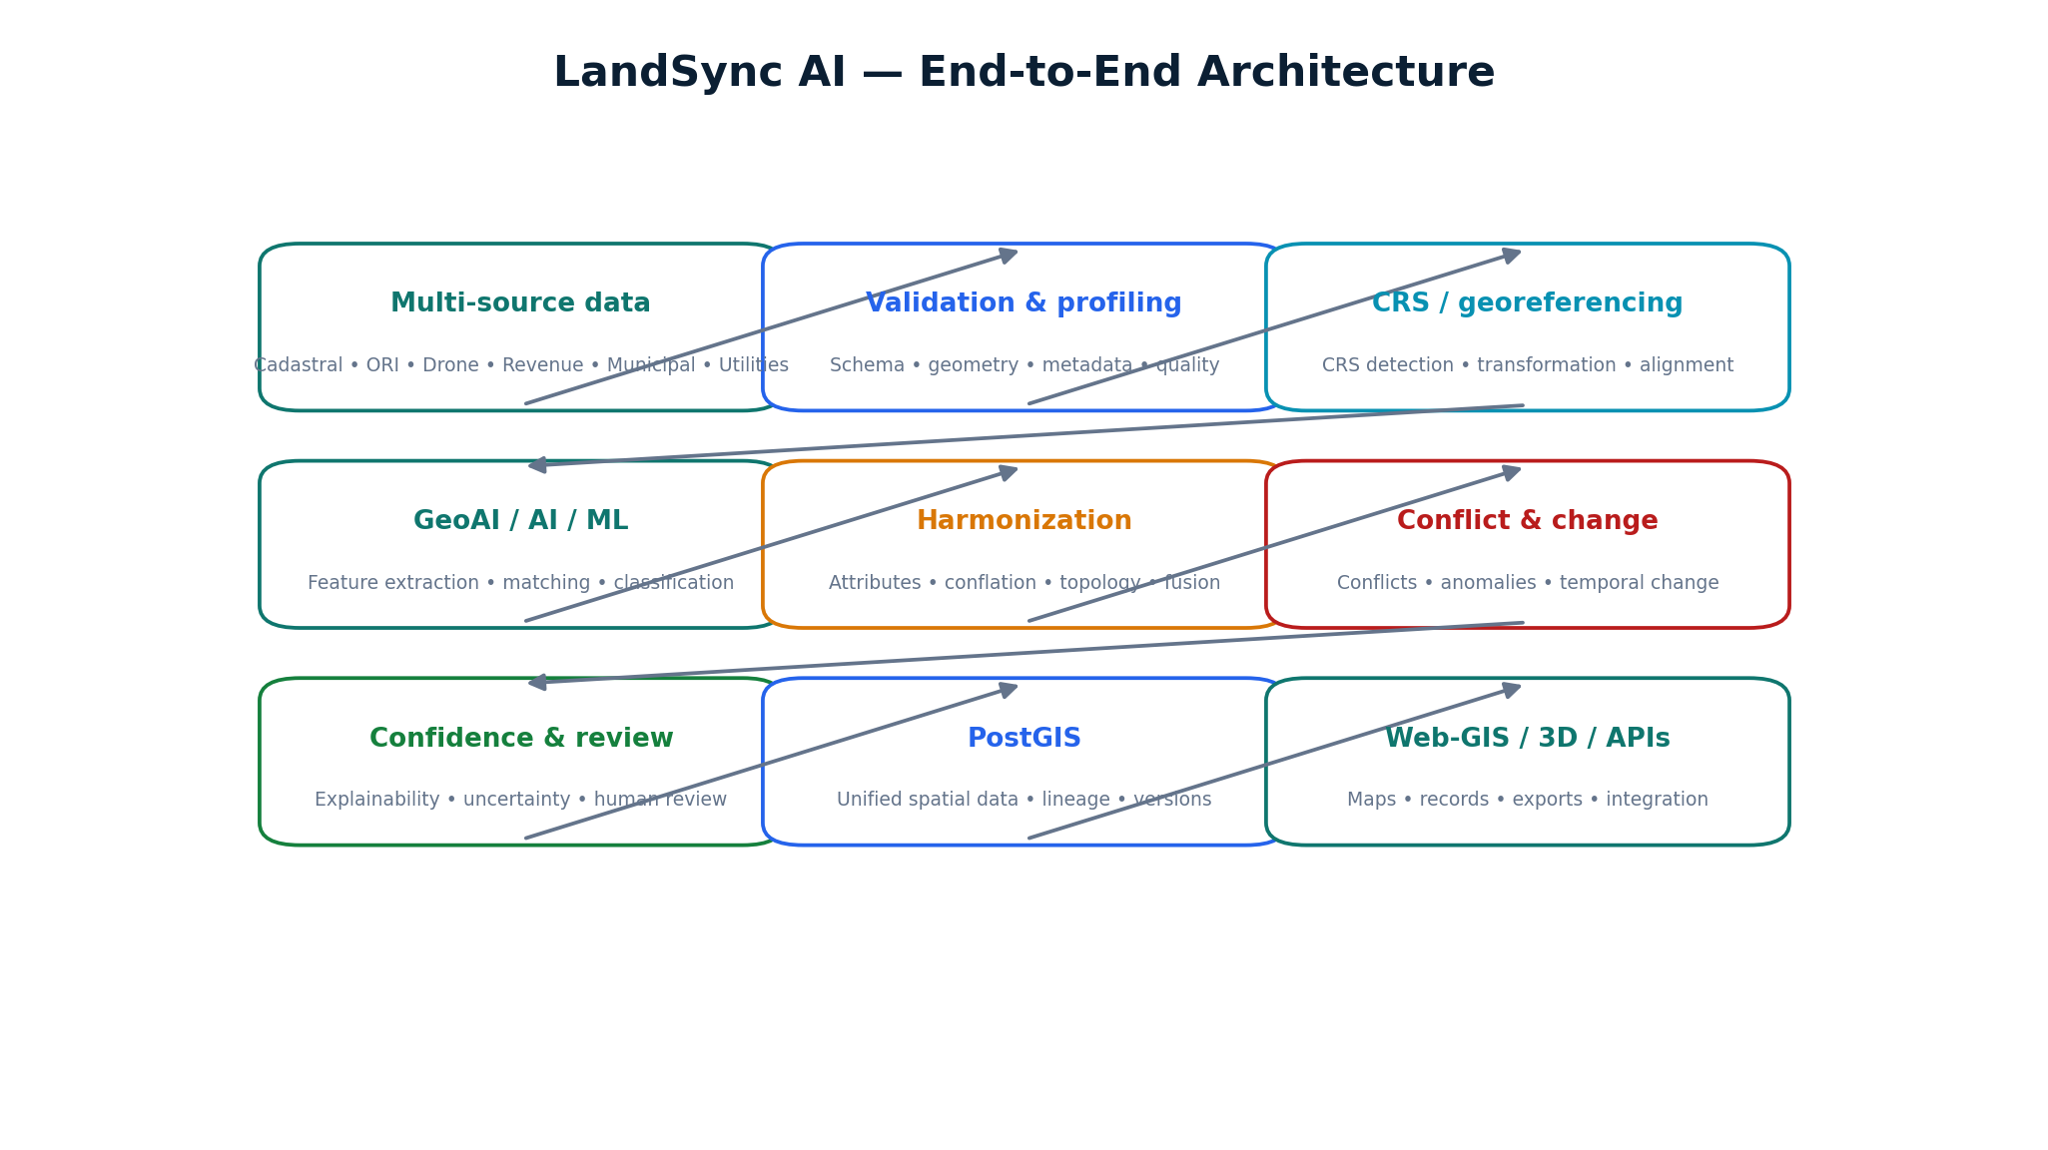
Figure 1. LandSync AI — system concept
Explanation: A unified pipeline connects heterogeneous urban land data to deterministic geospatial processing, GeoAI/AI/ML, harmonization, conflict handling, confidence scoring, human review and publication.
Judge takeaway: The proposal is not a single AI model; it is an auditable geospatial integration system with AI placed where it adds value.
Project Detail | Value
Problem Statement | SIH26013 — Automated Integration and Intelligent Harmonization of Multi-source Geospatial Data for urban Land Record Management
Team | Tech Vectors
Category | Software
Organization | Ministry of Rural Development
Department | Department of Land Resources (DoLR)
Programme Context | NAKSHA / urban land-record modernization
Core Domain | GeoAI • GIS • AI/ML • Remote Sensing • Spatial Data Engineering • Urban Land Records

CORE ARCHITECTURE PRINCIPLE Deterministic GIS for geometry and spatial correctness; AI/ML for feature extraction, matching, classification and uncertainty; human verification for authoritative decisions.

01 EXECUTIVE SUMMARY

Executive Summary
LandSync AI addresses the integration problem at the boundary of geospatial data engineering, GeoAI and human-governed land administration.
Urban land administration depends on spatial and non-spatial evidence produced by different departments, agencies and survey mechanisms. NAKSHA's public programme material describes GIS-integrated urban land parcels supported by aerial imagery, drones, GNSS-based field surveys and Web-GIS. LandSync AI is proposed as a harmonization layer that can bring these heterogeneous sources into a common, traceable processing workflow.
The platform ingests cadastral maps, Drone Imagery, Orthorectified Imagery (ORI), DSM/DTM, Revenue Records, Municipal GIS, Utility Network Data, Ground Truthing (GT), GNSS/CORS survey data and Building Footprints. It validates source quality, performs CRS-aware georeferencing and Coordinate Transformation, uses AI/ML and Computer Vision for feature extraction where appropriate, performs evidence-based Spatial Matching and Intelligent Attribute Mapping, checks topology, detects conflicts and temporal changes, produces Explainable AI confidence information, and routes uncertain cases to Human-in-the-loop review.
DESIGN PRINCIPLE The key differentiator is workflow integration: the system combines spatial ETL, deterministic GIS operations, GeoAI, reconciliation and review rather than treating AI as a replacement for authoritative GIS judgment.
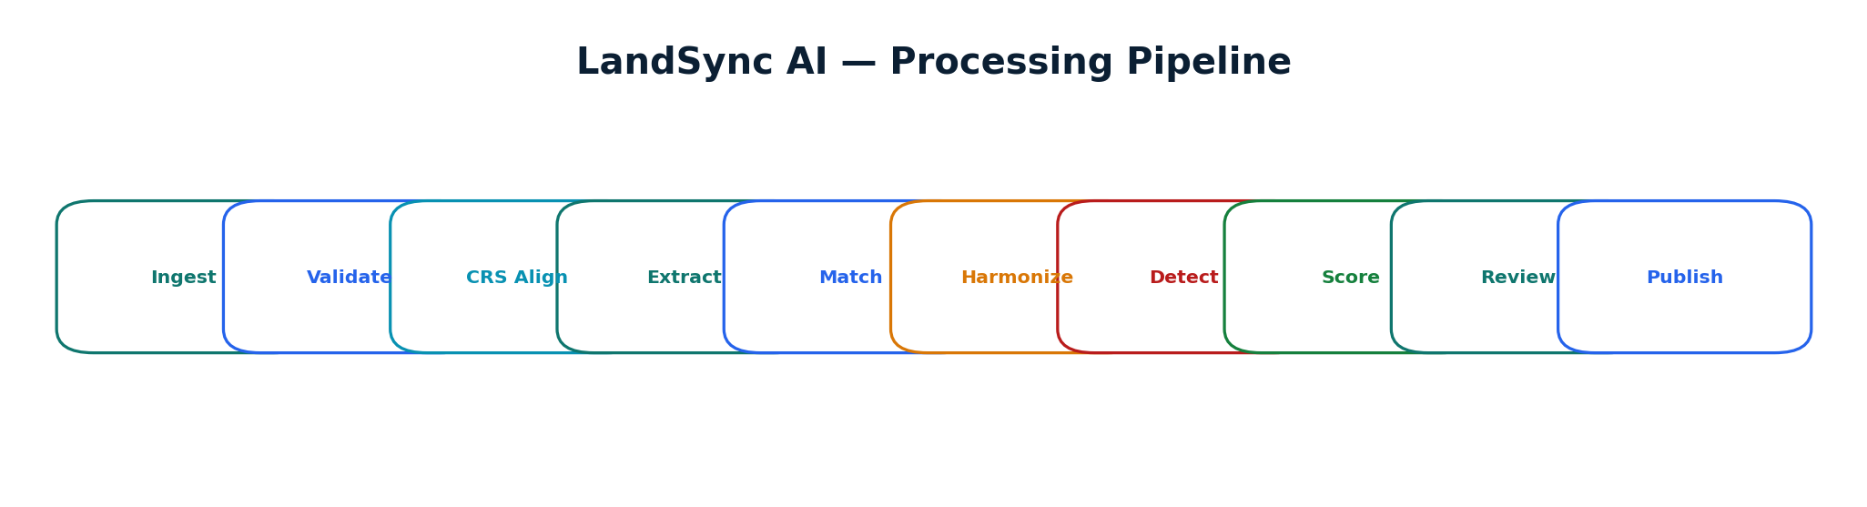
Figure 2. End-to-end LandSync AI pipeline
Explanation: The pipeline moves from source ingestion through validation, alignment, extraction, matching, harmonization, conflict/change analysis, confidence scoring and review.
Judge takeaway: Every stage has an explicit responsibility and can be tested independently.
Design objective | LandSync response
Reduce repetitive GIS integration effort | Automated ingestion, validation, transformation and evidence preparation
Improve consistency | Canonical schemas, CRS normalization, geometry validation and topology rules
Enable interoperability | REST APIs, standard geospatial formats, metadata and provenance
Handle uncertainty | Multi-factor confidence scoring and review queues
Protect authoritative decisions | Human verification before high-risk record changes

02 PROBLEM STATEMENT

Problem Statement
Translate the SIH26013 challenge into an engineering problem that can be demonstrated and evaluated.
The core engineering problem is not merely storing GIS layers. It is determining how multiple representations of the same real-world urban land entity can be aligned, compared, reconciled and presented as a consistent information product while retaining evidence about where every value came from.
Source family | Typical information | Integration challenge
Cadastral Maps | Parcel boundaries, survey references | Legacy geometry, scale and coordinate differences
Drone / ORI | High-resolution imagery | Raster processing, extraction and temporal differences
DSM / DTM | Elevation / terrain | Resolution, vertical reference and raster alignment
Revenue Records | Parcel-related attributes | Schema differences and authoritative-field handling
Municipal GIS | Property / land-use layers | Different identifiers, geometry and update cycles
Utility Networks | Water, electricity and infrastructure | Network topology and cross-layer relationships
GNSS / CORS | Survey observations / control | Coordinate reference and quality metadata
Ground Truthing | Field verification evidence | Linking observations to mapped features
Building Footprints | Building geometry / status | Source provenance and temporal variation

NAKSHA's public portal explicitly exposes workflow concepts including ORI upload, Ground Truthing, ROR tagging and active rover status, reinforcing the practical importance of linking imagery, field survey and record evidence in urban land workflows. [1]
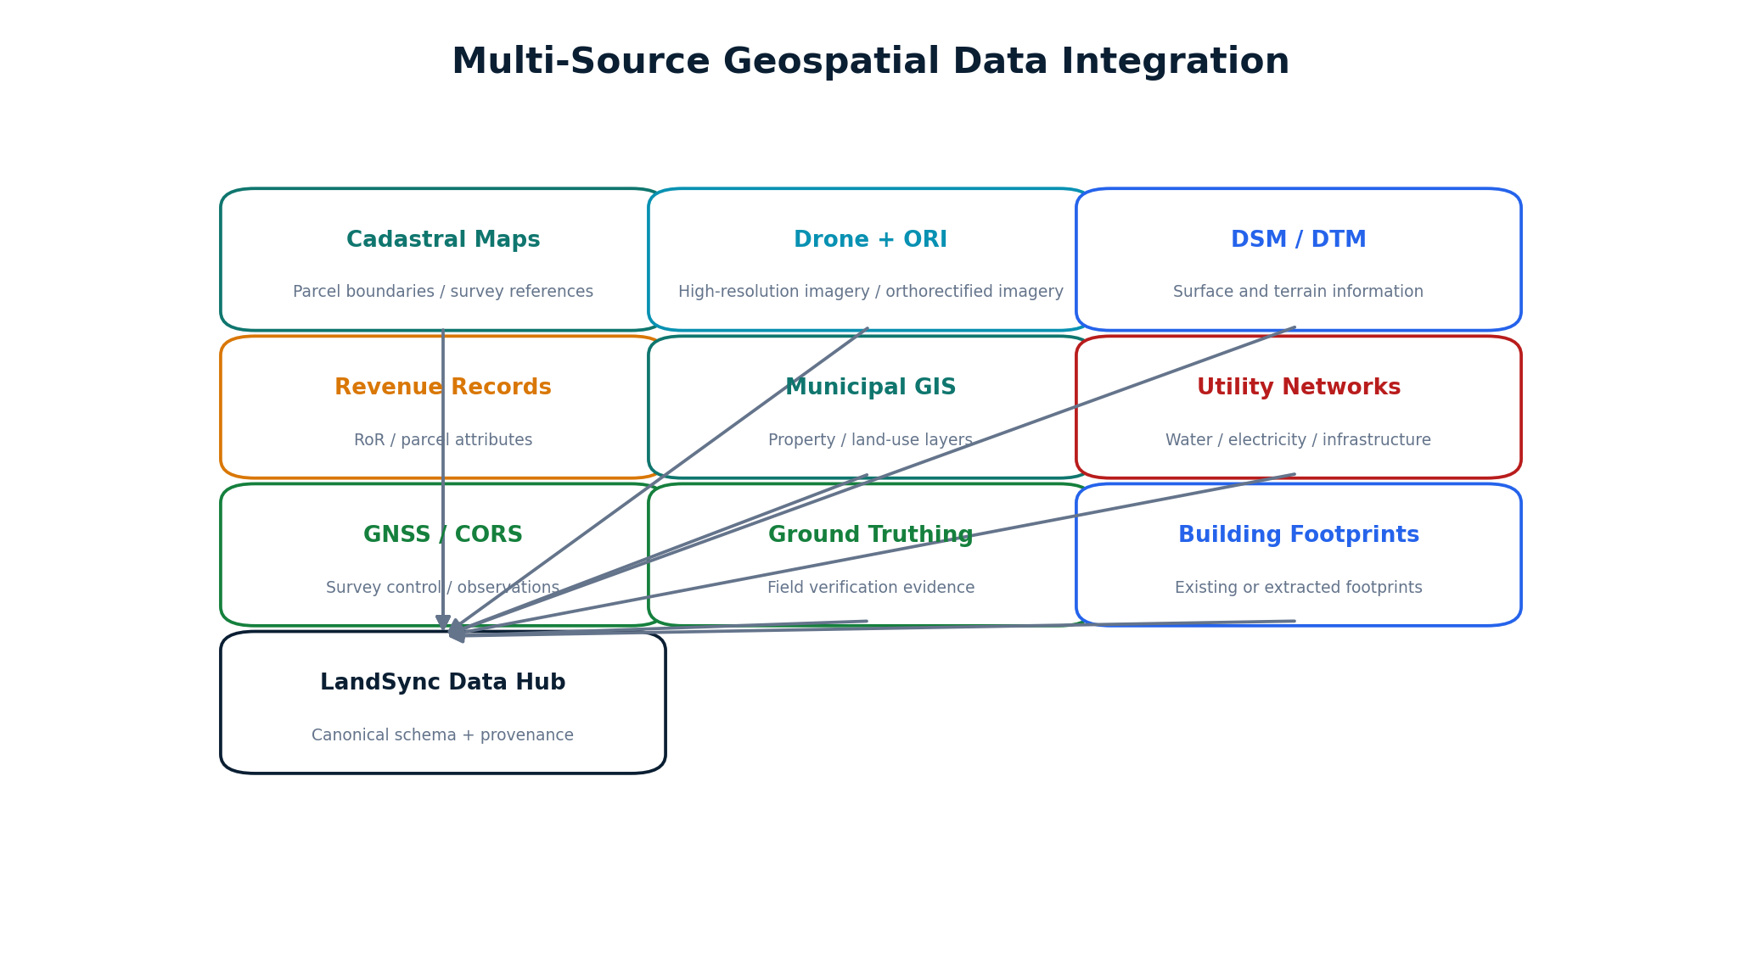
Figure 3. Multi-source evidence landscape
Explanation: LandSync treats each source as evidence about the same geographic reality and retains source identity throughout processing.
Judge takeaway: The system is designed around data integration rather than a single-source GIS.

03 BACKGROUND AND CONTEXT

Background and Context
Position the proposal within urban land-record modernization without claiming government adoption or endorsement.
DoLR describes NAKSHA as a one-year pilot under DILRMP focused on urban land records and GIS-integrated parcel mapping. Its public material states that the initiative uses aerial and field survey techniques and aims to build a comprehensive GIS-integrated database of urban land parcels. [2]
LandSync AI is not presented as an official NAKSHA component. It is a proposed technical solution aligned to the integration and harmonization problem described by SIH26013. The design therefore emphasizes modularity, source adapters, standards-aware geospatial processing, explainability and human review.
SCOPE BOUNDARY Programme context is sourced from DoLR/NAKSHA public material. LandSync AI is a proposed prototype architecture, not an assertion of official deployment.
Why the integration layer matters:
- A common map view does not by itself reconcile geometry, attributes, data vintages or provenance.
- Spatial data can be technically valid while still disagreeing about the same physical entity.
- AI-derived features need spatial validation and traceability before they can support operational review.
- Authoritative land decisions can require institutional rules and human verification beyond algorithmic similarity.

04 EXISTING WORKFLOW AND LIMITATIONS

Existing Workflow and Limitations
Show why fragmented, manual integration creates an opportunity for an automation and evidence-management layer.
Figure 4. Current workflow concept
Explanation: In many heterogeneous GIS environments, integration can involve repeated format conversion, CRS handling, overlays, manual reconciliation and quality checks.
Judge takeaway: The proposed system targets repetitive integration steps while preserving review for uncertain cases.
Current challenge | Operational consequence | LandSync response
Manual GIS integration | High repetitive effort | Automated Spatial ETL and processing jobs
Different CRS | Misalignment risk | CRS detection, Georeferencing and Coordinate Transformation
Different schemas | Difficult field matching | Canonical schema + Intelligent Attribute Mapping
Different data vintages | Temporal inconsistency | Temporal metadata + Change Detection
Geometry errors | Invalid relationships | Geometry Validation + Topology Correction
Conflicting sources | Unclear reconciliation | Evidence comparison + Conflict Engine
No confidence layer | Hard to prioritize review | Configurable Confidence Scoring
Weak lineage | Difficult auditing | Data Provenance + Audit Trail

05 PROPOSED SOLUTION — LANDSYNC AI

Proposed Solution — LandSync AI
Define the product as a geospatial integration and reconciliation platform.
LandSync AI is a GeoAI-powered multi-source geospatial ETL, reconciliation and harmonization platform. Its primary output is not a black-box prediction; it is a validated, spatially aligned, harmonized and traceable land-information representation accompanied by conflict status, confidence information and review history.
ONE-LINE DEFINITION LandSync AI = Evidence integration + deterministic GIS + AI/ML assistance + human verification.
Layer | Responsibility
Ingestion | Accept heterogeneous vector, raster and non-spatial sources
Validation | Profile schema, geometry, metadata, nulls, duplicates and quality
Spatial Reference | Detect/verify CRS and transform data into a common working reference
AI/ML | Extract features, classify imagery and assist spatial matching
Harmonization | Map attributes, conflate parcels, fuse evidence and validate topology
Conflict / Change | Identify spatial, attribute and temporal inconsistencies
Confidence | Explain evidence strength and uncertainty
Human Review | Approve, reject or request field/survey verification
Publication | Serve Web-GIS, records, exports and APIs with provenance

Figure 5. Proposed LandSync AI architecture
Explanation: The architecture separates source ingestion, geospatial correctness, AI/ML services, harmonization, review and publication.
Judge takeaway: The modular design supports incremental implementation and independent validation of each subsystem.

06 OBJECTIVES

Objectives
Convert the problem statement into testable engineering objectives.
- Automate ingestion and profiling of heterogeneous geospatial and non-spatial land datasets.
- Normalize spatial reference systems and provide auditable georeferencing and coordinate transformation.
- Extract relevant features from imagery and raster sources using AI/ML and Computer Vision where justified.
- Match corresponding features across sources using geometry, attributes, spatial context, temporal information and source-quality evidence.
- Harmonize heterogeneous schemas into a canonical land-information model while retaining original field provenance.
- Detect and safely correct or flag geometry and topology problems.
- Detect spatial conflicts, anomalies and temporal changes and provide an evidence trail.
- Produce configurable confidence information to prioritize human review.
- Provide a Web-GIS workspace for 2D analysis, comparison, review and controlled publication, with optional 3D visualization.
- Expose APIs and interoperable exports so the system can participate in inter-departmental data exchange.
EVALUATION DISCIPLINE Objectives are written as capabilities to be implemented and evaluated, not as claims that the prototype has already achieved production performance.

07 STAKEHOLDERS AND TARGET USERS

Stakeholders and Target Users
Define users without assuming deployment-specific permissions.
Role / stakeholder | Primary need | LandSync capability
DoLR / programme stakeholders | Integrated urban land information workflow | Source harmonization, provenance and reporting
Municipal GIS team | Property / land-use layer reconciliation | GIS compare, matching and attribute mapping
Revenue team | Record-linked parcel information | Record linkage, conflicts and review evidence
Survey officer | Field evidence and GNSS observations | GNSS/GT integration, survey-request queue
GIS officer | Spatial QA and harmonization | Map overlays, topology and conflict tools
Reviewer | Evidence-based decision workflow | Human Review Workspace and audit trail
Data analyst | Quality and operational metrics | Data-quality dashboards and evaluation exports
Administrator | System configuration | RBAC, source adapters, thresholds and audit controls

Permissions should be configured by the deploying institution. The role model is a prototype access-control design, not a claim about official government authorization.

08 FUNCTIONAL REQUIREMENTS

Functional Requirements
Define what the prototype must actually do.
ID | Requirement | Acceptance evidence
FR-01 | Upload and register vector, raster and tabular datasets | Dataset appears with metadata and version
FR-02 | Validate format, schema, geometry and metadata | Validation report with errors/warnings
FR-03 | Detect/verify CRS and transform datasets | Before/after CRS report and aligned map
FR-04 | Extract selected features from imagery | Feature layer + model/version metadata
FR-05 | Match corresponding spatial entities | Match candidates + evidence + confidence
FR-06 | Map heterogeneous attributes | Canonical record + mapping provenance
FR-07 | Detect and correct/flag topology issues | Issue list + before/after geometry
FR-08 | Detect conflicts and temporal changes | Conflict/change event records
FR-09 | Generate confidence information | Explainable factor panel
FR-10 | Support human review | Approve/reject/survey action + audit log
FR-11 | Publish unified GIS view | Layered map + selected parcel record
FR-12 | Export and integrate through APIs | Controlled GeoJSON/CSV/GPKG/API response

09 NON-FUNCTIONAL REQUIREMENTS

Non-Functional Requirements
Define qualities needed for a serious institutional prototype.
Quality | Design response
Accuracy | Separate deterministic spatial operations from probabilistic AI; validate against reference data
Explainability | Evidence factors, model version, provenance and review actions
Interoperability | Common geospatial formats, CRS metadata, REST APIs and canonical schema
Scalability | Asynchronous processing, spatial indexing, tiling and modular workers
Security | RBAC, authentication, secure uploads, authorization, audit logging
Availability | Containerized services, health checks, backups and restartable jobs
Maintainability | API-first modules, versioned models, source adapters and tests
Usability | Map-centric review UI with concise evidence panels
Reproducibility | Dataset versions, job IDs, configuration and model metadata

PRODUCTION BOUNDARY A production deployment would require institutional security, data governance, infrastructure and operational controls beyond the prototype.

10 END-TO-END SYSTEM ARCHITECTURE

End-to-End System Architecture
Show the complete technical flow from source data to a governed output.
Figure 6. End-to-end architecture
Explanation: The central design separates ingestion, spatial reference management, AI/ML, harmonization, conflict/change analysis, confidence, review, storage and publication.
Judge takeaway: A judge can trace every major SIH26013 capability to a concrete system layer.
Architectural principles:
- Loose coupling through service boundaries and processing jobs.
- Deterministic GIS operations for coordinate, geometry and topology correctness.
- AI/ML adapters for feature extraction and evidence-based matching.
- Versioned datasets and processing jobs for reproducibility.
- Human-in-the-loop review for authoritative or ambiguous decisions.
- API-first integration for inter-departmental exchange.

11 MULTI-SOURCE DATA INTEGRATION

Multi-Source Data Integration
Explain how heterogeneous evidence becomes a common processing model.
Figure 7. Data-source integration model
Explanation: Each source is registered with type, CRS, schema, temporal metadata, provenance and quality information before harmonization.
Judge takeaway: The system does not erase source differences; it models them explicitly so they can be compared.
Source registration metadata should include:
- dataset_id and dataset_version
- source organization / system
- data type and format
- CRS / spatial reference
- capture or effective date
- schema description
- quality indicators
- license/access constraints
- processing lineage

12 DATA INGESTION AND VALIDATION

Data Ingestion and Validation
Make data quality the first gate before AI or spatial matching.
Validation family | Examples
Format | Supported extension, readable file, encoding
Schema | Required fields, types, aliases, duplicate field names
Geometry | Validity, self-intersections, closure, empty geometries
Attributes | Nulls, ranges, datatype normalization, duplicates
Metadata | CRS, units, source, vintage, processing history
Spatial quality | Extent anomalies, unexpected density, outliers
Raster quality | Band count, resolution, nodata, georeferencing

A dataset-quality profile can be represented as machine-readable metadata and shown to the user before processing. Validation should distinguish hard errors that block processing from warnings that permit controlled continuation.
ENGINEERING PRINCIPLE Validation is a gate, not a cosmetic dashboard. The system should make data-quality defects actionable.

13 GEOREFERENCING AND COORDINATE TRANSFORMATION

Georeferencing and Coordinate Transformation
Provide a CRS-aware foundation for every spatial comparison.
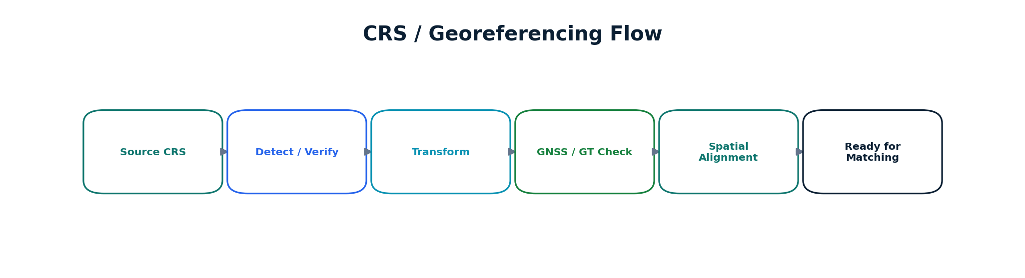
Figure 8. CRS / georeferencing flow
Explanation: Source coordinate systems are detected or verified, transformed through PROJ/GDAL/PyProj and checked against GNSS/GT evidence where available.
Judge takeaway: Spatial matching is meaningful only after coordinate systems and alignment assumptions are explicit.
PROJ is a coordinate transformation library capable of transforming coordinates between coordinate reference systems and supporting more complex geodetic transformations. [4] LandSync can use PROJ directly or through GDAL/PyProj. The design should record source CRS, target CRS, transformation operation, parameters and timestamp.
Control | Recorded value
Source CRS | Authority/code or explicit definition
Target working CRS | Configured project CRS
Transformation operation | Selected PROJ operation / pipeline
Ground control | GNSS / CORS / GT references where available
Residual / QA evidence | Measured or computed alignment diagnostics
Operator override | User, reason and timestamp if manual selection occurs

14 AI/ML AND GEOAI LAYER

AI/ML and GeoAI Layer
Use AI only where it adds measurable capability and keep geometry correctness deterministic.
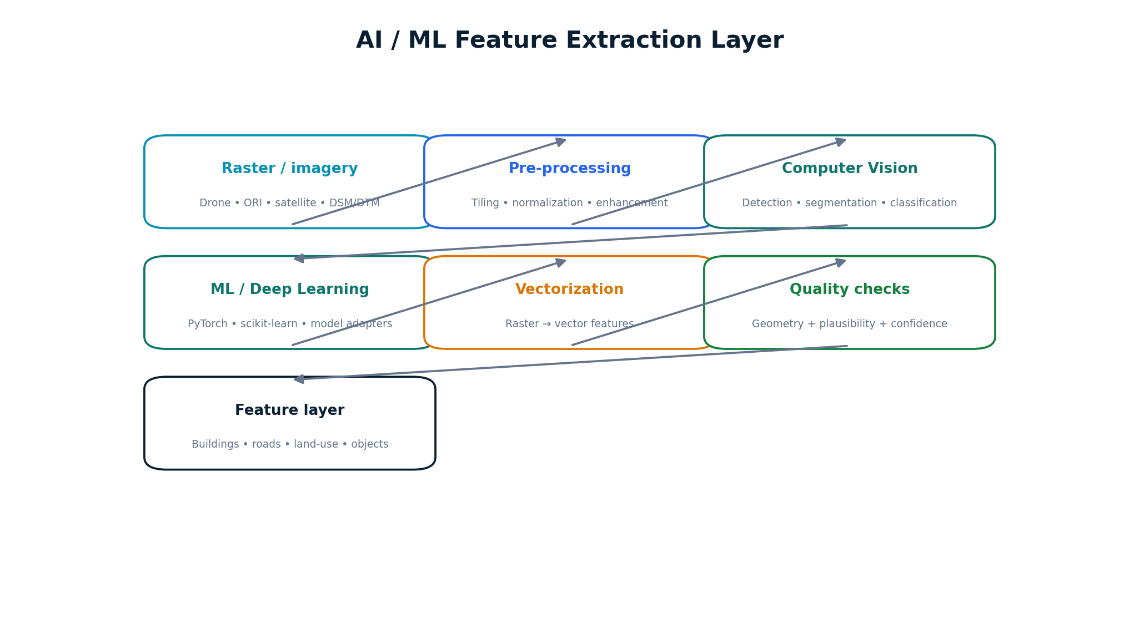
Figure 9. AI/ML feature-extraction architecture
Explanation: Raster/imagery data is preprocessed, passed to appropriate Computer Vision or ML models, converted to spatial features and then subjected to quality checks.
Judge takeaway: AI outputs are treated as candidate evidence, not automatically authoritative geometry.
Candidate AI/ML tasks include:
- Building detection and footprint extraction.
- Land-use or land-cover classification where training data supports it.
- Image segmentation and object detection.
- Feature extraction from high-resolution drone/ORI imagery.
- Candidate spatial matching scores.
- Anomaly or conflict classification.
PyTorch provides the model-development/inference framework; OpenCV provides image-processing primitives; scikit-learn can support classical ML and evaluation. Model choice should be dataset-driven rather than technology-driven.

15 COMPUTER VISION AND FEATURE EXTRACTION

Computer Vision and Feature Extraction
Explain the imagery pathway from pixels to GIS-ready features.
Step | Technical action | Output
Tiling | Split large imagery into manageable windows | Image tiles + spatial index
Pre-processing | Normalize, resize, denoise or enhance as required | Model-ready raster
Inference | Detection / segmentation / classification | Masks, boxes or class probabilities
Post-processing | Filter, merge and simplify candidate features | Candidate vector geometries
Geospatialization | Attach CRS and transform into project coordinates | GIS feature layer
Quality control | Geometry validity, plausibility and confidence checks | Accepted / flagged features

OpenCV's documented image-processing modules include filtering, morphology, geometric transformations and related operations useful for preprocessing. [11] Feature extraction should preserve the source imagery reference and model metadata.
AI EVIDENCE RULE Never report model accuracy in the proposal unless the team has actually trained/tested the model on a defined validation set.

16 AI/ML SPATIAL MATCHING

AI/ML Spatial Matching
Make spatial entity resolution the central intelligence component.
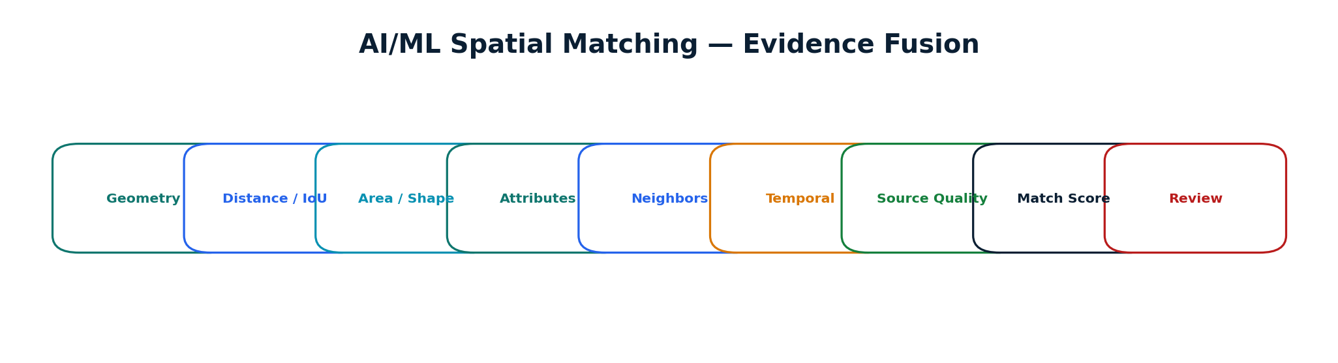
Figure 10. Spatial matching evidence model
Explanation: Candidate matches are generated using spatial indexes and deterministic filters, then scored using geometry, attributes, neighborhood, temporal and source-quality evidence.
Judge takeaway: The system can explain why two records were considered a match rather than returning an unexplained similarity score.
A practical candidate-generation strategy:
- Use spatial extent / bounding-box filters to reduce candidate pairs.
- Apply spatial-index-aware predicates such as intersection, proximity or containment.
- Compute geometric similarity features such as area ratio, centroid distance, overlap and boundary similarity.
- Compare normalized attributes and identifiers where available.
- Use neighboring features and building-parcel relationships as contextual evidence.
- Incorporate temporal compatibility and source-quality metadata.
- Combine evidence in a configurable scoring model and route uncertain candidates to review.
PostGIS supports spatial data storage, processing and spatial indexes; its documentation notes GiST-based spatial indexing and spatial predicates that can accelerate spatial queries. [3]

17 INTELLIGENT ATTRIBUTE MAPPING

Intelligent Attribute Mapping
Convert inconsistent schemas into a canonical model without losing original evidence.
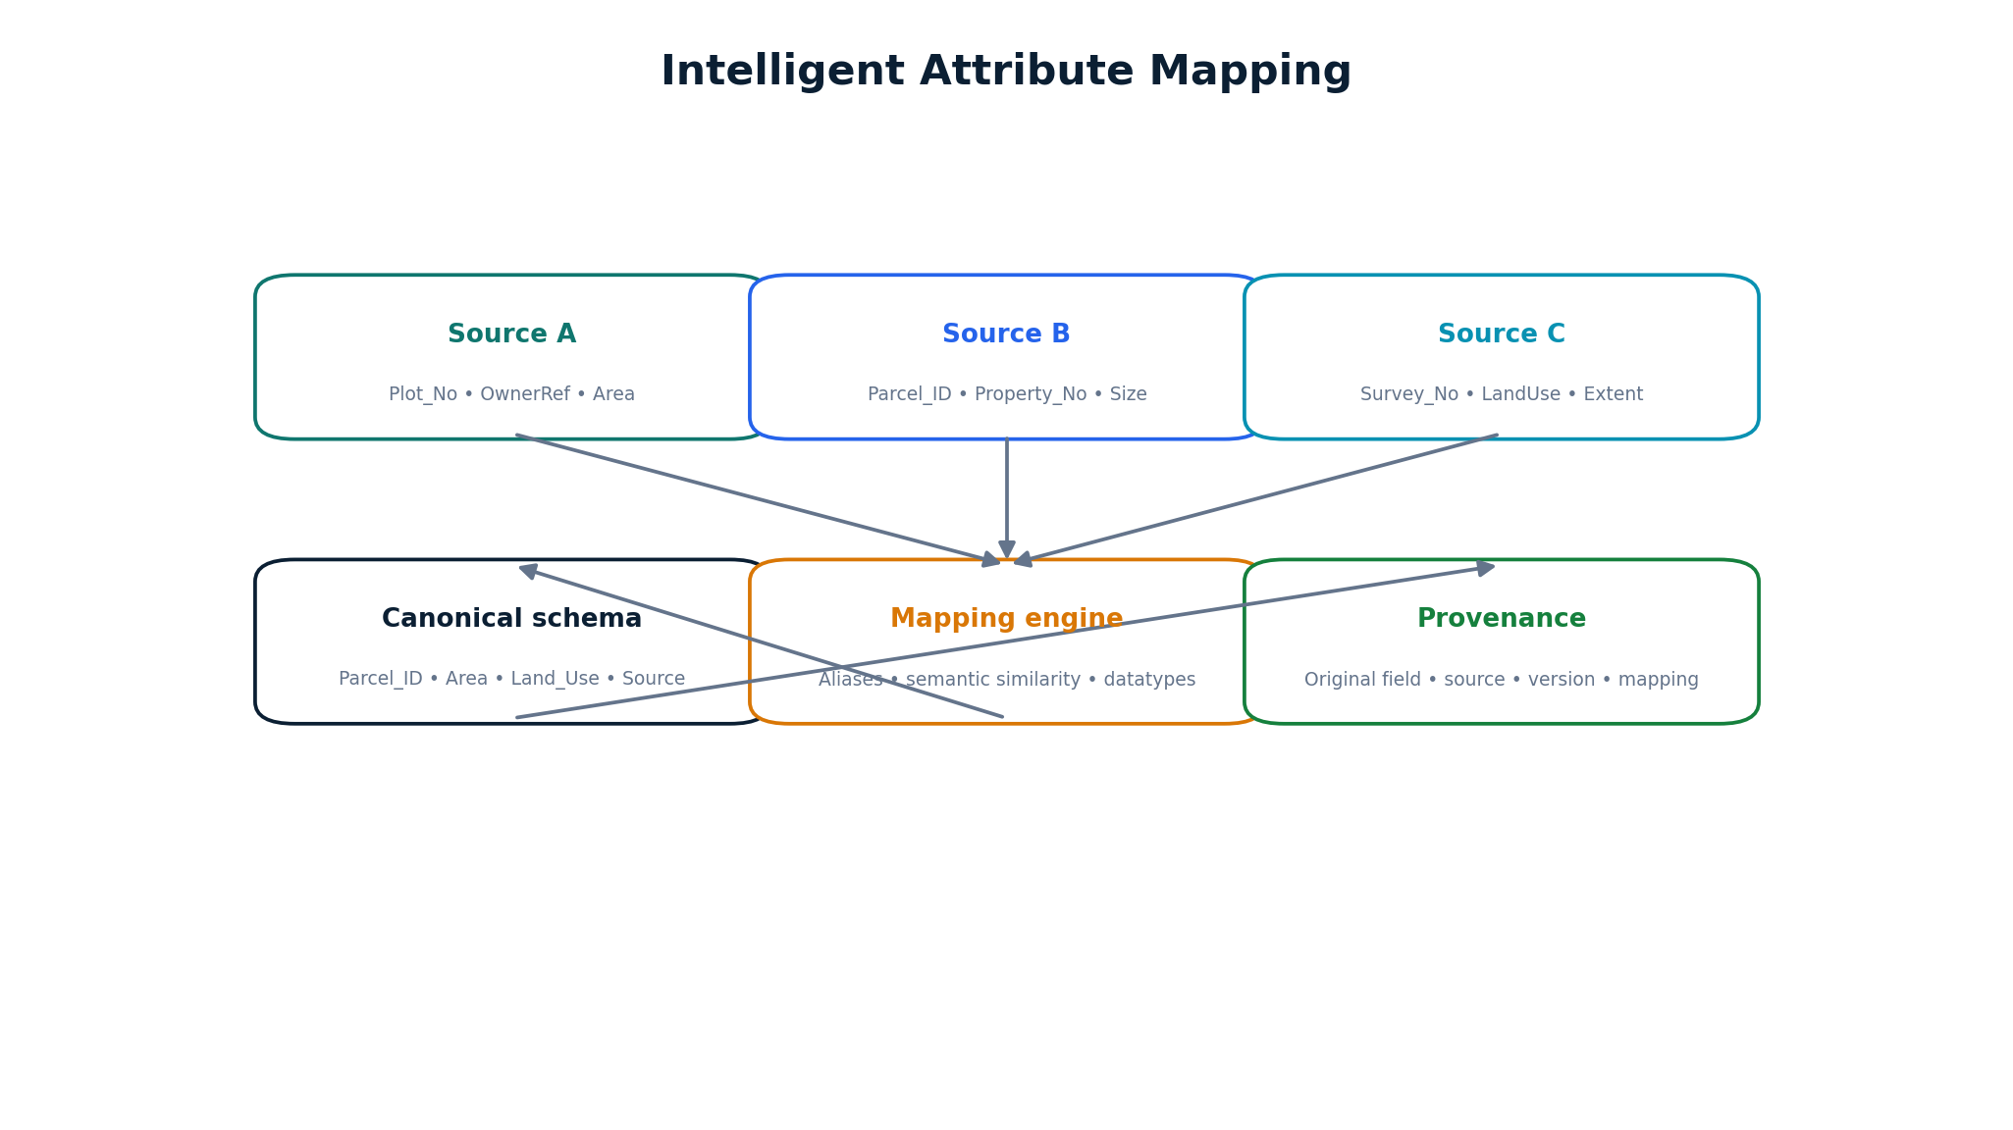
Figure 11. Attribute harmonization
Explanation: Different source fields are mapped into a canonical schema through aliases, semantic matching, type normalization and provenance tracking.
Judge takeaway: The canonical schema improves interoperability while preserving the source field and source version behind every mapped value.
Source field examples | Canonical field | Mapping evidence
Plot_No / Parcel_ID / Property_No | Parcel_ID | Identifier alias + spatial context
Survey_No / SurveyNumber | Survey_Number | Schema alias / exact field match
Area / Size / Extent | Area | Datatype + unit normalization
LandUse / PropertyType | Land_Use | Controlled vocabulary mapping
Building_Status / StructureType | Building_Status | Semantic mapping + source

AUTHORITY BOUNDARY Authoritative ownership or legal attributes should not be silently rewritten by semantic similarity. Such fields should be flagged for governed review.

18 PARCEL CONFLATION AND DATA FUSION

Parcel Conflation and Data Fusion
Explain how multiple geometries become evidence for a harmonized representation.
LandSync uses parcel conflation as an evidence-reconciliation operation:
- Align candidate geometries into a common CRS.
- Compare boundaries, area, shape, centroid and neighborhood relationships.
- Identify whether differences are within configurable tolerance, systematic displacement or a genuine conflict.
- Retain all source geometries instead of overwriting them.
- Generate a harmonized candidate plus conflict status and provenance.
- Escalate ambiguous or authoritative conflicts to human review.
Source | Evidence retained
Cadastral | Original geometry + source version
Municipal | Property geometry + identifiers
Revenue | Record-linked attributes
Drone/ORI | Observed visual evidence
GNSS/CORS | Survey control / observation evidence
Ground Truthing | Field confirmation / exception evidence

19 AUTOMATED TOPOLOGY CORRECTION

Automated Topology Correction
Use deterministic geometry rules to improve spatial validity and maintain auditability.
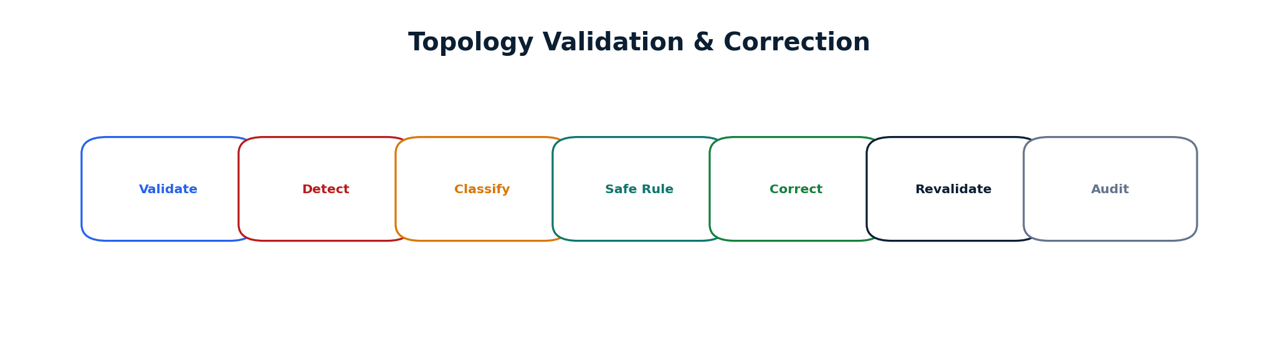
Figure 12. Topology correction workflow
Explanation: Invalid geometries and topology issues are detected, classified, corrected only when safe rules apply, revalidated and logged.
Judge takeaway: Every correction is reversible because original and corrected geometry are retained with provenance.
Issue | Example action | Audit record
Self-intersection | Attempt safe geometry repair | Original, corrected, method, job ID
Overlap | Flag or resolve according to configured topology rule | Affected features + rule
Gap | Detect and classify; repair only if rule is safe | Gap geometry + decision
Sliver | Detect small artifact polygons | Threshold + source evidence
Duplicate geometry | Identify duplicate features | Duplicate IDs + resolution

Shapely exposes geometry validity and spatial relationship operations, while PostGIS provides database-side spatial functions and topology-related capabilities. [3][8]

20 SPATIAL CONFLICT DETECTION

Spatial Conflict Detection
Turn disagreement between sources into structured, reviewable events.
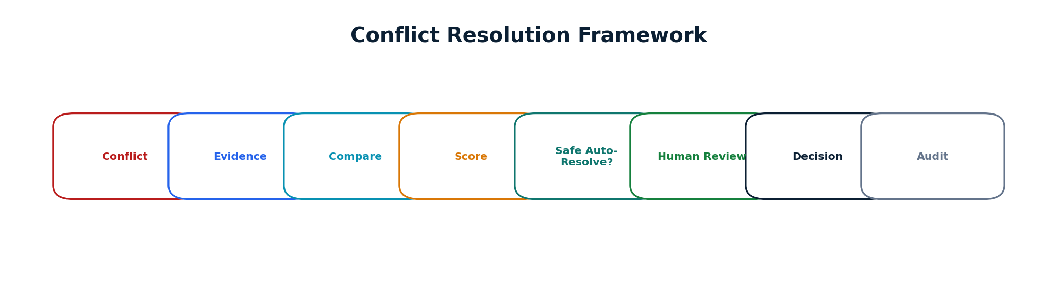
Figure 13. Conflict resolution framework
Explanation: Conflicts are classified, supported by evidence, scored and either handled through safe rules or escalated to human review.
Judge takeaway: A conflict becomes an explicit record with evidence and status instead of an invisible manual discrepancy.
Conflict type | Detection signal | Typical action
Boundary mismatch | Geometry difference / displacement | Compare sources; review if material
Area mismatch | Area ratio outside configured tolerance | Flag + evidence panel
Attribute conflict | Different normalized values | Compare source lineage + review
Building outside parcel | Building geometry not contained by parcel | Flag spatial anomaly
Utility crossing | Network intersects restricted/parcel geometry | Flag for inspection
Duplicate record | Near-identical geometry/identifier | Candidate merge review
Temporal inconsistency | Older source contradicts newer observation | Change analysis

21 CONFLICT RESOLUTION FRAMEWORK

Conflict Resolution Framework
Define controlled automation boundaries.
Conflict handling should follow four principles:
- Evidence first: show the source layers, metadata and geometry involved.
- Rule safety: automatically resolve only conflicts covered by explicit, tested rules.
- Uncertainty: send ambiguous or high-impact cases to human review.
- Traceability: record the decision, evidence, user, rule/model version and timestamp.
CLASSIFICATION DISCLAIMER LOW / MEDIUM / HIGH / CRITICAL are proposed configurable prioritization levels for the prototype, not official government standards.
Stage | System output
Detect | Conflict ID + type + affected entities
Collect evidence | Source layers + attributes + temporal context
Compare | Spatial and semantic evidence
Score | Confidence / uncertainty information
Decide | Auto-rule or human review
Record | Decision + audit + provenance

22 TEMPORAL CHANGE DETECTION

Temporal Change Detection
Identify meaningful differences between historical and current spatial evidence.
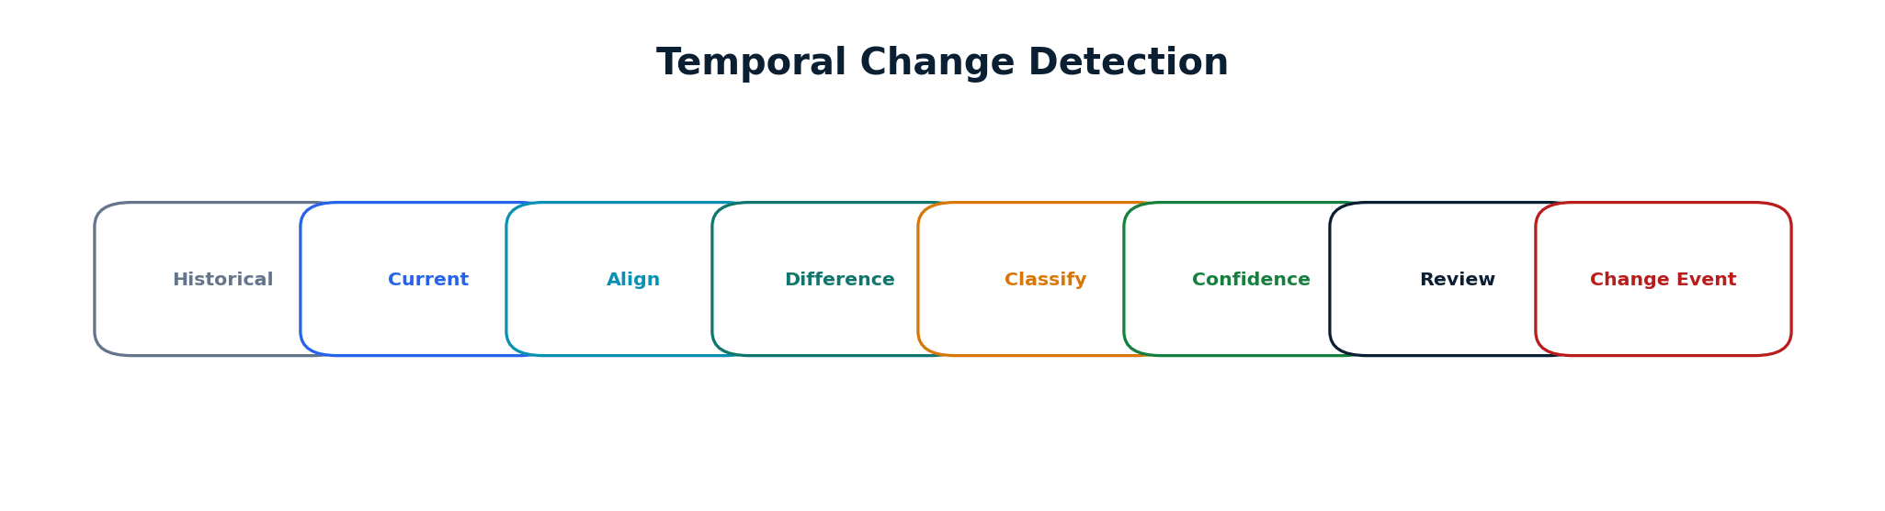
Figure 14. Change detection workflow
Explanation: Historical and current layers are aligned, compared and classified into geometry, attribute, building or land-use changes.
Judge takeaway: The output is a change event with evidence and confidence, not an automatic legal conclusion.
- New building candidate.
- Building removal or footprint modification.
- Parcel geometry modification.
- Land-use attribute change.
- Infrastructure or utility modification.
- Source-record update without corresponding spatial evidence.
Change events should store before-state, after-state, source dates, detection method and review status.

23 CONFIDENCE SCORING AND UNCERTAINTY ANALYSIS

Confidence Scoring and Uncertainty Analysis
Make uncertainty visible and actionable.
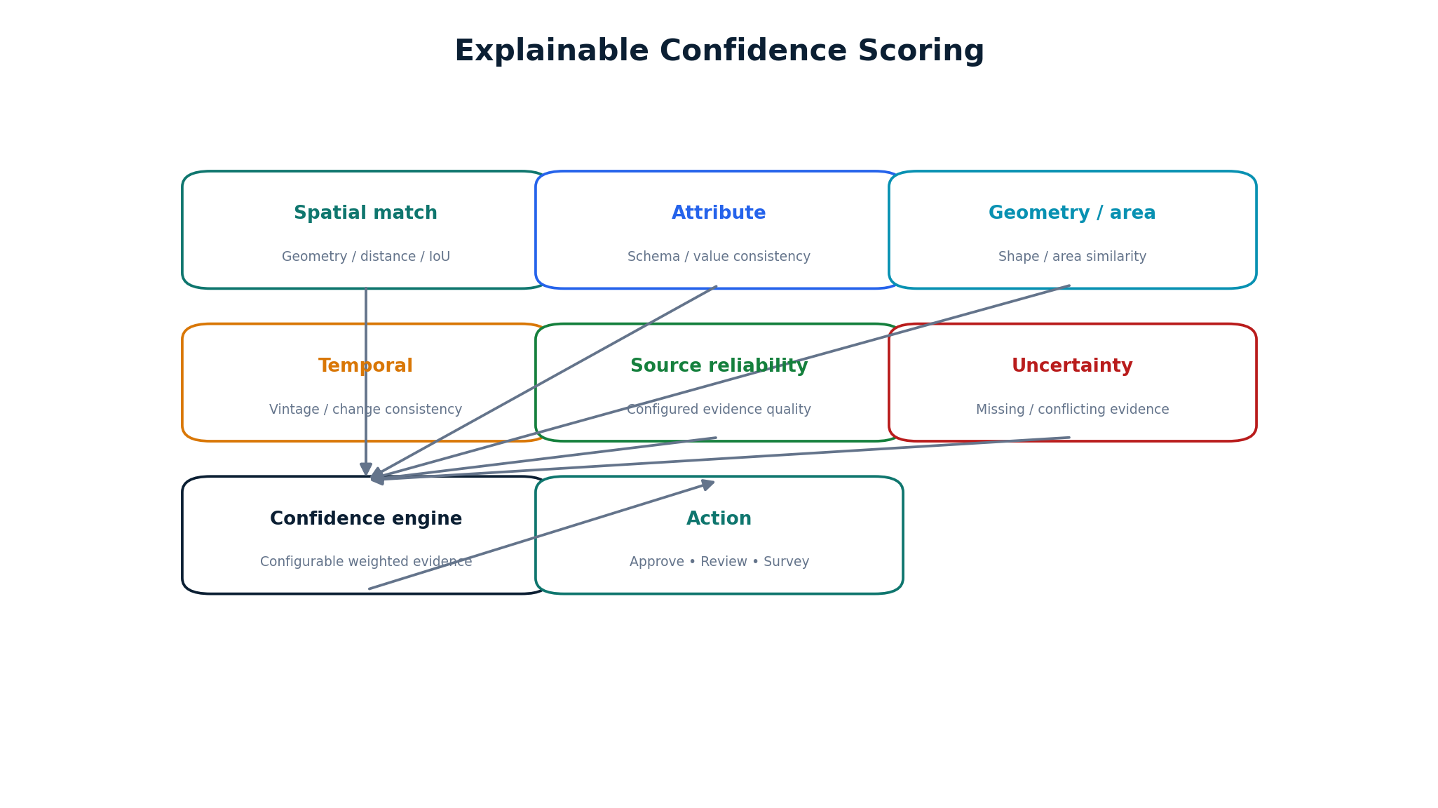
Figure 15. Explainable confidence model
Explanation: Confidence is formed from multiple evidence factors and is intended to prioritize review and explain why a recommendation is strong or weak.
Judge takeaway: The score is a decision-support signal, not a claim of legal truth or a statistically calibrated probability unless validated.
A conceptual score can combine:
- Spatial match strength.
- Attribute consistency.
- Geometry and area similarity.
- Temporal consistency.
- Source reliability configuration.
- Missing or conflicting evidence penalties.
Weights and thresholds should be calibrated against ground-truth validation data. The report intentionally does not claim a fixed formula or accuracy.

24 HUMAN-IN-THE-LOOP VERIFICATION

Human-in-the-Loop Verification
Protect authoritative workflows by making human review a first-class system component.
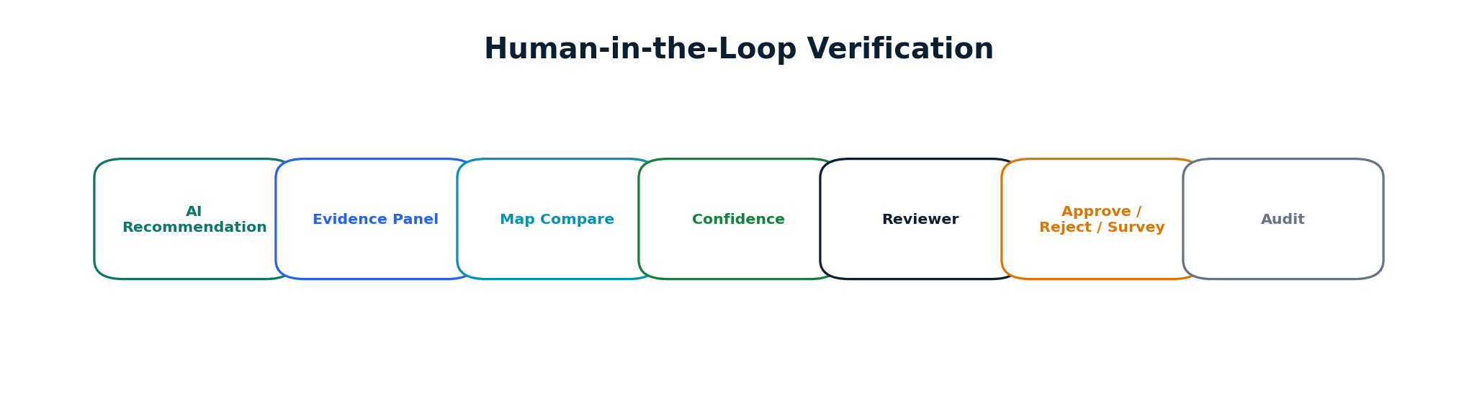
Figure 16. Human verification workflow
Explanation: The reviewer receives the AI recommendation alongside source evidence, geometry comparison, confidence factors and change history.
Judge takeaway: The system makes it easy to verify evidence before any authoritative update is committed.
Reviewer action | System behavior
Approve | Commit proposed harmonized state and record decision
Reject | Retain sources; mark recommendation rejected with reason
Request survey | Create field-verification task and preserve conflict
Edit | Record manual edit with before/after geometry/attributes

CORE GOVERNANCE RULE AI recommends. GIS validates. Human reviewers approve authoritative changes.

25 DATA PROVENANCE AND AUDIT TRAIL

Data Provenance and Audit Trail
Make every important transformation reconstructable.
Provenance field | Example
Source dataset/version | cadastral_v03
Processing job | JOB-2026-000184
Transformation | CRS transformation / geometry repair / mapping
Model version | building-extractor-v0.1
Timestamp | UTC timestamp
User/reviewer | Authenticated user ID
Previous value | Original geometry/attribute
New value | Harmonized geometry/attribute
Confidence | Configured evidence score
Decision | Approved / rejected / survey requested

The audit trail should be append-oriented and protected through database access controls. The design does not require blockchain. If future governance requires stronger tamper-evidence, cryptographic chaining or an external evidence service could be evaluated separately.

26 WEB-GIS ARCHITECTURE

Web-GIS Architecture
Provide a map-centric operational interface for spatial evidence and review.
Core map layers:
- Cadastral parcels
- Municipal GIS
- Revenue-linked features
- Drone / ORI imagery
- DSM / DTM
- Building footprints
- Utility networks
- GNSS / CORS points
- Ground Truthing points
- Conflicts
- Change events
Control | Purpose
Layer selector | Toggle source and derived layers
Opacity | Compare overlapping evidence
Time slider | Explore historical/current layers
Compare mode | Side-by-side or swipe comparison
Parcel search | Locate records by canonical ID / permitted identifiers
Identify | Open evidence and provenance
Measure | Inspect geometry and distances
Export | Generate controlled outputs

MapLibre GL JS is a TypeScript/WebGL mapping library for interactive maps and vector-tile rendering. [12] It is proposed for the 2D Web-GIS client.

27 2D AND 3D VISUALIZATION

2D and 3D Visualization
Use 3D as an analysis and communication layer rather than as the core harmonization engine.
2D Web-GIS | 3D View
Parcel boundaries | Building massing
Source overlays | Terrain / elevation context
Conflict visualization | Drone-derived urban context
Attribute inspection | 3D spatial context
Change comparison | Optional 3D time/context view

CesiumJS is an open-source JavaScript engine for 3D geospatial visualization; its official quickstart demonstrates loading and interacting with real-world 3D data. [13]
SCOPE OF 3D 3D improves visual interpretation of urban features; it does not replace spatial matching, topology validation or authoritative review.

28 DATABASE ARCHITECTURE

Database Architecture
Define a normalized spatial data model that supports versions, relationships and lineage.
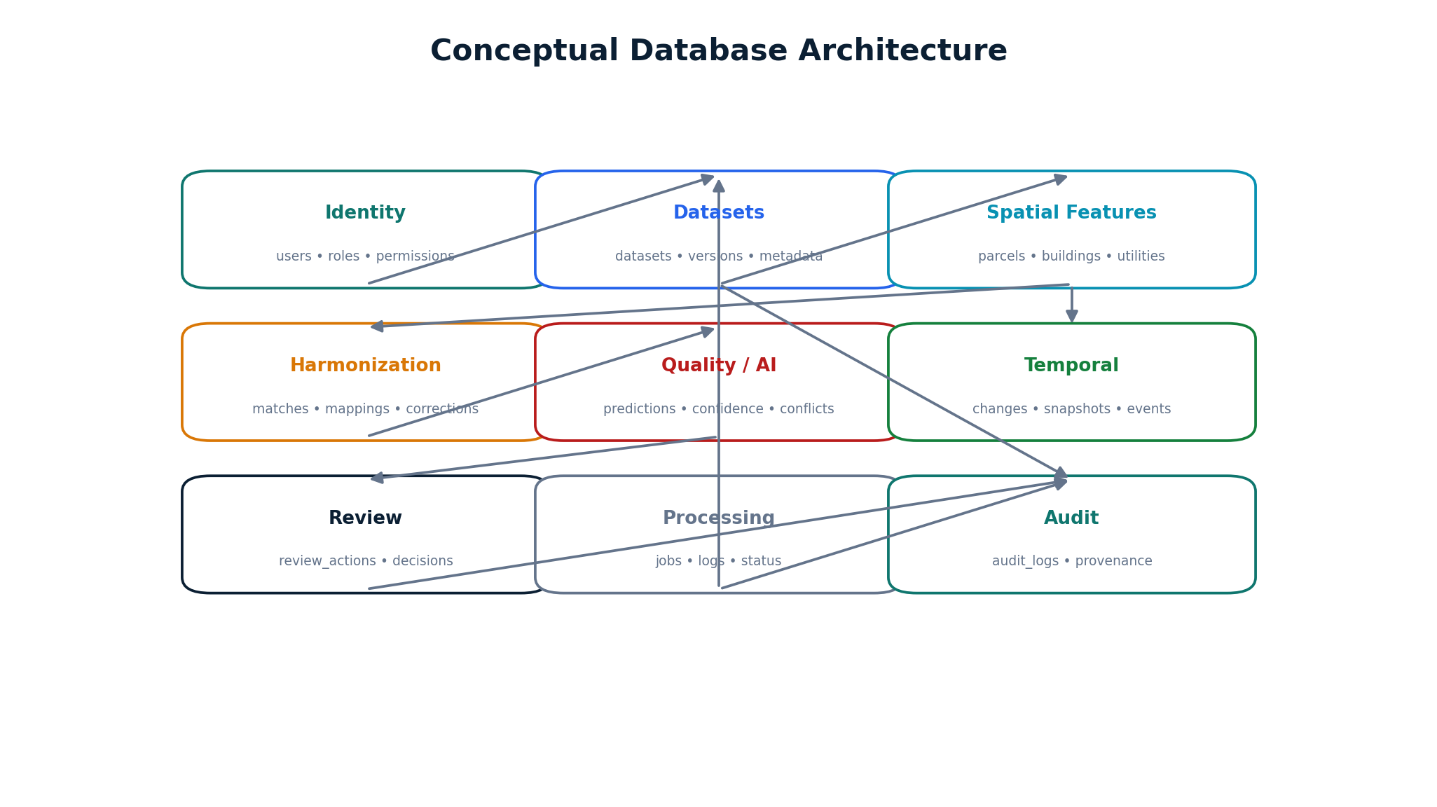
Figure 17. Conceptual database architecture
Explanation: PostgreSQL/PostGIS stores spatial entities, relationships, job state, review actions and provenance while preserving dataset versions.
Judge takeaway: The data model supports both geospatial queries and ordinary relational governance.
Entity | Purpose
datasets / dataset_versions | Source registration and versioning
spatial_features | Generic spatial feature registry
parcels / buildings / utility_features | Domain-specific spatial entities
revenue_records / municipal_records | Non-spatial or linked record data
spatial_matches / attribute_mappings | Harmonization evidence
topology_corrections / conflicts / changes | QA and reconciliation events
ai_predictions / confidence_scores | AI outputs and evidence
review_actions | Human decisions
processing_jobs | Asynchronous processing state
audit_logs | Provenance and traceability

29 API ARCHITECTURE

API Architecture
Expose modular capabilities through versioned REST APIs.
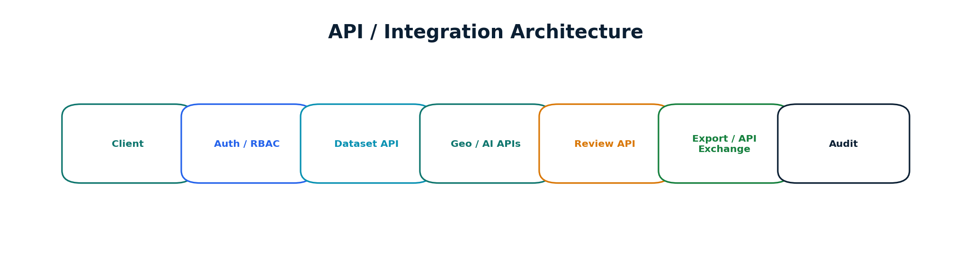
Figure 18. API integration architecture
Explanation: The API layer separates authentication, dataset services, geospatial/AI services, review and controlled data exchange.
Judge takeaway: The architecture allows future inter-departmental integrations without coupling external systems to internal processing code.
Endpoint family | Purpose
/api/datasets | Register, list and inspect datasets
/api/datasets/upload | Secure upload / registration
/api/datasets/{id}/validate | Run validation
/api/datasets/{id}/process | Start asynchronous processing
/api/georeference | Coordinate alignment
/api/features/extract | AI feature extraction
/api/matching | Spatial entity matching
/api/harmonization | Attribute / parcel harmonization
/api/conflicts | Conflict lifecycle
/api/changes | Temporal changes
/api/confidence | Confidence evidence
/api/reviews | Human review actions
/api/export | Controlled export
/api/audit | Audit/provenance queries

FastAPI is proposed for the Python API layer; its official documentation describes it as a Python framework for building APIs with standard Python type hints and automatic interactive API documentation. [14]

30 SECURITY ARCHITECTURE

Security Architecture
Treat geospatial data and record-linked information as controlled institutional data.
Control | Implementation direction
Authentication | Session/OIDC/JWT-based institutional identity as appropriate
RBAC | Role-based access to datasets, processing and review actions
Authorization | Object-level checks for dataset and record access
Secure uploads | File type validation, size limits, malware scanning and isolated processing
Encryption | HTTPS in transit; encryption at rest where supported
Secrets | Environment/secret manager; never hard-code credentials
Audit | Record security-relevant and data-changing actions
Backups | Database + object storage backup strategy
Rate limiting | Protect APIs and processing endpoints
Input validation | Schema and payload validation before processing

No specific government security certification or compliance status is claimed. Production deployment would require formal security assessment.

31 SCALABILITY AND DEPLOYMENT

Scalability and Deployment
Show how a prototype can evolve into an institutional service.
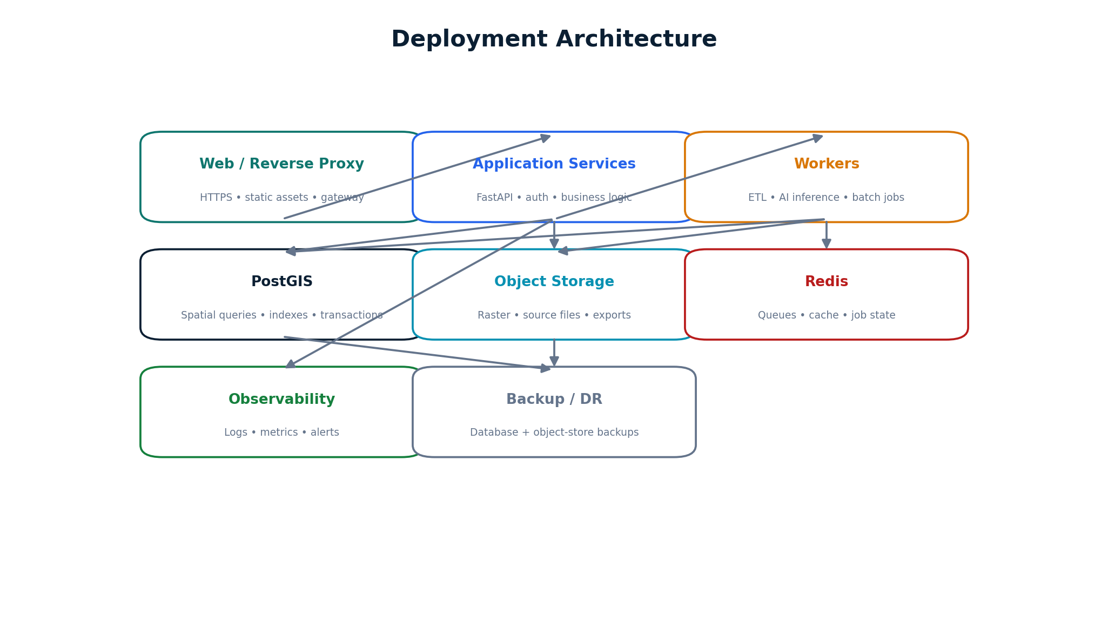
Figure 19. Deployment architecture
Explanation: The deployment separates web/API services, asynchronous workers, spatial database, object storage, cache/queue and observability.
Judge takeaway: Heavy raster/AI workloads can run asynchronously without blocking interactive GIS operations.
- Spatial indexing for parcel and feature queries.
- Tiled raster processing and pyramids for large imagery.
- Asynchronous jobs for ETL and AI inference.
- Object storage for large source files and derived artifacts.
- Horizontal scaling of stateless API services.
- Worker pools for parallelizable processing.
- Caching of frequently requested map/query results.
- Database partitioning or archival strategies when dataset volume requires it.
PostGIS documentation describes spatial indexes and spatial predicates that can accelerate spatial queries; this supports the proposed indexing strategy. [3]

32 TECHNOLOGY STACK

Technology Stack
List the proposed implementation stack and explain why each technology exists.
Technology | Role | Why it is used
React + TypeScript | Frontend | Typed component architecture for the operational Web-GIS
Vite + Tailwind CSS | Frontend tooling/UI | Fast development and consistent visual system
MapLibre GL JS | 2D Web-GIS | Interactive browser maps / vector-tile rendering
CesiumJS | 3D visualization | 3D terrain/building/geospatial context
FastAPI | Backend | Typed Python API layer and service endpoints
PostgreSQL + PostGIS | Spatial database | Spatial storage, queries, indexes and relational controls
GDAL | Geospatial ETL | Raster/vector format processing and transformations
PROJ / PyProj | CRS engine | Coordinate and geodetic transformations
GeoPandas | Vector analytics | Python geospatial data manipulation
Shapely / GEOS | Geometry | Validation and spatial operations
Rasterio | Raster processing | Python raster I/O and analysis
PyTorch | AI/ML | Deep learning model training/inference where required
scikit-learn | ML/evaluation | Classical models and evaluation utilities
OpenCV | Computer Vision | Image preprocessing and CV operations
Redis + Celery/RQ | Jobs | Queueing and background processing
Docker | Deployment | Reproducible containerized services

33 FEASIBILITY ANALYSIS

Feasibility Analysis
Assess technical, operational and deployment feasibility without overstating readiness.
Dimension | Assessment | Evidence / approach
Technical | Feasible as a modular prototype | Mature open-source GIS, database, API and ML components
Data | Feasible with synthetic/public/authorized samples | Adapters + validation + canonical schema
AI | Feasible for bounded extraction/matching tasks | Pretrained models + local evaluation
GIS | High technical maturity | PostGIS, GDAL, PROJ, GeoPandas, Shapely
Operational | Requires configured workflows | RBAC + review queues + source adapters
Deployment | Local / institutional / cloud-ready | Dockerized services + separated workers
Governance | Requires institutional rules | Human review + provenance + configurable thresholds

The strongest feasibility argument is not that every feature is production-ready; it is that each subsystem can be built, tested and integrated using established technologies with clear interfaces.

34 RISK ANALYSIS AND MITIGATION

Risk Analysis and Mitigation
Identify failure modes before they become implementation surprises.
Risk | Impact | Mitigation
Poor-quality input data | Wrong downstream outputs | Validation + quality score + blocking errors
CRS mismatch | Spatial misalignment | CRS detection + PROJ/GDAL + manual verification
AI false positives | Incorrect feature candidates | Confidence + validation + human review
Different data vintages | False conflict interpretation | Temporal metadata + change detection
Large datasets | Long processing times | Async jobs + spatial indexes + tiling
Authoritative conflicts | Governance risk | Escalation + human decision + provenance
Model generalization | Reduced extraction quality | Local validation + model adapters
Geometry errors | Invalid spatial relationships | Topology checks + revalidation
Security risks | Unauthorized access / malicious files | RBAC + secure upload + audit
Integration complexity | Delayed adoption | API-first modular architecture

35 TESTING AND VALIDATION STRATEGY

Testing and Validation Strategy
Make evaluation reproducible and evidence-based.
Test class | What is tested | Evidence
Unit | Pure functions, schema rules, geometry utilities | Automated test suite
Integration | Service-to-service and database workflows | End-to-end test cases
CRS | Transformation correctness and metadata | Reference coordinate checks
GIS geometry | Validity, intersection, containment, topology | Known geometry fixtures
AI model | Detection/classification performance | Held-out validation dataset
Matching | Precision, recall, candidate ranking | Ground-truth entity pairs
Conflict detection | Correct conflict classification | Labeled conflict fixtures
Change detection | True/false change events | Temporal reference pairs
Security | Auth, RBAC, upload and API abuse | Security test report
Performance | Latency, throughput, job duration | Benchmark report

VALIDATION RULE The proposal distinguishes proposed evaluation metrics from achieved results. No benchmark number is claimed here.

36 PROTOTYPE DEMONSTRATION

Prototype Demonstration
Create a screening-round demonstration that makes the complete workflow visible.
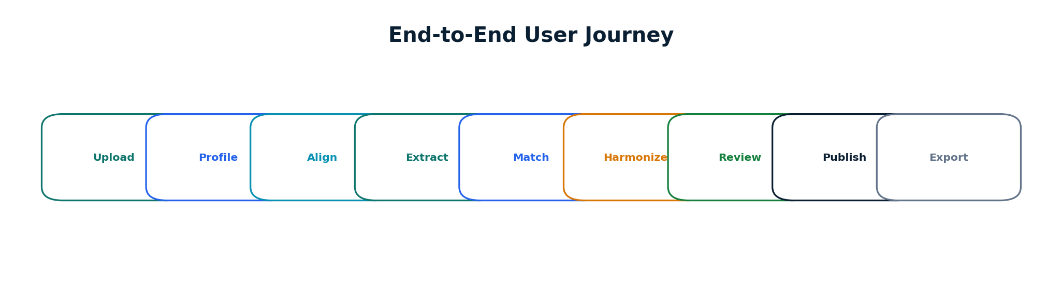
Figure 20. Prototype demonstration journey
Explanation: The demonstration is deliberately end-to-end: it begins with heterogeneous files and ends with a reviewed, traceable land record.
Judge takeaway: The judge sees the problem, the automation, the AI contribution and the human-governed result in one continuous story.
- Upload cadastral map.
- Upload municipal GIS layer.
- Upload revenue CSV.
- Upload drone/ORI sample.
- Upload building footprints.
- Upload GNSS/GT sample.
- Run validation and show detected issues.
- Show CRS alignment and before/after map.
- Run feature extraction.
- Run spatial matching and open a matched parcel.
- Show attribute harmonization.
- Show a topology issue and correction provenance.
- Open a conflict event.
- Show temporal change.
- Open confidence evidence.
- Send uncertain case to human review.
- Approve/reject/request survey.
- Open audit trail.
- Show final unified record and export.

37 IMPACT AND BENEFITS

Impact and Benefits
Describe potential impact without inventing quantitative outcomes.
Impact area | Potential benefit
Administrative | Less repetitive GIS integration and clearer review queues
Technical | Consistent spatial reference, canonical schemas and reusable processing
Economic | Better utilization of GIS staff time by automating repetitive preparation
Governance | Traceable reconciliation, evidence-based review and auditability
Interoperability | API and format support for multi-department exchange
Urban planning | More coherent spatial context for authorized analysis
Environmental | Better reuse of existing geospatial evidence and targeted field verification

These are expected or potential benefits of the proposed workflow. They are not measured outcomes of the prototype unless experimentally demonstrated.

38 INNOVATION AND DIFFERENTIATION

Innovation and Differentiation
Explain what is innovative about the proposed combination without claiming global novelty.
The innovation is the integration of multiple capabilities into a single evidence-driven harmonization pipeline targeted at urban land records. LandSync AI combines geospatial ETL, CRS-aware processing, AI-generated feature extraction, spatial entity matching, Intelligent Attribute Mapping, parcel conflation, topology validation, conflict detection, temporal Change Detection, Confidence Scoring, Human-in-the-loop verification and provenance.
Capability | Manual / fragmented workflow | Generic GIS | LandSync AI proposal
Multi-source ingestion | Often manual / tool-specific | Supported with configuration | Unified source registration + adapters
CRS handling | Operator-driven | Available | Automated detection/verification + auditable transform
AI feature extraction | External/manual | Not core to generic GIS | Integrated AI/ML service
Spatial matching | Manual overlays / scripts | Possible via tools | Dedicated evidence-based matching engine
Attribute harmonization | Manual schema work | Possible | Canonical schema + mapping provenance
Topology | Manual QA | GIS tools | Automated checks + safe corrections + audit
Conflict workflow | Often ad hoc | Tool dependent | Structured conflict lifecycle + review
Confidence | Usually external | Not necessarily integrated | Explainable evidence scoring
Human review | Separate process | Editing tools | First-class review workspace
Provenance | Varies | Dataset metadata | Transformation-level lineage

The comparison describes the proposed workflow versus typical patterns; it is not a benchmark of specific commercial or government systems.

39 REQUIREMENT TRACEABILITY

Requirement Traceability
Map SIH26013 requirements directly to implementation components and validation.
SIH26013 requirement | LandSync module | Technology | Expected output | Validation
AI/ML-based spatial matching | Spatial Matching Engine | GeoAI/ML + PostGIS | Matched candidates + confidence | Labeled entity pairs
Automated topology correction | Topology Engine | PostGIS + Shapely/GEOS + GDAL | Validated/corrected geometry | Geometry fixtures
Intelligent attribute mapping | Schema Harmonizer | Canonical schema + mapping rules/ML assist | Standardized attributes + lineage | Field mapping dataset
Geo-referencing | CRS Engine | GDAL + PROJ + PyProj | Aligned spatial layers | Control/reference coordinates
Coordinate transformation | CRS Engine | PROJ/GDAL/PyProj | Transformed geometries | Reference transform tests
Change detection | Temporal Engine | PostGIS + GeoPandas + CV | Change events | Temporal ground truth
Spatial conflict resolution | Conflict Engine | Spatial rules + evidence + review | Resolved/escalated conflicts | Conflict test cases
Confidence scoring | Confidence Engine | Configurable evidence model | Score + factors | Calibration dataset
Multi-source integration | Data Hub | Spatial ETL + PostGIS | Unified project workspace | Ingestion matrix
AI-generated feature extraction | Feature Extraction Service | PyTorch/OpenCV/Rasterio | Candidate features | Labeled imagery

40 IMPLEMENTATION ROADMAP

Implementation Roadmap
Sequence the build so the team can demonstrate a coherent vertical slice early.
Phase | Deliverable | Validation method
1. Requirements + data model | Canonical schema + data dictionary | Schema review
2. Ingestion + validation | Dataset registry + QA engine | Format/geometry fixtures
3. CRS engine | Alignment service | Reference coordinates
4. AI extraction | Prototype building/feature model | Held-out sample
5. Spatial matching | Candidate + scoring service | Labeled pairs
6. Attribute mapping | Canonical mapper | Mapping test set
7. Topology + conflict | Issue/correction engine | Known defects
8. Change detection | Temporal comparison | Synthetic temporal set
9. Confidence + review | Review workspace | Scenario walkthrough
10. Web-GIS + 3D | Operational UI | UX + integration tests
11. API integration | Versioned REST API | Contract tests
12. Testing + validation | Benchmark and QA report | Acceptance criteria
13. Pilot demonstration | End-to-end scenario | Judge-ready demo

41 LIMITATIONS

Limitations
State the boundaries clearly to increase technical credibility.
- AI model performance depends on the quality, representativeness and labeling of training/validation data.
- Legacy cadastral maps may contain distortions that cannot be removed solely through coordinate transformation.
- Confidence scores are decision-support signals and require calibration against ground-truth data.
- Automated harmonization cannot replace authoritative legal verification or institutional record-governance procedures.
- High-resolution imagery and large raster datasets can require substantial compute and storage.
- Departmental schemas and identifiers may be incompatible without local mapping configuration.
- Some conflicts are inherently ambiguous and should remain in a human-review queue.
- Production deployment requires institutional security, privacy, data governance, backup and operational controls.

42 FUTURE ENHANCEMENTS

Future Enhancements
Separate future research and deployment possibilities from the prototype scope.
- Advanced geospatial foundation models and multimodal GeoAI.
- Additional satellite and aerial data integrations.
- Mobile field verification and offline survey workflows.
- Real-time GNSS/CORS integration where institutional interfaces permit.
- Active learning from reviewer decisions.
- Automated survey-priority generation from unresolved conflicts.
- Advanced 3D city models and temporal urban visualization.
- Model monitoring, drift detection and continuous evaluation.
- Federated or controlled inter-departmental data exchange.
- Multilingual user interfaces for operational accessibility.
SCOPE DISCIPLINE Future features are not represented as implemented capabilities in the prototype unless separately demonstrated.

43 CONCLUSION

Conclusion
Close with a factual, implementation-focused statement of value.
LandSync AI proposes an integrated platform for transforming fragmented Multi-source Geospatial Data into validated, spatially aligned, harmonized, conflict-aware, confidence-scored, human-verified and traceable urban land information.
The architecture directly maps the core SIH26013 requirements to concrete engineering modules: AI/ML-based Spatial Matching, Automated Topology Correction, Intelligent Attribute Mapping, Geo-referencing, Coordinate Transformation, Change Detection, Spatial Conflict Resolution and Confidence Scoring. Supporting components—Spatial ETL, PostGIS, Web-GIS, Remote Sensing, Computer Vision, API Integration, Data Provenance and Human-in-the-loop review—make the workflow implementable as a modular prototype.
The strongest technical proposition is the division of responsibility: deterministic GIS is used for geometry and spatial correctness; AI/ML is used for feature extraction, matching, classification and uncertainty; and human reviewers remain responsible for authoritative decisions. This makes the platform explainable, testable and safer than an opaque end-to-end automation approach.
DEMONSTRATION THESIS The screening-round proof point is a complete vertical slice: ingest → validate → align → extract → match → harmonize → detect conflict/change → score → review → publish.

44 RESEARCH AND REFERENCES

Research and References
Primary problem context and official/technical sources used to ground the architecture.
[1] NAKSHA Portal, Department of Land Resources. NAKSHA programme portal and pilot workflow indicators. https://naksha.dolr.gov.in/NakshaPortal/
[2] Department of Land Resources, Government of India. About NAKSHA. https://dolr.gov.in/en/about-naksha/
[3] PostGIS Documentation. Introduction, spatial data, spatial indexes and GIS processing. https://postgis.net/docs/postgis_introduction.html
[4] PROJ Documentation. Coordinate transformation and CRS operations. https://proj.org/en/stable/
[5] GeoPandas Documentation. Geospatial data structures and spatial operations. https://geopandas.org/
[6] GDAL Documentation. Geospatial raster/vector data translation and processing. https://gdal.org/
[7] Rasterio Documentation. Python raster processing and geospatial I/O. https://rasterio.readthedocs.io/
[8] Shapely Documentation. Geometry operations and validity. https://shapely.readthedocs.io/
[9] PyTorch Documentation. Machine learning and tensor framework. https://pytorch.org/docs/
[10] scikit-learn Documentation. Machine learning and model evaluation. https://scikit-learn.org/stable/
[11] OpenCV Documentation. Image processing and computer vision modules. https://docs.opencv.org/
[12] MapLibre GL JS Documentation. Interactive WebGL maps and vector-tile rendering. https://maplibre.org/maplibre-gl-js/docs/
[13] CesiumJS Documentation. 3D geospatial visualization. https://cesium.com/learn/cesiumjs-learn/cesiumjs-quickstart/
[14] FastAPI Documentation. Python API framework and interactive API documentation. https://fastapi.tiangolo.com/
[15] SIH26013 problem-statement mirror used for the exact SIH 2026 problem wording and identifier: https://sih2026.flugelsoft.com/ps/sih26013-automated-lntegration-and-lntelligent-harmonization-of-multi-sour
Research note: the report uses the DoLR/NAKSHA sources for programme context and official technical documentation for software roles. Academic claims should be expanded with peer-reviewed literature during final submission if the team makes research-specific claims about algorithmic performance.

45 APPENDIX A — SYSTEM ARCHITECTURE

Appendix A — System Architecture
Condensed architecture reference for implementation.
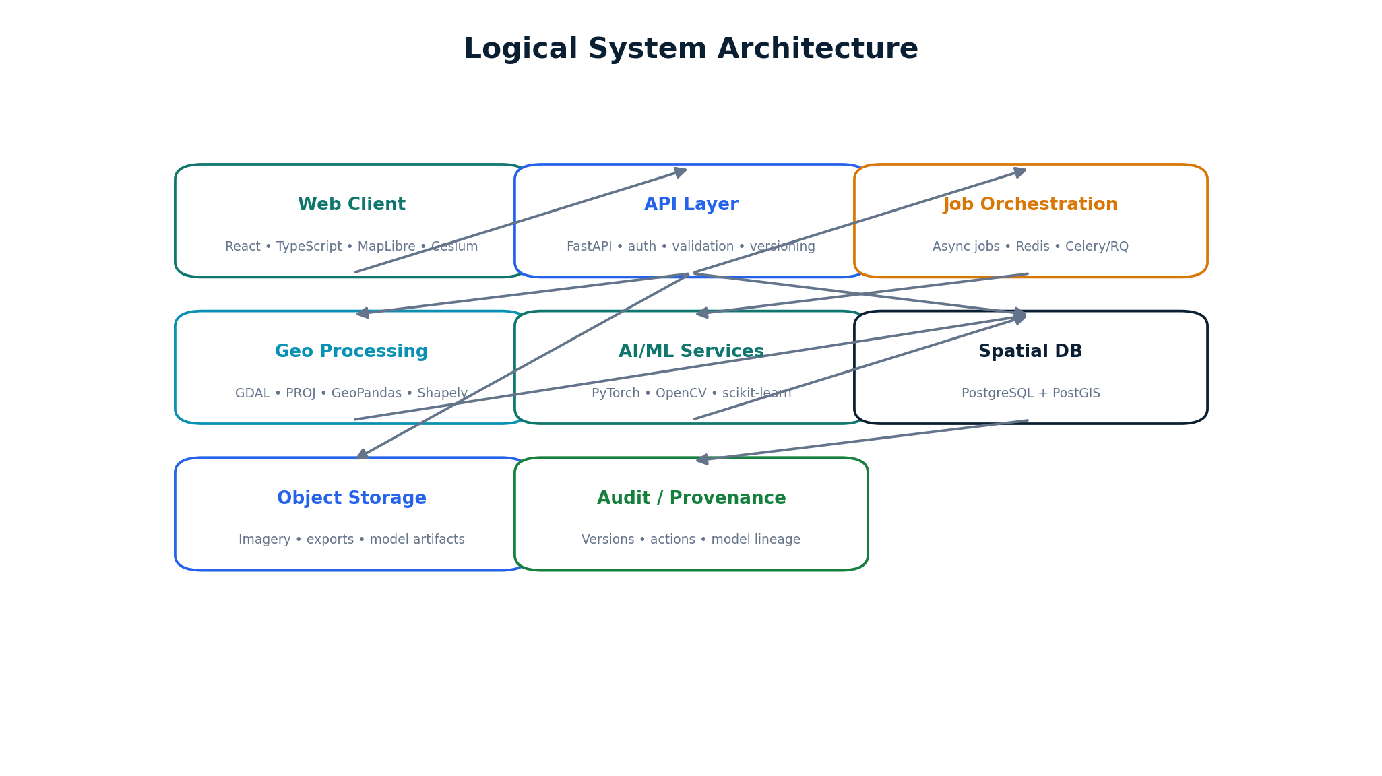
Figure 21. Logical service architecture
Explanation: The frontend communicates with FastAPI services; background workers handle heavy ETL/AI jobs; PostGIS stores spatial state; object storage holds large files; audit and observability surround the system.
Judge takeaway: The architecture supports local development, institutional servers and cloud-ready deployment.

46 APPENDIX B — DATA MODEL

Appendix B — Data Model
Conceptual entities and relationships.
Entity | Key relationships
datasets | 1:N dataset_versions; source of features
dataset_versions | 1:N spatial_features; source lineage
parcels | Links to matches, records, buildings, conflicts, changes
buildings | Spatial relationship to parcels and imagery-derived features
spatial_matches | Links source entities to candidate/harmonized entities
attribute_mappings | Links source fields to canonical fields
conflicts | Links affected entities and evidence
changes | Links before/after states and temporal sources
confidence_scores | Links to match, feature or conflict decisions
review_actions | Links reviewer, action, evidence and timestamp
audit_logs | Links data-changing actions to provenance

47 APPENDIX C — API ENDPOINT REFERENCE

Appendix C — API Endpoint Reference
Prototype endpoint inventory.
Method | Endpoint | Purpose
POST | /api/datasets/upload | Upload/register dataset
GET | /api/datasets | List datasets
GET | /api/datasets/{id} | Inspect dataset
POST | /api/datasets/{id}/validate | Validate dataset
POST | /api/datasets/{id}/process | Start processing job
POST | /api/georeference | Run CRS/georeferencing workflow
POST | /api/features/extract | Run feature extraction
POST | /api/matching | Generate spatial matches
POST | /api/harmonization | Run harmonization
GET | /api/conflicts | List conflicts
GET | /api/changes | List change events
GET | /api/confidence/{id} | Get confidence evidence
POST | /api/reviews | Record human review
GET | /api/parcels/{id} | Get unified parcel view
GET | /api/audit | Query audit trail
POST | /api/export | Create controlled export

48 APPENDIX D — DEMO WORKFLOW

Appendix D — Demo Workflow
A judge-facing script for a 5–8 minute technical demonstration.
Time | Action | What to show
0:00–0:45 | Problem setup | Multiple source layers that disagree
0:45–1:30 | Upload | Cadastral + municipal + revenue + ORI + GT/GNSS
1:30–2:15 | Validate | Schema/geometry/CRS issues
2:15–3:00 | Align | Before/after CRS and map alignment
3:00–4:00 | AI extraction | Building/feature candidate extraction
4:00–4:45 | Matching | Matched parcel + evidence factors
4:45–5:30 | Harmonize | Canonical attributes + topology issue
5:30–6:15 | Conflict/change | Conflict center + temporal change
6:15–7:00 | Confidence | Evidence breakdown + uncertainty
7:00–7:45 | Review | Approve/reject/request survey
7:45–8:00 | Audit/output | Traceability + final unified record

49 APPENDIX E — EVALUATION METRICS

Appendix E — Evaluation Metrics
Metrics to be measured during prototype validation.
Metric | Definition | Status
Ingestion success rate | Share of intended files/features successfully registered | To be measured
Validation detection rate | Known injected defects detected | To be measured
Spatial matching precision | Correct matches / predicted matches | To be measured
Spatial matching recall | Correct matches / true matches | To be measured
Attribute mapping accuracy | Correct canonical mappings / tested mappings | To be measured
Topology validity | Share of outputs passing geometry/topology checks | To be measured
Conflict detection precision/recall | Detection quality against labeled conflicts | To be measured
Change detection accuracy | Correct change events against reference data | To be measured
Confidence calibration | Agreement between confidence and observed correctness | To be measured
Human review time | Time to resolve a review case | To be measured
Processing throughput | Features/files processed per unit time | To be measured
API response time | Latency for representative endpoints | To be measured

FINAL EVIDENCE RULE These are proposed evaluation metrics, not achieved results. Benchmark numbers should be added only after controlled experiments.
LANDSYNC AI • TECH VECTORS • SIH26013 • SMART INDIA HACKATHON 2026

