**Programs**

1. Write a program to implement insertion sort.

Ans:

#include<stdio.h>

#include<conio.h>

void insert(int a[],int n)

{

int i,j,temp;

for(i=1;i<n;i++)

{

temp=a[i];

j=i-1;

while(j>=0 && temp<=a[j])

{

a[j+1]=a[j];

j=j-1;

}

a[j+1]=temp;

}

}

void display(int a[],int n)

{

int i;

for(i=0;i<n;i++)

printf("%d\t",a[i]);

}

void main()

{

int a[10],n,i;

clrscr();

printf("Enter how many elements you want to insert:");

scanf("%d",&n);

for(i=0;i<n;i++)

{

printf("Enter element:");

scanf("%d",&a[i]);

}

printf("Before sorting:\n");

display(a,n);

insert(a,n);

printf("\nAfter sorting:\n");

display(a,n);

getch();

}

Output:

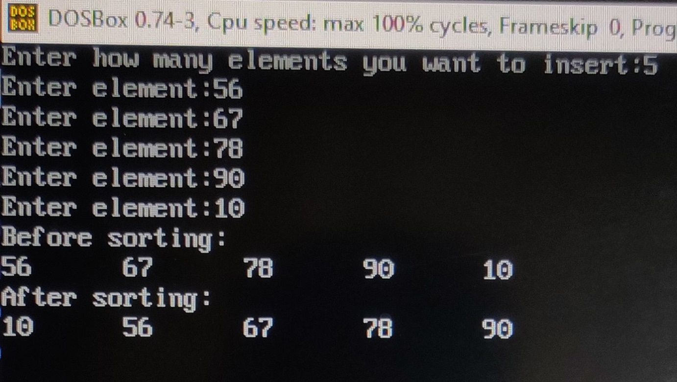

1. Write a program to implement selection sort.

Ans:

#include<stdio.h>

#include<conio.h>

void selection(int a[],int n)

{

int i,j,small,temp;

for(i=0;i<n-1;i++)

{

small=i;

for(j=i+1;j<n;j++)

if(a[j]<a[small])

small=j;

temp=a[small];

a[small]=a[i];

a[i]=temp;

}

}

void display(int a[],int n)

{

int i;

for(i=0;i<n;i++)

printf("%d\t",a[i]);

}

void main()

{

int a[10],n,i;

clrscr();

printf("Enter how many elements you want to insert:");

scanf("%d",&n);

for(i=0;i<n;i++)

{

printf("Enter element:");

scanf("%d",&a[i]);

}

printf("Before sorting:\n");

display(a, n);

selection(a, n);

printf("\nAfter sorting:\n");

display(a, n);

getch();

}

Output:

