**Programs**

1. Write a program to evaluate infix expression to prefix expression.

Ans:

#include<stdio.h>

#include<conio.h>

#include<stdlib.h>

#include<ctype.h>

#include<string.h>

#define SIZE 100

char stack[SIZE];

int top=-1;

void push(char item)

{

if(top>=SIZE-1)

{

printf("\nStack Overflow.");

}

else

{

top=top+1;

stack[top]=item;

}

}

char pop()

{

char item;

if(top<0)

{

printf("stack under flow: invalid infix expression");

getchar();

exit(1);

}

else

{

item=stack[top];

top=top-1;

return(item);

}

}

int is_operator(char symbol)

{

if(symbol=='^'||symbol=='*'||symbol=='/'||symbol=='+'||symbol=='-')

{

return 1;

}

else

{

return 0;

}

}

int precedence(char symbol)

{

if(symbol=='^')

{

return(3);

}

else if(symbol=='*'||symbol=='/')

{

return(2);

}

else if(symbol=='+'||symbol=='-')

{

return(1);

}

else

{

return(0);

}

}

void InfixToPrefix(char infix_exp[], char prefix_exp[])

{

int i,j;

char item,x;

push('(');

strcat(infix_exp,")");

i=0;

j=0;

item=infix_exp[i];

while(item!='\0')

{

if(item=='(')

{

push(item);

}

else if(isdigit(item)||isalpha(item))

{

prefix_exp[j]=item;

j++;

}

else if(is_operator(item)==1)

{

x=pop();

while(is_operator(x)==1&&precedence(x)>=precedence(item))

{

prefix_exp[j]=x;

j++;

x=pop();

}

push(x);

push(item);

}

else if(item==')')

{

x=pop();

while(x!='(')

{

prefix_exp[j]=x;

j++;

x=pop();

}

}

else

{

printf("\nInvalid infix Expression");

getchar();

exit(1);

}

i++;

item=infix_exp[i];

}

if(top>0)

{

printf("\nInvalid infix Expression");

getchar();

exit(1);

}

if(top>0)

{

printf("\nInvalid infix Expression");

getchar();

exit(1);

}

prefix_exp[j]='\0';

}

int main()

{

char infix[SIZE],prefix[SIZE];

clrscr();

printf("Enter Infix expression: ");

gets(infix);

strrev(infix);

InfixToPrefix(infix,prefix);

printf("Prefix Expression:");

strrev(prefix);

puts(prefix);

getch();

return 0;

}

Output:

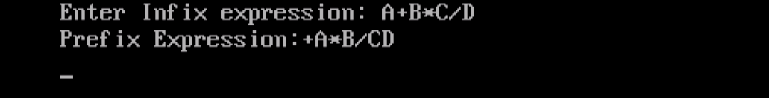

1. Write a program to evaluate a given postfix expression using stacks.

Ans:

#include<stdio.h>

int stack[20];

int top = -1;

void push(int x)

{

stack[++top] = x;

}

int pop()

{

return stack[top--];

}

int main()

{

char exp[20];

char *e;

int n1,n2,n3,num;

printf("Enter the expression: ");

scanf("%s",exp);

e = exp;

while(*e != '\0')

{

if(isdigit(*e))

{

num = *e - 48;

push(num);

}

else

{

n1 = pop();

n2 = pop();

switch(*e)

{

case '+':

{

n3 = n1 + n2;

break;

}

case '-':

{

n3 = n2 - n1;

break;

}

case '*':

{

n3 = n1 * n2;

break;

}

case '/':

{

n3 = n2 / n1;

break;

}

}

push(n3);

}

e++;

}

printf("Result= %d",pop());

return 0;

}

Output:

