|  |  |
| --- | --- |
| **Name:** Omkar Bhoir | **Branch:** CSE AIML |
| **UID:** 2022601002 | **Course:** ADV Batch D |

**Experiment-10**

**Aim:** Design Big Data Dashboard using Tableau on the dataset - Education Sector **Dataset:** The dataset being used is a world education dataset. It contains columns:

1. **Countries and Areas**: Name of the countries and areas.
2. **Latitude**: Latitude coordinates of the geographical location.
3. **Longitude**: Longitude coordinates of the geographical location.
4. **OOSR_Pre0Primary_Age_Male**: Out-of-school rate for pre-primary age males.
5. **OOSR_Pre0Primary_Age_Female**: Out-of-school rate for pre-primary age females.
6. **OOSR_Primary_Age_Male**: Out-of-school rate for primary age males.
7. **OOSR_Primary_Age_Female**: Out-of-school rate for primary age females.
8. **OOSR_Lower_Secondary_Age_Male**: Out-of-school rate for lower secondary age males.
9. **OOSR_Lower_Secondary_Age_Female**: Out-of-school rate for lower secondary age females.
10. **OOSR_Upper_Secondary_Age_Male**: Out-of-school rate for upper secondary age males.
11. **OOSR_Upper_Secondary_Age_Female**: Out-of-school rate for upper secondary age females.
12. **Completion_Rate_Primary_Male**: Completion rate for primary education among males.
13. **Completion_Rate_Primary_Female**: Completion rate for primary education among females.
14. **Completion_Rate_Lower_Secondary_Male**: Completion rate for lower secondary education among males.
15. **Completion_Rate_Lower_Secondary_Female**: Completion rate for lower secondary education among females.
16. **Completion_Rate_Upper_Secondary_Male**: Completion rate for upper secondary education among males.
17. **Completion_Rate_Upper_Secondary_Female**: Completion rate for upper secondary education among females.
18. **Grade_2_3_Proficiency_Reading**: Proficiency in reading for grade 2-3 students.
19. **Grade_2_3_Proficiency_Math**: Proficiency in math for grade 2-3 students.
20. **Primary_End_Proficiency_Reading**: Proficiency in reading at the end of primary education.
21. **Primary_End_Proficiency_Math**: Proficiency in math at the end of primary education.
22. **Lower_Secondary_End_Proficiency_Reading**: Proficiency in reading at the end of lower secondary education.
23. **Lower_Secondary_End_Proficiency_Math**: Proficiency in math at the end of lower secondary education.
24. **Youth_15_24_Literacy_Rate_Male**: Literacy rate among male youths aged 15-24.
25. **Youth_15_24_Literacy_Rate_Female**: Literacy rate among female youths aged 15-24.
26. **Birth_Rate**: Birth rate in the respective countries/areas.
27. **Gross_Primary_Education_Enrollment**: Gross enrollment in primary education.
28. **Gross_Tertiary_Education_Enrollment**: Gross enrollment in tertiary education.
29. **Unemployment_Rate**: Unemployment rate in the respective countries/areas.

**Analysis and description of charts/dashboard**

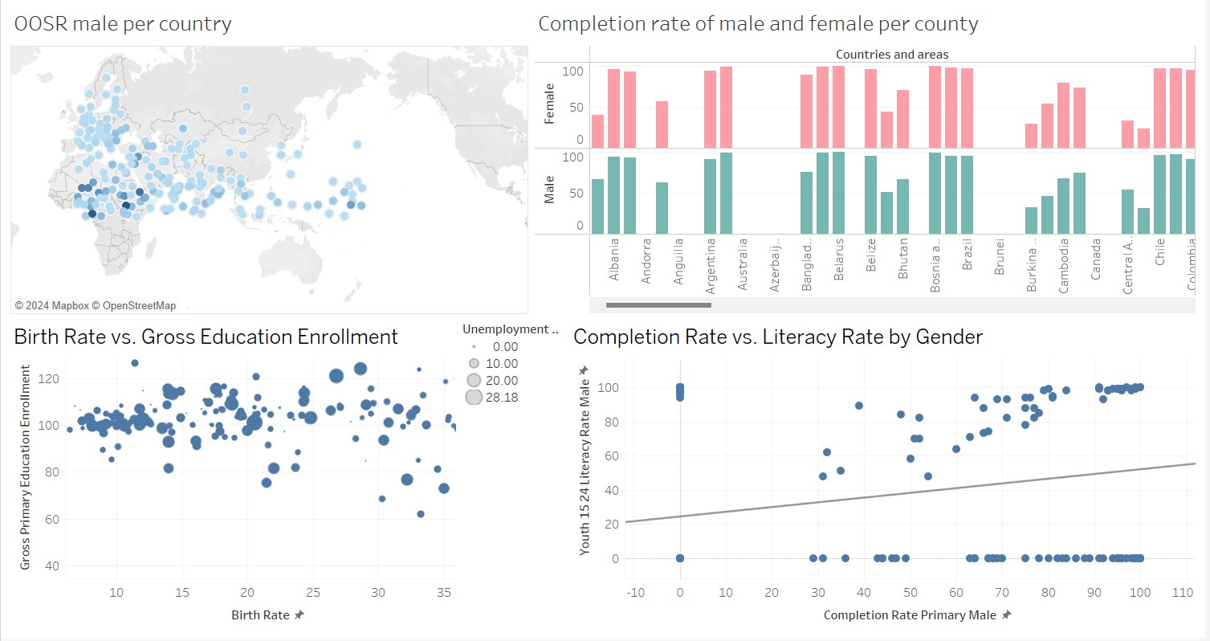

# OOSR Male per Country (Map)

* **Description**: This map displays the out-of-school rate (OOSR) for males across different countries. The size and color intensity of each circle represent the out-of-school rate, with darker and larger circles indicating higher rates.
* **Analysis**: Countries with higher out-of-school rates for males are more prominent on the map. This visualization is useful for identifying regions where male children are more likely to be out of school. For example, certain regions in Africa and South Asia show darker circles, indicating that male out-of-school rates are a significant issue in these

areas. The map helps in visually locating countries that may need targeted interventions to increase male school enrollment.

# Completion Rate of Male and Female per Country (Bar Chart)

* **Description**: This bar chart compares the completion rates of males and females for each country. The chart is divided by gender, with bars showing the completion rate percentages for males (green) and females (red) across different countries.
* **Analysis**: This visualization provides insights into gender disparities in educational completion rates. In some countries, females have higher completion rates than males, while in others, males outperform females. For instance, countries like Argentina and Australia show higher completion rates for females, while other countries display an opposite trend. This chart highlights where gender gaps exist in education completion rates, allowing stakeholders to identify and address inequalities.

# Birth Rate vs. Gross Primary Education Enrollment (Scatter Plot)

* **Description**: This scatter plot compares birth rates with gross primary education enrollment across countries. Each point represents a country, and the size of the points indicates the unemployment rate.
* **Analysis**: This chart examines if there is any visible correlation between birth rates and gross primary education enrollment, with point size adding an extra layer for unemployment rate. Countries with higher birth rates tend to have varying enrollment rates, but no clear linear correlation is evident. Countries with smaller dots have lower unemployment rates, while larger dots indicate higher unemployment. This visualization allows for a multi-dimensional analysis, exploring how birth rates, education enrollment, and unemployment rates interact with each other.

# Completion Rate vs. Literacy Rate by Gender (Scatter Plot with Trend Line)

* **Description**: This scatter plot shows the relationship between male primary completion rates and male youth literacy rates (ages 15-24). Each point represents a country, and a trend line indicates the overall correlation between these two metrics.
* **Analysis**: The trend line suggests a positive correlation between primary completion rates and literacy rates for young males, meaning that countries with higher primary completion rates generally tend to have higher literacy rates among young men. However, the scatter plot also shows some variation, with certain countries achieving high literacy rates even if primary completion rates are lower. This insight can help assess the effectiveness of primary education completion in improving youth literacy and identify areas where additional literacy programs may be beneficial.

**Conclusion**: Through this lab, I have gained proficiency in using Tableau to create informative and visually appealing dashboards for world education data. I have explored a variety of chart types and learned how to interpret the insights they provide. The skills acquired in this lab can be applied to various data visualization tasks and contribute to effective decision-making.