|  |  |
| --- | --- |
| **Name:** Omkar Bhoir | **Branch:** CSE AIML |
| **UID:**  2022601002 | **Course:** ADV Batch D |

**Experiment 08**

**Aim:** Experiment to design interactive dashboards and create visual storytelling using D3.js on a dataset related to Environment/Forest cover, covering basic and advanced charts

**Theory:**

D3.js is a JavaScript library for producing dynamic, interactive data visualizations in web browsers. It makes use of Scalable Vector Graphics, HTML5, and Cascading Style Sheets standards. It is the successor to the earlier Protovis framework

Its low-level approach built on web standards offers unparalleled flexibility in authoring dynamic, data-driven graphics. For more than a decade D3 has powered groundbreaking and award-winning visualizations, become a foundational building block of higher-level chart libraries, and fostered a vibrant community of data practitioners around the world.

**Dataset:**

Link: <https://www.kaggle.com/datasets/webdevbadger/world-forest-area/data>

This dataset contains information about the world's forest area changes since 1990.

Studying global forest area changes is crucial for assessing environmental health, informing conservation strategies, and understanding the impact of human activities on biodiversity and climate regulation

It has 2 main attributes

1. Country - Name of the country / region
2. Year wise forest coverage - in sq km

**Dashboard:**

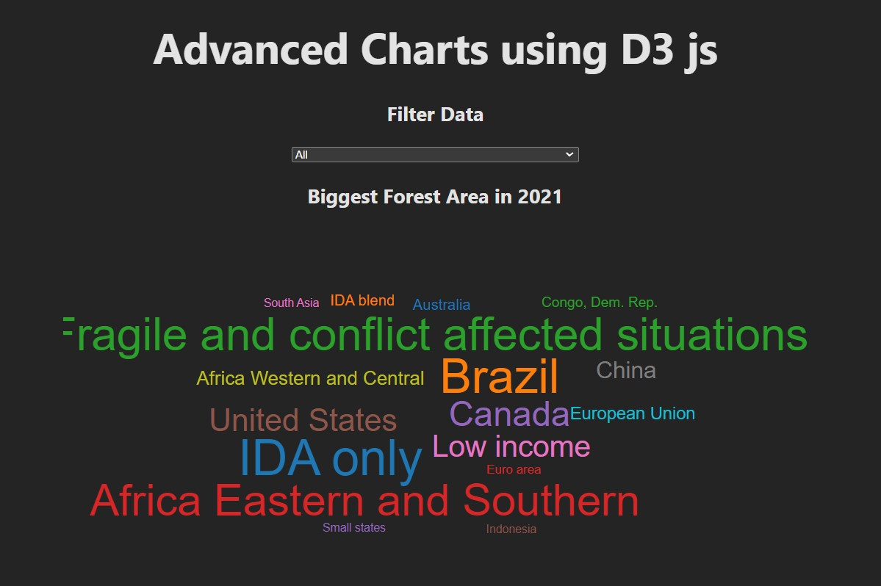

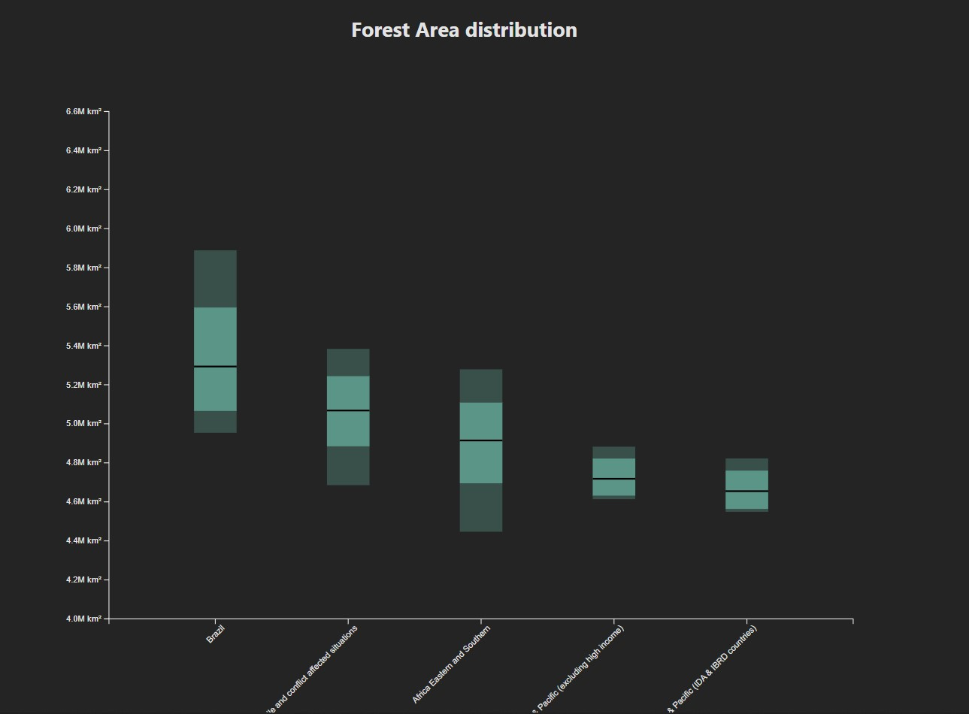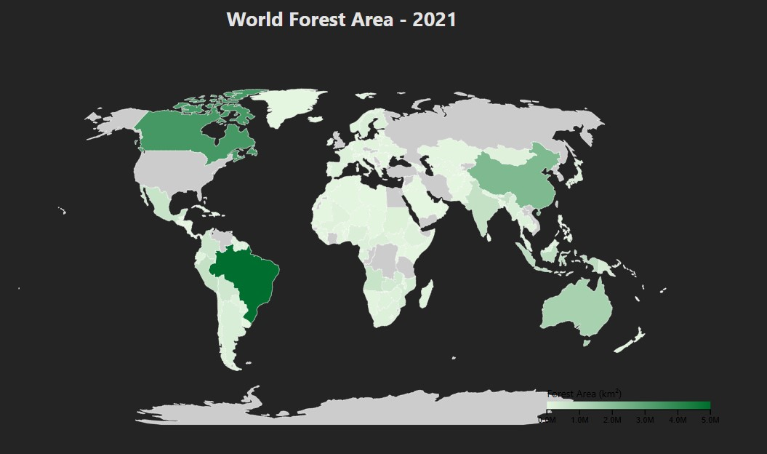

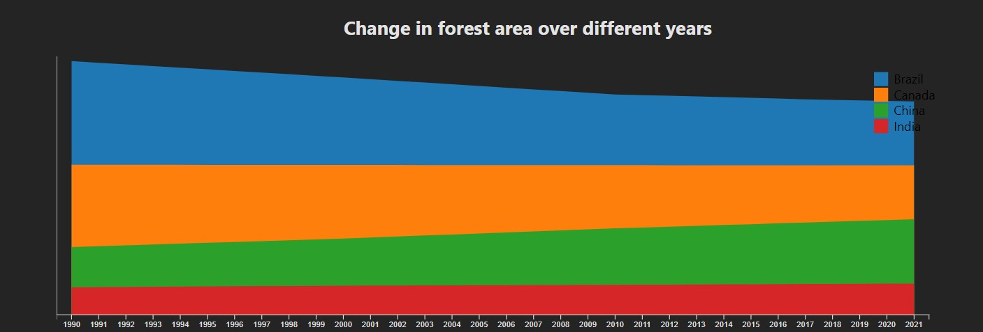

**Analysis and Story:**

1) Word Cloud

* The word cloud highlights regions and countries, with terms like "Brazil", "Africa Eastern and Southern", and "fragile and conflict affected situations" standing out due to their larger size, indicating their importance or frequency in the dataset.
* Fragile and conflict-affected areas, along with regions in Africa, appear to be of significant focus, suggesting they are major themes or key areas of concern, likely related to socio-economic or development issues

2) Forest Distribution over the years

* The bar chart shows forest area distribution across different regions, with

Brazil having the largest forest area, while regions like South Asia and Pacific (IDA & IBRD countries) have much smaller forest areas in comparison.

* Brazil dominates in terms of forest coverage, which may highlight its critical role in global environmental sustainability, particularly in discussions around deforestation and climate change. Other regions, especially fragile and conflict-affected situations, show smaller but varied forest areas, likely affected by socio-economic and environmental factors.

3) Forest Distribution around the world

* Brazil has the largest forest area (shown in darkest green) compared to all other countries on the map as of 2021.
* Despite having significant landmass, some regions like Central Asia and the Middle East show minimal forest coverage (indicated by light/grey coloring), suggesting that geographical and climatic conditions play a crucial role in forest distribution rather than just available land area.

4) Forest Area change over the years

* The forest areas of all four countries (Brazil, Canada, China, and India) have remained relatively stable over the 30-year period from 1990 to 2021, with no dramatic changes visible in the stacked area chart.
* While Brazil shows the largest forest area of the four countries, the combined forest areas of Canada and China appear to be roughly equivalent to Brazil's, suggesting that these three nations together account for a significant portion of the world's forest coverage.
* Interactivity

The top select bar can allow us to view distribution of particular country

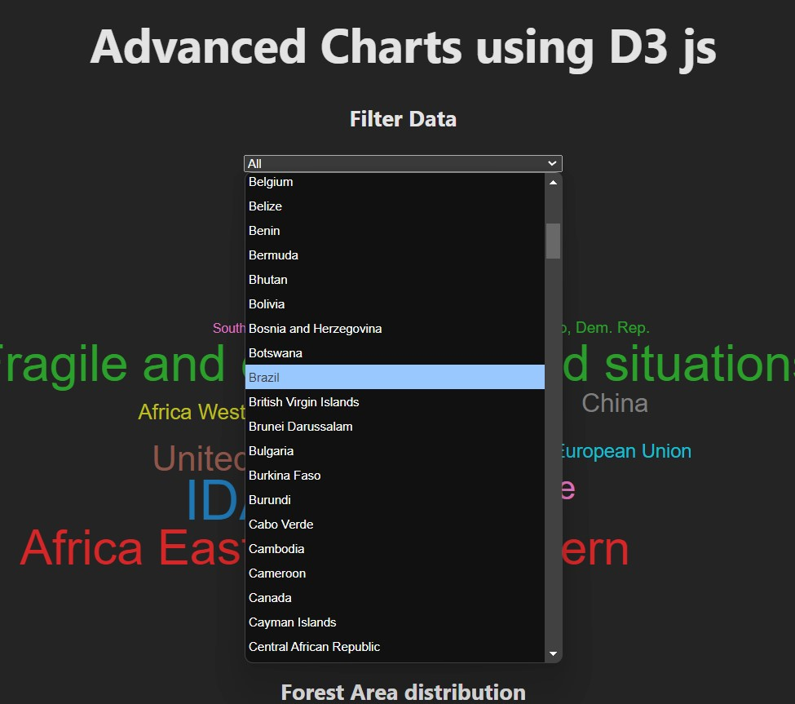

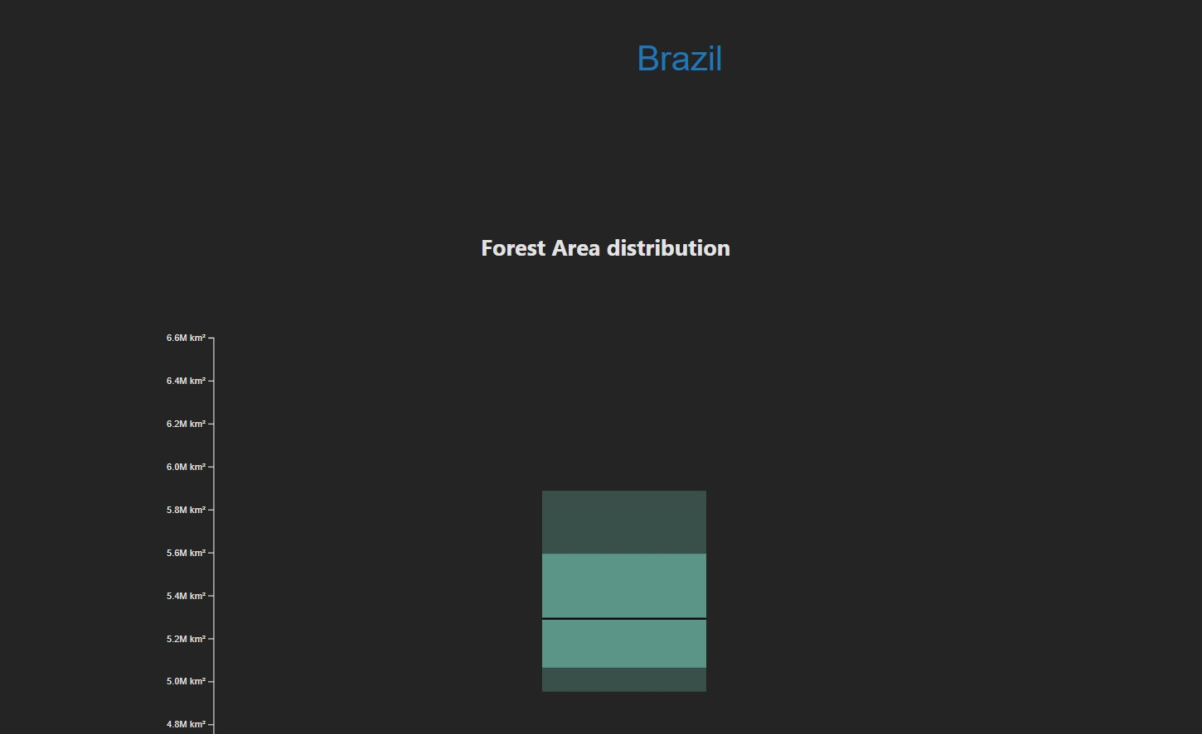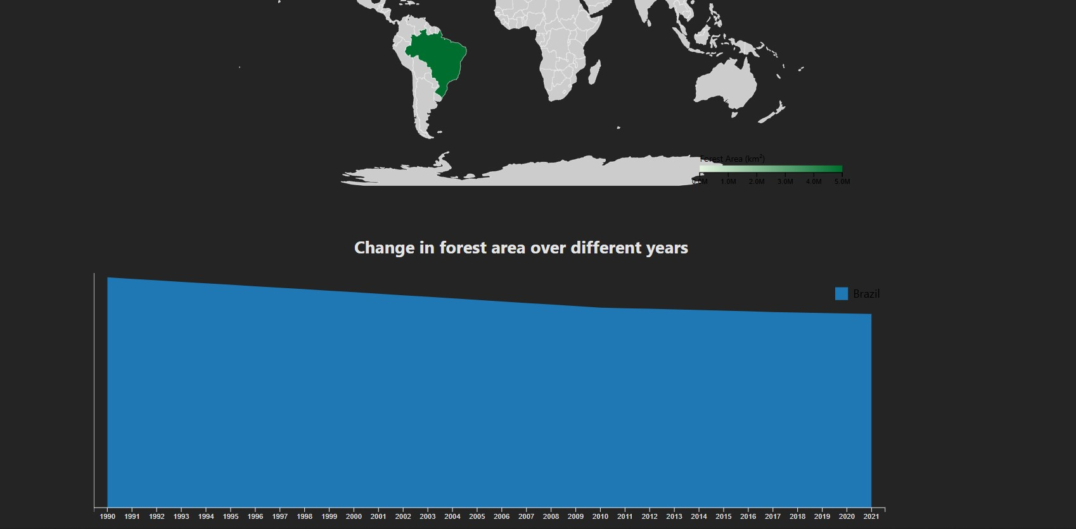

**Conclusion:**

Using D3.js in web development enables the creation of interactive forest data visualizations that seamlessly integrate into environmental monitoring platforms.

These dynamic features allow users to explore temporal deforestation patterns and compare regional forest densities, transforming complex forest datasets into actionable insights.