|  |  |
| --- | --- |
| **Name:** Omkar Bhoir | **Branch:** CSE AIML |
| **UID:** 2022601002 | **Course:** ADV Batch D |

**Experiment 09**

**Aim:** To effectively visualize and analyse large-scale datasets related to women empowerment and gender participation using Tableau, creating interactive and informative dashboards.

**Objectives:**

* Learn the fundamentals of Tableau and its application in data visualization.
* Create various chart types (basic and advanced) to represent different aspects of women empowerment data.
* Understand the significance of each chart type in conveying insights.
* Develop a comprehensive dashboard that integrates multiple visualizations for effective storytelling.

**Dataset:**

Link: <https://www.kaggle.com/datasets/iamsouravbanerjee/women-empowerment-index>

The Women Empowerment Index (WEI) is a multifaceted tool designed to assess and track the progress of women's empowerment within societies. Drawing from diverse metrics and indicators, the WEI offers a nuanced understanding of the status of women across various domains. It builds upon the foundation laid by existing indices like the Gender Inequality Index (GII) but focuses specifically on aspects related to women's empowerment. The WEI encompasses several key dimensions, including economic participation, political representation, access to education and healthcare, and social inclusivity. By analyzing these dimensions, the index sheds light on the extent to which women are able to exercise agency, access resources, and participate fully in societal processes.

This dataset provides essential information on gender development indicators, facilitating comprehensive analysis and comparison across countries and regions. Here are the key columns included:

1. **Country:** The name of the country or territory included in the dataset.
2. **Women's Empowerment Index (WEI) - 2022**: Quantifies women's empowerment within each country for the year 2022, offering insights into gender dynamics and opportunities for women.
3. **Women's Empowerment Group - 2022**: Categorizes countries based on their performance and status regarding women's empowerment, facilitating comparative analysis.
4. **Global Gender Parity Index (GGPI) - 2022:** Measures gender parity at a global level for the year 2022, indicating the degree of equality between men and women.
5. **Gender Parity Group - 2022:** Classifies countries into groups based on their level of gender parity, aiding in the identification of trends and disparities.
6. **Human Development Group - 2021:** Classifies countries into specific groups based on their Human Development Index (HDI) scores and development levels for the year 2021.

**Dashboard:**

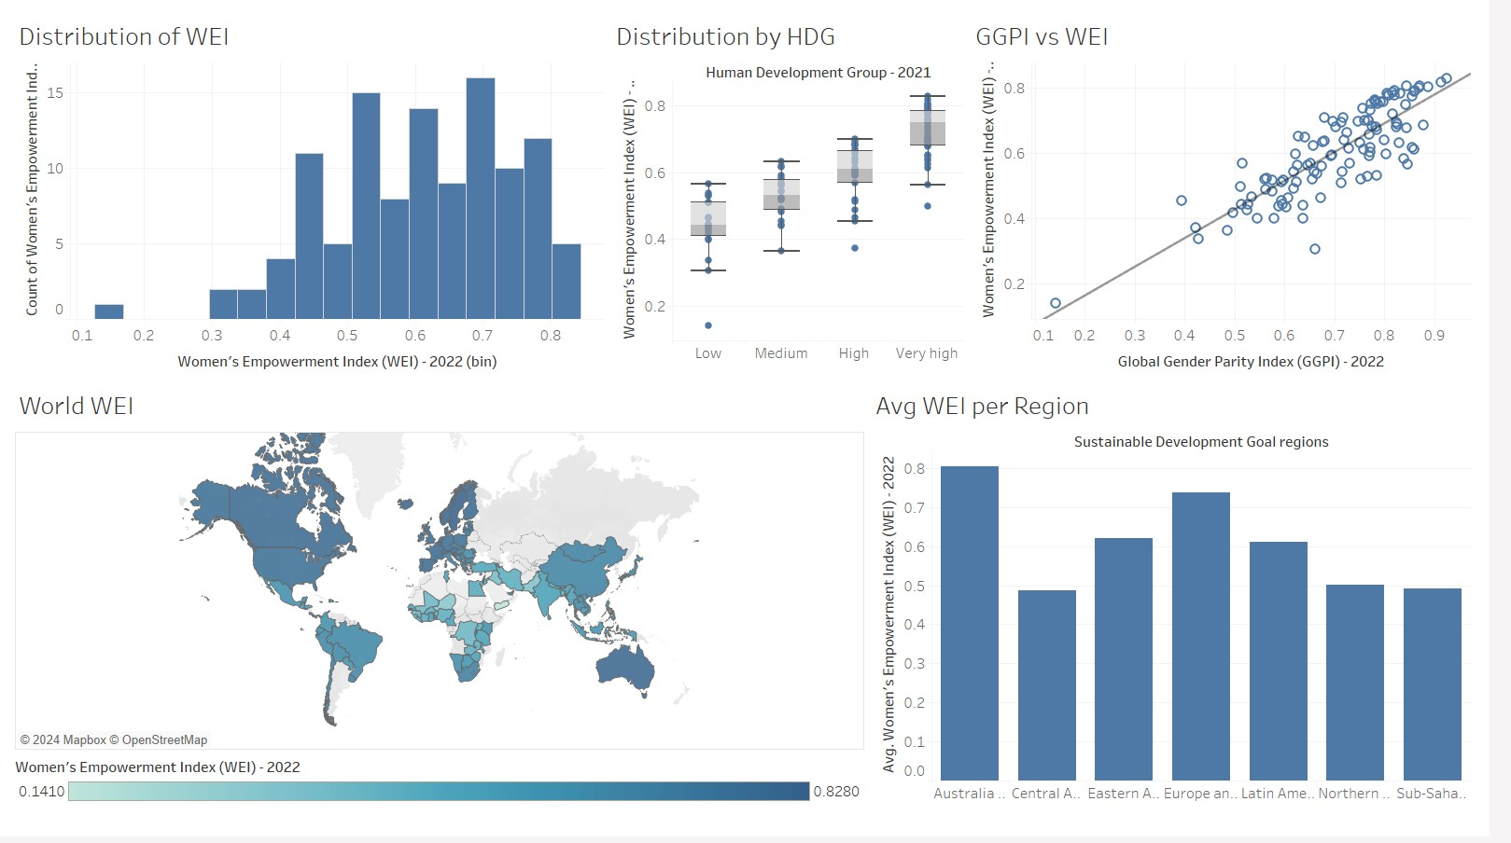

**● Basic Charts**

1) Distribution of WEI Index histogram

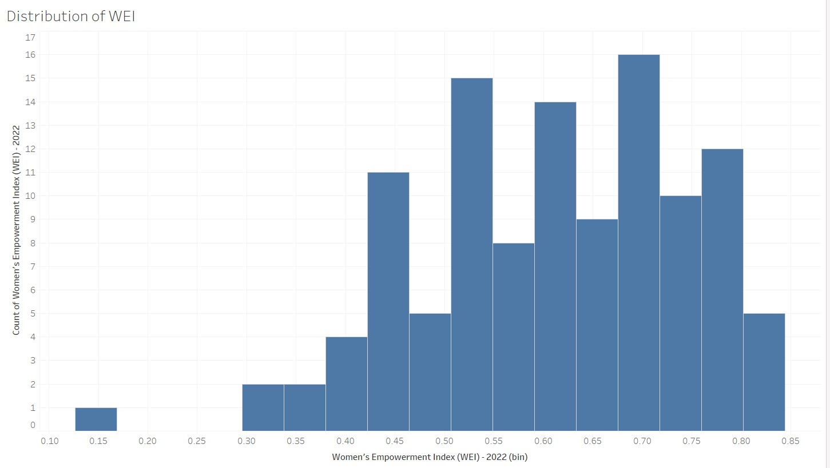

* The Women's Empowerment Index (WEI) scores across countries show a roughly normal distribution with most countries falling between 0.45 and

0.75, while there are a few outliers with very low scores around 0.15.

* The wide spread of WEI scores (from 0.15 to 0.85) suggests significant global inequality in women's empowerment, with a small number of countries achieving high scores above 0.75 while others lag far behind, indicating there's still substantial work needed to achieve gender equality worldwide.

2) ScatterPlot of WEI vs GGPI

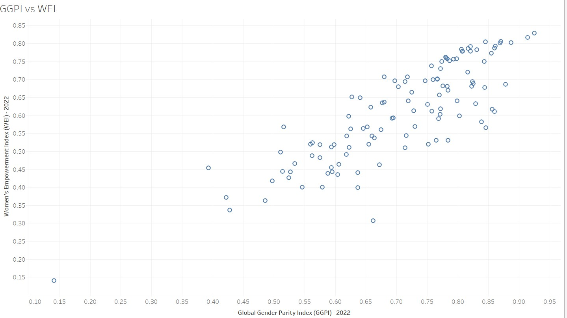

* The scatter plot shows WEI (Women's Empowerment Index) and GGPI (Global Gender Parity Index) scores for different countries, with values ranging from 0.15 to 0.85 for WEI and 0.15 to 0.95 for GGPI.
* There is a clear positive relationship between the two indices, suggesting that countries with higher gender parity scores tend to also have higher women's empowerment scores, though there is some variation in this pattern with several outliers.

3) Bar chart of region wise WEI index

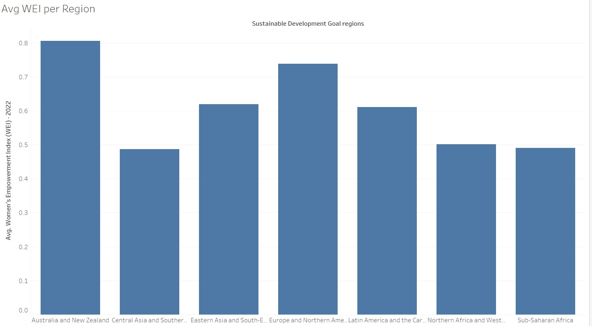

* Australia and New Zealand leads with the highest average WEI of around 0.8, while Sub-Saharan Africa and Northern Africa/Western Asia show the lowest scores at approximately 0.5, with other regions falling in between.
* There appears to be a significant regional divide in women's empowerment, with developed regions generally showing higher WEI scores, suggesting that economic development and regional policies may play a crucial role in women's empowerment levels.

**● Advanced Charts**

1) TreePlot of WEI in regions

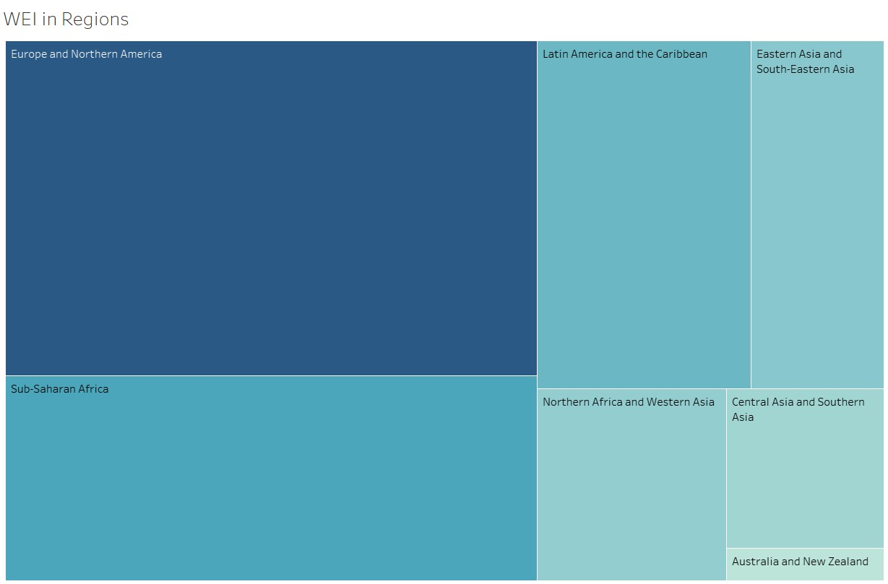

* The relative sizes of different regions, with Europe and Northern America occupying the largest area, followed by Sub-Saharan Africa, while regions like Australia and New Zealand have notably smaller representations.

Regression Plot of GGPI vs WEI

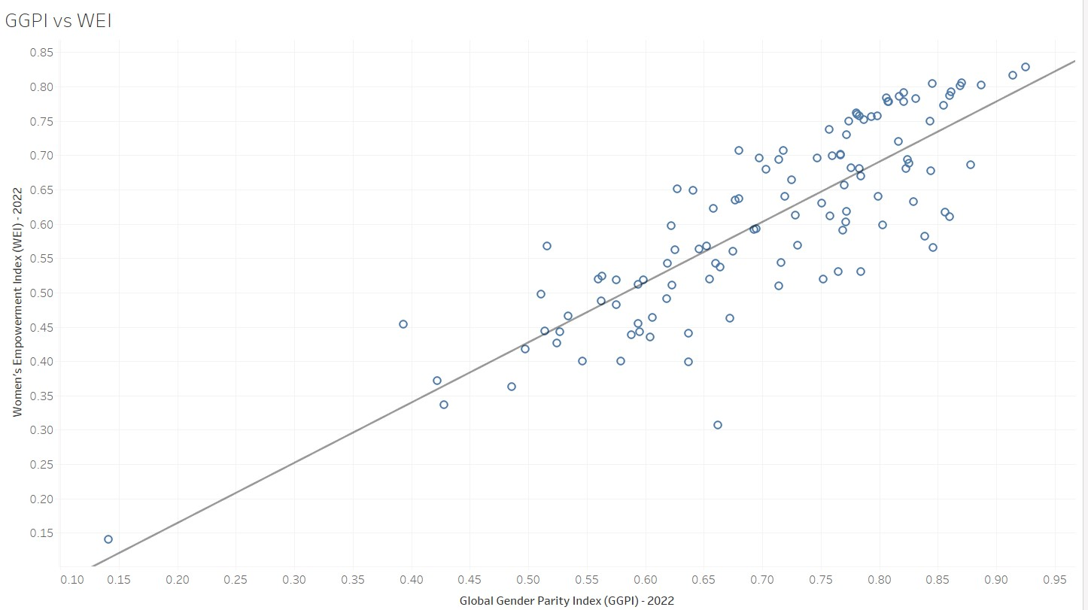

* The scatter plot includes a regression line that runs from approximately (0.15, 0.15) to (0.95, 0.85), showing a clear positive linear relationship between GGPI and WEI scores.
* The regression line's strong positive slope and the relatively tight clustering of points around it suggests that GGPI is a reliable predictor of WEI, indicating that countries' efforts to achieve gender parity (GGPI) typically translate into improved women's empowerment (WEI) outcomes.

Choropleth Map of WEI in countries

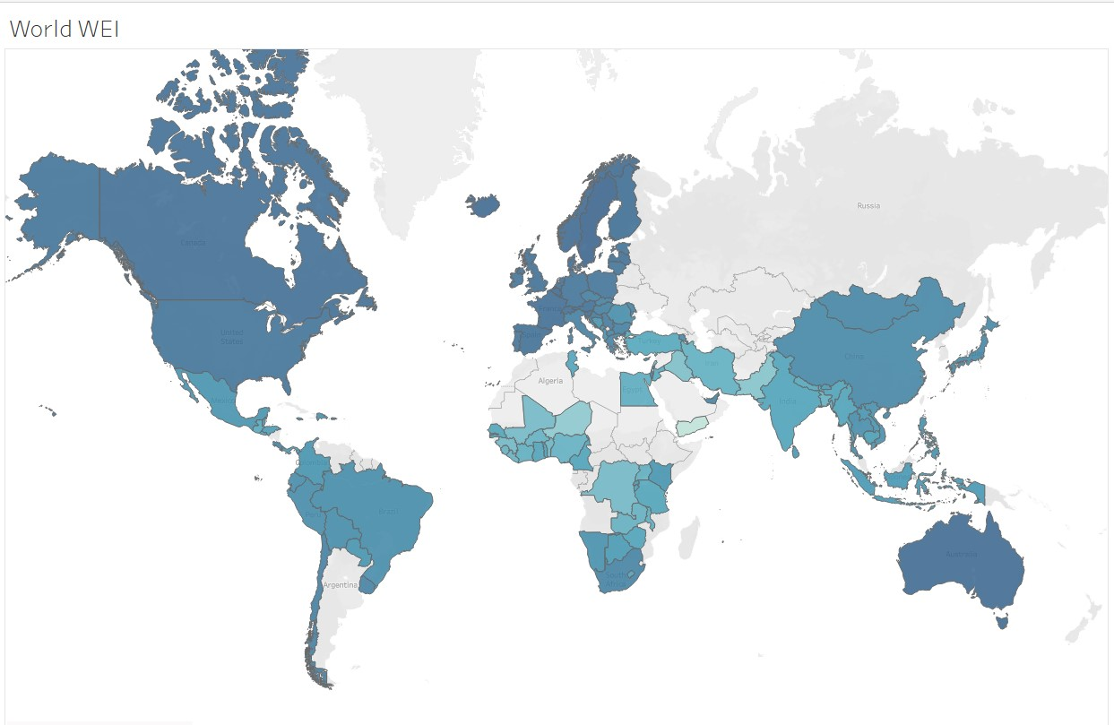

* The world map shows WEI scores represented by varying shades of blue, with darker blues concentrated in North America, Europe, and Australia/New Zealand, while large portions of Asia, Africa, and some South American countries appear in gray, indicating missing data.
* The geographic distribution reveals not only a socioeconomic divide in women's empowerment but also a significant data gap, particularly in many developing regions, suggesting a critical need for more comprehensive data collection to better understand and address global gender inequality.

Box plot and whisker for HDG and WEI

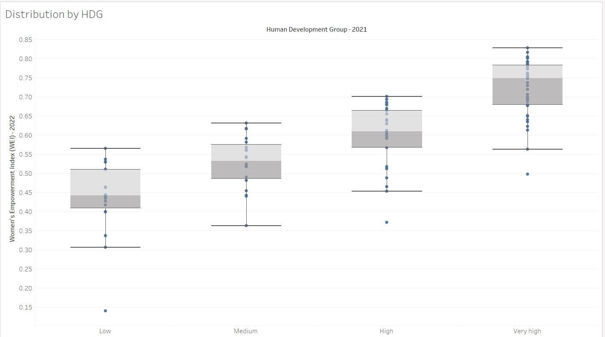

* The Women's Empowerment Index (WEI) shows a clear positive correlation with Human Development Group (HDG) levels, with median values increasing from around 0.45 in Low HDG to 0.75 in Very High HDG countries.
* Despite the overall positive trend, there is notable overlap in WEI scores between adjacent HDG categories, suggesting that a country's development level alone doesn't fully determine women's empowerment outcomes

5) Word Cloud based on WEI

* Europe and Northern America appears as the largest text, suggesting it has the highest Women's Empowerment Index (WEI) scores among all regions.
* 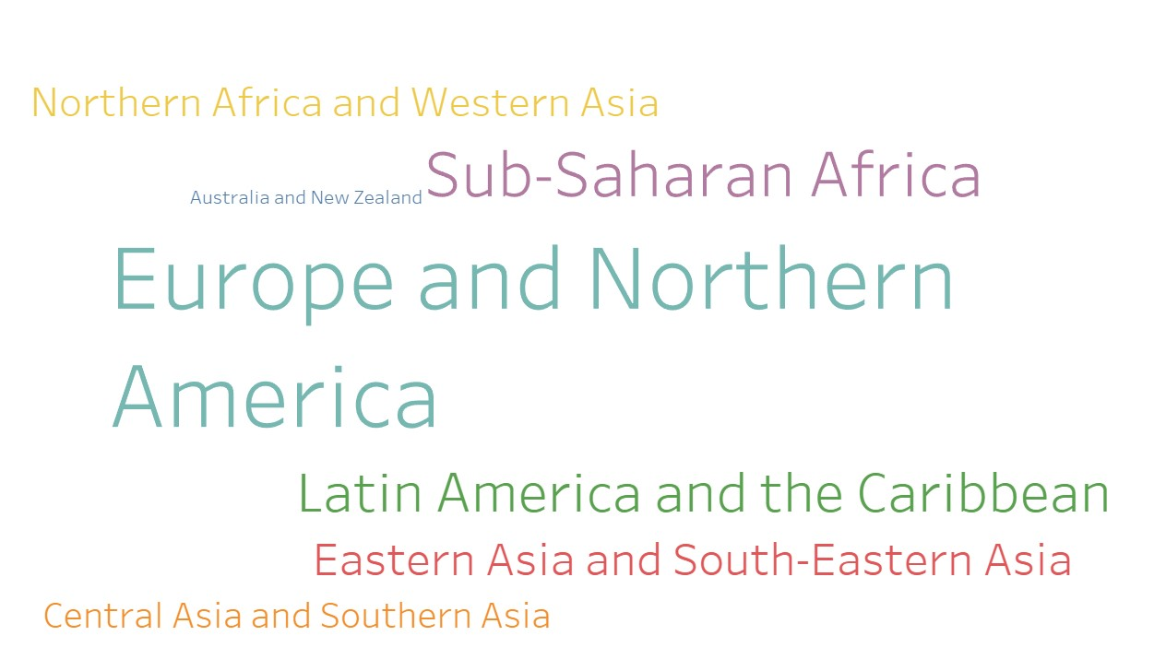The text size hierarchy reveals a stark global inequality in women's empowerment, with a noticeable divide between Western/developed regions and developing regions, particularly Sub-Saharan Africa and parts of Asia

6) Jitter of WEI and Parity Index on the basis of Gender Parity Group

* There's a strong positive correlation between the Women's Empowerment Index (WEI) and Global Gender Parity Index (GGPI) across all parity groups, with "High" parity countries clustering in the upper right (high scores on both indices).
* 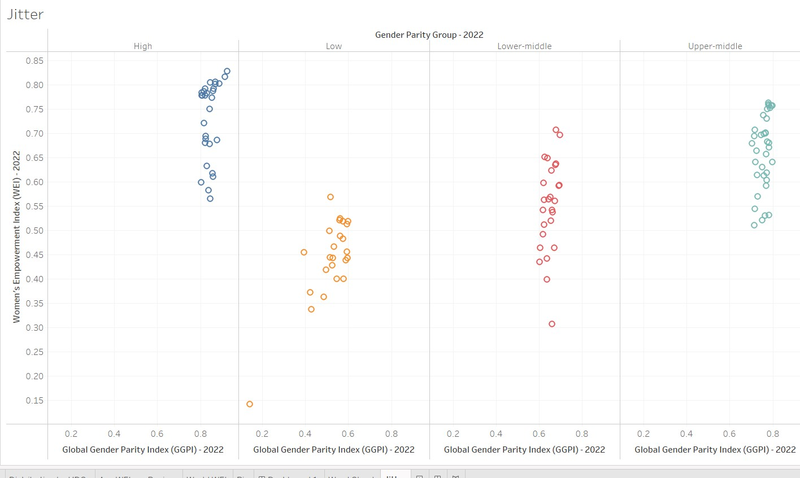The clustering pattern suggests that gender parity and women's empowerment are mutually reinforcing, but the distinct groupings also indicate that countries tend to progress on both metrics together rather than excelling in one while lagging in the other

**Conclusion:**

Through this lab, I have gained proficiency in using Tableau to create informative and visually appealing dashboards for women empowerment data. I have explored a variety of chart types and learned how to interpret the insights they provide. The skills I have acquired in this lab can be applied to various data visualization tasks and contribute to effective decision-making in my future work.