1. Clone the repo:
https://github.com/omkar9392/infracloudlab/tree/master/helm_assignment/csvserver_chart

2. To validate the yaml configurations:
helm lint
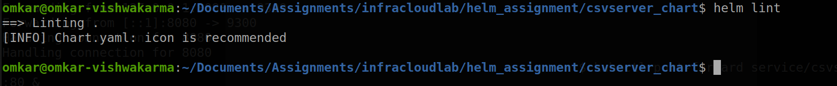
3. Install helm chart:
cd helm_assignment
helm install <ReleaseName> csvserver_chart
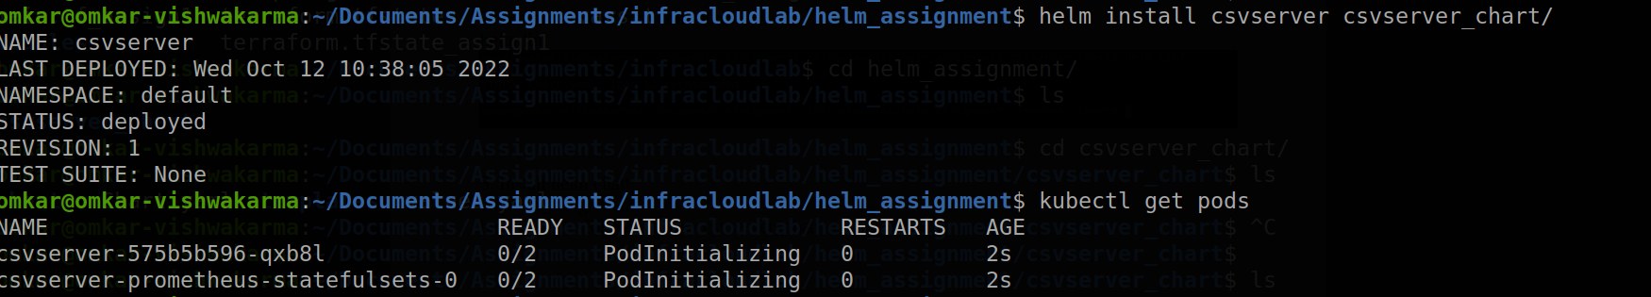
4. Port forwarding locally to test:
kubectl port-forward service/csvserver-service 8080:80 &
kubectl port-forward service/csvserver-prometheus-service 9090:9090

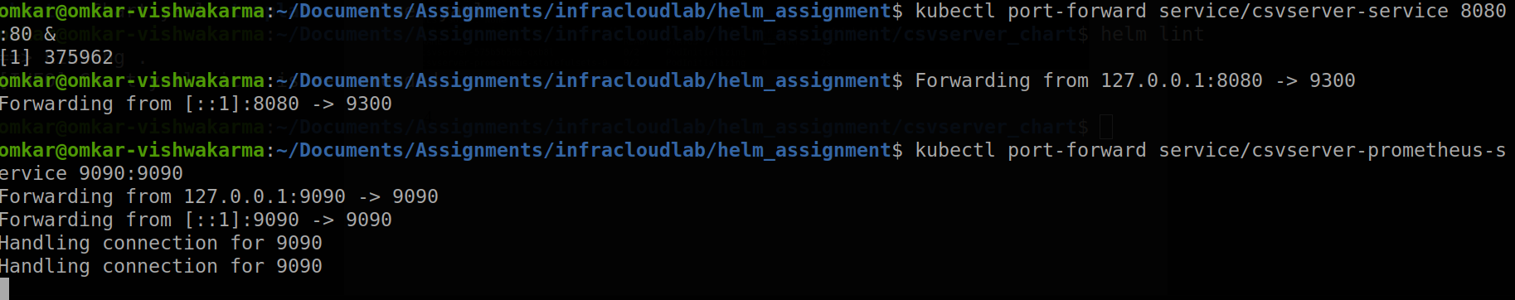

5. Outputs:
csvserver:
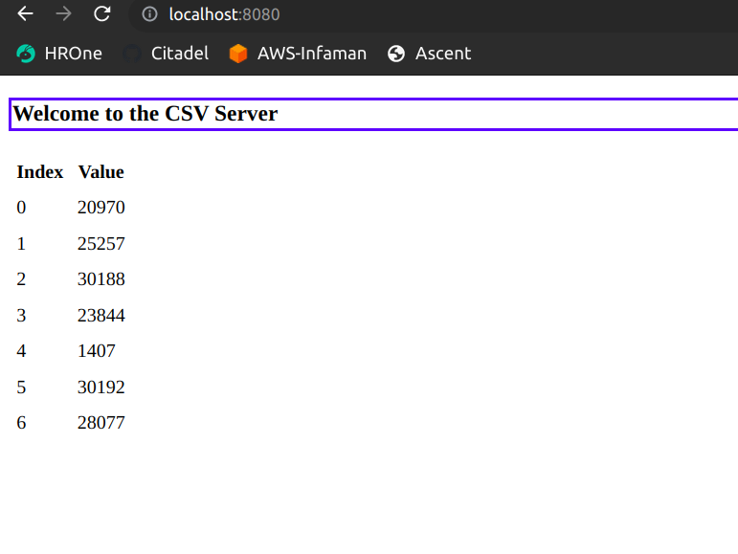
prometheus:
