* By inspecting the element we find the following fields:

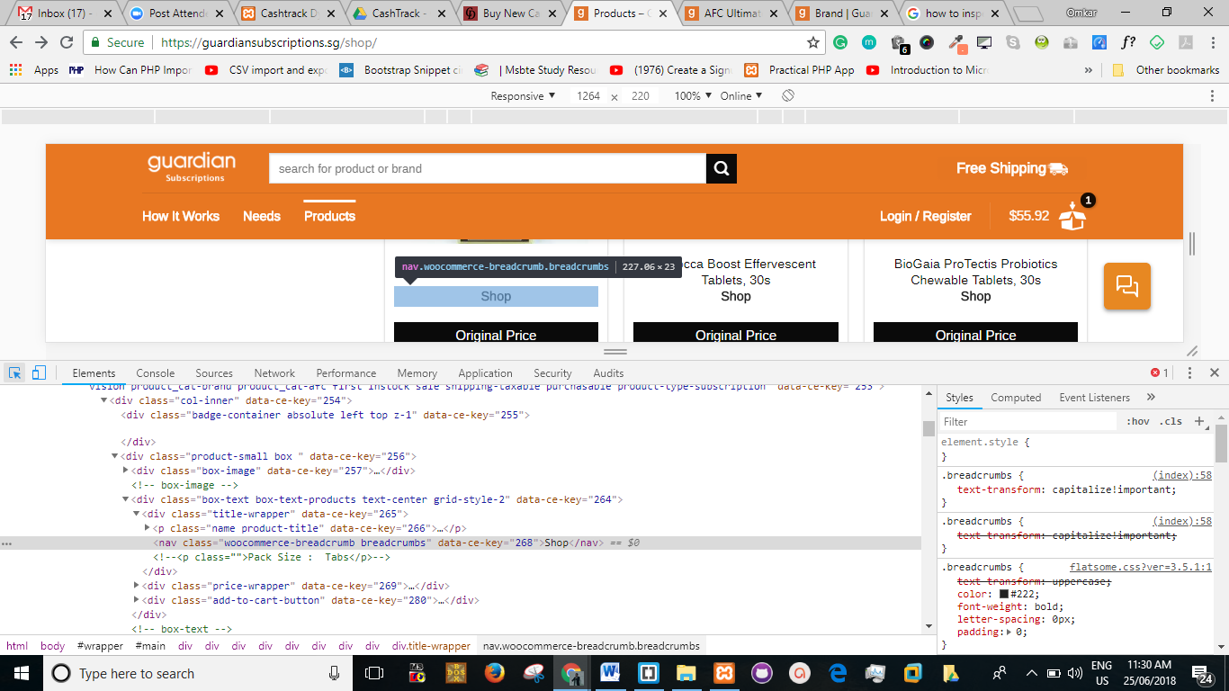

**2**

**1**

From inspection, we see that the breadcrumb in the product-box belongs to a main class named **box-text box-text-products text-center grid-style-2. (as indicated by 1)**

* Similarly, we inspect the breadcrumb in the product description page:

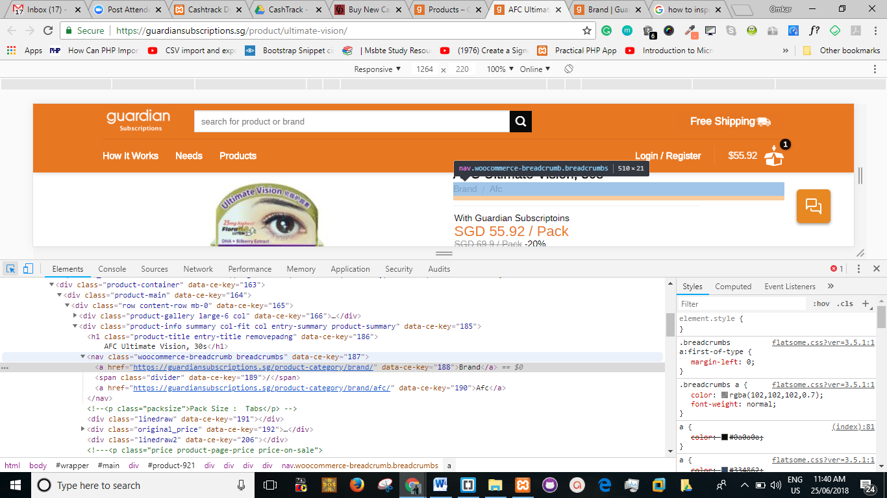

**3**

**4**

From inspection, we see that the breadcrumb in the product description page belongs to a main class named **product-info summary col-fit col entry-summary product-summary (as indicated by 3)**

* From 2 and 4 indications, we find that the breadcrumb belongs to the same class **woocommerce-breadcrumb breadcrumbs** of <nav>
* However, their main classes are different.
* If we try removing the breadcrumb using the class given in the <nav>, then all such breadcrumbs will be removed.

We cannot hook our styling to the breadcrumb of <nav> tag as shown beow, as this could remove all the breadcrumbs from all the pages.

**nav.woocommerce-breadcrumb.breadcrumbs {**

**display: none;**

**}**

* Hence we hook our required breadcrumb from the **main class**, i.e **box-text box-text-products text-center grid-style-2.**

**.box-text.box-text-products.text-center.grid-style-2 .breadcrumbs{**

**display: none;**

**}**

The above code will remove the breadcrumb ONLY from the products page and the breadcrumbs in the other page will not be effected.

* Further the website is developed in WordPress as detected using wpdetector.

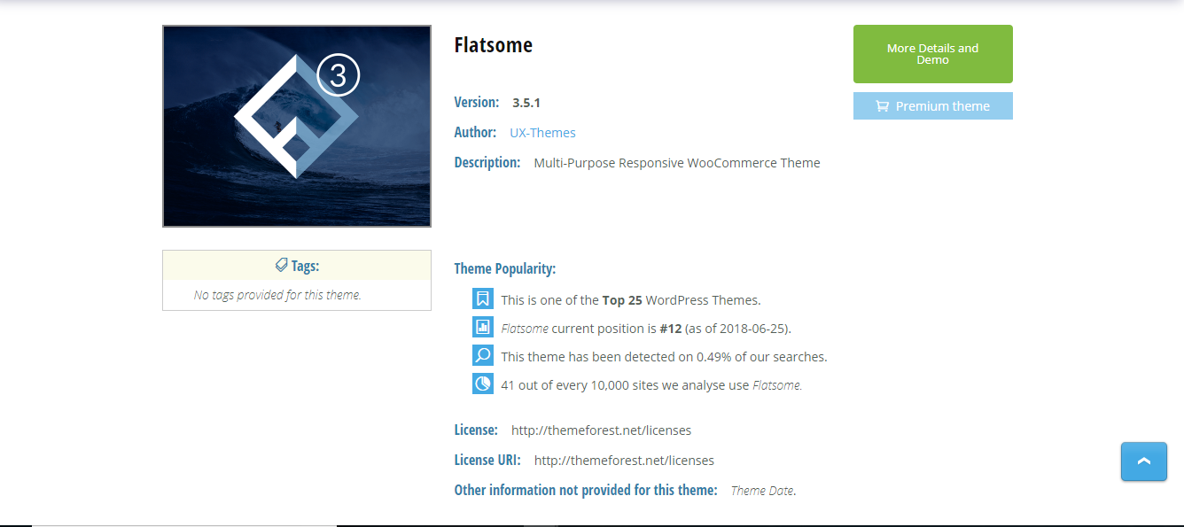We will need to install a plugin named **“Custom CSS”** and place the below code in the plugin.

**.box-text.box-text-products.text-center.grid-style-2 .breadcrumbs{**

**display: none;**

**}**

I hope this can solve the problem. However, I am still searching for other possible solutions.

**Cheers!**