

**Customer Transaction Prediction**

**Omkar Annabathula**

**05-09-2019**

**Table of Contents**

1. Introduction3

1.1 Problem Statement3

1.2 Problem Description3

1.3 Data 3

2. Pre-Processing**4**

2.1 Missing Value Analysis 5

2.2 Data Visualizations 6

2.3 Feature Selection 9

2.4 Handling Imbalanced Data 10

2.5 Re Sampling Techniques 10

3. Model Development12

3.1 Confusion Matrix 12

3.2 Logistic regression 12

3.3 Random forest13

3.4 Naive Bayes13

4. Model Deployment14

5. Conclusion15

6. Deliverables 16

**INTRODUCTION**

**1.1 PROBLEM STATEMENT:**

In this challenge, we need to identify which customers will make a specific transaction in the future, irrespective of the amount of money transacted.

**1.2 PROBLEM DESCRIPTION:**

At Santander, mission is to help people and businesses prosper. We are always looking for ways to help our customers understand their financial health and identify which products and services might help them achieve their monetary goals. Our data science team is continually challenging our machine learning algorithms, working with the global data science community to make sure we can more accurately identify new ways to solve our most common challenge, binary classification problems such as:

* is a customer satisfied?
* Will a customer buy this product?
* Can a customer pay this loan?

According to past data and from the given problem the output is Classification and it comes under Supervised Machine Learning. We train the model with past data and when the new data is given we predict the outcome

**1.3 DATA:**

Given data contains numeric feature variables, the binary target column, and a string ID code column. The task is to predict the value of target column in the test set.

**ID code (string); Target;**

**200 numerical variables, named from var_0 to var_199;**

It has 201 predictors or independent variables and 1 target variable ‘target’

**Exploratory Data Analysis**

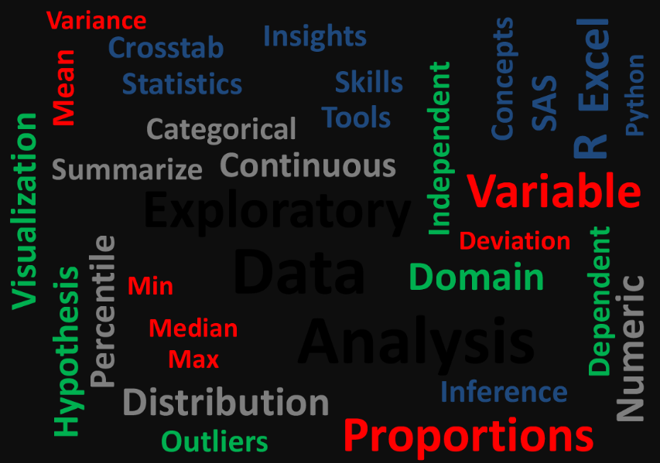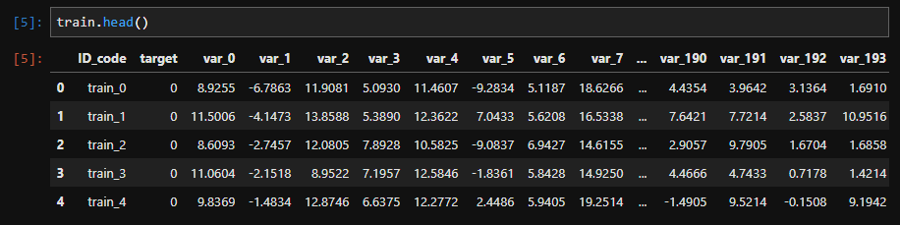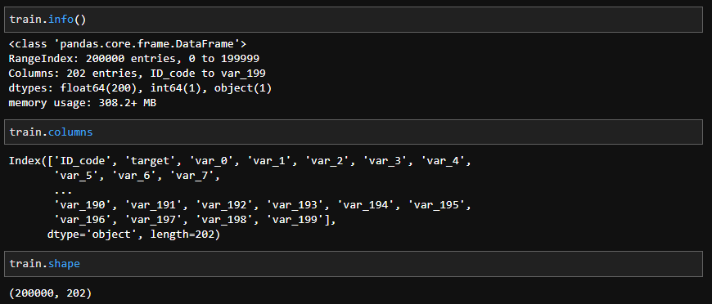

**Pre-processing**

**2.1 Missing Value Analysis:**

Missing values are which, where the values are missing in an observation in the dataset. It can occur due to human errors, individuals refusing to answer while surveying, optional box in questionnaire Usually we only consider those variables for missing value imputation whose missing values is less than 30%, if it above this we will drop that variable in our analysis as imputing missing values which are more than 30% doesn’t make any sense and the information would also be insensible to consider.

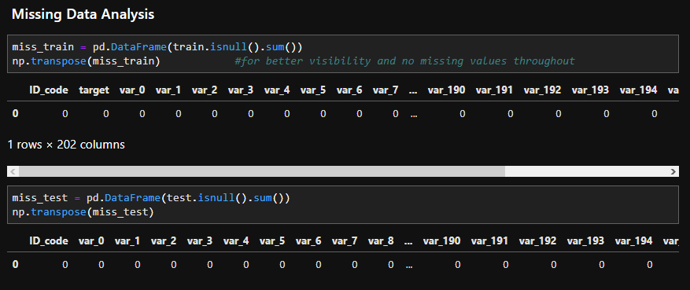

IN OUR GIVEN DATASET WE ARE NOT HAVING ANY MISSING VALUES….SO WE ARE NOT PROCEEDING WITH THIS STEP TO IMPUTE ANY MISSING VALUES.

**2.2 DATA VISUALIZATIONS**

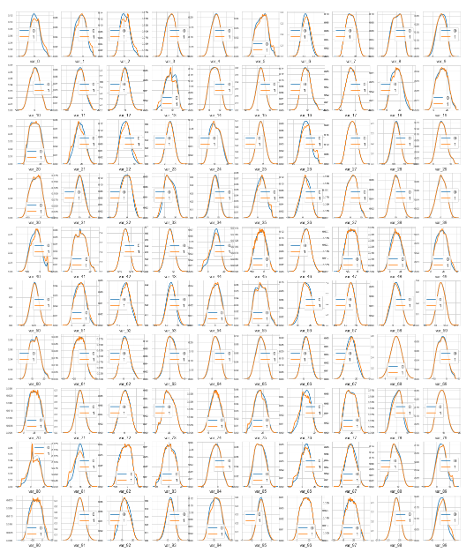

Fig: Density plots of features

We can observe that there is a considerable number of features with significant different distribution for the two target values.

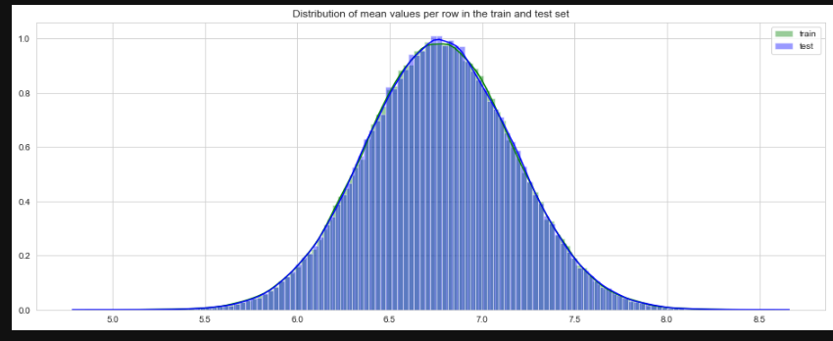

Distribution of the mean values per row in the train and test set.

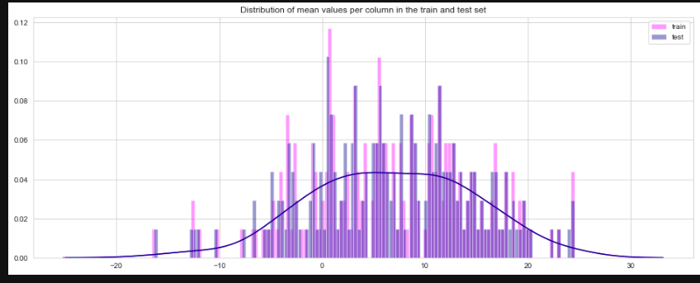

distribution of the mean values per columns in the train and test set.

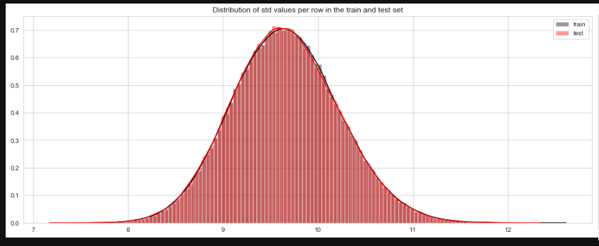

Distribution of standard deviation of values per row for train and test datasets.

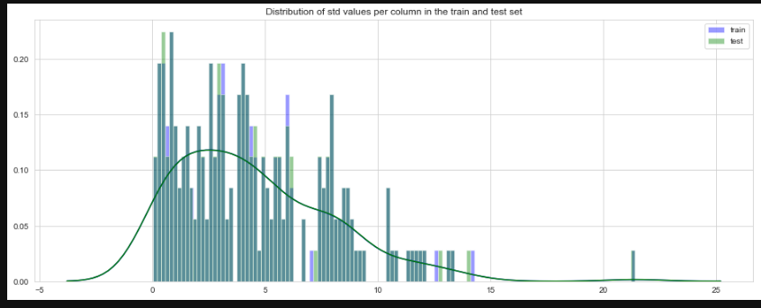

Distribution of the standard deviation of values per columns in the train and test datasets.

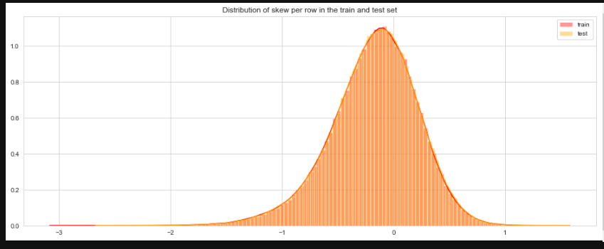

Distribution of skew per row in the train and test set.

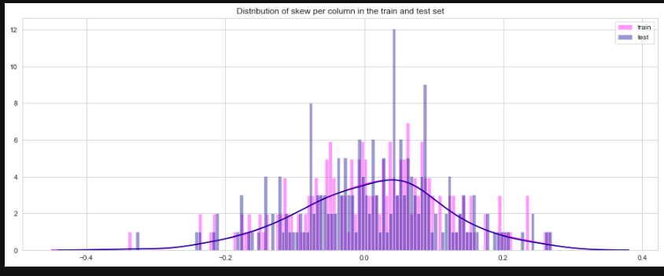

Distribution of skew per column in the train and test set.

**2.3 FEATURE SELECTION**

**CORRELATION:**

Before performing any type of modelling we need to assess the importance of each predictor variable in our analysis. There is a possibility that many variables in our analysis are not important at all to the problem of class prediction. This process of selecting a subset of relevant features/variables is known as feature selection. There are several methods of doing feature selection. I have used correlation analysis.

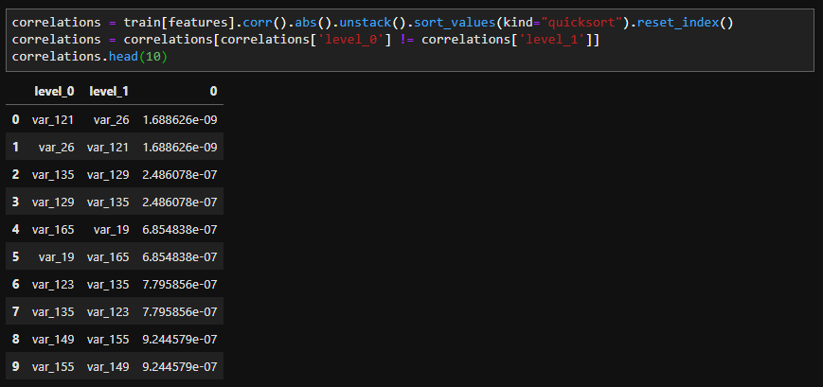

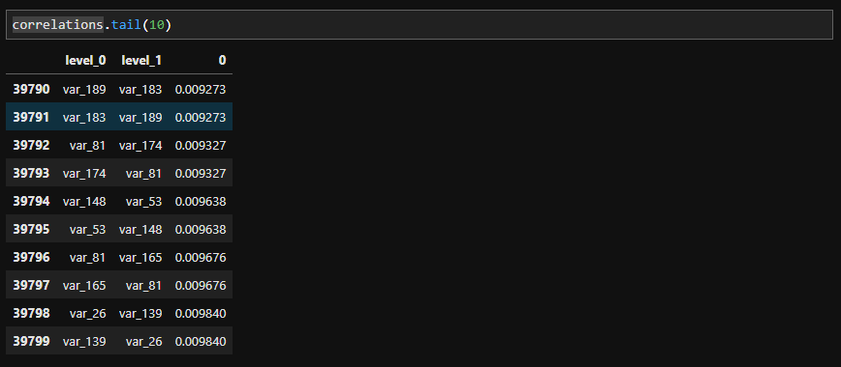

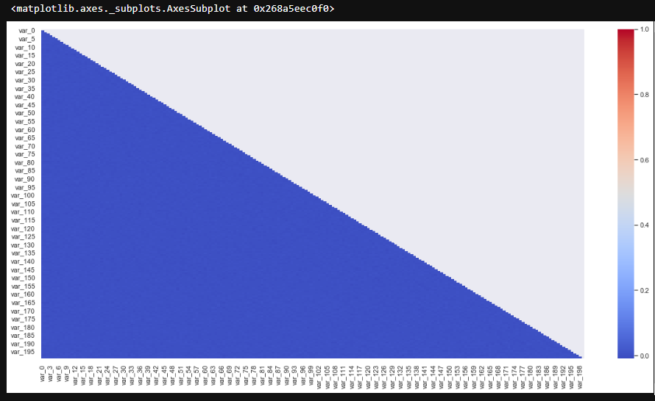

In our dataset, the correlation between the train attributes is very small. So, there is no need to remove variables.

**2.4 HANDLING IMBALANCED DATA**

Imbalanced classes are a common problem in machine learning classification where there is a disproportionate ratio of observations in each class. Class imbalance can be found in many different areas including medical diagnosis, spam filtering, and fraud detection. Some popular methods for dealing with class imbalance.

**1. Change the performance metric**

Accuracy is not the best metric to use when evaluating imbalanced datasets as it can be very misleading. Metrics that can provide better insight include:

* Confusion Matrix: a table showing correct predictions and types of incorrect predictions.
* Precision: the number of true positives divided by all positive predictions. Precision is also called Positive Predictive Value. It is a measure of a classifier’s exactness. Low precision indicates a high number of false positives.
* Recall: the number of true positives divided by the number of positive values in the test data. Recall is also called Sensitivity or the True Positive Rate. It is a measure of a classifier’s completeness. Low recall indicates a high number of false negatives.
* F1: Score: the weighted average of precision and recall.

**Change the algorithm**

While in every machine learning problem, it’s a good rule of thumb to try a variety of algorithms, it can be especially beneficial with imbalanced datasets. Decision trees, Random Forests and Naive Bayes frequently perform well on imbalanced data. They work by learning a hierarchy of if/else questions and this can force both classes to be addressed.

**2.5 Resampling Techniques**

**Oversample minority class**

Our next method begins our resampling techniques. Oversampling can be defined as adding more copies of the minority class. Oversampling can be a good choice when you don’t have a ton of data to work with.

We will use the resampling module from Scikit-Learn to randomly replicate samples from the minority class.

Always split into test and train sets BEFORE trying oversampling techniques! Oversampling before splitting the data can allow the exact same observations to be present in both the test and train sets. This can allow our model to simply memorize specific data points and cause overfitting and poor generalization to the test data.

After resampling we have an equal ratio of data points for each class

**Under sample majority class**

Under sampling can be defined as removing some observations of the majority class. Under sampling can be a good choice when you have a ton of data -think millions of rows. But a drawback is that we are removing information that may be valuable. This could lead to under fitting and poor generalization to the test set.

**Generate synthetic samples**

A technique similar to up sampling is to create synthetic samples.

SMOTE (Synthetic Minority Oversampling Technique) uses a nearest neighbours algorithm to generate new and synthetic data we can use for training our model.

Again, it’s important to generate the new samples only in the training set to ensure our model generalizes well to unseen data.

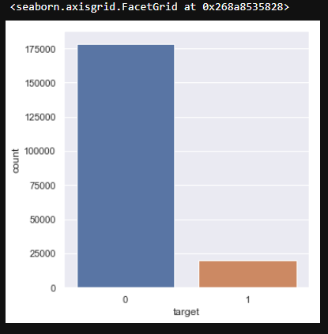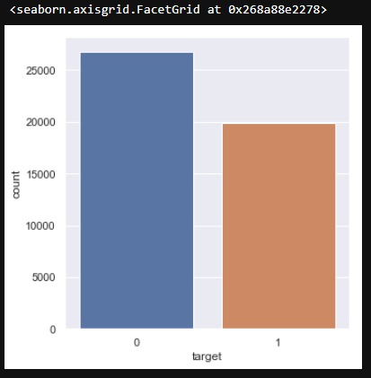

IN OUR CASE GIVEN DATA IS IMBALANCED……WHERE 90% OF SAMPLES BELONGS TO CLASS 0 AND ONLY 10% BELONGS TO CLASS 1.

After applying under sampling technique, we get the balanced data as shown above.

**Model Development**

This is the final phase of our project where we would build some machine learning models and will train our model on the data for future predictions. We would consider different machine learning algorithms to check which gives the best result.

**3.1 Confusion Matrix**

Confusion Matrix as the name suggests gives us a matrix as output and describes the complete performance of the model.

Let’s assume we have a binary classification problem. We have some samples belonging to two classes: YES, or NO. Also, we have our own classifier which predicts a class for a given input sample. On testing our model on 165 samples, we get the following result.



**Confusion Matrix**

There are 4 important terms:

* True Positives: The cases in which we predicted YES and the actual output was also YES.
* True Negatives: The cases in which we predicted NO and the actual output was NO.
* False Positives: The cases in which we predicted YES and the actual output was NO.
* False Negatives: The cases in which we predicted NO and the actual output was YES.

3.2 LOGISTIC REGRESSION:

Logistic regression is a classification algorithm used to assign observations to a discrete set of classes. Unlike linear regression which outputs continuous number values, logistic regression transforms its output using the logistic sigmoid function to return a probability value which can then be mapped to two or more discrete classes.

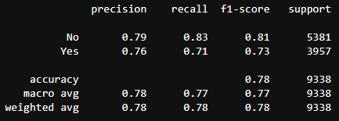

**3.3 RANDOM FOREST**

Random forests are based on a simple idea: 'the wisdom of the crowd'. Aggregate of the results of multiple predictors gives a better prediction than the best individual predictor. A group of predictors is called an ensemble. Thus, this technique is called Ensemble Learning.

To improve our technique, we can train a group of Decision Tree classifiers, each on a different random subset of the train set. To make a prediction, we just obtain the predictions of all individuals trees, then predict the class that gets the most votes. This technique is called Random Forest.

Random forest chooses a random subset of features and builds many Decision Trees. The model averages out all the predictions of the Decisions trees.

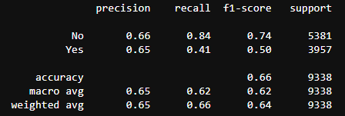

**3.4 Naive Bayes**

Naive Bayes is a Classification Algorithm. It is one of the most practical Machine Learning methods. It performs Probabilistic classification. It works on Bayes theorem of probability to predict the class of unknown data set. Bayes' theorem with strong (naive) independence assumptions between the features. Attribute values are conditionally independent given the target value. Bayes theorem provides a way of calculating posterior probability P(c|x) from P(c), P(x) and P(x|c). Look at the equation below:



P(c|x)is the posterior probability of class (target) given predictor (x,attributes).

P(c) is the prior probability of class.

P(x|c) is the likelihood which is the probability of predictor given class.

P(x) is the prior probability of predictor.

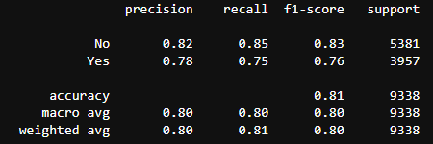

As per the project requirement we have to predict the results based Recall, Precision and Accuracy of all machine learning algorithm. “To get the most accurate model out of various models the value of Recall, Precision, AUC should be high”, out of all the above developed Machine Learning algorithms we can deduce that “Naïve Bayes” is giving all the quantities highest among all other algorithms. Hence “Naïve Bayes” is selected to predict target variable from our given Test Data.

**Model Deployment**

After performing the machine learning algorithm and tested it for test data we have fetch out from train dataset the most accurate method. Now we are ready to predict any external data given to us. Now in the external data named as test.csv is given to us contain all variables of train data except “target” variable. Our task is to predict the target value in form of 0 and 1 where using the most appropriate algorithm we have formed in previous section. As we have developed in our previous section that NAÏVE BAYES gives most accurate model so we will use NAÏVE BAYES to predict the target value.

Steps followed for predicting target variable in test data.

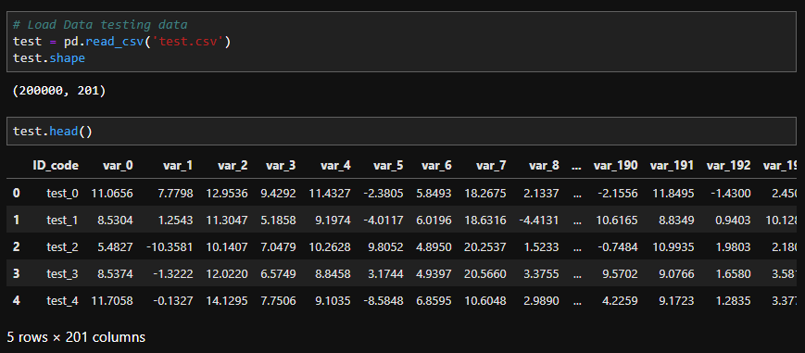

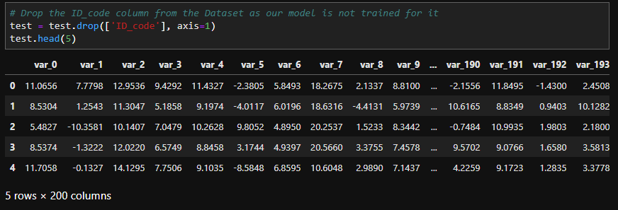

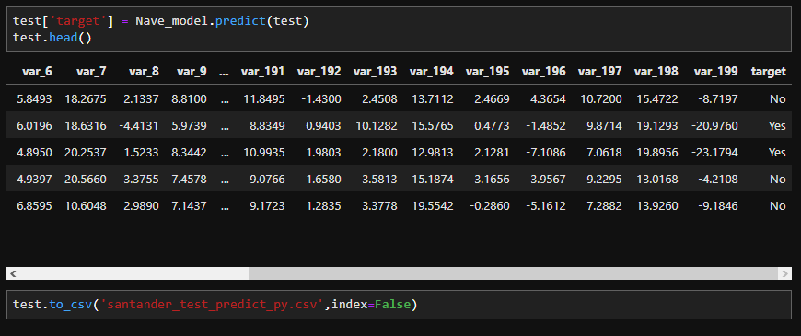

**Conclusion**

* Santander is interested in finding which customers will make a specific transaction in the future, irrespective of the amount of money transacted.
* Hence, it is interested in correctly identifying the customers with target label as 1, (i.e. customers who will make a specific transaction in the future)
* Since our dataset is an imbalance class dataset, where the proportion of positive samples is low **(around 10%)**, we should aim for **higher precision since it does not include True negatives in calculation, and hence it will not affected by class imbalance.**

LIST OF DLIVERIBLES

Instruction to run and deploy the code.

* Only the file location should be changed in os.chdir function according to the user file location.
* User can simply use shift + enter to get all command run.
* Files included are:

1. Project report in both word and pdf formats.
2. python code file - Santender_Project.ipynb, Santender_Project.py
3. r code file - santander_predict_test_R.R
4. Dataset with target variable in .csv format.

* santander_test_predict_py
* santander_test_predict_R

