1. **WAP to calculate sum of all numbers in an array**
2. **Describe any 2 features of ES6 with examples.**
3. **Given the array**

Persons= [

{name:'Tom',age:23},

{name:'Karen',age:12},

{name:'Jo',age:54},

{name:'Mark',age:30},

{name:'Ronny',age:63}]

Use the **forEach** loop to display below output base on ***logic***- person less than 30 is young and more than 30 or 30 is old

**Output:**

"Tom is young"

"Karen is young"

"Jo is old"

"Mark is old"

"Ronny is old"

1. **WAP to display below output**

**Output:**

Hello

(engine shall wait for 5 seconds and display below message)

Sorry, I am late.

1. **Explain with example**
2. In below code, carCost is declared twice, which value of carCost is taken for calculation and why?
3. What will happen to output if extraCost is declared as ***let***
4. What type of function is calculate?

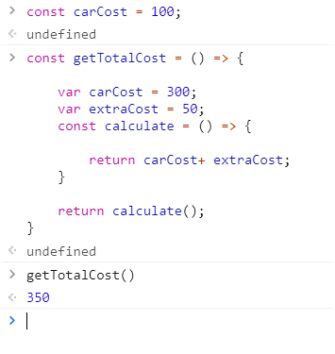

1. **Create object in javascript using new keyword and parameterized constructor**
2. **WAP which accepts fruit name and returns its price**
3. **Explain Self Invoking Functions with example**
4. **WAP  to check if a vowel is present in the string**
5. **Find GitHub API which gives all the user information based on github username.**

**Create below page and on button click, call the API USING ONLY AJAX**

**And once API is called, display how many people the mentioned user is following.**

