Final Year B.Tech. (CSE) – VII [2024-25]
6CS452: High Performance Computing Lab

Assignment No: 10

Analysis of MPI Programs

PRN: 21510042 Name: Omkar Rajesh Auti

Title: Analysis of MPI Programs

Problem Statement 1:

Execute the MPI program (Program A) with a fixed size broadcast. Plot the performance of the broadcast with varying numbers of processes (with constant message size). Explain the performance observed.

Code for Creation of Sample Files:

import numpy as np
import os

def create_matrix_file(filename, rows=512, cols=512):
# Create the directory if it doesn't exist
directory = os.path.dirname(filename)
if not os.path.exists(directory):
os.makedirs(directory)

# Generate a matrix of random floating-point numbers
matrix = np.random.rand(rows, cols)

# Write the matrix to the file
with open(filename, 'w') as f:
for row in matrix:
row_str = ' '.join(f'{val:.6f}' for val in row)
f.write(row_str + '\n')

# Create sample/in1 and sample/in2 files
create_matrix_file('sample/in1')
create_matrix_file('sample/in2')

print("Files sample/in1 and sample/in2 have been created if they did not exist.")

Corrected Code:

#include <assert.h>
#include <math.h>
#include <string.h>
#include <stdio.h>
#include <stdlib.h>
#include <mpi.h>

typedef struct
{
float r;
float i;
} complex;

static complex ctmp;

#define C_SWAP(a, b) \
{ \
ctmp = (a); \
(a) = (b); \
(b) = ctmp; \
}

#define N 512

void c_fft1d(complex *r, int n, int isign)
{
int m, i, i1, j, k, i2, l, l1, l2;
float c1, c2, z;
complex t, u;

if (isign == 0)
return;

/* Do the bit reversal */
i2 = n >> 1;
j = 0;
for (i = 0; i < n - 1; i++)
{
if (i < j)
C_SWAP(r[i], r[j]);
k = i2;
while (k <= j)
{
j -= k;
k >>= 1;
}
j += k;
}

/* m = (int) log2((double)n); */
for (i = n, m = 0; i > 1; m++, i /= 2)
;

/* Compute the FFT */
c1 = -1.0;
c2 = 0.0;
l2 = 1;
for (l = 0; l < m; l++)
{
l1 = l2;
l2 <<= 1;
u.r = 1.0;
u.i = 0.0;
for (j = 0; j < l1; j++)
{
for (i = j; i < n; i += l2)
{
i1 = i + l1;

/* t = u * r[i1] */
t.r = u.r * r[i1].r - u.i * r[i1].i;
t.i = u.r * r[i1].i + u.i * r[i1].r;

/* r[i1] = r[i] - t */
r[i1].r = r[i].r - t.r;
r[i1].i = r[i].i - t.i;

/* r[i] = r[i] + t */
r[i].r += t.r;
r[i].i += t.i;
}
z = u.r * c1 - u.i * c2;

u.i = u.r * c2 + u.i * c1;
u.r = z;
}
c2 = sqrt((1.0 - c1) / 2.0);
if (isign == -1) /* FWD FFT */
c2 = -c2;
c1 = sqrt((1.0 + c1) / 2.0);
}

/* Scaling for inverse transform */
if (isign == 1)
{ /* IFFT*/
for (i = 0; i < n; i++)
{
r[i].r /= n;
r[i].i /= n;
}
}
}

void getData(char fileName[15], complex **data)
{
FILE *fp = fopen(fileName, "r");

int i, j, result;

for (i = 0; i < N; i++)
{
for (j = 0; j < N; j++)
{
result = fscanf(fp, "%g", &data[i][j].r);
data[i][j].i = 0.00;
}
}

fclose(fp);
}

void transpose(complex **data, complex **transp)
{
int i, j;
for (i = 0; i < N; i++)
for (j = 0; j < N; j++)
transp[j][i] = data[i][j];
}

void mmpoint(complex **data1, complex **data2, complex **data3)
{

int i, j;

float real, imag;

for (i = 0; i < N; i++)
{
for (j = 0; j < N; j++)
{
data3[i][j].r = (data1[i][j].r * data2[i][j].r) - (data1[i][j].i * data2[i][j].i);
data3[i][j].i = (data1[i][j].r * data2[i][j].i) + (data1[i][j].i * data2[i][j].r);
}
}
}

void printfile(char fileName[15], complex **data)
{

FILE *fp = fopen(fileName, "w");

int i, j;

for (i = 0; i < N; i++)
{
for (j = 0; j < N; j++)
{
fprintf(fp, " %.7e", data[i][j].r);
}
fprintf(fp, "\n");
}

fclose(fp);
}

int main(int argc, char **argv)
{
int my_rank, p, source = 0, dest, x;

complex **data1, **data2, **data3, **data4;

data1 = malloc(N * sizeof(complex *));
data2 = malloc(N * sizeof(complex *));
data3 = malloc(N * sizeof(complex *));
data4 = malloc(N * sizeof(complex *));

for (x = 0; x < N; x++)
{
data1[x] = malloc(N * sizeof(complex));
data2[x] = malloc(N * sizeof(complex));
data3[x] = malloc(N * sizeof(complex));
data4[x] = malloc(N * sizeof(complex));
}

complex *vec;

char fileName1[15] = "sample/in1";
char fileName2[15] = "sample/in2";
char fileName3[15] = "mpi_out_test";

MPI_Status status;

MPI_Init(&argc, &argv);

MPI_Comm_rank(MPI_COMM_WORLD, &my_rank);

MPI_Comm_size(MPI_COMM_WORLD, &p);

/* Setup description of the 4 MPI_FLOAT fields x, y, z, velocity */
int blocklens[2] = {1, 1};

MPI_Aint indices[2] = {0, sizeof(float)};
MPI_Datatype old_types[2] = {MPI_FLOAT, MPI_FLOAT};

MPI_Datatype mystruct;

/* Make relative */
// MPI_Type_struct(2, blocklens, indices, old_types, &mystruct);
MPI_Type_create_struct(2, blocklens, indices, old_types, &mystruct);

MPI_Type_commit(&mystruct);

int i, j;

double startTime, stopTime;

// Starting and send rows of data1, data2

int offset;

int tag = 345;

int rows = N / p;

int lb = my_rank * rows;
int hb = lb + rows;

printf("%d have lb = %d and hb = %d\n", my_rank, lb, hb);

// Starting and send rows of data1, data2

if (my_rank == 0)
{
getData(fileName1, data1);
getData(fileName2, data2);

/* Start Clock */
printf("\nStarting clock.\n");
startTime = MPI_Wtime();

for (i = 1; i < p; i++)
{
offset = i * rows;
for (j = offset; j < (offset + rows); j++)
{
MPI_Send(&data1[j][0], N, mystruct, i, tag, MPI_COMM_WORLD);
MPI_Send(&data2[j][0], N, mystruct, i, tag, MPI_COMM_WORLD);
}
}
}
else
{

for (j = lb; j < hb; j++)
{
MPI_Recv(data1[j], N, mystruct, 0, tag, MPI_COMM_WORLD, &status);
MPI_Recv(data2[j], N, mystruct, 0, tag, MPI_COMM_WORLD, &status);
}
}

// Doing fft1d forward for data1 and data2 rows

vec = (complex *)malloc(N * sizeof(complex));

for (i = lb; i < hb; i++)
{
for (j = 0; j < N; j++)
{
vec[j] = data1[i][j];
}
c_fft1d(vec, N, -1);
for (j = 0; j < N; j++)
{
data1[i][j] = vec[j];
}
}

free(vec);

vec = (complex *)malloc(N * sizeof(complex));

for (i = lb; i < hb; i++)
{
for (j = 0; j < N; j++)
{
vec[j] = data2[i][j];
}
c_fft1d(vec, N, -1);
for (j = 0; j < N; j++)
{
data2[i][j] = vec[j];
}
}

free(vec);

// Receving rows of data1, data2

if (my_rank == 0)
{
for (i = 1; i < p; i++)
{
offset = i * rows;
for (j = offset; j < (offset + rows); j++)
{
MPI_Recv(data1[j], N, mystruct, i, tag, MPI_COMM_WORLD, &status);
MPI_Recv(data2[j], N, mystruct, i, tag, MPI_COMM_WORLD, &status);
}
}
}
else
{

for (j = lb; j < hb; j++)
{
MPI_Send(&data1[j][0], N, mystruct, 0, tag, MPI_COMM_WORLD);
MPI_Send(&data2[j][0], N, mystruct, 0, tag, MPI_COMM_WORLD);
}
}

// Starting and send columns of data1, data2

if (my_rank == 0)
{
transpose(data1, data3);
transpose(data2, data4);

for (i = 1; i < p; i++)
{
offset = i * rows;
for (j = offset; j < (offset + rows); j++)
{
MPI_Send(&data3[j][0], N, mystruct, i, tag, MPI_COMM_WORLD);
MPI_Send(&data4[j][0], N, mystruct, i, tag, MPI_COMM_WORLD);
}
}
}
else
{
for (j = lb; j < hb; j++)
{
MPI_Recv(data3[j], N, mystruct, 0, tag, MPI_COMM_WORLD, &status);
MPI_Recv(data4[j], N, mystruct, 0, tag, MPI_COMM_WORLD, &status);
}
}

// Doing fft1d forward for data1 and data2 columns

vec = (complex *)malloc(N * sizeof(complex));

for (i = lb; i < hb; i++)
{
for (j = 0; j < N; j++)
{
vec[j] = data3[i][j];
}
c_fft1d(vec, N, -1);
for (j = 0; j < N; j++)
{
data3[i][j] = vec[j];
}
}

free(vec);

vec = (complex *)malloc(N * sizeof(complex));

for (i = lb; i < hb; i++)
{
for (j = 0; j < N; j++)
{
vec[j] = data4[i][j];
}
c_fft1d(vec, N, -1);
for (j = 0; j < N; j++)
{
data4[i][j] = vec[j];
}
}

free(vec);

// Receving columns of data1, data2

if (my_rank == 0)
{
for (i = 1; i < p; i++)
{
offset = i * rows;
for (j = offset; j < (offset + rows); j++)
{
MPI_Recv(data3[j], N, mystruct, i, tag, MPI_COMM_WORLD, &status);
MPI_Recv(data4[j], N, mystruct, i, tag, MPI_COMM_WORLD, &status);
}
}
}
else
{
for (j = lb; j < hb; j++)
{
MPI_Send(&data3[j][0], N, mystruct, 0, tag, MPI_COMM_WORLD);
MPI_Send(&data4[j][0], N, mystruct, 0, tag, MPI_COMM_WORLD);
}
}

if (my_rank == 0)
{
transpose(data3, data1);
transpose(data4, data2);
mmpoint(data1, data2, data3);
}

// Starting and send rows of data1, data2

if (my_rank == 0)
{
for (i = 1; i < p; i++)
{
offset = i * rows;
for (j = offset; j < (offset + rows); j++)
{
MPI_Send(&data3[j][0], N, mystruct, i, tag, MPI_COMM_WORLD);
}
}
}
else
{

for (j = lb; j < hb; j++)
{
MPI_Recv(data3[j], N, mystruct, 0, tag, MPI_COMM_WORLD, &status);
}
}

// Doing fft1d forward for data1 and data2 rows

vec = (complex *)malloc(N * sizeof(complex));

for (i = lb; i < hb; i++)
{
for (j = 0; j < N; j++)
{
vec[j] = data3[i][j];
}
c_fft1d(vec, N, 1);
for (j = 0; j < N; j++)
{
data3[i][j] = vec[j];
}
}

free(vec);

// Receving rows of data1, data2

if (my_rank == 0)
{
for (i = 1; i < p; i++)
{
offset = i * rows;
for (j = offset; j < (offset + rows); j++)
{
MPI_Recv(data3[j], N, mystruct, i, tag, MPI_COMM_WORLD, &status);
}
}
}
else
{
for (j = lb; j < hb; j++)
{
MPI_Send(&data3[j][0], N, mystruct, 0, tag, MPI_COMM_WORLD);
}
}

// Starting and send columns of data1, data2

if (my_rank == 0)
{
transpose(data3, data4);

for (i = 1; i < p; i++)
{
offset = i * rows;
for (j = offset; j < (offset + rows); j++)
{
MPI_Send(&data4[j][0], N, mystruct, i, tag, MPI_COMM_WORLD);
}
}
}
else
{
for (j = lb; j < hb; j++)
{
MPI_Recv(data4[j], N, mystruct, 0, tag, MPI_COMM_WORLD, &status);
}
}

// Doing fft1d forward for data1 and data2 columns

vec = (complex *)malloc(N * sizeof(complex));

for (i = lb; i < hb; i++)
{
for (j = 0; j < N; j++)
{
vec[j] = data4[i][j];
}
c_fft1d(vec, N, 1);
for (j = 0; j < N; j++)
{
data4[i][j] = vec[j];
}
}

free(vec);

// Receving columns of data1, data2

if (my_rank == 0)
{
for (i = 1; i < p; i++)
{
offset = i * rows;
for (j = offset; j < (offset + rows); j++)
{
MPI_Recv(data4[j], N, mystruct, i, tag, MPI_COMM_WORLD, &status);
}
}
}
else
{
for (j = lb; j < hb; j++)
{
MPI_Send(&data4[j][0], N, mystruct, 0, tag, MPI_COMM_WORLD);
}
}

if (my_rank == 0)
{
transpose(data4, data3);
/* Stop Clock */
stopTime = MPI_Wtime();

printf("\nElapsed time = %lf s.\n", (stopTime - startTime));
printf("--------------------------------------------\n");
}

MPI_Finalize();

if (my_rank == 0)
{
printfile(fileName3, data3);
}

free(data1);
free(data2);
free(data3);
free(data4);

return 0;
}

Output:

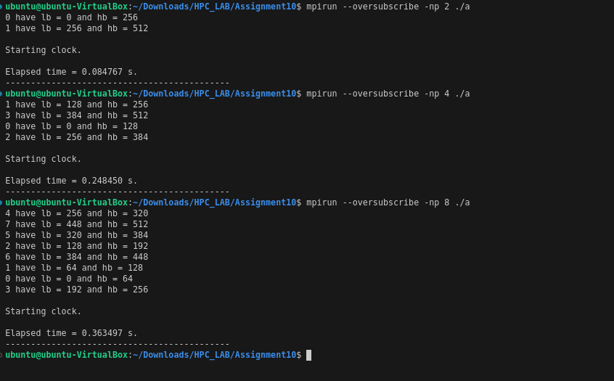

Analysis:

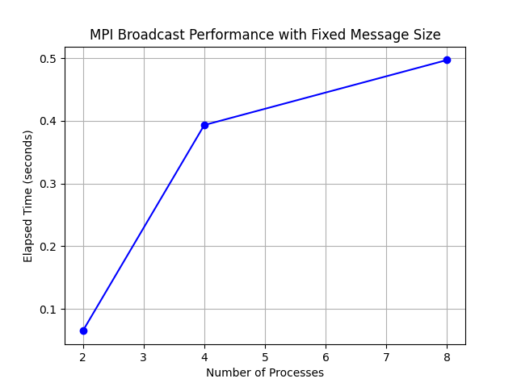

Problem Statement 2:

Repeat problem 2 above with varying message sizes for reduction (Program B). Explain the observed performance of the reduction operation.

Code:

#include <stdio.h>
#include <stdlib.h>
#include <time.h>
#include <mpi.h>

int main(int argc, char *argv[])
{
if (argc != 2)
{
printf("Usage : reduce message_size\n");
return 1;
}

int rank;
int size = atoi(argv[1]);

char input_buffer[size];
char output_buffer[size];

MPI_Init(&argc, &argv);

MPI_Comm_rank(MPI_COMM_WORLD, &rank);

int i;
srand(time(NULL));

for (i = 0; i < size; i++)
input_buffer[i] = rand() % 256;

double total_time = 0.0;
double start_time = 0.0;

for (i = 0; i < 100; i++)
{
MPI_Barrier(MPI_COMM_WORLD);
start_time = MPI_Wtime();

MPI_Reduce(input_buffer, output_buffer, size, MPI_BYTE, MPI_BOR, 0, MPI_COMM_WORLD);

MPI_Barrier(MPI_COMM_WORLD);
total_time += (MPI_Wtime() - start_time);
}

if (rank == 0)
{
printf("Average time for reduce : %f secs\n", total_time / 100);
}

MPI_Finalize();
return 0;
}

Output:

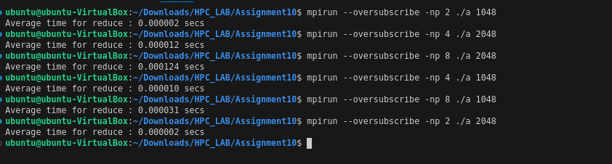

Analysis:

