Course: High Performance Computing Lab

Practical No 1
PRN: 21510042
Name:Omkar Rajesh Auti
Batch:CSE

Title: Introduction to OpenMP

Problem Statement 1 – Demonstrate Installation and Running of OpenMP code in C
Recommended Linux based System:
Following steps are for windows:
OpenMP – Open Multi-Processing is an API that supports multi-platform shared-memory multiprocessing programming in C, C++ and Fortran on multiple OS. OpenMP uses a portable, scalable model that gives programmers a simple and flexible interface for developing parallel applications for platforms ranging from the standard desktop computer to the supercomputer.

To set up OpenMP,
We need to first install C, C++ compiler if not already done. This is possible through the MinGW Installer.
Reference: Article on GCC and G++ installer (Link)
Note: Also install `mingw32-pthreads-w32` package.

Then, to run a program in OpenMP, we have to pass a flag `-fopenmp`.
Example:
To run a basic Hello World,
#include <stdio.h>
#include <omp.h>

int main(void)
{
#pragma omp parallel
printf("Hello, world.\n");
return 0;
}

gcc -fopenmp test.c -o hello
.\hello.exe
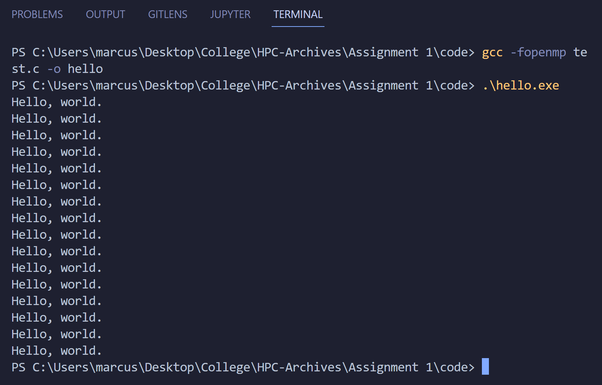

Problem Statement 2 – Print ‘Hello, World’ in Sequential and Parallel in OpenMP
We first ask the user for number of threads – OpenMP allows to set the threads at runtime. Then, we print the Hello, World in sequential – number of times of threads count and then run the code in parallel in each thread.

Code snapshot:
#include <iostream>
#include <omp.h>
#include <chrono>

int main() {
const int numIterations = 1000;

// Sequential execution
auto start_time = std::chrono::high_resolution_clock::now();
for (int i = 0; i < numIterations; ++i) {
// Print "Hello, World" for each iteration (can be commented out for performance measurement)
}
auto end_time = std::chrono::high_resolution_clock::now();
std::chrono::duration<double, std::milli> sequential_duration = end_time - start_time;
std::cout << "Sequential Time taken: " << sequential_duration.count() << " milliseconds" << std::endl;

// Parallel execution
start_time = std::chrono::high_resolution_clock::now();

#pragma omp parallel
{
#pragma omp for
for (int i = 0; i < numIterations; ++i) {
// Print "Hello, World" for each iteration (can be commented out for performance measurement)
}
}

end_time = std::chrono::high_resolution_clock::now();
std::chrono::duration<double, std::milli> parallel_duration = end_time - start_time;
std::cout << "Parallel Time taken: " << parallel_duration.count() << " milliseconds" << std::endl;

return 0;
}

Output snapshot:
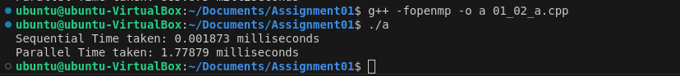
Analysis:

Parallel Time > Sequential Time
( For smaller size of iterations )

GitHub Link: make a public repository upload code of an assignment and paste its link here.

https://github.com/omkarauti11/HPC_LAB

Problem statement 3: Calculate theoretical FLOPS of your system on which you are running the above codes.

theoreticalFLOPS = clockSpeedHz * numCores * operationsPerCycle;

Code :

#include <iostream>
#include <cmath>
#include <chrono>

int main() {
// Define the number of floating-point operations
long long numOperations = 1e8; // 100 million operations

// Sequential execution
auto start = std::chrono::high_resolution_clock::now();

double result = 0.0;
for (long long i = 0; i < numOperations; ++i) {
result += std::sin(i * 0.1); // Example floating-point operation
}

auto end = std::chrono::high_resolution_clock::now();
std::chrono::duration<double, std::milli> elapsed = end - start;
double sequential_time_ms = elapsed.count();
double sequential_time_s = sequential_time_ms / 1000.0; // Convert milliseconds to seconds
double sequential_flops = numOperations / sequential_time_s; // FLOPS = operations / time (in seconds)
double sequential_gflops = sequential_flops / 1e9; // Convert to GFLOPS

std::cout << "Sequential Execution:" << std::endl;
std::cout << "Elapsed Time: " << sequential_time_ms << " milliseconds" << std::endl;
std::cout << "Estimated FLOPS: " << sequential_flops << " FLOPS" << std::endl;
std::cout << "Estimated GFLOPS: " << sequential_gflops << " GFLOPS" << std::endl;

return 0;
}

Output:
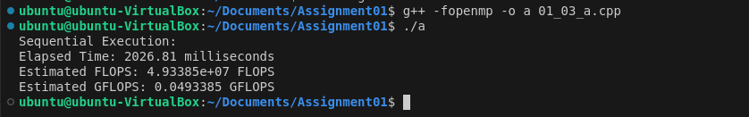

Elaborate the parameters and show calculation.

Example for a GPU:
- Clock Speed: 1.5 GHz (1.5 × 10^9 Hz)
- Number of Cores: 256
- Floating-Point Operations per Clock Cycle: 2
Theoretical FLOPS (GPU) = 1.5 × 10^9 Hz × 256 Cores × 2 FLOP/Cycle = 768 × 10^9 FLOPS = 768 GFLOPS

