Docker: To install docker, install docker desktop first
- To check docker version use this command
docker –version

- If java 21 is not there, update project structure to use java 21 library and download java 21 by using this command :
docker pull eclipse-temurin:21

- To build/create a docker image this command used :

docker build -t realtime-app .

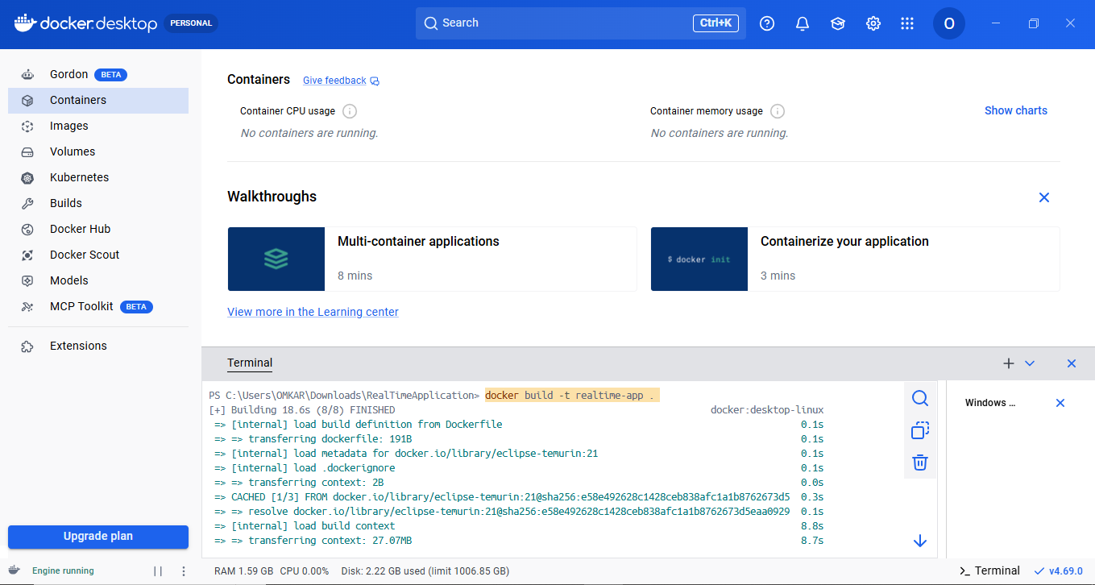

- Use the below command to run the created image specifying port, image name etc.
docker run -p 8080:8080 realtime-app

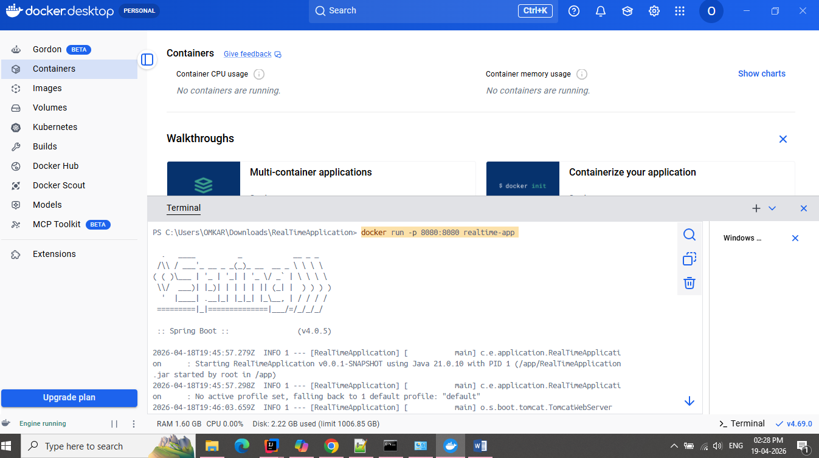

Kubernetes (k8s): (ref – 1. https://www.youtube.com/watch?v=05MNwC4XJBs
2.https://www.youtube.com/watch?v=xhxmExC9N1U&list=PLVz2XdJiJQxybsyOxK7WFtteH42ayn5i9&index=5 )
minikube delete === If misconfigured minikube is there remove it with command

minikube version === To check version of successfully installed minikube

minikube start --driver=docker === To start minikube with docker drivers

minikube status === To check what is status of minikube
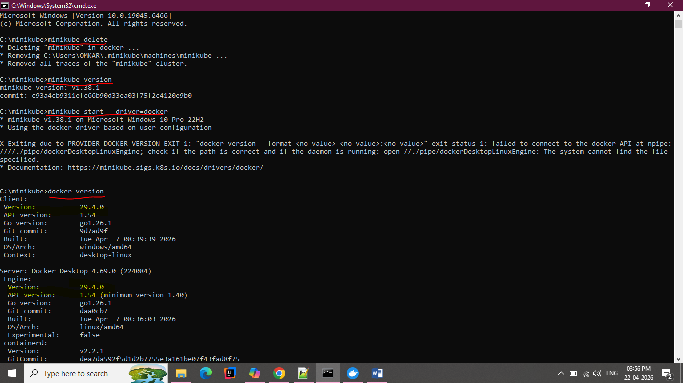
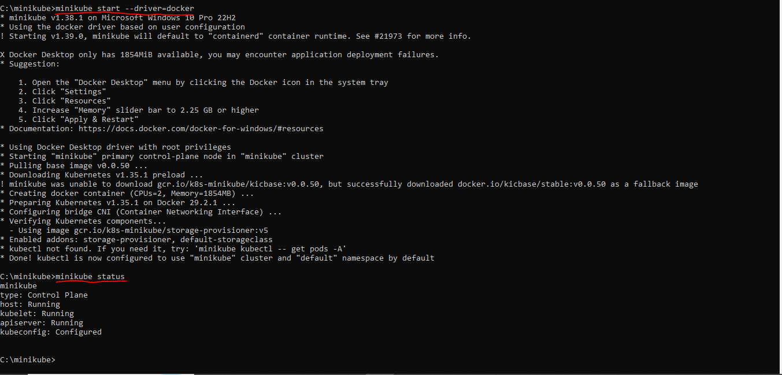
- To interact with your cluster
kubectl get po -A

- To Create a sample deployment and expose it on port 8080:

kubectl apply -f k8s/deployment.yaml
kubectl apply -f k8s/service.yaml

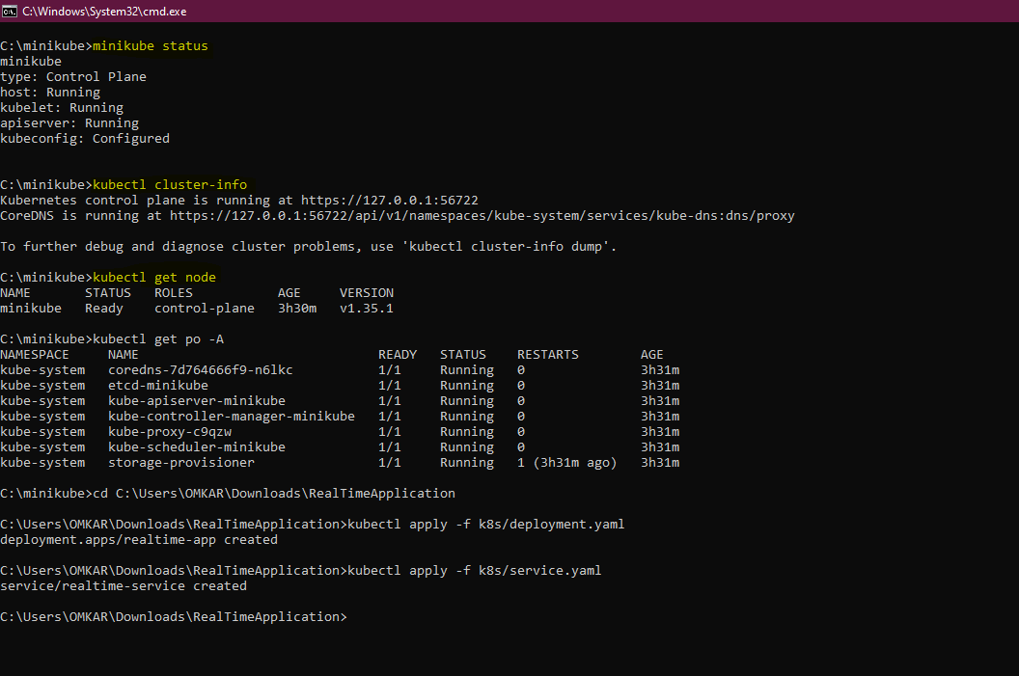

- Manage your cluster
- Pause Kubernetes without impacting deployed applications:
minikube pause

- Unpause a paused instance:
minikube unpause

- Halt the cluster:
minikube stop

- Change the default memory limit (requires a restart):
minikube config set memory 9001

- Browse the catalog of easily installed Kubernetes services:
minikube addons list

- Create a second cluster running an older Kubernetes release:
minikube start -p aged --kubernetes-version=v1.34.0

- Delete all of the minikube clusters:
minikube delete --all

- If you make any code change and want to redeploy use below steps ===>>>>

🔧 Step-by-step redeployment workflow

create jar - maven clean install
minikube start --driver=docker
minikube status
& minikube -p minikube docker-env | Invoke-Expression
docker build -t realtime-app:latest .
docker pull eclipse-temurin:21 (if needed then only)
docker images
kubectl delete pod -l app=realtime-app
kubectl apply -f k8s/deployment.yaml
kubectl apply -f k8s/service.yaml
kubectl get pods
kubectl get endpoints realtime-service
kubectl port-forward svc/realtime-service 8080:8080 (to register this port)
minikube service realtime-service

