Academic Project Report
End-to-End SSH Brute-force Attack Simulation, Detection & Prevention using Splunk & Suricata
Submitted by: Babar Omkar Sukhdev
Modern College, Nanded
Project Type: Academic / SOC Lab Project

Objective
The objective of this project is to simulate a realistic SSH credential brute-force attack using Hydra, ingest Linux authentication logs and Suricata IDS metadata into Splunk, build detection and correlation searches, configure alerts, visualize attacker activity, and apply firewall-based prevention. This project replicates an end-to-end SOC workflow.

Lab Setup
Environment Topology:
• SIEM Server: Ubuntu 22.04 with Splunk Enterprise
- Index: auth (Linux auth logs)
• DMZ/Target Server: Ubuntu 22.04 running ssh
• Attacker Machine: Kali Linux with Hydra & Metasploit (optional)
• Network: VirtualBox/VMware NAT or internal LAN
Log Forwarding Requirements:
• /var/log/auth.log → Splunk index=auth

Preparation on Target Server
Verify SSH service is running:
sudo systemctl status ssh
Monitor authentication logs:
sudo tail -f /var/log/auth.log
Enable password authentication (for lab testing only):
sudo nano /etc/ssh/sshd_config
PasswordAuthentication yes
sudo systemctl restart ssh

Attack Simulation from Kali (Hydra)
Create password list:
cat > /tmp/passlist.txt <<'EOF'
password
123456
admin123
welcome
P@ssw0rd
letmein
qwerty
one1

Run Hydra brute-force attack:
hydra –l two2 -P password.txt -f ssh://<TARGET_IP>
Flags Explained:
• -f → stop when password is found
• -l → username

Detection & Investigation in Splunk
Validate log ingestion:
index=auth | stats count
Search for failed SSH logins:
index=auth "Failed password" | stats count by src_ip, user | sort - count
Detect brute-force attempts (>5 failures in 10 min):
index=auth "Failed password"
| bin _time span=10m
| stats count by src_ip, _time
| where count > 5
Detect password spray (many usernames, low attempts):
index=auth "Failed password"
| stats dc(user) as unique_users, count as total_fails by src_ip
| where unique_users > 5 AND total_fails < 20

Alerting (Splunk SavedSearch)
Sample alert for brute-force detection:
[SSH Brute Force - >5 Fails in 10m]
source="auth.log" host="ubuntu" index="main" sourcetype="auth" rhost="192.168.179.160"
action.email = 1
action.email.to = your@email

Firewall Blocking & Prevention
Block attacker IP via UFW:
sudo ufw insert 1 deny from <src_ip> to any port 22 proto tcp
Block via iptables:
sudo iptables -I INPUT -s <src_ip> -p tcp --dport 22 -j DROP
Verify rule:
sudo ufw status numbered
Retest SSH from attacker → connection should fail immediately.

Screenshots
- Hydra brute-force attack execution.
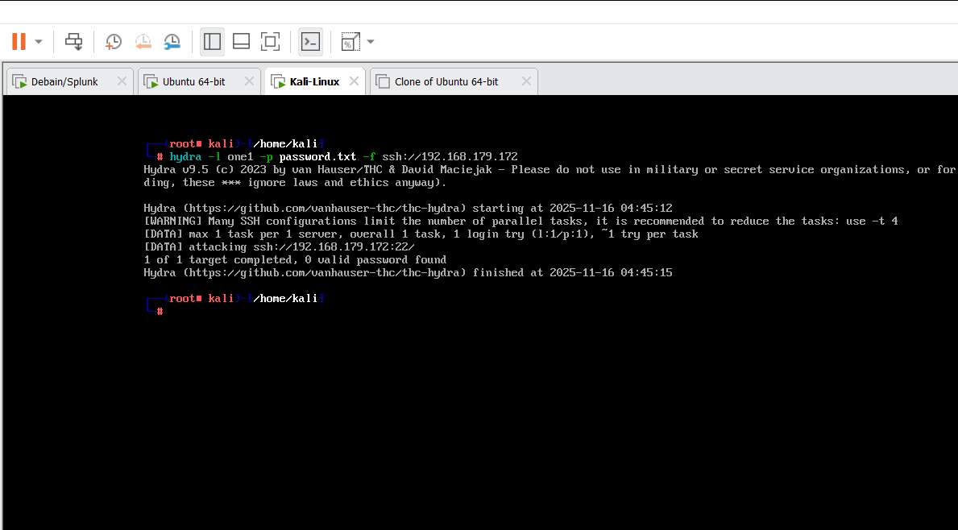

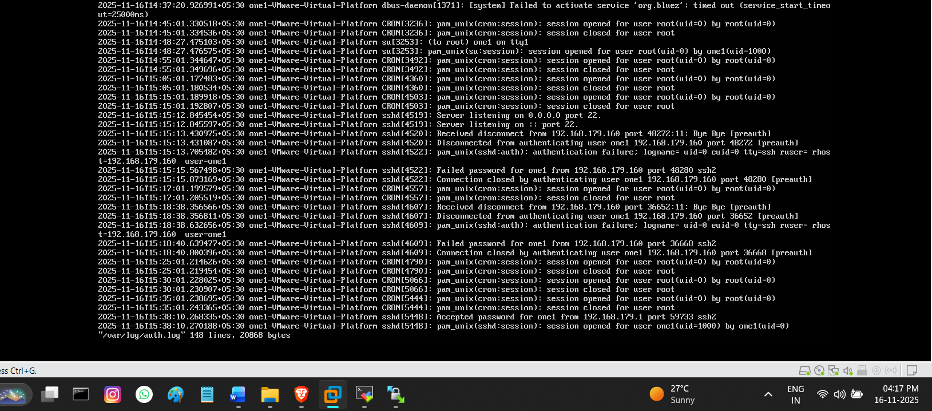
- auth.log showing failed password entries.

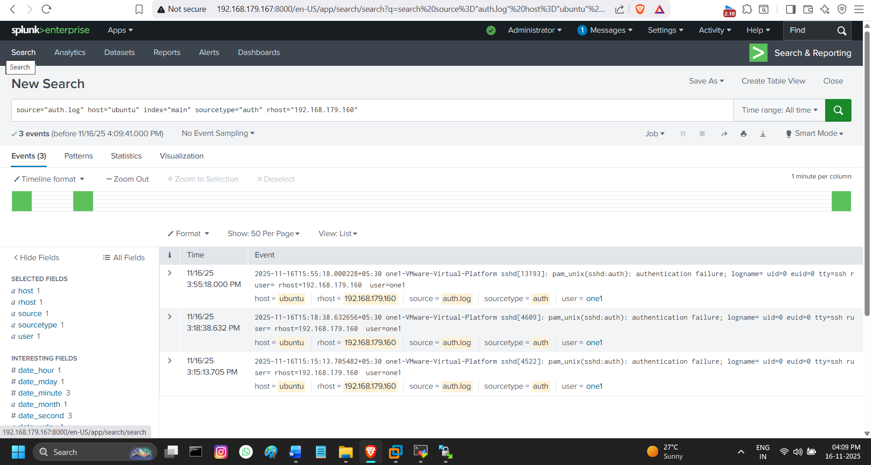
3. Failed login SPL results.

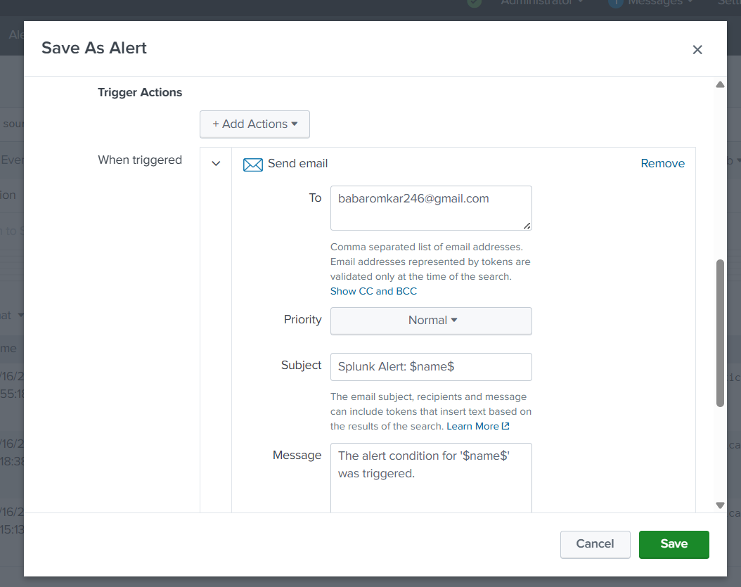
4. Correlation search output.
.
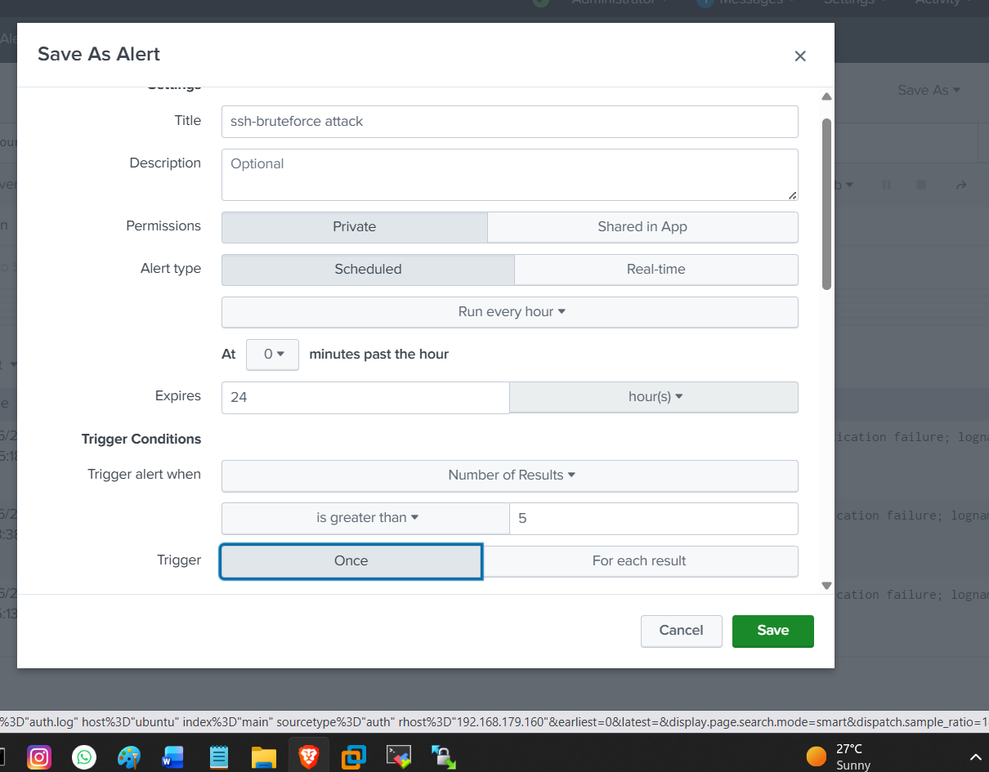
5. Splunk alert configuration

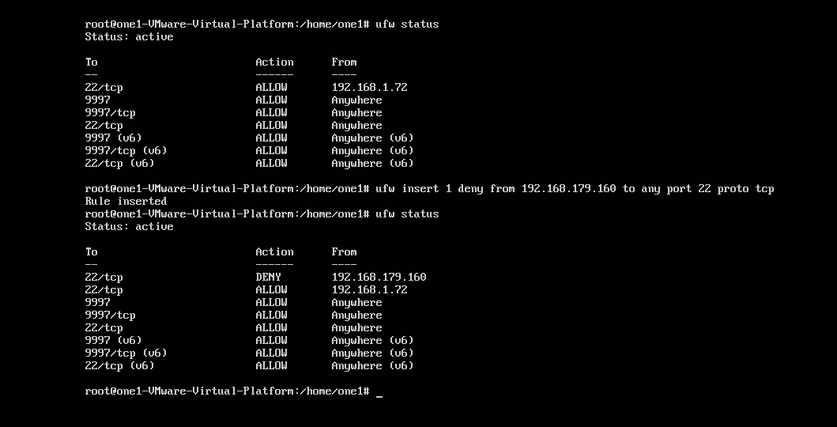
6. Firewall rule insertion.

Safety & Ethics
All attack simulations must be performed in isolated environments. Never run brute-force tools on unauthorized networks or systems.

Conclusion
This project successfully demonstrates an end-to-end SOC workflow including attack generation, log ingestion, detection engineering, alerting, and active response using firewall rules. It provides strong practical skills required for SOC Analyst, Detection Engineer, and Threat Hunter roles.

