Academic Project Report

Memory Forensics Investigation using Volatility & FTK Imager
Submitted by: Babar Omkar Sukhdev
Modern College, Nanded
Project Type: Academic Project

Objective
Understand how to acquire, analyze, and interpret volatile memory data to detect evidence of compromise, malicious code, and system activities that may not appear on disk.

Summary
This project demonstrates memory acquisition using FTK Imager and analysis using Volatility 3. It includes acquisition steps, integrity verification, and memory analysis outputs (processes, command-lines, network connections, and injection scans).

Tools Used
- FTK Imager (memory acquisition)
- Volatility 3 (memory analysis)
- certutil / sha256sum (hash verification)
- VirtualBox / VMware (lab)
- Kali Linux (analysis host)

Step-by-step Implementation (with screenshot placeholders)

Step 1 - Memory Capture (FTK Imager)
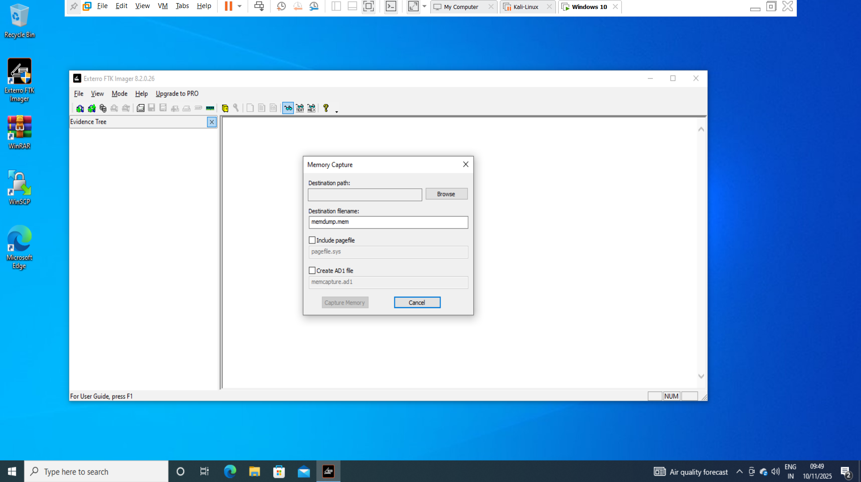
Run FTK Imager as Administrator and capture RAM: File -> Capture Memory. Save the .mem file and note the full path.

Step 2 - Hash Verification (Windows)
Run certutil to generate SHA256 hash and save it to a text file for chain-of-custody evidence.
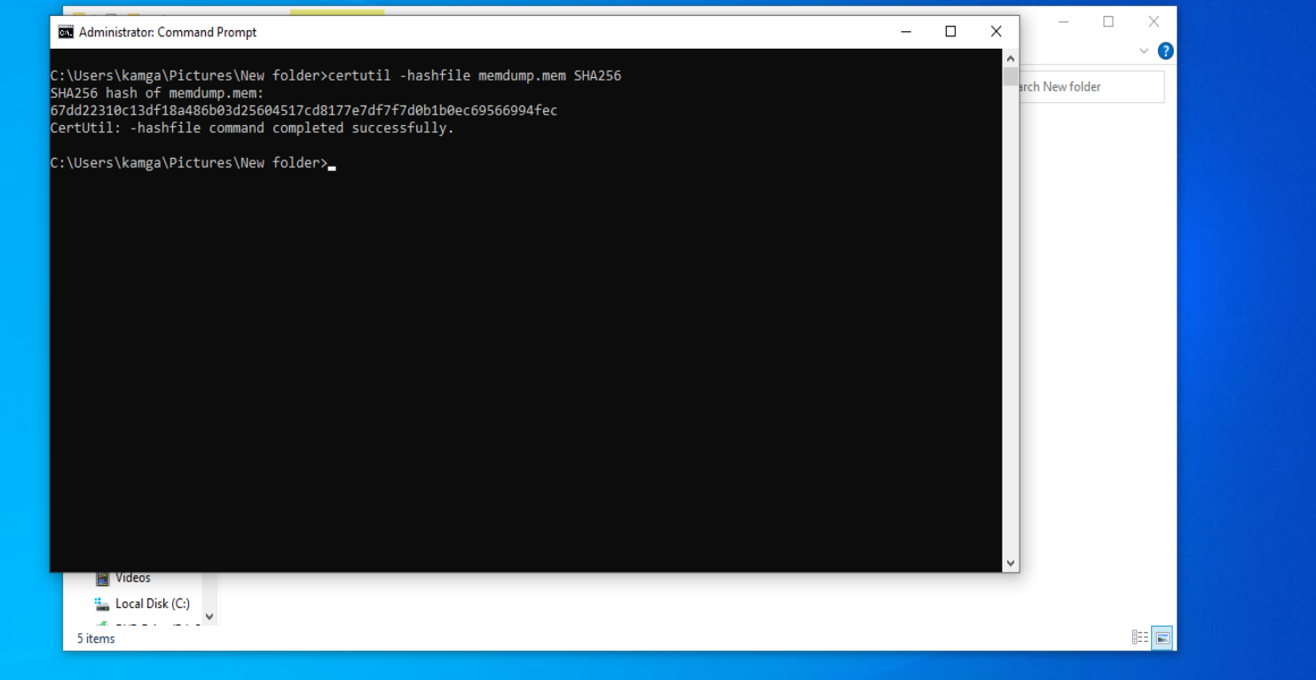

Step 3 - Transfer to Analysis Machine
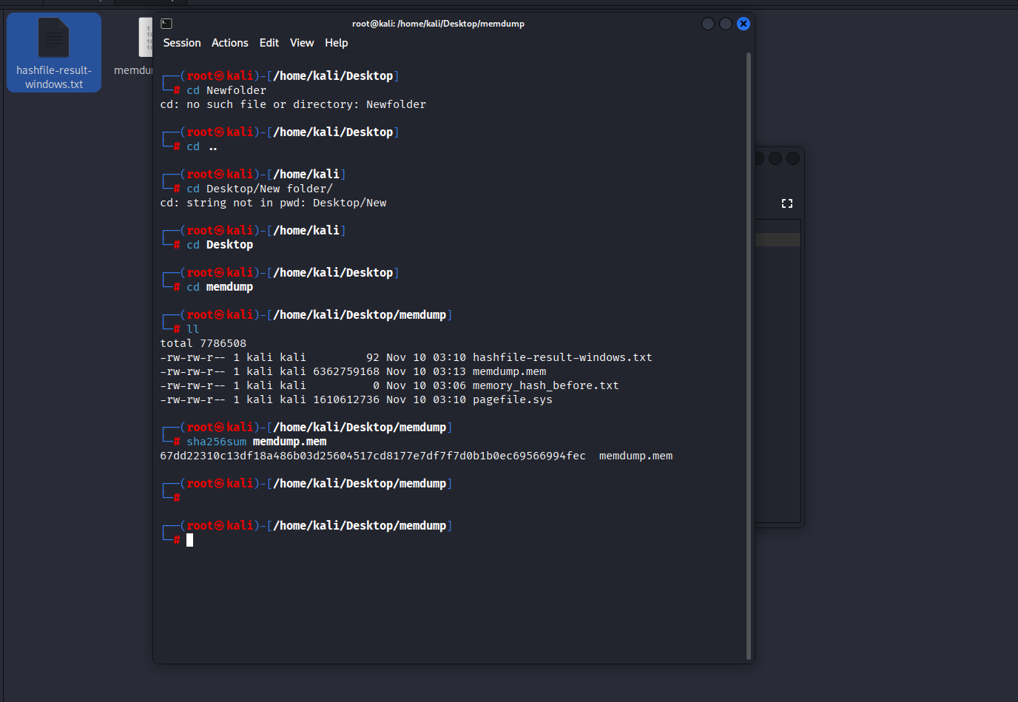
Copy the .mem file to your analysis host . Then re-compute SHA256 on Linux to confirm integrity.

Step 4 - Volatility Setup
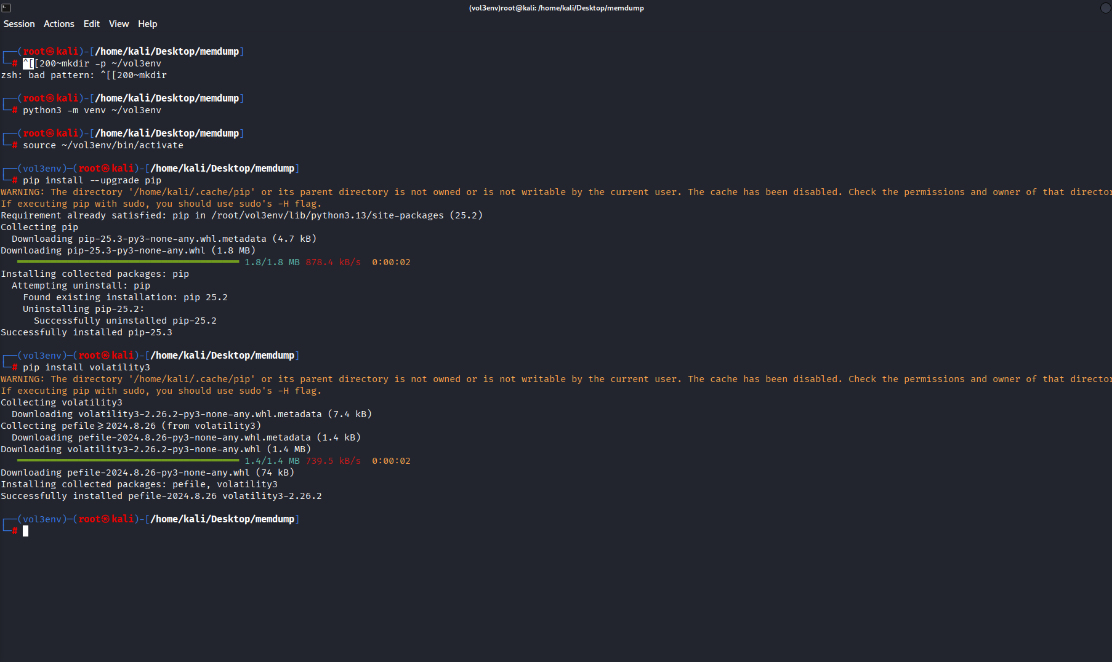
Install volatility3 in a Python venv and confirm installation with the help text.

Step 5 - System Info
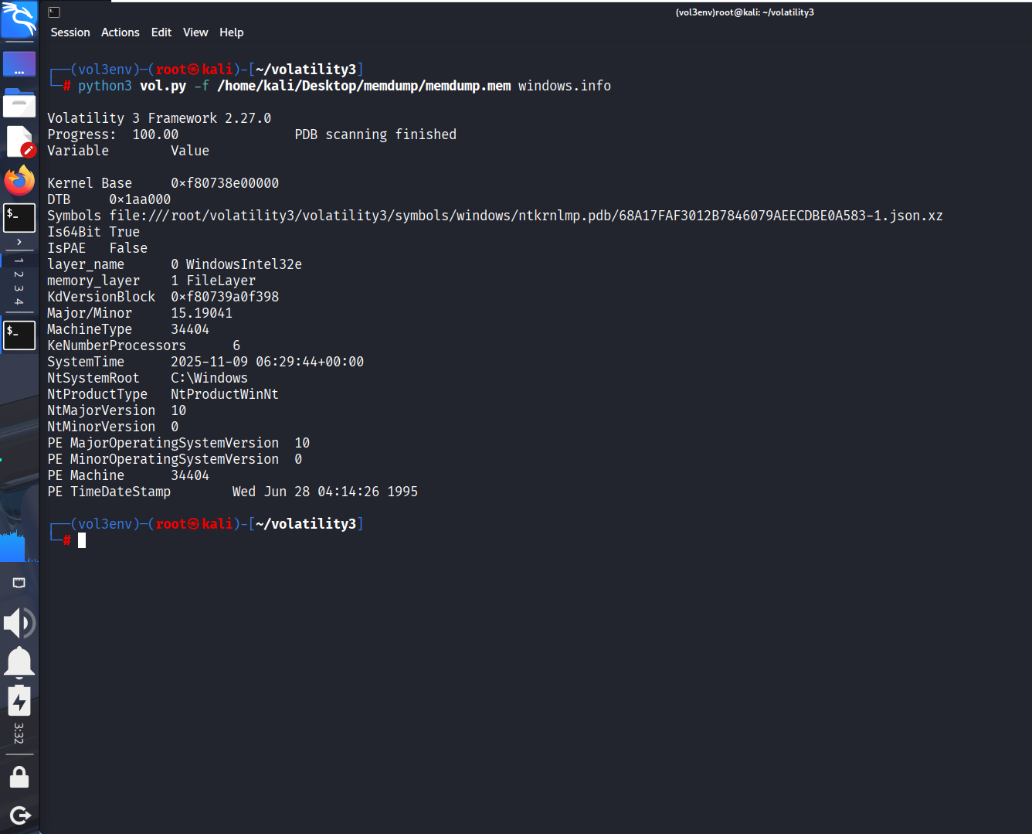
Run windows.info to validate the memory dump and capture OS metadata.

Step 6 - Processes & Command-lines
Run windows.pstree and windows.cmdline to list running processes and their command-line arguments.
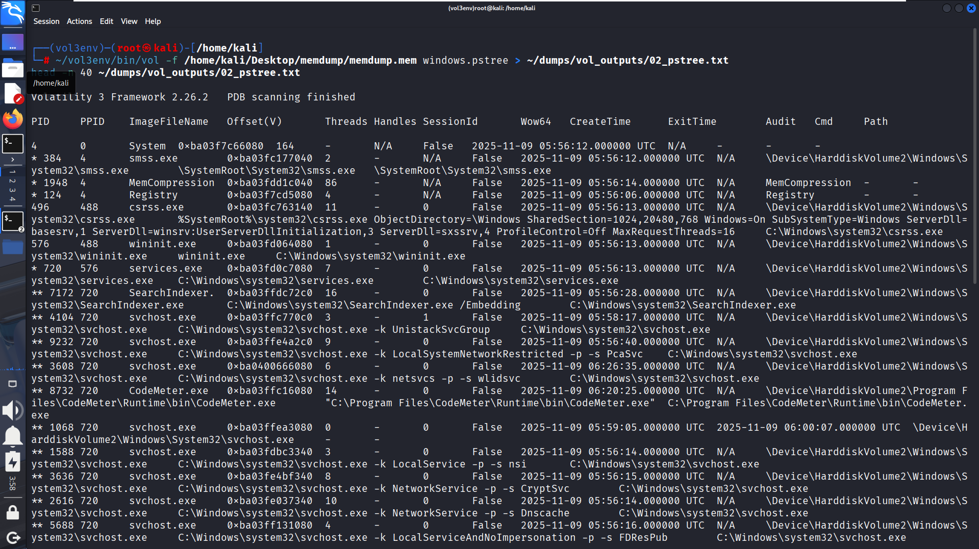

Step 7 - Network Connections
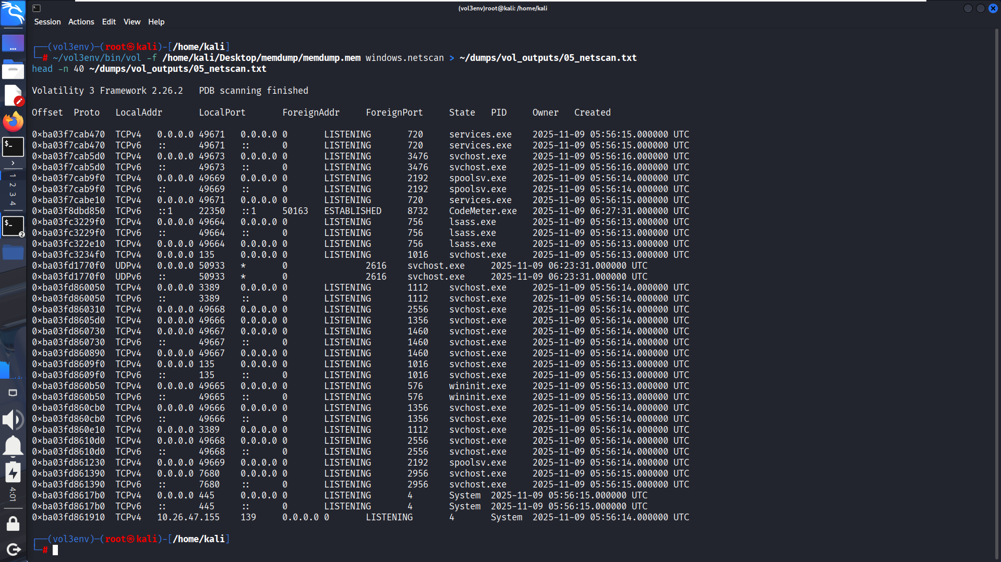
Run windows.netscan to list active network sockets and the owning PIDs/process names.

Step 8 - Injection Scan
Run windows.malfind to detect suspicious RWX memory regions or injected code.
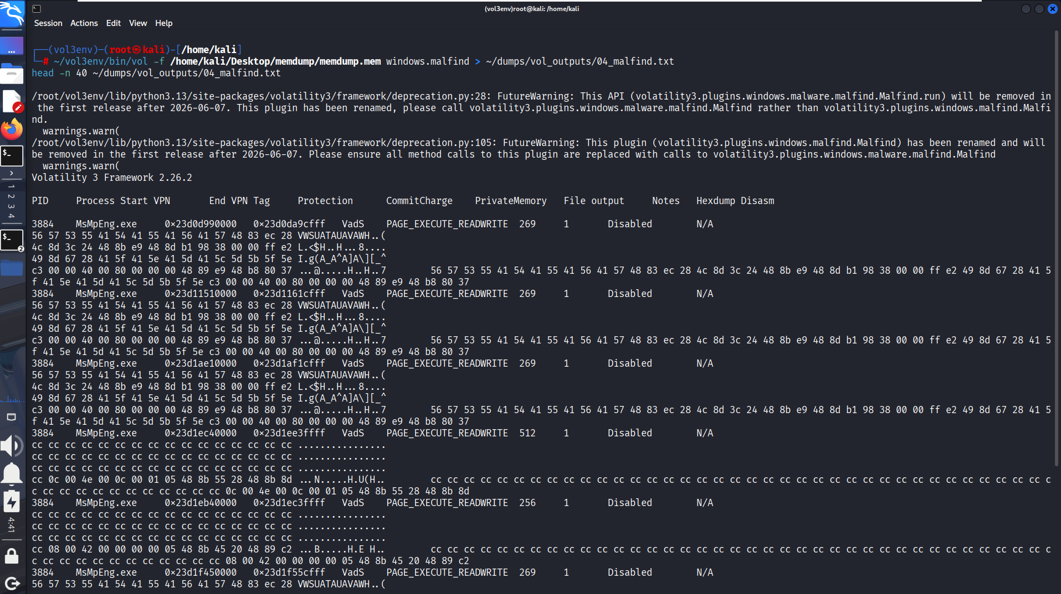

Findings
- No suspicious processes detected.
- Network connections are to expected services.
- No malfind injections detected.

Conclusion
This project demonstrates the capture and forensic analysis of volatile memory using FTK Imager and Volatility 3. It highlights the importance of live-memory analysis in detecting fileless malware and transient attacker activity.

