Part 1:

what are the problem that may trigger

code logic error:

1.does not validated product
null cases , wrong inputs and existing product
not used proper message and error code
does not checked float value price can be in decimal

2. data not handled properly
not used error handling techniques can cause app crash

business logic
- the product may exist before .the code did not check the existing product
- if product exist does not need to add it inventory just modify quantity

solution

- use of error handling techniques
- use of data parse during push to the database
- handling proper validation
- checking existing product and update inventoy

const expres = require('express');
const app = express();
const PORT = 3000;
const bodyparser = require("body-parser");

app.use(bodyparser.json());

app.get("/product", (req, res) => {
const { name, sku, price, warehouse_id, initial_quantity } = req.body;

try {
if (!name || !sku || !price || !warehouse_id || !initial_quantity) {
return res.status(400).json({ message: 'missing values, required all fields' });
}

if (initial_quantity <= 0) {
return res.status(400).json({
message: 'quantity should not be 0'
})
}
//find the product if its existed
const existingProduct = products.find(sku == sku);
if (existingProduct) {
const invItem = inventory.find(product_id == existingProduct && warehouse_id == warehouse_id);

if (invItem) {
invItem.quantity = invItem.quantity + initial_quantity;

} else {
inventory.push({
product_id: existingProduct.id,
warehouse_id: warehouse_id,
quantity: initial_quantity

});
}
} return res.status(200).json({
message: 'inventory updated for existing product', product_id: existingProduct.id
})
else {
const newProduct = {
id: nextProductId++,
name,
sku,
price: parseFloat(price),
warehouse_id: warehouse_id
};
product.push(newProduct);

inventory.push({
product_id: product_id,
warehouse_id: warehouse_id,
quantity: initial_quantity
});

return res.status(201).json({

message: 'new product created', product_id: newProduct.id
})
}

} catch (error) {
console.log('API Error', error.message)
return res.status(500).json({
message: 'internal server error'
})
}

});

part 2:
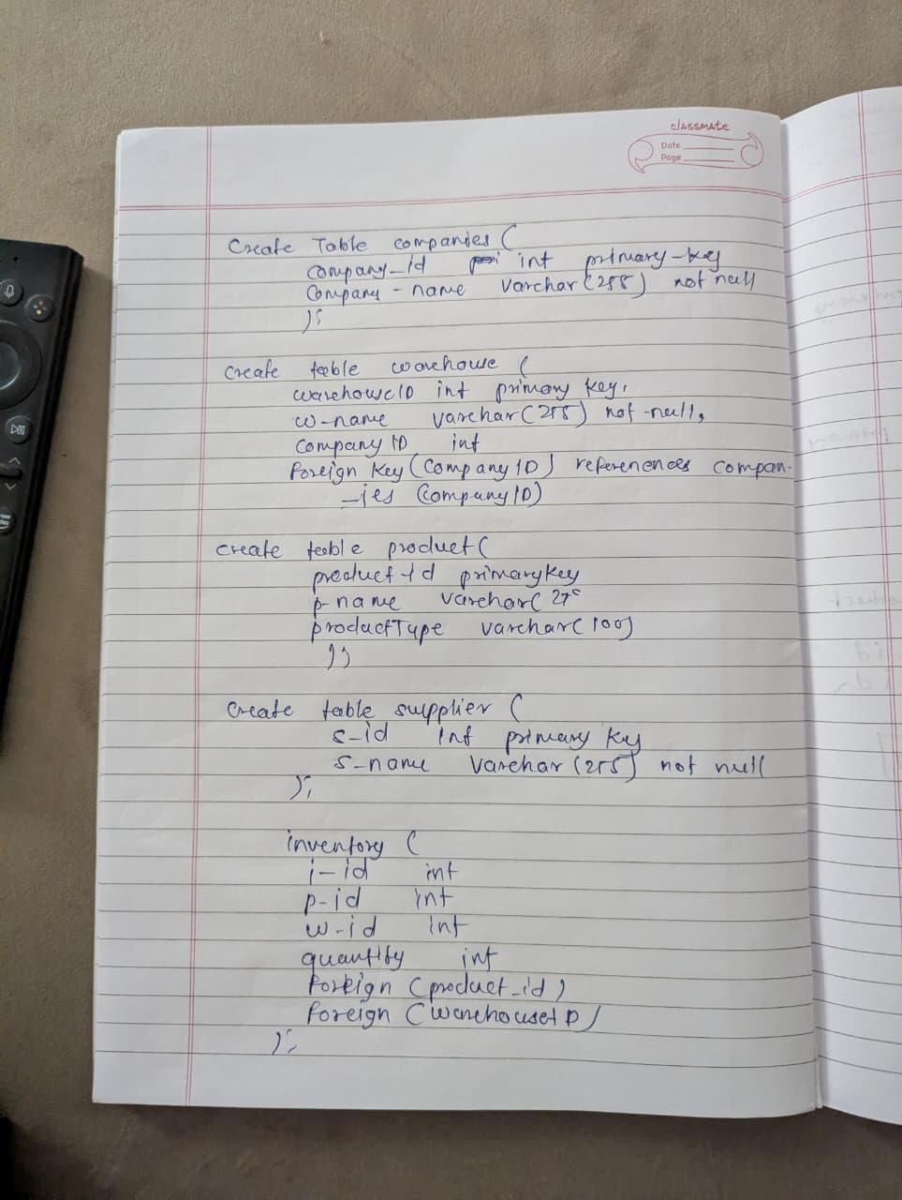
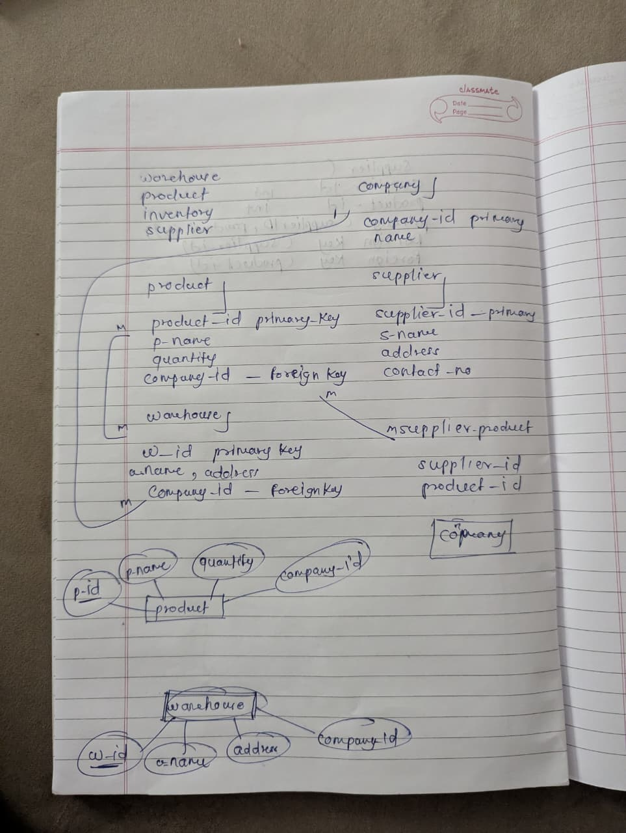
Part 3 :
In this question we have to send alert on low inventory

assume we have database ;

inventory{
i_id primary
p_id foreign
w_id foreign
quantity
}

sales{
s_id,
p_id,
sales
}
what we need to do in this case

on every sale we need to check product quantity if its get low we need to trigger a alert
what we have to return

product info
supplier_info
warehouse info

