LAB 2

Team : 3

Group Member:

1. Sushil Subedi
2. Rahul Niraula
3. Shrawan Adhikari
4. Omkar Chaudhary

Problem 1:

1. f(x) = -x2;

f’(x) = -2x;

for x = -1, f’(x) = 2

for x = 1, f’(x) = -2

for x = 0, f’(x) = 0

Result: Increasing on -ve axis and decreasing on +ve axis

1. f(x) = x2+2x+1;

f’(x) = 2x+2

for x = -1, f’(x) = 0

for x = 0, f’(x) = 2

for x = 1, f’(x) = 4

Result: Decreasing on -ve axis and increasing on +ve axis

1. f(x) = x3+x

f’(x) = 2x2+1

for x= -1, f’(x) = 3

for x= 1, f’(x) = 3

Result: Increasing

Problem :2

1. f(x) = 2x2 and g(x) = x2+1

f’(x) = 4x g’(x)= 2x

As degree of both function is same, they grow at the same rate

1. f(x) = x2 and g(x)= x3

f’(x) = 2x g’(x) = 3x2

As degree of g’(x) is higher, it will grow faster.

1. f(x) = 4x+1 and g(x)= x2-1

f’(x) = 4 g’(x) = 2x

As degree of g’(x) is higher, it will grow faster

Problem2 : GCD

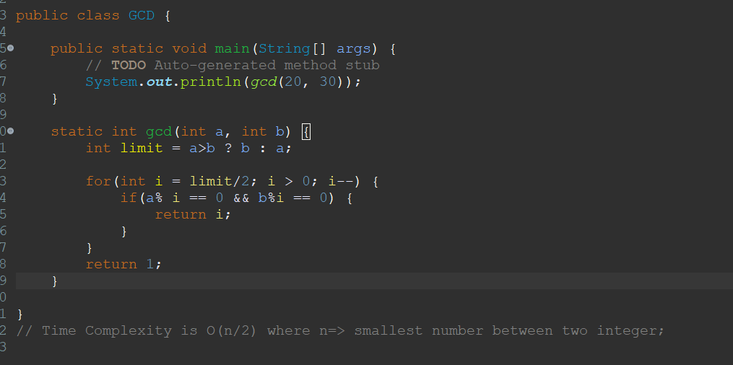

OR Euclidian Method:

Time Complexity is O(logn) where n is smallest number between two integer.

Problem 3: Subset

Time complexity is O(n) where n is length of an array.

Problem 3:

Solution: The algorithm is not feasible. Let say an array S= {2,4,6}, k = 9. If we use greedy strategy, the algorithms populate the set T with 2, 4 and then cannot continue, so the final value is T = {2, 4}. Since the sum of elements in T is not 9, the return is (incorrectly) null

Problem 4:

Solution: With the given solution T, we can verify that the T is correct. As sn-1 belongs to T, and the set T-{sn-1} is solution. The solution T also contains the subset of element which will be equal to k. As last element sn-1 belongs to k. Assuming k = 10, then k’ = k – sn-1 evaluates to k-k, also is 0. So, the set T –{sn-1} will be correct for k’ = k -sn-1.