**Lab 9 Heap**

|  |  |
| --- | --- |
| Student ID | Name |
| 614760 | Omkar Nath Chaudhary |
| 614732 | Sushil Subedi |
| 614604 | Rahul Niraula |
| 614600 | Shrawan Adhikari |

Q1.

Illustrate the operation of Max_Heapify(A, 3) using the array



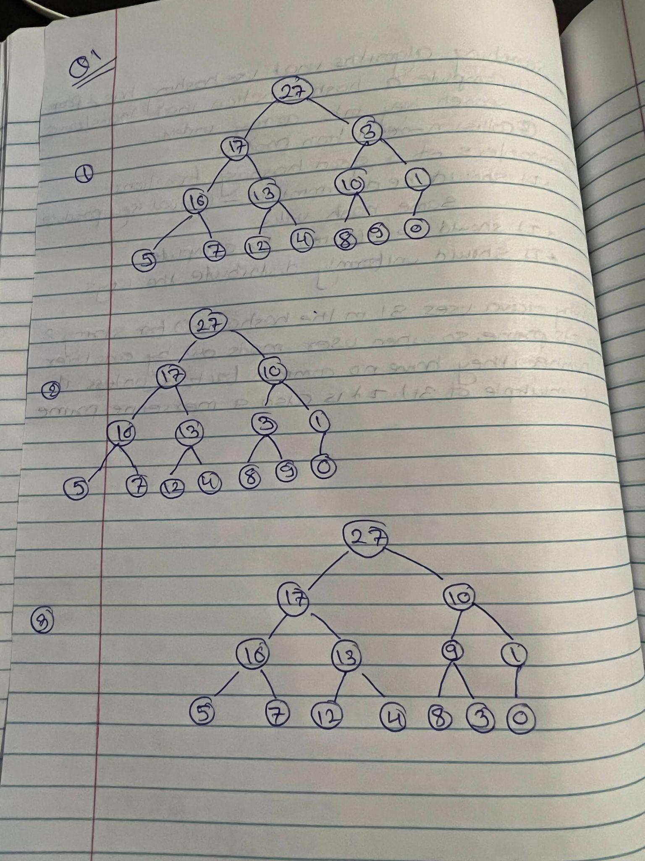

**Q2.**

**Show the operation of Build-Heap using the array below:**



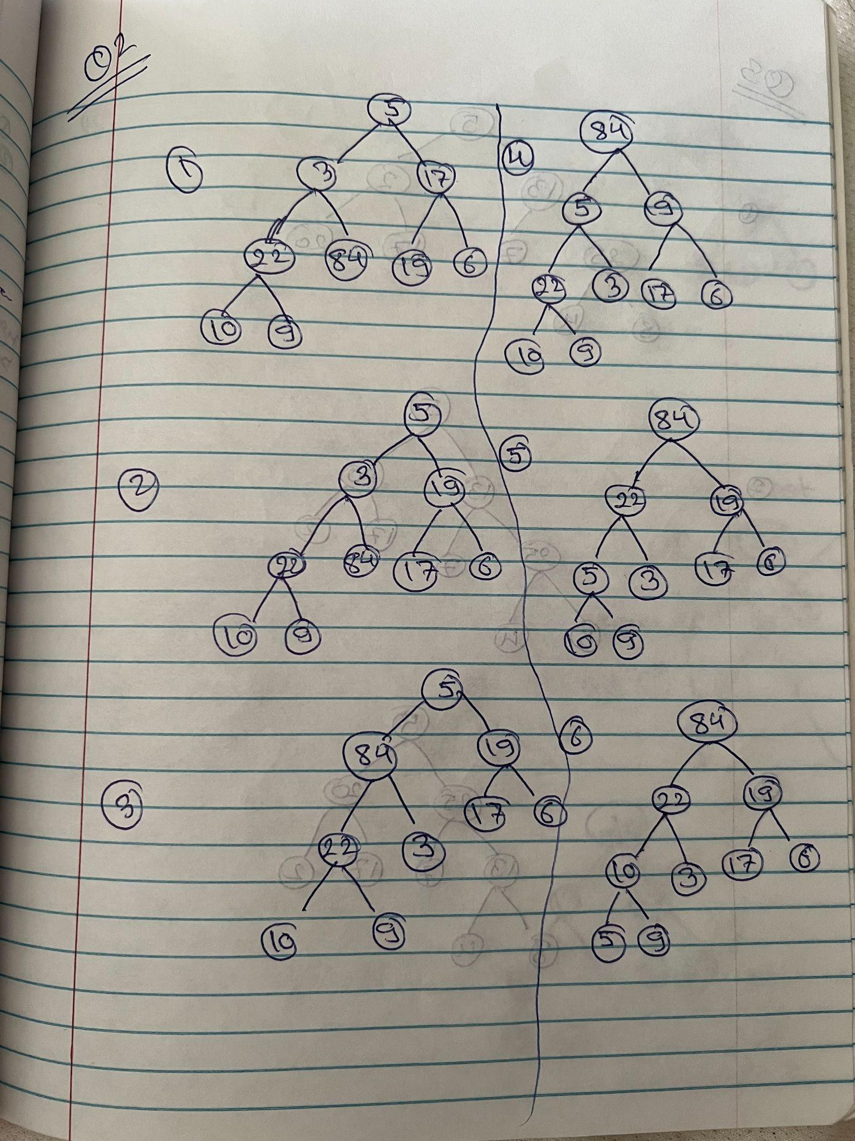

**Q3. Illustrate the operation of Heapsort using the array below:**



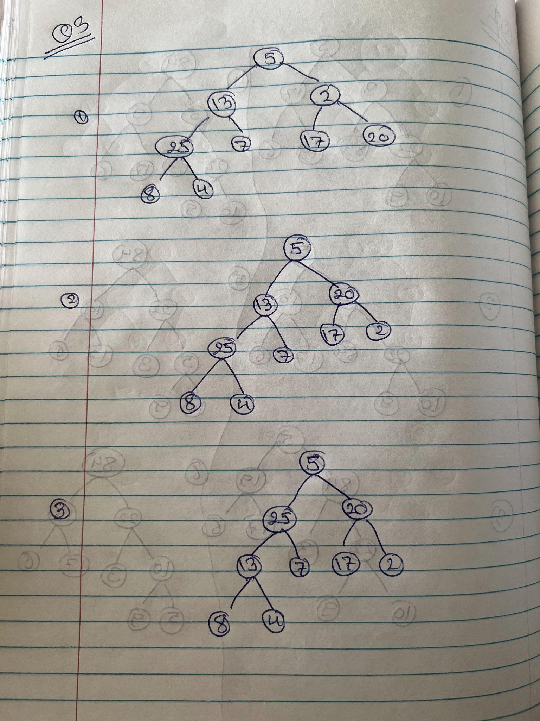

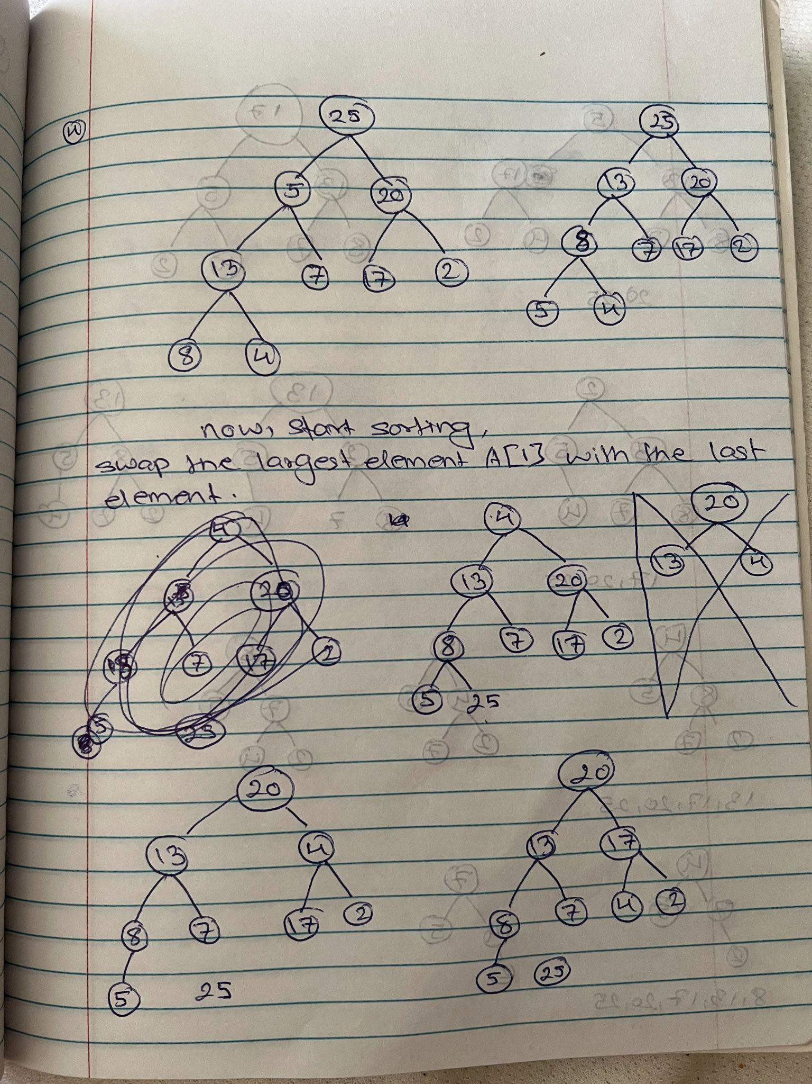

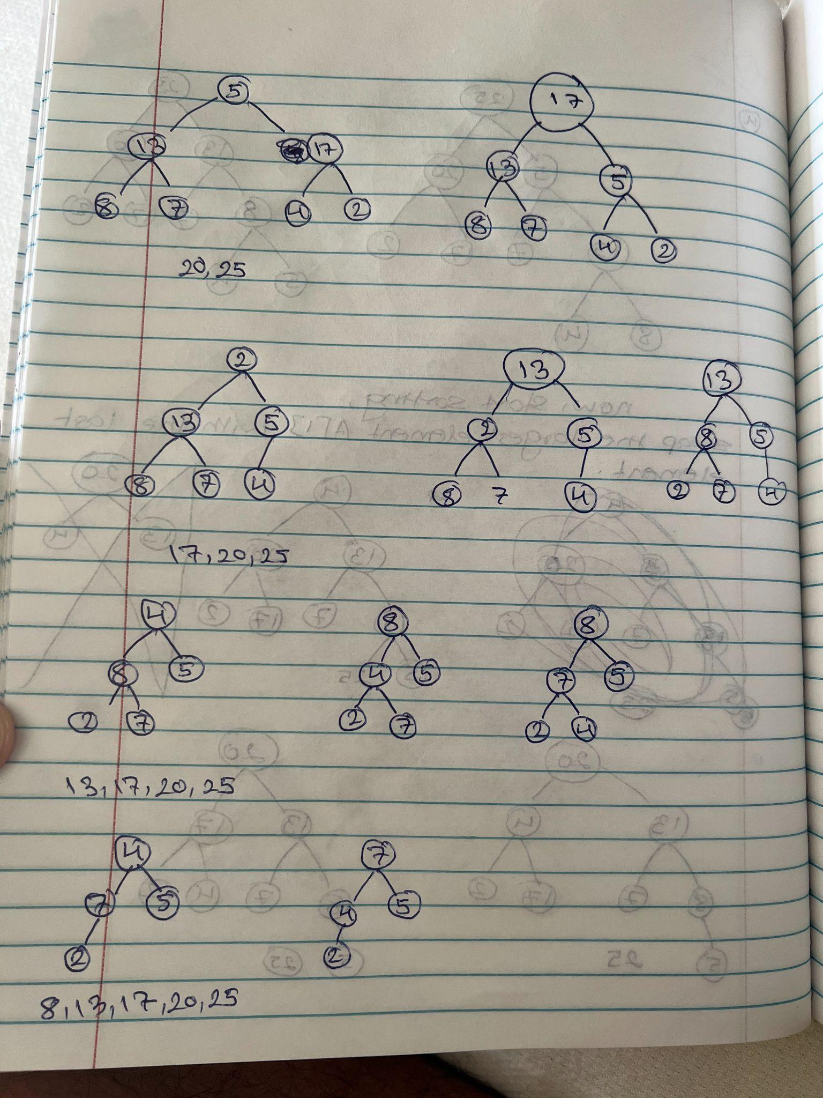

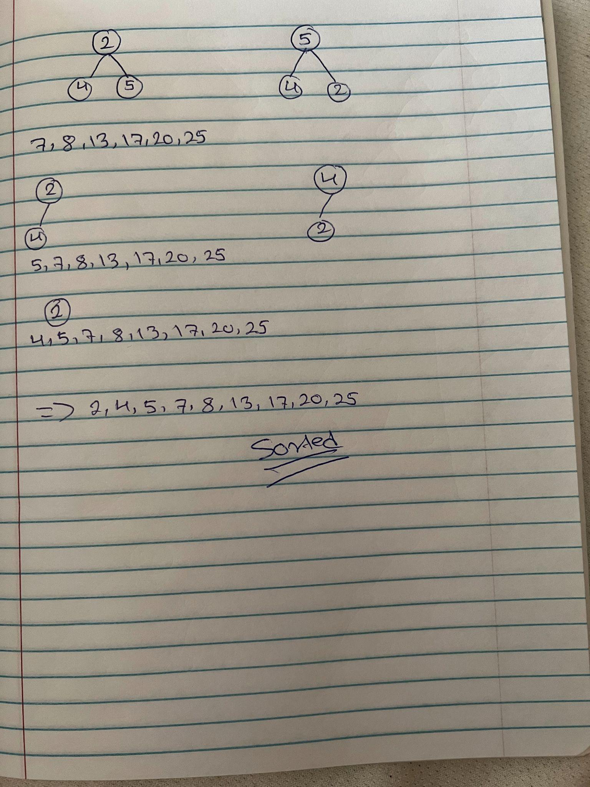

**Q4.**

Show that in an n-element heap, there are at most  nodesof height h.

For any n > 0, the number of leaves of nearly complete binary tree is n/2.

Proof by induction

Base case: Show that it’s true for h = 0. This is the direct result from above observation.

Inductive step: Suppose it’s true for h − 1. Let Nh be the number of nodes at height h in the n-node tree T .

Consider the tree T’ formed by removing the leaves of T. It has n’ = n – n/2 = n/2 nodes.

Note that the nodes at height h in T would be at height h-1 in tree T’. Let N’ h-1 denote the number of nodes at height h-1 in T’,

We have Nh = N’h-1.

By Induction, we have

Nh= N’h-1 = n’/2h <= (n/2)/2h = n/2h+1