Data Feed Configuration – Workflow Document

Overview
This document outlines the end-to-end workflow for configuring Data Feeds in G3, including required pre-checks, EDF connectivity, configuration steps, monitoring, and task closure.

Pre-Checks for Data Feed Configuration
Step 1: Client IP Whitelisting
At the start of the Data Feeds workflow, CRM/CPM must confirm with the client that the following IDeaS Cloud IP addresses are whitelisted to allow server connectivity (mandatory for new property setup):
- 3.128.14.50
- 3.131.145.62
- 3.21.193.46
If IPs are not whitelisted, request the client to complete this before proceeding further.

Step 2: Add Client on EDF
Once IP whitelisting is confirmed:
- Verify whether the client is already added on EDF. (By asking EDF Team(Amol Bembde / Sharayu Abhang ) is this client already added on EDF)
- If not added, reach out directly to EDF Team(Amol Bembde / Sharayu Abhang ) to add the client on EDF.

Step 3: EDF Test Connection
After the client is added on EDF:
- Request EDF Team(Amol Bembde / Sharayu Abhang )to perform the EDF test connection.
- Use the template below for communication:
Hello Sharayu,
This is regarding Case: ******** | Salesforce – Request to perform EDF test connection.
The client has already whitelisted the required IPs.
SFTP Username: cwl-ideas
SFTP Password: Provided on the case
SFTP Host/IP: s-456637e68d8345209.server.transfer.eu-central-1.amazonaws.com
SFTP Port: 22
✅ These SFTP details should be available at the case level.
❌ If any details are missing, return the task to the case owner and request them to update the information.
Proceed only after confirmation that the EDF test connection is successful.

G3 Data Feed Configuration
Client-Level Configuration

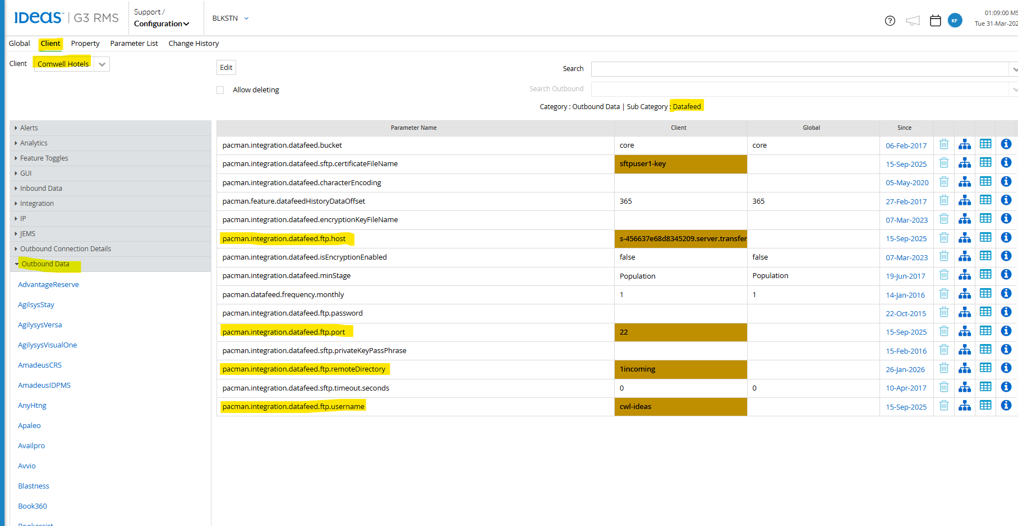
Navigate to:
Configuration → Client Level → Client Name → Outbound Data → Data Feed
Update the following parameters:
pacman.integration.datafeed.ftp.host
pacman.integration.datafeed.ftp.port
pacman.integration.datafeed.ftp.username
pacman.integration.datafeed.ftp.remoteDirectory

Property-Level Configuration

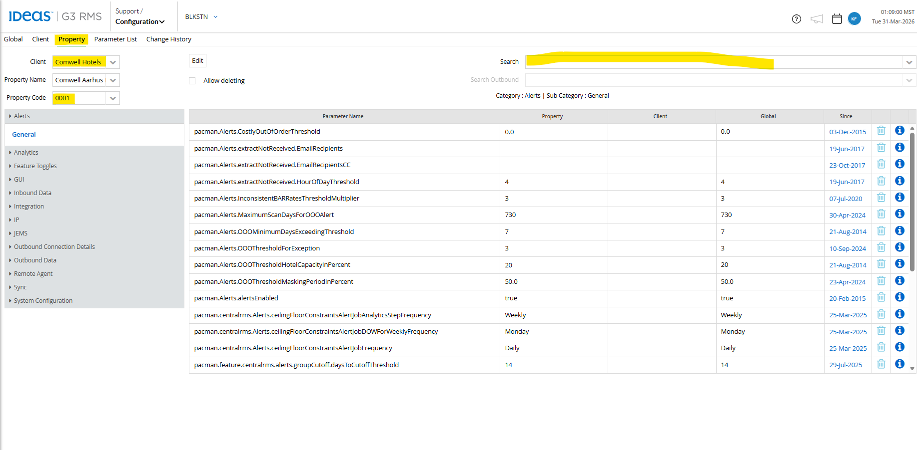
Set the following parameters at the property level:
pacman.preProduction.notifyAWSPostProcessingEnabled = True
(Triggers EDF notification after BDE completion)

pacman.feature.isDatafeedFileEnabled = False
(Disables “NGI Generate Datafeed File” job in G3)

pacman.feature.isEDFDatafeedFileEnabled = True
Once configuration is completed, wait for BDE (Batch Data Extract) to complete.

Monitoring Data Feeds
Post-BDE Monitoring (Next Day)
Monitor data feeds after BDE completion using Datadog:
Datadog Dashboard

https://ideas.datadoghq.com/dashboard/wsd-6wx-7cn/prod-cedf-g3-feeds-dashboard?fromUser=false&index=%2A&refresh_mode=sliding&view=spans&from_ts=1712748139509&to_ts=1712834539509&live=true

Update the following filters:
- System Date
- Client Code
- Client Property Code
- IsClientUploadEnabled = True
Use the Feeds Uploaded Count to verify how many files have been successfully sent.
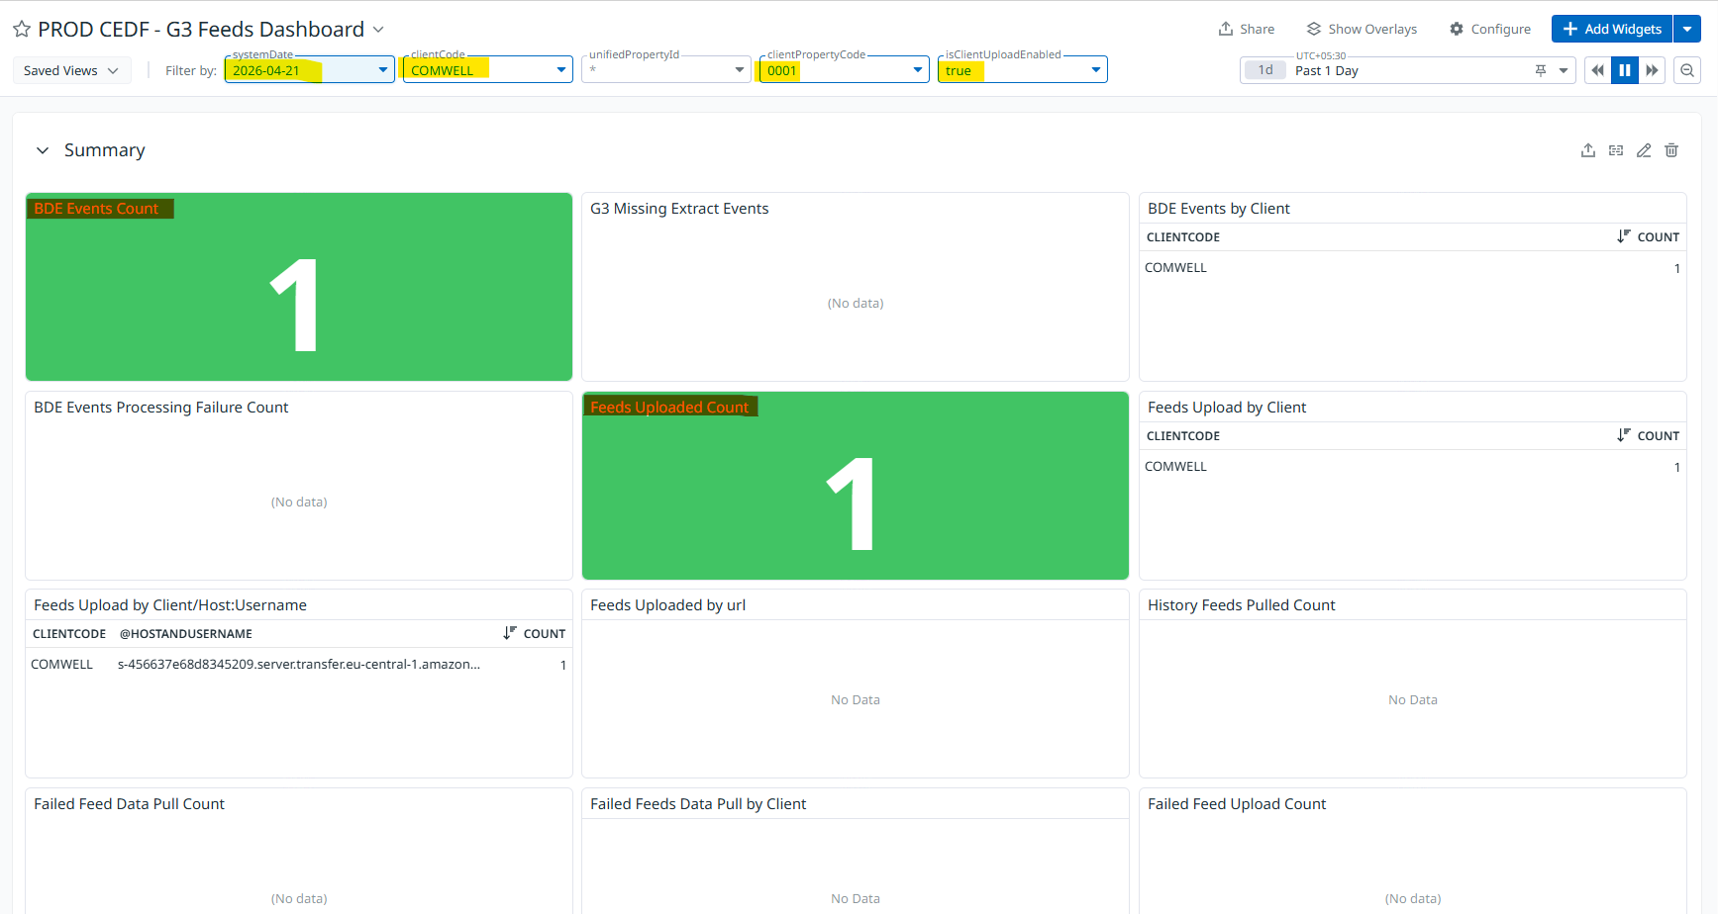

Task-Based Workflow Summary

Case Reason- G3 Data Feed Configuration

Task 1 - G3 Data Feed Connection Information | Salesforce
CPM must confirm the following details from the client:
- Product Sold (Bucket)
- SFTP Username
- SFTP Password
- Authentication Mode (Password / Certificate Key)
- SFTP Host/IP
- SFTP Port
- Remote Directory

Task 1a – IP Whitelisting Confirmation
CPM must confirm that the required IDeaS IPs are whitelisted by the client.

Task 2 – Validate SFTP Details
Verify the following parameter:
Configuration → Client Level → Client Name
pacman.integration.datafeed.ftp.port = 22

Task 3 – EDF Connectivity Test
Coordinate with Amol Bembde / Sharayu Abhang to:
- Add the client on EDF (If already added then no need to connect)
- Perform EDF test connectivity
Proceed only after receiving a successful confirmation.

Task 4 – Enable Data Feed Configuration
Client Level → Outbound Data → Data Feed
pacman.integration.datafeed.ftp.host
pacman.integration.datafeed.ftp.port
pacman.integration.datafeed.ftp.username
pacman.integration.datafeed.ftp.remoteDirectory
Property Level
pacman.preProduction.notifyAWSPostProcessingEnabled = True
pacman.feature.isDatafeedFileEnabled = False
pacman.feature.isEDFDatafeedFileEnabled = True
After BDE completion, monitor data feed status via Datadog and verify uploaded feeds.

Task 5 - G3 Monitor Data Feed Delivery | Salesforce
https://ideas.datadoghq.com/dashboard/wsd-6wx-7cn/prod-cedf-g3-feeds-dashboard?fromUser=false&index=%2A&refresh_mode=sliding&view=spans&from_ts=1712748139509&to_ts=1712834539509&live=true

Update the following filters:
- System Date
- Client Code
- Client Property Code
- IsClientUploadEnabled = True
Use the Feeds Uploaded Count to verify how many files have been successfully received.

Task 5 – Update Case Owner
Once data feeds are successfully received and validated:
- Assign the task back to the case owner
- Share confirmation and monitoring details

Conclusion
This completes the G3 Data Feed Case Workflow, from initial pre-checks through configuration, validation, monitoring, and task closure.

