Computation of emission probability

Hidden
States HS1 → HS2 → HS3 → HS4 →HS5 → HS6 → HS7 → HS8 → ……………………..HSN
Observed
Sates OS1 → OS2 → OS3 → Os4 →OS5 → OS6 → OS7 → OS8 → ……………………..OSN

where HS(i) is pos tags and OS(i) is given word

emission probability is calculated as P(word/tag) = count(word and tag) / count(tag)
we will do these for all words present in training data and letter used it for testing that is for observed words
so we will have emission_matrix as

 | tag1 | tag2 | tag3 | tag4 | . | . | . | tagN
word1 | count(word1 and tag1) / count(tag1) | count(word1 and tag2) / count(tag2) | count(word1 and tag3) / count(tag3) | count(word1 and tag4) / count(tag4) | . | . | . | count(word1 and tagN) / count(tagN)
word2 | count(word2 and tag1) / count(tag1) | count(word2 and tag2) / count(tag2) | count(word2 and tag3) / count(tag3) | count(word2 and tag4) / count(tag4) | . | . | . | count(word2 and tagN) / count(tagN)
word3 | . | . | . | . | . | . | . | .
word4 | . | . | . | . | . | . | . | .
. | . | . | . | . | . | . | . | .
. | . | . | . | . | . | . | . | .
. | . | . | . | . | . | . | . | .
wordN | count(wordN and tag1) / count(tag1) | count(wordN and tag2) / count(tag2) | count(wordN and tag3) / count(tag3) | count(wordN and tag4) / count(tag4) | . | . | . | count(wordN and tagN) / count(tagN)

wordi and tagi belongs to training data

Computation of transition probability

Here we will generate the transition probability matrix it is tag x tag matrix and each value represents the p(tag_i/tag_j)=count(tag_i and tag_j) / count(tag_j)

transition_matrix

 | tag1 | tag2 | . | . | tagN
tag1 | count(tag1 and tag1) / count(tag1) | count(tag1 and tag2) / count(tag2) | . | . | count(tag1 and tagN) / count(tagN)
tag2
.
.
tagN | count(tagN and tag1) / count(tag1) | count(tagN and tag2) / count(tag2) |  |  | count(tagN and tagN) / count(tagN)

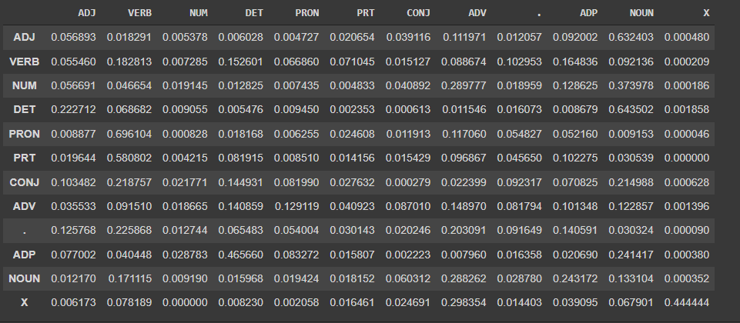
here tagi belongs to training data
it follows markov property that is t th state depends on t-1 th state

computation of initial probabilities of hidden state(Pi)

it is calculated from transition_matrix
Repeated Matrix multiplication
pi = lim transition_matrix ^ n
n→ inf
but here we had take n as 10^2
but we can use Monto carlo or left eigen vector to compute the pi

Accuracy:

Algorithm Accuracy: 90.04975124378109

Trigram

Emission probabilities

 | tag1&tag1 | tag1&tag2 | . | . | . | . | . | tagN&tagN
word1 | count(word1 and tag1&tag1) / count(tag1&tag1) | count(word1 and tag1&tag2) / count(tag1&tag2) | . | . | . | . | . | count(word1 and tagN&tagN) / count(tagN&tagN)
word2 | count(word2 and tag1&tag1) / count(tag1&tag1) | count(word2 and tag1&tag2) / count(tag1&tag2) | . | . | . | . | . | count(word2 and tagN&tagN) / count(tagN&tagN)
word3 | . | . | . | . | . | . | . | .
word4 | . | . | . | . | . | . | . | .
. | . | . | . | . | . | . | . | .
. | . | . | . | . | . | . | . | .
. | . | . | . | . | . | . | . | .
wordN | count(wordN and tag1&tagN) / count(tag1&tag1) | count(wordN and tag1&tag2) / count(tag1&tag2) | . | . | . | . | . | count(wordN and tagN&tagN) / count(tagN&tagN)

tarnsition probabilities

 | tag1&tag1 | tag1&tag2 | . | . | tagN&tagN
tag1 | count(tag1 and tag1&tag1) / count(tag1&tag1) | count(tag1 and tag1&tag2) / count(tag1&tag2) | . | . | count(tag1 and tagN&tagN) / count(tagN&tagN)
tag2
.
.
tagN | count(tagN and tag1&tag1) / count(tag1&tag1) | count(tagN and tag1&tag2) / count(tag1&tag2) |  |  | count(tagN and tagN&tagN) / count(tagN&tagN)

