Creating superuser to perform all administartive level tasks

As i already configured application firstapp in project hospital now we will create table in databases
through django and let admin to allow to do tasks.

1.let’s look at directory structure of project & firstapp

hospital[projectdir]
|
|---->hospital [django will create this MODULE for us]
|
|---->manage.py [file for database operation’s]

hospital[module hospital]
|
|---->__init__.py[this to make module]
|
|---->urls.py[all urls related to application is defined here]
|
|---->wsgi.py[explains how webserver communicates with application]
|
|---->settings.py[registering application,templates,stattic files with project ]

firstapp
|
|--->admin.py
|
|---> apps.py
|
|---> __init__.py
|---> migrations
|
|---> models.py
|
|--->tests.py
|
|--->views.py
|

2.database configuration

settings.py

DATABASES = {
'default': {
'ENGINE': 'django.db.backends.sqlite3',
'NAME': os.path.join(BASE_DIR, 'db.sqlite3'),
}
}
#sqlite3 is default database engine,you can change it.

3.define models

models.py

from django.db import models

# Create your models here.

class student_info(models.Model):
fname=models.CharField(max_length=20)
mname=models.CharField(max_length=20)
lname=models.CharField(max_length=20)
studentid=models.CharField(max_length=15)

4.after defining models migrate this model to database

$~python3 manage.py makemigartions [convert python code to sql code]
$~python3 manage.py migrate [execute sql code]
hence now table is created in databse as applicationname_tablename

5.configure admin.py file

admin.py

from django.contrib import admin
from . import models
# Register your models here.
class student_info_admin(admin.ModelAdmin):
list_display=['fname','mname','lname','studentid']

admin.site.register(models.student_info,student_info_admin)

6.create superuser

omkar@omz:~/django/Hospital$ python3 manage.py createsuperuser
Username: omkargavhane
Email address: omkargavhane@outlook.com
Password:
Password (again):
Superuser created successfully.

7.now runserver

omkar@omz:~/django/Hospital$ python3 manage.py runserver
Performing system checks...

System check identified no issues (0 silenced).
September 23, 2018 - 06:21:48
Django version 1.11, using settings 'Hospital.settings'
Starting development server at http://127.0.0.1:8000/
Quit the server with CONTROL-C.

Copy url,paste it into browser’s searchbar and make request for admin i.e

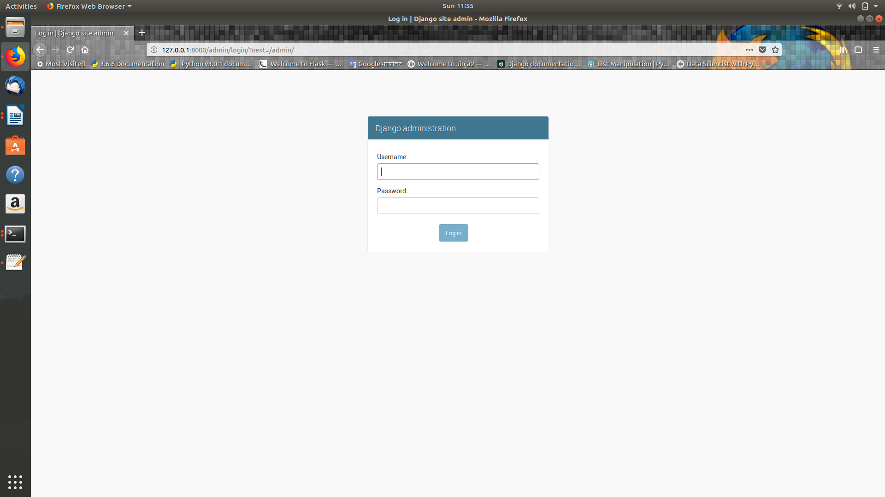

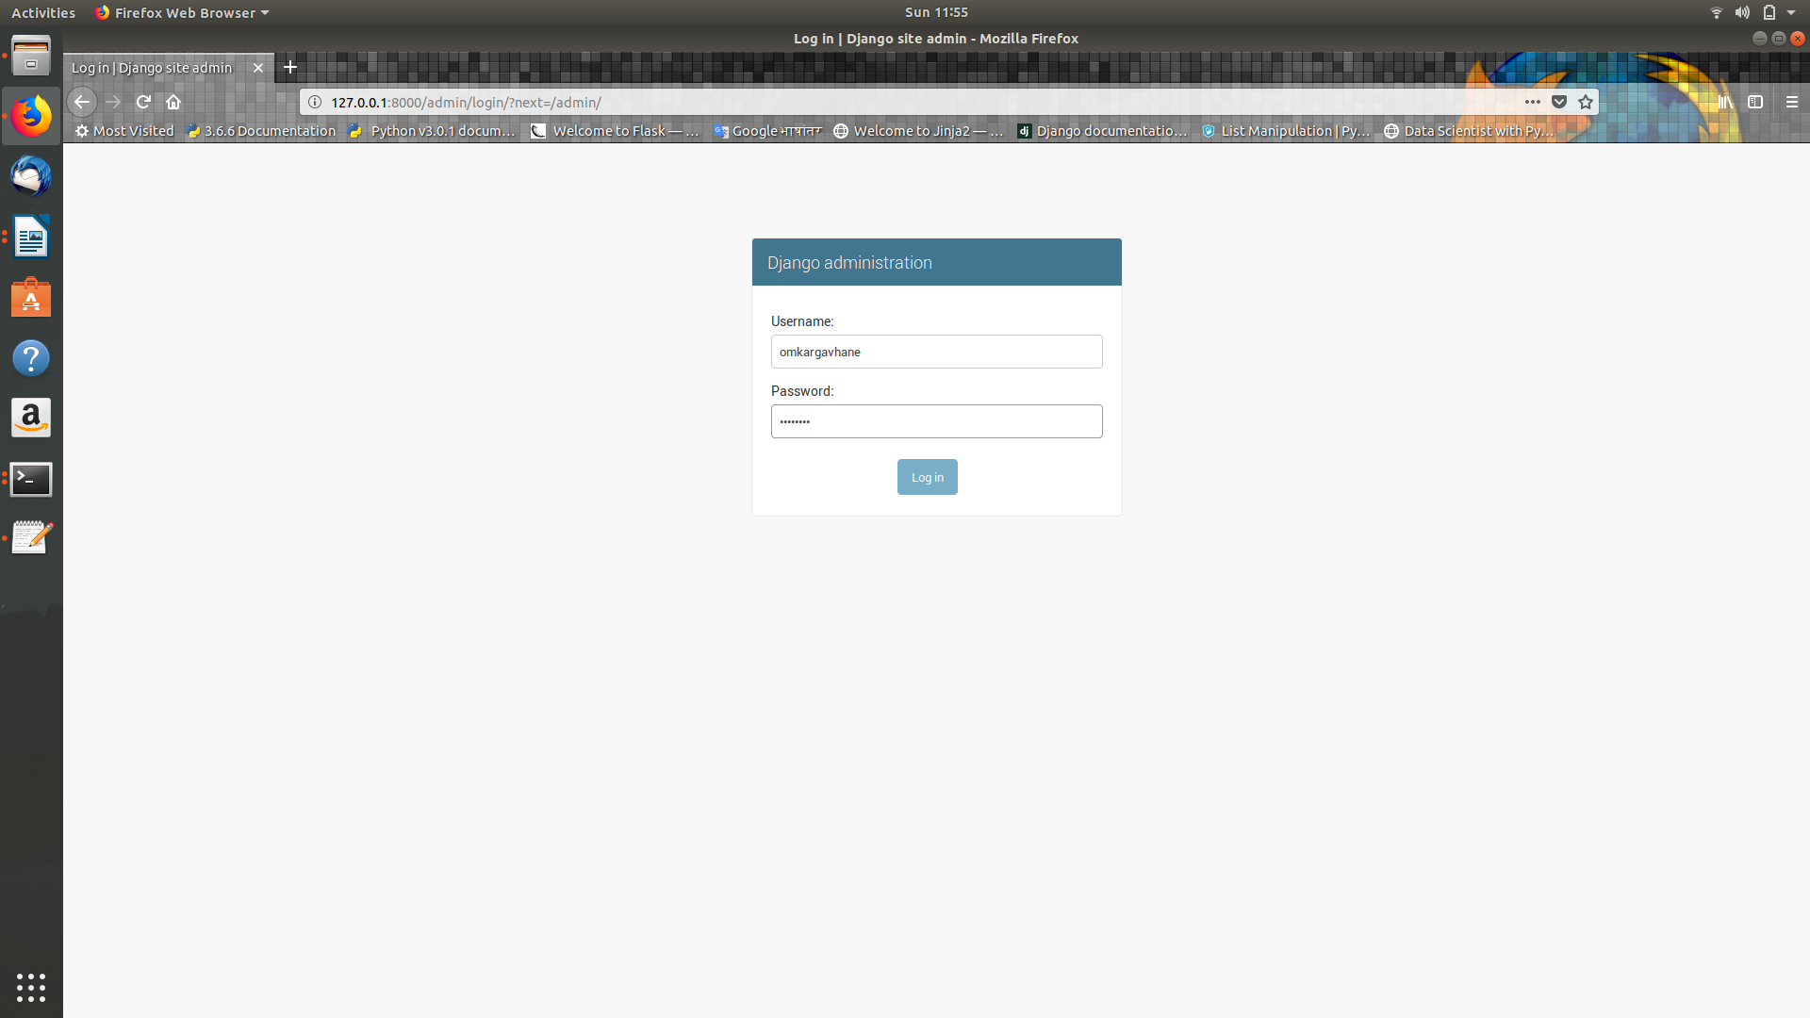

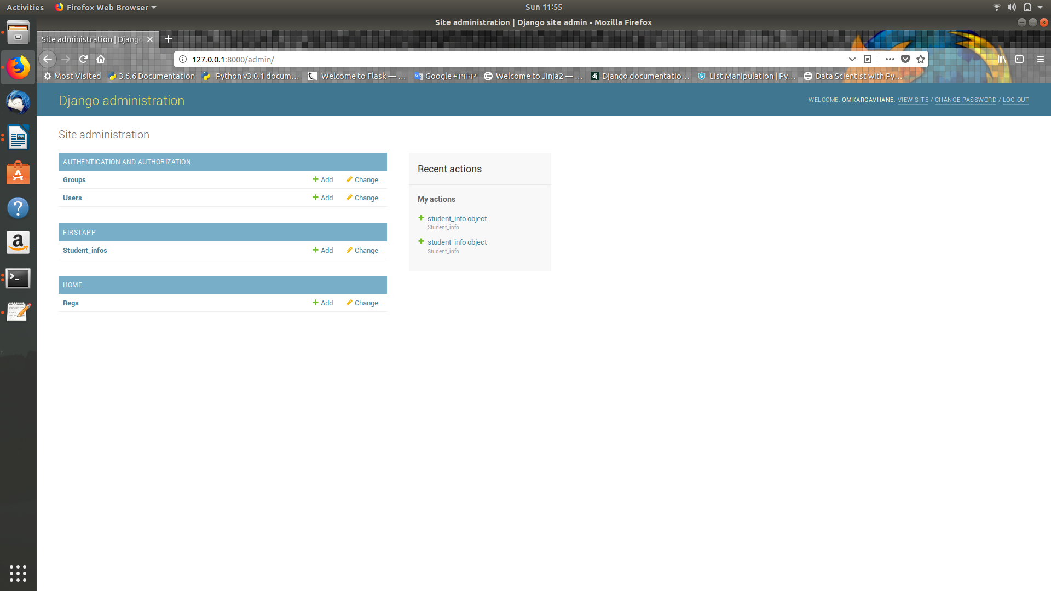

in first app student_infos table is prsent if we open it then

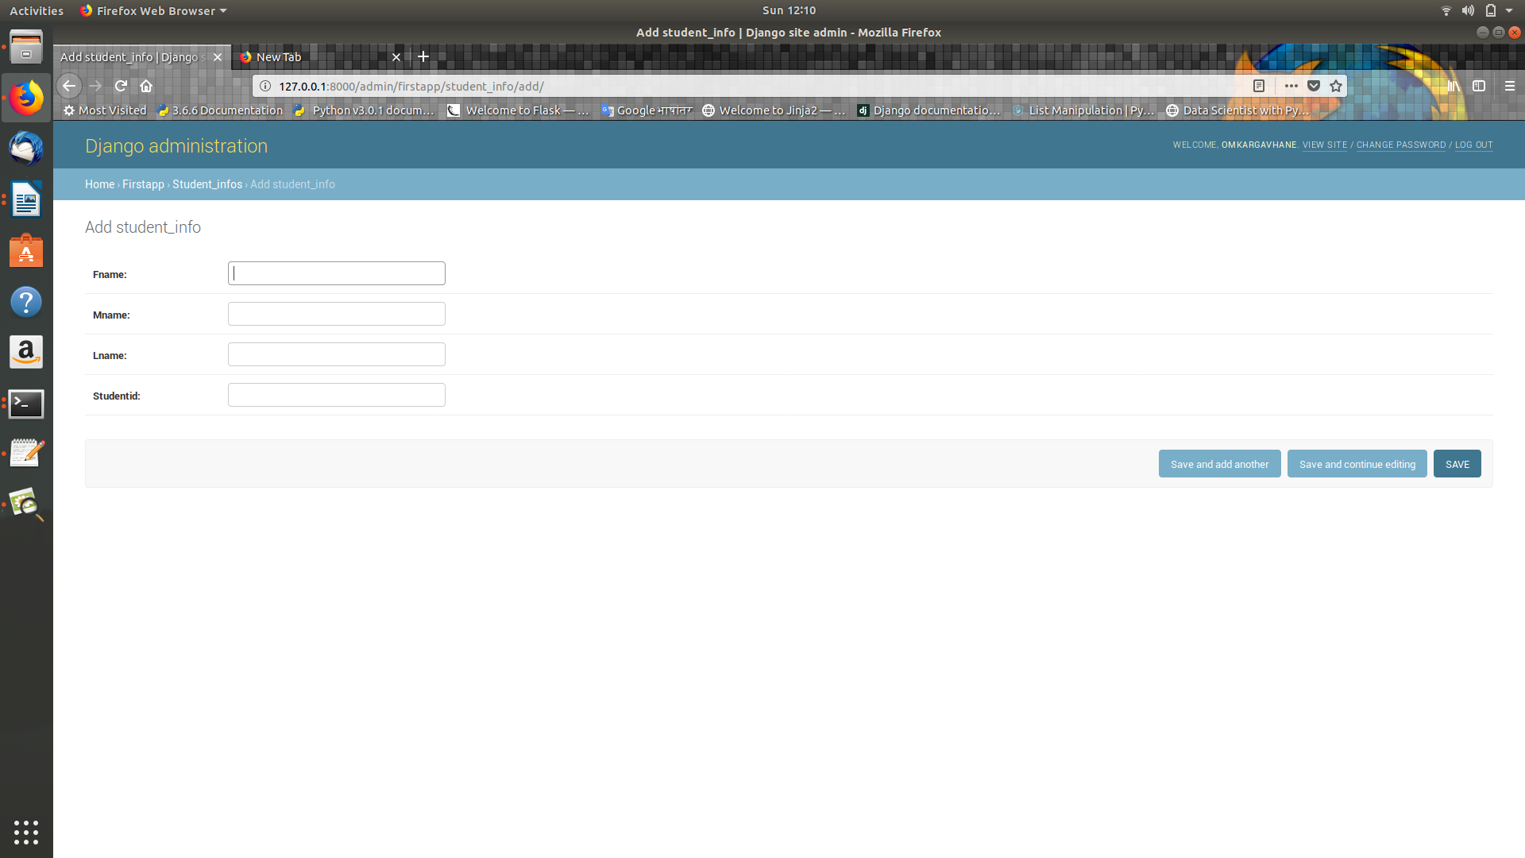

add record here

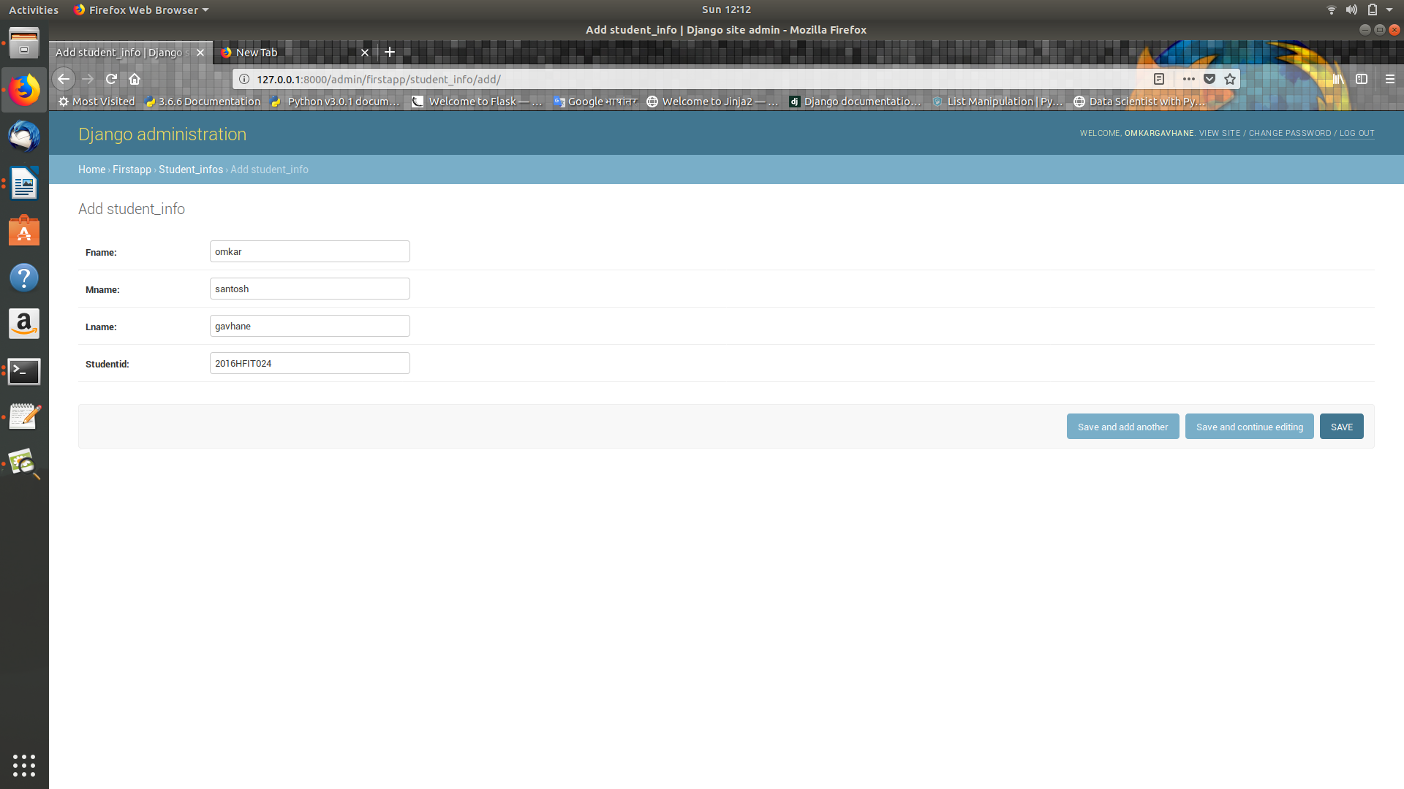

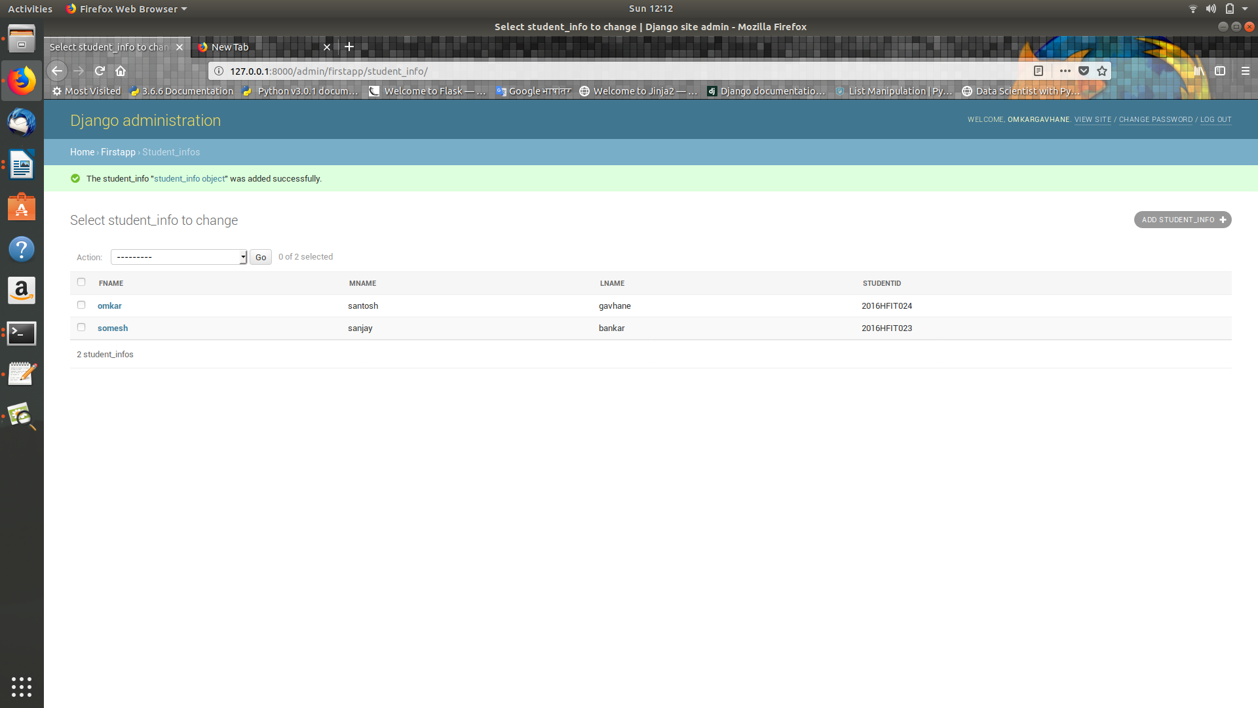

8.now check in database

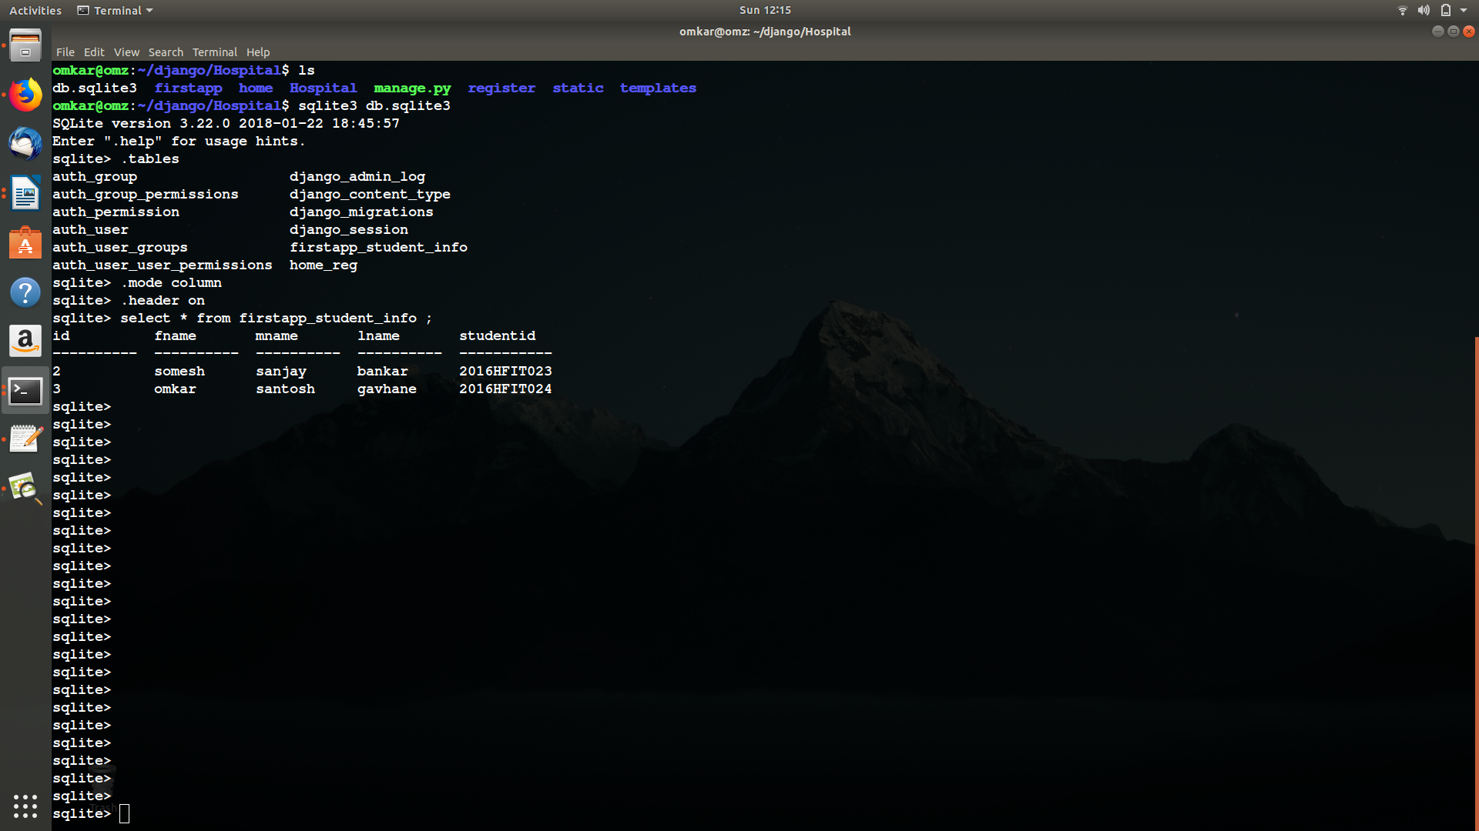
both records added successfully.

