A PROJECT REPORT ON

SkillsBridge – An AI- Powered Job Readiness Platform
SUBMITTED TOWARDS THE
PARTIAL FULFILLMENT OF THE REQUIREMENTS OF

BACHELOR OF ENGINEERING (Computer Engineering) BY

Omkar Ghodekar Roll No: BECO2526B067
Utkarsh Salunke Roll No: BECO2526B048
Raj Wagh Roll No: BECO2526B008
Sandhya Dhaygude Roll No: BECO2526B046

Under The Guidance of

Dr. Mrs. Madhuri A. Potey



DEPARTMENT OF COMPUTER ENGINEERING

D. Y. Patil College of Engineering, Akurdi, Pune-44

SAVITRIBAI PHULE PUNE UNIVERSITY
2025-26



D.Y. Patil College of Engineering, Akurdi, Pune-44 DEPARTMENT OF COMPUTER ENGINEERING

CERTIFICATE
This is to certify that the Project Entitled

“SkillsBridge – An AI- Powered Job Readiness Platform”

 | Submitted by
Omkar Ghodekar |  | Roll No: BECO2526B067
Utkarsh Salunke |  | Roll No: BECO2526B048
Raj Wagh |  | Roll No: BECO2526B008
Sandhya Dhaygude |  | Roll No: BECO2526B046

is a bona-fide work carried out by students under the supervision of Dr. Mrs. Madhuri A. Potey and it is submitted towards the partial fulfillment of the requirement of Bachelor of Engineering (Computer Engineering).

Prof. Dr. Mrs. Madhuri A. Potey Prof. Dr. Mrs. Madhuri A. Potey Internal Guide H.O.D
Dept. of Computer Engg. Dept. of Computer Engg.

Dr. Mrs. P. Malathi Principal
D. Y. Patil College of Engineering, Akurdi, Pune 44

Signature of Internal Examiner Signature of External Examiner

PROJECT APPROVAL SHEET

A Project on

SkillsBridge – An AI- Powered Job Readiness

Platform

Is successfully completed by

Omkar Ghodekar Roll No : BECO2526B067

Utkarsh Salunke Roll No : BECO2526B048

Raj Wagh Roll No : BECO2526B008

Sandhya Dhaygude Roll No : BECO2526B046

DEPARTMENT OF COMPUTER ENGINEERING
D. Y. Patil College of Engineering, Akurdi, Pune

SAVITRIBAI PHULE PUNE UNIVERSITY, PUNE
2024-2025

Prof. Dr. Mrs. Madhuri A. Potey Prof. Dr. Mrs. Madhuri A. Potey Internal Guide H.O.D
Dept. of Computer Engg. Dept. of Computer Engg.

Abstract

The rapid evolution of industry demands has widened the gap between academic learning and employer expectations, leading to challenges for students and fresh graduates in securing suitable job opportunities. To address this issue, SkillBridge is proposed as an AI-powered job readiness and interview preparation platform that provides end-to-end career support. The system extracts technical and soft skills from user resumes using NLP-based approaches such as SBERT and TF-IDF, and maps these skills against real-time job descriptions sourced through automated web scraping. Based on relevance ranking, users receive personalized job recommendations.
SkillBridge further integrates an AI-driven mock interview module using the Ollama–Mistral model to generate domain-specific interview questions, while the Gemini model evaluates user responses based on accuracy, communication, and confidence. The platform generates a structured and personalized learning path to help users improve skill gaps identified during evaluation. By automating resume analysis, job-role matching, interview assessment, and upskilling recommendations, SkillBridge aims to create a comprehensive, scalable, and intelligent ecosystem that enhances job readiness and supports candidates in achieving successful career outcomes.

Acknowledgment

It gives us great pleasure in presenting the preliminary project report on ‘SkillsBridge – An AI-Powered Job Readiness Platform’

I would like to take this opportunity to thank my internal guide Dr. Mrs. Madhuri A. Potey for giving me all the help and guidance I needed. I am really grateful to them for their kind support. Their valuable suggestions were very helpful.

I am also grateful to Prof. Mrs. M. A. Potey, Head of Computer Engineering Department D.
Y. Patil College of Engineering, Akurdi, Pune for her indispensable support, suggestions.

In the end our special thanks to Mrs. Supriya Sathe for providing various resources such as laboratory with all needed software platforms, continuous Internet connection, for our project.

Omkar Ghodekar Utkarsh Salunke Raj Wagh
Sandhya Dhaygude
(B.E. Computer Engg.)

Contents

- Synopsis

  - Project Title 12
  - Project Option…………………….. 12
  - Internal Guide 13
  - Sponsorship and External Guide 13
  - Technical Keywords (As per ACM Keywords) 13
  - Problem Statement 13
  - Abstract 14
  - Goals and Objectives 15
  - Relevant mathematics associated with the Project 15
  - Names of Conferences / Journals where papers can be published 16
  - Review of Conference/Journal Papers supporting Project idea ...................................
  - Plan of Project Execution.............................................................................................
- Technical Keywords
  - Area of Project 18
  - Technical Keywords 18
- Introduction
  - Project Idea 19
  - Motivation of the Project 19
  - Literature Survey 20
- Problem Definition and scope
  - Problem Statement 24
    - Goals and objectives 24
    - Statement of scope 15
  - Major Constraints 25
  - Methodologies of Problem solving and efficiency issues 26
  - Outcome 26
  - Applications 27
  - Hardware Resources Required 28
  - Software Resources Required 29
- Project Plan
  - Project Estimates 30
    - Reconciled Estimates 30
    - Project Resources 31
  - Risk Management w.r.t. NP Hard analysis 32
    - Risk Identification 32
    - Risk Analysis 34
    - Overview of Risk Mitigation, Monitoring, Management 35
  - Description of Tasks 40
    - Project task set 31
    - Task network 39
    - Timeline Chart 40
  - Task Network 43
  - Timeline Chart 44
  - Team Organization 44
    - Team structure 44
    - Management reporting and communication 45
- Software requirement specification
  - Introduction 46
    - Purpose and Scope of Document 46
    - Overview of responsibilities of Developer 46
  - Usage Scenario 47
    - Use Cases 49
    - Use Cases View 46
  - Data Model and Description 50
    - Data Description 50
  - Functional Model and Description 50
    - Data Flow Diagram 50
    - Activity Diagram 52
    - Non Functional Requirements 53
    - State Diagram 54
- Detailed Design Document using Appendix A and B 55
  - Introduction 55
  - Architectural Design 55
  - Component Design 57
    - Class Diagram 57
- Project Implementation 58
  - Introduction 58
  - Tools and Technologies Used 58
  - Methodologies/Algorithm Details 59
    - Algorithm 1/Pseudo Code 59
    - Algorithm 2/Pseudo Code 59
    - Algorithm 2/Pseudo Code 60
- Software Testing
  - Type of Test Cases Used 61
  - Test Cases and Expected Output 63
- Results
  - Screenshots 67
  - Outputs ........................................................................................................................
- Deployment and Maintenance
  - Installation and un-installation .....................................................................................
  - User Help......................................................................................................................
- Conclusion and future scope 74
Appendix References 77
Appendix Laboratory assignments on Project Analysis of Algorithmic Design 78
Appendix Laboratory assignments on Project Quality and Reliability Testing of Project Design
Appendix Project Planner
Appendix Reviewers Comments of Paper Submitted 84
Appendix Plagiarism Report 85
Appendix Term-II Project Laboratory Assignments 86
Appendix Information of Project Group Members 87

Figure No | Figure Name | Page No.
1. | 5.1 Task Network | 42
2. | 5.2 Timeline Chart | 43
3. | 6.1 Use Case Diagram | 46
4. | 6.2 Level 0 Data Flow Diagram | 47
5. | 6.3 Level 1 Data Flow Diagram | 48
6. | 6.4 Activity Diagram | 49
7. | 6.5 State Diagram | 51
8. | 8.1 Architecture Diagram | 53
9. | 8.2 Class Diagram | 54
10. | Plagiarism Report | 73

Table No | Table Name | Page No.
1. | 1.1 Plan of Project Execution | 14
2. | 3.1 Literature Survey | 17- 20
3. | 4.1 Hardware Resources Required | 25
4. | 5.1 Risk Table | 31
5. | 5.2 Risk Management Plan | 32
6. | 5.3 Risk Probability Definitions | 34
7. | 5.3 Risk A | 35
8. | 5.4 Risk B | 35
9. | 5.5 Risk C | 36
10. | 5.6 Task Assigned | 36
11. | 5.7 Team Structure | 41
12. | 6.1 Use Cases | 45
13. | 9.1 Test Cases and Expected Output | 60
14. | IDEA Matrix | 67

Synopsis

Project Title
SkillsBridge – An AI-Powered Job Readiness Platform.

Project Options

    - Project Title: Car Price Prediction Using Machine Learning
      - Type: Self-Sponsored.
      - Description: This project proposes the development of a predictive system that estimates the selling price of used cars based on features such as brand, model, mileage, engine capacity, and age. Machine learning algorithms like Linear Regression, Random Forest, and Gradient Boosting would be used to build an accurate price prediction model. The system can assist buyers and sellers in making informed decisions by providing a data-driven estimation.
      - Key Technologies: Python, Machine Learning, Scikit-Learn, Pandas, NumPy, Matplotlib.

    - Project Title: Heart Disease Prediction Using Machine Learning
      - Type: Self-Sponsored.
      - Description : This project aims to create a machine learning–based model that predicts the likelihood of heart disease using clinical parameters such as age, blood pressure, cholesterol levels, heart rate, and ECG patterns. The system would utilize classification algorithms to analyze patient data and identify potential health risks. It supports early detection and can assist healthcare providers in preventive diagnosis.
      - Key Technologies :Python, Machine Learning, Logistic Regression,Random Forest, Data Preprocessing, Healthcare Datasets.

Internal Guide

Internal Guide Name – Dr. Mrs. Madhuri A. Potey

Sponsorship and External Guide

Not Applicable

Technical Keywords (As per ACM Keywords)

    - Artificial Intelligence
    - Natural Language Processing (NLP)
    - Machine Learning
    - Resume Parsing and Skill Extraction
    - Semantic Similarity Scoring
    - Skill Gap Detection
    - Mock Interview Simulation
    - Career Recommendation System
    - User Profiling and Personalization
    - AI-Based Evaluation and Feedback

Problem Statement

Students and job seekers often lack clarity about required industry skills, suitable job roles, and effective interview preparation. Traditional methods provide limited personalization, leading to poor job readiness. There is a need for an AI-driven platform that analyzes skills, matches relevant jobs, conducts mock interviews, and offers targeted improvement guidance.

Abstract

The rapid evolution of industry demands has widened the gap between academic learning and employer expectations, leading to challenges for students and fresh graduates in securing suitable job opportunities. To address this issue, SkillsBridge is proposed as an AI-powered job readiness and interview preparation platform that provides end-to-end career support. The system extracts technical and soft skills from user resumes using NLP-based approaches such as SBERT and TF-IDF, and maps these skills against real-time job descriptions sourced through automated web scraping. Based on relevance ranking, users receive personalized job recommendations.
SkillsBridge further integrates an AI-driven mock interview module using the Ollama–Mistral model to generate domain-specific interview questions, while the Gemini model evaluates user responses based on accuracy, communication, and confidence. The platform generates a structured and personalized learning path to help users improve skill gaps identified during evaluation. By automating resume analysis, job-role matching, interview assessment, and upskilling recommendations, SkillsBridge aims to create a comprehensive, scalable, and intelligent ecosystem that enhances job readiness and supports candidates in achieving successful career outcomes.

Goals and Objectives

- Research AI-Driven Job Readiness Techniques:
Explore existing technologies used for resume analysis, job-role mapping, and AI-powered interview simulation. Study current NLP and machine learning methods used for skill extraction, semantic similarity, and candidate evaluation.
- Develop and Test an Intelligent Job Readiness System:
Design and implement an AI-based system capable of extracting skills, matching job descriptions, generating mock interviews, and evaluating user responses. Continuously refine system performance using accuracy metrics, relevance scores, and user feedback.
- Evaluate Ethical, Fairness, and User-Centric Concerns:
Assess fairness, transparency, and reliability of AI-generated evaluations. Address concerns related to bias, data privacy, secure handling of resumes, and ensuring that recommendations and interview assessments remain objective and user-friendly.

Relevant Mathematics Associated with the Project

- Vector Space Modeling & Similarity Measures :
User skills and job descriptions are represented as high-dimensional vectors. Similarity between these vectors is calculated to determine job relevance using methods such as
- Cosine Similarity:
$$\text{Cosine Similarity}=\frac{V_{s}⋅V_{j}}{∥V_{s}∥∥V_{j}∥}$$
- Euclidean Distance:
$$d(Vs , Vj) =\sqrt{\sum_{i=1}^{n}{(Vsi -Vji)2}}$$
- TF-IDF Weighting for Keyword Importance:
Resume and job description text is processed using Term Frequency–Inverse Document Frequency (TF-IDF) to quantify keyword importance:
$$\text{TF-IDF}(t,d)=TF(t,d)×log⁡(\frac{N}{DF(t)})$$

- Semantic Similarity through Sentence Embeddings:
SBERT encodes sentences into dense vector representations. Mathematical operations such as dot-product and mean pooling are used to generate meaningful embeddings representing candidate profiles and job descriptions.

Skill Gap Analysis using Set Theory :
Skill-gap computation is performed using set operations:

$$\text{Gap}=J_{\text{skills}}-U_{\text{skills}}$$

Where:
- $J_{\text{skills}}$= Required skills for the job
- $U_{\text{skills}}$= Extracted skills from the resume
This identifies the missing skills that must be recommended in the learning path.

Scoring and Normalization Techniques :

Performance metrics derived from evaluation (accuracy, confidence, communication clarity) are normalized for consistency:

Min-Max Scaling:

$$x^{'}=\frac{x-x_{min}}{x_{max}-x_{min}}$$

Ranking Algorithms for Job Prioritization:
Jobs are sorted using a weighted relevance function:

$$R=w_{1}S_{match}+w_{2}E_{exp}+w_{3}K_{alignment}$$

Interview Evaluation Metrics :

Gemini-generated evaluation uses statistical measures such as:

Mean and variance of response quality

Confidence score mapping

Weighted grading functions for communication and accuracy

.

1.5 Names of Conferences / Journals Where Papers Can Be Published

Conferences

IEEE International Conference on Machine Learning and Applications (ICMLA))
Suitable for research involving machine learning-driven job role matching, skill extraction, and employment analytics.

ACM International Conference on Intelligent User Interfaces (IUI)
Relevant due to the platform’s AI-driven interview interface, personalized recommendations, and interactive learning environment..

IEEE International Conference on Big Data (BigData)
Well-suited for SkillBridge’s use of large-scale job datasets, resume corpora, and data-driven relevance ranking techniques.

International Conference on Natural Language Processing (ICON)

Pertinent for contributions related to NLP models such as SBERT, TF-IDF-based keyword extraction, and semantic matching.

International Conference on Artificial Intelligence and Education (ICAIED)

Ideal for work focusing on AI-powered educational pathways, upskilling analytics, and personalized learning systems.

Journals

  - IEEE Transactions on Learning Technologies (TLT)
This journal focuses on the interaction of learning technologies with machine learning research, thus making it an apt place for research on automated systems that aim to ensure fair coding assessments and cheating detection.

IEEE Transactions on Learning Technologies (TLT)
A strong fit for research on AI-based learning path generation, automated evaluations, and adaptive skill development.

Journal of Artificial Intelligence Research (JAIR)

Suitable for technical publications involving multi-model AI integration, semantic similarity modeling, and intelligent recommendation systems.

ACM Transactions on Intelligent Systems and Technology (TIST)

Relevant for advanced AI algorithms, job-role matching techniques, and AI-driven interview simulation methodologies.

International Journal of Human–Computer Interaction (IJHCI)

An appropriate venue for studies on user experience, AI avatar interviews, and interaction-based performance evaluation.

Elsevier Expert Systems With Applications

Suitable for practical applications of AI in job-readiness systems, decision support, and automated career guidance tools.
Table 1.1: Plan of Project Execution

Task | Start Week | End Week | Duration
Project Planning | Week 1 | Week 4 | 4 Weeks
UI/UX Design | Week 20 | Week 24 | 4 Weeks
Backend Development | Week 28 | Week 32 | 4 Weeks
Frontend Development | Week 22 | Week 26 | 4 Weeks
Algorithm Optimization | Week 18 | Week 24 | 6 Weeks
Machine Learning Model Development | Week 16 | Week 20 | 4 Weeks
Testing and Quality Assurance | Week 28 | Week 32 | 4 Weeks
User Feedback and Iteration | Week 30 | Week 34 | 4 Weeks
Final Deployment and Monitoring | Week 32 | Week 36 | 4 Weeks
Documentation and Reporting | Week 36 | Week 40 | 4 Weeks

2 Technical Keywords

Area of Project

AI in Education and Employability

Cognitive Computing and Human Skill Evaluation

Recommender Systems and Intelligent Tutoring

Natural Language Understanding for Resume and Job Data

Generative AI for Interactive Assessments

Technical Keywords
- Artificial Intelligence (AI)
- Natural Language Processing (NLP)
- Machine Learning (ML)
- Semantic Similarity Analysis
- TF-IDF Weighting
- Skill Gap Detection
- Mock Interview Simulation
- AI-Based Evaluation and Feedback
- Career Recommendation System
- User Profiling and Personal

Introduction

Project Proposal

The proposed project, SkillsBridge, is an AI-powered job readiness platform designed to assist students and job seekers in identifying suitable roles, improving required skills, and preparing effectively for interviews. The system extracts skills from resumes using NLP techniques and matches them with real-time job descriptions to provide relevant opportunities.
An AI-driven mock interview module generates job-specific questions and evaluates user responses to measure technical accuracy, communication skills, and confidence. Based on this assessment, the system creates a personalized learning path to address skill gaps.
The platform aims to offer a structured, intelligent, and user-centric solution that enhances employability by enabling users to understand industry expectations, improve performance, and become job-ready.

Motivation of the Project

The motivation for this project arises from the appearance of some difficulties and issues in achieving fairness and integrity in assessment tools used in online coding assessments. Automated testing in digital learning platforms and recruitment processes has accelerated the need for such situations, which also permits cheating or manipulation. Traditional methods of identifying cheating, particularly code review manually, are very time- consuming and not effective with large-scale assessments. The presence of sophisticated code plagiarism and manipulation tools calls for a reliable system that can be automatic in ascertaining the fact of validity and fairness in any coding assessment that has been made. This project, therefore, seeks to give greater prestige to online assessments while following fair judgments that may eventually boost the dependence of more people on digital education and hiring processes as well.

3.1.3 Literature Survey

Table 3.1: Literature Survey

Sr.No | Title and Author | Conference / Journal Name & Publication Year | Topic Reviewed/ Algorithms or Methodology used | Advantages and Disadvantages
1 | SkillForge AI-Powered Learning & Placement Platform - Krishnan, S. et al. | 2025 11th ICCSP, IEEE | AI-powered platform for learning and placement using personalized learning pathways and skill tracking. | Advantages: Personalized learning, integrated placement support.  Disadvantages: High implementation complexity, dependent on accurate profiling.
2 | AI knows you: Prediction of extroversion trait - Naz, A. et al. | IEEE Access, 2024 | Deep learning model (CNN) for personality trait prediction using social media/textual data. | Advantages: Predicts personality traits effectively.  Disadvantages: Privacy concerns, needs large labeled data.
3 | Contribution of Job Readiness Application - Nurmalasari, R. | 2021 7th ICEEIE, IEEE | Survey-based analysis using regression on job readiness factors and competency mapping. | Advantages: Provides empirical insight into education-employment gap.  Disadvantages: Limited to certain demographics or regions.
4 | Prediction of Student Job Readiness - Gemilang, H. et al. | 2024 ICoDSA, IEEE | MLP and XGBoost to predict job readiness from student performance metrics. | Advantages: High prediction accuracy with ensemble models.  Disadvantages: Data quality sensitive, model interpretability low.
5 | Enhancing Career Readiness - Jiranantanagorn, P. | 2023 CSDE, IEEE | Online platform for competency assessment and matching with workplace preferences. | Advantages: Facilitates self-assessment and employer matching.  Disadvantages: Requires regular platform updates and employer participation.
6 | Collaborative Mock Interview Platform - Ahmad, M.M. et al. | 2024 OTCON, IEEE | Web-based mock interview with collaborative tools, AI feedback. | Advantages: Real-time collaboration, useful for preparation.  Disadvantages: Quality dependent on AI feedback system.
7 | Virtual Job Interview Simulator - Rao, G.S. et al. | 2025 ICOEI, IEEE | NLP-based virtual interviewer using real-time text and audio processing. | Advantages: Simulates real interviews, improves confidence.  Disadvantages: NLP limitations may affect accuracy.
8 | Intelligent Resume Recommendation - Mishra, A. et al. | 2024 ICCCNT, IEEE | NLP-based resume parser and recommender with feedback system. | Advantages: Provides personalized resume improvements.  Disadvantages: May overlook creative/unique formats.
9 | AI-Powered Mock Interview Platform - Sharma, T. et al. | 2025 ICSSAS, IEEE | Combines Computer Vision, NLP, and GenAI to simulate interviews and evaluate responses. | Advantages: Multi-modal analysis of interview performance.  Disadvantages: High resource consumption.
10 | AI-Powered Resume Builder - Jha, R. et al. | 2025 ICDT, IEEE | AI-based resume template recommender and content enhancer. | Advantages: Boosts application quality with intelligent suggestions.  Disadvantages: May generate generic suggestions.

Problem Definition and Scope

Problem Statement

Students and job seekers often lack clarity about required industry skills, suitable job roles, and effective interview preparation. Traditional methods provide limited personalization, leading to poor job readiness. There is a need for an AI-driven platform that analyzes skills, matches relevant jobs, conducts mock interviews, and offers targeted improvement guidance.

Goals and objectives

Goals and Objectives
        - Develop an AI-Driven Resume Analysis System:
Create a module that extracts technical and soft skills from resumes using NLP techniques such as SBERT and TF-IDF.
        - Implement Intelligent Job Role Matching:
Design a matching system that compares user skills with real-time job descriptions and ranks roles using semantic similarity algorithms.
        - Provide AI-Powered Mock Interview Simulation:
Generate domain-specific interview questions and conduct interactive mock interviews using the Ollama–Mistral model.
        - Evaluate User Performance Objectively:
Use Gemini-based evaluation to assess accuracy, communication clarity, and confidence, followed by detailed feedback.
        - Generate Personalized Learning Paths:
Identify skill gaps and recommend targeted upskilling through structured, AI-generated learning roadmaps..

Input and Output
          - Input: User resume, job description selection, and interview responses.
          - Output: Extracted skills, matched job roles, interview evaluation results, and a personalized learning path indicating required improvements.

Statement of Scope

Scope of the Software:
Input Size: User resumes, job descriptions, and interview responses of varying lengths and formats, ranging from short single-page resumes to detailed multi-page profiles and diverse interview inputs.
Constraints on Input: Inputs must be in acceptable formats such as PDF, DOCX, or plain text for resumes, and standard text formats for interview responses. Job descriptions must follow structured or semi-structured text formats to enable accurate NLP-based extraction.
Input Validation: Code inputs are validated for proper format, syntax, and adherence to project guidelines before proceeding to plagiarism and originality checks.
Input Dependency: The effectiveness of the plagiarism detection system depends heavily on the code quality and compliance with coding standards. Poorly written or obfuscated code may require additional processing to ensure accurate detection.
I/O State Diagram: Intake of code submissions, processing through originality and plagiarism detection algorithms, and outputting a classification result ("Fair" or "Cheating") with associated scores.

Major Constraints

Input Quality: The accuracy of skill extraction and job-role matching depends heavily on the clarity, structure, and formatting of user resumes. Resumes with inconsistent layouts, missing keywords, or scanned/low-quality files may reduce NLP performance and lead to incomplete skill detection.
Dataset Limitations: Job matching and relevance scoring rely on the quality and diversity of job descriptions obtained through web scraping. Limited or outdated datasets may affect the accuracy of recommendations and reduce the system’s ability to align user skills with current industry requirements.
Real-Time Processing Constraints: Generating mock interview questions and evaluating responses using large language models such as Mistral and Gemini may introduce latency. Real-time interaction with AI interviewers requires significant computational resources and may slow down during high usage periods.
Continuous Model Updates: The system requires frequent updates to incorporate new skills, emerging job roles, and evolving industry trends. Without continuous improvements, the recommendation accuracy and interview simulation quality may decline over time. Scalability Issues: As the number of users increases, the system must handle large volumes of resumes, job descriptions, and interview sessions. This growth may introduce computational overhead, increased storage requirements, and additional load on NLP and AI models.
Ethical and Privacy Considerations: Processing personal resumes and interview responses raises concerns regarding data privacy and user consent. AI-based evaluations must avoid bias and ensure fairness so that no user is disadvantaged due to demographic, linguistic, or stylistic differences.

Methodologies of Problem Solving and Efficiency Issues

- Problem Solving Methodologies:

- NLP-Based Skill Extraction:
The system uses advanced Natural Language Processing techniques such as SBERT embeddings and TF-IDF weighting to extract technical and soft skills from user resumes. These methods help identify key competencies, keywords, and experience patterns essential for accurate job-role mapping.
- Semantic Similarity and Job Matching:
Resume vectors are compared with job description vectors using cosine similarity and relevance ranking algorithms. This ensures that recommended job roles closely align with the user’s existing skill set and desired career path.
- AI-Powered Interview Simulation:
Mock interviews are generated using the Ollama–Mistral language model, which creates domain-specific questions and simulates real interview scenarios. User responses are evaluated by Gemini to assess accuracy, clarity, and communication effectiveness.
- Personalized Learning Path Generation:
Identified skill gaps are processed through rule-based and ML-driven recommendations to create tailored learning paths. These paths guide users toward the exact topics and skills needed for improvement.

Efficiency Issues:

High Computational Load for NLP Models:
Skill extraction, semantic similarity computation, and AI-based interview generation require significant processing power. Running large models like Mistral and Gemini may cause delays during peak usage.
Handling Large Job Datasets:
Processing and ranking a high volume of job descriptions can increase computation time, especially when dealing with multiple scraped sources such as LinkedIn, Naukri, and Internshala.
Real-Time Interaction Constraints:
Providing real-time AI interview responses, instant evaluation, and immediate feedback may be challenging due to response generation time, model load, and network latency.
Adaptability to Evolving Job Market Trends:
As job roles, skill requirements, and hiring standards evolve, the system must continuously update its datasets and models. Without frequent updates, the accuracy of job matching and learning recommendations may decline.

Dependence on Resume Quality:
Poorly structured or incomplete resumes may reduce the effectiveness of skill extraction algorithms, requiring additional preprocessing steps that increase processing time.

Outcome

The system will offer an AI-driven platform designed to boost job readiness by streamlining resume reviews, identifying key skills, and accurately matching users to suitable job roles. It will also simulate realistic mock interviews and provide clear, unbiased feedback powered by advanced AI models. With personalized learning paths, users will receive focused guidance to strengthen areas where they need improvement. Overall, this solution aims to make career preparation more fair, efficient, and dependable helping students and job seekers gain confidence, meet industry standards, and increase their chances of employment..

Applications

Educational Institutions:
Colleges and universities can use the platform to help students strengthen their job readiness through automated resume reviews, skill-gap identification, and guided interview practice.
Placement Cells:
Placement teams can assess how prepared students are, suggest suitable job roles, and monitor their progress with AI-generated interview insights and readiness scores.
Corporate Recruitment:
Companies can rely on the system to evaluate candidate skills, run initial AI-powered interviews, and shortlist applicants based on how well they fit the job requirements.
Career Development Centers:
The platform offers personalized learning paths and tailored skill recommendations, allowing career counselors to support students and job seekers more effectively.
Online Training & Upskilling Platforms:
It can integrate with existing e-learning systems to deliver targeted training modules based on identified skill gaps, boosting learner engagement and performance.
Job Portals:
Job platforms can enhance their services by adding smart job-role matching, automated resume screening, and AI-driven interview assessments

Hardware Resources Required
Table 4.1: Hardware Resources Required

Sr. No. | Parameter | Minimum Requirement | Justification
1. | CPU  Speed | 8-core (3.0 GHz or higher) | A multi-core CPU is needed for the horsepower powering the intense computations, especially when doing model inferences and token generation. More cores as well as higher speeds improve total performance and response time..
2. | TPU | Google Colab-15 GB | A latest TPU is required for parallel processing and  manipulation of the deep learning operations. Increased Tensor cores in TPUs model execution speed.
3. | RAM | 8 GB | At least 8 GB is the requirement of system RAM so that it can accommodate all the processes and system operations. The process ensures that the system is able to handle loading large datasets, running parallel tasks, and  avoid memory bottlenecks.
4. | Storage | 512 GB SSD (NVMe  preferred) | SSD storage does ensure that many large model weights, datasets, and logs are read in and written out much faster than they would be with the traditional storage.

Software Resources Required

- Operating System: Windows 10+

Windows 10 or newer is recommended as the preferred operating system because it works well with most modern development tools, frameworks, and libraries. It provides a stable and efficient environment for running Python-based machine learning models, along with web applications built using technologies like Node.js, ReactJS, and MongoDB..

IDE: VS Code / PyCharm

  - Visual Studio Code (VS Code) is recommended as the primary Integrated Development Environment because it offers strong support for Python, Node.js, and ReactJS. Its built-in debugging tools, Git integration, and large extension marketplace make it a great fit for machine learning, NLP tasks, and full-stack web development.
  - PyCharm can be used as an alternative for Python-focused work. It provides powerful features like smart code suggestions, environment and package management, and advanced debugging options, making it well-suited for developing and experimenting with machine learning models.
  - Jupyter Notebooks are ideal for interactive Python development, offering an easy way to prototype, test, and refine machine learning workflows through a clear, step-by-step and visual interface.

Programming Languages & Frameworks:

  - Node.js:
Node.js is used as the backend runtime environment to manage server-side operations, handle user authentication, process job-matching requests, and facilitate communication between the frontend and AI modules. It supports the creation of RESTful APIs and enables efficient handling of asynchronous tasks such as resume parsing, job scraping, and interview scheduling.
  - ReactJS:
ReactJS is utilized for the front-end interface, allowing users to upload resumes, browse matched job roles, attempt mock interviews, and access personalized learning paths. Its component-based structure enables the development of an interactive, dynamic, and responsive user experience essential for a career-readiness platform.
  - MongoDB:
MongoDB is used as the main database for managing user details, extracted skills, job descriptions, interview responses, evaluation reports, and progress data. Its flexible, document-based structure makes it ideal for storing unstructured NLP outputs, large collections of job-related information, and user records that change frequently.

Project Plan

Project Estimates

Reconciled estimates are the final, polished numbers that come together after the team talks through options, reviews resources, and thinks about possible risks. They give a realistic and well-balanced picture of the project’s overall cost and timeline.

Reconciled Estimates

Reconciled estimates represent the finalized, polished numbers created after the team reviews feedback, available resources, and any possible risks. These estimates provide a practical and well-rounded picture of the project’s total cost and timeline.
The cost estimate includes the following components:

        - Cloud Services:
Most of the platform’s operations rely on free-tier services like Firebase and third-party APIs for financial news or external data. At this stage, these services do not generate any direct costs.

        - Training/Fine-Tuning AI Models:
Some expenses are expected for training and fine-tuning machine learning and NLP models that power features such as resume analysis, job matching, and interview evaluation. These tasks may require GPU-based computing resources.

        - Hosting Costs:
After the models are trained, they need to be deployed on dependable cloud services to keep the system scalable and accessible. This may involve minimal hosting expenses.

        - Total Cost Estimate:
The total estimated cost includes cloud usage, model training, and hosting. Because free tiers are used whenever possible, the overall project cost stays relatively low.

Time Estimates
The project is organized into clear phases, and each phase has an estimated timeline based on its complexity and workload. Estimated project duration: 8–9 months.

        - Project Planning and Research: 2 months.
        - Development: 4-5 months.
        - Testing and Quality Assurance: 1 month.
        - Deployment: 1 month.
        - Feedback and Iteration: 1 month.

Total Time Estimate: 8-9 months.

Project Resources

The project relies on a balanced mix of people, hardware, and software to ensure smooth development and deployment. A four-member team handles all major responsibilities.

People
        - Project Manager: Manages timelines, keeps the project on track, and coordinates across teams.
        - Designer: Builds UI/UX layouts and visual designs for all modules.
        - Software Developer: Works on both the frontend and backend, designs the system architecture, integrates APIs, and manages database operations.
        - Tester: Checks accuracy, performance, and the overall user experience.

Hardware
        - CPU: 8-core (3.0 GHz or higher)
        - RAM: 16 GB to manage large data processing.
        - Storage: 512 GB SSD (provides fast read/write speeds and smooth model loading)

Software
        - Operating System: Windows 10 or newer
        - IDE: VS Code
        - Programming Language: NodeJS, NextJS, MongoDB, Python 3.9 or higher, Ollama

Risk Management (Based on NP-Hard Analysis)

      - Risk Identification

Risk identification for the SkillsBridge platform focuses on understanding the factors that could impact the system’s performance, timeline, or quality. By reviewing the project goals, technical design, AI model dependencies, and stakeholder input, several technical, managerial, and operational risks were identified. The following key questions were examined to identify potential risks:

- Managerial Commitment
Question: Are senior managers, mentors, and project stakeholders committed to supporting the AI-driven development process?
Risk: Weak commitment may slow decision-making, delay approvals, or limit access to important resources such as APIs, model infrastructure, and scraping tools.

- User Involvement
Question: Are end-users (students, job seekers, and placement officers) actively providing feedback?
Risk: Low user involvement may lead to inaccurate skill suggestions, irrelevant interview questions, or low overall adoption of the platform.

- Requirements Clarity
Question: Do developers and stakeholders clearly understand the entire workflow—from resume parsing and job matching to mock interviews and personalized learning paths?
Risk: Misunderstood requirements may lead to incorrect model integration, missing features, or rework in NLP pipelines and evaluation modules.

- Customer Participation in Requirement Gathering
Question: Are stakeholders actively helping define AI model behavior, job scraping sources, and evaluation criteria?
Risk: Poor participation can result in incomplete job-matching rules, unclear success metrics, and low-quality learning paths.

- User Expectations
Question: Are user expectations realistic regarding AI capabilities like skill extraction accuracy, job matching reliability, and avatar-based interviews?
Risk: Unrealistic expectations may cause dissatisfaction if the AI does not perform perfectly, even when the platform is functioning as intended.

- Team Skillset
Question: Does the team have expertise in NLP, AI model integration (Ollama, Mistral, Gemini), web scraping, and full-stack development?
Risk: Skill gaps could slow progress, produce inaccurate model outputs, or reduce the system’s stability and performance.

- Project Stability
Question: Are core requirements—AI models, scraping sources, and evaluation criteria—stable throughout development?
Risk: Frequent changes, especially involving model updates or API adjustments, may disrupt progress and create inconsistencies.

- Team Size
Question: Is the team size sufficient to handle frontend (Next.js), backend (Python), AI components, job scraping, and testing?
Risk: A small or overloaded team may struggle to manage multiple tasks at once, causing delays or incomplete features.

- Consensus on Requirements
Question: Do all stakeholders agree on accuracy targets, UI flow, job ranking logic, and evaluation standards?
Risk: A lack of consensus may lead to reworking workflows, AI outputs, or backend logic, resulting in major delays.

.

Risk Analysis
Table 5.1: Risk Table

ID | Risk Description | Probability | Schedule Impact | Quality Impact | Overall Impact
1 | Unclear commitment from stakeholders regarding AI model integration and infrastructure. | Low | High | High | High
2 | Low end-user (students/job seekers) engagement causing poor adoption. | Medium | High | Medium | Medium
3 | Incomplete understanding of AI workflow requirements by the development team. | Medium | High | High | High
4 | Insufficient stakeholder involvement during requirement gathering for job matching and evaluation modules. | Medium | High | High | High
5 | Unrealistic expectations from users about AI accuracy and avatar interview capabilities. | Low | Medium | Medium | Medium
6 | Skill gaps in NLP, scraping, and AI model integration within the engineering team. | Medium | High | High | High
7 | Frequent updates to AI models, APIs, or job scraping sources affecting system stability. | High | High | Medium | High
8 | Insufficient development team size to manage frontend, backend, AI modules, and testing. | Medium | Medium | High | Medium
9 | Stakeholder disagreements on evaluation criteria, scoring logic, or system outputs. | Medium | Medium | High | Medium

Table 5.2: Risk Probability Definitions

Probability | Value | Description
High | Probability of occurrence is >75% | Indicates a significant risk highly likely to occur in the SkillsBridge system, especially due to dynamic AI model updates, job scraping changes, or complex integrations. These risks can severely impact project timelines and system reliability.
Medium | Probability of occurrence is 26–75% | Indicates a moderate risk that may impact the platform—for example, NLP extraction inaccuracies, inconsistent user engagement, or delays in AI model responses. These require continuous monitoring and mitigation.
Low | Probability of occurrence is <25% | Indicates a minimal risk that is unlikely to affect development, such as complete system failure or long-term model unavailability. May not need immediate action but should still be documented.

Overview of Risk Mitigation, Monitoring, Management

The risk management plan for the SkillsBridge – AI-Powered Job Readiness Platform focuses on proactively identifying, reducing, and continually tracking risks that could affect the system’s performance, AI accuracy, user adoption, or development schedule. Because the platform relies heavily on evolving AI models, real-time job scraping, NLP pipelines, and user-driven workflows, ensuring system reliability and data quality is essential.
To maintain consistent performance, SkillsBridge prioritizes regular model updates, prompt tuning, dataset improvements, and verification of job sources. Ongoing monitoring of scraping modules (LinkedIn, Naukri, Internshala), resume-parsing accuracy, and AI-generated interview feedback helps protect the system’s relevance, accuracy, and overall reliability.

Table 5.3: Risk Management Plan

ID | Risk Description | Mitigation Strategy | Monitoring Approach | Management Plan
1 | Inaccurate or insufficient data for resume parsing, skill extraction, or job‑matching models. | Collect diverse resumes, job descriptions, and user samples to ensure balanced AI training. | Regularly review extraction accuracy and identify underrepresented patterns. | Expand datasets, perform data augmentation, and retrain AI pipelines periodically.
2 | High false‑positive or false‑negative rates in skill extraction, job relevance ranking, or interview evaluation. | Use ensemble NLP techniques and multiple ranking models for improved accuracy. | Track accuracy, precision/recall, and incorrect recommendations. | Refine prompts, adjust thresholds, and retrain models with corrected samples.
3 | Difficulty handling diverse job descriptions or evolving market skill requirements. | Integrate advanced semantic matching models and update scraping sources. | Monitor relevance percentage against user selections and feedback. | Continuously update algorithms and retrain using fresh job–market datasets.
4 | Poor user experience or lack of trust in AI‑generated interview questions or feedback. | Provide clear explanations for feedback, question logic, and evaluation parameters. | Collect user ratings and subjective feedback after each interview session. | Improve transparency and refine evaluation rules based on user feedback.
5 | High computational cost for real‑time NLP, scraping, and AI interview generation. | Optimize algorithms and cache recurring job patterns and parsed results. | Monitor system CPU/GPU usage and response time. | Scale using cloud compute services when workload increases.
6 | Privacy concerns related to uploading resumes, interview recordings, or voice data. | Implement encryption during upload, processing, and storage. | Audit security logs and compliance regularly. | Enforce strict privacy policies, anonymize data, and maintain user consent mechanisms.
7 | Misclassification of user skills or incorrect evaluation of interview responses. | Define standardized evaluation rubrics and enforce consistent scoring logic. | Compare AI evaluation with expert manual reviews to assess deviation. | Tune evaluation models and update scoring parameters for higher accuracy.
8 | Inadequate testing across various job roles, domains, or skill categories. | Train and test models using diverse job domains and edge cases. | Track performance across sectors (IT, management, design, etc.). | Regularly retrain using domain‑specific datasets for broader accuracy.
9 | Legal and ethical concerns related to scraping job data or using AI for evaluation. | Ensure compliance with job-site terms, AI ethics guidelines, and data protection laws. | Monitor updates in compliance requirements and ethical standards. | Consult legal advisors and ensure continuous alignment with regulations.

Table 5.4: Risk A

Risk ID | 1
Risk Description | Unclear stakeholder commitment towards AI model integration and system requirements.
Category | Management
Source | Project Scope & Stakeholder Communication
Probability | Low
Impact | High
Response | Mitigate
Strategy | Schedule regular sync-up meetings with supervisors and stakeholders to ensure alignment on requirements and progress.
Risk Status | Occurred

Table 5.5: Risk B

Risk ID | 2
Risk Description | AI models (Ollama, Mistral, Gemini) unable to properly communicate due to format mismatch or API failures.
Category | Technical
Source | Development Phase
Probability | Medium
Impact | High
Response | Mitigate
Strategy | Implement strict integration protocols and standardized data formats for smooth model-to-model communication.
Risk Status | Identified

Table 5.6: Risk C

Risk ID | 3
Risk Description | Insufficient computational resources for running NLP, scraping, and AI interview generation.
Category | Resource Management
Source | Backend Processing & Infrastructure
Probability | Medium
Impact | Medium
Response | Accept
Strategy | Use cloud-based compute scaling and pre-scheduled resource allocation during heavy workloads.
Risk Status | Identified

Table 5.7: Task Assigned

Task ID | Task Description | Duration | Assigned To | Status
Task 1 | Initial Requirement & Planning | 2 weeks | Omkar Ghodekar | Completed
Task 2 | AI & Model Integration (Ollama, Mistral, Gemini) | 8 weeks | Team Member 1 | In Progress
Task 3 | Frontend (Next.js) & Backend (Python) Development | 8 weeks | Team Member 2 | Not Started
Task 4 | Testing, Debugging & Deployment | 5 weeks | Team Member 3 | Not Started
Task 5 | Documentation & Review | 3 weeks | Team Member 4 | Not Started

Description of Tasks:

Task 1: Initial Phases

- Requirement Gathering:
Collect and document all functional and technical requirements from stakeholders, including students, job seekers, and training partners. Identify expectations for resume analysis, job matching, mock interviews, AI-based evaluations, and learning-path generation. Clearly define data flow, performance needs, AI model usage, and expected system outcomes to support smooth development and deployment.

- System Architecture Design:
Design a complete system architecture outlining key components such as the NLP skill-extraction pipeline, job-scraping engine, AI model orchestration (Ollama + Gemini), frontend-backend communication, and database structure. Ensure the architecture is scalable, supports real-time AI evaluations, and keeps a clean separation between UI, model inference, and asynchronous processing.

Task 2: Data & Model Development

- Dataset Collection & Preprocessing:
  - Gather and prepare datasets needed for skill extraction and job recommendations, including sample resumes, job descriptions, and skill ontologies.
  - Preprocess live job-scraping data by cleaning text, removing noise, standardizing job requirements, and extracting domain-specific skill sets.
  - When job data is incomplete or inconsistent, create synthetic or standardized entries to keep job roles uniform and support accurate similarity scoring.

- Model Development (SBERT, TF-IDF, Mistral, Gemini):
  - Use SBERT and TF-IDF to extract meaningful skills, keywords, and experience indicators from user resumes.
  - Develop relevance-ranking logic using similarity scoring to match candidate profiles with scraped job descriptions.
  - Configure the Mistral model through Ollama to generate job-specific technical and HR interview questions.
  - Integrate the Gemini model to evaluate user responses and generate personalized learning paths based on strengths and weaknesses.

- Model Training & Validation:

  - Fine-tune and test the skill-extraction pipeline across different resume styles and domains to improve accuracy.
  - Validate job-relevance scoring using sample job descriptions and compare expected and generated ranking results.
  - Continuously test the quality of mock interview questions and evaluation accuracy using trial responses to ensure realistic and reliable feedback.

Task 3: Web-Based Application Development
- User Interface Development:
  - Build a modern, intuitive, and responsive UI using Next.js where users can upload resumes, explore job matches, take mock interviews, and view AI feedback.
  - Create dashboards for tracking progress, storing interview history, visualizing readiness scores, and providing personalized learning roadmaps

- Backend Integration:
  - Integrate NLP modules, the scraping engine, the Ollama API, and the Gemini evaluation model into the backend to automatically process resumes, match jobs, generate interview questions, and score responses.
  - Develop secure backend endpoints for storing interview data, maintaining user profiles, and retrieving recommendations from MongoDB and Supabase.
  - Ensure smooth real-time interaction between the AI avatar interviewer and backend logic to deliver realistic interview simulations

Task 4: Testing and Deployment
- Testing & Quality Assurance:
- Carry out unit, integration, and end-to-end testing to ensure smooth communication between the frontend (Next.js) and backend (Python), especially in modules such as resume processing, job-relevance ranking, interview-question generation, and AI-based evaluations.
- Verify the performance of SBERT, TF-IDF, Mistral, and Gemini modules across different resume formats, job roles, interview responses, and user scenarios to maintain consistent accuracy and reduce errors in skill extraction, job matching, and feedback generation.
Conduct usability testing to confirm that users experience a smooth process—from uploading their resumes to receiving personalized learning paths.
.

  - Deployment & Integration:
- Deploy the platform on a scalable cloud environment (e.g., Vercel for the frontend and AWS/Render for the backend) to support real-time resume parsing, job scraping, AI inference, and mock-interview evaluation.
- Ensure the deployment setup provides low latency, high performance, and secure handling of sensitive data such as resumes, interview recordings, and user profiles.

Task 5: Documentation & Review

  - Documentation & Report Writing:
    - Create detailed documentation covering all stages of development, including system architecture, module workflows, AI model configurations (SBERT + TF-IDF for skill extraction, Mistral for interview generation, Gemini for evaluation and learning-path creation), and the integration process between backend APIs and frontend components.
    - Document the technical specifications for each module—resume-processing pipeline, job-scraping engine, interview generator, evaluation logic, and database schemas.
Include explanations of preprocessing steps, similarity-scoring techniques, AI model interactions, and the methods used to evaluate candidate performance.
  - Final Project Review & Closure:
- Prepare the final report summarizing the system’s functionality, development challenges, testing outcomes, and key insights.
- Offer suggestions for future enhancements such as adding more job portals, improving avatar realism, integrating voice-emotion detection, or supporting multi-round interview simulations.
- These recommendations will help guide future development phases for SkillsBridge

Task network
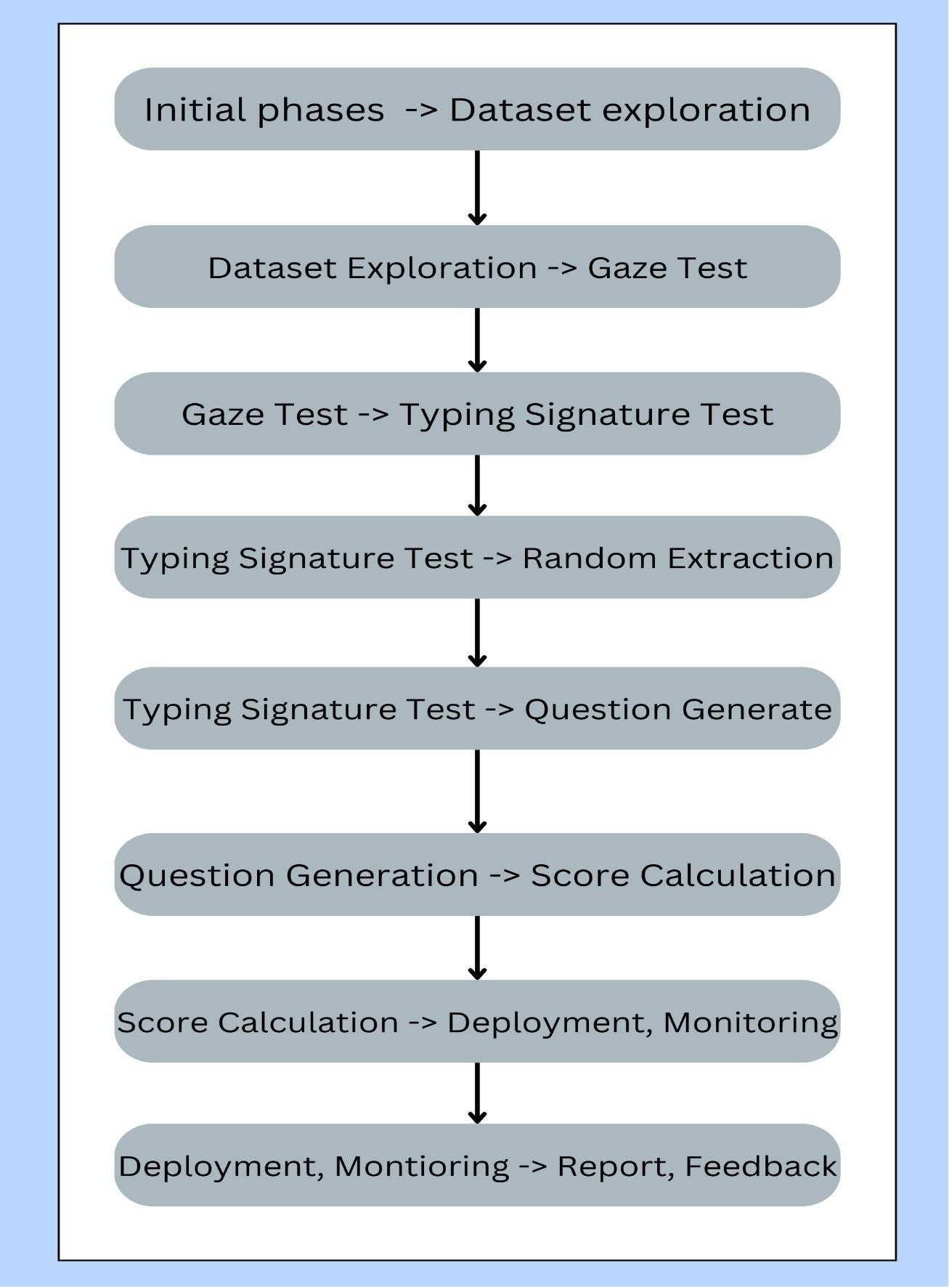

Fig 5.1. Task Network

Timeline Chart
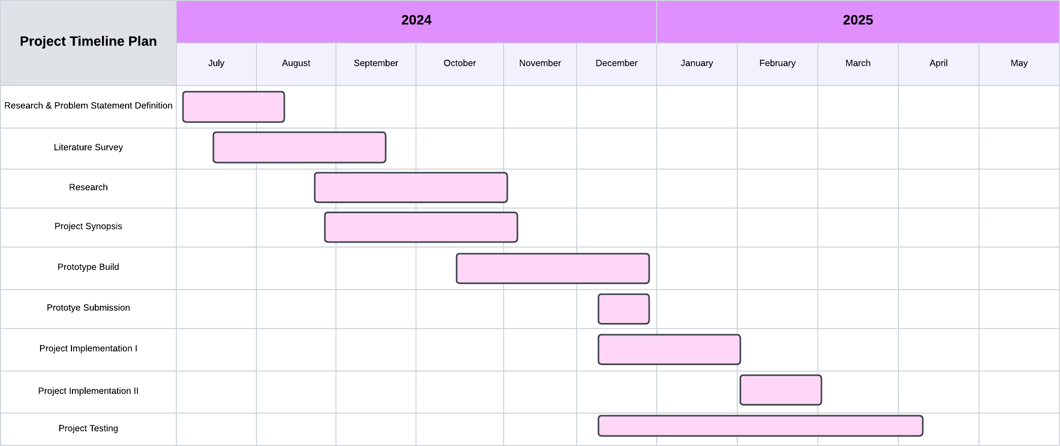
Fig 5.2. Timeline chart

Team Organization

We plan to split the work equally amongst the four of us. We assigned each task a due date. Individual results are ultimately combined into a single result.

6.6.1 Organization of the team

The project's team structure is determined. Roles are established.
Table 5.8: Team Structure

Sr. No. | Name | Role
1 | Darshana Upadhye | Design + Documentation
2 | Suraj Darade | Development + Testing
3 | Aftab Mulani | Development + Testing
4 | Pushkar Jambhulkar | Development + Testing
5 | Sujit Dudhe | Development + Testing

Management, Reporting and Communication

A dedicated team of four developers effectively manages the progress of the Integrated Assessment of Programming Skills using Originality Check project through the following strategies:

Inter-Team Communications:

Virtual platforms (e.g., Slack, Microsoft Teams) are used to maintain continuous communication, allowing developers to collaborate seamlessly, share updates, and quickly resolve any issues that arise.

Mentorship Guidance:

Monthly mentor meetings are scheduled to receive expert advice and guidance on technical challenges, project direction, and solutions to potential bottlenecks. These mentors help the team navigate complex decisions, ensuring the project stays on track.

- Software Requirement Specification (SRS)
  - Introduction

Purpose and Scope of Document
This Software Requirements Specification (SRS) outlines the complete set of requirements for the SkillsBridge: AI-Powered Job Readiness and Career Development Platform. Its purpose is to provide a detailed and shared understanding of what the system is expected to do, how it should operate, and the performance standards it must meet. By acting as a central reference point, this document helps ensure that everyone involved—developers, designers, stakeholders, and end users—has a consistent view of the system’s goals and limitations.
The SRS describes the system’s key objectives, including both functional and non-functional requirements, expected user interactions, workflow processes, and major design considerations. It also captures core capabilities such as resume evaluation, job-role matching, AI-driven mock interviews, performance assessment, and personalized learning recommendations. With a clearly defined set of requirements, this document supports smooth communication across the project team and guides the development process so the final product effectively improves job readiness in a structured, intelligent, and user-focused way

Overview of Responsibilities of Developer
In the SkillsBridge: AI-Powered Job Readiness and Career Development Platform, developers are responsible for several key tasks:

Requirement Analysis:

Developers work closely with stakeholders—such as project mentors, domain experts, and potential users—to understand and refine the system’s requirements. This involves clarifying expectations for features like resume analysis, skill extraction, job-role matching, AI-driven mock interviews, and performance evaluation. They ensure that all functional and non-functional requirements are well-defined, practical, and aligned with both user needs and industry standards.

- System Design:
Design a scalable and modular architecture that supports core functionalities such as resume parsing, NLP-based skill extraction, job description processing, interview question generation, and evaluation workflows. This includes planning database structures, API layers, UI components, and ensuring seamless integration between frontend, backend, and AI models..

- Model Development:
Develop and optimize AI and NLP models required for the platform, including SBERT-based skill extraction, TF-IDF keyword analysis, semantic similarity scoring, and AI-driven interview generation using Mistral. Implement evaluation models using Gemini to assess user responses on accuracy, clarity, and confidence. Ensure high precision and reliability to minimize incorrect skill detection and inaccurate performance assessments.
- Application Development:
Build an intuitive and user-friendly application interface that allows users to upload resumes, view extracted skills, explore matched job roles, participate in mock interviews, and review evaluation feedback. Ensure seamless backend integration to process inputs, generate AI-driven responses, and deliver personalized learning paths in real time.

- Testing:
Perform rigorous testing across all system components, including unit tests for NLP modules, integration tests for backend–frontend communication, and end-to-end evaluations for resume analysis, job matching, and interview simulation. Validate that all functionalities operate accurately and reliably under different user scenarios.

- Documentation:
Prepare comprehensive documentation covering system architecture, functional workflows, API specifications, and guidelines for installation, usage, and maintenance. Develop user manuals for students and administrators to ensure effective utilization of platform features and support future enhancements.

- Maintenance and Support:
Provide ongoing maintenance to address bugs, improve system performance, and ensure compatibility with evolving AI models and job market trends. Implement regular updates to maintain accuracy in skill extraction, job matching, and evaluation processes while supporting users with timely technical assistance.

Usage Scenario
This section provides an overview of common usage scenarios, illustrating how different users will interact with the SkillsBridge: AI-Powered Job Readiness and Career Development Platform and highlighting its core functionalities. These scenarios demonstrate typical user journeys, system behavior, and the role of AI-driven features in enhancing job readiness through resume analysis, job-role matching, mock interview participation, and personalized learning recommendations.

Table 6.1: Use Cases

Sr. No. | Use Case | Description | Actors | Assumptions
1 | User Logs into the Platform | The user navigates to the login page, enters valid credentials, and successfully accesses the dashboard. | Student, Instructor | The user has a valid registered account and remembers their login credentials.
2 | Student Submits a Coding Assessment | The student accesses an assigned coding assessment and solves the problem using the integrated coding interface with optional voice input support. | Student | The assessment is active, and the coding environment is fully functional.
3 | Instructor Reviews Submission | The instructor evaluates the student’s submitted solution, provides comments, feedback, and assigns grades. | Instructor | The instructor is logged into the system and has access to the student's submissions.
4 | Dynamic Question Generation | The system automatically generates coding questions dynamically to evaluate the student's conceptual understanding. | System, Student | The system has access to the student’s previously submitted code or performance data.
5 | Code Similarity Check | The system performs similarity analysis by comparing the student's submitted code against a real-time database to ensure code originality. | System, Student | The similarity-checking tool (e.g., STRANGE) is integrated and functioning correctly.

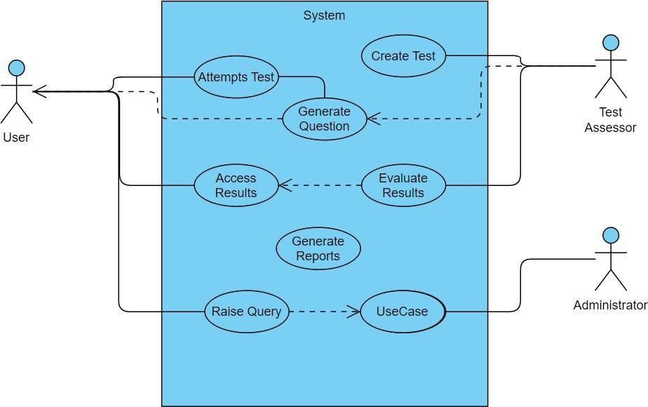

Fig 6.1. Use case diagram

Use Case View

• SkillBridge System is at the center, representing the core functionalities of the platform.
• Each use case is represented as an oval and is connected to the relevant actors, depicted as stick figures.
• End User (Student / Job Seeker) can initiate the following use cases :

• Upload Resume:
Users upload their resume to enable NLP-based skill extraction and analysis.
• View Extracted Skills:
Users can see the technical and soft skills identified from their resume.
• Explore Job Matches:
Users view ranked job recommendations based on semantic similarity between their skills and real-time job descriptions.
• Attempt Mock Interview:
Users participate in an AI-driven mock interview generated by the Mistral model.
• View Interview Evaluation:
Users receive AI-generated feedback on their interview performance based on accuracy, communication ability, and confidence.
• Access Learning Path:
Users view a personalized skill-development roadmap designed to address identified gaps.

• Provide Feedback:
Users give feedback on job matching accuracy, interview relevance, and overall system usability.

Data Model and Description

    - Data Description

The data handled by the SkillsBridge System includes various forms of user input, AI-generated outputs, evaluation metrics, and interaction logs. These data objects are essential for ensuring accurate skill extraction, job-role matching, mock interview processing, and personalized learning path generation. The key data elements are described below:
1. User Profile:
Contains user-specific information such as name, email, education details, experience, and authentication data. This enables personalized recommendations and progress tracking.
2. Resume Data:
Raw resume files and extracted textual content obtained through NLP processing. This includes identified skills, projects, experience summaries, and relevant keywords derived from SBERT and TF-IDF models.
3. Job Description Data:
Details of job roles collected from external job portals, including required skills, experience levels, job responsibilities, and semantic vectors used for matching.
4. Interview Responses:
User responses during AI-driven mock interviews, stored as text transcripts or audio-to-text conversion outputs. This data is analyzed by evaluation models for accuracy, communication, and confidence.
5. Evaluation Report:
AI-generated assessment of the user’s interview performance, including scores, qualitative feedback, improvement suggestions, and readiness indicators.
6. Learning Path Data:
Personalized skill-development recommendations derived from performance evaluations and skill-gap analysis. Includes suggested topics, difficulty levels, and progression timelines.
7. User Feedback:
Feedback provided by users regarding job match accuracy, interview relevance, system usability, and evaluation fairness. This data helps improve platform performance.
8. System Logs:
Log files capturing server actions, API calls, errors, model processing times, and system events. These logs are essential for debugging, performance monitoring, and maintaining platform reliability.
.

Data Flow Diagram
    - Level 0 Data Flow Diagram
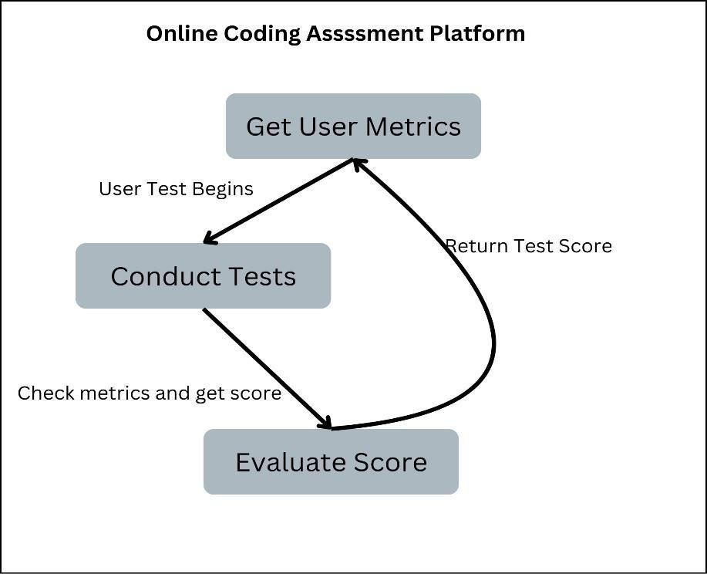
Fig 6.2. Level 0 Data Flow Diagram

Level 1 Data Flow Diagram

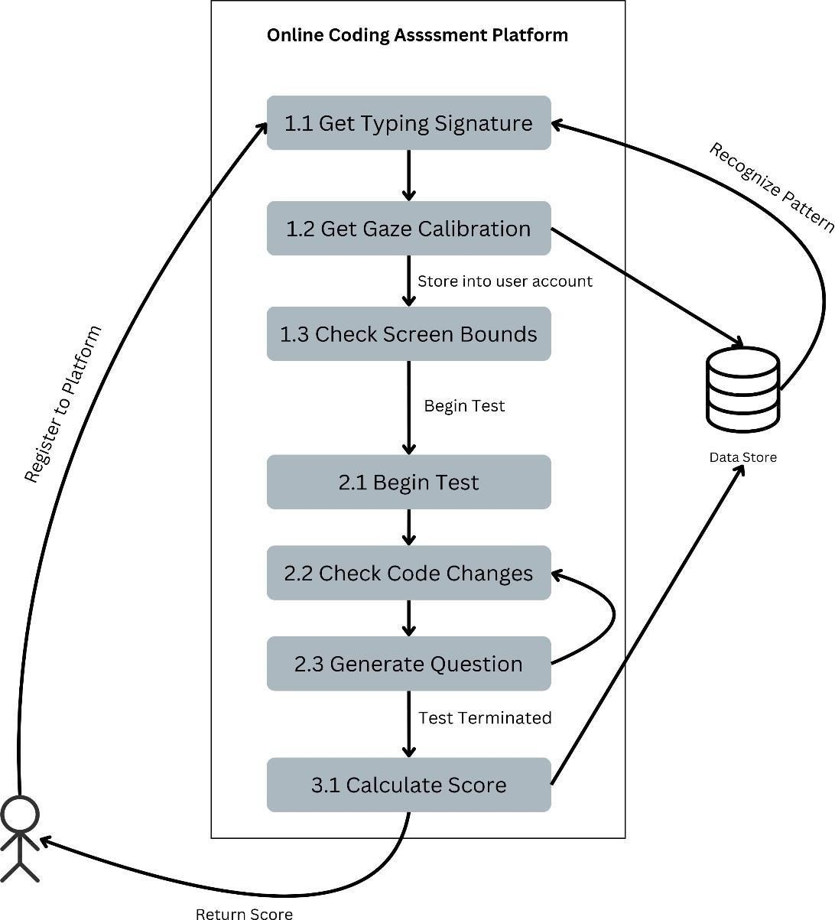

Fig 6.3. Level 1 Data Flow Diagram

tware sof

Activity Diagram:

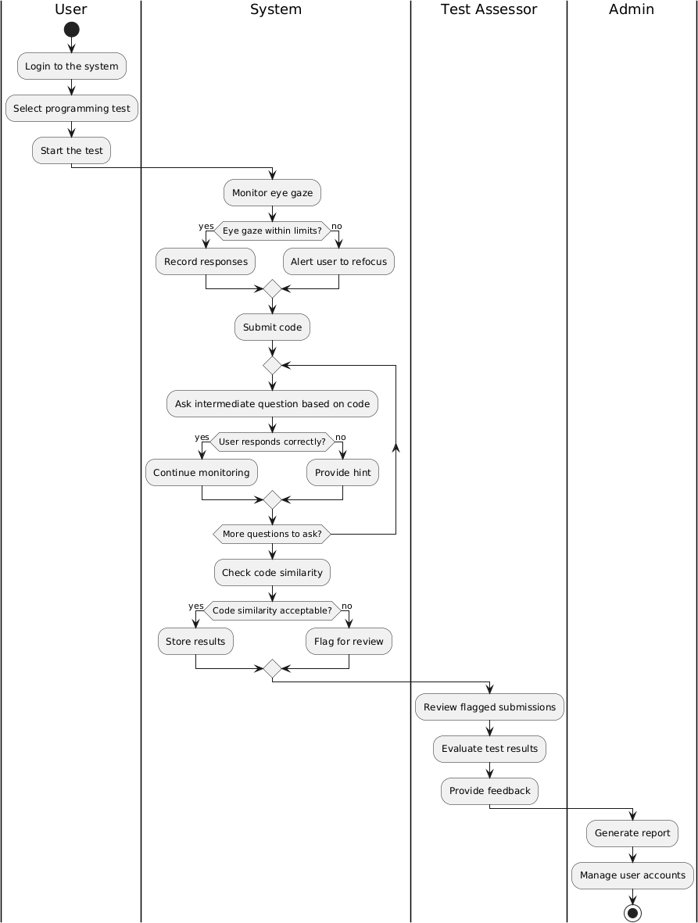
Fig 6.4. Activity Diagram

  - Non-Functional Requirements

Interface Requirements
• The SkillBridge platform should provide an intuitive and user-friendly interface, enabling users to upload resumes, view extracted skills, explore job matches, and participate in mock interviews with ease.
• The system must be fully responsive and accessible across various devices, including desktops, tablets, and mobile phones.
• Clear error messages should be displayed for unsupported file formats, incomplete inputs, or server-side issues to guide users effectively.
• The interface should offer smooth navigation between modules such as resume analysis, job recommendations, interview simulations, and learning paths.

Performance Requirements
• The system must process resume uploads and generate skill extraction results within a short time frame, ideally within a few seconds for at least 90% of requests.
• Job-role matching and recommendation generation should be optimized to ensure efficient retrieval even when handling large job datasets.
• AI-driven mock interviews and evaluations should respond with minimal latency to maintain a realistic and interactive user experience.
• The platform must support a high volume of concurrent users (minimum 100–200 simultaneously) without degrading performance.
• System uptime should be maintained at 99.5% or higher to ensure continuous accessibility for students and job seekers.

s State Diagram

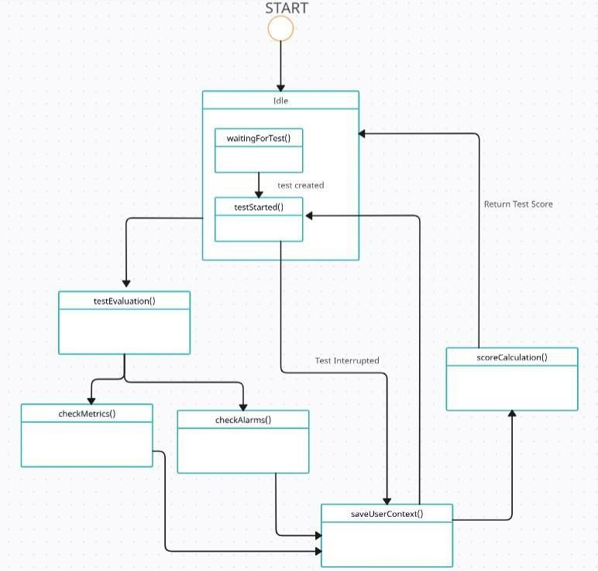
Fig. 6.5. State Diagram

Detailed Design Document using Appendix A and B

Introduction
This document outlines the design used to address the problem of cheating in coding assessments using eye-gaze detection, code similarity and typing signature techniques. The Integrated Assessment of Programming Skills using Originality Check processes user-submitted videos and identifies whether they have been manipulated using advanced deepfake techniques. This section introduces the overall design structure, laying the foundation for more detailed sections on architecture and data handling, with references to Appendix A (Data Flow) and Appendix B (ER Diagram).

Architectural Design

The architectural design provides a high-level overview of the Integrated Assessment of Programming Skills using Originality Check. The system architecture is divided into three major components: Candidate, Test Assessor, and System. These components are interconnected and manage data flow from the user’s video upload to the generated analysis result.

Key elements:

- User Interface (UI):

  - The UI handles user interactions, including video upload, result display, and feedback submission. It supports multiple devices (desktop, mobile) and ensures a smooth user experience, as described in Appendix A.

Processor:

  - This module processes the uploaded video by performing necessary preprocessing steps such as frame extraction, resizing, and normalization. It

ensures that the video data is formatted correctly before being analyzed by the detection model.

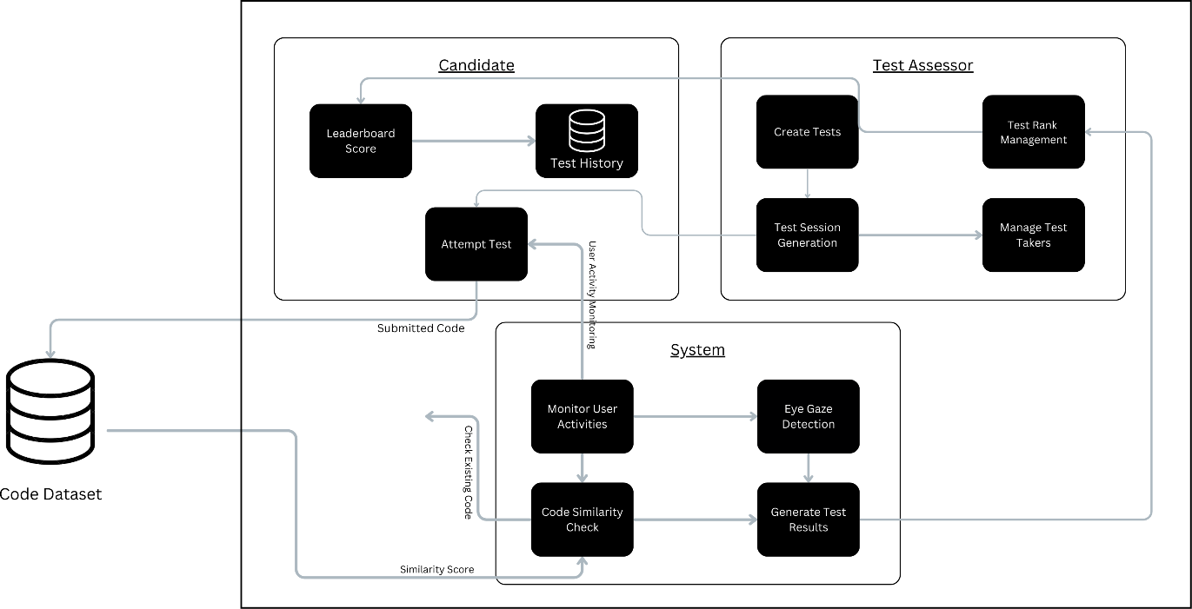

Fig 7.1. Architecture Diagram

Component Design

    - Class Diagram

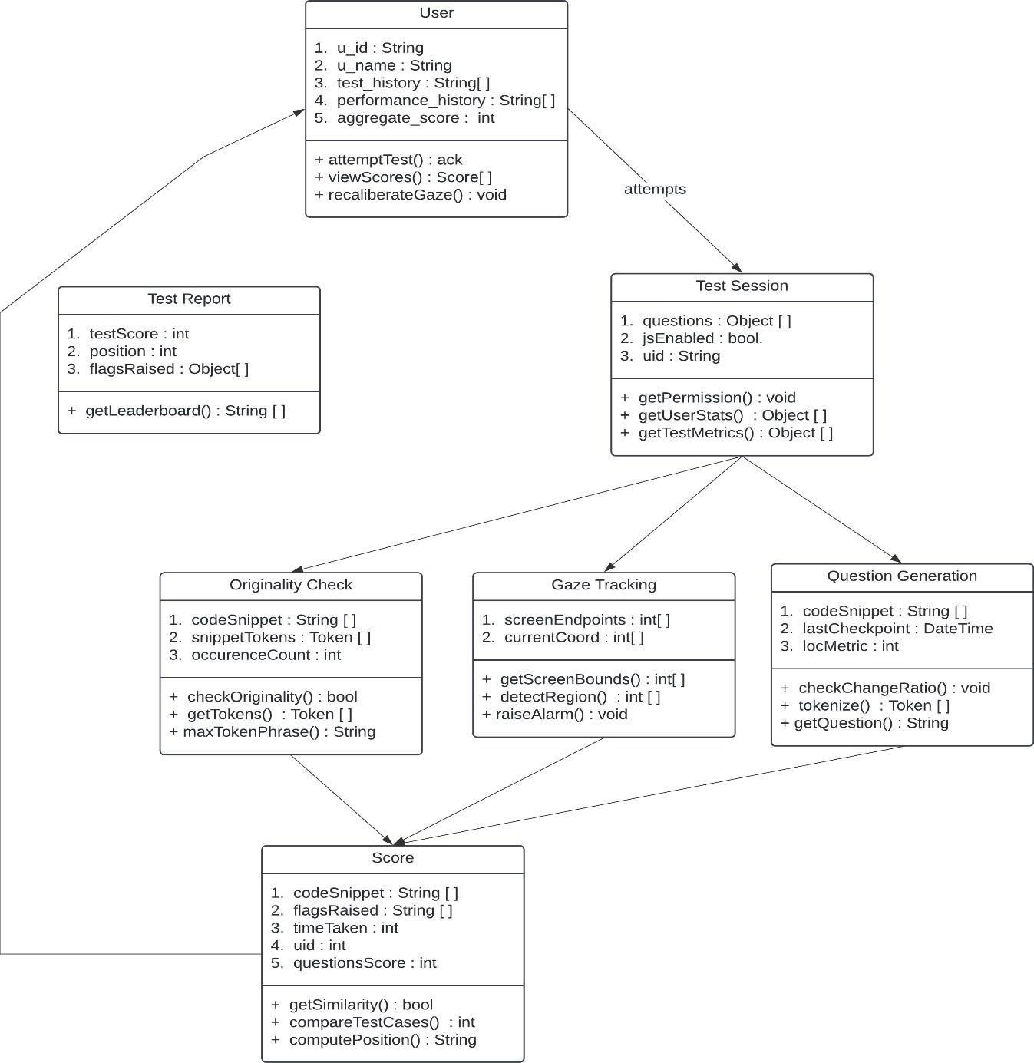

Fig 7.2 Class Diagram

Project Implementation

Introduction

The implementation of the Integrated Assessment of Programming Skills using Originality Check involves the use of state-of-the-art tools and technologies to build a reliable, scalable platform that provides better code authentication and candidate. This section outlines the tools, technologies, and deep learning models used to implement the project, followed by detailed methodologies on how the system components were developed and integrated.

Tools and Technologies Used

The implementation of this project relies on a variety of tools and technologies to ensure functionality, scalability, and ease of use. These include:

- Frontend: ReactJS for building a responsive and interactive user interface.
- Backend: NodeJS and ExpressJS for handling server-side operations and API integrations.
- Database: MongoDB for managing candidate records, test data, and storing code submissions.
- Machine Learning: Python for implementing code similarity checks and user activity monitoring models.
- Cloud Infrastructure: AWS for hosting the platform and ensuring reliable, scalable performance.
- Other Tools: WebSocket (for real-time updates), Docker (for containerization), and Jenkins (for CI/CD).

Methodologies/Algorithm Details

To assess the candidate’s activities and provide better code judegment, the Integrated Assessment of Programming Skills using Originality Check employs several algorithms focusing on gaze detection, frame analysis, typing signature analysis.

Algorithm 1/Pseudo Code – Question Generation

- At each checkpoint, check if content is changed significantly.

  - If yes, pass the changed content to a summarizer, and generate a question with context.
  - Stop test timer until the question interval ends.

- Update test score based on the answer.

- Set checkpoints for the previous question generation line of code.
- If no, continue.

Algorithm 2/Pseudo Code – Code Similarity

This algorithm monitors candidate’s activity during tests to detect potential cheating through gaze tracking and interaction patterns.

Pseudo Code:

- Start

- Check user system support for webcam.

- Begin GazePointer stream for eye-tracking.

- Get user screen bounds by calculating Xmin, Xmax, Ymin, Ymax.

- Calibrate eye-tracking for current user environment.

- At interval of 5 seconds, check gaze position on the screen.

- If gaze co-ordinates exceeds screen boundary beyond the threshold, raise flags.

- Stop

    - Algorithm - Gaze Detection

This algorithm monitors candidates' activity during tests to detect potential cheating through gaze tracking and interaction patterns.
Pseudo Code:

- Start

- Check user system support for webcam.

- Begin Gaze Pointer stream for eye-tracking.

- Get user screen bounds by calculating Xmin, Xmax, Ymin, Ymax.

- Calibrate eye-tracking for current user environment.

- At interval of 5 seconds, check gaze position on the screen.

- If gaze co-ordinates exceeds screen boundary beyond the threshold, raise flags.

- Stop

Software Testing

Type of Testing Used

To ensure the reliability and functionality of the Online Assessment Platform, various testing methodologies were employed at different stages of development:

Unit Testing:

  - Objective: Test individual functions and components in isolation to verify their correctness.
  - Example: Testing the function that processes and collects candidate activities properly before submission.

Integration Testing:

  - Objective: Ensure that different modules (e.g., Eye gaze detection, Similarity check, Question generation) work together seamlessly.
  - Example: Verifying that the user interface successfully accepts user code, and analyzes the submissions and candidate activities.

System Testing:

  - Objective: Test the entire Online Assessment Platform as a whole, simulating real-world usage scenarios to validate overall functionality.
  - Example: Ensuring the system can handle multiple users simultaneously and provide accurate assessment results within acceptable time limits.

Performance Testing:

  - Objective: Assess the system’s performance, particularly when processing complex videos or handling multiple requests at the same time.
  - Example: Evaluating the system's response time when multiple users submit for code compilation, ensuring that performance remains acceptable.

User Acceptance Testing (UAT):

  - Objective: Ensure that the system meets user expectations and requirements by involving actual users in the testing process.
  - Process: Real users, such as college candidates and IT professionals, tested the system by checking for correctness and authenticity for analysis and providing feedback on usability and accuracy.
  - Feedback: Collected feedback was used to refine the user experience, enhance functionality, and improve assessment metrics based on user interactions.

Test Cases and Expected Output

Table 9.1: Test Cases and Expected Output

Test Case ID | Description | Input | Expected Output
TC- 01 | Check if the system accepts valid user credentials | Username & Password | User authenticated
TC- 02 | Check system response for invalid user credentials | Invalid Username/Password | Authentication failure
TC- 03 | Verify the test initiation process | Click on "Start Test". | Test is initiated
TC- 04 | Verify the originality check process | Submit a copied answer | Originality check fails
TC- 05 | Verify originality check for original answers | Submit original answer | Originality check passes
TC- 06 | Test eye gaze tracking activation after test start | Start Test | Eye gaze tracking activated
TC- 07 | Verify system behavior when eye gaze tracking fails | Eye gaze tracking fails | System alerts the user
TC- 08 | Check eye gaze tracking accuracy | User consistently looks away | System identifies anomaly

Test Case ID | Description | Input | Expected Output
TC-09 | Validate next question generation | Submit answer to question 1 | Question 2 is generated
TC- 10 | Check question generation for different difficulty levels | Answer easy question correctly | Harder question is generated
TC- 11 | Test submission of all answers | Submit final answer | Test concludes
TC- 12 | Verify report generation after test completion | Test completed | Report generated
TC- 13 | Verify the test metrics calculation | Complete test | Correct metrics in report
TC- 14 | Test report generation when originality check fails | Submit copied answer | Report flags the issue
TC- 15 | Check the consistency of report data | Complete multiple tests | Reports match actual performance
TC- 16 | Verify correct question formats | Start test | Questions have correct format
TC- 17 | Verify time tracking for each question | Answer questions | Time recorded

Test Case ID | Description | Input | Expected Output
TC- 18 | Check system behavior with no internet connection | Disconnect internet during test | System prompts to reconnect
TC- 19 | Test multi-user scenario | Two users start tests | Both tests run independently
TC- 20 | Verify security of test data | Access test data | Data is encrypted and secure
TC- 21 | Check system response to unusual user inputs | User submits blank answer | System alerts for incomplete submission
TC- 22 | Verify test time extension request handling | Request for extra time | Time extension granted/refused based on criteria
TC- 23 | Validate question shuffling mechanism | Start test multiple times | Questions appear in different order each time
TC- 24 | Verify system logs for test activity | Complete test | Logs show correct sequence of events
TC- 25 | Check response to invalid input formats | Submit invalid data format | System rejects the input

Test Case ID | Description | Input | Expected Output
TC- 26 | Verify screen recording functionality (if applicable) | Start test | Screen recording activates
TC- 27 | Validate retaking a test after completion | Complete test | User is allowed/disallowed to retake
TC- 28 | Check system response when a question is skipped | Skip question | System prompts user
TC- 29 | Verify completion of partially submitted test | Partially submit answers | System saves answers and allows resumption
TC- 30 | Verify email notification after test completion | Complete test | User receives test completion email

Results

Screenshots

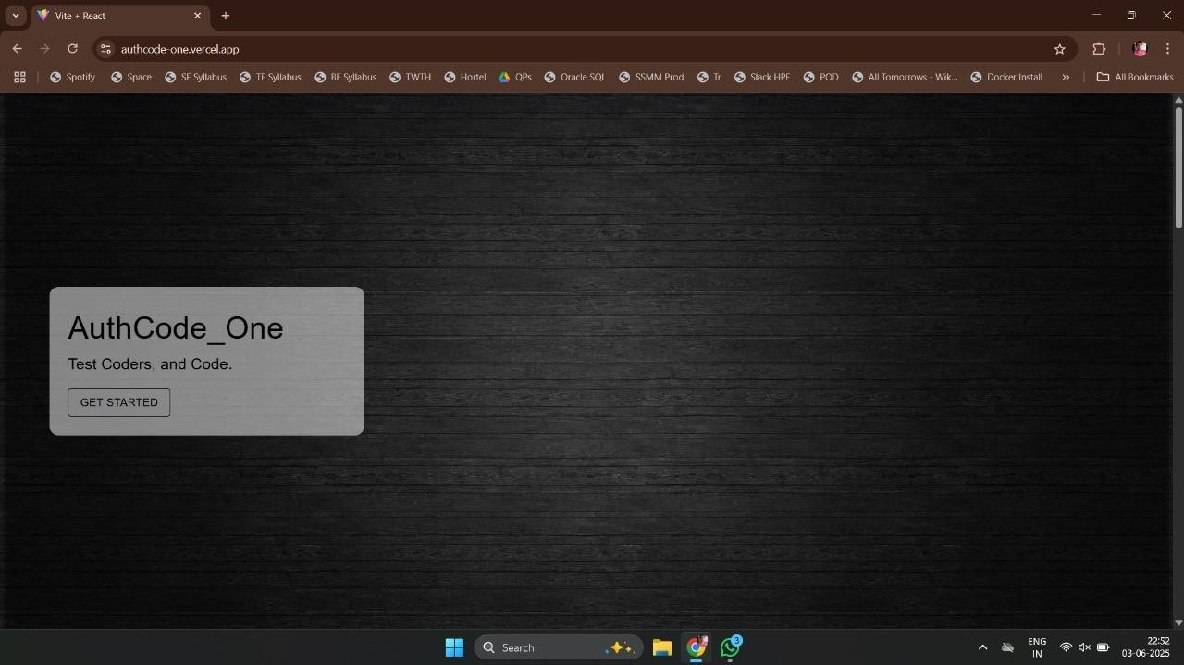

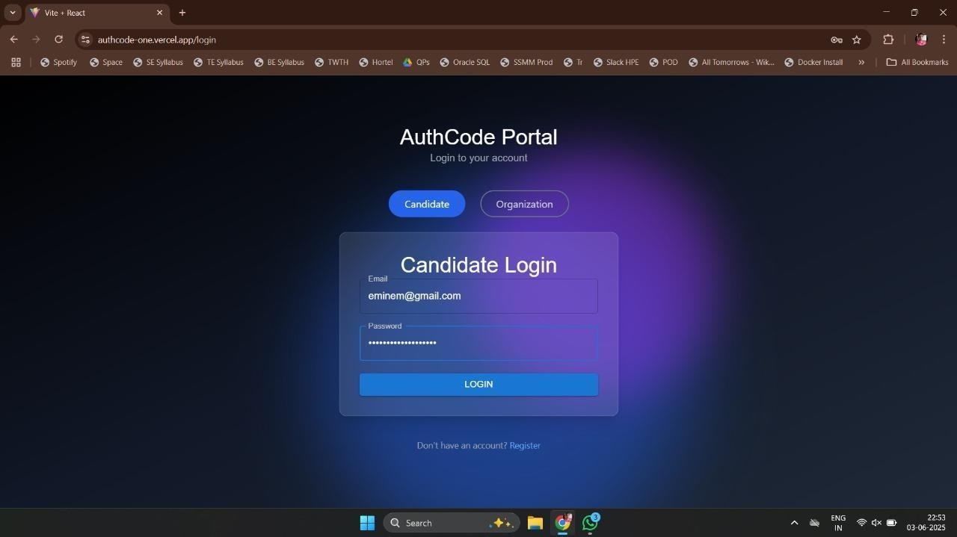

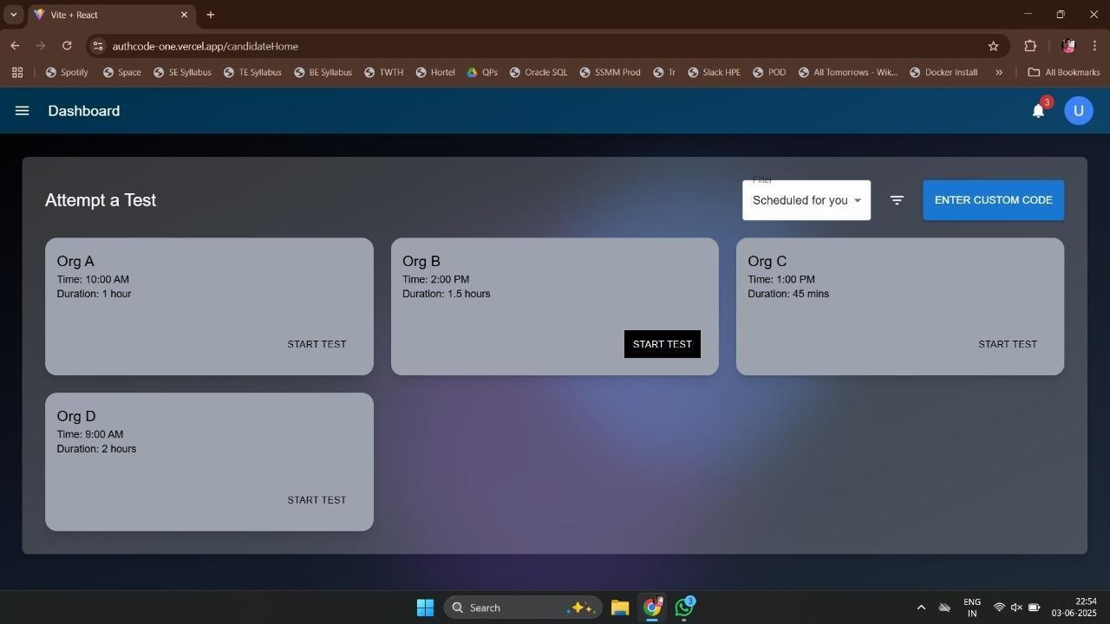

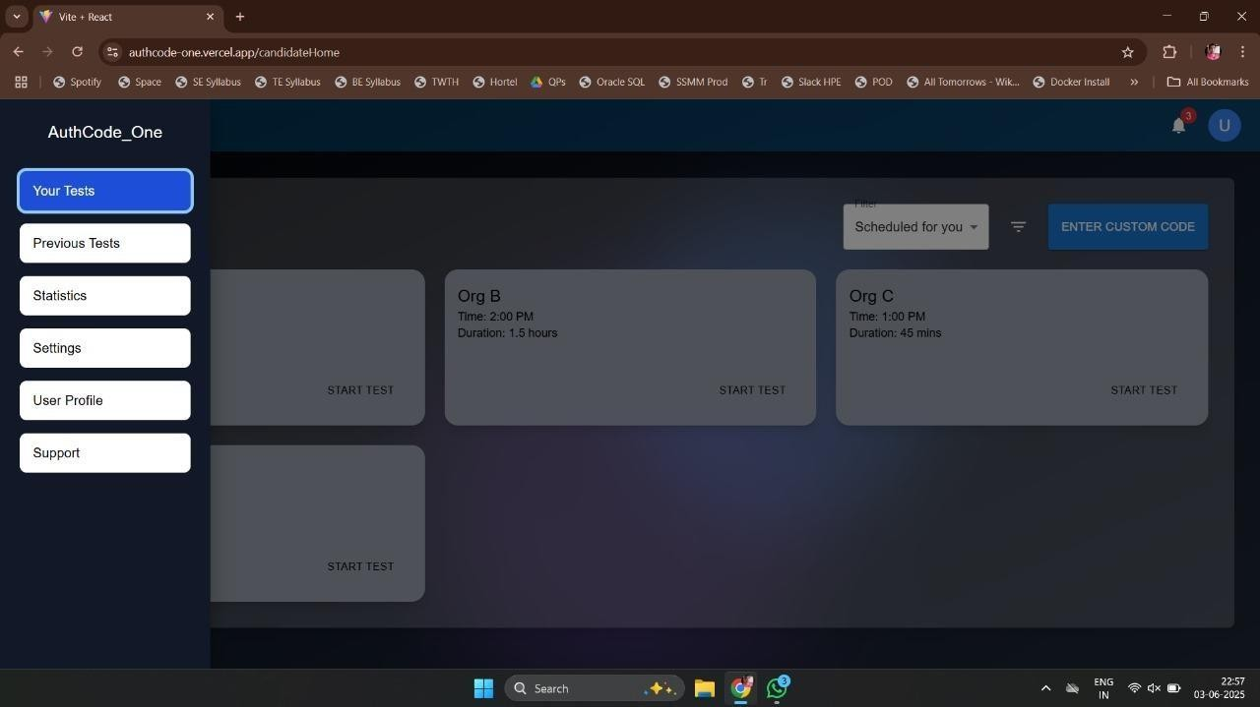

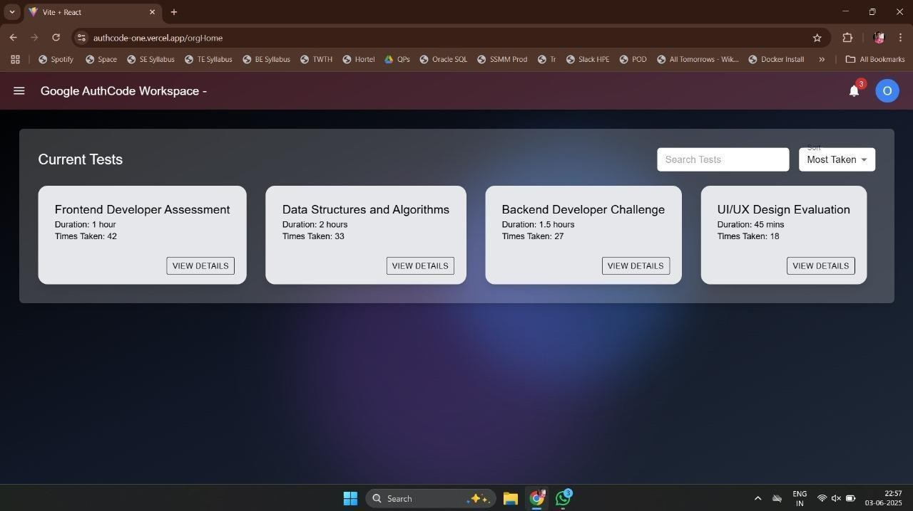
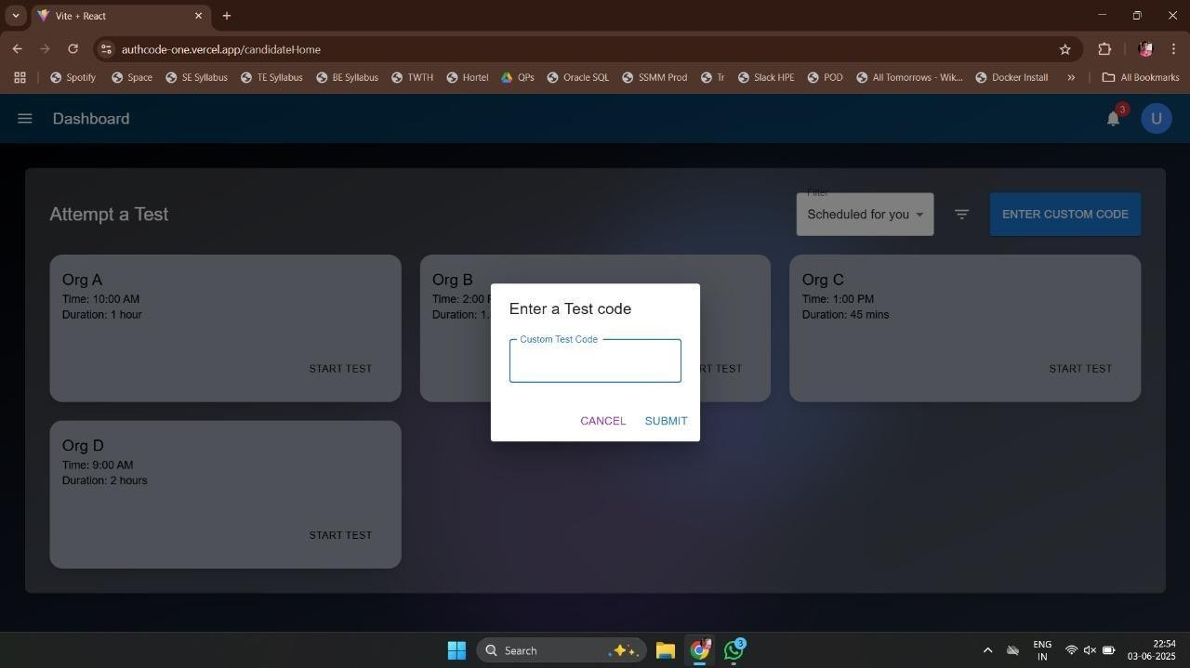

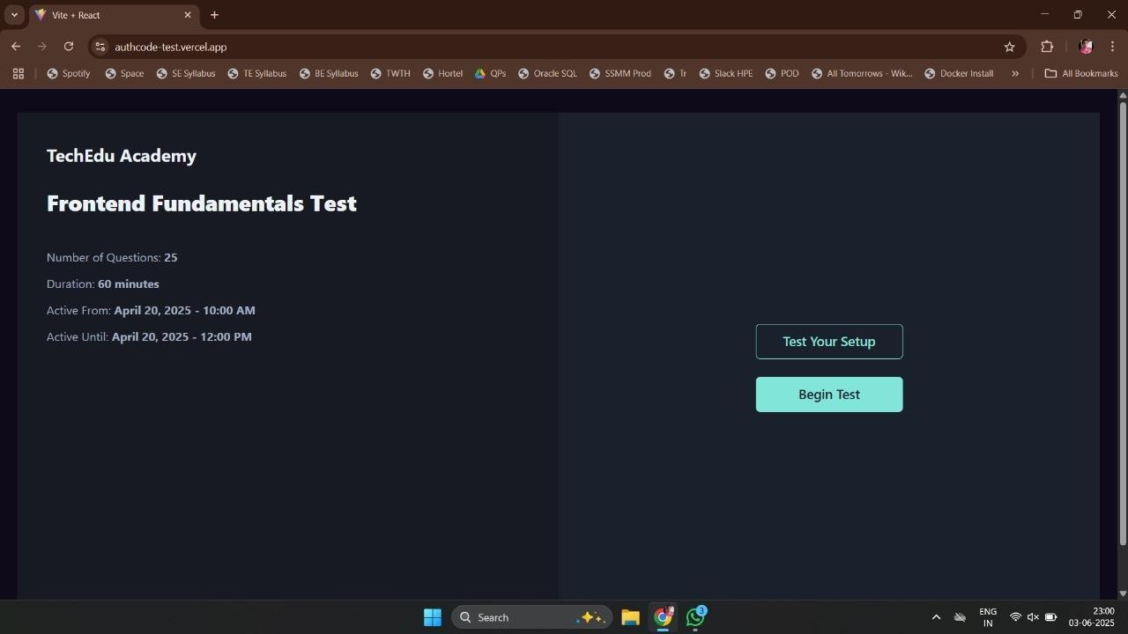
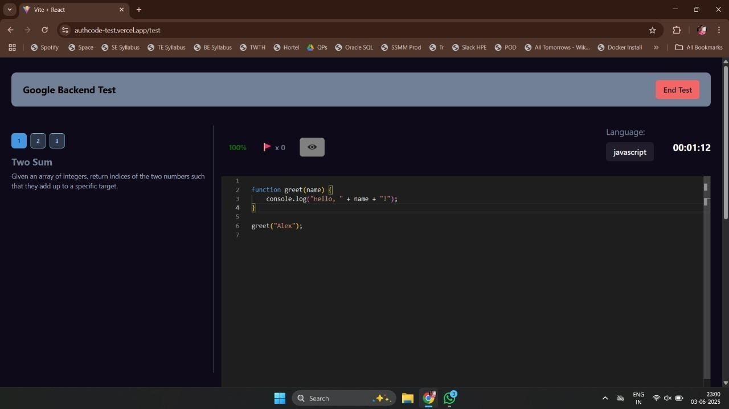

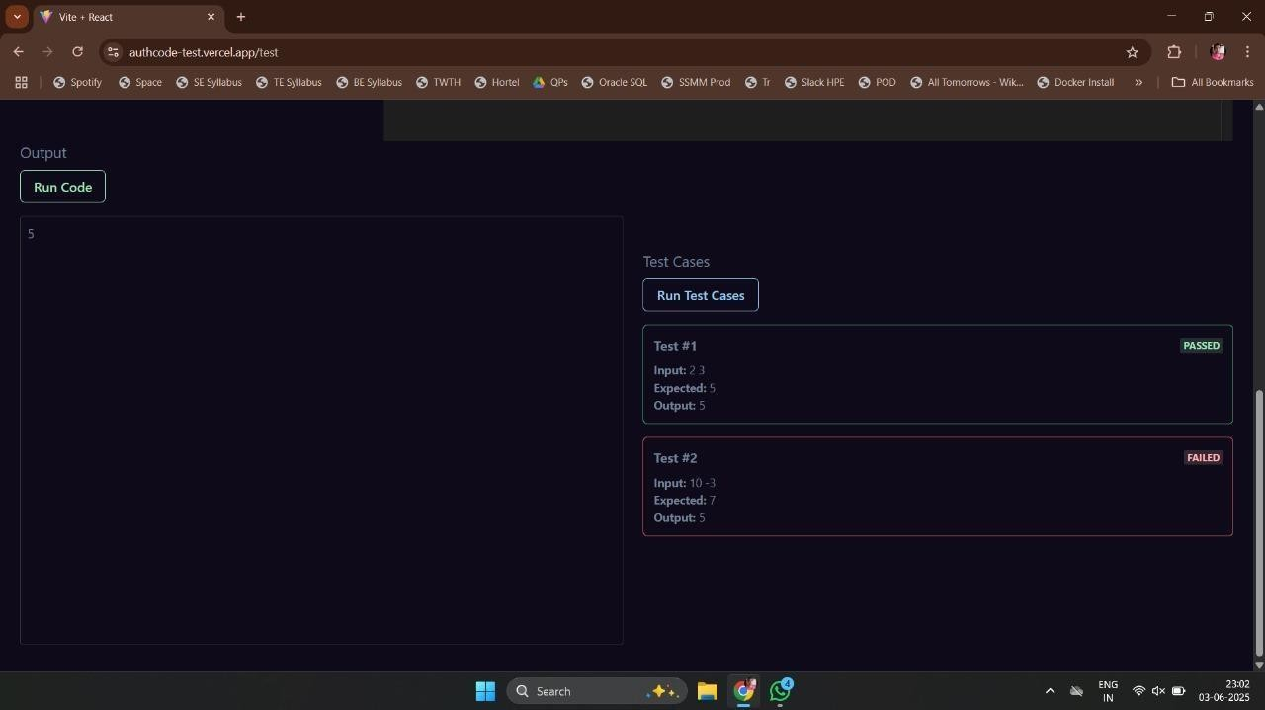
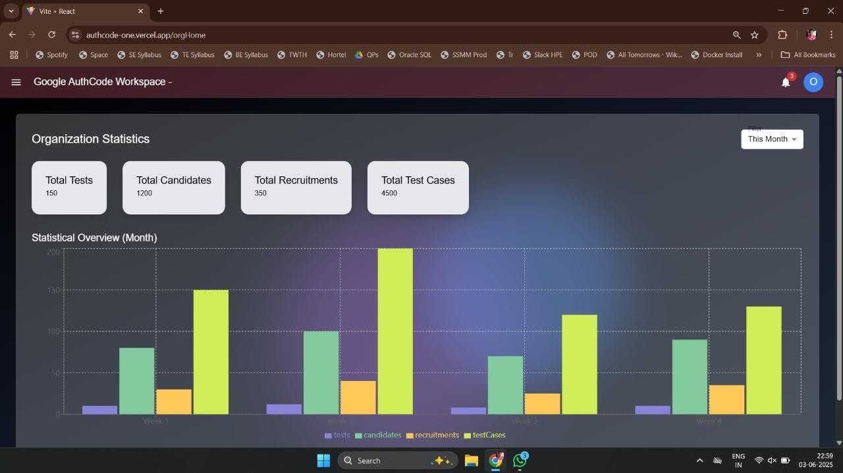

Deployment and Maintenance

Installation and Uninstallation

Installation Steps:

- 1. Make a copy of the repository: https://github.com/your-repo/project-name.git git clone
- Go to the directory for the project: CD project name
- Configure the backend: Go to the directory for the backend. Add environment variables like these to a .env file:

JWT_SECRET=your_jwt_secret MONGO_URI=mongodb://localhost:27017/project_db

- Install dependencies:
npm install

  - Run the backend server:
npm start

Set up the frontend:
  - Navigate to the frontend directory.
  - Install dependencies:
npm install

  - Start the React development server:
npm start

Machine Learning Model Setup:
  - Ensure Python environment is configured.
  - Install required Python packages using:
pip install -r requirements.txt

  - Run the ML server (if it’s a Flask or FastAPI-based model):
python app.py

Uninstallation Steps:

- Stop all servers and processes.
- Delete the local project folder.
- Drop the MongoDB database using MongoDB Compass or CLI:

use project_db
db.dropDatabase()

- Uninstall dependencies if needed using npm uninstall or pip uninstall.

User Help

Help Features in the App:
  - Tooltips on hover to guide users through form fields.
  - Validation messages for incorrect or missing inputs.
  - Admin dashboard for monitoring submissions and results.

Documentation:
  - A comprehensive README.md file with setup, usage, and troubleshooting.
  - In-code comments for backend API routes and frontend component logic.

Support:
  - Users can raise issues via GitHub or contact developers via email (see Appendix).

Conclusion and Future Scope

Conclusion
In conclusion, this integrated coding assessment system enhances the integrity, fairness, and reliability of online evaluations by combining advanced plagiarism detection and eye-gaze tracking. By addressing malpractices such as code plagiarism and unauthorized resource usage, the system ensures that candidates are fairly evaluated based on their true skills, while also maintaining privacy and ethical standards. This approach not only promotes originality and honesty in coding assessments but also adapts to evolving cheating techniques, making it a valuable tool for institutions and organizations.

Future Scope
The Online Programming Assessment Security System can be enhanced with several features to further improve its effectiveness and accessibility:

- Integration with Learning Management Systems (LMS): Collaborating with popular LMS platforms (e.g., Moodle, Canvas, Blackboard) to allow seamless integration and monitoring during online exams or coding assignments, making it easier for educators to implement the system within their existing infrastructure.

- Enhanced Behavioral Monitoring: Expanding the behavioral analytics to include other forms of monitoring, such as keystroke dynamics, mouse movements, and screen activity, to provide a more comprehensive picture of the candidate's actions during assessments.

- Adaptive Cheating Detection Models: Integrating advanced machine learning techniques (e.g., reinforcement learning) to dynamically adjust detection algorithms based on real-time user behavior and detected patterns of cheating, improving accuracy over time.

- Cross-platform Compatibility: Expanding the system’s functionality to support a wider range of devices (e.g., smartphones, tablets, and low-end computers) to ensure that it can be used in diverse settings, including on-the-go assessments and low-resource environments.

- Ethical Framework and Guidelines: Developing a set of ethical guidelines to govern the use of the system, ensuring that it is used responsibly and in compliance with data privacy regulations.

Bibliography

- ReactJS Documentation – https://reactjs.org
- Node.js Documentation – https://nodejs.org
- MongoDB Manual – https://www.mongodb.com/docs/manual/
- Scikit-learn – https://scikit-learn.org
- TF-IDF Algorithm – Wikipedia
- Cosine Similarity – Stanford NLP

References
- Nimesha Dilini, Asara Senaratne, Tharindu Yasarathna, Nalin Warnajith, Leelanga Seneviratne - Detection of Cheating in Browser-based Online Exams Utilizing Eye Gaze Tracking 78-1-6654-2000-6/21/ ©2021 IEEE
- Giora Alexandron, Aviram Berg, Jose A. Ruipérez-Valiente - A Comprehensive Anomaly- Based Approach for Identifying Cheaters in Online Courses - IEEE TRANSACTIONS ON LEARNING TECHNOLOGIES, VOL. 17, 2024
- Benfeng Yu - Development and Implementation of an Objective Question Generation System for Examination Papers Based on a Random Extraction Algorithm 79-8-3503 4271-0/23/31.00
©2023 IEEE
- OSCAR KARNALIM, AND SIMON - Analysis of Code Similarity, Digital Object Identifier 10.1109/ACCESS.2021.3073703

- Akash Budhrani, Upasna Singh, Bhupendra Singh - Investigating Attached USBs: A Study of Windows 11 Artifacts, DOI: 10.1109/ICONAT57137.2023.10080101

- Daniel Septianto, Lukas, Bagus Mahawan - Forensic Analysis of USB Flash Drives to Identify Crown Jewel Data Breaches in PT. XYZ (Coffee Shop Retail - Case Study), DOI: 10.1109/ICoICT52021.2021.9527419

- Baluprithviraj.K.N, Monesh.M.S, Pranesh Raj.C, Varuna.S - Student Activity Tracking System Based on Application Programming Interface (API), DOI: 10.1109/ICAISS55157.2022.10010843
- Paper from the 2021 6th International Conference on Information Technology Research
(ICITR), ”978-1-6654-2000-6/21/©2021 IEEE — DOI: 10.1109/ICITR54349.2021.9657277,”

- Haotian Li, Min Xu, Yong Wang, Huan Wei, and Huamin Qu. A Visual Analytics Method to Enhance the Proctoring of Online Exams. In Proceedings of the 2021 CHI Conference on Human Factors in Computing Systems, pages 1–17, 2021

Laboratory Assignments on Project Analysis of Algorithmic Design
Table: IDEA Matrix

Category | Increase/Improv e (I-) | Drive/Delive r (D-) | Educate/Evaluate (E-) | Accelerate/Associat e (A-)
Automation & Detection | Increase the | Drive innovation by integrating real-time eye-gaze tracking and behavioral analytics into the assessment  process. |  | Accelerate detection capabilities by leveraging cloud computing for real- time data  processing and analysis.
 | accuracy and |  | Educate users
 | efficiency of |  | (candidates,
 | code similarity  detection using optimized |  | evaluators) on how  cheating detection algorithms work
 | algorithms (e.g., |  | and their
 | AST, |  | importance.
 | Levenshtein).
 | Improve the | Deliver a robust system that ensures secure and smooth online assessments without significant delays or interruptions  . | Evaluate user  feedback to continuously improve the UI and interaction flow of the platform. | Associate with
 | interface to |  |  | existing online
 | provide a |  |  | education
User | seamless, |  |  | platforms to
Experience | intuitive |  |  | integrate the
 | experience for |  |  | system for broader
 | both candidates |  |  | use across
 | and evaluators. |  |  | institutions.
 | Increase the | Drive | Educate users on | Accelerate the use
Cheating | system's ability | adoption by | how the system | of multi-factor
Detection | to detect subtle | delivering | detects cheating | authentication and
 | cheating | accurate and | and the ethical | biometric

 | behavior (e.g., external device usage) through enhanced anomaly detection. | reliable cheating risk scores that reflect both code originality and focus  metrics. | considerations of maintaining academic integrity. | verification to enhance cheating prevention.
Real-Time Monitoring |  | Deliver real- | Evaluate the  effectiveness of real-time monitoring by gathering feedback on false  positives/negatives  .
 | Improve eye- | time insights
 | gaze tracking | into |  | Associate with
 | accuracy and | candidate |  | hardware and
 | responsiveness  under varying environmental | focus and  attention during |  | camera technology  providers to ensure compatibility with
 | conditions (e.g., | assessments |  | diverse setups and
 | lighting, camera | to flag |  | conditions.
 | angle). | suspicious
 |  | activity.
Performanc e &  Scalability |  | Drive |  | Associate with cloud providers for scalable infrastructure to handle spikes in demand and ensure uptime.
 |  | platform
 | Improve system | performance | Evaluate system
 | scalability to | by | performance
 | handle large volumes of real- time data,  particularly | optimizing backend algorithms  for quicker | through real-time testing and gather performance  metrics to
 | during peak | data | continuously
 | testing periods. | processing | refine the solution.
 |  | and faster
 |  | assessments.

Laboratory assignments on Project Quality and Reliability Testing of Project Design

Integrated Programming Skill Assessment

- Test cases execution
- Functional correctness
- Code efficiency (time/space complexity)

b. Originality/Plagiarism Detection

- Token-based, AST-based, or ML-based comparison
- Tools: MOSS, JPlag, or custom comparison algorithms

c. Machine Learning Usage

- Features extracted: token count, identifier similarity, structure match
- ML models: Decision Tree, SVM, or Neural Network to classify originality
- Dataset creation and labeling (e.g., original vs plagiarized)

Tools and Technology
- Frontend: React.js
- Backend: Node.js, Express.js
- Database: MongoDB
- ML: Python (scikit-learn / TensorFlow / PyTorch)
- Code Execution: Online judge or Docker-based container execution
- Plagiarism Detection: Custom AST comparator / JPlag API / MOSS

Experiments

Experiment 1: Program Submission and Auto-Evaluation

- Aim: To evaluate the correctness of user-submitted code.

Procedure:
  - Accept code in multiple languages (e.g., Python, C++).
  - Compile and run it against test cases.
  - Return pass/fail, and runtime/output.
- Expected Output: List of passed/failed test cases.
- Tools: Docker or code runner backend
- Result Screenshot: Include UI and backend logs

Experiment 2: Code Similarity & Originality Detection

- Aim: To detect plagiarism in programming code.

Procedure:
  - Extract code features (structure, variable names, control flow).
  - Compare with existing submissions.
  - Calculate similarity score.
- Tools: Custom Python script / MOSS / JPlag
- Expected Output: Similarity percentage + highlighted areas
- Result: Pie chart of originality results

Experiment 3: ML Model for Originality Classification

- Aim: To classify whether a submission is original or plagiarized using ML.

Procedure:
  - Prepare dataset (labelled original/plagiarized).
  - Extract features: token match %, edit distance, syntax tree similarity.
  - Train classifier (e.g., Logistic Regression or SVM).
  - Test model on unseen data.
- Result: Accuracy, confusion matrix, precision/recall.
- Tools: scikit-learn / pandas / matplotlib
- Screenshot: Jupyter notebook training output

Observations & Results
- Code correctness accuracy: XX%
- Originality detection precision/recall: XX%
- ML classification accuracy: XX%
- Pie charts or graphs showing originality distribution

Project Planner

Title: Integrated Assessment of Programming Skills using Originality
Duration: ~8–10 Weeks (can be adjusted based on academic schedule)

Weekly Milestone Plan

Week 1: Requirement Analysis Define goals and features.
Research existing tools like MOSS, JPlag.
Prepare Software Requirements Specification (SRS).

Week 2: System Design
Design overall system architecture (Frontend–Backend–ML). Create database schema (users, submissions, results).
Decide how code execution and evaluation will be handled.

Week 3: Frontend Setup Initialize React project. Build UI for:
User registration/login Code editor for submission Submission history
Use Tailwind CSS for styling.

Week 4: Backend Development – Part 1 Set up Node.js backend.
Implement APIs for:
User authentication (JWT) Code submission
Setup code execution environment using Docker or Judge0 API.

Week 5: Backend Development – Part 2 Store submissions and detect similarity.
Implement plagiarism detection logic (custom logic, JPlag, or MOSS integration).

Week 6: ML Model Development
Create or gather dataset with original and plagiarized code. Extract features like:
Token similarity Identifier match AST structure
Train ML model (SVM/Random Forest/Logistic Regression). Evaluate accuracy, precision, recall.

Week 7: Integration and Testing Integrate ML model with backend.

Test full pipeline: submission → evaluation → originality check.
Handle errors and edge cases.

Week 8: UI/UX Improvements Enhance result view with:
Pass/fail status Originality score Similarity highlights
Make UI responsive and accessible.

Week 9: Documentation & Finalization Prepare:
Final report User manual
Presentation slides
Perform internal demo and fix last bugs.

Week 10: Final Presentation & Submission Deliver final presentation and demo.
Submit source code and documentation.

Reviewers Comments of Paper Submitted

- Paper Title: Integrated Assessment of Programming Skills using Originality Check

Name of the Conference/Journal where paper submitted: NCFCAI

- Paper Status: Submitted, result to be declared (Acceptance/Rejection)

- Review Comments by Reviewer: “Well Written”

- Corrective Actions: - NA

Plagiarism Report

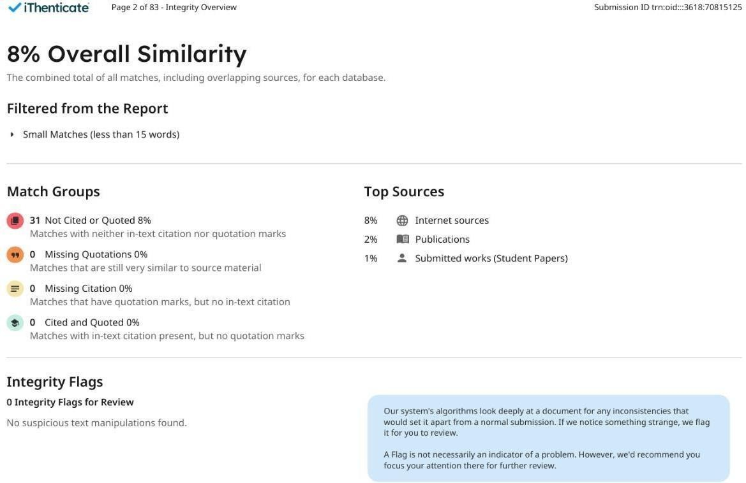

Fig. Plagiarism Report

Term-II Project Laboratory Assignments Title:
Integrated Assessment of Programming Skills using Originality Check

Description:

This project aims to develop an intelligent system for evaluating programming skills by combining automated code assessment with originality detection. The platform enables students to submit programming solutions that are automatically tested for correctness against a predefined set of test cases and evaluated for plagiarism or similarity with other submissions.

The primary objective is to address two core concerns in academic programming assessments:

- Correctness Evaluation – Ensuring the submitted solution is logically and syntactically correct by compiling and executing it against multiple test cases.

- Originality Check – Detecting if the submitted code is copied or plagiarized by comparing it with existing solutions using both rule-based and ML-based techniques.

The originality detection module uses machine learning models trained on extracted features such as token similarity, syntax structure, identifier mapping, and code length. These models classify submissions as either "Original" or "Plagiarized," enhancing the reliability of the evaluation process and reducing manual inspection.

By integrating code execution, result validation, and plagiarism detection into a single platform, the project ensures:

  - Fair grading

  - Academic integrity

  - Scalable assessment for large batches

Python-based machine learning models for originality analysis, Node.js and Express for the backend, React.js for the frontend, and MongoDB for data storage are all used in the system's construction

Information of Project Group Members

Name: Darshana Manoj Upadhye

- Date of Birth: 17/02/2004

- Gender: Female

- Permanent Address: Wakad, Pune.

- E-Mail: dmupadhye17@gmail.com

- Mobile/Contact No.: +919309940365

- Placement Details: In progress

- Paper Published: Result Awaited

Information of Project Group Members

Name: Suraj Narayan Darade

- Date of Birth: 17/05/2003
- Gender: Male
- Permanent Address: Rm No 10, Herambh Sankul, Dubere Naka, Near Navjeevan Day School, Sinnar. Nashik.
- E-Mail: daradesuraj05@gmail.com
- Mobile/Contact No.: +917038468629
- Placement Details: EPAM Systems
- Paper Published: Result Awaited

Information of Project Group Members

Name: Aftab Chand Mulani

- Date of Birth: 21/07/2003
- Gender: Male
- Permanent Address: Chhinchwadgaon, Pune.
- E-Mail: aftu2103@gmail.com
- Mobile/Contact No.: +919172082555
- Placement Details: Hewlett Packard Enterprises
- Paper Published: Result Awaited

Information of Project Group Members

Name: Pushkar Anil Jambhulkar

- Date of Birth: 03/08/2003
- Gender: Male
- Permanent Address: At Post Savalivihir, Shirdi.
- E-Mail: pushkarjambhulkar200@gmail.com
- Mobile/Contact No.: +919763514611
- Placement Details: Karmacts System
- Paper Published: Result Awaited

Information of Project Group Members

Name: Sujit Nanasaheb Dudhe

- Date of Birth: 22/07/2003
- Gender: Male
- Permanent Address: At Post Wangi No 3, Karmala, Solapur.
- E-Mail: sujitdudhe.2003@gmail.com
- Mobile/Contact No.: +917020200452
- Placement Details: Infosys, Tech M, Euronet.
- Paper Published: Result Awaited

