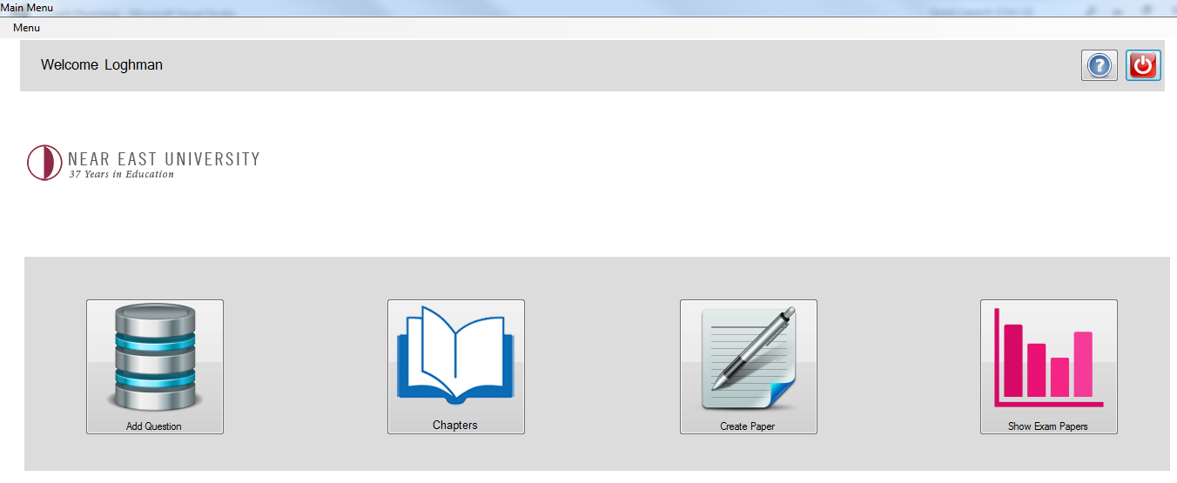

**Figure 1: Snapshot of Teacher Menu Page**

Here the user add question, chapters, create paper and save create exam papers.

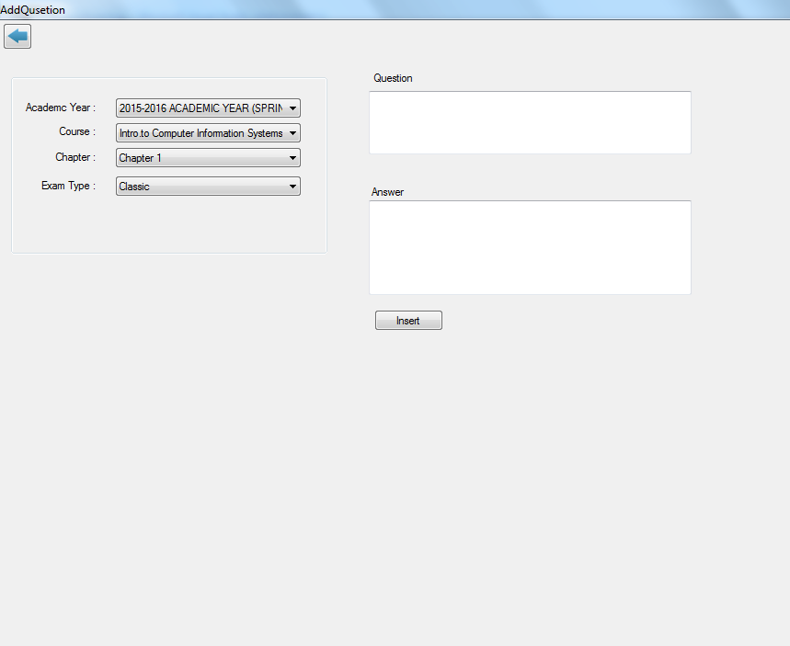

**Figure 2: Snapshot of Add Question Page**

Here the user which is the teacher add question like classic, multiple choice and true/false questions.

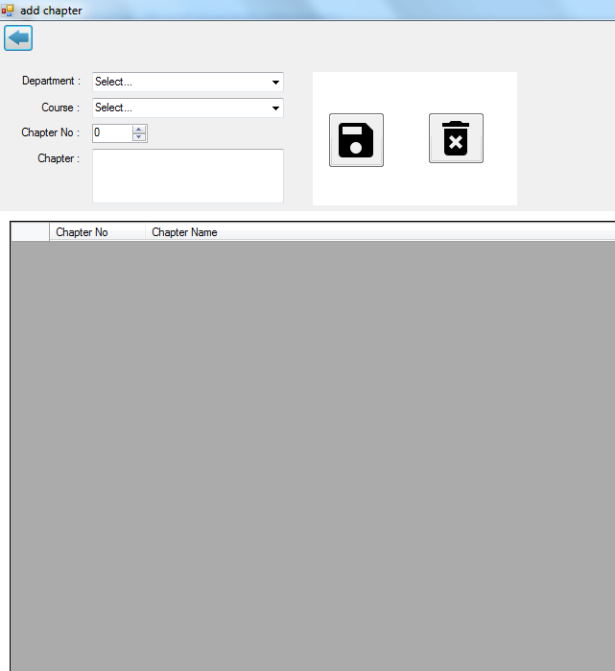

**Figure 3: Snapshot of Add Chapter**

Admin add all courses chapter to this menu, admin can also update and delete a particular course.

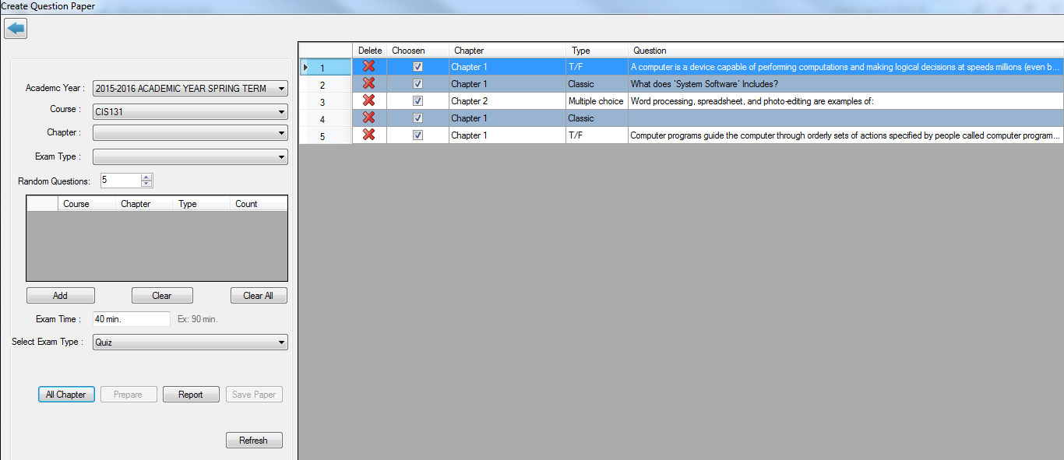

**Figure 4: Snapshot of Create Question Page**

Here is the main form of this project, it signifies what the project is all about, the teacher have alternative ways of creating question either by setting questions randomly from each chapter or setting randomly from all type of question an so on.

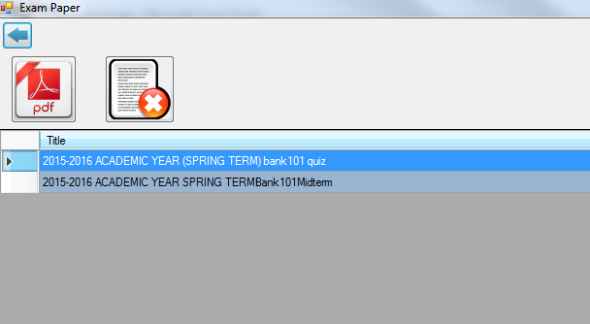

**Figure 5: Snapshot of Saved exam papers page**

Here is the menu for saved exam papers. If you click delete button it removes the saved exam paper.