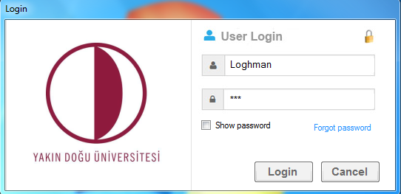

**Figure 1: Snapshot of Login Page**

This is where the admin or user logins in to the system. It also consist of forgot password menu whereby a user forget its password to the system, with the use of the secret question and answer he or she can still have access to get another password with the same account.

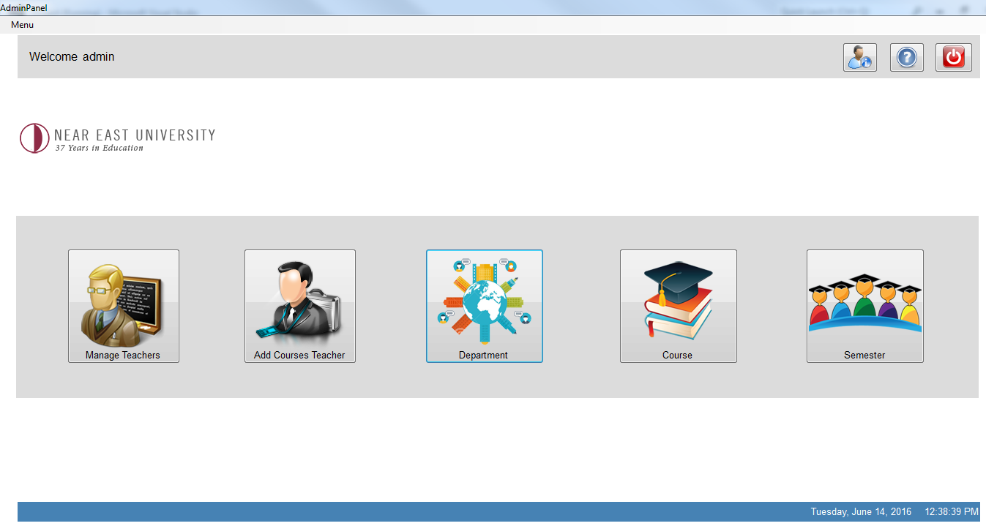

**Figure 2: Snapshot of Admin Page**

Here admin takes responsibilites, such as manage teachers,add teachers,department and courses and also make relations of teachers and courses accordingly.

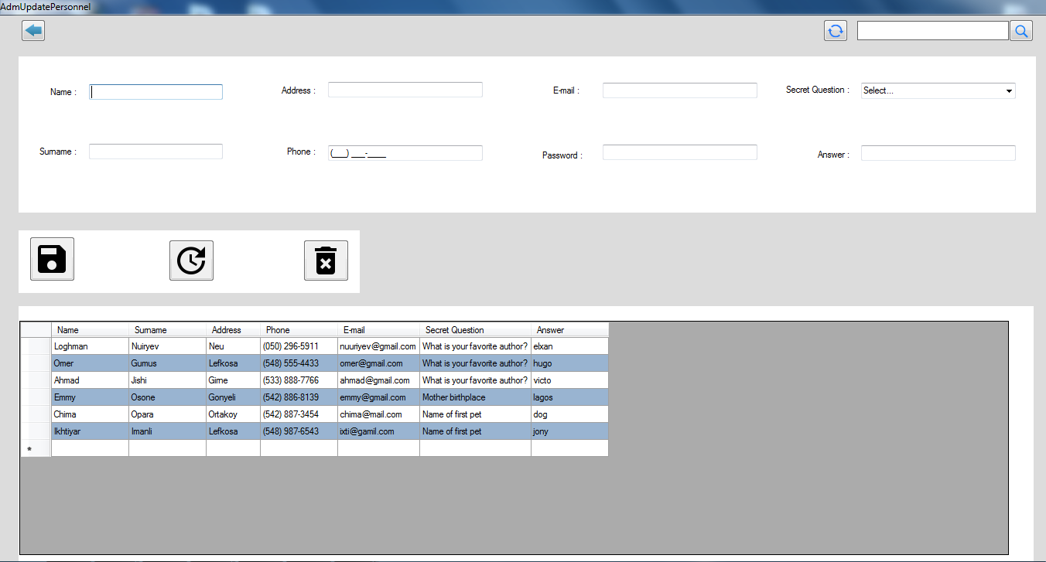

**Figure 3: Snapshot of Manage Teacher**

In this menu the admin add users of the menu mostly teachers and their basic details to be able to use the system efficiently.

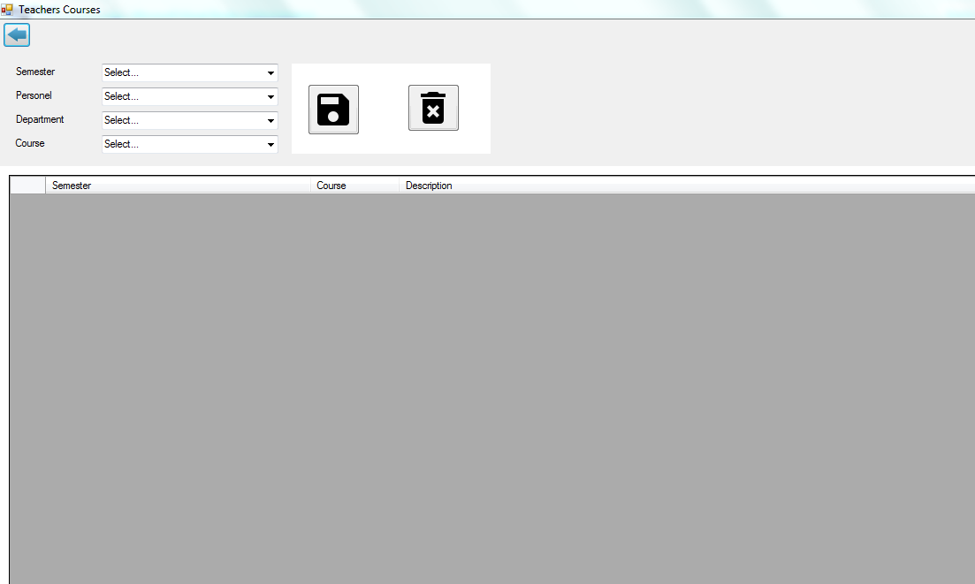

**Figure 4: Snapshot of Teachers Course**

**In this menu Admin merge the teacher and courses accordingly.**

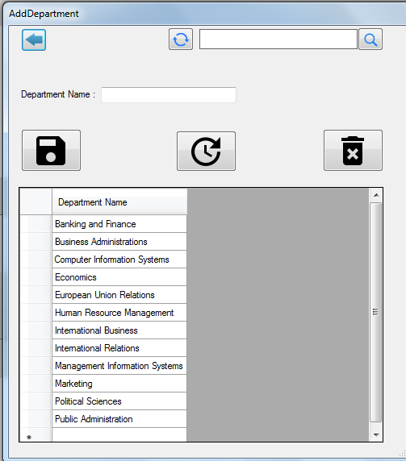

**Figure 5: Snapshot of Add Department**

Admin add all department to this menu, admin can also update and delete a particular department.

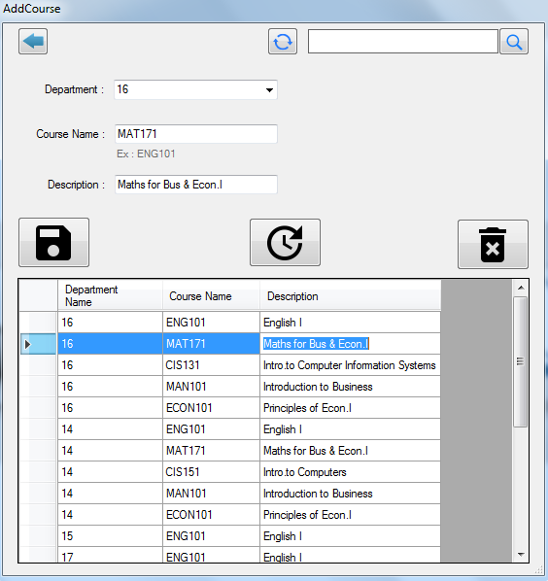

**Figure 6: Snapshot of Add Course**

Admin add all courses to department in this menu, admin can also update and delete a particular course.

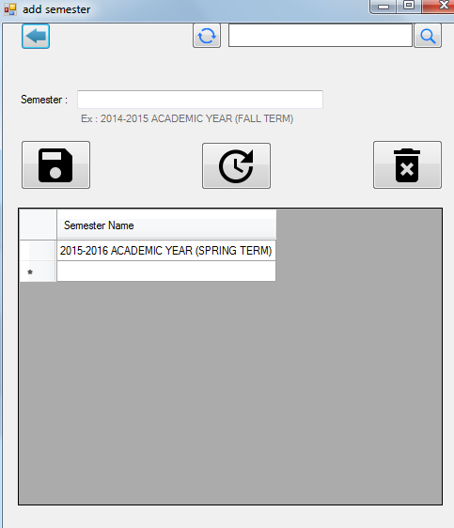

**Figure 7: Snapshot of Add Semester**

Admin add semester to this menu, admin can also update and delete a particular semester.

**Forget Password Page**

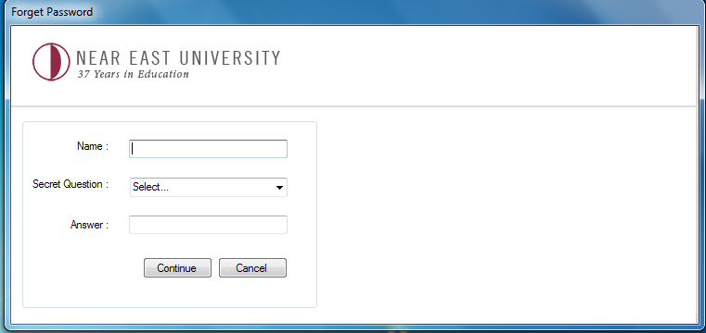

**Figure 8: Snapshot of Forget Password Page**

**Here the system user can have their account back with the secret question and password if they forgot their password.**