PERSONAL FINANCE ADVISOR BOT
& WEALTH ENGINE
PROJECT DOCUMENTATION
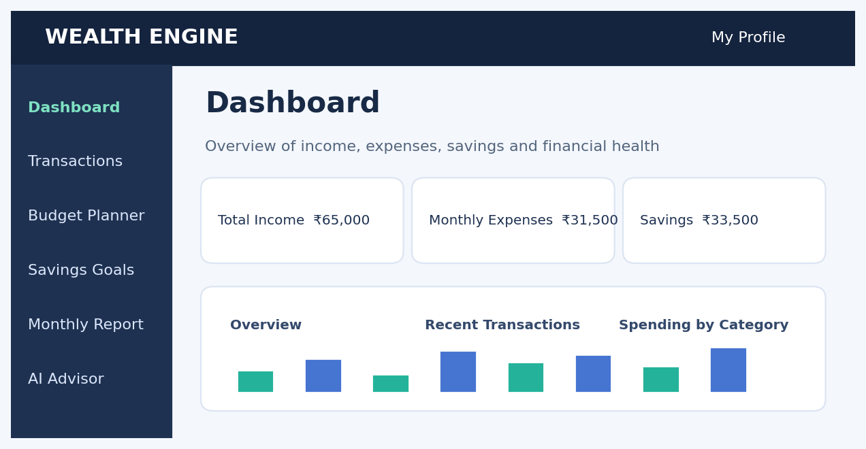
Department: Artificial Intelligence & Data Science
Prepared by: Omkar Gorad
Roll Number: 22130
Academic Project Report | October 2026

Abstract
Personal Finance Advisor Bot & Wealth Engine is a full-stack web application designed to help users understand their income, expenses, budgets and savings goals. It combines transaction management, visual reporting and an AI-assisted financial information interface. The system is built with React, TypeScript, Tailwind CSS, Express and an optional Google Gemini integration. A built-in rules-based advisory mode can provide basic guidance when an AI API key is unavailable. This report describes the system architecture, major modules, development workflow, illustrative interface designs, testing approach, limitations and future enhancements.

1. Introduction
Managing personal finances requires a clear understanding of where money comes from and where it is spent. Manual tracking in notebooks or scattered spreadsheets can make it difficult to identify spending patterns. This project presents an integrated web application for monitoring transactions, creating budgets, planning savings and viewing monthly summaries.

2. Problem Statement
Many users lack a simple consolidated interface for tracking expenses, checking budget allocations and planning future savings. Financial data may be spread across different tools, and beginners may find financial terminology confusing. The proposed solution organizes these activities in one accessible interface.

3. Objectives
- Provide a single dashboard for income, expenses and savings.
- Enable transaction entry, editing, categorization and CSV export.
- Support budget allocation and progress monitoring.
- Track savings goals and emergency fund targets.
- Generate understandable monthly financial summaries.
- Provide general financial education through an AI-assisted chat interface.

4. Existing and Proposed Systems
Aspect | Traditional Approach | Proposed Application
Tracking | Manual notes or sheets | Categorized transaction ledger
Budgeting | Separate calculations | Editable budget planner
Insights | Manual summaries | Dashboard and monthly reports
Assistance | External searches | Integrated advisory interface

5. Technology Stack
- Frontend: React, TypeScript, Tailwind CSS and Vite.
- Backend: Node.js and Express, with server-side API endpoints.
- AI integration: Google Gemini where configured; deterministic advisory fallback otherwise.
- Data: browser-side persistent application state as described in the project documentation.
- Development: npm, Node.js 18+ and standard web development tools.

6. System Architecture
The browser renders the React user interface and maintains user interactions across financial modules. Application logic calculates spending totals, budget proportions and savings progress. API service connectors communicate with the Express server for supported services such as advisory chat and currency information. The server can use a configured Gemini key for AI responses, while fallback logic supports basic financial guidance.
USER → REACT FRONTEND → FINANCIAL MODULES
FINANCIAL MODULES → LOCAL STATE / CALCULATORS
REACT FRONTEND → API SERVICE → EXPRESS BACKEND
EXPRESS BACKEND → OPTIONAL GEMINI API / FALLBACK ADVISOR

7. Modules and Illustrative Website Interfaces
The following figures are original illustrative UI mockups based on the documented project features. They are not screenshots captured from the deployed website. The monetary figures are sample data used for demonstration.

7.1 Dashboard
Overview of income, expenses, savings and financial health. The module helps users review and act on their financial information through an organized web interface.
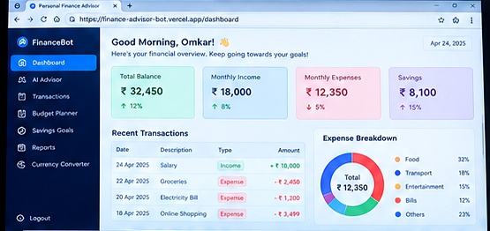
Figure 1: Illustrative Dashboard interface (sample data; not a live screenshot).

7.2 AI Financial Advisor
Conversational assistance for general budgeting and financial questions. The module helps users review and act on their financial information through an organized web interface.
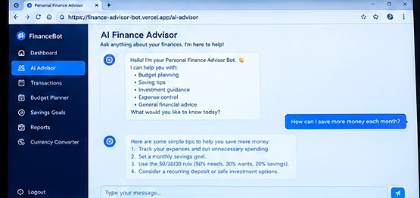
Figure 2: Illustrative AI Financial Advisor interface (sample data; not a live screenshot).

7.3 Expense Tracker
Organize and edit income and expense entries. The module helps users review and act on their financial information through an organized web interface.
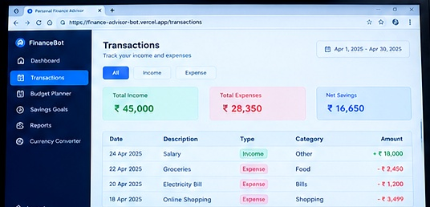
Figure 3: Illustrative Expense Tracker interface (sample data; not a live screenshot).

7.4 Budget Planner
Allocate a monthly budget using customizable categories. The module helps users review and act on their financial information through an organized web interface.
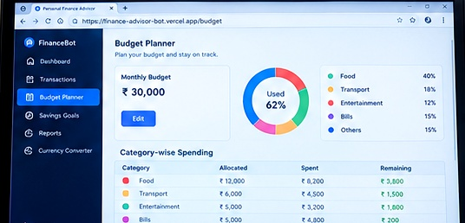
Figure 4: Illustrative Budget Planner interface (sample data; not a live screenshot).

7.5 Savings Goals
Plan savings targets and track milestones. The module helps users review and act on their financial information through an organized web interface.
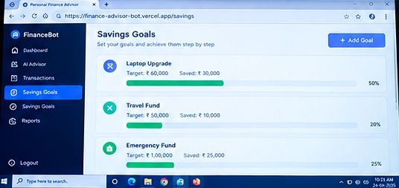
Figure 5: Illustrative Savings Goals interface (sample data; not a live screenshot).

7.6 Monthly Report
Summarize finances and prepare printable reports. The module helps users review and act on their financial information through an organized web interface.
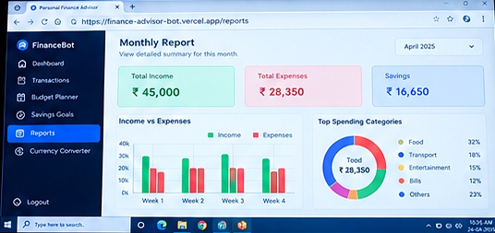
Figure 6: Illustrative Monthly Report interface (sample data; not a live screenshot).

8. Working Methodology
- Open the application and choose or create a user profile.
- Record income and expenses with suitable categories and dates.
- Review calculated totals on the dashboard.
- Adjust category budgets and create savings goals.
- Consult monthly reports to understand spending patterns.
- Use the advisor to ask general budgeting questions and evaluate suggestions critically.

9. Example Calculation
Illustrative monthly income: ₹65,000; expenses: ₹31,500; savings: ₹33,500. Savings = Income − Expenses = ₹33,500. Savings rate = (₹33,500 ÷ ₹65,000) × 100 ≈ 51.5%. These are example figures, not observed user records.

10. Testing Plan
Test Case | Expected Behavior | Status
Add expense | Transaction appears in ledger and totals update | To verify
Edit transaction | Edited values are reflected in summaries | To verify
Set budget | Category allocation is displayed correctly | To verify
Create savings goal | Goal progress updates with changes | To verify
AI chat without key | Fallback advisory response is available | To verify
Export CSV | Download contains transaction records | To verify
The statuses above are intentionally marked “To verify” because a live test execution log was not provided.

11. Advantages
- Integrated overview of personal finance activities.
- Simple visual presentation of spending and saving trends.
- Editable records and category-based planning.
- Educational guidance for everyday budgeting questions.
- Responsive web technology suitable for further extension.

12. Limitations
- AI-generated financial suggestions may be incomplete or inaccurate and are not professional financial advice.
- Actual security, persistence and API reliability depend on deployment configuration.
- Exchange-rate information may vary by source and refresh time.
- Illustrative interface images in this report do not establish that every feature has been tested.

13. Future Scope
- Optional secure account authentication and encrypted cloud synchronization.
- Bank statement import with user permission.
- More advanced spending forecasts and anomaly alerts.
- Accessibility and multilingual improvements.
- Automated testing, audit logs and deployment monitoring.

14. Conclusion
Personal Finance Advisor Bot & Wealth Engine brings together important personal finance functions in a single web application. Its dashboards, transaction tools, budget planning and savings goal modules provide a practical basis for learning financial management. The AI advisor can complement these tools with general information, while important financial decisions should still be independently checked. The project offers a foundation for future improvements in reliability, privacy and automation.

15. References
- Project README: Personal Finance Advisor Bot & Wealth Engine (user-provided project documentation).
- React documentation — https://react.dev/
- TypeScript documentation — https://www.typescriptlang.org/docs/
- Express documentation — https://expressjs.com/
- Tailwind CSS documentation — https://tailwindcss.com/docs

