AIL PRACTICAL – 4
AI IMAGE GENERATION
Name :- Omkar Hebbalkar
Roll No :- SE A 40

Task 1 : Comparative Research

Prompt Used:
Generate a photorealistic image of an ancient lighthouse standing on a rocky island in the middle of the ocean during a dramatic sunset. Show powerful waves crashing against the rocks, seagulls flying in the distance, warm sunlight reflecting on the water, and a realistic cinematic atmosphere.

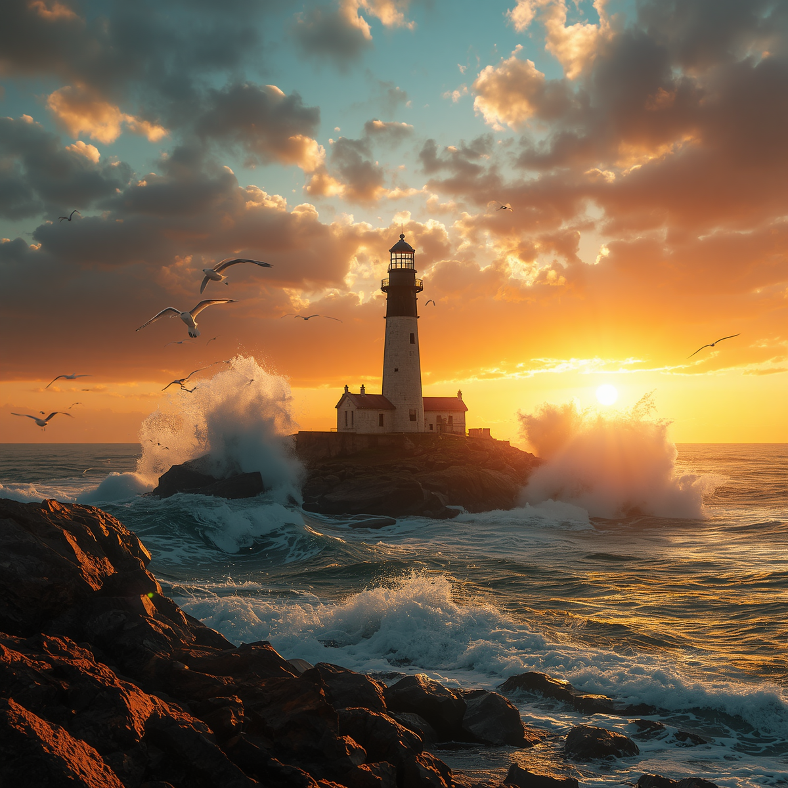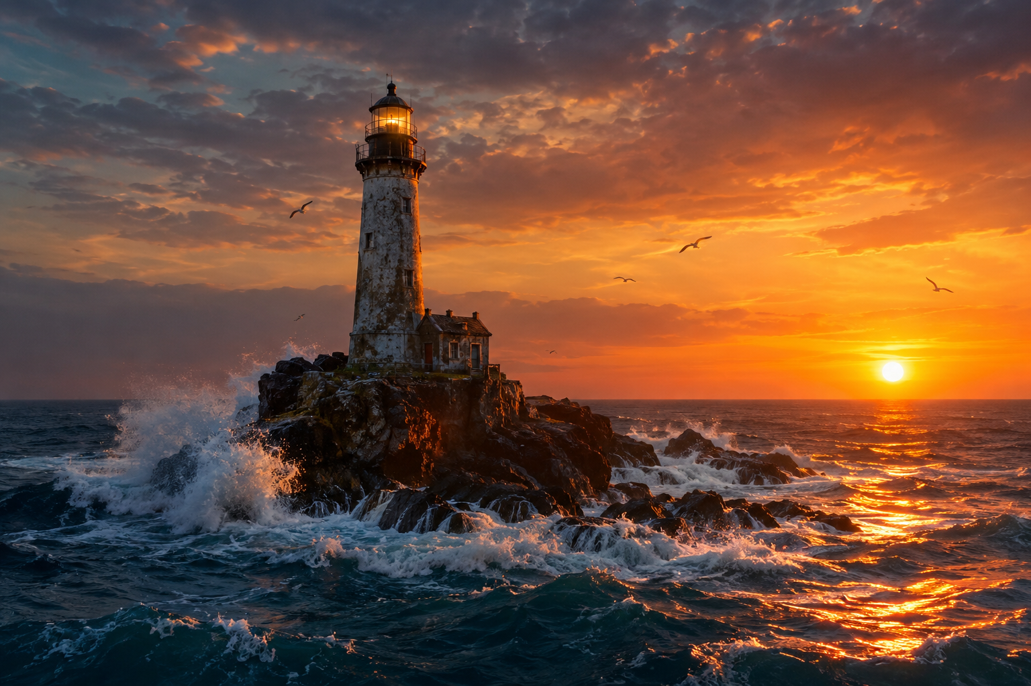
1.Image Generated From Canva 2.Image Generated from ChatGPT

Task 2 : Visual Design Project

Prompt Used:
Create a professional promotional poster for a fictional “Future Tech Expo 2026” technology exhibition. Show a futuristic exhibition hall filled with holographic displays, advanced robots, smart devices, and glowing digital interfaces. Use a premium corporate design, dramatic lighting, and a modern technology-focused visual style.
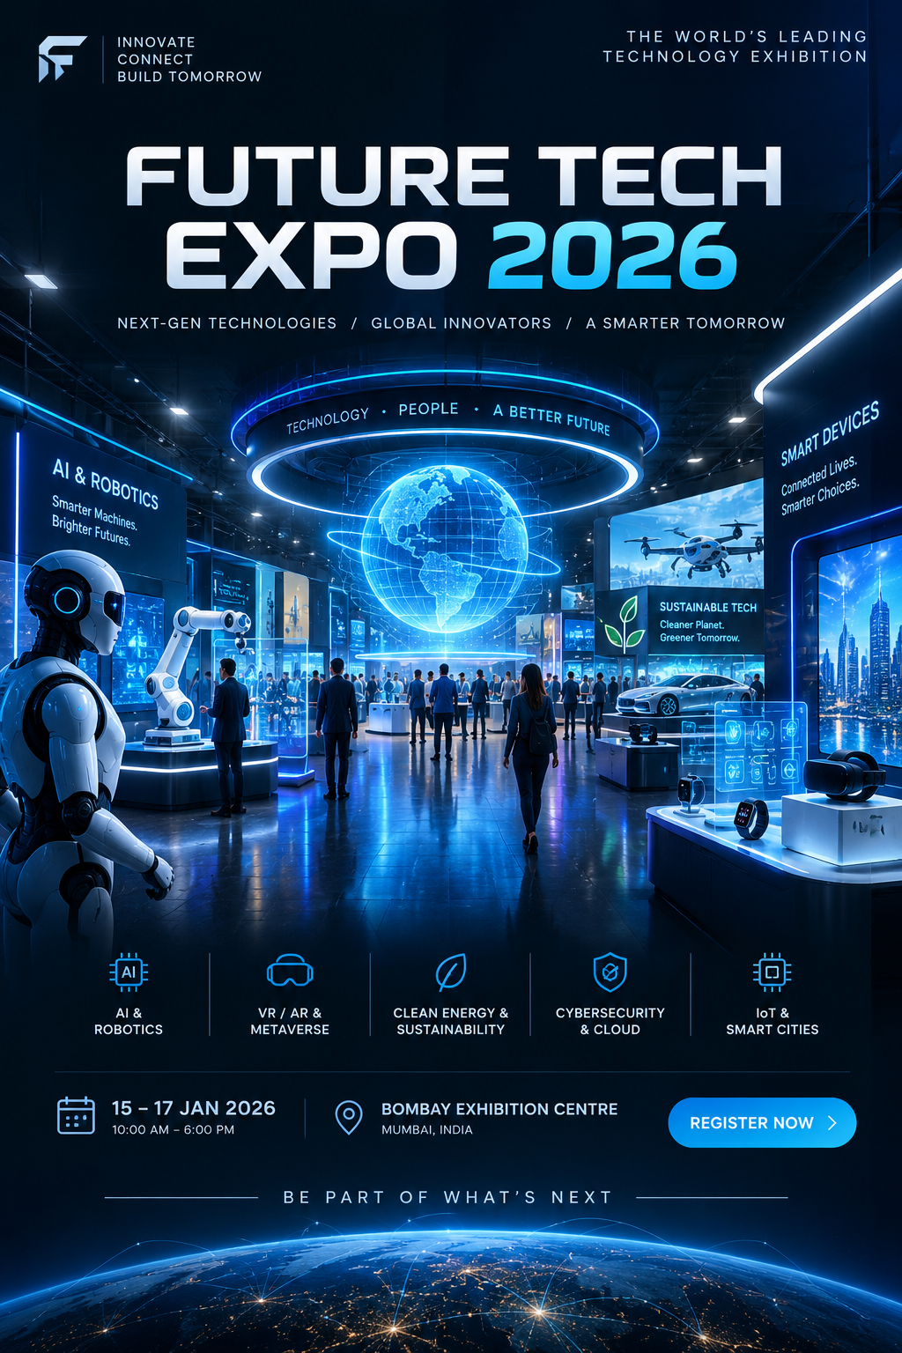

Task 3.Design a Visual Story Using 3 Image Prompts

Prompt 1 Used :Create a realistic image of a young aspiring chef preparing his first dish in a small home kitchen. Show him carefully following a recipe book while ingredients and cooking utensils are arranged on the counter. The atmosphere should represent curiosity, learning, and the beginning of his journey.
Prompt 2 Used: Create a realistic image of the same aspiring chef working confidently in a professional kitchen. Show him preparing multiple dishes with organized ingredients, cooking equipment, and other kitchen details around him. His expression should show concentration and growing confidence.
Prompt 3 used: Create a realistic image of the same chef receiving a prestigious culinary award at a grand food festival. Show him standing on a stage holding a trophy while an audience applauds. Include professional stage lighting, a large event backdrop, and a celebratory atmosphere representing the success of his journey.

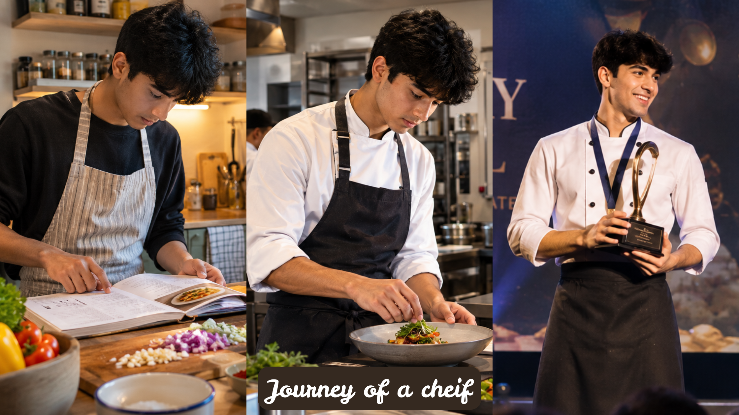

Task 4.Generate Concept Art for an Educational Topic

Prompt Used
Create a detailed educational concept-art infographic explaining the Solar System. Show the Sun at the centre with the planets arranged in their correct order, clearly distinguishable planetary appearances, orbital paths, asteroid belt, and a dark space background with stars. Use clean educational labels, balanced composition, scientifically inspired visual design, high clarity, and realistic planetary textures. Do not include any people or individual.

Educational Concept Art

