KARNATAK LAW SOCIETY’S

GOGTE INSTITUTE OF TECHNOLOGY

UDYAMBAG, BELAGAVI-590008

(An Autonomous Institution under Visvesvaraya Technological University, Belagavi)

**(APPROVED BY AICTE, NEW DELHI)**

Department of Electronics and Communication Engineering



*Course Project Report on*

**OPERATING SYSTEMS**

**FARMER INFORMATION APP FOR AGRICULTURE**

*Submitted in partial fulfilment of the requirement for the award of the degree of*

Bachelor of Engineering in

*Electronics & Communication.  
Submitted by*

Omkar Hegde – 2GI17EC064

Pavan Chaudhari – 2GI17EC069

Prasad Vernekar – 2GI17EC079

Parshwanath Mirji – 2GI17EC067

Guide

Prof. Aashish Gadgil

2019 – 2020

1.INTRODUCTION:

Indian agriculture currently faces a host of diverse challenges and fresh constraints due to the ever growing population, increasing food and fodder needs, natural resources degradation, higher cost of inputs & concerns of climate change. A phenomenal increase in food grain production is achieved using improved technology. The country‘s population is expected to reach 1660 million by the year 2050 and for which 349 million tons of food grains will be required. To meet this requirement there is urgent need to double the productivity of agricultural crops from the existing level. Since it is not possible to increase the land for cultivation, so the only option remains is to increase the productivity of farming using modern technology. For the sustainable development of farmer, it is necessary that decision making regarding farming should be perfect. The progress in production or steady growth in output is necessary to face the challenges posed by present economic, political and technological environment. It is also a fact that highly productive lands have been diverted from agriculture to infrastructural development, urbanization and other related activities. Under these circumstances the only option is to increase the productivity vertically. In view of these situations, using Information technology is the only way through which the target could be achieved. As we know IT is continuously increasing its roots in every fields and increasing their efficiency and from current scenario only farmers seems to be untouched with it, and probably the reason for the backwardness of our farmers. IT can improve the agriculture technique and hence a noticeable increase in crop yield can be noticed

2. BLOCK DIAGRAM OF THE APP:

3. SNAPSHOTS OF THE APP:-

MAIN SCREEN: ABOUT US:

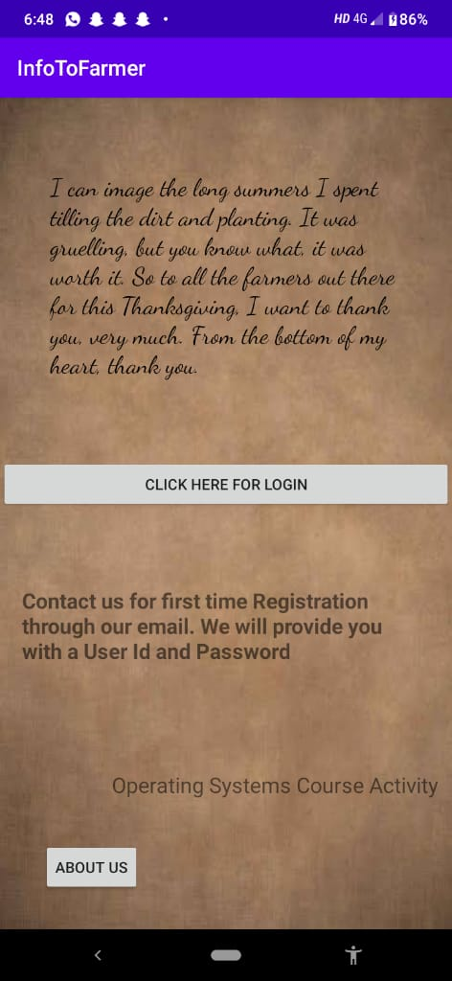 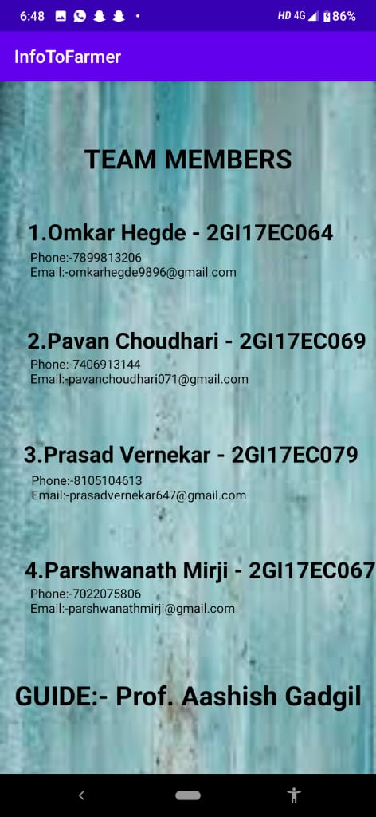

LOGIN PAGE:

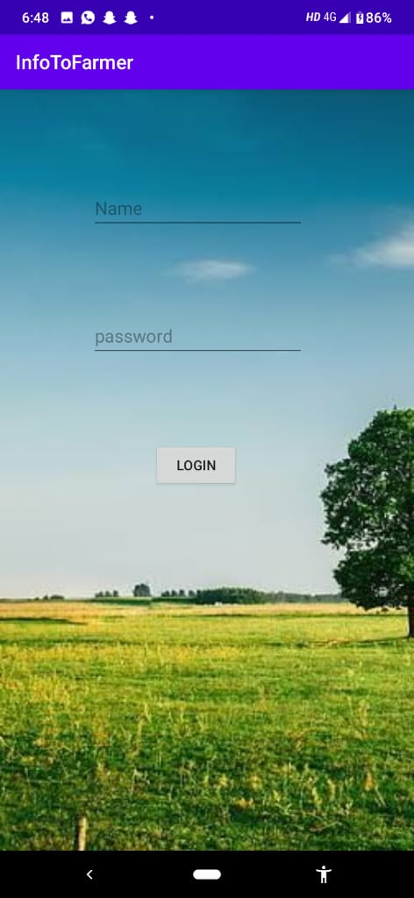 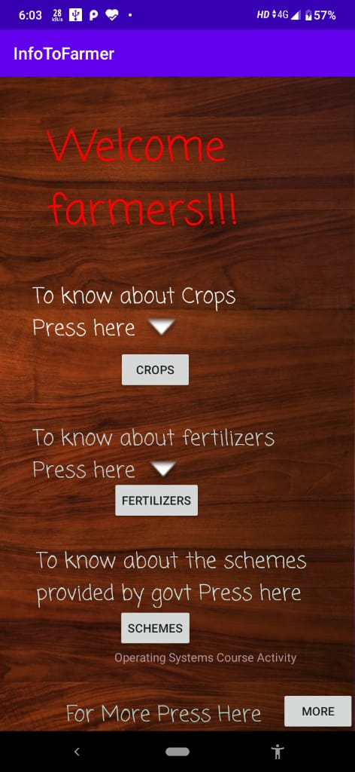 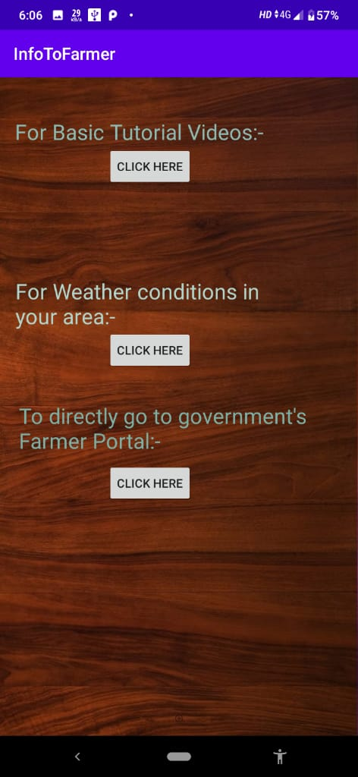

CONCLUSION:

InfoToFarmer will offer expertise service to farmers regarding cultivation of crops, pricing, fertilizers, and disease detail method of cure to be used etc. and even suggestions regarding modern techniques for cultivation, usage of bio-fertilizers, etc. Our main aim will be concentrated on bringing the modern agricultural techniques to the remote farmers. The relentlessly increasing importance and application of Information Technologies (ITs) in Agriculture have given birth to a new field called e-Agro, which focus on improving agricultural and rural development through a variety of technologies. Our android application InfoToFarmer will support all the smart phones on android OS(4.2.2 onwards). It will not only displays current weather parameters also will suggest them the most suitable crop and even with the required fertilizers, pesticide, herbicide throughout their work.

REFRENCES:

1 .https://en.wikipedia.org

2. <https://farmer.gov.in>

3. <https://krishijagran.com>

4. <https://www.youtube.com>

5. <https://www.accuweather.com>

CODE:-

**MAIN ACTIVITY :-**

KOTLIN CODE:-

**package** com.example.infotofarmer  
**import** android.content.Intent  
**import** androidx.appcompat.app.AppCompatActivity  
**import** android.os.Bundle  
**import** kotlinx.android.synthetic.main.activity_main.*  
**class** MainActivity : AppCompatActivity() {  
  
 **override fun** onCreate(savedInstanceState: Bundle?) {  
 **super**.onCreate(savedInstanceState)  
 setContentView(R.layout.*activity_main*)  
  
 aboutuss.setOnClickListener **{  
 val** intent = Intent(**this**,aboutus::**class**.*java*)  
 startActivity(intent)  
 **}** logininitial.setOnClickListener **{  
 val** intent = Intent(**this**,loginpage::**class**.*java*)  
 startActivity(intent)  
 }  
 }  
}

LAYOUT CODE:-

*<?***xml version="1.0" encoding="utf-8"***?>*<**androidx.constraintlayout.widget.ConstraintLayout xmlns:android="http://schemas.android.com/apk/res/android"  
 xmlns:app="http://schemas.android.com/apk/res-auto"  
 xmlns:tools="http://schemas.android.com/tools"  
 android:layout_width="match_parent"  
 android:layout_height="match_parent"  
 android:background="@drawable/back"  
 tools:context=".MainActivity"**>  
  
  
 <**TextView  
 android:id="@+id/quote"  
 android:layout_width="329dp"  
 android:layout_height="217dp"  
 android:layout_marginLeft="20dp"  
 android:layout_marginRight="20dp"  
 android:fontFamily="cursive"  
 android:text="I can image the long summers I spent tilling the dirt and planting. It was gruelling, but you know what, it was worth it. So to all the farmers out there for this Thanksgiving, I want to thank you, very much. From the bottom of my heart, thank you."  
 android:textColor="@android:color/primary_text_light"  
 android:textSize="23sp"  
 app:layout_constraintBottom_toBottomOf="parent"  
 app:layout_constraintHorizontal_bias="0.494"  
 app:layout_constraintLeft_toLeftOf="parent"  
 app:layout_constraintRight_toRightOf="parent"  
 app:layout_constraintTop_toTopOf="parent"  
 app:layout_constraintVertical_bias="0.126"** />  
  
 <**Button  
 android:id="@+id/aboutuss"  
 android:layout_width="wrap_content"  
 android:layout_height="wrap_content"  
 android:text="About Us"  
 app:layout_constraintBottom_toBottomOf="parent"  
 app:layout_constraintEnd_toEndOf="parent"  
 app:layout_constraintHorizontal_bias="0.12"  
 app:layout_constraintStart_toStartOf="parent"  
 app:layout_constraintTop_toBottomOf="@+id/quote"  
 app:layout_constraintVertical_bias="0.923"** />  
  
 <**Button  
 android:id="@+id/logininitial"  
 android:layout_width="0dp"  
 android:layout_height="wrap_content"  
 android:text="Click Here for Login"  
 app:layout_constraintBottom_toBottomOf="parent"  
 app:layout_constraintEnd_toEndOf="parent"  
 app:layout_constraintHorizontal_bias="0.0"  
 app:layout_constraintStart_toStartOf="parent"  
 app:layout_constraintTop_toBottomOf="@+id/quote"  
 app:layout_constraintVertical_bias="0.113"** />  
  
 <**TextView  
 android:id="@+id/signup"  
 android:layout_width="369dp"  
 android:layout_height="84dp"  
 android:text="Contact us for first time Registration through our email. We will provide you with a User Id and Password"  
 android:textSize="20sp"  
 android:textStyle="bold"  
 app:layout_constraintBottom_toBottomOf="parent"  
 app:layout_constraintEnd_toEndOf="parent"  
 app:layout_constraintHorizontal_bias="0.38"  
 app:layout_constraintStart_toStartOf="parent"  
 app:layout_constraintTop_toBottomOf="@+id/logininitial"  
 app:layout_constraintVertical_bias="0.231"** />  
  
 <**TextView  
 android:id="@+id/project"  
 android:layout_width="wrap_content"  
 android:layout_height="wrap_content"  
 android:layout_marginStart="70dp"  
 android:layout_marginLeft="70dp"  
 android:layout_marginTop="580dp"  
 android:layout_marginEnd="70dp"  
 android:layout_marginRight="70dp"  
 android:layout_marginBottom="8dp"  
 android:text="Operating Systems Course Activity"  
 android:textSize="20sp"  
 app:layout_constraintBottom_toBottomOf="parent"  
 app:layout_constraintEnd_toEndOf="parent"  
 app:layout_constraintHorizontal_bias="0.629"  
 app:layout_constraintStart_toEndOf="@+id/aboutuss"  
 app:layout_constraintTop_toTopOf="parent"  
 app:layout_constraintVertical_bias="0.0"** />  
  
</**androidx.constraintlayout.widget.ConstraintLayout**>

**app:layout_constraintStart_toStartOf="parent"  
 app:layout_constraintTop_toTopOf="parent"  
 app:layout_constraintVertical_bias="0.178"** />  
</**androidx.constraintlayout.widget.ConstraintLayout**>

FOR DETAILED CODE VISIT:-www.github.com/omkarhegde9896/InfoToFarmerApp