To create the task management application
Step 1 : create the folder (task management) than create the Backend and task_ frontend folder
Backend folder in cmd to
Command is – npm init -y
npm install express mysql2 cors dotenv bcryptjs jsonwebtoken
npm install nodemon --save-dev
Create folder backend/
backend/
│── server.js
│── db.js
│── .env
│── package.json
│
├── routes/
│ ├── authRoutes.js
│ ├── taskRoutes.js
│ ├── adminRoutes.js
├── controllers/
│ ├── authController.js
│ ├── taskController.js
│ ├── adminController.js
│
├── middleware/
│ ├── authMiddleware.js
│ ├── adminMiddleware.js
Step 2: Create Database in XAMPP
- CREATE DATABASE task_manager;

- CREATE TABLE users (
id INT AUTO_INCREMENT PRIMARY KEY,
name VARCHAR(100) NOT NULL,
email VARCHAR(100) UNIQUE NOT NULL,
password VARCHAR(255) NOT NULL,
role ENUM('admin','user') DEFAULT 'user'
);
- CREATE TABLE tasks (
id INT AUTO_INCREMENT PRIMARY KEY,
title VARCHAR(200) NOT NULL,
description TEXT,
status ENUM('pending','in-progress','done') DEFAULT 'pending',
assigned_to INT,
created_by INT,
created_at TIMESTAMP DEFAULT CURRENT_TIMESTAMP,
FOREIGN KEY (assigned_to) REFERENCES users(id) ON DELETE SET NULL,
FOREIGN KEY (created_by) REFERENCES users(id) ON DELETE CASCADE
);

Step 3: React Frontend Folder Structure
npm create vite@latest task-frontend
- React
- JavaScript

To install package
cd task-frontend
npm install
npm install axios react-router-dom bootstrap
Now folder structure:
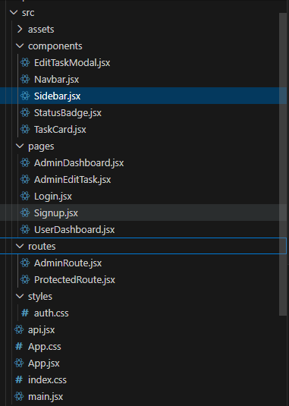

To run the backend
Cmd node server.js
To run the frontend - npm run dev

