ADO.NET:

ADO.NET provides a bridge between the front end controls and the back end database. The ADO.NET objects encapsulate all the data access operations and the controls interact with these objects to display data, thus hiding the details of movement of data.

The following figure shows the ADO.NET objects at a glance:

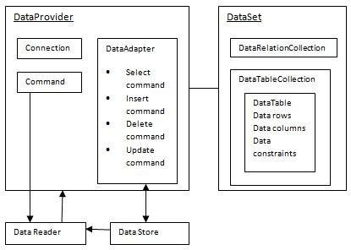

The DataSet Class :

The dataset represents a subset of the database. It does not have a continuous connection to the database. To update the database a reconnection is required. The DataSet contains DataTable objects and DataRelation objects. The DataRelation objects represent the relationship between two tables.